

Programme: Master of Business Administration
Module Name: Marketing Management
Module Code: LCMB7024
Lecturer’s Name: Dr Laila Maazouz

Student Name: Nurul Hasan
Student ID: 2509169

Word Count: 2692

Table of Contents
Introduction 3
Element 1: Segmentation, Targeting, Differentiation, and Positioning (STDP) Analysis 4
Introduction and New Brand Concept 4
Market Appeal and Emerging Trends 4
Segmentation 5
Targeting 7
Differentiation 7
Positioning 8
Element 2: Marketing Mix for LEAFMOTION 9
Product Strategy 9
Price Strategy 10
Promotion Strategy 12
Element 3: Marketing Strategy Pitch 14
Element 4: Reflection 16
Conclusion 18
References 19

Introduction
This report offers a strategic brand expansion of Patagonia into the electric bicycle market with the LEAFMOTION brand. Patagonia, with its environmental leadership, is usable to take advantage of the increasing trends in sustainable urban mobility solutions applying to environmentally conscious consumers between 16-40 who compose the intended audience. This project is in line with international trend of sustainable transport and fits the consistency with the initial idea of environmental concern and quality standards of Patagonia.

Element 1: Segmentation, Targeting, Differentiation, and Positioning (STDP) Analysis

Introduction and New Brand Concept
Patagonia has a well-established reputation as an environmental steward, which gives it a solid platform to expand into sustainable transportation (Marin et al., 2018). The LEAFMOTION idea is a logical elevation to the brand, which will be consistent with Patagonia environmental principles but will cater to the new mobility demands. Effective line extensions are based on the similarity of the features and the brand architecture, which LEAFMOTION manages to attain due to the ongoing sustainability messaging and quality control (Sezen et al., 2024). Based on strategic marketing management principles, the extension finds the opportunities in the market based on the organisational strengths and consumer values, which the Patagonia environmental mission directly extends into the urban mobility solutions (Aaker and Moorman, 2023).
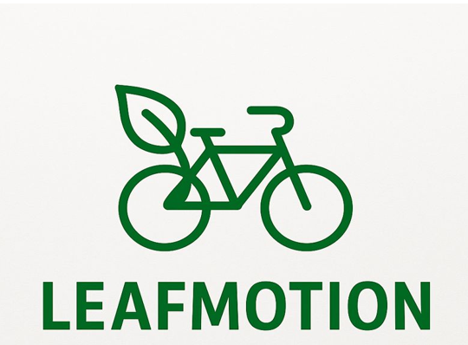
Figure: LEAFMOTION logo
Source: Self-made

Market Appeal and Emerging Trends
LEAFMOTION leverages the major market trends that are driving the rapid adoption of sustainable transportation. The e bike market is growing rapidly worldwide, as urbanisation and the increase of environmental awareness are the primary drivers, and younger consumers shift toward environmentally friendly mobility solutions ((Statista, 2025).
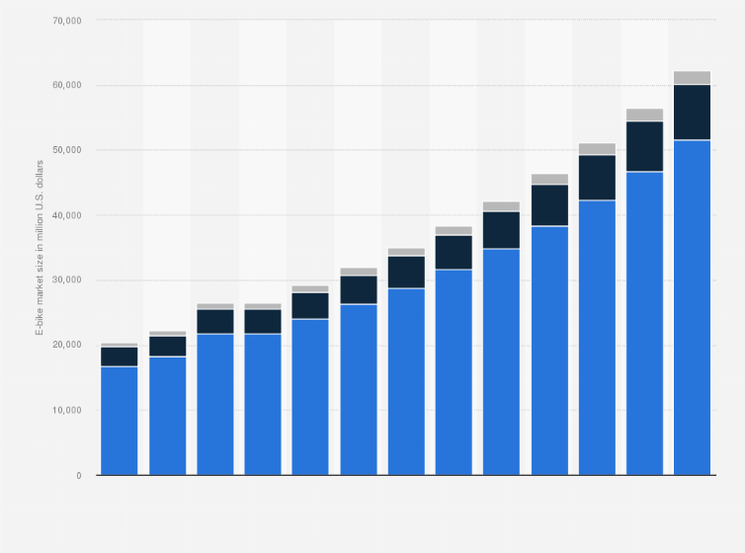
Figure: Global E-bike market forecast
Source: (Statista, 2025)
Generation Z is eco-conscious and ready to spend on sustainable goods, and data-driven insights become essential to comprehend the preferences and lifestyle-based buying behaviour (Hajli et al., 2020). Simultaneously, urbanisation and the rise in health consciousness are increasing pressure on active and efficient options of commuting. By matching market potentials to organisational strengths, LEAFMOTION presents a solution that will also solve the urban mobility issue and will contribute to the healthier and environmentally responsible living (Chernev, 2025).

Segmentation
The successful implementation of segmentation implies the thorough examination of all four criteria, namely demographic, psychographic, geographic, and behavioural criteria in terms of categorising unique customer segments (Saqib, 2020). The STDP analysis indicates three major market segments:
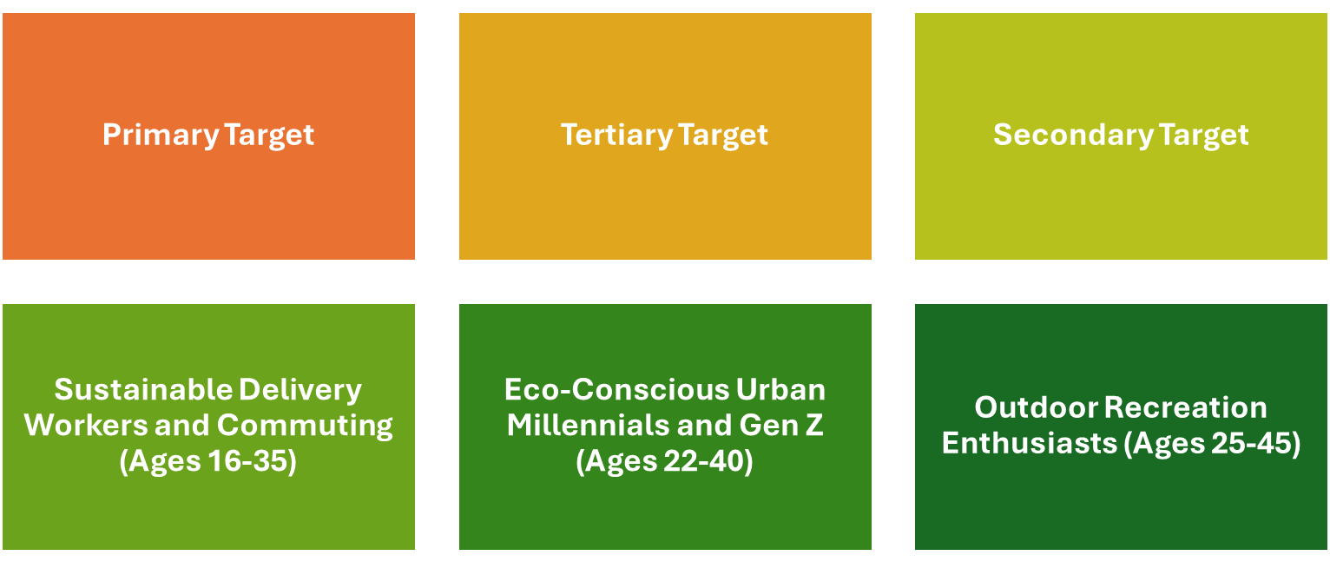
Figure: Segmentation
Source: Self-made
Primary Target: Eco-Conscious Urban Millennials and Gen Z (Ages 22-40)
This group is a group of environmentally conscious practitioners and middle to upper-middle income earning students who focus on the sustainability issue when making purchases. They will actively pursue brands that can prove to be genuinely committed towards the environment. According to research, there is a strong correlation between environmental consciousness and brand loyalty when the company provides real environmental benefits (Zulfikar, 2022).
Secondary Target: Sustainable Delivery Workers and Commuting (Ages 16-35)
Learners and delivery agents that need affordable, convenient ways of travelling to their educational and business destinations. They have a high testimony to practical benefits as reduced costs, convenience, and reliability and they even have an appreciation to the environment benefits as an extra value. This segment is a promising one because of the increased gig economy employment.
Tertiary Target: Recreationists (Ages 25-45)
Patagonia consumers who were already interested in outdoor pursuits and leisure cycling and wanted premium machine work, but they needed products that were environmentally suitable. This segment reflects natural brand extension prospects because of the existing brand loyalty and common values.

Targeting
LEAFMOTION will mainly target Eco-Conscious Urban Millennials and Gen Z as this segment reflects best when it comes to sustainable consumption trends and high-end pricing possibility. The principles of strategic market management focus on the necessity to retain resources in areas that promise the most significant returns and alignment with the brand (Aaker and Moorman, 2023). The target audience is environmental-conscious, highly digital, and seeks authentic brands with true sustainability values (Zulfikar, 2022). Their urban environment generates inherent requirements of a fast, sustainable transportation system. Also, the increasing purchasing power and brand advocacy potential of this segment due to the impact of social media makes them strategic asset in long-term market penetration and brand building campaigns.

Differentiation
LEAFMOTION has a competitive advantage in the form of some strategic strengths:
True Environmental Heritage: LEAFMOTION will have an edge over its competitors as opposed to the competitors who might be involved in greenwashing activities as Patagonia has established environmental responsibility throughout its 50-year history. Lozada (2020) illustrates the successful implementation of the Triple Bottom Line in marketing strategy by Patagonia, forming the legitimate competitive advantage, which appeals to consumers who are environmentally aware.
High-Quality Sustainable Materials: LEAFMOTION uses the expertise of Patagonia in the selection of sustainable materials and the manufacturing process with responsible practices. The responsible marketing mix strategy makes the product development coherent with sustainability aspects, where they differentiate themselves with genuine, environmental value (Kerem, 2024).
Community and Advocacy Integration: The brand will build on the existing environmental advocacy platform at Patagonia and give customers the opportunity to participate in environmental activities beyond the purchase of their product, building a stronger brand presence and community.

Positioning
LEAFMOTION proposes itself as "The conscious commuter sustainable option- where urban mobility innovations and environmental responsibility meet.
The branding puts LEAFMOTION in the high-end sustainable mobility sector, which generally focuses on focusing on environmental impact and viable urban mobility. Positioning strategy stands out among the budget-oriented competitors but retains reach to the target demographic income levels (Saqib, 2020). Positioning must have effective positioning value propositions, values appealing to the target audience, and creating a competitive edge (Kotler et al., 2020). The strategy will capitalise on the genuine environmental legacy of Patagonia to create credibility and meets real-world mobility concerns in the city. The positioning focuses on the emotional appeal with its environmental care and the rational value with innovative usability, developing a high-level brand differentiation in the environmentally friendly transportation industry.

Element 2: Marketing Mix for LEAFMOTION
The marketing mix framework offers a methodical planning of strategic marketing decisions and makes sure that all aspects of product, pricing, place and promotion are properly considered (Kotler et al., 2020).
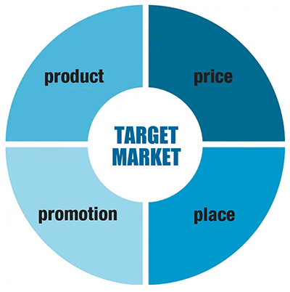
Figure: Marketing Mix (4Ps)
Source: Kotler et al. (2020)

Product Strategy
LEAFMOTION focuses on eco-friendly design and technology in keeping up with the trend in the e-bikes market. Digital transformation of innovation processes allows the development of the collaborative approach to development, combining customer feedback (Marion and Fixson, 2021). The main characteristics are recycled aluminium frames, interchangeable 500Wh lithium-ion batteries that cover the range of 50-80km, and 250W mid-drive motors, complying with EU standards.
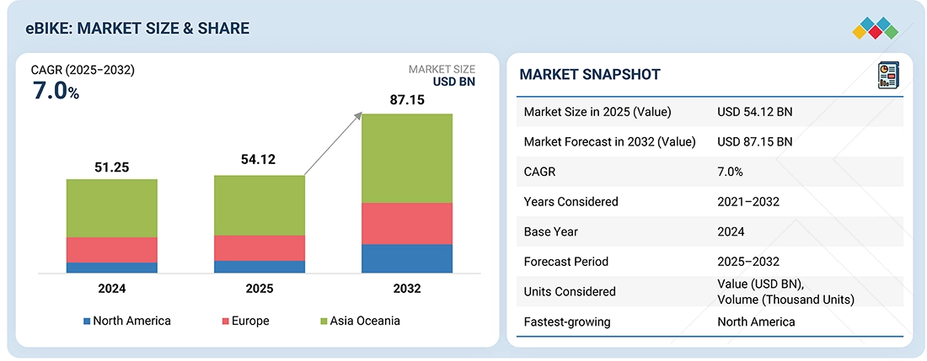
Figure: E-bike market size data
Source: (www.marketsandmarkets.com)
Technical features include built-in GPS, cell phone connexion via Bluetooth, light emitting diodes, and anti-theft alarms. Design also focuses on longevity and IPX4 weather resistance and punctureproof tyres. Planned risk management provides quality standards that promote premium positioning (Smith and Merritt, 2020). The responsible marketing mix balances the development with the sustainability aspects (Kerem, 2024).
There are three models that aim at key segments: Urban Commuter (£1,200), Cargo model that is aimed at deliveries (£1,800), and Recreation model (£2,200). Other modular accessories are panniers, phone mounts and child seats. Smart capabilities offer ride insights, service notification and route optimization with specific app help in personalised travel organisation (Liu et al., 2025).
The augmented offers are three-year warranty, LEAFMOTION Community membership, exclusive events, and repair services. Long service contracts cement durability messages as they create customer loyalty.
Price Strategy
LEAFMOTION will use Premium Value pricing of 1,200-2,200 based on the willingness of 73 percent of the consumers to spend on sustainable products. This is between mass-marketing brands (£400-800) and ultra-premium segment (£3,000+). Strategy pricing assists brand positioning as profitability is maximised (Chernev, 2025).
Present e-bike market records 15 percent growth in prices yearly because of component prices and demand. The pricing of LEAFMOTION generates an ideal value proposition among environmentalists who need quality but should not be charged high prices. Gross margins between 45-50 allows sustainability and environmental investment.
Financing alternatives consist of 0% APR in 24 months with Patagonia Financial Services, covering the cost problem of two-thirds of the prospective customers. The trade-in scheme will provide conventional bicycles with a trade in the value of up to £200-400 credit towards sustainable upgrades. Acquisition is supported by student discounts (15%), the Patagonia loyalty pricing (10%), and integrity (Hooley, 2020).
Corporate affiliations of green employers are volume-based discounts on employee programmes, focused on green commuting initiatives undertaken in companies. Maintenance packages and replacement guarantees are both available as leasing options to delivery workers.
Place Strategy
LEAFMOTION will use hybrid distribution by using Patagonia infrastructure and build special channels. Global marketing management focuses on coverage and brand control (Kotabe and Helsen, 2022).
Online sales via Patagonia.com take advantage of 40 percent of e-bikes sales that happen on the Internet. Advanced configurator allows customization at real-time prices. The services of click-and-collect in Patagonia stores save shipping fees and provide the opportunity to test rides.
Hands-on experience is offered physically by having designated areas at 25 flagship Patagonia stores. Professional personnel provide test ride and technical advice. The choice of strategic places is in high cycling adoption locations.
Premium bicycle retailer partnerships increase access but do not change positioning. Couples should be environmentalists and offer qualified professionals. It has 150+ authorised repair centres and mobile maintenance operations in urban centres.
Geographic focus is on European cities (London, Amsterdam, Copenhagen) and North American markets (Portland, San Francisco, Toronto) that have developed cycling infrastructure. The initial rollout will serve 15 large metropolitan areas and will serve 50 or more cities at the end of the third year.

Promotion Strategy
LEAFMOTION focuses on the true storytelling and community involvement in line with the Patagonia strategy. Combined communication plans touch on target values (Zulfikar, 2022).
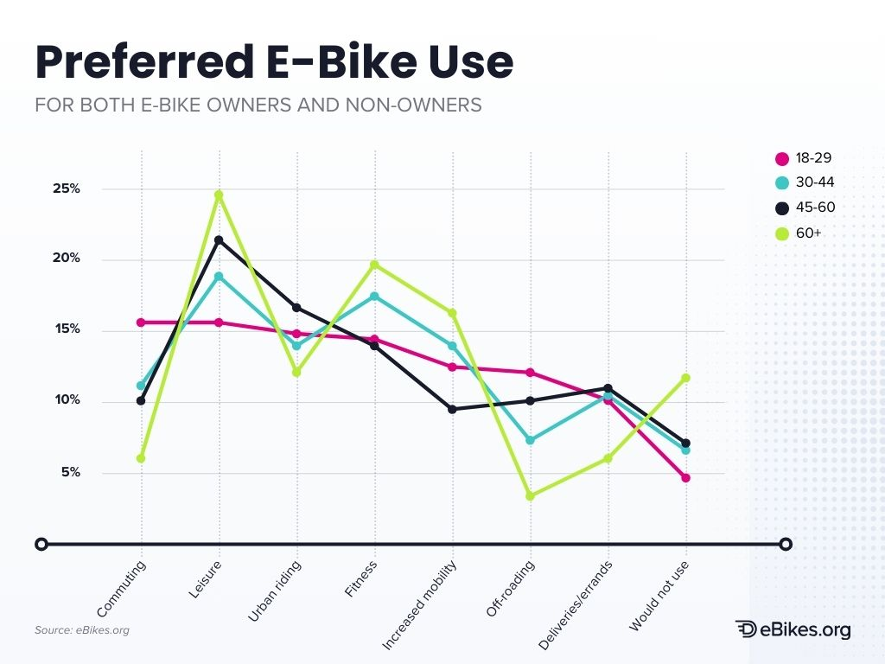
Figure: Preferred e-bike use data
Source: (Reid, 2024)
Digital marketing pays attention to Instagram and Tik Tok where 78% of Gen Z learn about brands. They have customer journey storeys, environmental impact statistics (CO2 saved, miles travelled) as well as maintenance tutorials. Market agility needs to be optimised by utilising analytics (Aljumah, et al., 2021).
The influencer partnerships focus on micro-influencers (10K-100K followers) in the realms of sustainability and urban lifestyle with the average engagement rates of 3.5 as compared to 1.2 in micro-influencers. The campaigns related to user-generated multimedia tell customers to share their daily commuting moments via the #LEAFMOTIONLife.
Some examples of experiential marketing would be testing riding events in cities, attending Earth Day festivals, and collaborating with cycling advocacy groups. Sustainable Commuter monthly gatherings produce community and create word-of-mouth marketing.
Thought leadership is done via content marketing in terms of blog articles, YouTube tutorials and various reports on environmental impact. Collaboration with environmental groups enhances message delivery but remains credible within a target population that is highly doubtful by corporate environmentalist arguments.

Element 3: Marketing Strategy Pitch
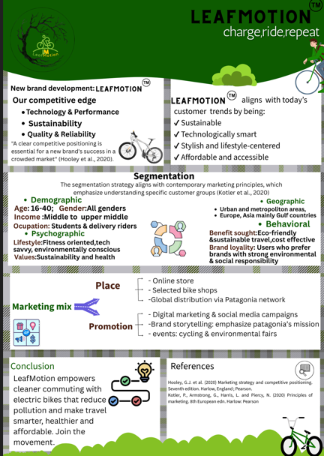
Global e-bike market poses unparalleled growth potential with massive growth being projected till 2030. Urban carbon emissions stimulate consumers to buy sustainable transportation options, and target demographics indicate high levels of environmental awareness and high willingness to pay premium prices (Hajli et al., 2020).
Introducing the LEAFMOTION by Patagonia: Patagonia introduces LEAFMOTION and capitalises on 50 years of environmental leadership in sustainable city travel. Patagonia sustainable materials are paired with innovative e-bike technology to make commuting cleaner with the help of transportation solutions that eliminate pollution (Lozada, 2020).
Product Innovation and Positioning: LEAFMOTION has sustainable design with recycled materials, a range of 50-80km, and smart technology. High pricing of about £1,200-2,200 makes LEAFMOTION affordable luxury: to the environmentally aware demographic aged 16-40 who values sustainability in deliveries and/or students, a target market.
Competitive Advantages: Strategic differentiation is based on a true five-decade environmental legacy, sustainable quality construction, in-built smartphone connectivity, and community-oriented advocacy initiatives. LEAFMOTION is providing quantifiable sustainability by instituted supply chain programmes (Kerem, 2024).
Distribution Strategy: Multi-channel distribution will use the retail base of Patagonia and establish specialisation. Market penetration and promotion through online sales, flagship store integration, and premium retailer partnerships will target European and North American urban centres initially.
Projected Impact: LEAFMOTION puts Patagonia on the leading edge of sustainable mobility and creates additional sources of revenue. According to conservative forecasts, the market share potential of premium sustainable segments remains high and endorses market growth along with environmental mission development (Aaker and Moorman, 2023).

Element 4: Reflection
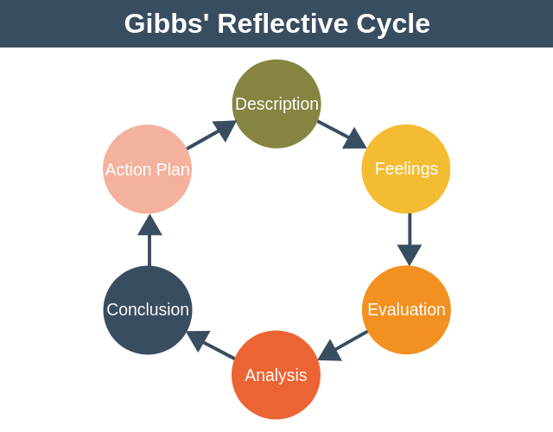
Figure: Gibbs’ reflective cycle
Source: (Oviawe, 2020)
Description
This reflection looks at how I developed the marketing strategy of LEAFMOTION, especially the section of the marketing strategy pitch. To develop a strong business case over (brand extension) of Patagonia, I needed to have detailed market research, critical thinking, and strong selling abilities. The pitch required balancing advanced market research, customer behaviour and positioning in a short, compelling format that appeals to investors and consumers.
Feelings
At first, I was confident to employ theoretical frameworks, as I possessed good basic knowledge on STDP analysis and the basis of marketing mix. Nevertheless, it posed serious challenges to come up with a valid brand extension and preserve the same consistency with the environmental values of Patagonia. The presentation of the marketing strategy produced a specific stress because of the need to create an analytical base and strong narrative storey within a limited range of requirements.
Evaluation
The project was able to illustrate how marketing theory can be applied practically in the real-life situation. The planning of LEAFMOTION helped me to comprehend the concept of strategic brand extension more, especially, how to preserve the brand authenticity when opening the new possibilities. My most useful learning experience was the pitch, which involved distillation of market research into gripping storey with the ability to be both analytically credible and emotionally attractive.
Weaknesses were time management issues contributed to the level of competitive analysis that I faced and were possibly a constraint on strategic differentiation information. Development areas were identified in technical presentation, that is, producing visually compelling content that can effectively communicate complex strategic concepts.
Analysis
The pitch presentation of marketing strategy exposed critical areas of learning. Most importantly, I learned better the importance of storytelling in strategic marketing by seeing how objective insights need to be converted into powerful narratives that attract various parties (Aaker and Moorman, 2023). The integration of consumer behaviour research was highly useful, and it showed how scholarly knowledge can be applied directly to marketing decisions. The use of Graham Gibbs reflection model allowed revealing learning areas and development opportunities (Oviawe, 2020).
The challenges were in meeting analytical rigour with creative presentation in creative presentation and logical argumentation at the same time. The knowledge of the Generation Z sustainability priorities served as a basis to target strategies, as well as aiding the pricing decisions, but there was a problem of communicating this.
Conclusion
LEAFMOTION made my strategic thinking and presentation skills scale many heights and proved practical application of the marketing theory. The practise enhanced my knowledge on principles of sustainable branding and consumer behaviour study besides identifying areas of further development. The pitch specifically helped me to improve my presentation abilities and strategic communication skills that are required to market myself as a successful professional.
Action Plan
Development Area | Identified Challenge | Planned Action | Expected Outcome
Visual Communication | Limited design skills for strategic presentations | Complete advanced presentation design course and practice with professional tools | Enhanced presentation impact and stakeholder engagement
Strategic Storytelling | Balancing data analysis with compelling narrative | Develop storytelling framework and practice pitch delivery | Stronger strategic communication and persuasion abilities
Competitive Analysis Depth | Time constraints limited comprehensive competitor research | Implement structured competitive intelligence process | More robust strategic positioning and differentiation
Market Research Integration | Occasional disconnect between research insights and strategic recommendations | Create systematic research-to-strategy translation methodology | Improved evidence-based decision making

Conclusion
LEAFMOTION is a strategically viable brand extension that uses the environments of Patagonia to seize the market opportunities of sustainable urban mobility. The integrated marketing strategy will also focus on environmentally friendly consumers by being authentic in positioning, high in price, and promoting it within the community. The solution ensures brand consistency at the same time and creates new revenue generators and improves relationships with younger audiences.

References
Aaker, D.A. and Moorman, C., 2023. Strategic market management. John Wiley & Sons.
Aljumah, A.I., Nuseir, M.T. and Alam, M.M., 2021. Traditional marketing analytics, big data analytics and big data system quality and the success of new product development. Business Process Management Journal, 27(4), pp.1108-1125.
Chernev, A., 2025. Strategic marketing management. Cerebellum Press.
Diamondopoulos, J., 2020. The STDP theory of financial crises (Doctoral dissertation, Birkbeck, University of London).
Hajli, N., Tajvidi, M., Gbadamosi, A. and Nadeem, W., 2020. Understanding market agility for new product success with big data analytics. Industrial Marketing Management, 86, pp.135-143.
Hooley, G. J., et al. (2020). Marketing strategy and competitive positioning. Seventh edition. Harlow, England: Pearson.
Kerem, K., 2024. The Responsible Marketing Mix: Aligning the 4Ps with Sustainability Dimensions. In Performance Challenges in Organizational Sustainability: Practices from Public and Private Sector (pp. 61-85). Singapore: Springer Nature Singapore.
Kotabe, M.M. and Helsen, K., 2022. Global marketing management. John Wiley & Sons.
Kotler, P., Armstrong, G., Harris, L. C., and He, H. (2020). Principles of Marketing Eight European Edition. Uk: Pearson.
Kotler, P., Armstrong, G., Harris, L. C., and Piercy, N. (2020). Principles of marketing. 8th European edn. Harlow: Pearson.
Liu, B., Ge, J. and Wang, J. (2025). Vaiage: A Multi-Agent Solution to Personalized Travel Planning. [online] arXiv.org. Available at: https://arxiv.org/abs/2505.10922?utm [Accessed 2 Sep. 2025].
Lozada, P.P., 2020. How Patagonia apply Triple Bottom Line in their marketing strategy.
Marin, L., Ruiz De Maya, S., and Rubio, A. (2018). The role of identification in consumers' evaluations of brand extensions. Frontiers in Psychology, 9, 2582.
Marion, T.J. and Fixson, S.K., 2021. The transformation of the innovation process: How digital tools are changing work, collaboration, and organizations in new product development. Journal of Product Innovation Management, 38(1), pp.192-215.
Oviawe, J. (2020). Application of Graham Gibbs model of reflection to improve teaching understanding among technical education students in Ambrose Alli University Ekpoma Edo State. Sumerianz Journal of Education, Linguistics and Literature, 3(2), 1201-2617.
Reid, A. (2024). eBikes.org’s Data-Driven Insights Into the E-Bike Market. [online] Electric Bike Reviews. Available at: https://ebikes.org/general/e-bike-market-insights/.
www.marketsandmarkets.com. (n.d.). E-Bike Market Growth, Industry Trends, and Statistics by 2025. [online] Available at: https://www.marketsandmarkets.com/Market-Reports/electric-bike-market-110827400.html.
Saqib, N. (2020). Positioning–a literature review. PSU Research Review, 5(2), 141-169.
Sezen, B., Pauwels, K., and Ataman, B. (2024). How do line extensions impact brand sales? The role of feature similarity and brand architecture. Journal of Marketing Analytics, 12(3), 537-550.
Shehata Nakhil, S., 2024. Modern urgencies creating a market advantage: Sustainable business models in the fashion industry-a Patagonia Case Study.
Smith, P.G. and Merritt, G.M., 2020. Proactive risk management: Controlling uncertainty in product development. productivity press.
Statista. (2025). Global e-bike market forecast by end-use 2030| Statista. [online] Available at: https://www.statista.com/statistics/1334663/global-e-bike-market-forecast-by-end-use/?srsltid=AfmBOoo7wpidfpY2X1dP1fBSw_tVcSsuOz07fow_JJyUoZP7PEgzTTVB [Accessed 14 Dec. 2025].
Zulfikar, I., 2022. Building a strong brand: Marketing strategy to increase brand awareness and consumer loyalty. Neo Journal of economy and social humanities, 1(4), pp.280-284.

