Courtneys in- class mind map!
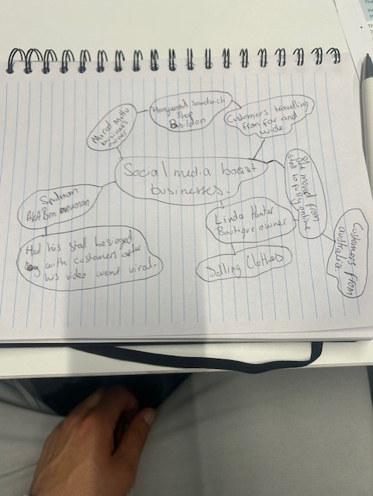

Q1. What is the main idea of the whole text?
A1. I believe the main idea of the whole text is to explain to the readers that social media platforms have made it easier to get businesses noticed. In the article the writer says that Instagram and tiktok have made it easier than ever to get noticed all around the world
Q2. What is one key point that supports the main idea, and which specific example from this text shows this.
A2. The key point in this text is that social media helps small businesses get noticed by a larger and wider audience and brings new customers. The specific example I will give is in the writer of the artlicles subheading “ customer travelled three hours for our burger” which suggest social media does encourage customers to try new stuff. This is proof that social media and creating content for your business can pay off.
Q3. What is a different key point that supports the main idea, and which specific example from the text shows this.
A3. I believe a different key point in this text is that customers also play a part in getting them noticed. A specific example from the text the writer, writes that the sandwich shop does post it own videos on tiktok, but is content posted by its customers that have boosted it bottom line. Viral trends help create a buzz for businesses.
Q4. Which part of the text do you think is most important, and why?
A4. The most important part of the text is explaining the power of social media and how it has helped all those business in this particular article gain some sort of recognition that they never had. The text gave us a specific example of a customer travelling three hours for a burger! This is extremely important as it shows that social media can turn viral trends in to sales.
Reflection.
Q5. What did you find difficult in this task (including in-class components), and why was it difficult?
A5. I found trying to explain the specific examples a bit tricky from the text like trying to explain what the writer was saying. Was thinking do I quote him or what? Well I think maybe I might be over thinking I’ll have to wait and see
Q6. What helped you with this difficulty, and how did it help you?
A6. To be honest I think I might be referring to referencing that is probably going to need a little more help with

