Developing
Creative
Project
CAMF6001 (IUMW)
ALANY AZZUDDIN
1708707
Portfolio 1:
ZEST. MAGAZINE
(Online Food Magazine)
CONTENT
No. | Title | Page
1. | PROPOSAL | 1
2. | TREATMENT | 2-3
3. | RESEARCH | 4-6
4. | SCHEDULE | 7-12
5. | MOODBOARD | 13-18
6. | LAYOUT | 19-21
7. | TEST LAYOUT | 22-24
8. | PROTOTYPE | 25
9. | MASTHEAD IDEAS | 26-29
10. | COLOURS AND FONTS | 30-31
11. | ASSET LIST | 32-33
12. | BIBLIOGRAPHY | 34

PROPOSAL
ONLINE FOOD MAGAZINE
My interest in magazine and the publication industry is the reason I wanted to create a magazine for my creative project. The objective of my project is for me to further venture and improve my understanding of the industry. Besides that, I hope that I’ll obtain new skills through this project. I would also like to share my experiences through this medium.
The initial idea of the magazine was to make it a travel guide but after further consideration and discussion, I have decided to narrow it down and focus on one aspect. Which is why I decided that my main focus would be about food. This decision was based on my beliefs that food connects everyone together. I want to share my experiences and tell my story through food, which I believe speaks to all. This magazine is a way to show my (food) journey throughout my exchange programme.
My inspiration was based on my favourite food magazine, Bon Appetit. It is a food magazine that has all sorts of articles, from recipes to tips on cooking and even articles about famous chefs. Therefore, I would like incorporate those kinds of articles in my magazine too. I want the magazine to contain recipes or recipes I’ve used while I’m here in Wales, insights on places to go for food or even reviews of places I have been to and also my thoughts on the food I’ve tried here. I want the food magazine to be informative but also entertaining at the same time. I want my personality and character to shine through this project.
The idea for the magazine is that it would have different issues every month. Each issue will have a different them. The one I plan on creating would be an issue regarding either the food in the UK, Wales or just Carmarthen. I have not made a decision on how big/small my scope will be and which area/location I should focus on. Other than that, my main targeted audience would be millennials which would mean that I would have to make the magazine visually appealing and easy to read or use. But I do want all demographics to be able to enjoy the food magazine.

TREATMENT
Media Product: Online Magazine
Genre: Food
Aims:
The aim for this magazine is to be able to reach out to a wide audience and share experiences and stories with them through food.
Objectives:
The objective of this magazine is to let future tourist/international students that are visiting Carmarthen have a better understanding of the food scene here. I want the readers to have access to information regarding where and what to eat in Carmarthen from a first timer’s point of view.
Brand Identity:
The message for my magazine is that I want to promote the places I go to and share all my experiences here, to the audience. At the same time, allow my audience to relate to the content I am creating. The brand identity of this magazine is that everything is coming from a first timer’s point of view. I want the targeted audience to know that I have been in their situation, where they are lost in regards to where to eat, what to eat and what is the best place to experience the local cuisine/culture. I want the magazine to be a guide for every tourists’ food woes.
Intended Targeted Audience:
Millennials (Generation X onwards) will be my main targeted audience, but I want other demographics to be able to enjoy it too. I want to reach a more global audience, as I want my readership to not only be from home but also from other places. I want travellers (18-25 year olds), families that are going on holiday, backpackers, student studying abroad, and even locals to use the magazine as a food guide.
Contents that would be included:
- Featured articles
- Short articles
- Recipes
- Short videos
- Instagram page (with hyperlinks)
The look of the magazine:
The title will be Zest.
The colour scheme of the magazine will be warm tones. (Research shows that warm colours, especially red brings up a person’s appetite). I want to create a warm feeling for the magazine. My intention is to make the audience feel at home when they see/read the magazine. I want the feel of the magazine to be heart-warming. At the same time, the look of the magazine will be minimalistic and sleek (relevant to the targeted audience). Since, the magazine is catered to a younger audience, I want it to be more visual than heavily written content.
Software used:
- Adobe InDesign
- Adobe Photoshop
- Adobe Premier Pro
- iMovie
- Joomag (Online Digital Publishing Website)
- Yumpu (Online Digital Publishing Website)

RESEARCH
SWOT Analysis
- Fresh point of view since I’ll be experiencing everything in a first timer’s point of view. (S)
- Content will be honest and non-bias. (S)
- Due to the lack of experience in using Adobe InDesign, it might affect the progress and quality of work. (W)
- Getting the opportunity to interview the owner of the restaurants (O)
- Getting quality information from resources (locals & friends). (O)
- Software being used, crashing while doing work. (T)
- Cost for food and transport too high, which would affect the amount of content that can be created. (T)
- Distance from campus to some restaurants might be too far or hard to get to. (T)
- The weather could affect trips to certain locations, for example the outdoor markets. It could also make the trip to town difficult. (T)
Cost, Resource, Budget
- The prices food at different restaurants vary, therefore a good amount of money is needed for the budget.
- Personal funding
- Current budget allocated ranging from 100-150£
- To cut cost and be able to try all sorts of dishes, I’ll be inviting friends to join the food journey. So that everyone gets to experience all sorts of dishes and the cost could be split evenly.
- Most trips will be in town, therefore I would be able to cut cost of transportation.
- Getting resources and information from local residents
Places to go (suggested by locals)
- Wright’s Emporium
- Y Polyn
- The Warren
- Caffi Iechyd Da
- Morgan’s Chippy
- The Butcher’s Arm
- Blasus Delicatessen
- Y Pantri
- Ginger (Asian Cuisine)
- Fortune House (Asian Cuisine)
- Oriental China (Asian Cuisine)
- Friend’s Arm (Pubs/Bars)
- The Parrot (Pubs/Bar)
- Palm Caye (Sweets/Desserts)
- Lammas Pizza (Late Night/ Street Food)
- Cwmgerrig @ Cefneithin (Market)
- Indoor/Outdoor Market in town

Justification for places to go
Morgan’s Chippy
This was one the most recommended place to go, according to the few local students and residents that I’ve interviewed. According to the masses, Morgan’s Chippy serves the best fish and chips in town. Therefore, I decided to include it in the list of places to go.
Caffi Iechyd Da
This café is located on Jackson’s Lane in town. The place is known for their friendly service and their delicious variety of Vegan friendly meals.
Fortune House
One of the most well rated Chinese restaurant on TripAdvisor and was also recommended by locals. I wanted to try out the food here and compare it to Chines food I’ve eaten back home in Malaysia.

Palm Caye
The ice cream shop run by two doctors. The decision to put Palm Caye was not only because of the recommendation that was given by others but also the story of two doctors running an Ice Cream shop as a hobby strike my interest.
Magazine Content
- Welsh Food
- Asian Cuisine
- Sweets & Desserts
- Pubs & Bars
- Street Food
- Markets
SCHEDULE
- 2 places per week, 2 articles/content per week
- Throughout the month of March & April
- Write articles, compile the work and visiting places simultaneously

GANTT CHART
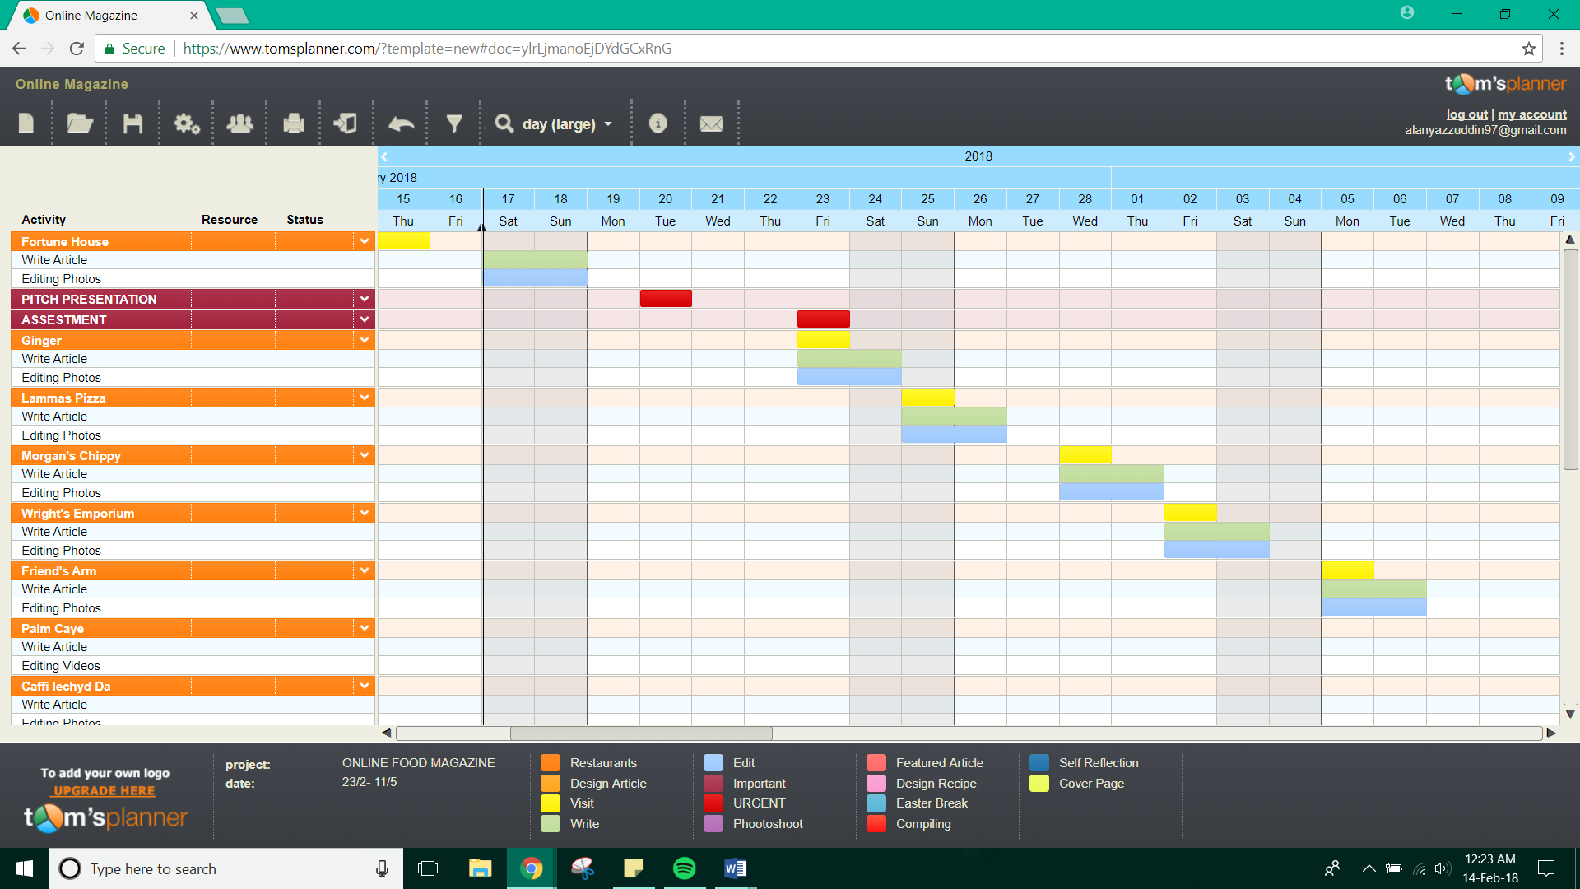

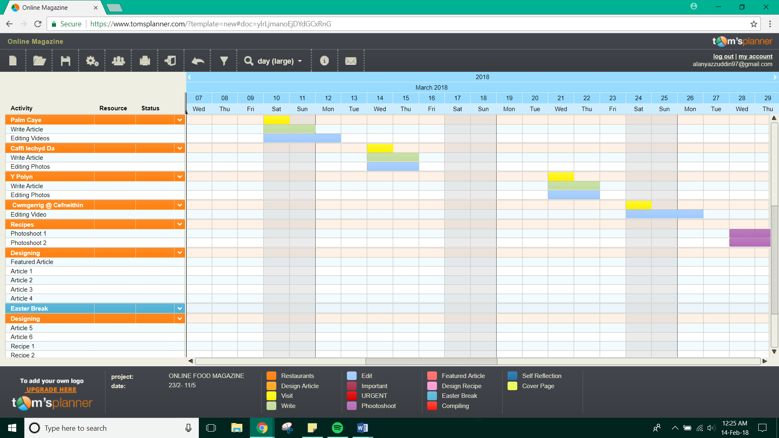

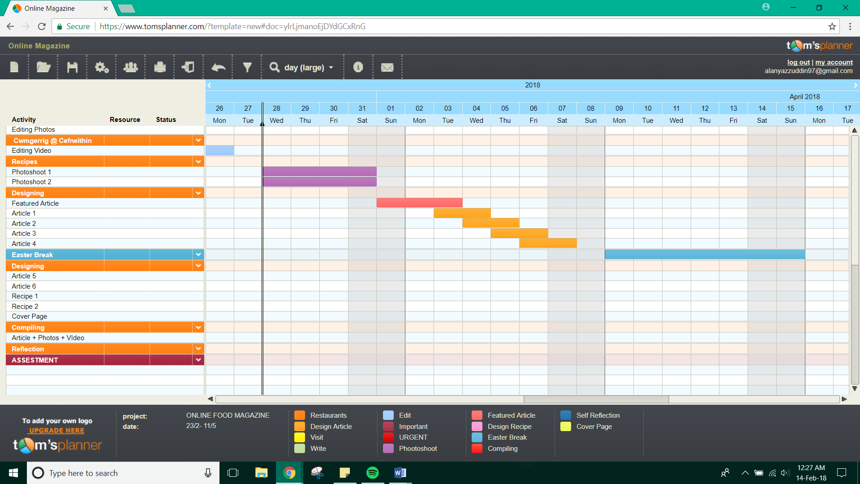

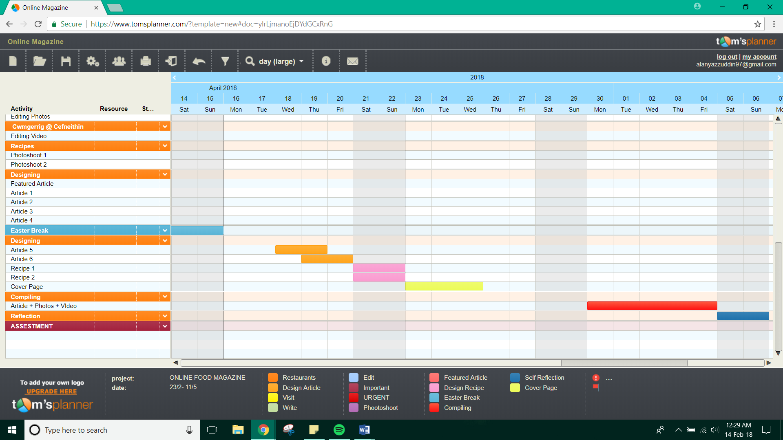

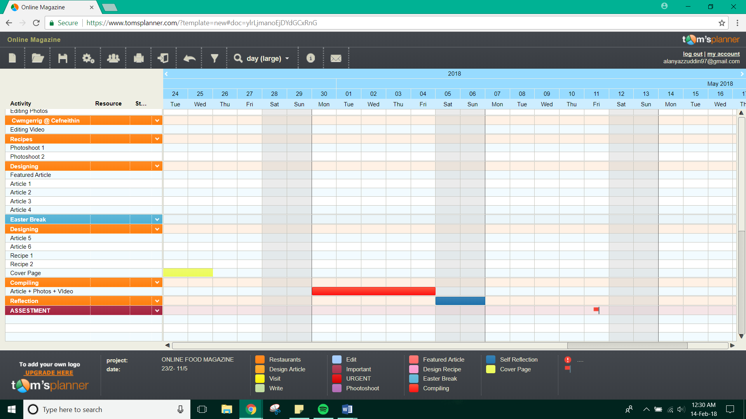

MOODBOARD
Style and Layout
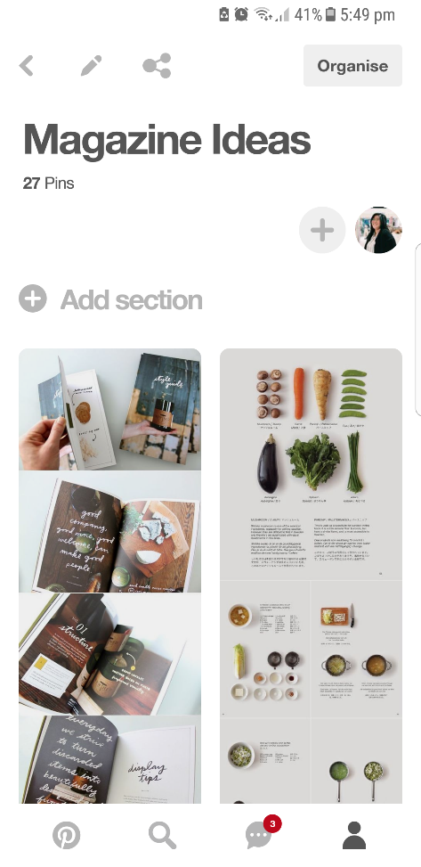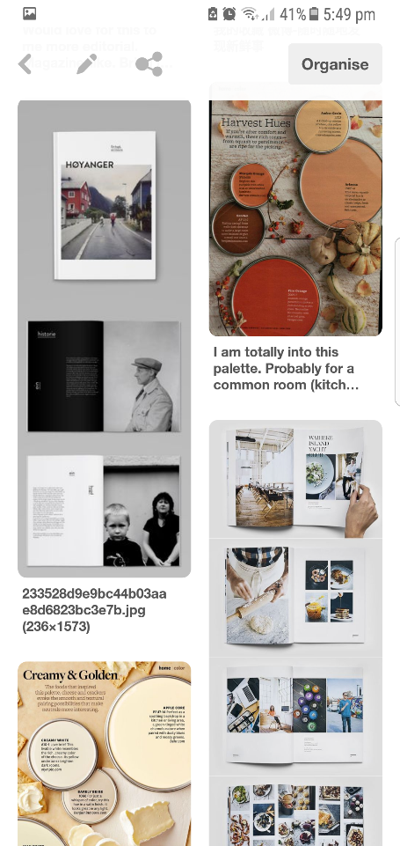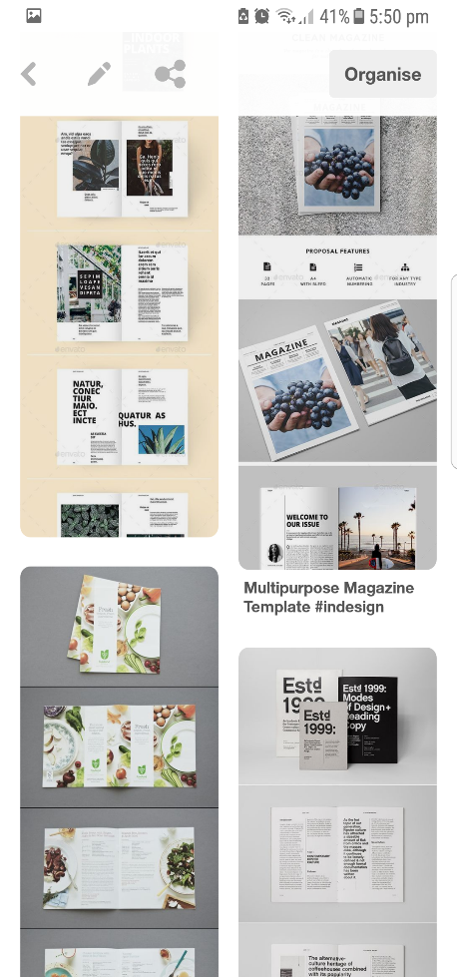

https://www.pinterest.co.uk/alanyazzuddin/magazine-ideas/
The layout of most of the magzines were very minimalistic and clean. Which is what I want for my magazine’s layout. I did not want the pages of the magzine to be cluttered, the layout should be easy on the eyes of the readers.
Colour Scheme

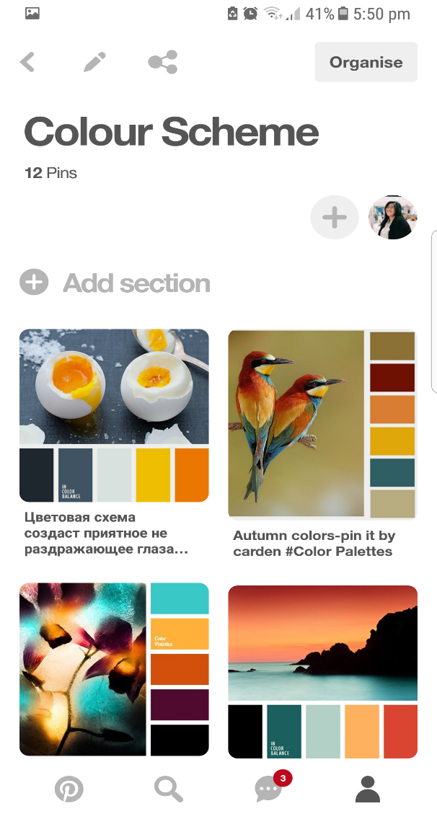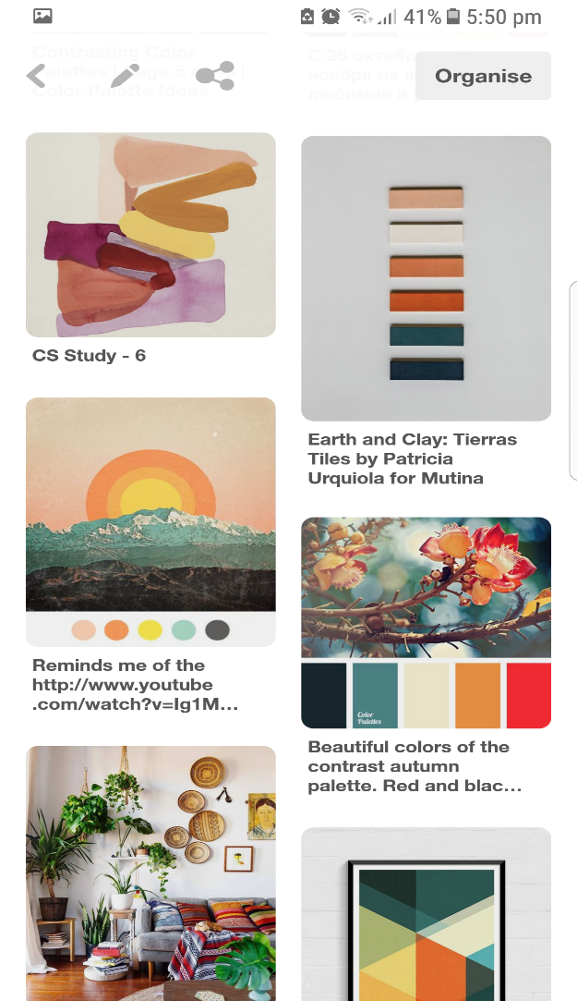

https://www.pinterest.co.uk/alanyazzuddin/colour-scheme/
Research has shown that warm tones worked great with food photography, it increases appetite. Beside that, I wanted to create a heartwarming layout. I want my readers to think of homecooked meals and family when they read my magazine. There is consideration to use orange, red, yellow, peach, light pink, teal, some shades of green, black and white.
Inspiration
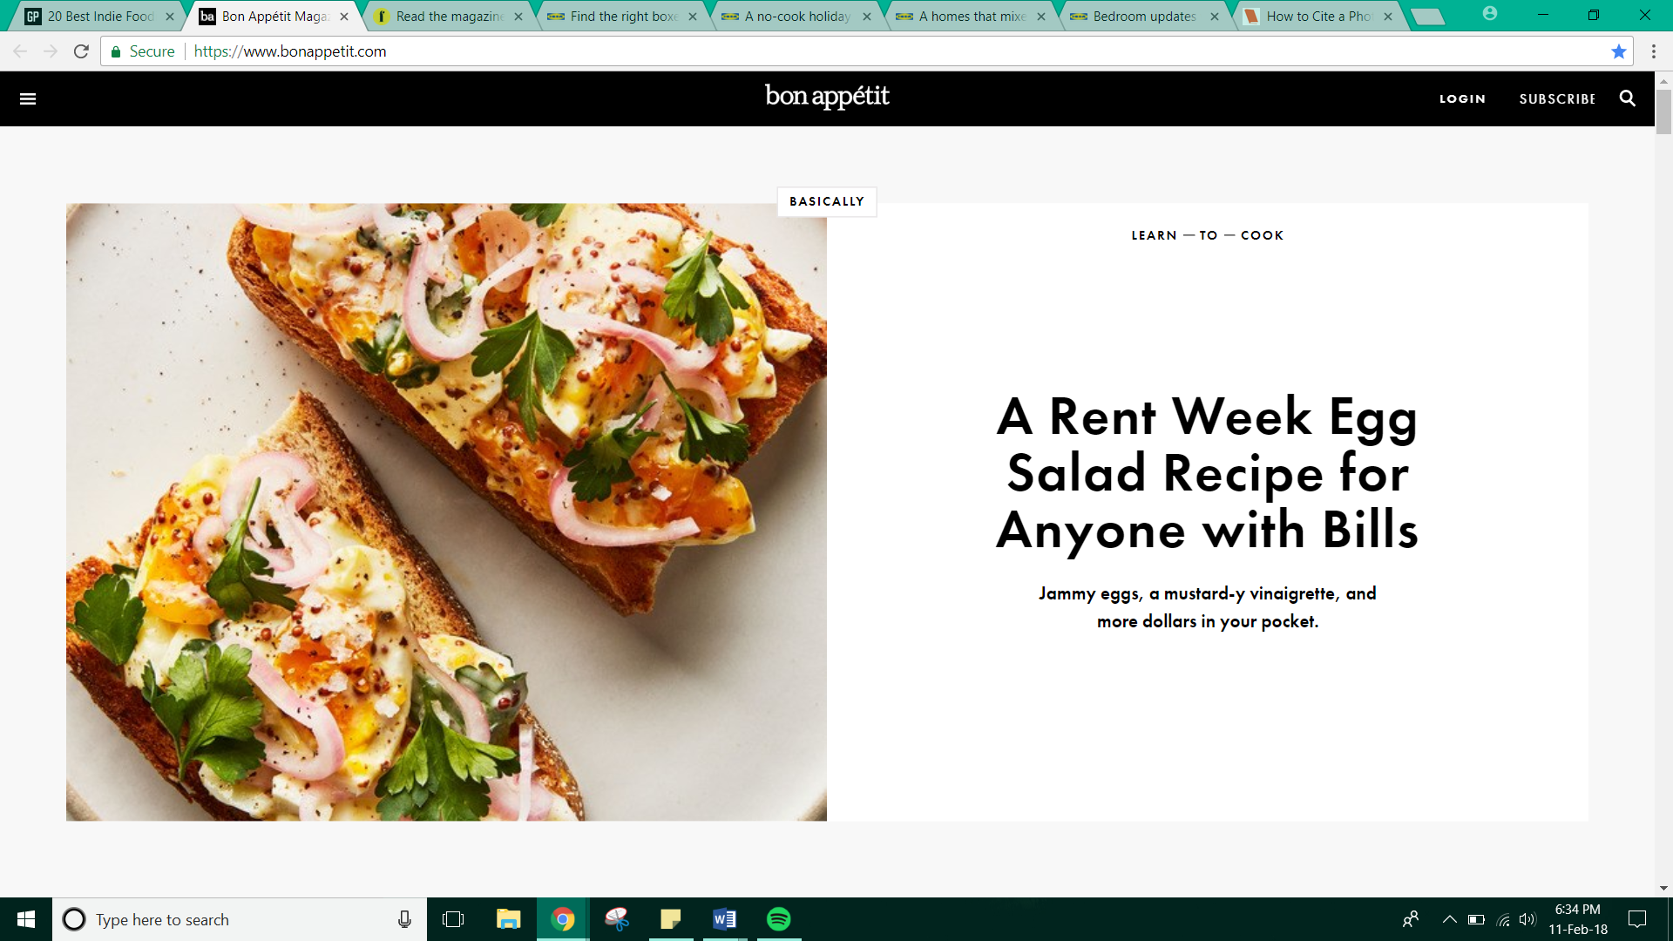
Bon Appetit Magazine (https://www.bonappetit.com/)
This magazine is my all time favourite food magazine. The articles offered in the magazine are very useful, they have content for amateur cooks and even professional ones. Not only does Bon Appetit have articles, they have recipes and al sort of food/cooking related videos. I’m inspired to create content like Bon Appetit.

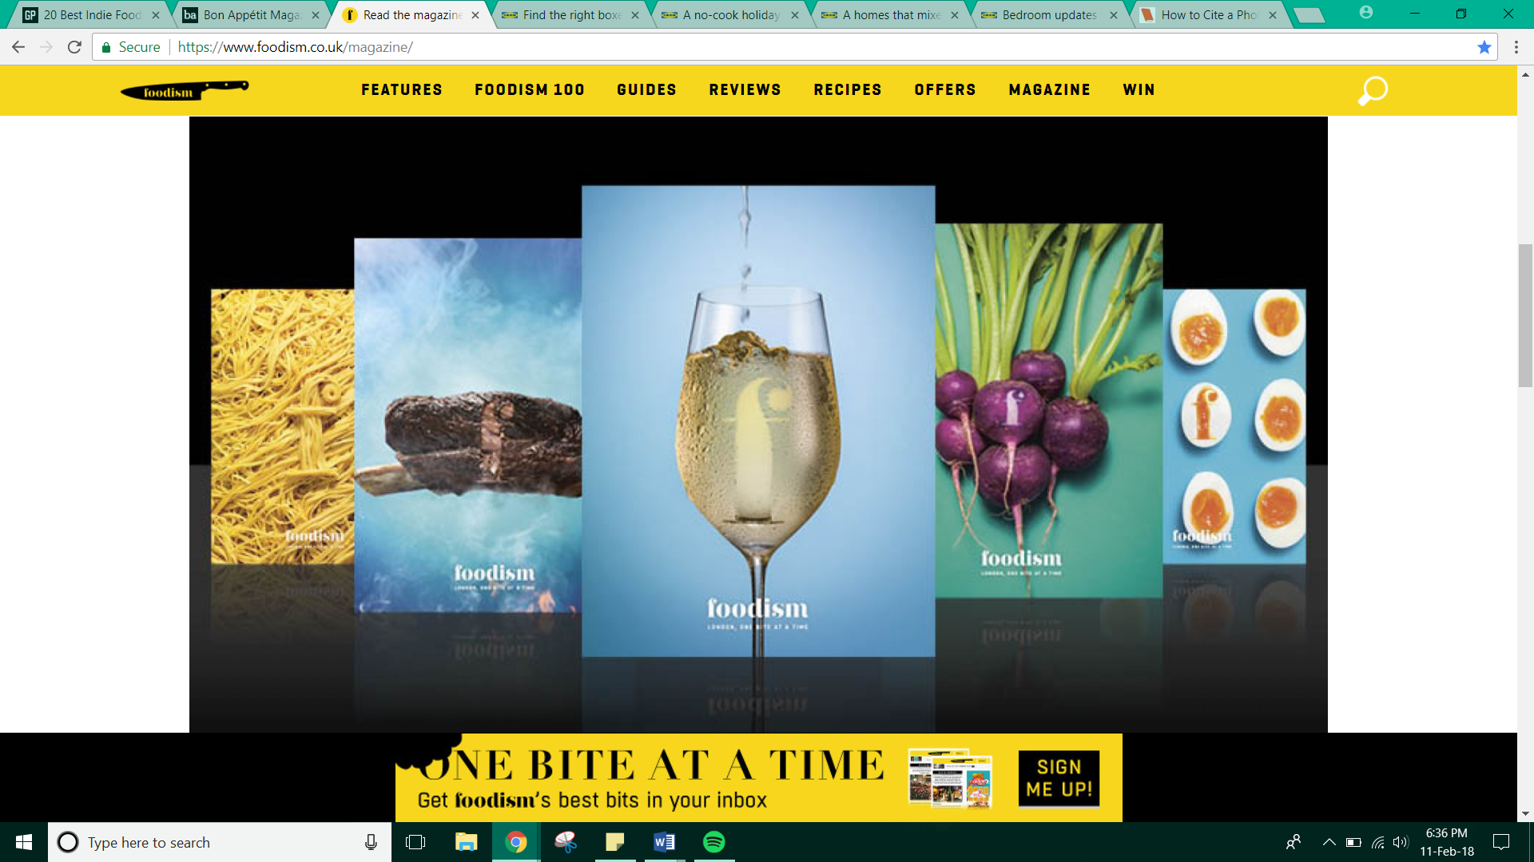
Foodism Magazine (https://www.foodism.co.uk/magazine/)
I was inspired by Foodism’s cover page. It gave me the idea to create a cover page that is both simple and bold.

Photography Style and Angles
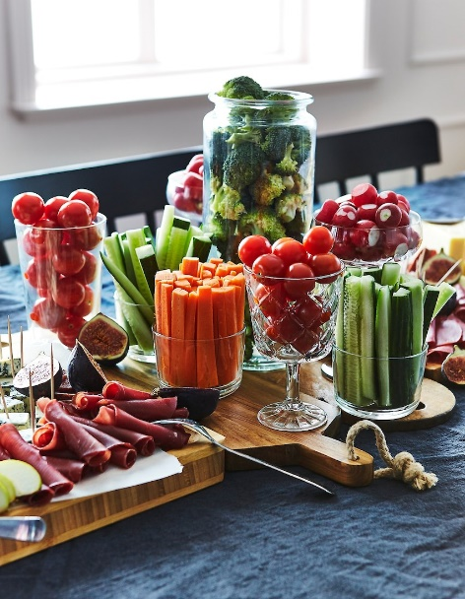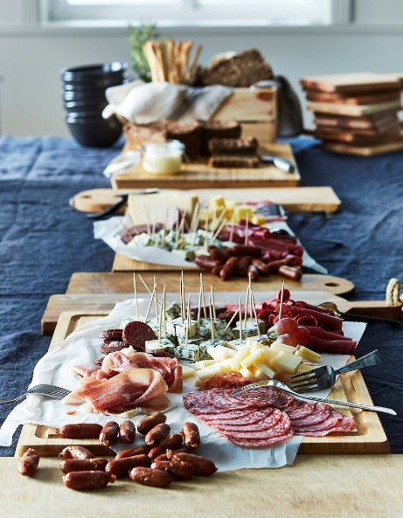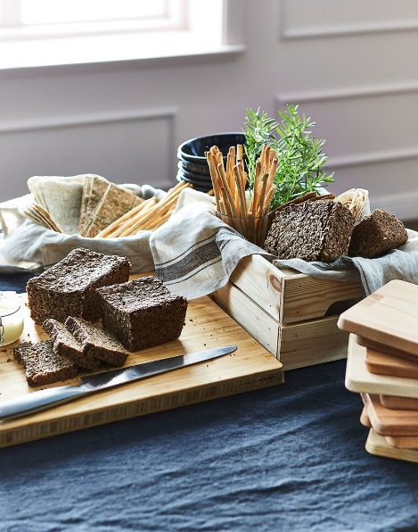
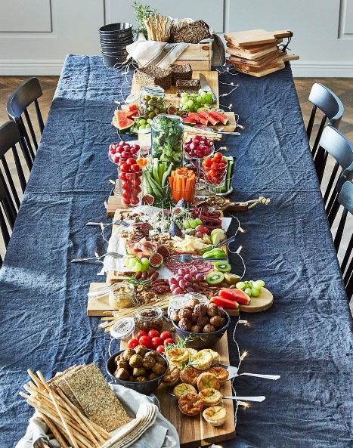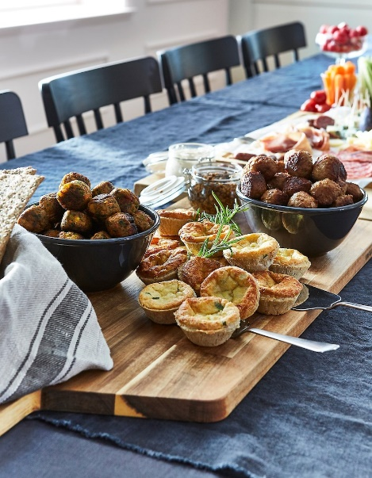
The goal is to take food photos with these style of photography. Using side profile shots.

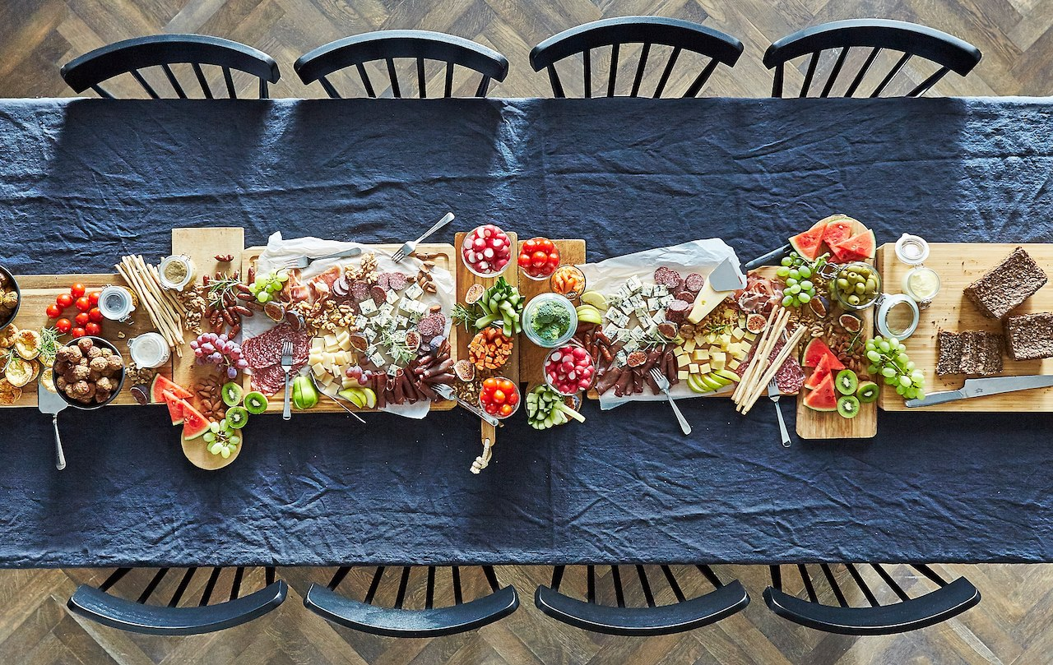
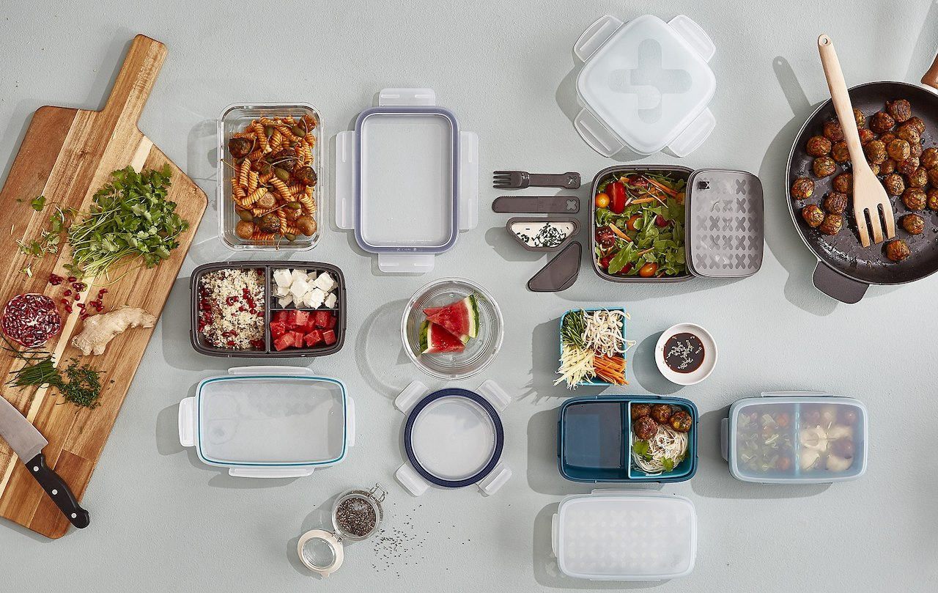
Some of the food photography will be flat lay shots.
LAYOUT
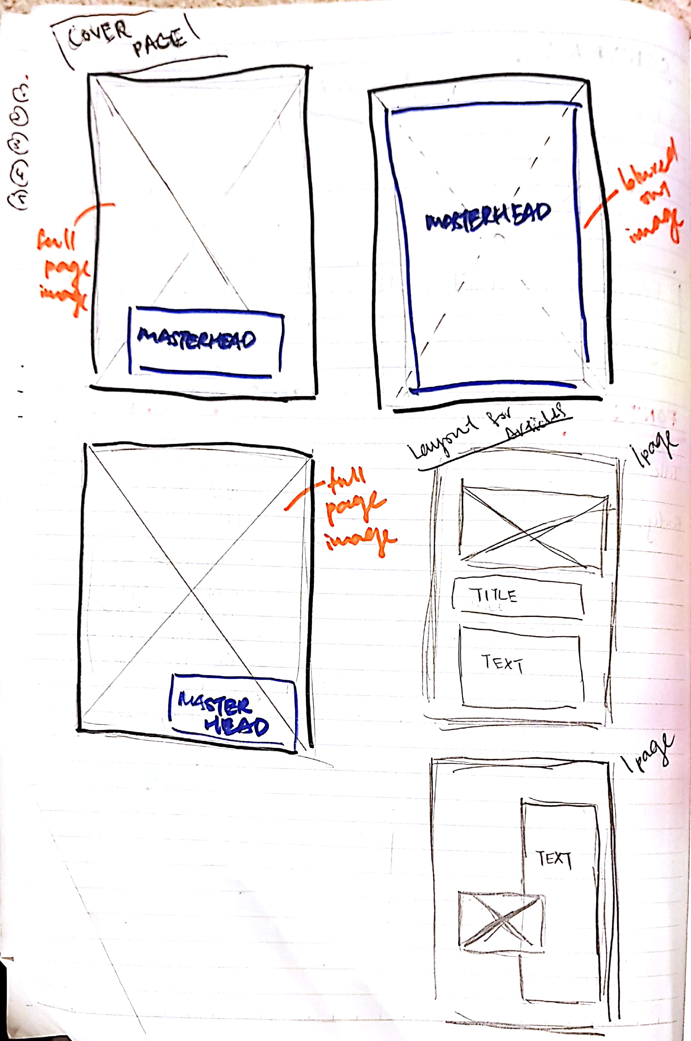
Layout ideas for cover page and 1 page spread articles
*Masthead
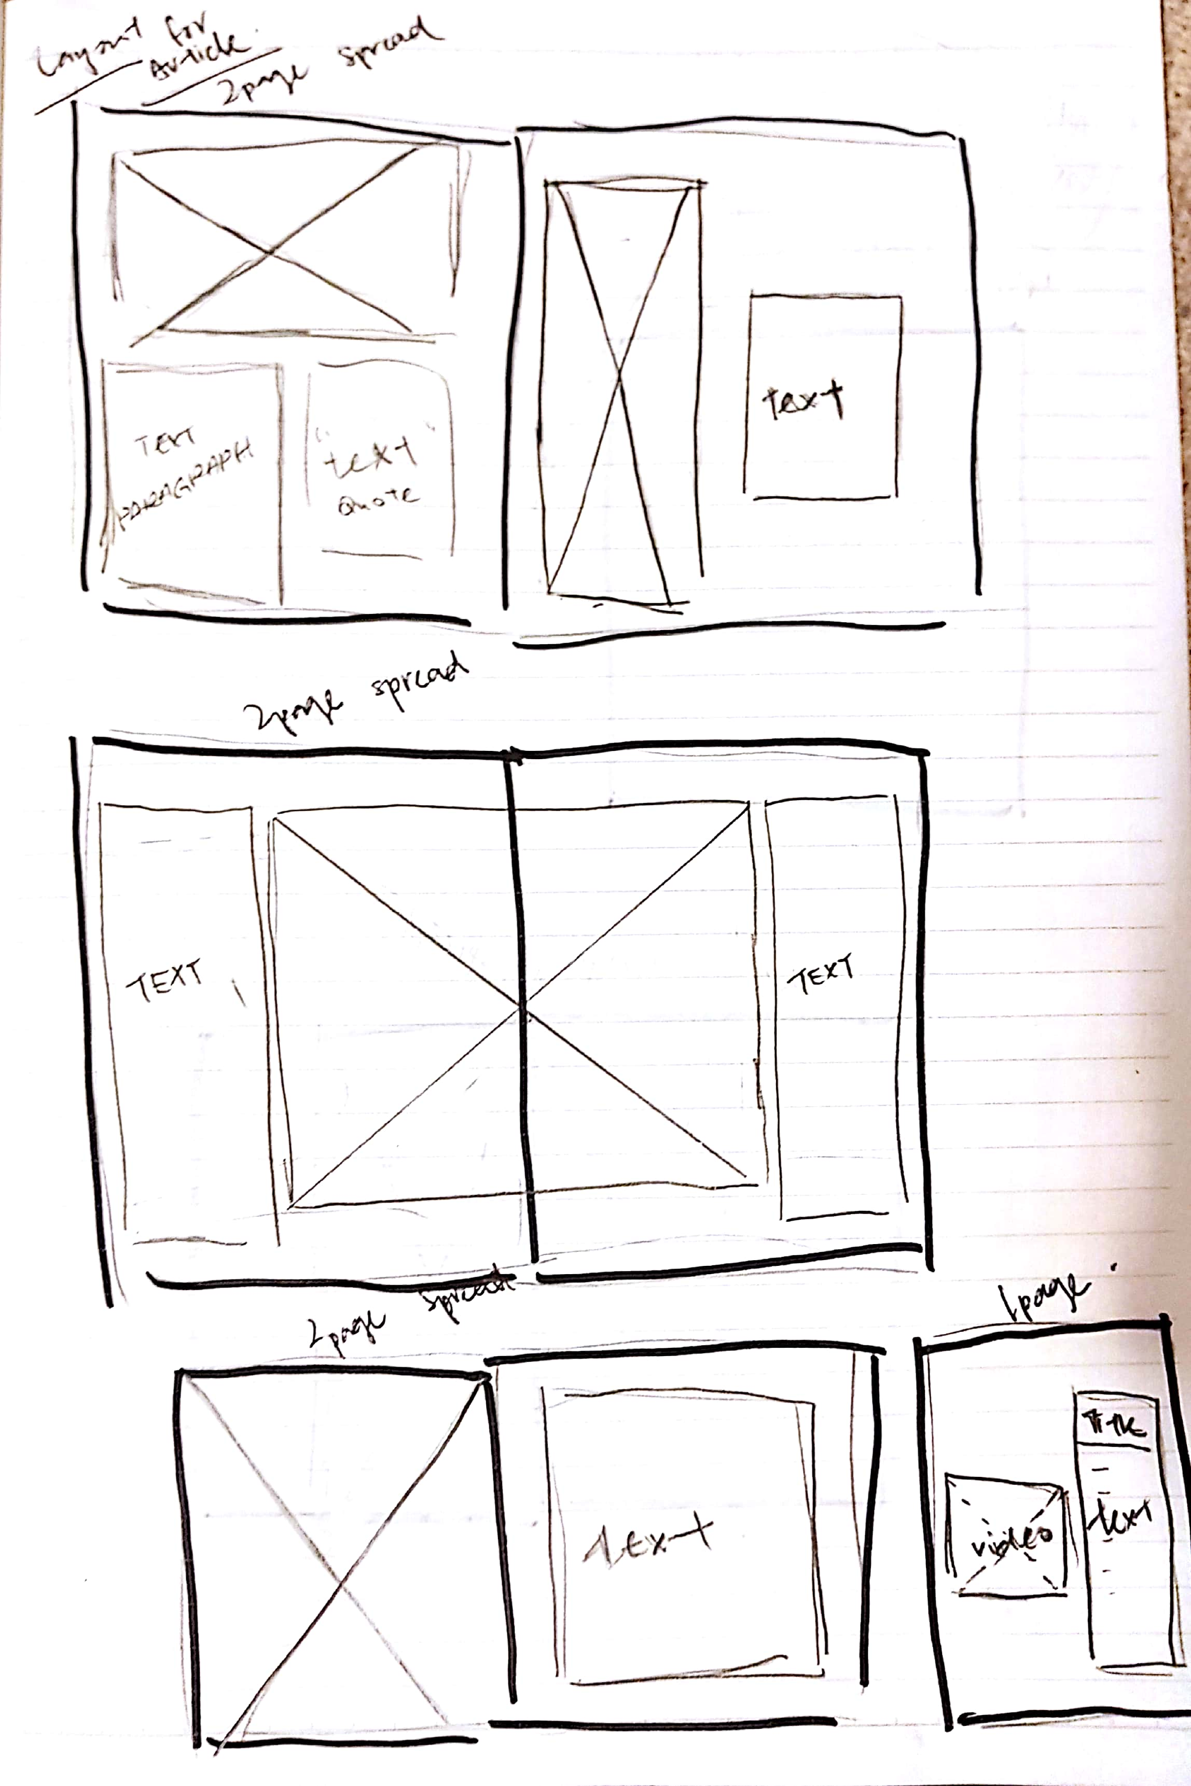
Layout ideas for 2 page spread articles, 1 page spread articles and articles with videos
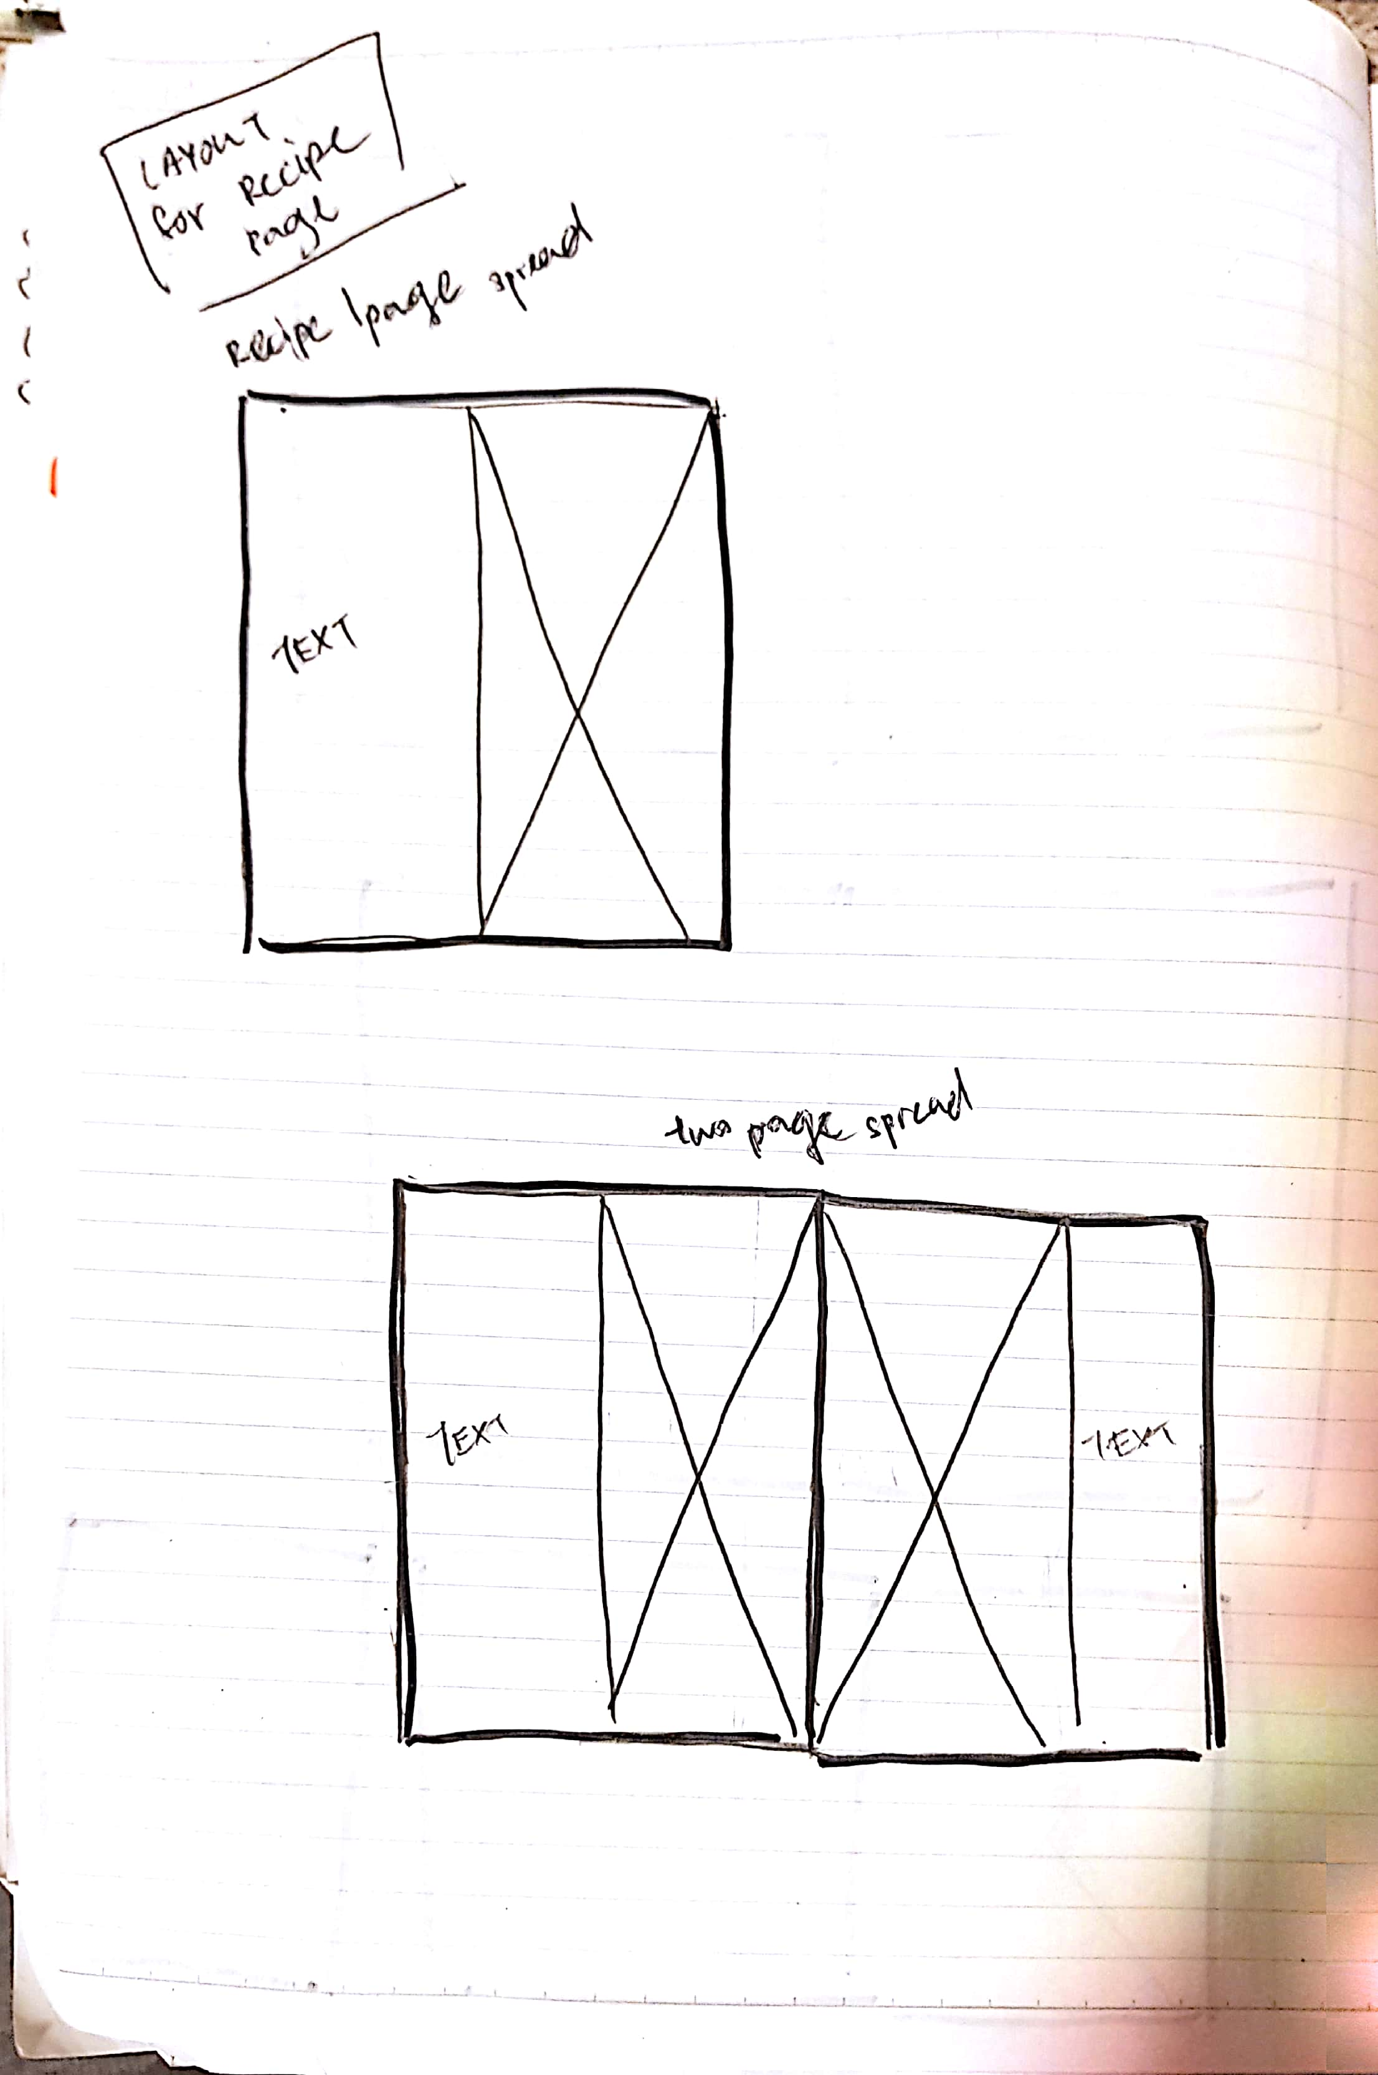
Layouts for recipes (article).

TEST LAYOUT (InDesign)
These are some of the layout design done using InDesign after initial design on paper.
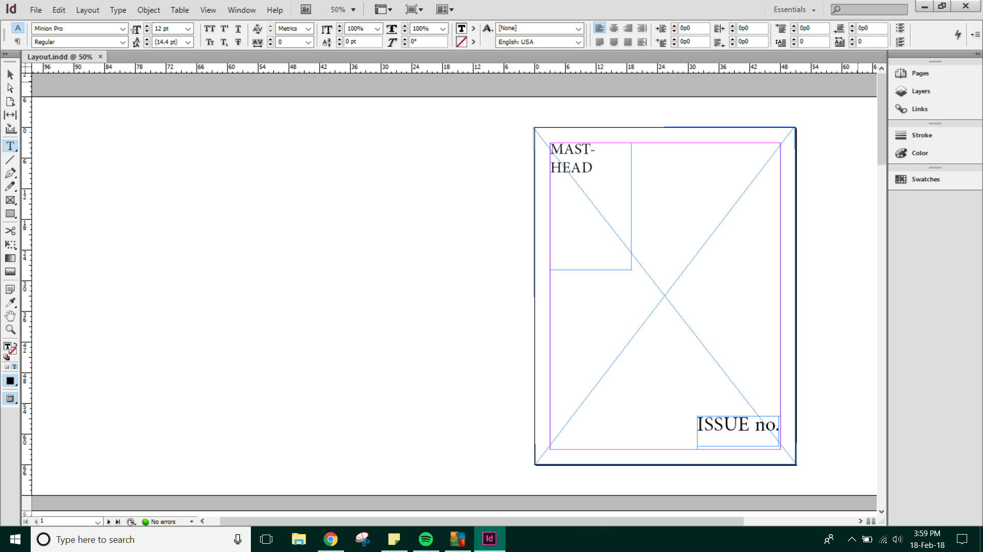
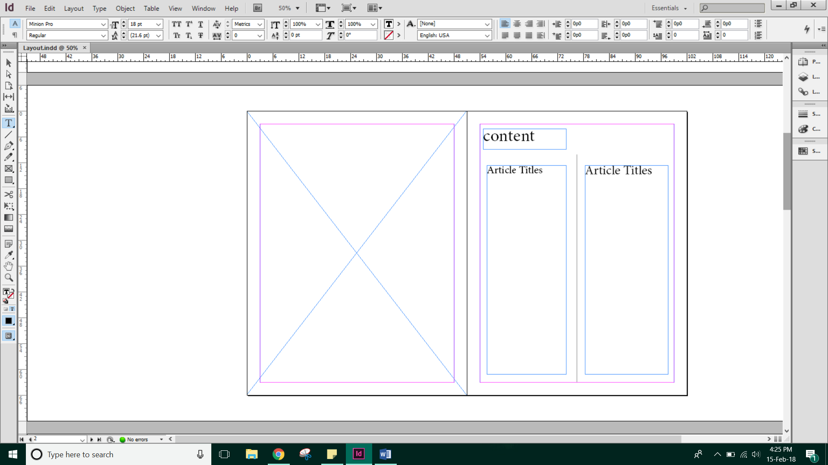
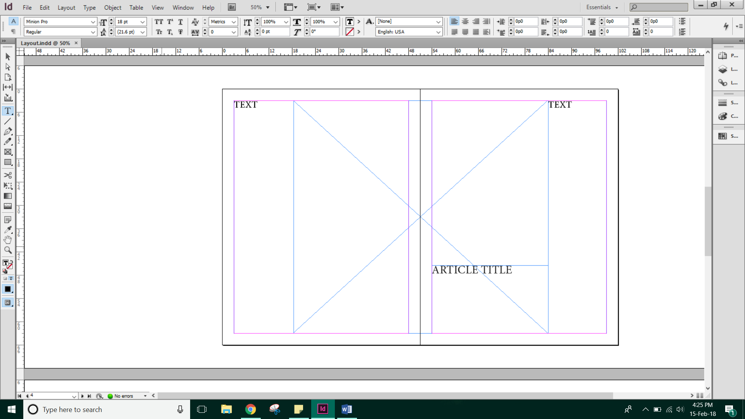
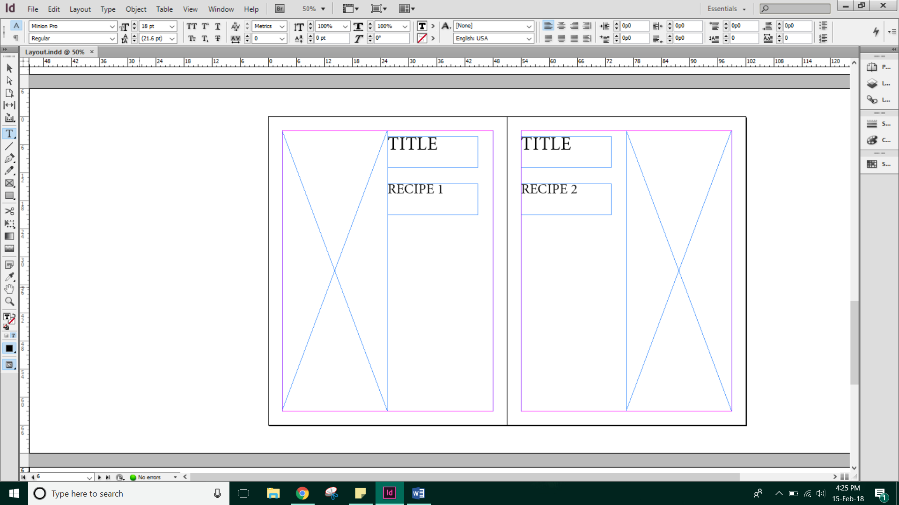
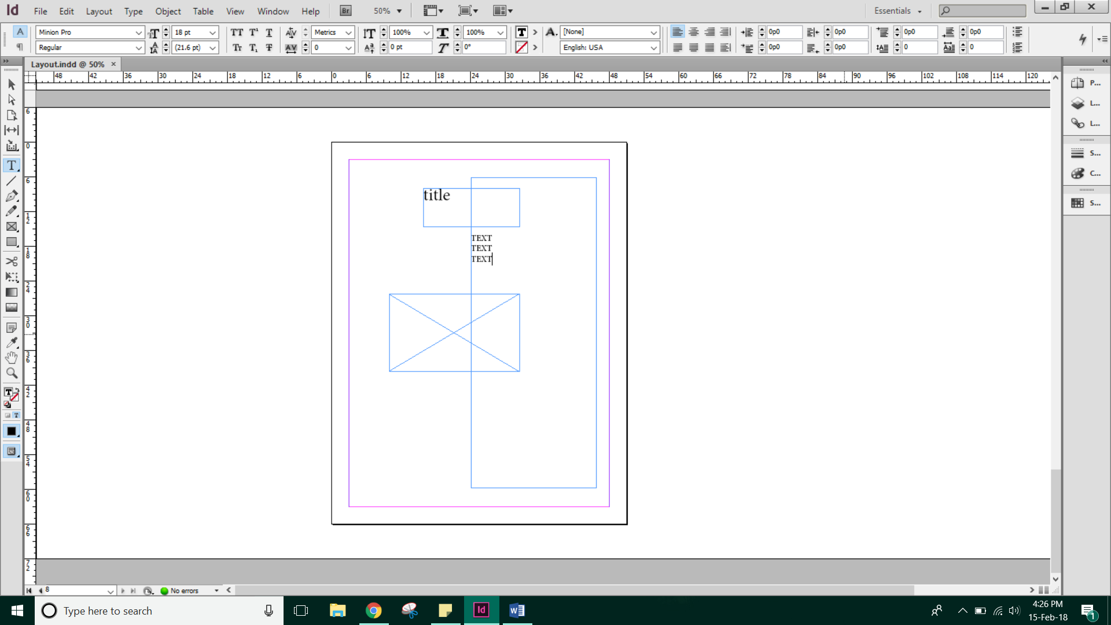

PROTOTYPE
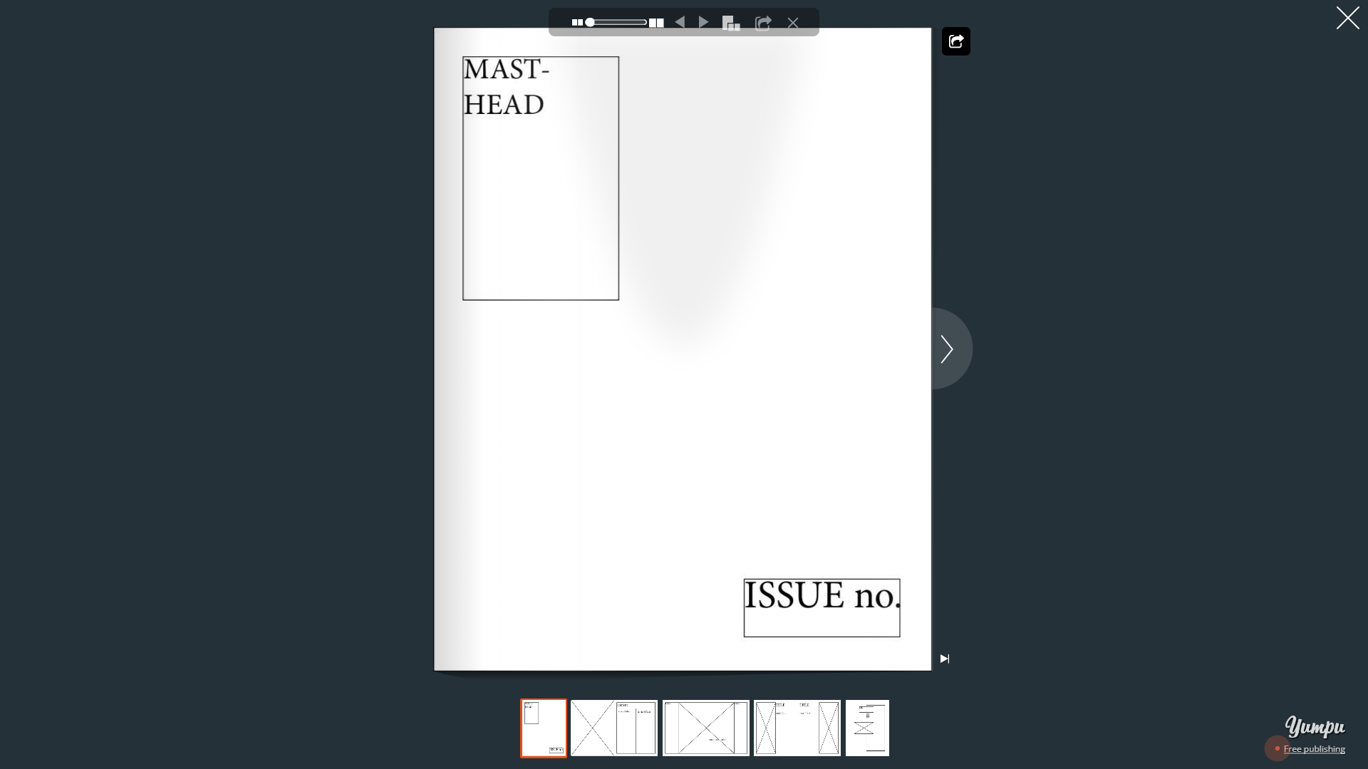
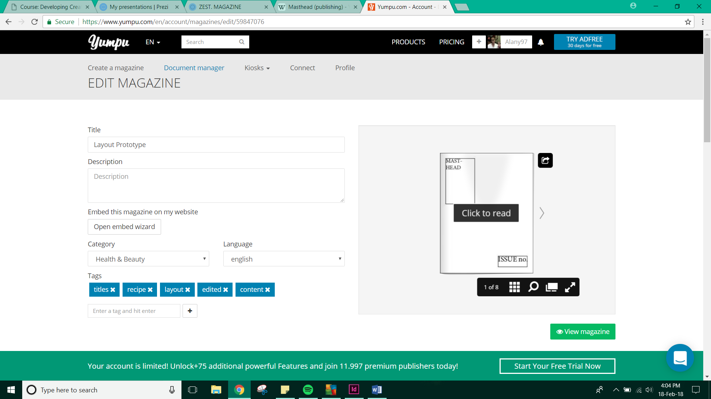

I decided to use Yumpu because it allows me to add different types of multimedia element and it has a simple interface that is easy to work with.
https://www.yumpu.com/en/document/view/59847076/layout-prototype
MASTHEAD IDEAS
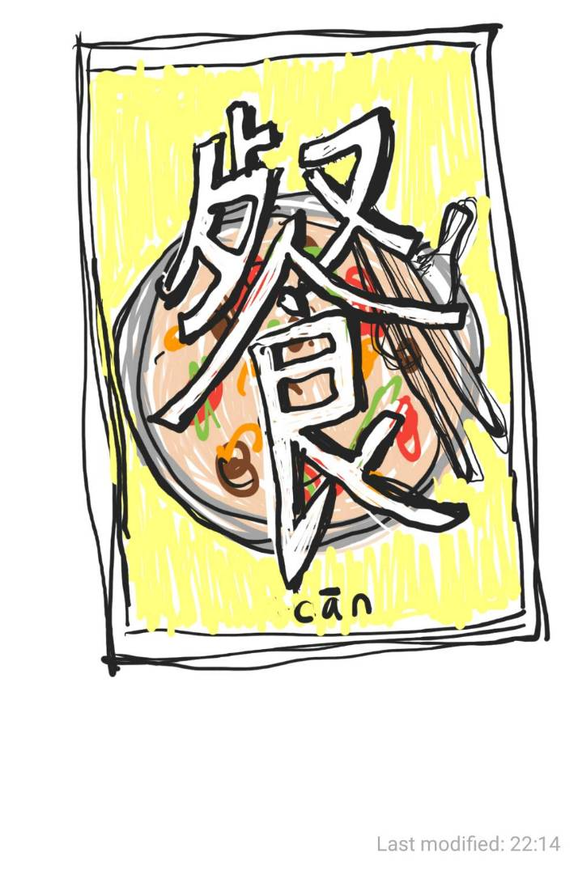
The drawing above was one of the initial ideas for the front cover. I incorporated the Chinese character “can” which means the word “dish”, into the design of the cover page because I wanted to have a part of my heritage shown through my work. Then, I realise it would not fit the theme of the first issue of the magazine, which is talking about Carmarthen, Wales.
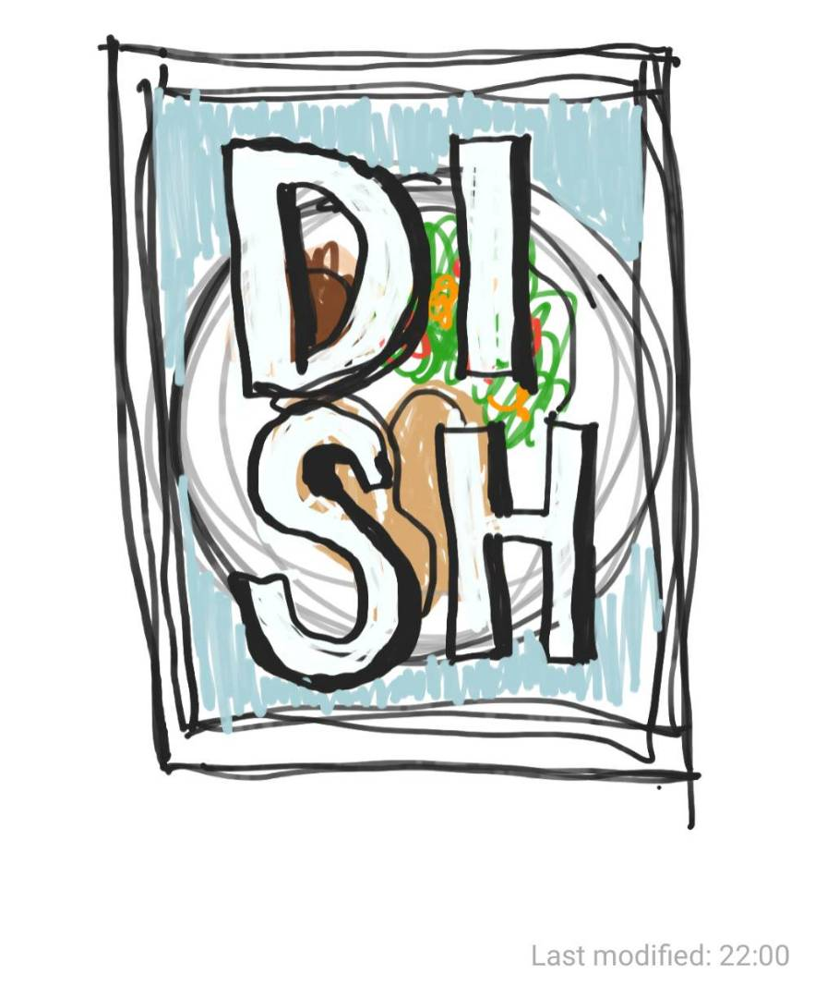
The second design of the front cover had “DISH” as the masthead. I knew that if I wanted to target a more global audience, I needed a masthead that was universal.
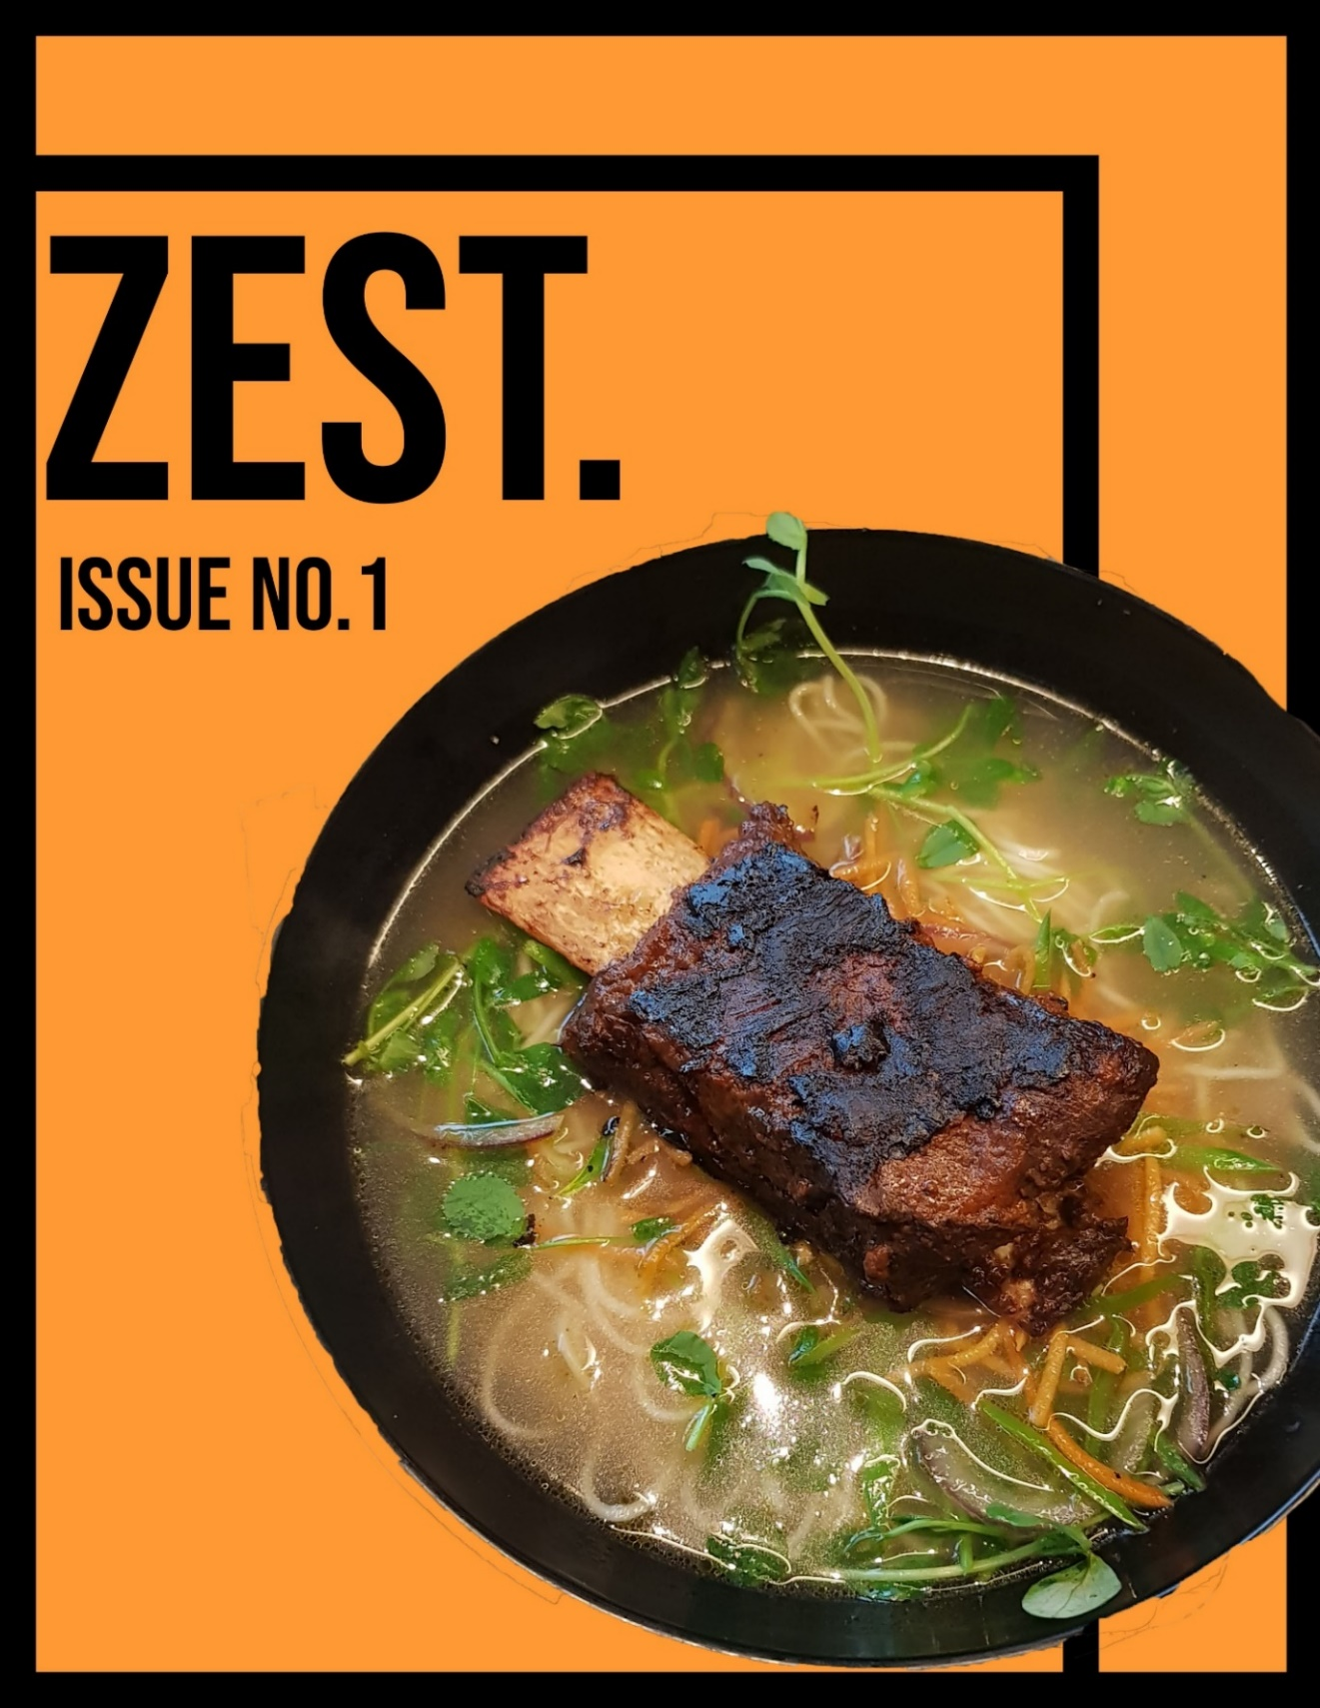
Cover 1
This is was my first design for the magazine’s cover page.
Cover 2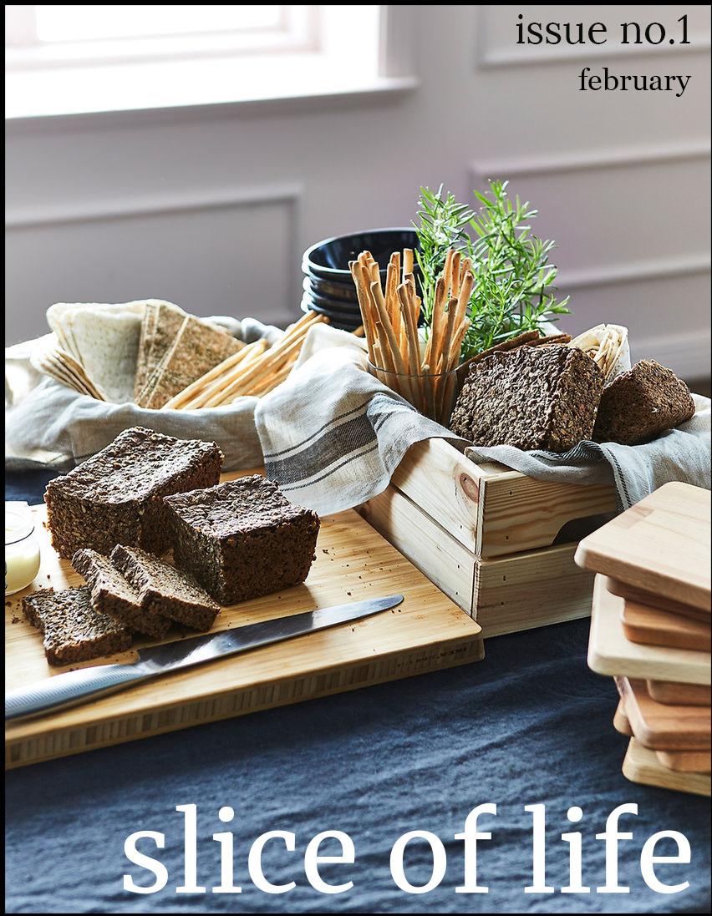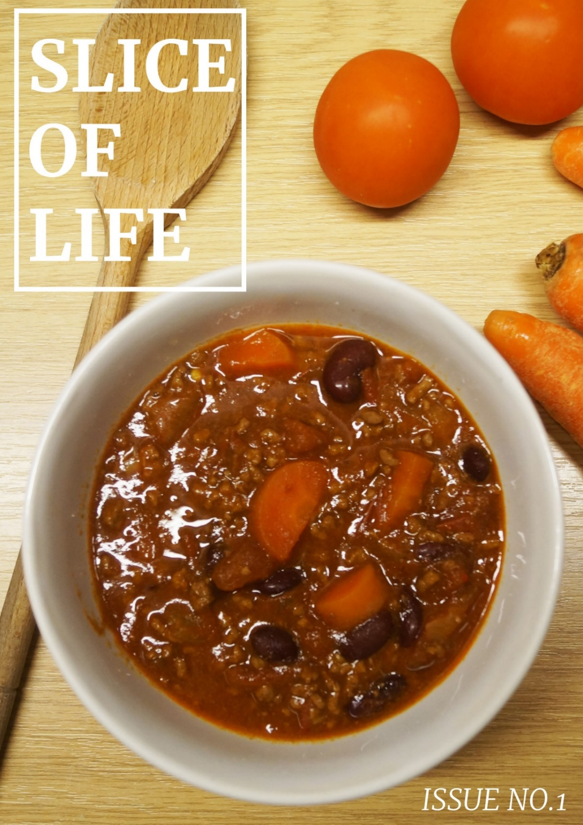
Cover 3
This cover was done using an original photo and was the last style of cover page. I decided not to clutter the front cover with too much fonts.

COLOUR AND FONTS
Fonts used:
Bebas neue
BEBAS
Merriweather
Georgia
Lemon/milk light
Colours used:
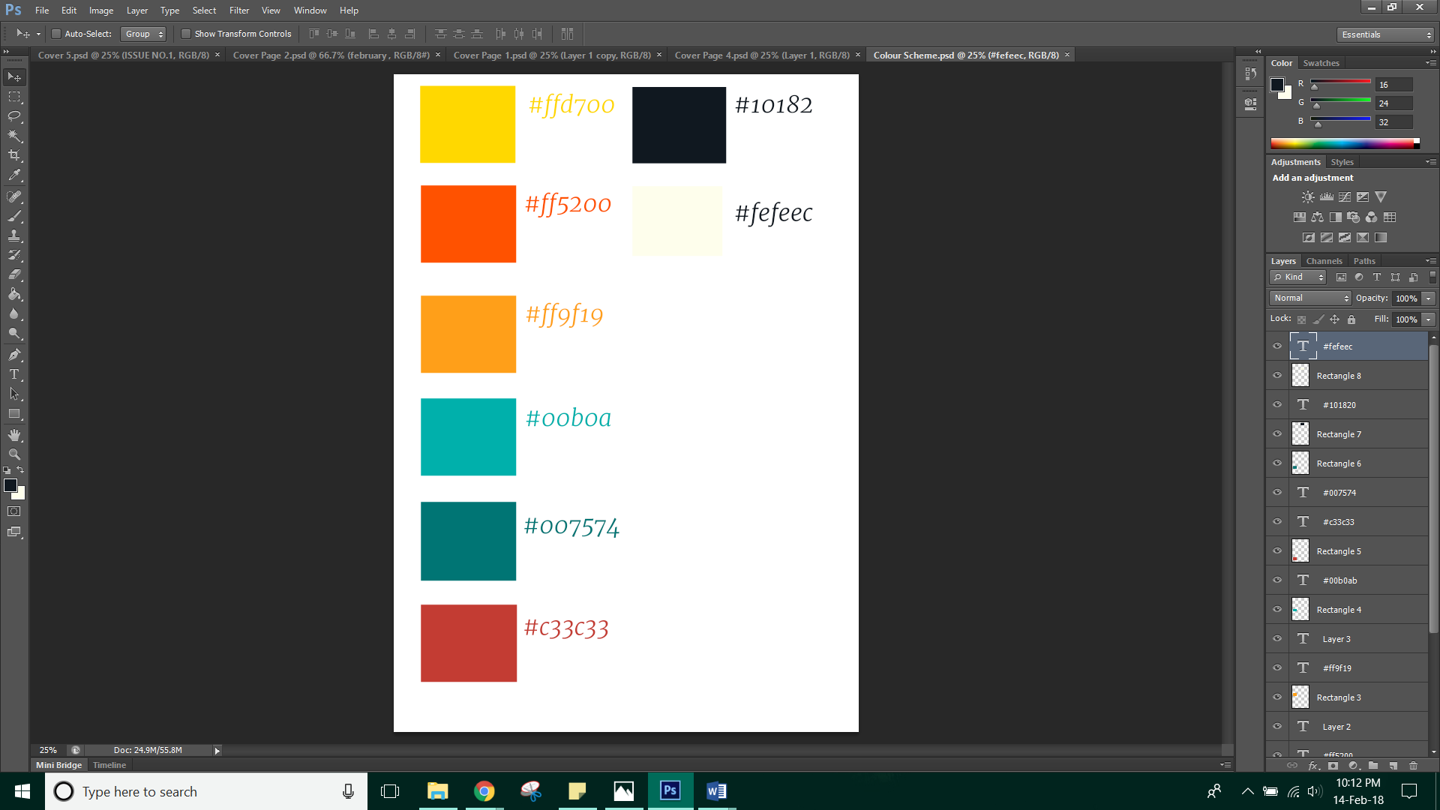
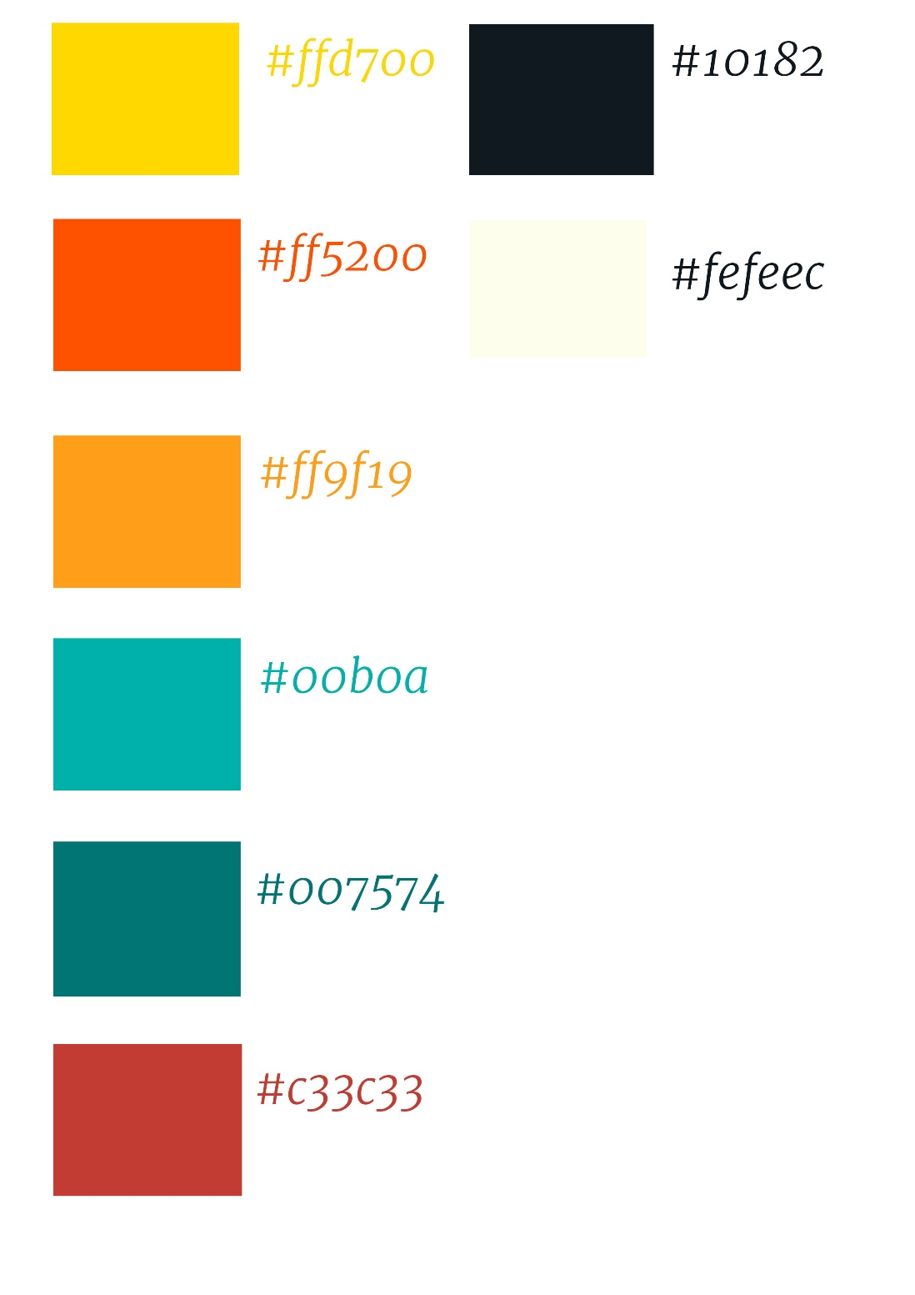
These colours will be used for layouts, page designs, but the overall colours of the magazine and photos will be warm tones. As mentioned earlier, I want my readers to think of home and warmth when reading/looking at the magazine.

ASSET LIST
No. | Content | Check
1. | Cover Page
 | - Masthead
 | - Cover photo
2. | Content page
3. | Featured Article (1)  - 450-600 words  - 5 pictures
4. | Short Article (1) [Asian]  - 250-350 words  - 3 pictures
5. | Short Article (2) [Street Food/Late Night]  - 250-350 words  - 3 pictures
6. | Short Article (3) [Pubs/Bars]  - 250-350 words  - 3 pictures
7. | Short Articles (4) [Other Restaurants]  - 300-400 words  - 4 pictures
8. | Short Article + 1 min Video [Market]  - 150-250 words
9. | Short Article + 30 sec Video [Sweets/Dessert]  - 150-250 words
10. | Short Video (1.30mins)
11. | Recipe (1)  - 2 pictures
12. | Recipe (2)  - 2 pictures
13. | Recipe (3)  - 2 pictures
14. | Acknowledgement  - 150-250 words

BIBLIOGRAPHY
Websites:
Sudweeks, D. (2016) Fonts for Editorial. Available at: https://www.fontshop.com/content/fonts-for-editorial (Accessed: 10 February 2018)
Morton, J. L. (1995) Color & Appetite Matters. Available at: https://www.colormatters.com/color-and-the-body/color-and-appetite-matters (Accessed: 10 February 2018)
Onlystaples. (2016) Colors that affect your appetite. Available at: https://medium.com/@onlystaples/colors-that-affect-your-appetite-cfdb8fecbd72 (Accessed: 10 February 2018)
Connolly, D. C. (2013) Colors that Influence Food Sales. Available at: http://jenndavid.com/colors-that-influence-food-sales/ (Accessed: 10 February 2018)
https://www.pinterest.co.uk/alanyazzuddin/colour-scheme/ (Colour Scheme Moodboard)
https://www.pinterest.co.uk/alanyazzuddin/magazine-ideas/ (Layout Moodboard)

