DS 1 Template

My Screenshots/Photos
- Please add 4–6 screenshots or photos of your digital life.
- You can use your phone or laptop.
- For each screenshot, write one or two sentences explaining what it shows.

Screenshot/Photo 1
[Insert Photo/Screenshot below]
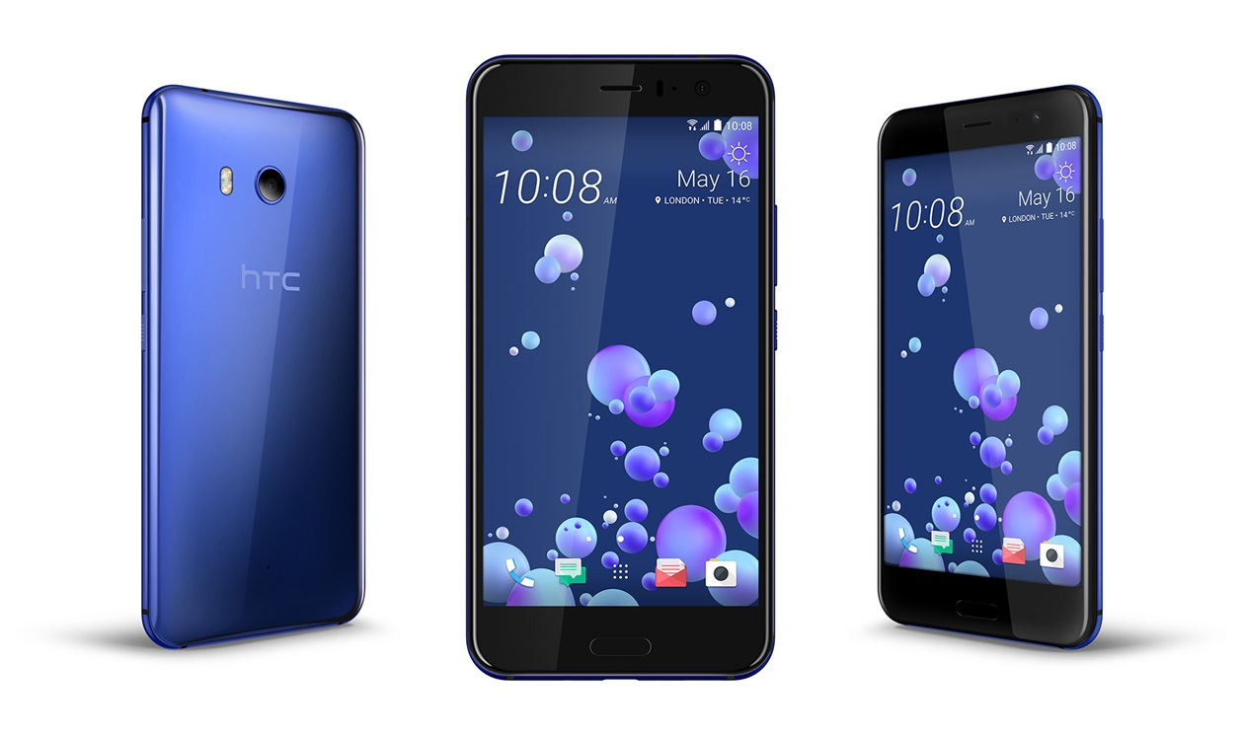
This shows me the width of the screen
Different cases can be added
It shows how modern the phone is
Can store a good amount of data

Screenshot/Photo 2
[Insert Photo/Screenshot below]
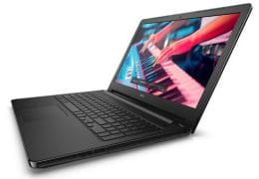
This shows me that it can hold a lot of data
Has a wide enough screen for multiple viewing
This shows me that the screen has good resolution
Can connect anywhere in the world

Screenshot/Photo 3
[Insert Photo/Screenshot below]

This shows me that’s it’s light and can be carried around easily
This also shows me that it does not need a monitor, keyboard or messy wires
Has faster response time
Its easier to fit in cases or bags

Screenshot/Photo 4
[Insert Photo/Screenshot below]
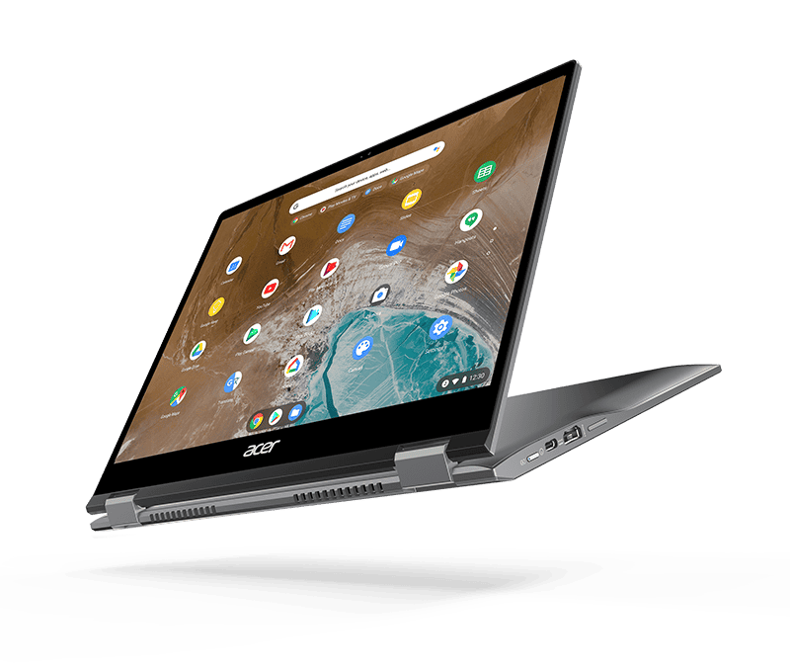
Can fold both ways and not break
Has installed touchscreen so you down need to use the keyboard
It stores more apps
Has better memory

Screenshot/Photo 5
[Insert Photo/Screenshot below]
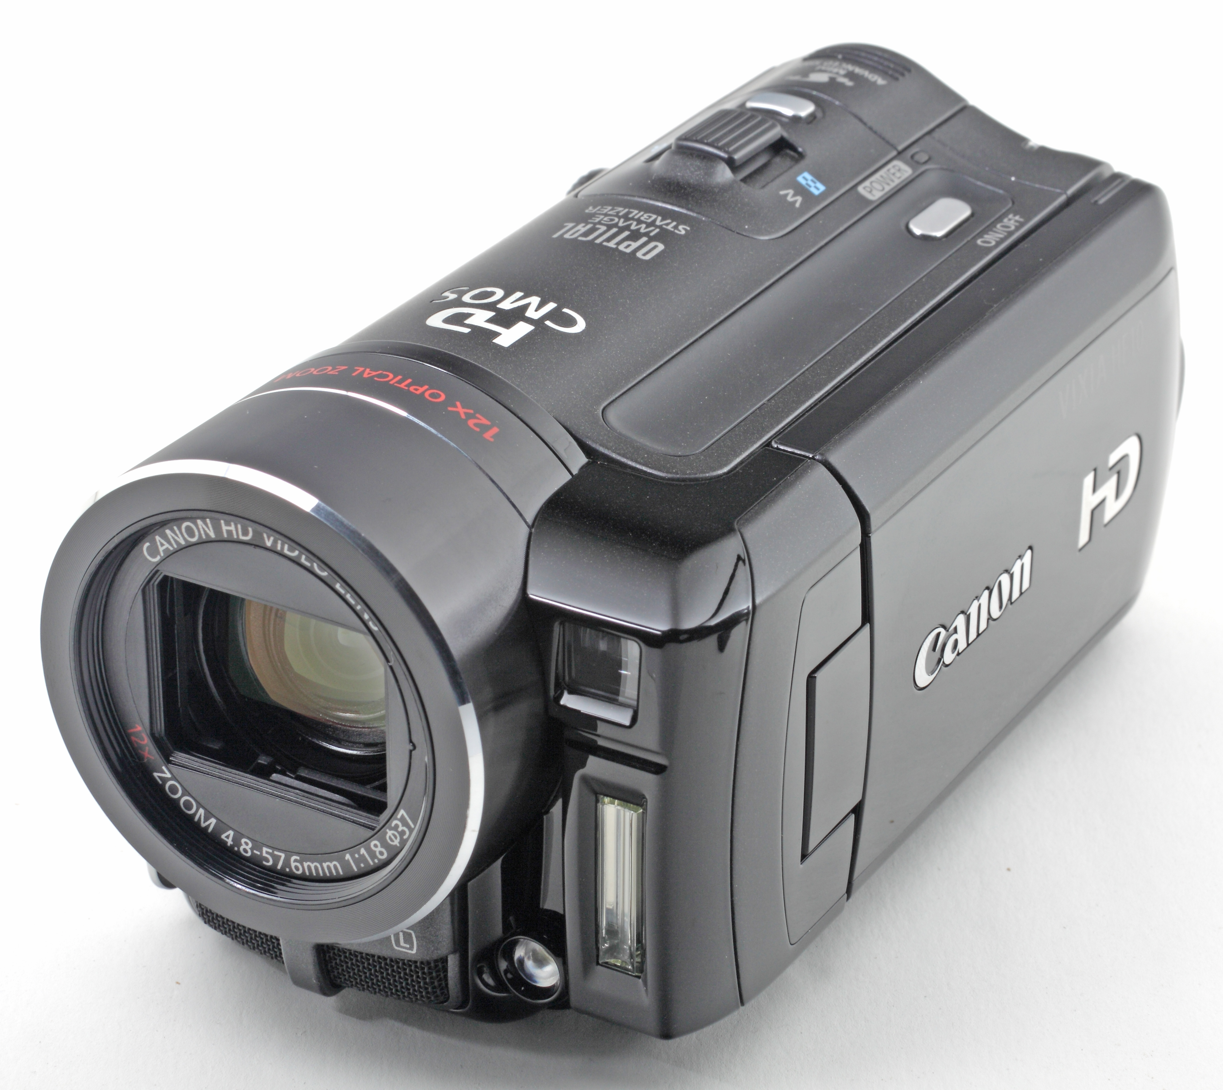
Can record video and take pics
Holds large data of footage and go anywhere
Can great zooming out range
Can hold thousands of pictures or hours of videos

Screenshot/Photo 6
[Insert Photo/Screenshot below]
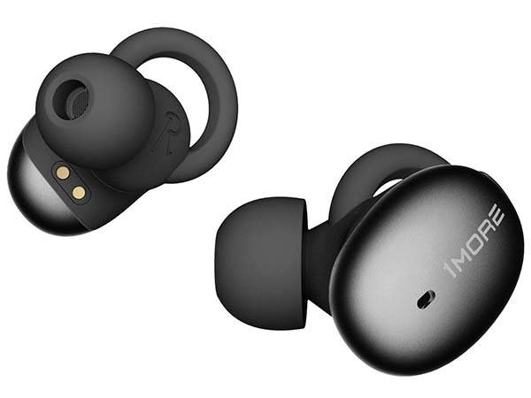
Comfort and crisps sounds wherever you go
Wireless and has a lengthy battery life
Can charge anywhere
Has noise cancellation capabilities

My Short Reflection
- Write 5–8 simple sentences about your digital life.
- You can use the sentence starters below if helpful.
- I use digital tools to say the environment
- I feel confident when I possess a device
- I want to improve my typing
- I often use these tools to get work done
- I sometimes feel nervous about dealing with complicated technology task
- I hope this module will help me to understand technology better
- Digital skills are important for me because it takes me out of my comfort zone

Sentence starters
- I use digital tools to reach others
- I feel confident when I use my phone
- I want to improve on my digital knowledge
- I often use these tools for work or fun
- I sometimes feel nervous about not saving my work or data
- I hope this module will help me understand technology more
- Digital skills are important for me because it improves my skills
You can write more if you want.

Submission Checklist
Before you submit, please check:
​​​ ☒ I added 4–6 screenshots
☒ I wrote short sentences for each screenshot
☒ I wrote my short reflection
☒ My work is my own
☒ My file opens correctly
​​☒ My file opens correctly

