Title: The Impact of Online Learning
Student Name: Georgi Georgiev
Student ID: 1908324
Course: Access to Higher Education with Skills for the Workplace
Term: 2
Module: Digital Skills and Research Methods
Lecturer: Joy Botu

Contents
Introduction 3
Background 3
Aims and Objectives 4
Conclusion 8
References 8
Appendix 9

Introduction
This essay will be researching the advantages and disadvantages of studying online, as well as how easy it is to use the platform. With this we will find out how the usage of the online platform moodle has impacted students' lives in the university campus “University of Wales Trinity Saint David” which is based at the central parts of London at Chancery Lane. With the help of a questioner students will be asked questions regarding the online platform and come with the conclusions regarding the usage of the platform and whether it has had a positive impact or a negative impact on the academic lives of the students. The students are only from this university. This research will help me get a greater insight on how the students are affected by the online platform, how useful they are finding it because I am a student who is studying online, and it surely has affected my life greatly. Namely with travel and expenses. It will also analyse whether it is providing students with enough source materials for their course and investigate if there are any areas within the online platform that students find to be in need of improvements.

Background
  - What is online learning?
There are two types of learning online, one is being online learning and one being distance learning. The difference between the two is that online learning can be done in a classroom while doing your digital assignment but distance learning is done from home where you work from your computer in a digital classroom (Stauffer, 2020).

  - What are the advantages of online learning?
There are many benefits and disadvantages when it comes to online studying. In a meta-analysis research conducted by the U.S. Department of Education has determined and discovered that students in online conditions performed better than those receiving face-to-face instruction (Means B. et al, 2009). It is also statistically proven with this analysis that the students which were studying online would spend more time on the task than the students which were in a face-to-face environment (Means B. et al, 2009). Classes will also not be disrupted by snow days if they are done distantly and students can access information at times that is best suited for them (Stauffer, 2020). Of course, if you are someone like me who lives very far away from the university this comes to be very useful and economical solution to my studying. Normally, I spend about an hour to an hour and a half, depending on how busy traffic is to get to my university which going to and back from university equals to three hours of travelling which I could have invested into studying or warming up for my class. Then, I save a lot of money on petrol for staying at home and this allows me to buy more books which help me with my researches. This has been a rapidly increasing practice in many countries worldwide. The greatest benefits are that it expands the educational opportunities and improve students’ outcomes and skills (Dabner N. et al, 2012). This also has a positive impact on students’ lives, when I first was getting ready to apply for an undergraduate diploma, I had to obtain GCSE’s in Maths and English with a grade of C. After applying I failed two times and when I was resitting the entry exams for the third time I was told that it is impossible to do it a third time if I failed twice but to my luck the man let me try again which resulted in another fail and I only needed two points to pass. He felt sorry for me, greatly, and referred me to an online course where he sent my result and told me to pray that they accept me. A week later I received an e-mail which stated that the teacher will give me a chance and if I was keeping up with the homework, he would keep me on the course and after one year I passed with a grade which exceeded his expectations. This is also a great way of studying and it has been growing ever since this way of teaching has been introduced. In a survey done in 2012 the total students which were in online studying then were 5,085,909 and by the year 2016 that has increased to 6,340,291 (Lederman, 2018). That is an increase of 1.24% in students which are choosing to study from home rather than in the classroom.
  - What are the disadvantages of online learning?
But as with everything it does have its disadvantages too. If students do not have the money needed for them to buy digital devices at home, they will not be able to study online (Stauffer, 2020). Cheating can be done easier because the teacher will not be present and does not see everything which is going on around the student because the teacher can not walk around the room as he would be able to in a real classroom. This method of studying increases the on-screen time of students which can lead to eyesight problems. Last but not least teachers can not see the students in person and find what their strengths and weaknesses are so easily as they would be when they are in a classroom, this does not help the teacher evaluate its students and allow him to push them forward as he would be able to do in a real classroom.

Aims and Objectives
The aim in the research which will be conducted, will be to understand and get insight whether people are finding the online platform moodle to be efficient and helpful enough for any online, distance or e-learning activities. Also, I would like to find out if there are any additions which can be added to the website such as if the library needs more case study materials for students’ courses. The method which will be used is a questionnaire which I have compiled and will send out to other students in the university and analyse the data which I will gather from it.

Methods
The method used to conduct the research is a questionnaire which is compiled with various questions regarding the students. From what their age and genders are, to whether they miss the real classroom and whether they think the information on moodle provided by the university is enough for them to study from home.

Results
The first part of the questionnaire was asking the students whether they missed the interaction which they have had with other students in the classroom. Most of them voted that they miss it with 83% voting “Yes” and only a percentage of 17% voting “No”.
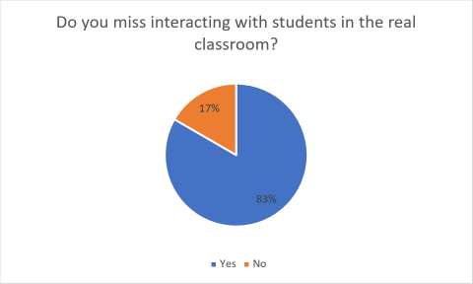

The second question asked was whether students preferred to study in a real classroom or a digital classroom. Here the majority voted that they prefer the real classroom rather than a digital one where it was ten to two once again.
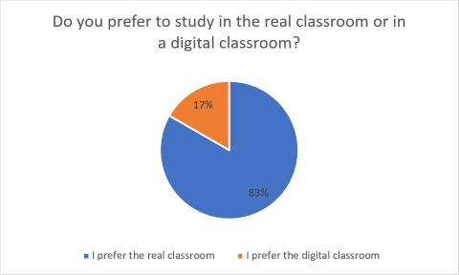

The third question that students were faced with was whether studying online has had a helpful impact on their life or not. Here the majority said that neither their lives have become better nor worse. Whilst at the second place took the people stating that it has improved their lives and last that it made it even harder.
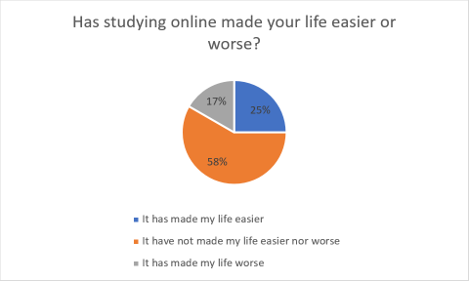

The fourth question was regarding the library and whether students can find enough books to help them with their course. Here there are signs that the library must be improved because ten people voted that it needs more books and only two find that it has enough.
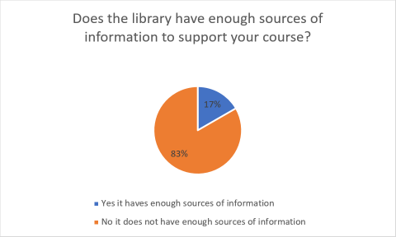

When I asked the students how the platform has improved their lives or made it worse two of them said that there were a lot of technical problems when attending the class and it was not very practical for them to use it. One other student finds it very helpful because they can prepare for the upcoming class and if they miss any lessons, they can find them online and watch them.

Last question that will be addressed is whether students found the videos provided on the online platform useful enough. Here the majority voted that they can be improved.
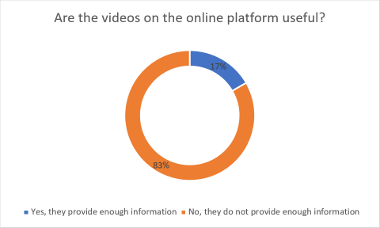

Discussion
From the information which I had received by my questionnaire I can see that the majority of the students miss being in the real class. A lot of the students which were questioned had problems with the online platform and it was making their academic lives difficult because it was hard for them to study. There are also a lot of signs of areas of improvement that can be implemented in the university online platform. The online library does not have enough supplies to provide students with information on subjects regarding their courses. This is a great disadvantage for the students because if they are not interacting with other students and discussing their ideas like they would be in the real-classroom they will not be able to find ideas so easily which will slow down the producing of their assignments. Another grey area that can be seen is the feedback which was received regarding the online videos on the platform. Clearly it is another area where students find the information provided to be lacking and needs to be improved. When I have discussed this with the students in the online group, they stated that if there were exercises that can be done after the class it would help them remember the lessons learned more. The resemblance between my research and theirs is that we both have identified the great benefits that can come from online studying. Contrasting them however, shows that my research is focused on the online platform ‘moodle’ that is being used at our university. The helpfulness of the platform and how it can be improved. Whilst the other researches have focused on the growth of online studying throughout the years. Also, their attention goes on which areas are likely to go on distance and online learning like the students that live in rural areas. Indistinguishable to see is how we both see that teachers can not evaluate so easily their students strengths and weaknesses in a digital classroom as they would in a real classroom.

Conclusion
The conclusion of this research is that even though there are a lot of benefits which online studying can provide like creating more opportunities for students, making their lives more economical and opens more time for them, they prefer to study in the real class. There students can share their ideas with others and discuss them which can create more insights on the subjects which are required for their assignments. The lack of social interaction is missed by a lot of the students and the fact that they cannot create friendships within the class is being taken negatively by most students. Also, with the areas that need to be improved on the online platform, students find it hard to learn new material online and have to go long ways sometimes to find the information they need for their assignments. People, who have difficulties working with technologies are experiencing difficulties and are displeased by the platform. To my observation I have seen that even teachers find it difficult to use the online platforms at times and it can be quite the unpleasant experience when you want to learn the lesson and the teacher is disconnecting every ten minutes because of internet or application problems. I can also see that if there is an internet outage there will be no ways for you to receive your lessons and that will make our lives harder because we will not only miss class but our attendance will go down and it could lead to us losing our spot in the classroom. If you are like me who is efficient at working alone, live far away from the university and can find sources easily it can have positive impacts on your life, because I have learned how to adapt to these changes and make the best of them.

References
Dabner, N., Davis, N. and Zaka, P., 2012. Authentic Project-Based Design Of Professional Development For Teachers Studying Online And Blended Teaching. [online] Learntechlib.org. Available at: <https://www.learntechlib.org/p/37659/> [Accessed 19 April 2020].
Laderman, D., 2020. Who is Studying Online and Where [online] Mtsac.edu. Available at: <https://www.mtsac.edu/president/cabinet-notes/2017-18/Who_Is_Studying_Online_and_Where.pdf> [Accessed 19 April 2020].
Means, B., Toyama, Y., Murphy, R., Bakia, M. and Jones, K., 2009. Evaluation of Evidence-Based Practises in Online Learning [online] Repository.alt.ac.uk. Available at: <https://repository.alt.ac.uk/629/1/US_DepEdu_Final_report_2009.pdf> [Accessed 18 April 2020].
Stauffer, B., 2020. What’S The Difference Between Online Learning And Distance Learning?. [online] Aeseducation.com. Available at: <https://www.aeseducation.com/blog/online-learning-vs-distance-learning> [Accessed 19 April 2020].

Appendix
Link to my survey: https://freeonlinesurveys.com/s/Px7Jk5FQ


