
Callum Jones
2305269
ACHA5012
ACMA5007
Project Planning

Contents
- Contents page 2
- Introduction page 3
- Team roles page 4
- Overall tasks page 5
- Our project and aims page 6
- My Role page 8
- Bill of materials page 10
- Milestones page 11
- Gateway objections page 12
- Possible areas of concern page 13
- Gantt chart page 14
- References page 15

Introduction
In this project I and my group have been tasked to design, research, measure and modify a BMW E87 130i. We are running as a rally car in the 2025 motorsport UK asphalt rally championships overall as a rally team is to as increase vehicle performance, we have 3 teams all looking at different areas of the car including engine, front and rear suspension and finally aerodynamics. I am a member of the engine team, which is divided into two groups. One group focuses on analysing overall airflow on the intake side of the engine, while my team specializes in camshafts, springs, and valves.
Our goal as a team in this project including both teams is to increase house power and output torque by 5% together with the intake team and the Cam team. Talk is critical in valley applications as it directly influences low end power delivery acceleration from corners exits and overall driveability as well as horsepower is still important for higher end power, but low-end power is more useful. We are looking to explore Cam profiles modifications valve timings and spring rate optimization to enhance airflow therefore increasing efficiency across the engines combustion operating range.

Subsystem | Team Member | Role | Expanded Responsibilities
N52 Intake | Robbie Sandford | Project Manager | Define project scope and objectives; manage timelines and resources; coordinate cross-team tasks; ensure compliance with Motorsport UK regulations; oversee risk management and quality assurance.
N52 Intake | Isaac Jones | Design Engineer | Develop CAD models of intake components; perform Computational Fluid Dynamics (CFD) simulations; validate designs against performance targets; collaborate with testing engineers for design refinement.
N52 Intake | Wesley Ives | Test Engineer | Conduct Ricardo Wave simulations; perform flow bench testing; analyse test data for volumetric efficiency; recommend design adjustments based on empirical results.
N52 Intake | Snasloy D’Silva | Innovation Specialist | Research emerging intake technologies; collect competitor benchmarking data; evaluate material options for lightweight and high-strength components; provide insights for continuous improvement.
N52 Valvetrain | Finlay Kingscott | Vice Project Manager | Assist in overall project coordination; lead CAD modelling of camshaft and valvetrain components; perform CFD analysis for airflow; support design reviews and ensure torque optimization alignment.
N52 Valvetrain | Callum Jones | Development Engineer | Collect baseline performance data (torque, horsepower, RPM range); develop initial camshaft design concepts; coordinate dyno testing; validate modifications against performance targets; prepare technical reports.
N52 Valvetrain | Odin Robinson | Research & Testing Engineer | Conduct material strain and fatigue analysis; research advanced camshaft profiles and timing strategies; perform durability and reliability testing under simulated rally conditions; ensure compliance with safety and performance standards.
Team roles
We have three members to our smaller camp team.
N52 Valvetrain

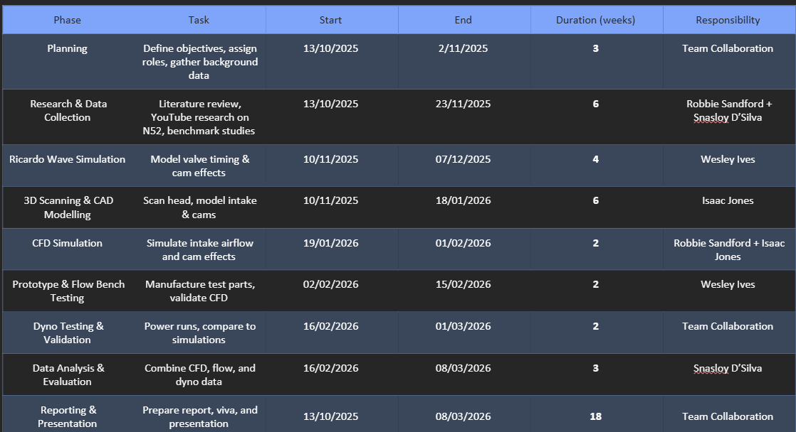
Overall tasks

Phase | Task | Assigned member
Measurements | Measure camshaft lobes and valve spring rates for intake/ exhaust. | Callum
Research | 3D scanning of head, analyse valve spring options, review BMW examples. | Odin/ Finlay
 | investigate camshaft profiles, timing strategies, and flow impact. | Callum/ Odin
Designing | create initial camshaft profiles using CAD, design new valve springs. | Callum / Finlay
Simulation | CFD analysis of air flow, run camshaft timing simulations, validate torque gains. | Finlay/ Odin
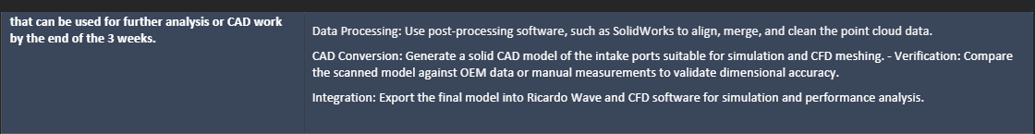
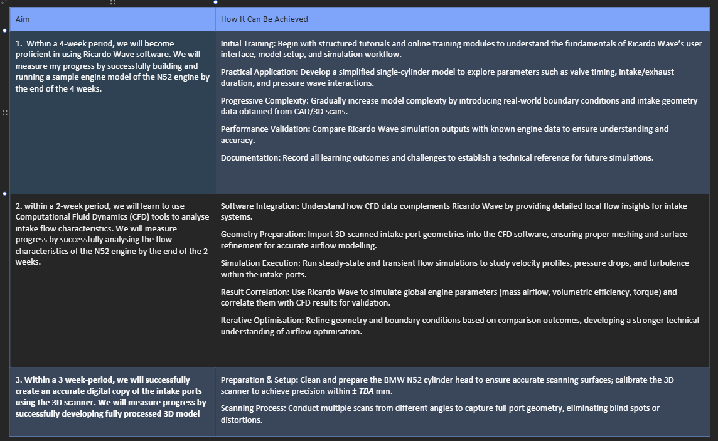
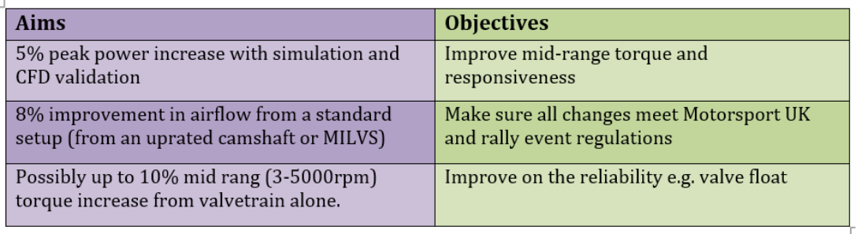
Our project and aims

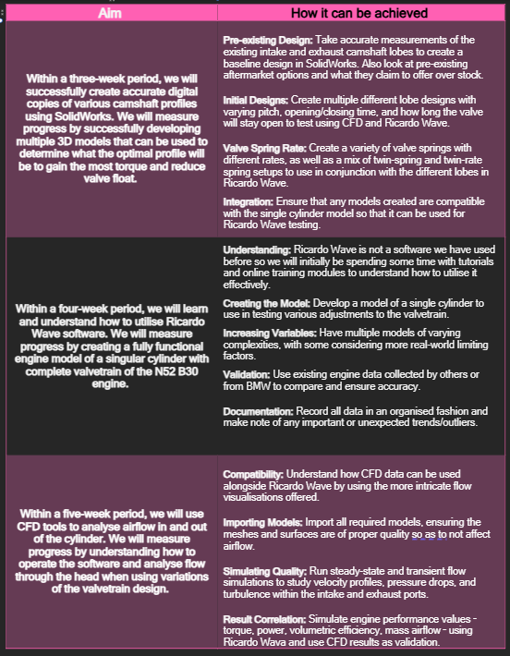
My role
I am the development engineer for the valvetrain, responsible for collecting baseline performance data and improving it through dyno testing. Then to validate it with our performance targets and goals against our baseline performance (horsepower RPM range, torque). I will be collaborating with Odin Robinson and utilizing his research to validate our enhancements to the camshafts and valve train, as well as to determine which new components should be purchased and installed.

Core Responsibilities:
- Baseline Data Collection: Gather stock engine performance metrics (torque, horsepower, RPM range) using dyno testing and ECU logs.
- Initial Design Development: Create preliminary camshaft profiles focusing on lift, duration, and timing to optimize torque delivery for rally conditions.
- Testing Coordination: Plan and execute dyno sessions to validate modifications, ensuring compliance with Motorsport UK regulations.
- Performance Evaluation: Analyse torque curves, powerband shifts, and drivability improvements post-modification.
- Documentation: Prepare technical reports detailing design changes, test results, and recommendations for further optimization.

Belbin’s team roles is an established model that identifies nine distinct roles by using straightforward questions to determine an individual’s personality. After answering the questions there are 9 different roles that are possible. I tried this and I was placed into team worker,
‘Helps the team to gel, using their versatility to identify the work required and complete it on behalf of the team.
Strengths: Co-operative, perceptive and diplomatic. Listens and averts friction.
Allowable weaknesses: Can be indecisive in crunch situations and tends to avoid confrontation.
Don't be surprised to find that: They might be hesitant to make unpopular decisions.’
https://www.belbin.com/about/belbin-team-roles
I agree with this assessment of my skills and personality to some extent, as I am confident in my ability to make decisions that may not always be popular when necessary.

Tools and methods
I will need to use a range of tools and methods to achieve the performance objectives of this project, for example computer aided design (CAD). Where I will model the cam profiles and other valve train components to visualise the dimensions and the curve coefficient. With our CAD models we are looking to 3D print a Cam profile to have a visual reference of the Cam profile that we have chosen to show off in our presentations. Secondly, Computational Fluid Dynamics (CFD) will be employed to evaluate airflow characteristics within valve train systems, with the objective of maximizing volumetric efficiency and minimizing flow restrictions. Both virtual validation tools will help to support our design improvements therefore minimalizing prototyping costs and increasing development speed and ironing out any simple mistakes before too much time was spent on a specific design.
All validation tools will adhere to our structured methodology, beginning with original simulation-based analysis, followed by physical testing of the selected design.

Bill of materials
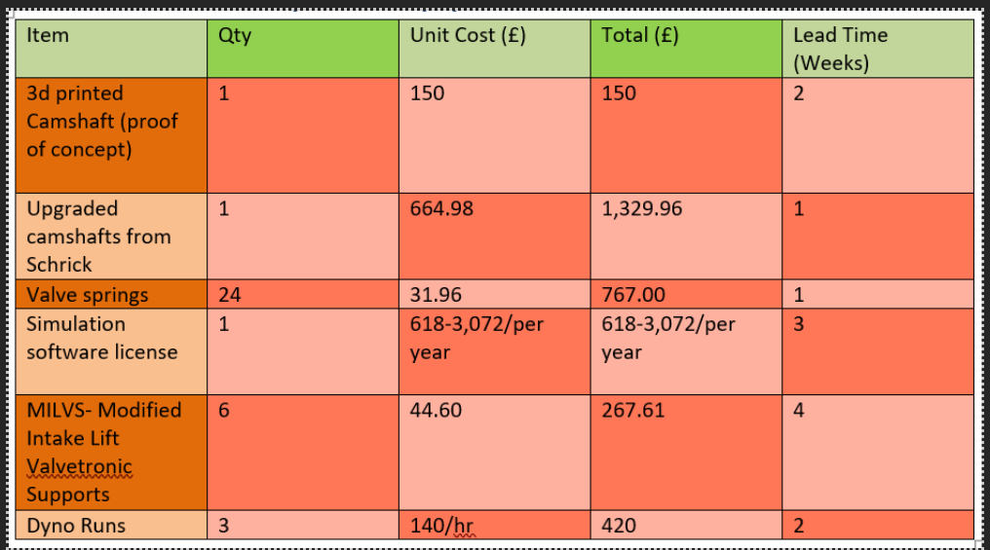
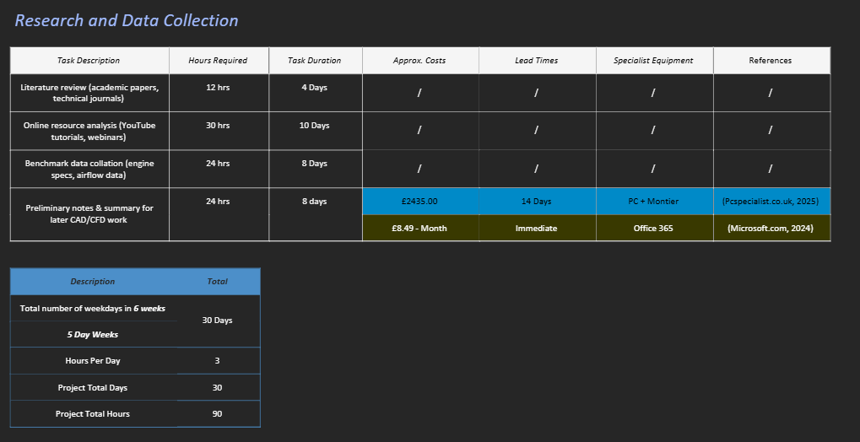
Research and data collection

This shows our tasks for research and data collection to show some of the cost of gathering data and the time taken to complete tasks appropriately. As I have previously mentioned, my team and I will be using CFD and CAD software to simulate the valve train. Additionally, we plan to use various workshop tools to collect base data, including Vernier calliper gauge, weighing scale, micrometer, and other measuring devices.
Our intake team will be using the flow bench to measure airflow.
Finaly we will hopefully be using a 3D printer to print a example of the cam profile to demonstrate which design we are choosing.

Milestones
My milestones are group related tasks that are competed by everyone but are splint into individual tasks. They are all compled to a specific date’s so ensure that everything will be done by the final project data and to stop leaning off track to keep all work to a professional standad.
My individual milestones are documented in the tables provided under overall tasks, while our team's progress is detailed beneath our project and aims. In summary, baseline data collection, research, modification, and testing constitute the primary objectives; all specific tasks are categorised within these main areas.
My first milestone is to collect baseline data on all valve train components, focusing on valve lift and cam profile. This also includes putting the car on the rolling road to gather stock engine performance metrics e.g., horsepower, torque and rpm range. To put the car on the dyno is had to put a specific date on it as the car has a rally stage on the 15th of November. This will be hopefully completed by the 22nd of November, to allow me to help my other team members on there jobs and then move on to my next job.
Anther milestone will be finalising initial camshaft concepts using our research and cad simulations to decide on the correct concept of camshaft curve coefficient. This incudes lift of the valve, the duration of how long the valve will be open meaning a slightly wider cam profile to keep the valve lifted for longer and finally the timing of the exhaust cam and the intake cam.
On the week starting of the 8th of December with have our 1st presentation of two to demonstrate what we have been working on and what will be our next steps.
The remaining milestones were included.
- Simulation analysis
- Prototype design
- Dyno testing
- Performance validation
- Final report

Gateway objectives
A gateway objective is a milestone that is critical to allow progression to allow the project to move on the then next stage at a structed rate, as without completing these objectives you are not able to move on to the next task without it causing future problems.

As I have said above a gateway objective is one of my tasks that is gathering baseline valve data, this need to be completed as early aspoible to allow the team to start to work on improving our torque and horsepower from our measured baseline. A deadline has been established for this task to be completed by 22nd November. This measure is crucial to ensure that other team members can concentrate on their specific responsibilities, ultimately enhancing overall efficiency and professionalism in delivering the final product.

In this project we will have two presentations to show off our work the first presentation is a general introduction to the project and our team’s direction that we have decided to go into and how we look to achieve our goals and aims. Therefore, it will be necessary to prepare a PowerPoint presentation as part of our gateway objectives. This task should be completed within a specified timeframe to effectively showcase the required work. Then a final presentation to display our finished projects this is where everything we want to complete will need to be done, we will need to display all our data research and finished product. We only have 30 minutes for our team which works out to 3 minutes per person so everyone's work will need to be displayed in that time, we will have to practise our presentation to ensure each member speaks coherently at a professional standard to best display that work.

Possible areas of concern
In rallying camshaft profiles influence valve timing that there fore affects low and mid rpm torque witch I have previously stated is curtail to a rally car for acceleration out of corners. Our goal is to boost both horsepower and torque. However, increasing torque may lead to a loss of power at higher RPMs and in the upper gears. Despite this trade-off, we believe it is worthwhile since it should enable us to save more time in the corners compared to simply having higher straight-line speed.

‘Ambiguity can be demotivating. Keep your team members motivated by establishing clear and achievable goals for their parts of every project.
Ensure that everyone understands their role and responsibilities within the team. When your team knows what is expected of them, they can focus on their tasks with confidence and enthusiasm.
If they are accountable for certain aspects of each project, they are also more likely to communicate when there are issues. If you encourage your team to be solution focused, they are more likely to come with a solution to the team issue or their issue, resulting in more productive solutions for everyone.’
https://howtobasically.co.uk/7-key-factors-that-drive-team-motivation/
Looking online for ways to keep the team on track to keep ensure that all work is completed to a professional stranded. I found this; this backs my theory and will boost the way I look at how I give out specific tasks.

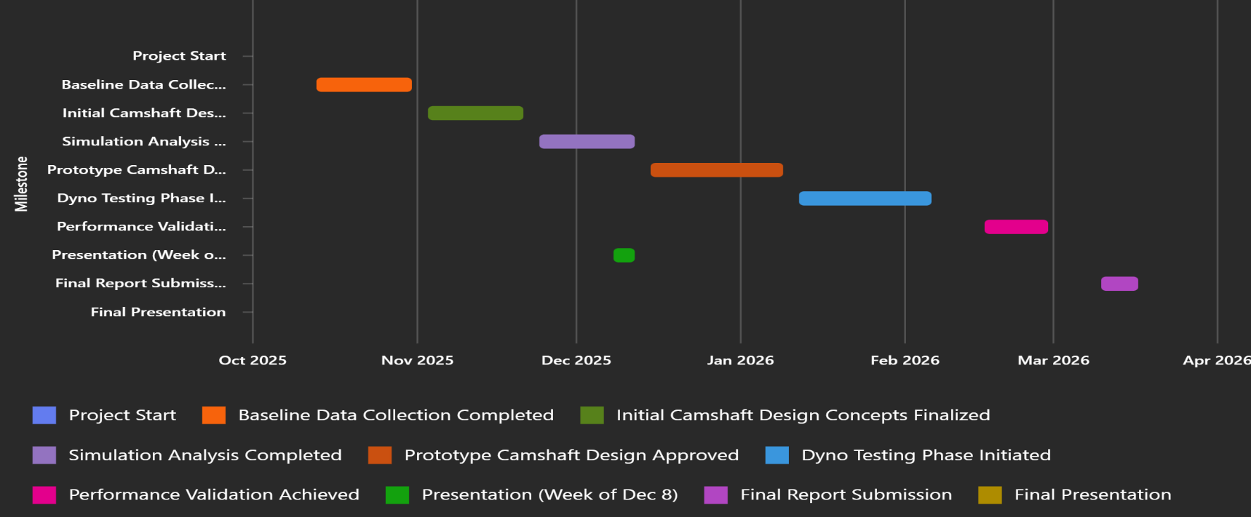
Gnatt charts

Reference list
Belbin (2010). The Nine Belbin Team Roles. [online] Belbin. Available at: https://www.belbin.com/about/belbin-team-roles [Accessed 15 Nov. 10AD].
Turner, J. (2023). 7 key factors that drive team motivation. [online] How To Basically. Available at: https://howtobasically.co.uk/7-key-factors-that-drive-team-motivation/ [Accessed 18 Nov. 17AD].

