University of Wales Trinity Saint David
Wales Institute of Science and Art


Electronic Circuits Testing and Applications
Vehicle Electronics

Harri Evans
2500728
19/04/2026
Contents
1 Task 3 1
1.1 Scope Time Division Calculations (6) 1
1.2 Function Generator output square wave (6) 1
1.3 Capacitor charge and discharge wave marked at correct points. (6) 2
1.4 Basic Capacitor Calculations (6) 2
1.5 Capacitor discharge table (5) 3
1.6 Plot log(V) Gradient (5) 3
1.7 Gradient Calculations and Compare(8) 3
1.7.1 Gradient Calculations 3
1.7.2 Comparison table 4
1.8 Capacitor Uses (5) 4
1.9 Inaccuracies Question (4) 5
1.10 Risk Question (10) 5
2 References 7

Task 3

Scope Time Division Calculations (6)
$$T=RC$$
$$T=100×1×{10}^{-6}=0.0001s$$
$$T=100μs$$
$$40T=40×100μs=4ms$$
$$f=\frac{1}{4x{10}^{-3}}=250Hz$$
$$\frac{4ms}{10}=0.4ms$$
$$400μs$$
Rounded to the nearest Hantak setting $=500μs$/div

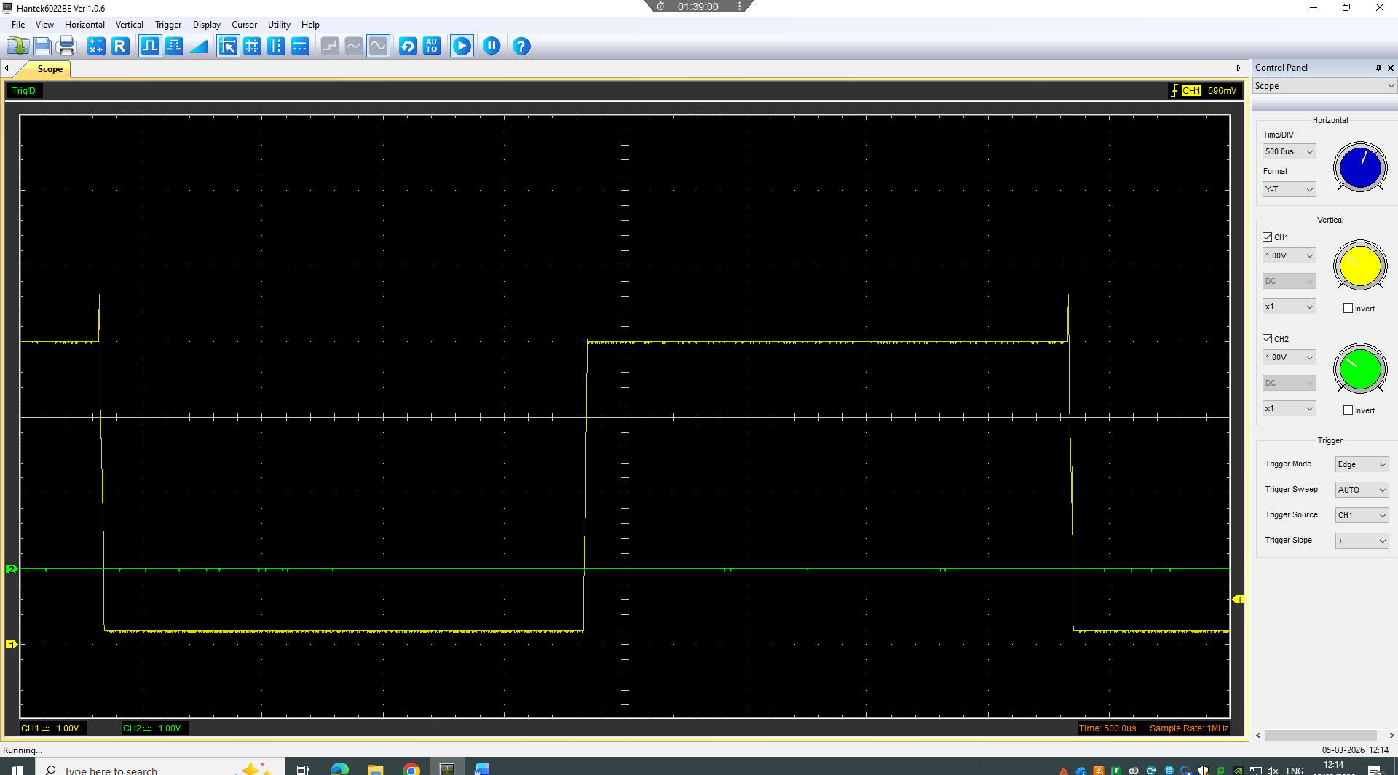
Function Generator output square wave (6)
Figure 1 (Square Wave Form)
The output of the function generator produced a square wave which was used to repeatedly charge and discharge the capacitor. The capacitor voltage rises during charging and falls during discharge, as shown in the square wave form.

Capacitor charge and discharge wave marked at correct points. (6)

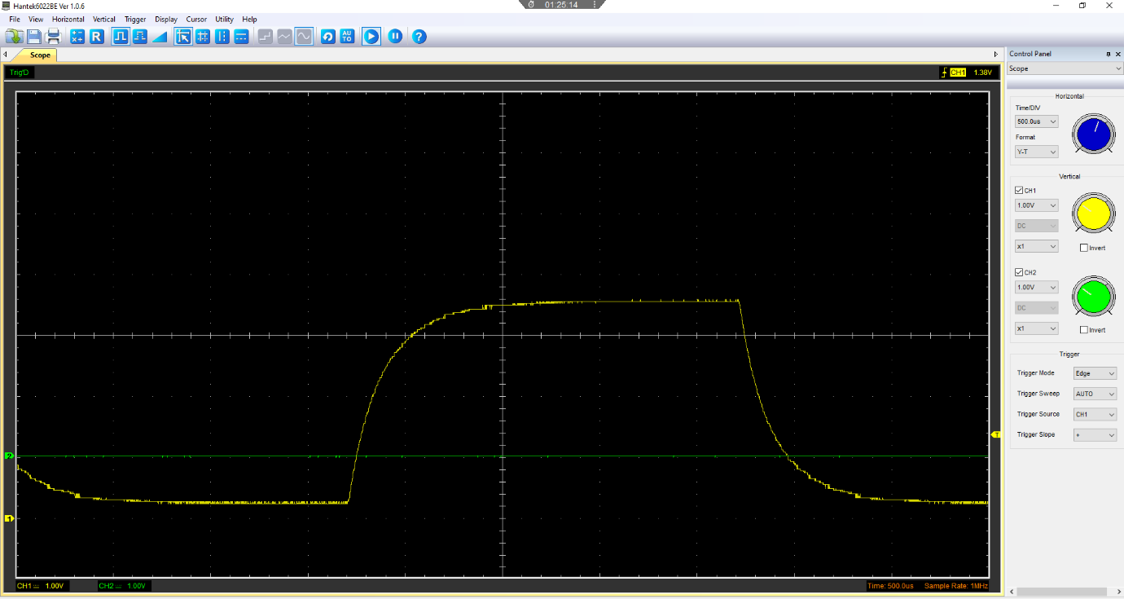
36.8% Discharge
63.2% Charge
Fully discharged
Discharging curve
Charging curve
Fully charged
Time on discharge
Time on charge

Figure 2 (Sine Wave Form)
Figure 2 displays a sine wave charging and discharging waveform showing the behaviour of an RC circuit capacitor with the relevant pointes marked.

Basic Capacitor Calculations (6)
$$C=\frac{t}{R}$$
$$C=100×\frac{{10}^{-6}}{100}$$
$$C=1×{10}^{-6F}$$
$$C=1μF$$
For the basic capacitor calculation, I used t = RC but rearranged it into C = t/R which gave $C=1μf$

Capacitor discharge table (5)
Time (s) | Voltage (V) | ln (V) | dy = y2 – y1  dy = ln(V)2-ln(V)1 | dx = x2- x1  dx = Time2 – Time1 | dy/dx
0 | 3.1059 | 1.133304 | x | x | x
0.0105 | 2.7608 | 1.01552 | -0.11778 | 0.0105 | -11.2174
0.021 | 2.4157 | 0.881989 | -0.13353 | 0.0105 | -12.7173
0.0315 | 2.1647 | 0.772282 | -0.10971 | 0.0105 | -10.4483
0.042 | 1.9137 | 0.649039 | -0.12324 | 0.0105 | -11.7375
0.0525 | 1.7255 | 0.545517 | -0.10352 | 0.0105 | -9.85921
0.063 | 1.5686 | 0.450184 | -0.09533 | 0.0105 | -9.07937
0.0735 | 1.4118 | 0.344865 | -0.10532 | 0.0105 | -10.0303
0.084 | 1.2863 | 0.25177 | -0.0931 | 0.0105 | -8.86625
0.0945 | 1.1922 | 0.1758 | -0.07597 | 0.0105 | -7.23519
Figure 3

Plot log(V) Gradient (5)

Figure 4
Above is a graph showing ln (V) versus time in seconds.

Gradient Calculations and Compare(8)

Gradient Calculations
$$Mean Gradient=\frac{dy/dx}{9}$$
$$Mean Gradient= -10.1323$$
$$\frac{1}{-10.1323}=0.0987s$$
$$Time Constant=\frac{1}{-10.1323}=0.0987s$$
$$C=\frac{0.0987}{100}$$
$$C=9.87×{10}^{-4}=987μF$$

Comparison table
 | Capacitance | Delta | Percentage difference
Actual | 1 µF | x | X
Marker Calculation | 1 µF | 0 µF | 0%
Gradient Calculation | 987 µF | 986 µF | 98600%
Figure 5

Capacitor Uses (5)
Capacitors are used in a wide range of electrical and automotive applications as they can store electrical charge and release when needed, commonly capacitors are used to smooth the rectified DC output and reduce voltage ripples. Another use for capacitors are decoupling and bypassing, where they remove unwanted electrical noise from supply lines to stabilise the circuit operation. When used in amplifier and signal circuits, capacitors are used for coupling because they allow alternating signals to pass while blocking direct current. They are also used in RC timing circuits where they’re charge and discharge characteristics are used to create time delays.
In automotive and motorsport applications capacitors play an important role in stabilising the voltage supplied to electronic control units, sensors and other components which helps to improve operating consistency. They are also used suppress electrical interference in ignition, charging and lighting circuits which will reduce the electromagnetic interference which may otherwise disrupt the system. In electric and hybrid vehicle power, capacitors are used to smooth voltage and support switching operations within inverter circuits. Also capacitors can be used in memory backup where the stored electrical charge provides temporary power during power supply interruptions. (Allen, 2026)

Inaccuracies Question (4)
The measured capacitance may differ from the specified value because both the component and the measuring device and method have limitations. Capacitors are manufactured within a tolerance, meaning the true capacitance may vary from the nominal value printed on the component. Also the capacitance may be affected by external factors such as temperature, frequency and applied voltage which may cause further variation due to the limitations of the testing equipment. Measurement inaccuracies also affect the results as the oscilloscope probe may affect the readings due to its own resistance and capacitance which may alter the wave form being measured. Small errors may also occur when identifying the correct voltage point on the wave form. Wiring resistance, resistor tolerance, capacitor leakage and equivalent series resistance can all affect the charging and discharging behaviour of the circuit. Therefore, the calculated capacitance may differ from the manufacturer's specified value due to a combination of different factors whilst conducting the test. (Burke and Miller, 2010)

Risk Question (10)
CAN bus is a critical part of the vehicle network as it allows ECUs to communicate and exchange data. A cyberattack on this network is serious as false information can mislead vehicle controllers and cause problems. NHTSA (Cybersecurity Best Practices for the Safety of Modern Vehicles, 2022) gives an example of a spoofed vehicle speed message could cause the ECUs to misinterpret whether the vehicle is moving or stationary. ISO/SAE 21434:2021 addresses this problem by conducting cybersecurity engineering and risk management through the full vehicle lifecycle from concept and development to production, operation and maintenance.
To mitigate CAN bus risks, manufacturers should carry out threat analysis and risk assessments to ensure that likely attack paths and safety impacts are identified early. Attack paths could include physical access such as OBD based tools or compromised OBD dongles and remote access through connected functions such as telematics or infotainment systems. Preventative measures should then be built into the vehicle, NHTSA recommends stronger partitioning of the vehicles network so connectivity devices are separate from safety crucial controllers with gateways treated like firewalls to prevent or monitor suspicious traffic. (Cybersecurity of Firmware Updates, 2020)
Authentication is also essential with ECUs, NHTSA also says that authentication and possibly encryption can be used for secure vehicle channels although adding cryptographic protection to conventual CAN is difficult due to its limited frame payload. However, entity authentication, digital signatures and message authentication codes can still be applied to selected communications so that compromised ECUs cannot easily give commands to other computer modules. Secure key handling, controlled diagnostic access, event logging and signed software updates should be used to prevent attacks and trace their origin. The most effective solution is a layered design in which risk assessment, secure architecture, controlled access and regular updates and monitoring are all applied together in line with ISO/SAE 21434:2021 standards. (ISO, 2021)

References
Allen, D. (2026). Double layer capacitors : automotive applications and modeling. Mit.edu. [online] doi:http://hdl.handle.net/1721.1/28337.
Burke, A. and Miller, M. (2010). Testing of electrochemical capacitors: Capacitance, resistance, energy density, and power capability. Electrochimica Acta, 55(25), pp.7538–7548. doi:https://doi.org/10.1016/j.electacta.2010.04.074.
Cybersecurity Best Practices for the Safety of Modern Vehicles. (2022). Available at: https://www.nhtsa.gov/sites/nhtsa.gov/files/2022-09/cybersecurity-best-practices-safety-modern-vehicles-2022-pre-final-tag_0_0.pdf [Accessed 17 Apr. 2026].
Cybersecurity of Firmware Updates. (2020). Available at: https://www.nhtsa.gov/sites/nhtsa.gov/files/documents/cybersecurity_of_firmware_updates_oct2020.pdf [Accessed 17 Apr. 2026].
ISO (2021). ISO/SAE 21434. [online] ISO. Available at: https://www.iso.org/standard/70918.html [Accessed 17 Apr. 2026].
Figure 1 - (Author)
Figure 2 - (Author)
Figure 3 - (Author)
Figure 4 - (Author)
Figure 5 - (Author)

