

Changemakers: Creativity and Value Creation
Professions (BMHP5014)

Component 1: Online portfolio of set exercises

Student name: Retchil Salubod
Student number: 2417230
Lecturer’s name: Dr Sadiq Sobhan

Table of contents
Introduction ..........................................................................3
Defining Key Concepts in Practice ......................................3-4
Mind Map .............................................................................4-5
Self-Reflection of Group Activity ..........................................5
Case Study Analysis of a UK Innovation ..............................5-6
Research Task .....................................................................6
Exploring Digital Innovation in Health and Social Care ........6-7
Understanding the NHS Leadership Framework ..................7-8
Self- Reflection Journal Entry ................................................8
References ............................................................................9

Introduction
This assignment examines innovation, creativity, value creation, and change, highlighting their importance and application within Health and Social Care.

Key Concepts in Practice
Innovation
Innovation is significant because it outlines how new ideas are generated and developed into healthcare interventions or service models that improve or preserve life, and how the most successful innovations are disseminated and embedded into standard clinical practice (Care Quality Commission, 2022). Innovation is important because it can result in increased productivity, efficiency and address challenging situations. For example, with MRI, it is easy to check the whole- body imaging compared to before. According to (Greenhalgh et.al. 2004), innovation in service delivery and organisation involves the planned and coordinated implementation of novel behaviours, routines, and work practices aimed at improving health outcomes, enhancing administrative efficiency, achieving greater cost-effectiveness, and optimising the experiences of service users.
Creativity
According to Runco et al. (2012) creativity can be defined as the ability to produce original and valuable ideas or activities. Creative health refers to application of creative practices and interventions that contribute positively to health, well-being, and quality of life. It can help prevent illness, encourage healthier lifestyles, support chronic health conditions, and assist in treatment and recovery throughout a person’s life (Coulter et al. 2024). It is important because it can improve health and well-being through personalised and engaging approaches to care. For instance, staff in the care home may use music to help people with dementia reduce anxiety and enhance their quality of life.
Value Creation
Prioritise the treatment and experiences that improve a person's life while making sure healthcare is managed responsibly so the community can benefit greatly (CEBM, 2019), and (Porter 2010) defines value-based healthcare refers to the extent to which positive patients' health outcomes are achieved relative to the resources and costs involved in providing care. In health and social care, it is important because services must deliver high-quality care. For example, preventive health programmes such as vaccination campaigns create value by reducing illness and lowering long-term health costs.
Change
Providing an evidence-based structural foundation, the change model facilitates continuous, long-term organisational improvement, delayed delivering concrete value to care providers, service users and society (NHS,2018). Kotter (1996) explains change as an eight-step procedure that contains making immediate action, building a coalition, forming a vision, removing barriers, creating short wins, combining gains, and anchoring change in the organisation. It is essential because services must adapt to new technologies and policies. For example, introducing electronic prescribing systems in hospitals requires staff training to ensure safe and effective use.
Mind Map

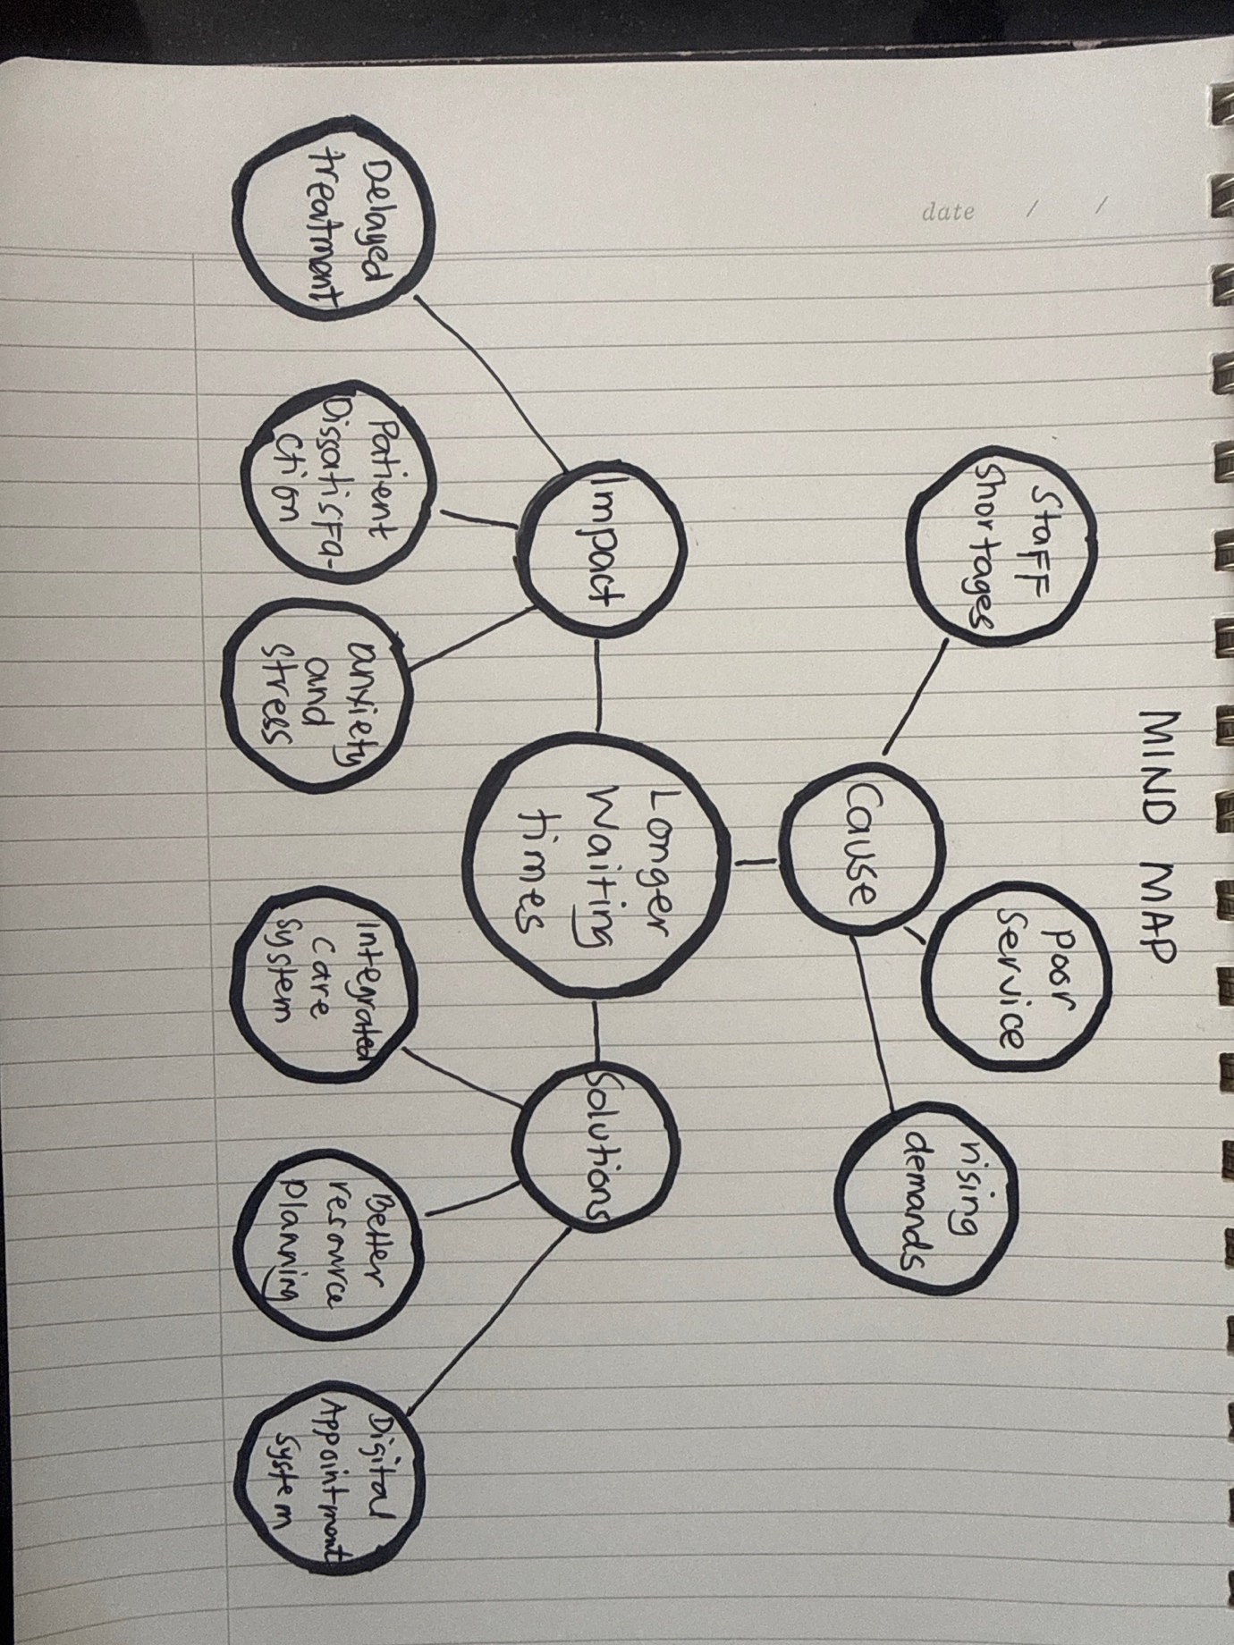
Longer waiting times are a major problem in health and social care because they can delay treatment, worsen health conditions, and reduce patients' satisfaction. Using a systems thinking approach (Meadows, 2008), this issue can be understood as the result of several interconnected factors rather than a single cause. Staff shortages, increasing demand for services, and poor coordination or service between care providers contribute to longer waiting lists. These delays can increase pressure on health and social care workers, leading to burnout and lower quality of care. Patients may experience worsening symptoms, anxiety, and reduced trust in services. The mind map shows how causes and impacts are linked within the wider carer system. Possible solutions include recruiting and retaining more staff, improving resource planning, expanding the digital appointments system, and strengthening community-based support. If not addressed, waiting times and service pressure are likely to continue increasing (Alansari et al,2025).

Self-Reflection
Using Gibbs Reflective Cycle 1988, I will reflect on a group activity in which we used convergent and divergent thinking to address a health and social care problem. In the description stage, our group explored solutions to long NHS waiting times. We first used divergent thinking to generate as many ideas as possible, including a digital triage system, increasing staffing, and improving GP referral pathways. During the feelings stage, I felt confident contributing ideas, but noticed the discussion became slightly unstructured as everyone was speaking at once. In the evaluation stage, I realised divergent thinking helped creativity, but we struggled ti prioritise. In the analysis stage, we shifted to convergent thinking, using a pros and cons discussion to narrow ideas. I suggested grouping similar ideas together, which improved focus and helped us reach agreements more effectively. This shoed me I contribute more when structure is needed. In the conclusion stage, I learned I tend to prefer convergent thinking because I value decisions, but I now see that divergent thinking is essential for generating stronger solutions first. Gibbs Reflective Cycle 1988 supports reflection as a means of turning experience into learning. Next time, I would introduce structure earlier, for example, time-limited brainstorming to balance creativity and organisation more effectively (The University of Edinburgh, 2024).

Case Study Analysis of a UK Innovation
A significant innovation in the NHS is the introduction of virtual wards, which support the delivery of hospital-level care in patients' homes by using remote monitoring to oversee their condition and treatment and contact with health professional. This innovation comes up from increasing pressure on hospital beds, ageing population, and unnecessary hospitalisation. Virtual wards facilitate the remote management of patients with respiratory and cardiovascular illnesses, allowing them to receive appropriate care in the house (NHS, 2026). Creativity helped address this challenge by combining digital technologies, remote monitoring devices, and multidisciplinary teams to make an alternative to traditional inpatient care. Instead of relying only on hospital-based treatment, the NHS redesigned care to deliver acute care in a patient's usual place of residence. Healthcare innovation created value for service users by improving comfort, independence, and patients experience. Staff get from more flexible delivery, while healthcare systems benefit from reduced pressure on hospital admission, earlier discharge, and increased virtual wards capacity (NHS,2024). This example can be linked to Rogers Diffusion of Innovation Theory, which indicates that innovation is more likely to be adopted when they give clear advantages and observable benefits. The success and expansions of virtual wards demonstrate how healthcare organisations adopt innovations that improve outcomes for patients and service (Vallente,2003).
Research Task
Workplace stress is a significant issue that affects employee wellbeing and organisational performance. According to Maulik (2017), workplace stress occurs when employees feel the job demands exceed their skills, knowledge or ability to cope. The article identifies several causes of stress, including poor organisational structure, ineffective management. Limited autonomy, inadequate job design, and a lack of social support. The study highlights that although workplace stress is widely research, many organisations fail to implement effective interventions. This article helps me understand that workplace stress is often caused by systematic and organisational factors rather than individual weaknesses. While Davies (2021) explains that high workloads poor management practices, and difficulties maintaining a healthy work-life balance are major causes of workplace stress. This article suggests that prolonged stress can lead to burnout, absenteeism, reduced job satisfaction, and staff turnover. This source helps me understand the wider consequences of workplace stress and importance of supportive workplace policies. Both articles agree that workplace stress is largely influenced by organisational factors and management practices. However, Mauli (2017) focuses more on the structural causes stress, whereas Davies (2021) emphasises its impact on employee wellbeing and organisational outcomes. This issue can be linked to Maslach Theory, which describe burnout as the enduring effects of chronic emotional and relational l stress in the workplace has become widely recognised and discussed (Whitcomb, 2025).
Exploring Digital Innovation in Health and Social Care
Wearable devices have transformed the way chronic health conditions are monitored and managed by providing continuous access to information. Technologies such as Apple watch, Fitbit, and continuous glucose monitors track a vital health measure, including heart rate, blood oxygen saturation, physical activity, and glucose levels. By delivering real-time health data, these devices enable individuals to detect changes in their condition, adopt healthier behaviours, and work more effectively with healthcare professionals to improve long-term health outcomes. Healthcare professionals can also use the collected data to identify early warnings signs, monitor disease progression, and personal treatment plans. As a result, patients become active participants in managing their own health rather than passive recipient of care. For example, Fitbit these devices enable users to monitor their physical activity and heart rate, allowing individuals with conditions such as cardiovascular disease to manage their health more effectively (Boyer, 2025). Electronic Health Records are digital systems that stores patients complete medical history, including diagnoses, medications, laboratory results, immunisation, X-rays and clinical notes or it help ensure that healthcare providers have access to the most current patient's information whenever it is needed. Unlike traditional paper records, EHRs allow healthcare information to be accessed securely by authorised professionals across different healthcare settings. This improves communication and collaboration between healthcare providers because all members of the care team can view up to as technologies date patients' information in real time. As a result, duplication of test is reduced, clinical decisions are better informed, and continuity of care is improved. EHRs support a more patient-cantered approach by enabling seamless information sharing between hospitals, specialists, GP and care homes (ISO,2024). While digital technology support preventive care and health promotion by helping individuals monitor their health, manage medications, and adopt healthier behaviours (WHO,2013). The World Health Organization (WHO,2023) classifies digital health interventions as technologies designed to address health system needs and improve health outcomes. An example is the Medisafe medication reminders to take medication and refill prescriptions when needed (KRANS, 2016). The Technology Acceptance Model of Davies 1989 suggests that individual is more likely to adopt digital health technologies when they perceive them as useful and easy to use (Charness,2020). For example, a person with hypertension could use a blood pressure monitoring device to maintain treatment adherence, reduce complications, and support long-term health promotion.
Understanding the NHS Leadership Framework
The NHS Healthcare Leadership Model is a framework designed to help individuals working in health and social care develop effective leadership behaviours. It consists of nine leadership dimensions that encourage self-reflection and continuous improvement. The framework applies to all staff, regardless of their role or level of responsibility, and helps individuals understand how their behaviour influences colleagues, organisational culture, and patient experiences. Central to the model are personal qualities such as self-awareness, resilience, confidence, and emotional intelligence, which support effective leadership practice. The framework promotes NHS values, encourages collaboration, and focuses on delivering high-quality patient cantered care. By helping leaders understand their strengths and areas for development, the model support positive workplace cultures and improved service delivery. Ultimately, the NHS Leadership Framework is important because effective leadership contributes directly to better patient outcomes, staff engagement, and organisational performance (NHS Leadership Academy, 2025). One important leadership behaviour within NHS Leadership Framework is inspiring shared purpose. This involves demonstrating commitment to NHS values and motivating others to work towards common goals that benefit patients and service users. A leader who inspires a shared purpose encourage staff to contribute ideas, challenge existing practices, and seek innovative solutions to improve care. For example, a ward manager introducing a digital patient monitoring system could involve staff in the decision-making process, helping them understand how the technology improves patient safety and care quality. This collaborative approach encourages creativity, increase staff engagement, and supports continuous service improvement (NHS Leadership Academy,2013). Transformational Leadership Theory suggests that leaders inspire innovation by creating a clear vision and supporting team members to embrace change (Notamicola et al.,2024).
Self-Reflection Journal
Throughout this module, my understanding of creativity and innovation in health and social care has grown significantly. Initially, I believed creativity was mainly about generating new ideas and developing new technologies. However, I now understand that it also involves developing practical solutions that improving patient outcomes, service delivery and organisational efficiency. One of the most influential aspects of the module was learning about digital technologies such as wearable devices, electronic health records, and mobile health application. This example demonstrated how innovation can improve communication between healthcare professionals, support patient cantered care and enable individuals to take a more active role in managing their health. Exploring these technologies helped me appreciate how digital innovation can make healthcare services more accessible, efficient and responsive to patient needs.
The Technology Acceptance Model particularly influenced my thinking by highlighting that successful innovation depends not only on the technology itself but also on whether users perceive it as useful and easy to use. This changed my perspective on the implementation healthcare technologies. In my future professional practice, I will apply this knowledge by supporting innovative and patient-focused approaches to care. I aim to embrace digital solutions that enhance healthcare delivery, improve patient experiences, and contribute to better health outcomes for individuals and communities.

Reference
Alansari, A.N et al. (2025). Staff Shortages Linked to burnout, depression, and Anxiety among Outpatient nurses: a cross-sectional Analysis at Hamad General Hospital, Qatar. BMC Nursing, 24(1). doi:https://doi.org/10.1186/s12912-025-03758-7. (Accessed: 20 June 2026).
Bowyer, M. (2025). How Wearable Technology Is Supporting GPs. [online] Key Medical Services. Available at: https://www.keymedicalservices.co.uk/wearable-technology-supporting-gps/. (Accessed: 20 June 2026).
Care Quality Commission (2022). Innovation and Why It Is Important - Care Quality Commission. [online] www.cqc.org.uk. (Accessed: 14 June 2026).
CEBM (2019). Defining value-based healthcare in the NHS — Centre for Evidence-Based Medicine (CEBM), University of Oxford. [online] www.cebm.ox.ac.uk. Available at: https://www.cebm.ox.ac.uk/ (Accessed 14 June 2026).
Charness, et al., (2020). Technology Acceptance Model - an Overview | ScienceDirect Topics. [online] Sciencedirect.com. Available at: https://www.sciencedirect.com/topics/social-sciences/technology-acceptance-model (Accessed 14 June 2026).
Coulter, A. et al.,(2024). CREATIVE HEALTH IN POLICY, SYSTEMS & COMMUNITIES International Forum on Quality & Safety in Healthcare The National Centre for Creative Health (NCCH) Kazzum Arts. [online] Available at: https://internationalforum.bmj.com/london/wp-content/uploads/sites/20/2024/04/F9.pdf. (Accessed 14 June 2026).
Davies, A.C.L. (2021). Stress at Work: Individuals or Structures? Industrial Law Journal, [online] 51(2). doi:https://doi.org/10.1093/indlaw/dwab006. (Accessed: 20 June 2026).
Greenhalgh, T., et al., (2004). Diffusion of Innovations in Service Organizations: Systematic Review and Recommendations. The Milbank Quarterly, [online] 82(4), pp.581–629. doi:https://doi.org/10.1111/j.0887-378x.2004.00325.x. (Accessed: 20 June 2026).
ISO (2024). Electronic Health Records Explained. [online] ISO. Available at: https://www.iso.org/healthcare/electronic-health-records. June 20
Kotter (1996). Competitive Advantage: reating and Sustaining Superior Performance - Book - Faculty & Research - Harvard Business School. [online] www.hbs.edu. Available at: https://www.hbs.edu/faculty/Pages/item.aspx?num=191. Accessed:june15
Krans, B. (2016). The 5 Best Reminders for Your Medications. [online] Healthline. Available at: https://www.healthline.com/health/best-medication-reminders. June 20
Maulik, P.K. (2017). Workplace stress: A neglected aspect of mental health wellbeing. The indian journal of medical research, [online] 146(4), pp.441–444. doi:10.4103/ijmr.IJMR_1298_17. (Accessed: 20 June 2026).
Meadows, D. (2008). Thinking in Systems. [online] earthscan. Available at: https://research.fit.edu/media/site-specific/researchfitedu/coast-climate-adaptation-library/climate-communications/psychology-amp-behavior/Meadows-2008.-Thinking-in-Systems.pdf. (Accessed: 16 June 2026).
NHS Leadership Academy (2025). Explore the Healthcare Leadership Model. [online] NHS Leadership Academy. Available at: https://www.leadershipacademy.nhs.uk/healthcare-leadership-model/explore-the-healthcare-leadership-model/. (Accessed: 24 June 2026).
NHS Leadership Academy (2013). Healthcare Leadership Model the Nine Dimensions of Leadership Behaviour. [online] Available at: https://www.leadershipacademy.nhs.uk/wp-content/uploads/dlm_uploads/2014/10/NHSLeadership-LeadershipModel-colour.pdf. (Accessed: 24 June 2026).
NHS, (2018). The Change Model Guide. [online] NHS England. Available at: https://www.england.nhs.uk/wp-content/uploads/2018/04/change-model-guide-v5.pdf. (Accessed: 15 June 2026).
NHS England (2024). Virtual Wards Operational Framework. [online] England.nhs.uk. Available at: https://www.england.nhs.uk/long-read/virtual-wards-operational-framework/. (Accessed: 20 June 2026).
NHS England (2026). Virtual Wards https://digital.nhs.uk/data-and-information/information-governance/guidance/virtual-wards (Accessed: 20 June 2026).
Notarnicola, I., et al., (2024). Transformational Leadership and Its Impact on Job Satisfaction and Personal Mastery for Nursing Leaders in Healthcare Organizations. Nursing Reports, [online] 14(4), pp.3561–3574. doi:https://doi.org/10.3390/nursrep14040260. (Accessed: 24 June 2026).
Porter, M.E. (2010). What Is Value in Health Care? New England Journal of Medicine, [online] 363(26), pp.2477–2481. Available at: https://www.nejm.org/doi/full/10.1056/NEJMp101024 (Accessed 15 June 2026).
Runco, M et al., (2012). (PDF) The Standard Definition of Creativity. [online] ResearchGate. Available at: https://www.researchgate.net/publication/254301596_The_Standard_Definition_of_Creativity. (Accessed 15 June 2026).
The University of Edinburgh (2024). Gibbs’ Reflective Cycle. [online] The University of Edinburgh. Available at: https://reflection.ed.ac.uk/reflectors-toolkit/reflecting-on-experience/gibbs-reflective-cycle. (Accessed: 16 June 2026).
Valente, T.W. (2003). Diffusion of innovations. Genetics in Medicine, [online] 5(2), pp.69–69. doi:https://doi.org/10.1097/00125817-200303000-00003. (Accessed 20 June 2026).
Whitcomb, I. (2025). Cristina Maslach: the Pioneer behind Burnout Research. [online] Apa.org. Available at: https://www.apa.org/members/content/burnout-research. (Accessed: 20 June 2026).
WHO (2023). Classification of Digital interventions, Services and Applications in health: a Shared Language to Describe the Uses of Digital Technology for health, 2nd Ed. [online]www.who.int. Available at: https://www.who.int/publications/i/item/9789240081949. (Accessed: 20 June 2026).
WHO (2023). Classification of Digital Health Interventions v1.0. [online] www.who.int. Available at: https://www.who.int/publications/i/item/WHO-RHR-18.06. (Accessed: 20 June 202,6).Organisations

