Index
Contents
Index 1
Introduction 1
Body 2
Foundation 2
Openings 3
Window openings 3
Openings 4
Door openings 4
Floorings 4
Suspended timber floor 5
Solid timber floor 5
Conclusion 5
References 5

Introduction
This report will cover the construction/ design of a two storey single dwelling. It will highlight the methods of which it is constructed, materials that will be used and a detailed look at certain elements of the structure. The standard in which these elements and materials are required to meet will also be included.
The build is a single, two storey detached domestic building with a loft room It is to be built on a level, greenfield site that has 450mm of topsoil above a firm subsoil with low level clay content and is above the local water table.
The wall is to be a block and block cavity with partial fill cavity insulation and a smooth render externally
All Plinths, soldier courses over all openings and porch pillars are to be natural sandstone.
There is a suspended timber ground floor and upper floors are to be traditional solid timber with tongue and groove softwood flooring.
Roof structure is to be trussed rafters at a 40⁰ pitch with a natural slate covering and closed eaves.
Windows and external doors are to be uPVC double glazed units with a light oak finish to them.

Body of report

In the body of this report I will be discussing the above and going into to further detail on the elements discussed to provide an analysis on the elements and how they meet standards.
The details of the element’s construction will be discussed and how these elements come to being part of the building’s envelope. The standards at which these elements are made to either on site or prefabricated will be shown and references to these will be made the same for references will be made to the design which can be found in the Appendix.

Foundation
The chosen foundation type is a strip foundation, the reason for this would be due to the natural of the soil and the size of the structure to be placed on it make it the ideal choice.

Materials
- concrete as specified by structural engineer
- hardcore
- steel reinforcement as specified by structural engineer
- timber shuttering

Construction method
The foundation will be constructed under the BS 8004:2015+A1:2020 (Britishstandards insitute , 2020) the excavation will be dug out at a depth specified by the structural engineer and the foundation will be supported by timber shuttering. See appendix I for visual of the foundation.
The steel reinforced cage will then be placed in shuttering with concrete poured into the shuttering. The concrete will be produced following BS8500 standards (British standards insitute , 2020)it will then be given a flat finish for the cavity walls and the external of the structure to be constructed off. The finish will be done by hand .

Openings

Window openings
As stated above the windows are to uPVC double glazed units with a light oak finish to the units. See below a brief material list to show what materials will be used, and the construction method for the window.
Materials
- uPVC window frame and glazing units.
- Concrete lintel ( prefabricated )
- Concrete block
- Insulation
- Steel wall tie
- Window sill
- Sandstone solider bricks
- Window packers
- Fire rated insulation foam
- Fire rated mastic/silicone
Construction method
The construction method for creating a window is simple as it follows the construction of the cavity wall. As the course of the block work progress the opening for the window will be created by missing out blocks in the correct position and placing the stone sill into the opening and bedding this with mortar
When at the height of the window a lintel will be installed to support the opening, as set out in BS EN 845-2:2003 (British standards insitute, 2020) the lintel will need to have an overlap of at least 150mm either side of the opening ( it will be required to be resting 150mm on block work) The lintel can have a height difference of 225mm from one side to the opposite side. See appendix A/C.
A layer of DPC may be placed under a drip tray that is placed over the opening. The window frame will then be placed in the opening being levelled with packers to ensure it stays level. The double-glazing units will be installed into the frame. The window will need to meet BS 7412:2007 (British standards Insitute , 2020) that set out the standard on uPVC with regards to weathertightness, glazing, jointing of unit, finishes, security.
The frame will have insulation foam in the gaps around it and then a seal of mastic will be placed around it when the interior/ exterior finishes are complete on the sills and block work.

Openings

Door openings
The external doors are to be uPVC with a light oak finish, there is 3 external doors on the property two being single leaf and a 3rd being a sliding double glazed unit.
Materials
- Concrete block
- Concrete lintel ( prefabricated)
- uPvc- door frame
- uPVC door
- fire rated silicone.
- Masonry screws

Construction method
Following similar steps to how the window opening was created the door would be in the same manner and with the placement of the lintel. All of which would follow the same standards and same detail see appendix C.
The door frame would be fixed to the blockwork using packers to make sure the frame is level all around. The frame will come with the stop already Installed. As the door is constructed of uPVC it will follow the same standards as windows (British standards Insitute , 2020).
The frame will be seal with fire rated foam and silicone both internally and externally to provide a weather tight seal.

Floorings

Suspended timber floor
On the ground floor of the structure there will be a suspended timber floor, as shown in appendix I the timber floor will be supported off the cavity wall and hollow sleeper walls (appendix J) .

Materials
- Timber joist
- Joist hanger
- Hardwood timber
- Concrete blocks
- Mortar
- Bricks
- Insulation
Construction method
During the construction of the cavity wall at the correct course joist hangers will be installed/placed in the mortar. The joist is then placed in the hanger the timber( see appendix I), to follow building regs the timber will be c24 softwood (British standard institue , 2020) in between the joist will have insulation fixed between with battern holding the insulation place. hardwood will then be laid on top and fixed to the joists with tongue and grove timber flooring laid on top.
Hollow/sleeper walls will be built and intervals to provide support to the joists these will be constructed before the joists are installed to although the mortar to set and for ease of construction. The sleeper wall will be constructed out of bricks and mortar and will be constructed to a height in which the joist is able to rest upon it and be at the joists required height also.

Solid timber floor
Solid timber floor is like that of a suspended. In this construction it is being used on the 1st floor of the building.
Materials
- Timber joist
- Concrete block
- Joist hanger
- Mortar
- Insulation

Construction method
The construction of a solid timber floor is similar to that of the suspended floor in which it will have insulation between the joists and a board placed on top was well as the tongue and grove flooring. , but it will have further braces horizontally to provide support rather than hollow/sleeper walls(see appendix L) . The joists will be fixed in place by hangers (see appendix K)

Roof

Closed eaves
Materials
- Rafter
- Wall plate
- Roof joist
- Fascia board
- Rafter tail
- Soffit board

Construction method
The eaves are constructed off the structure of the prefabricated roof trusses, these trusses will be constructed under BS EN 14250:2010 (British standards institute , 2020) A fascia board will be fixed providing a weather proof finished to the rafter this board will be fixed to the rafter tail. The base of the eave will be closed off with a soffit board that is fixed to the rafter tail and to a clip that is fixed on to the blockwork. See appendix F. in the design insulation will be placed between the rafters which will provide further resistance to weathering and thermal bridging.

Roof tiles
Materials
- Battern
- Natural slate roof tiles
- Mechanical fixings
Construction method
Slate tiles will be installed on top of battern that follows and meets the standards of BS5534:2014 (British standards institute , 2020)in its size and how it is treated, the battern to be used will be a minimum of 50mm width and 25mm depth. The slate tiles will be double lapped and fixed mechanically as part of the BS 5534 standard (British standard institute , 2020).

Rafters
Materials
- Prefabricated rafters
- Wall plate
- Restraint straps

Construction method
Rafters will be prefabricated before being brought to site to fixed in place the prefabricated rafter will have to comply with BS EN 1995-1-1:2004+A2:2014 (British standards institute , 2020)
, to ensure the level o the rafters is consistent a wall plate will be installed on top of the block work cavity wall. the rafter will rest upon this and be fixed in place using a restraining strap that will fix to the rafter and the wall plate and can be used to fix to the block work wall.

Roof construction
Materials
- Rafter
- Thick wood fibre board
- Insulation
- Battern
- Vapour barrier
Construction method
As shown in appendix G the tiles will be fixed upon battern that meets BS5534:2014 + A2:2018 (British standard institute , 2020) these battern are fixed upon a hardwood fibre board that has been fixed to the insulation/into the rafter, the insulation is held in place by these fixing and its own fixing into the rafters, a sheet of vapour barrier is laid between the insulation and the board to prevent any moisture vapour penetrating into the roofing void. As shown in appendix G

,
Conclusion
In conclusion through out the construction of a structure there are several key elements that during design it is important that the standard of the design is inspected as well as the when during the construction this is to ensure it is meeting the British standards, it is safe to construct, and it will be safe when constructed.
The standards are set to allow for the safest and sturdiest of structures to be built and should be kept to at all points of a construction project.

References

References
British standard institue . (2020). building regs . Retrieved from https://www.buildingregs4plans.co.uk/building_regulations_specifications.php
British standards Insitute . (2020). BS 7412:2007 specification . Retrieved from TheNBS publication: https://www.thenbs.com/PublicationIndex/documents/details?Pub=BSI&DocID=282260
British standards insitute . (2020). BS8500. Retrieved from HANSON : https://www.hanson.co.uk/en/ready-mixed-concrete/technical-information/bs-8500-concrete
British standards insitute. (2020). BS EN 845-2:2003. Retrieved from lintels.co.uk: https://www.lintels.co.uk/info-listed-are-the-british-and-european-standards-relating-to-our-products-642
British standards institute . (2020). BS EN 14250:2010. Retrieved from BSI: https://shop.bsigroup.com/ProductDetail?pid=000000000030152879
Britishstandards insitute . (2020). BS 8004:2015+A1:2020. Retrieved from BSI: https://www.bsigroup.com/en-GB/
JBKind . (2020, April 20). info centre standard doors . Retrieved from JBKind Doors : https://www.jbkind.com/info-centre/standard-door-sizes

Appendix A Window sills detail
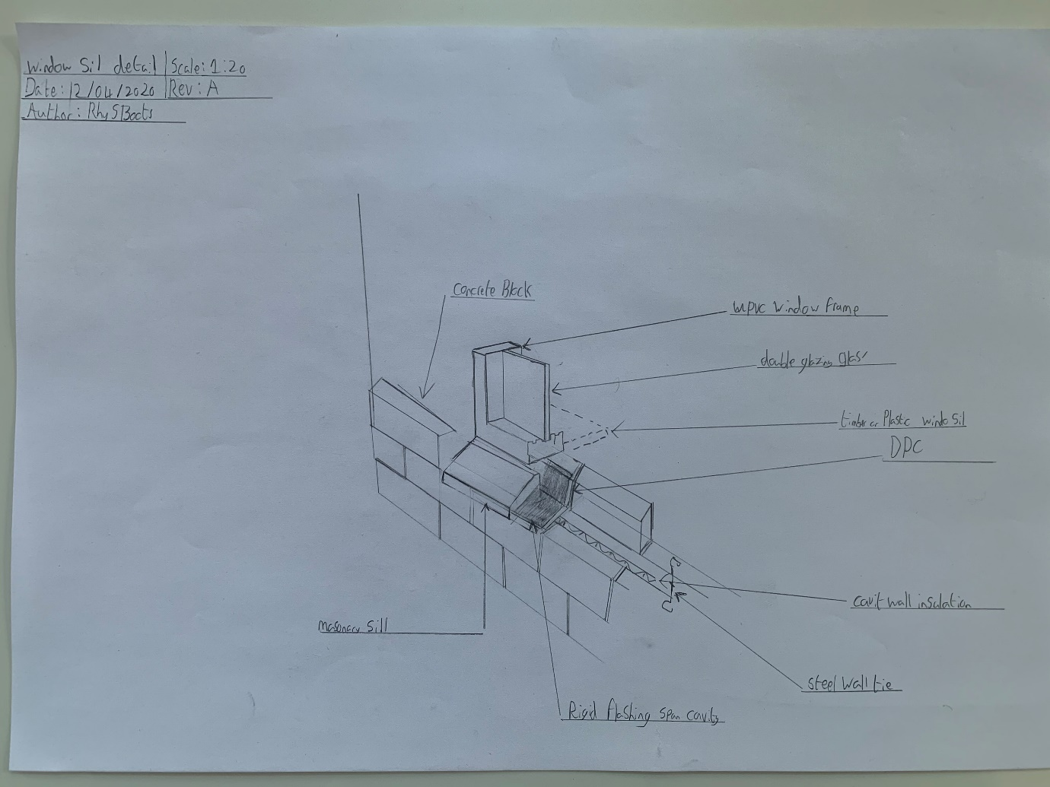

Appendix B Door Jamb detail
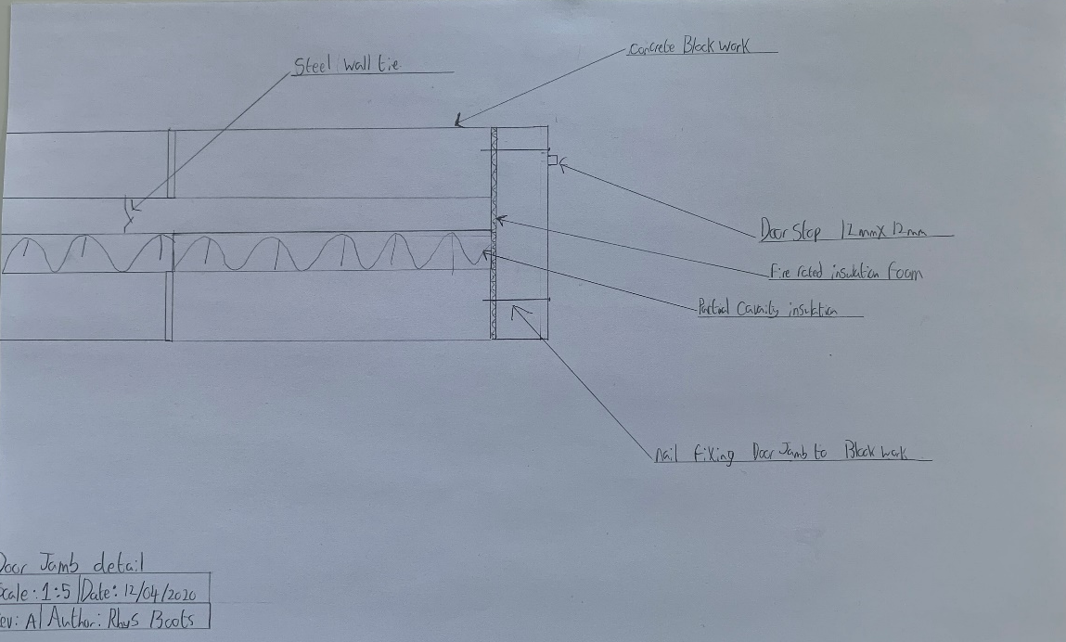

Appendix C Door Jamb and concrete lintel detail

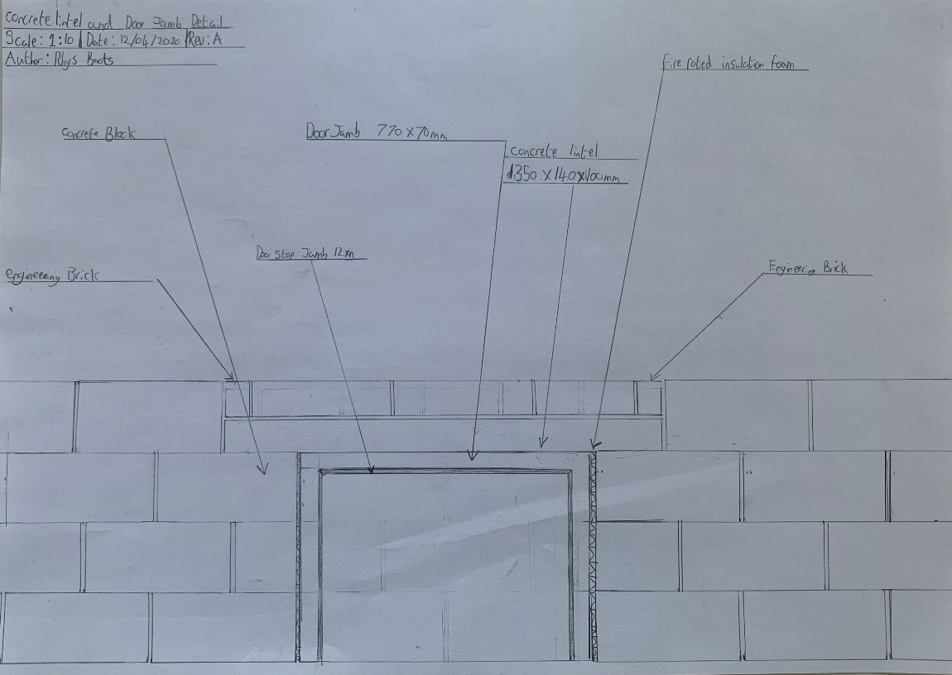

Appendix D Fixing dail for roof trusses 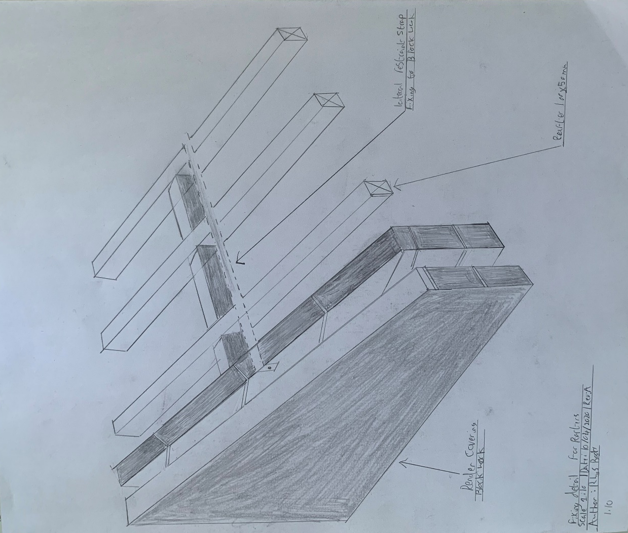

Appendix E Cross Section Detail of Roof elements
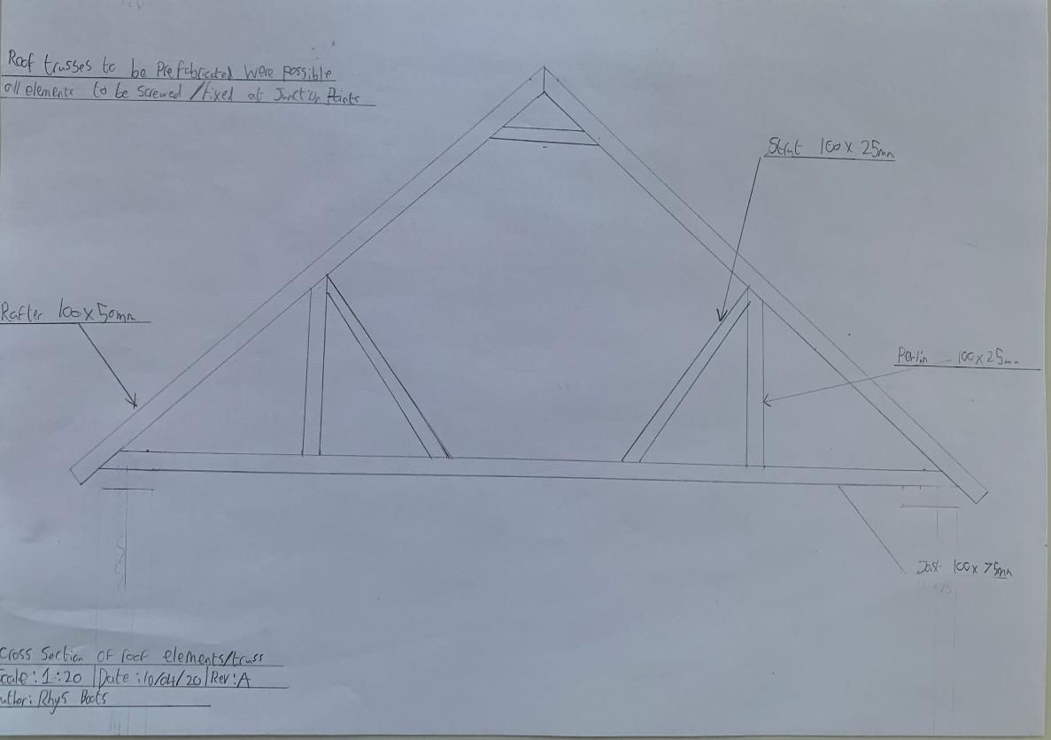

Appendix F Closed eavees cross section
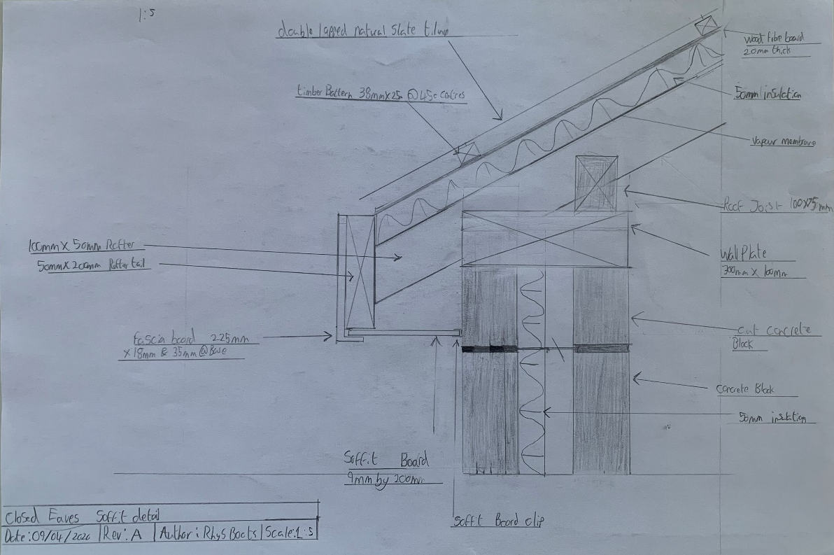

Appendix G Roofing detail
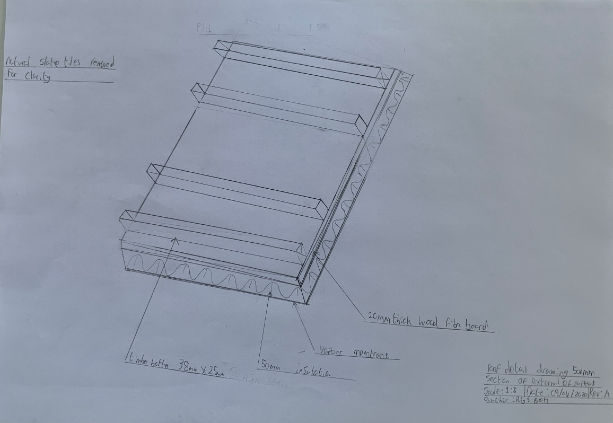

Appendix H Natural Slate tiles detail

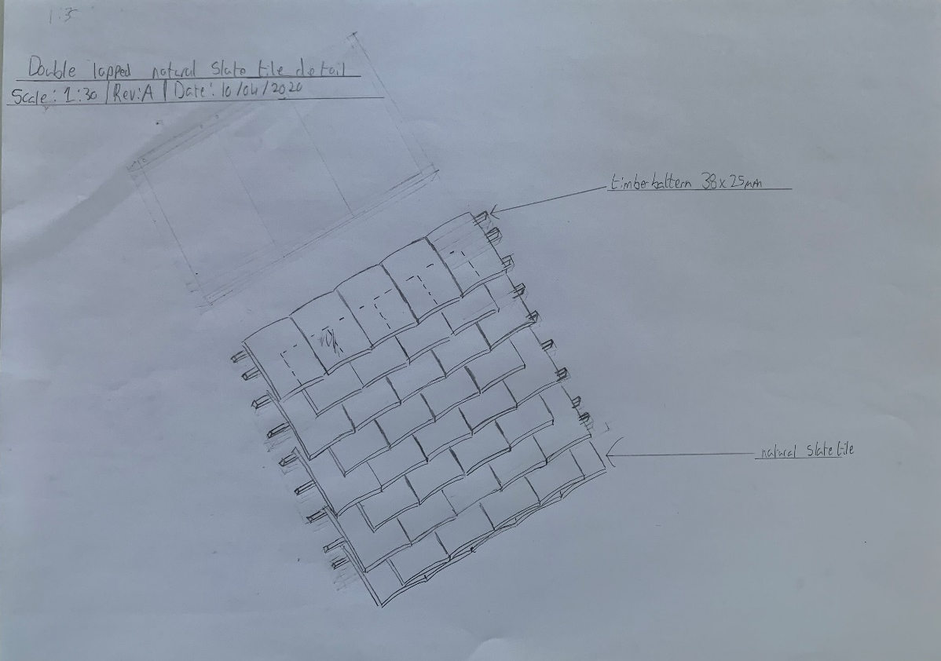

Appendix I Suspended timber flooring Cross section detail

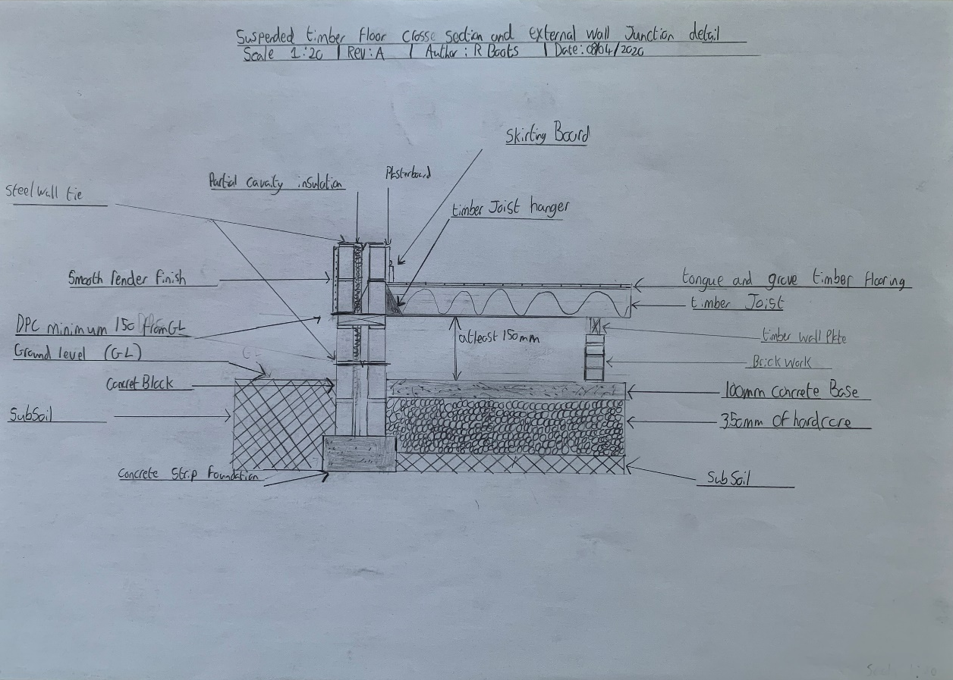

Appendix J Sleeper/hollow wall detail
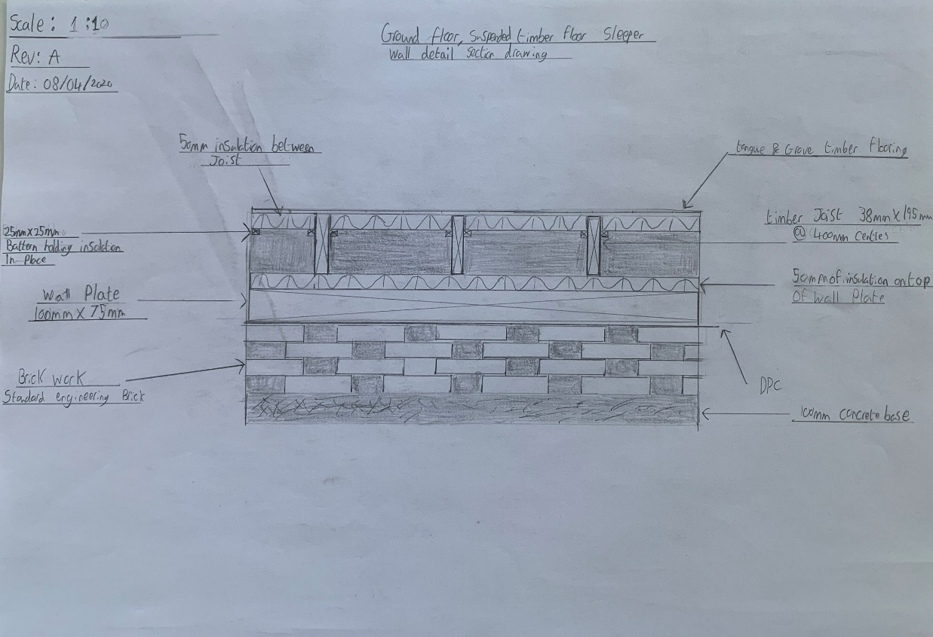

Appendix K Suspended timber floor fixing detail for 1st floor
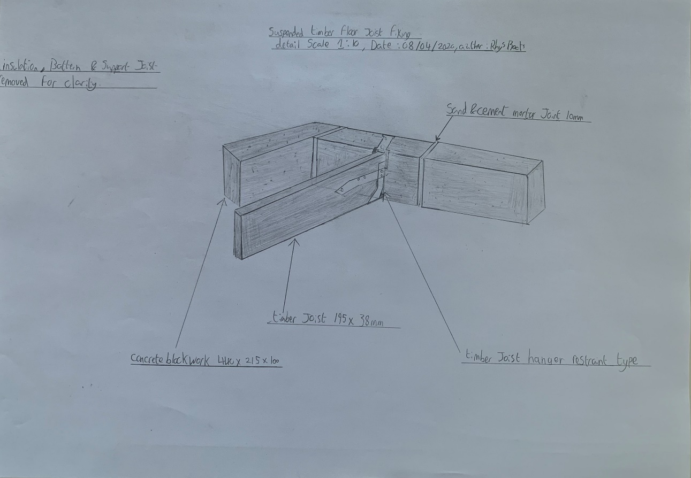

Appendix L 1ST Floor suspended timber floor detail.



