Login: Weebly
Email: ataur67@gmail.com
Password: Ar171066

Fig.1 Desktop View Home Page

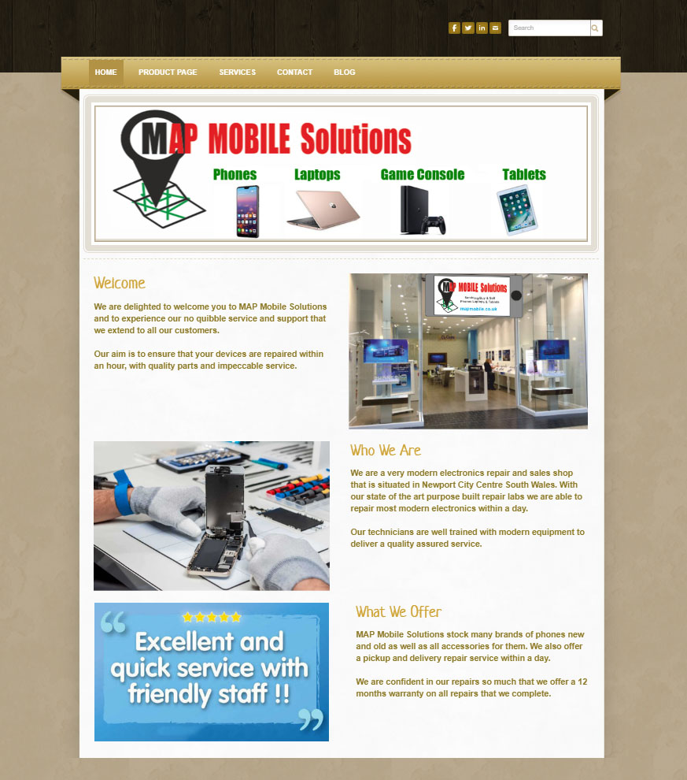

Fig. 2 Mobile View Home Page

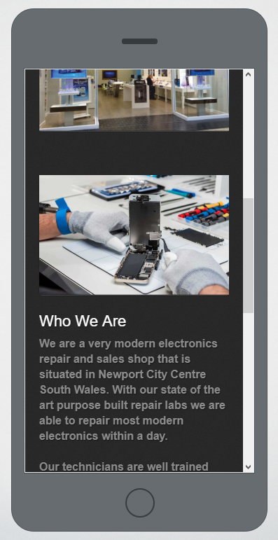

Web Design Aspects
Website visitors tend to find your homepage first and with that in mind my design was to keep it simple and visual. The design welcomes potential customers to the site and communicates to them exactly what our business does. As the homepage serves as a gateway to the site it is important to make a first impression.

This I did by keeping a simple intuitive navigation for the site as well as clearly marketing our business brand and image visually and expressing what exactly we do. Well-designed navigation schemes save time for online consumers leading to trust (Ganguly et al., 2010) and satisfaction (Yoon, 2002).

The visual design of a website is important because it improves website aesthetics and emotional appeal (Garrett, 2003), which in turn may culminate in positive attitudes (DeWulf et al., 2006) or trust (Cyr et al., 2009). A combination of product pictures and information on a website improves user recall better than text alone (Blanco et al., 2010).

Search Engine Optimisation (SEO)
SEO is based on the theory that people search with intent, rather than tolerating chance to influence their interests, and that by tracking keyword search referrals, web publishers can acquire a vision into the mind of the online audience (Enge et al., 2010).

SEO keywords are the keywords and phrases in our web page that make it likely for people to find our site via search engines. From the results of the variety of searches I conducted, I have included key words that repeatedly appeared for the SEO of our home page.
References

Blanco, C., Sarasa, R. and Sanclemente, C. (2010). Effects of visual and textual information in online product presentations: looking for the best combination in website design. European Journal of Information Systems, 19(6), pp.668-686.

Cyr, D., Head, M., Larios, H. and Pan, B. (2009). Exploring Human Images in Website Design: A Multi-Method Approach. MIS Quarterly, 33(3), p.539.

De Wulf, K., Schillewaert, N., Muylle, S. and Rangarajan, D. (2006). The role of pleasure in web site success. Information & Management, 43(4), pp.434-446.

Enge, E., Spencer, S. and Stricchiola, J. (2015). The Art of SEO. 3rd ed. Sebastopol, CA: O'Reilly Media.

Ganguly, B., Dash, S., Cyr, D. and Head, M. (2010). The effects of website design on purchase intention in online shopping: the mediating role of trust and the moderating role of culture. International Journal of Electronic Business, 8(4/5), p.302.

Garrett, J. (2011). The elements of user experience. Berkeley, CA: New Riders.

Yoon, S. (2002). The antecedents and consequences of trust in online-purchase decisions. Journal of Interactive Marketing, 16(2), pp.47-63.

