

BA (Hons)
Leadership and Management

DEVELOPING EMOTIONAL INTELLIGENCE SKILLS
(LCLM5006_LON)

Student Name: Janice P. Garcia
Student Number: 2334950
Session: February 2026 Term
Lecturer’s Name: Dr. Nishi Ramsurrun

Table of Contents
1
Introduction 3
Critical Evaluation of Emotional Intelligence in the Workplace 4
Self-Awareness 4
Self-Regulation 4
Motivation 5
Empathy 5
Social Skills 6
Comparison to Wiedmer and Goleman. 6
Critical Perspective 7
Integration of Bar-On’s EQ-i Model 7
Emotional Intelligence in Multigenerational Recruitment 9
Traditionalists (Silent Generation) 9
Baby Boomers 9
Generation X 10
Millennials (Generation Y) 10
Generation Z 10
Conclusion 11
Recommendations 11
References 13

Introduction
Emotional intelligence (EI) has become a fundamental concept and a central construct in organisational behaviour in understanding employee effectiveness and organisational performance. EI refers to the ability to perceive, understand, manage, and regulate emotions in oneself and others (Salovey and Mayer, 1990). It also defined broadly as the capacity to recognise, understand, and regulate emotions in oneself and others. In contrast to cognitive intelligence, EI focuses on interpersonal relationships, emotional regulation, and adaptability, which are essential in modern, dynamic workplaces (Cherniss, 2010).
Goleman’s (1998) model of emotional intelligence is widely applied in organisational contexts and identifies five key components: self-awareness, self-regulation, motivation, empathy, and social skills. Goleman’s model remains one of the most influential frameworks, proposing five interrelated competencies: These competencies are crucial for effective communication, leadership, and teamwork. Additionally, the Bar-On model expands this perspective by incorporating emotional and social competencies such as stress management and adaptability (Bar-On, 1997). This report critically evaluates how employees use emotional intelligence in the workplace and examines how managers can apply EI frameworks in recruiting employees from different generations. Wiedmer (2015) expands this conceptualisation by emphasising emotional expression, interpersonal sensitivity and adaptability, particularly within diverse and multigenerational workforces.

Critical Evaluation of Emotional Intelligence in the Workplace

Self-Awareness
Self-awareness refers to an individual’s ability to recognise and understand their own emotions and their impact on behaviour (Goleman, 1998). In the workplace, self-aware employees demonstrate improved decision-making, stronger interpersonal relationships, and enhanced performance (Boyatzis, 2009). For instance, employees who understand their emotional triggers can manage reactions during stressful situations, reducing workplace conflict and improving productivity (Cherniss, 2010).
From the Bar-On model, self-awareness aligns with intrapersonal competencies, including emotional self-awareness and self-regard (Bar-On, 1997). These competencies enable employees to assess their strengths and limitations realistically. However, self-awareness is not always effectively applied in practice. Employees may lack reflective skills or operate in environments that discourage openness and feedback (Matsumoto, 2006).
Furthermore, (MBWA) Management by Walking Around can support the development of self-awareness by encouraging informal feedback and interaction between managers and employees (Peters and Waterman, 1982). Despite its benefits, MBWA may be inconsistently applied, limiting its effectiveness. Therefore, while self-awareness is foundational to EI, its impact depends on organisational support and individual willingness to engage in reflection (Goleman, 1998).

Self-Regulation
Self-regulation involves controlling or redirecting disruptive emotions and maintaining emotional stability (Goleman, 1998). In workplace contexts, this competency is essential for managing stress, handling conflict, and maintaining professionalism (Gross, 1998). Employees with strong self-regulation contribute to a stable work environment and are better equipped to adapt to organisational changes (Cherniss, 2010).
Within the Bar-On model, self-regulation is linked to stress management and impulse control (Bar-On, 1997). Additionally, MBSR (Mindfulness-Based Stress Reduction) enhances self-regulation by promoting mindfulness and emotional control (Kabat-Zinn, 1990). Employees who practice mindfulness are better able to manage stress and maintain focus under pressure.
However, excessive self-regulation can lead to emotional suppression, which may negatively affect well-being and authenticity (Grandey, 2000). Employees who consistently suppress emotions may experience burnout and reduced job satisfaction. Therefore, organisations must balance emotional control with opportunities for expression, ensuring that employees maintain both professionalism and psychological well-being (Goleman, 1998).

Motivation
Motivation in Goleman’s model refers to intrinsic drive, commitment, and a passion for achieving goals (Goleman, 1998). Emotionally intelligent employees are often highly motivated, and is more inclined towards Herzberg motivational factors such as work satisfaction, work enhancement, job enlargement therein demonstrating resilience and persistence in the face of challenges (Ryan and Deci, 2000). This intrinsic motivation contributes to higher levels of engagement and performance.
The Bar-On model also incorporates motivation through general mood and optimism, as opined by Maslow in his pyramid of Hierarchy of needs which influence an individual’s outlook and persistence (Bar-On, 1997). In workplace settings, motivated employees are more likely to take initiative, seek feedback, and pursue professional development opportunities (Boyatzis, 2009) which contributes to a growth mindset.
However, motivation is influenced by organisational factors such as leadership, culture, and reward systems (Cherniss, 2010) and can be a dissatisfier as explained by Herzberg in his hygiene factors. Even employees with high emotional intelligence may become disengaged if they perceive a lack of recognition or support. Furthermore, excessive motivation may lead to work-life imbalance, particularly among high-performing individuals (Goleman, 1998). Therefore, organisations must create supportive environments that align individual and organisational goals to sustain motivation (Ryan and Deci, 2000).

Empathy
Empathy is the ability to understand and respond to the emotions of others, making it essential for effective teamwork and leadership (Goleman, 1998). Empathetic employees can build strong relationships, manage conflict, and create inclusive work environments (Mayer et al., 2008).
From the Bar-On perspective, empathy is part of interpersonal competencies, including social responsibility and interpersonal relationships (Bar-On, 1997). In addition, MBWA supports the development of empathy by encouraging direct interaction and communication between managers and employees (Peters and Waterman, 1982).
Furthermore empathy also presents challenges. Excessive empathy may lead to emotional exhaustion or compassion fatigue, particularly in roles involving high emotional labour (Figley, 2002). Additionally, empathy may result in biased decision-making if employees prioritise personal relationships over organisational objectives. Therefore, while empathy is critical, it must be balanced with objectivity and professional judgement (Goleman, 1998).

Social Skills
Social skills refer to the ability to manage relationships, communicate effectively, and influence others (Goleman, 1998). These skills are crucial for teamwork, leadership, and organisational success (Boyatzis, 2009). Employees with strong social skills can resolve conflicts, build networks, and foster collaboration.
The Bar-On model highlights interpersonal relationships as a key component of emotional intelligence, reinforcing the importance of social skills in organisational contexts (Bar-On, 1997). Additionally, MBWA enhances social skills by promoting informal communication and relationship-building (Peters and Waterman, 1982).
Nonetheless, social skills may vary depending on personality traits and communication preferences (Cain, 2012). The increasing use of digital communication may also limit face-to-face interaction, affecting the development of interpersonal skills (Twenge, 2017). Therefore, organisations must provide training and opportunities to develop communication competencies and accommodate diverse communication styles (Goleman, 1998).

Comparison to Wiedmer and Goleman.
While Goleman focuses on the theory of emotional intelligence and how it differs from one person to another, Wiedmer applied Emotional context to the individual and identify that Emotional intelligence or emotional quotient is a core skills that everyone inhibits however some individuals uses it and others supresses their emotions.

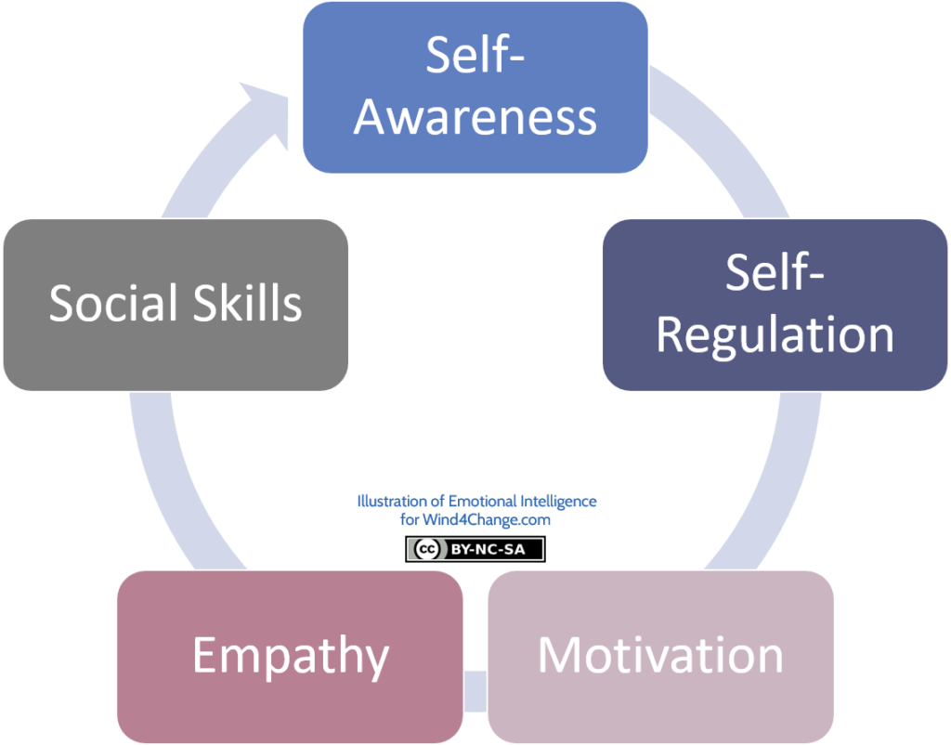

Source : Goleman Emotional Intelligence

Critical Perspective
Integration of Bar-On’s EQ-i Model
Bar-On’s model expands EI beyond emotional competencies to include stress management, adaptability, and general mood. These components provide a more holistic understanding of emotional functioning in the workplace.
• Intrapersonal skills (e.g., self-regard, emotional self-awareness) support confidence and self-reflection.
• Interpersonal skills (e.g., empathy, social responsibility) enhance collaboration and ethical behaviour.
• Adaptability enables employees to adjust to change, a critical skill in dynamic environments.
• Stress management supports resilience and prevents burnout.
• General mood influences motivation, optimism, and workplace morale.
Bar-On’s model provides a more comprehensive framework than Goleman’s, but critics argue that it overlaps significantly with personality constructs, raising questions about conceptual clarity.
2.5 Mindfulness-Based Stress Reduction (MBSR) and EI
MBSR is a structured programme that enhances emotional regulation, attention, and resilience through mindfulness practices. Research shows that mindfulness improves self-awareness, reduces stress, and enhances empathy. In the workplace, MBSR supports employees in managing emotional triggers, improving focus, and responding thoughtfully rather than reactively. However, MBSR requires sustained practice, and its effectiveness may vary depending on individual commitment and organisational support.
2.6 Management by Walking Around (MBWA) and EI
MBWA is a leadership approach that involves managers engaging directly with employees through informal interactions. This practice enhances social skills, empathy, and interpersonal sensitivity by enabling leaders to observe emotional cues, understand employee concerns, and build trust. MBWA operationalises EI by fostering open communication and psychological safety. However, MBWA may be perceived as intrusive if not implemented sensitively, highlighting the importance of emotional awareness in leadership behaviour.
3. EI Considerations in Recruiting Across Generations (≈1000 words)

Emotional Intelligence in Multigenerational Recruitment

Traditionalists (Silent Generation)
Traditionalists value stability, hard work, and loyalty, shaped by postwar economic conditions (Parry and Urwin, 2011). Their emotional intelligence is characterised by strong self-regulation and stress management (Bar-On, 1997). The cohort are very focus and career minded which makes them a good worker however tend to neglect their family to concentrate more on work loads
However, they may struggle with adaptability in modern workplaces (Twenge, 2017). Managers should use MBWA to assess their interpersonal skills and emotional maturity (Peters and Waterman, 1982).

Baby Boomers
Baby Boomers are career-oriented, responsible, and possess extensive knowledge (Lancaster and Stillman, 2010). Their emotional intelligence is strong in empathy and interpersonal relationships (Bar-On, 1997). Baby Boomers are often associated with strong interpersonal
Resistance to change may limit adaptability (Twenge, 2017). MBSR can support stress management, while recruitment should assess openness to learning (Kabat-Zinn, 1990).
Baby Boomers’ emotional intelligence is often rooted in experience, organisational loyalty, and traditional workplace values. Their EI development has largely occurred through long-term professional and social interactions, contributing to strong relationship management skills. According to Goleman, Boyatzis and McKee (2002), emotionally intelligent leadership is closely linked to experience, which positions Baby Boomers as effective in managing teams, resolving conflict, and building long-term trust.
In terms of self-awareness, Baby Boomers may demonstrate confidence in their emotional understanding, although they are sometimes less likely to openly discuss personal emotions due to generational norms around professionalism (Wiedmer, 2015). Their self-regulation is typically strong, as they are accustomed to hierarchical structures and formal workplace expectations, enabling them to control emotional expression in professional contexts.

Generation X
Generation X values work-life balance, independence, and technological competence (Parry and Urwin, 2011). Their emotional intelligence includes strong self-awareness and adaptability (Bar-On, 1997).
Their independence may limit teamwork (Goleman, 1998). Managers should assess collaboration using behavioural interviews and MBWA (Peters and Waterman, 1982). they may prefer maintaining professional boundaries rather than engaging in emotionally expressive interactions.
Regarding relationship management, Gen X tends to value direct communication, autonomy, and efficiency. They often demonstrate emotionally intelligent leadership through mentoring and practical support rather than overt emotional engagement (Lyons and Kuron, 2014). Critically, while their EI strengths lie in resilience and adaptability, they may face challenges in environments that require high emotional expressiveness or constant feedback, which are more aligned with younger generations’ expectations.

Millennials (Generation Y)
Millennials are tech-savvy, competitive, and focused on personal development (Twenge, 2017). They demonstrate adaptability and social awareness (Bar-On, 1997). Are often associated with a relatively high awareness and application of emotional intelligence (EI) IN the workplace. This generation has grown up in a more interconnected, feedback-driven, and collaborative environment, which has shaped how they develop and express EI competencies. Many millennials are comfortable reflecting on their emotions and seeking personal development through coaching, feedback and continuous learning. (Twenge,2010)
However, they may struggle with stress management (Schaufeli, 2013). MBSR can enhance resilience, while digital recruitment methods are effective (Kabat-Zinn, 1990). Millennials generally exhibit strong emotional intelligence characteristics, particularly in self-awareness, empathy, and collaborative relationship management. These strengths are accompanied by challenges that require balanced development, especially in adapting to different communication styles and organisational cultures.

Generation Z
Generation Z is pragmatic, financially cautious, and prone to anxiety (Twenge, 2017). Their emotional intelligence includes self-awareness but weaker stress management (Bar-On, 1997).
Recruitment should focus on supportive environments and mindfulness approaches (Kabat-Zinn, 1990). MBWA can help build trust and assess interpersonal skills (Peters and Waterman, 1982). In terms of self-regulation, Gen Z faces a mixed landscape. On one hand, access to digital tools (e.g., mindfulness apps, online therapy resources) can support emotional management. On the other hand, the immediacy of digital communication and exposure to online pressures may contribute to anxiety and reduced emotional control in high-stress situations (Twenge, 2017). This suggests that while Gen Z is aware of emotions, regulating them consistently can be more complex.

Gen Z also shows strong social awareness and empathy, particularly regarding social justice, diversity, and inclusion. They are often described as values-driven and globally conscious, demonstrating concern for societal issues such as climate change and equality (Francis and Hoefel, 2018). These traits align with EI competencies such as empathy and understanding others’ perspectives.

Conclusion
Emotional intelligence is essential for effective workplace performance and recruitment, particularly in multigenerational organisations (Goleman, 1998). Each generation demonstrates unique emotional competencies, requiring tailored recruitment strategies (Parry and Urwin, 2011). The integration of Goleman’s model with Bar-On, MBSR, and MBWA provides a comprehensive framework for evaluating and developing emotional intelligence (Bar-On, 1997). While EI offers significant benefits, it must be supported by organisational practices and balanced with other factors to ensure effectiveness (Schaufeli, 2013).
In conclusion, emotional intelligence is not uniformly distributed across generations but is instead shaped by contextual and developmental factors. Organisations that recognise and integrate these diverse EI strengths are better positioned to foster collaboration, enhance leadership effectiveness, and improve overall organisational performance. Developing inclusive strategies that encourage mutual understanding and continuous EI development across all age groups remains essential in today’s multigenerational workforce.

Recommendations
Organisations should integrate EI development into leadership training, performance management, and employee well-being programmes. Implementing MBSR initiatives can enhance self-awareness, stress management, and resilience, while MBWA can strengthen communication and trust. Recruitment processes should be tailored to generational preferences, using emotionally intelligent communication to build rapport and reduce anxiety. For Traditionalists and Baby Boomers, personalised and structured communication is essential; for Generation X, transparency and autonomy are key; for Millennials and Generation Z, digital fluency and psychological safety are critical. Organisations should also adopt EI-based assessment tools, such as the EQ-i, to evaluate emotional competencies during recruitment and development. The concept of continuous improvement in organisations such as the use of TQM Total quality management , Kaizen and just in time strategy can be implemented. Finally, fostering an inclusive culture that values empathy, adaptability, and collaboration will support long-term organisational success.
While Goleman’s model provides a comprehensive framework, it has been criticised for overlapping with personality traits and lacking clear measurement criteria (Landy, 2005). Furthermore, emotional intelligence alone cannot fully explain workplace performance, as organisational culture, leadership, and structural factors also play significant roles (Cherniss, 2010).
Nevertheless, integrating EI with models such as Bar-On, MBSR, and MBWA provides a more holistic approach to understanding and applying emotional intelligence in the workplace (Schaufeli, 2013). This integration enhances both individual and organisational effectiveness.

References
Bar-On, R. (1997) The Emotional Quotient Inventory (EQ-i): Technical Manual. Toronto: Multi-Health Systems.
Goleman, D. (1995) Emotional Intelligence: Why It Can Matter More Than IQ. New York: Bantam Books.
Kabat-Zinn, J. (2003) ‘Mindfulness-based interventions in context’, Clinical Psychology: Science and Practice, 10(2), pp. 144–156.
Peters, T. and Waterman, R. (1982) In Search of Excellence. New York: Harper & Row.
Wiedmer, T. (2015) ‘Generations do differ: Best practices in leading traditionalists, boomers, and generations X, Y, and Z’, The Delta Kappa Gamma Bulletin, 82(1), pp. 58–63.
Salovey, P. and Mayer, J. (1990) ‘Emotional intelligence’, Imagination, Cognition and Personality, 9(3), pp. 185–211.
Cherniss, C. (2010) ‘Emotional intelligence: Toward clarification of a concept’, Industrial and Organizational Psychology, 3(2), pp. 110–126.

