Database-Driven Website
Databases and Application Development
WON17834179 (Michelle Wong) 27/05/2021
2021
Contents
Website Security 2
Appendix 4
Website Demo 4
Bibliography 16

Website Security
For this document, this will be an overview of the security issues that would need to be considerate about if the website that I have made would be designed to go live as a website on the internet.
The security issues that the website could come across when it comes live would be injections, broken authentication, sensitive data exposure, XML external entities, broken access control, security misconfiguration, cross-site scripting XSS, insecure components with known vulnerabilities and insufficient logging and monitoring. Now will discuss some of them in more detail on what they do to the website.
The first issue that will be discussed would be injections, this is a vulnerability that will allow the user to go into the database and interfere with the queries. This will allow the hacker to be able to see the data that should not be able to get at all. The data can include users such as the admin which most likely will be able to all the information in the database/website. This will allow the hacker to be able to edit data on the website/database or even delete the data to change the application.
[1]
The second issue that would be discussed would be broken authentication; this vulnerability is mainly aiming for taking over accounts that are connected to the website/database and taking over the attacked user’s account. This means the authentication is broken when the attacks as the attacker can use people’s passwords and other details can be used/changed.
[2]
The fourth issue is broken access control, this is when the attacker can go into the database and that they can change the data for a user account enabling them to be able to access anything or do anything to the data on the website/database, also they are able to act as a user without being logged in at all or can act as admin but logged in as a user.
[3]
The firth issue is insufficient logging and monitoring, this is when logging and monitoring is lacking within a database/website and if the attacker notices this, this will allow the attack to be able to go into the website/database and do what they need to do in it but however, with the insufficient monitoring and logging, they are able to achieve what they need to do without being detected and handled properly.
[4]
The fourth issue is using components with known vulnerabilities, if the website/database is using something on the website that may require a third party, this could cause vulnerabilities for the website as attackers will use a script to look through the website for vulnerabilities and that will enable the attack to exploit the weaknesses in the system
[5]
The firth issue is cross-site scripting (XSS), this is an injection which has a malicious script within it and that it is implemented into a website that will send the malicious script, but the users that are using the website will only see it as a normal web application. The user who gets the script will not know if it malicious or not and that this will make them execute the script, and the script will then be able to access things that they should not be allowed to such as cookies etc.
[6]
The security measures that have only been taken on my website is that whenever any other users decide to login, who is not the admin, they are not able to see the users and they are not able to edit or do any other things that the admin is able to do, this is to stop from people who login into the system to not be able to edit the database or delete anything from the database.
The security for the website will need multiple things to be implemented and done to stop hackers from the website/database. First, to always make sure that the software to put up and keep up the website. Keeping software’s and other things that are connected to the website made sure to be updated because it will patch up the vulnerabilities which will stop hackers from being able to abuse them.
Secondly, there are SQL injection attacks that will allow the hacker to be able to gain access to the website/database and change the data in it. Ways to fix this problem would be that parameterising the query which will stop the hacker from changing the URL parameter. Another attack that the website should be projected from would be XSS attacks, this attack will put malicious script into the website then it will run in the background taking data and changing the contents on the page. To protect the website from this would be using a tool that will limit how and what JavaScript can be executed onto the website.
Thirdly, proper validation for both sides such as the website and the database that is connected to the website. Both things can be bypassed easily, users probably be able to enter numbers into a text field and leave out blanks when there should be text having to be added into it which is why validation is a very important security that should be implemented to the website as it will stop misinformation to being added to the website/database.
Finally, checking passwords of each of the users that can login into the website would be that each of the passwords should follow a rule such as 8 characters, signs, numbers and that it should be stored as encrypted values.
[7]

Appendix

Website Demo
Login as Admin
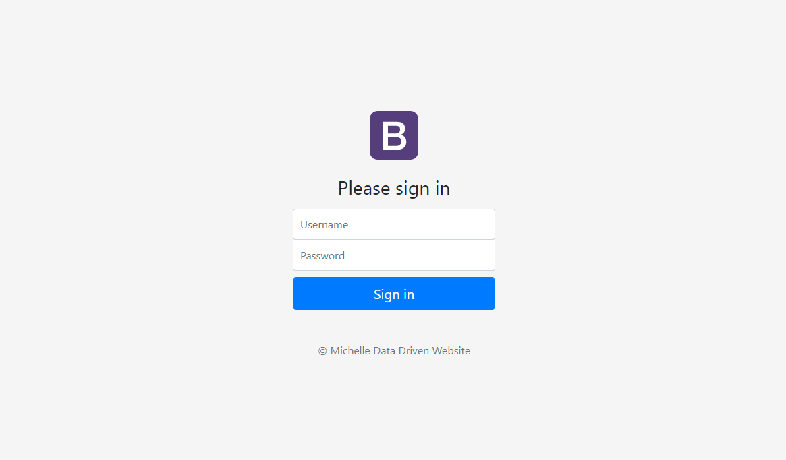
Homepage (Admin)
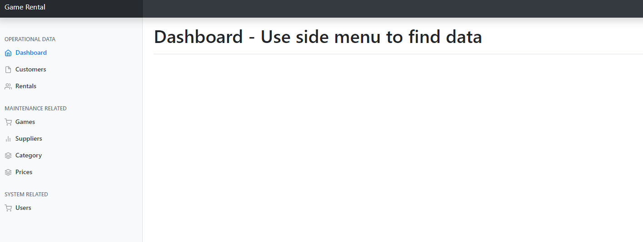

Customer (Admin)
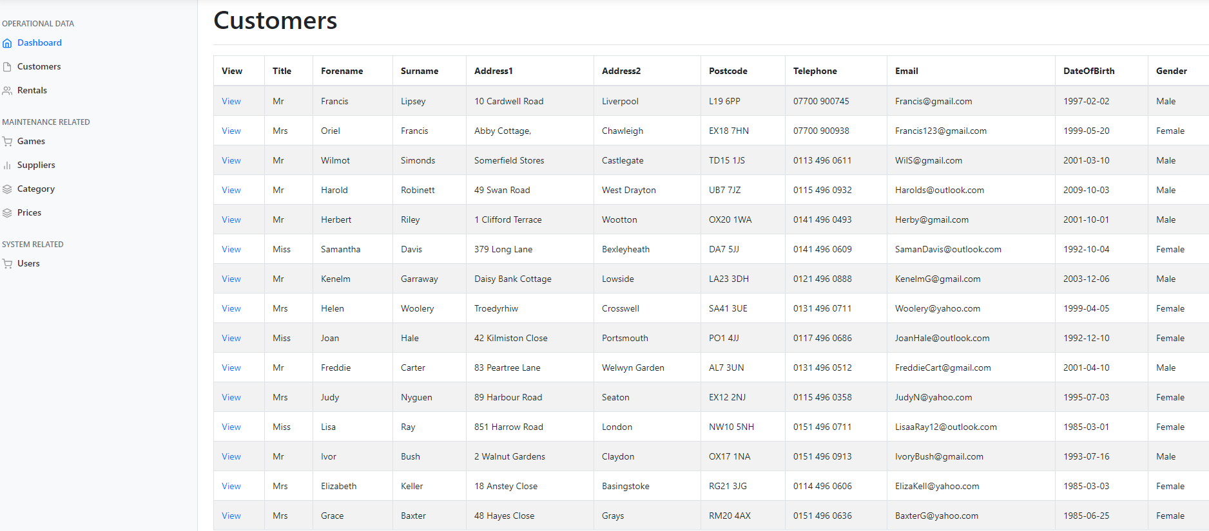
View Customer Details (Admin)
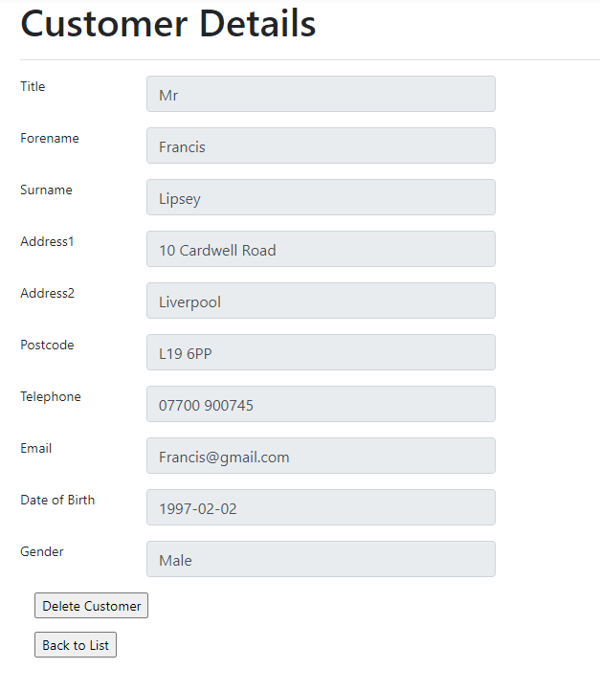

Delete Customer Francis Lipsey (Admin)
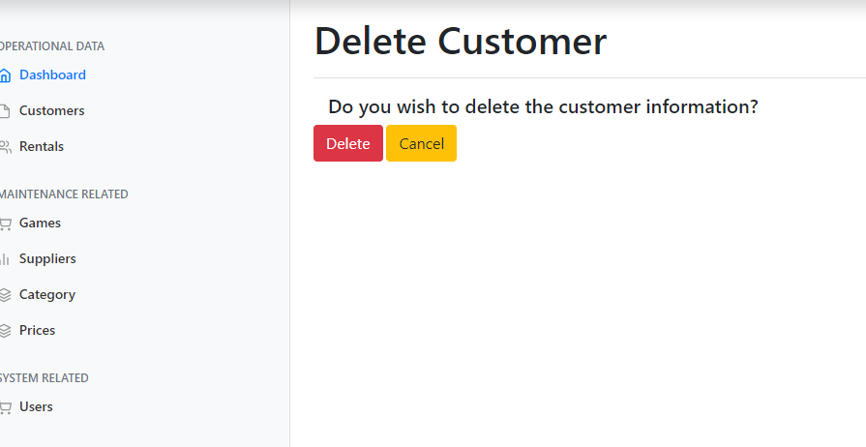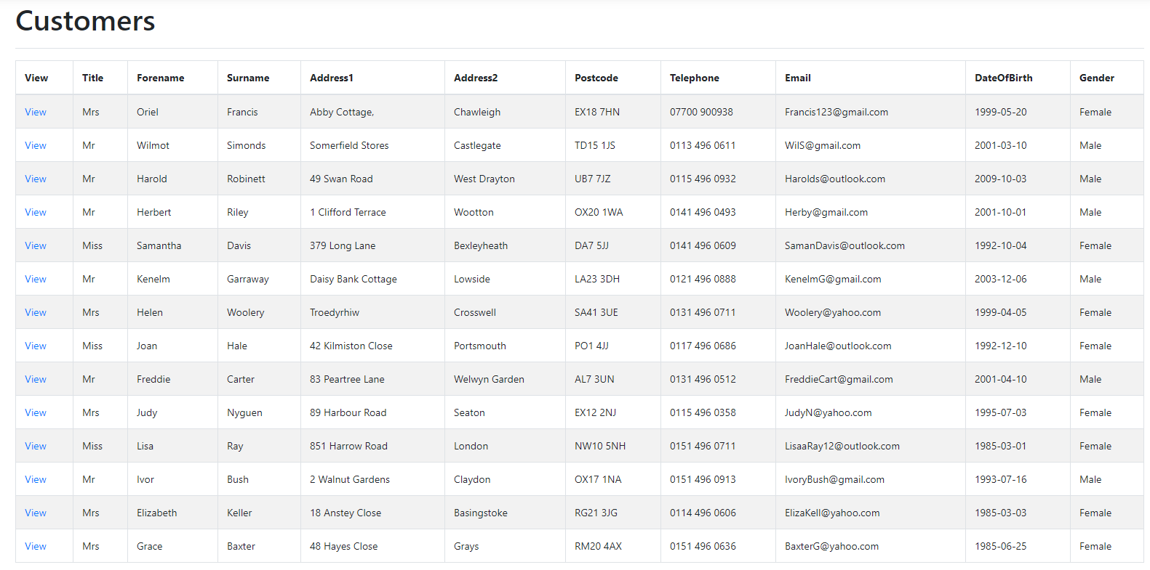
Rental (Admin)
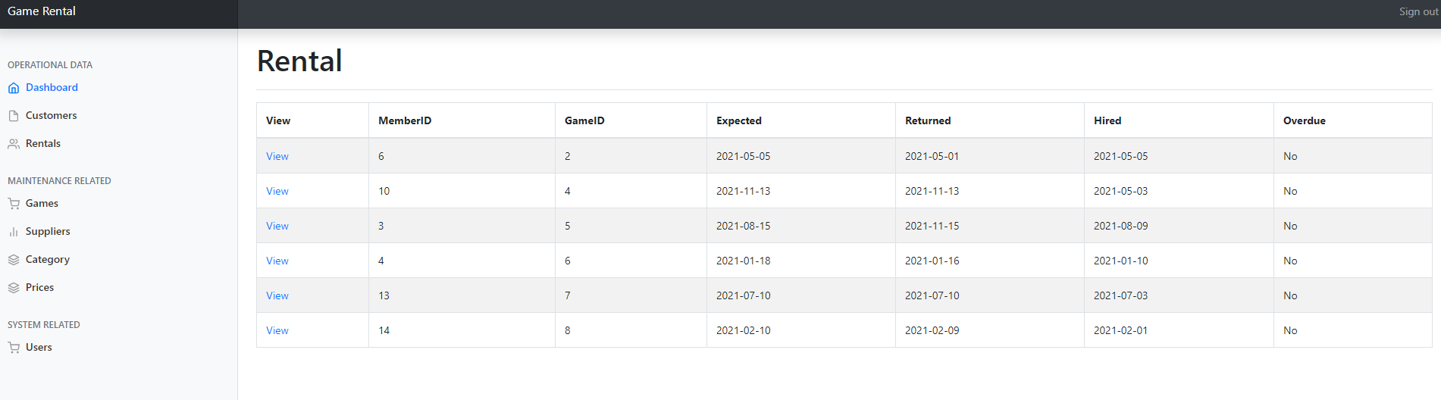

View Rental (Admin)
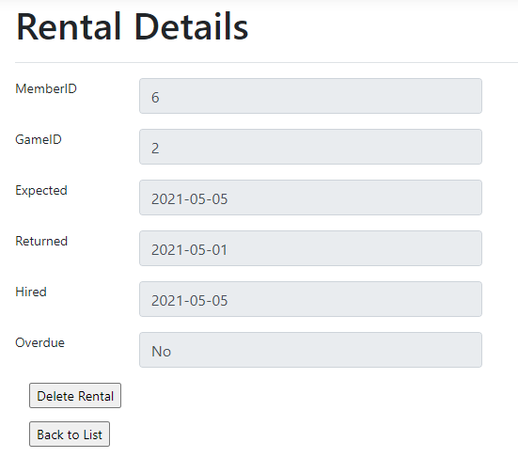
Delete Rental (Admin)
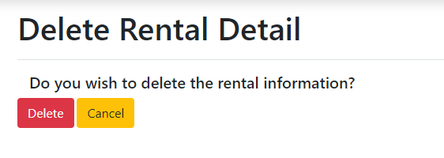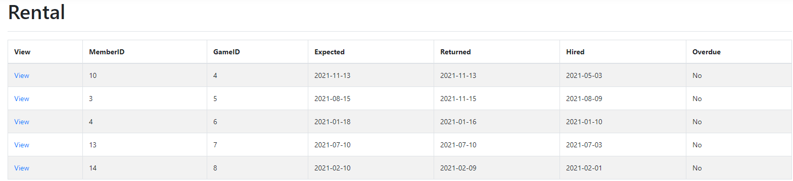

Games (Admin)
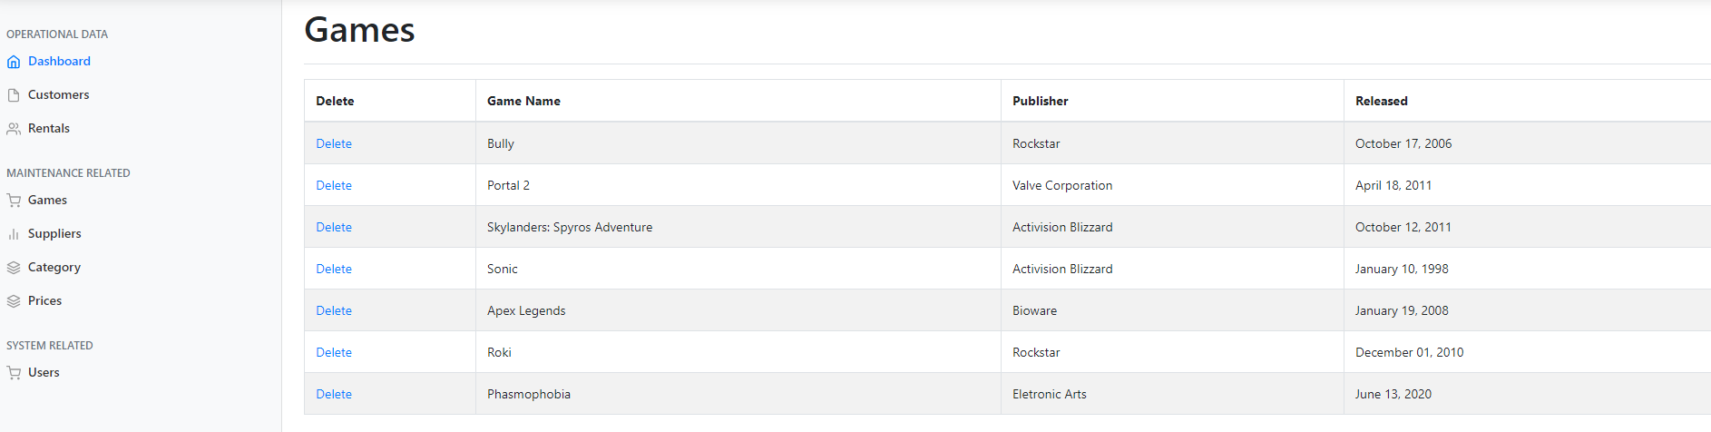
Delete Game (Admin)
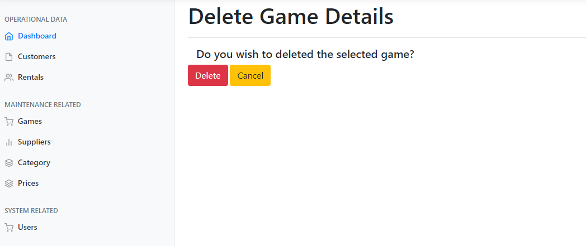
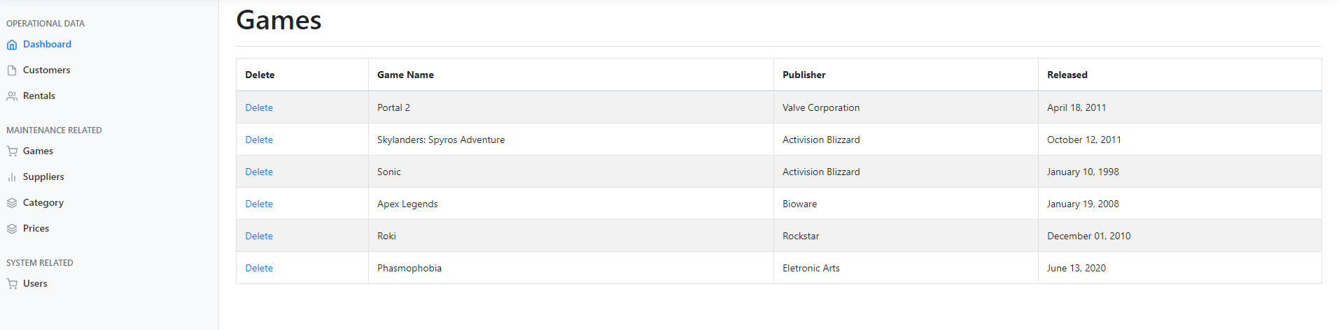

Supplier (Admin)
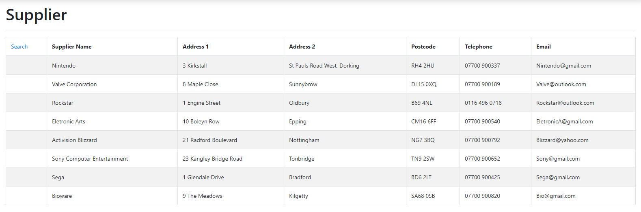
Supplier Search (Admin)
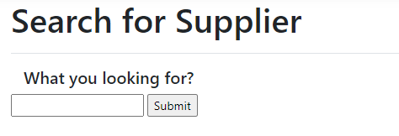
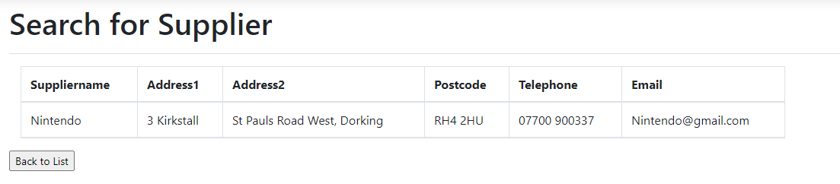

Category (Admin)
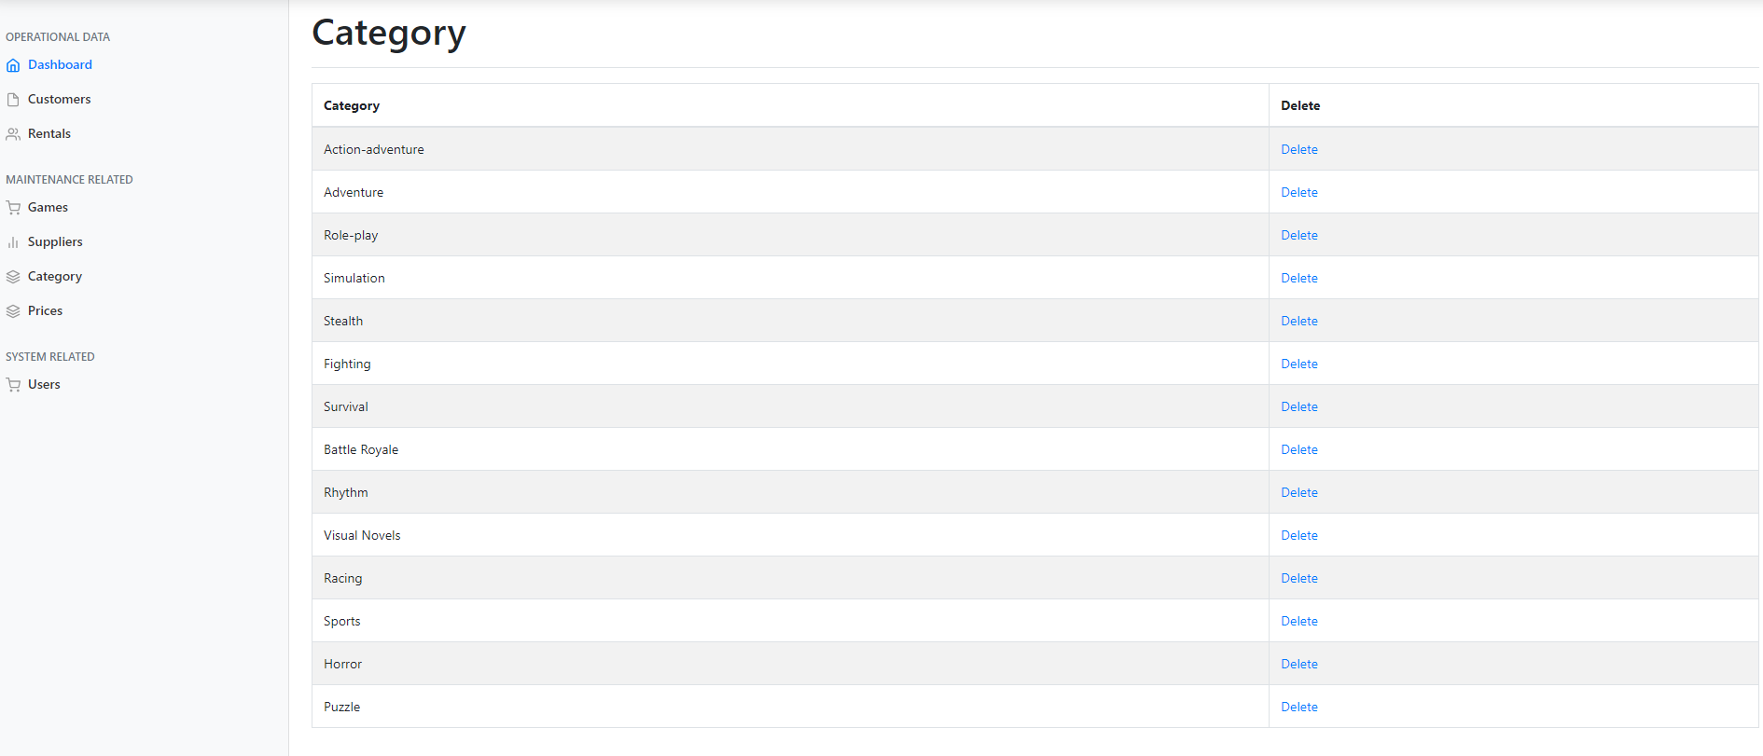

Category delete (Admin)
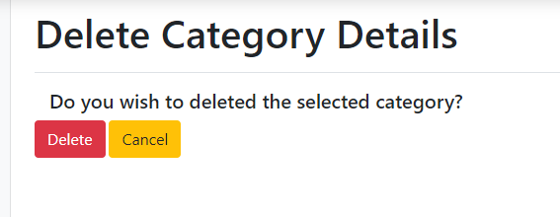
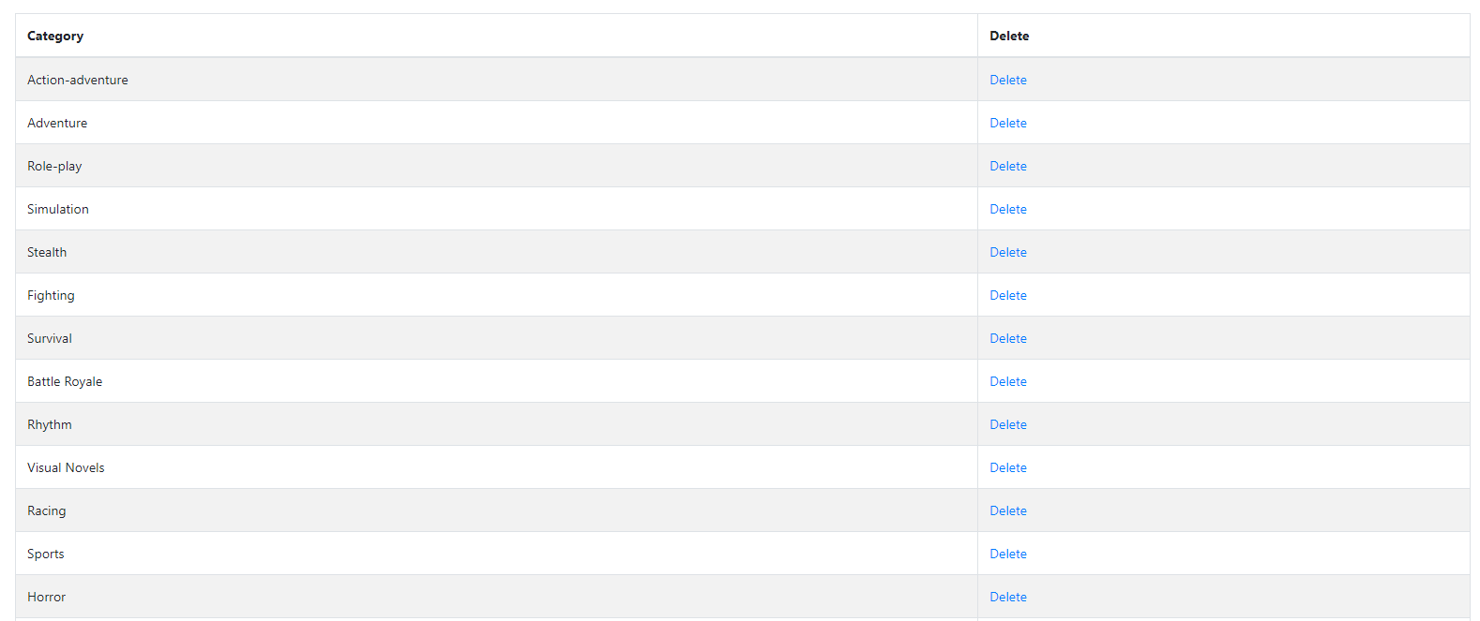
Price (Admin)
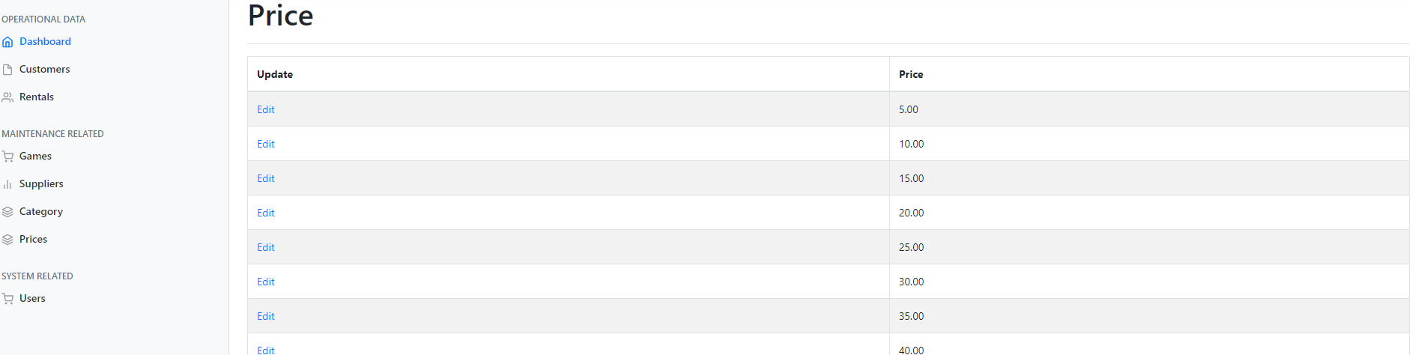
Price Update (Admin)
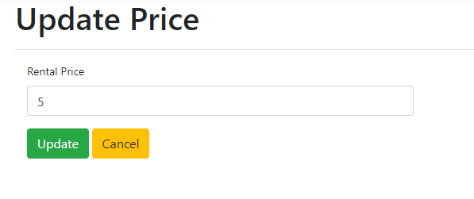
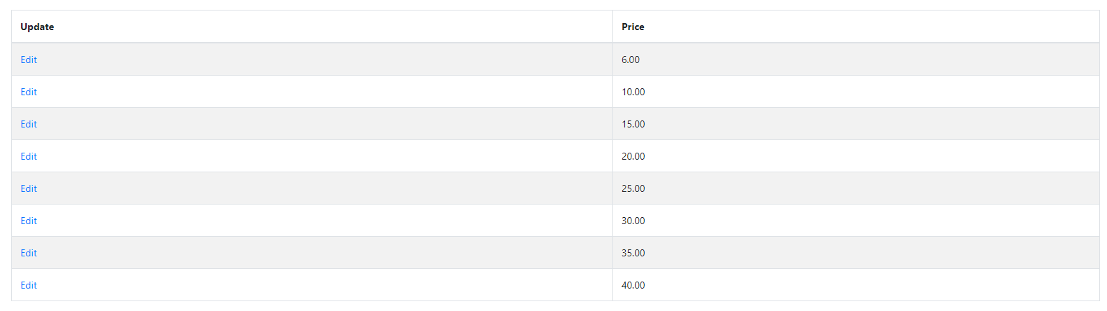

Users (Admin)
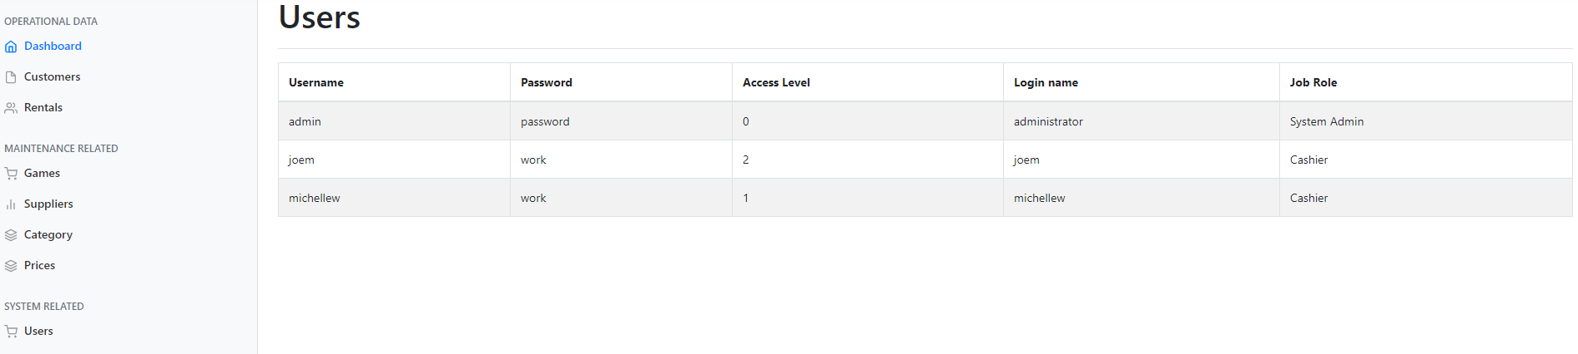

Homepage (Other User, joem)
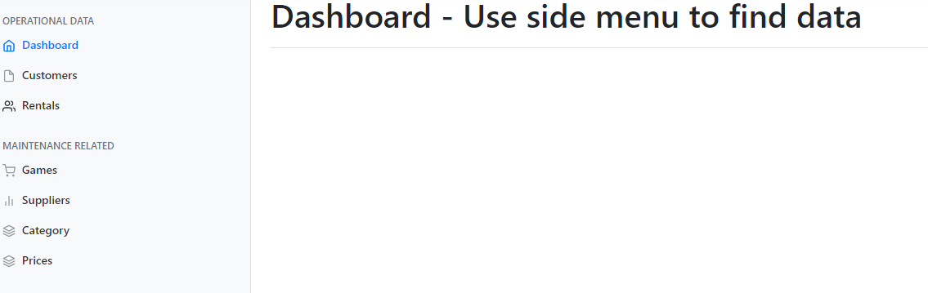
Customers
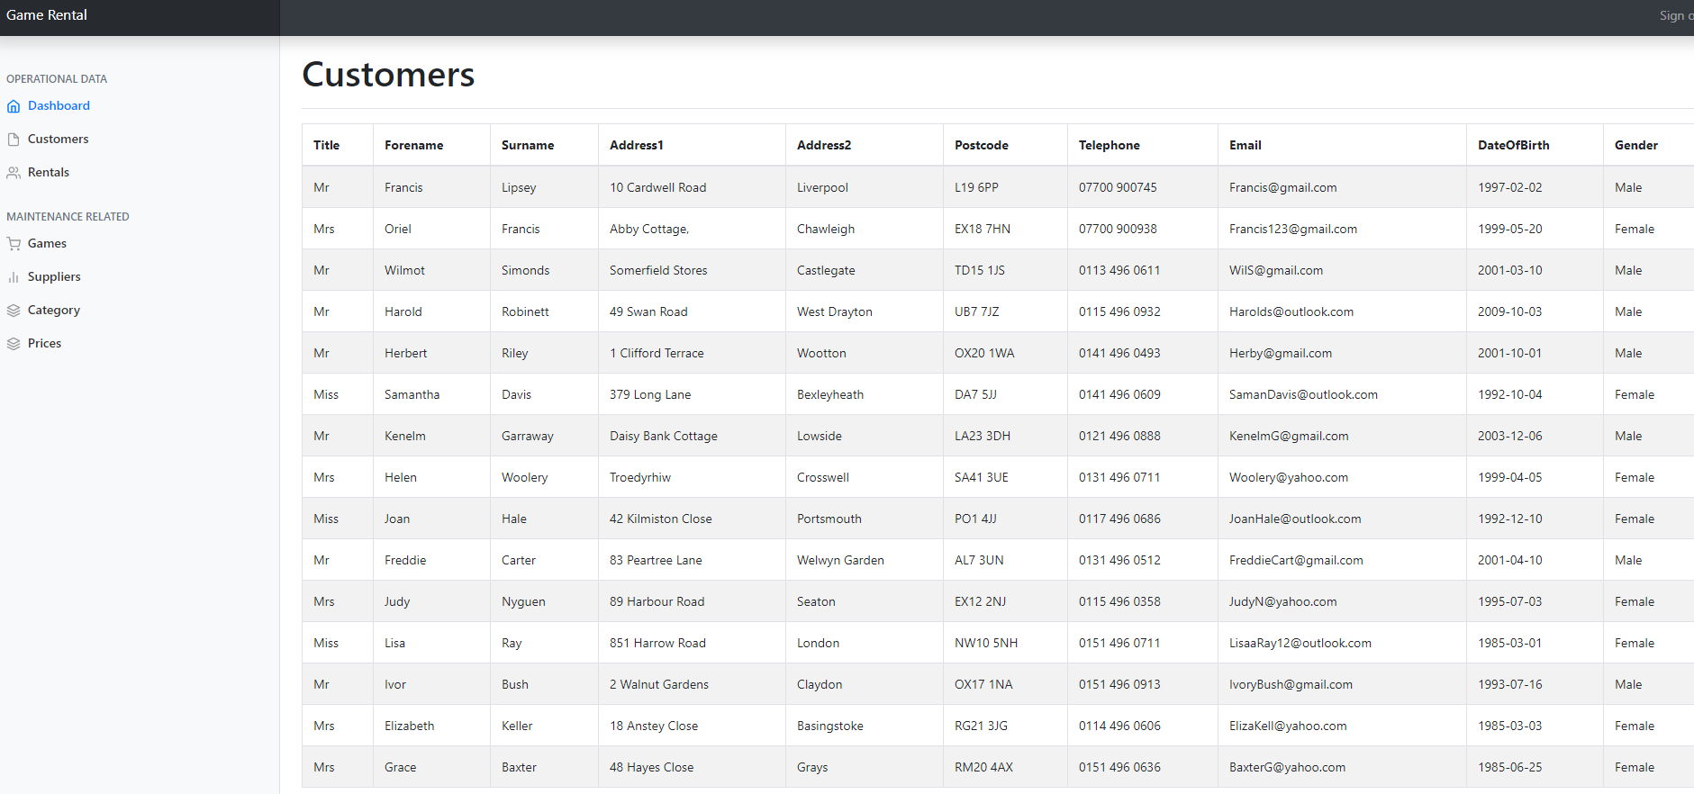
Rentals (Other User, joem)
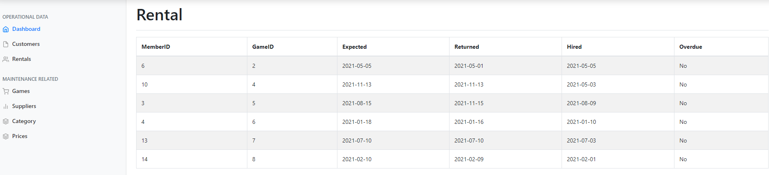
Games (Other User, joem)
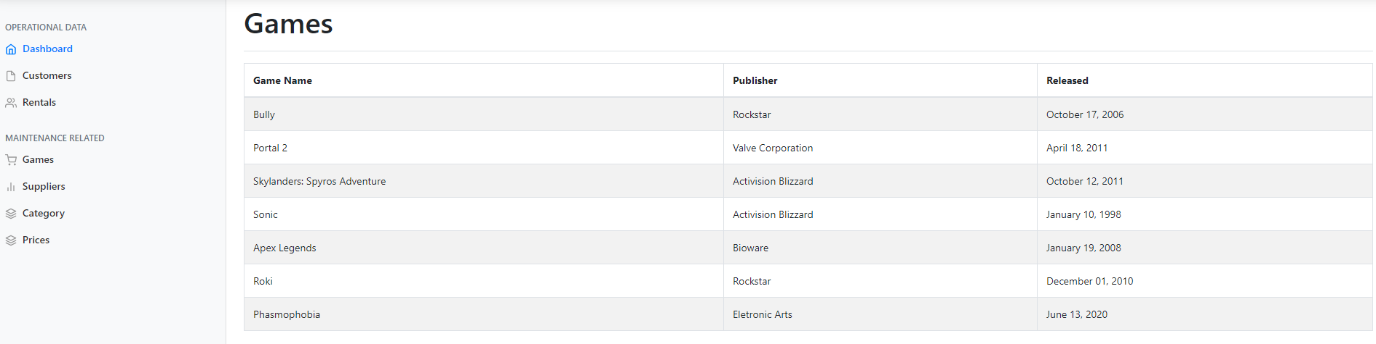
Suppliers (Other User, joem)
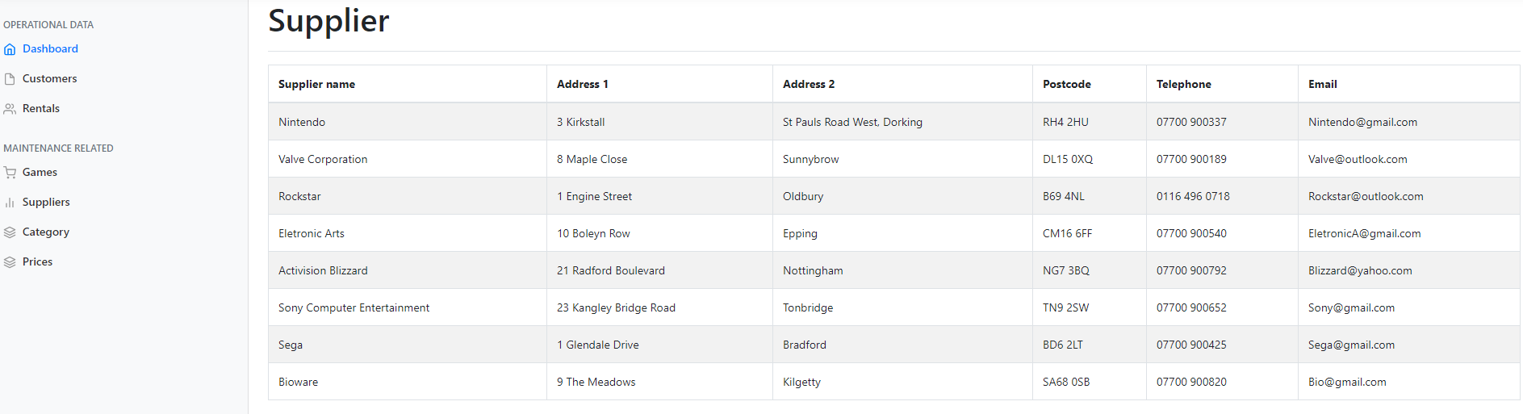
Category (Other User, joem)
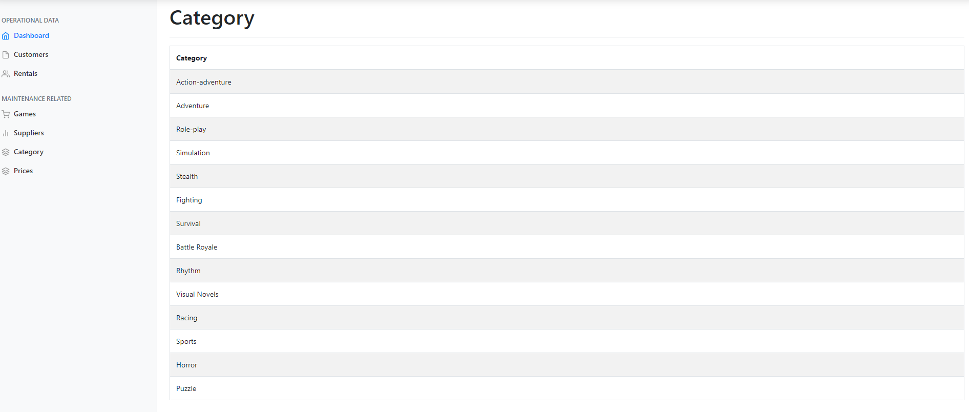
Prices (Other User, joem)
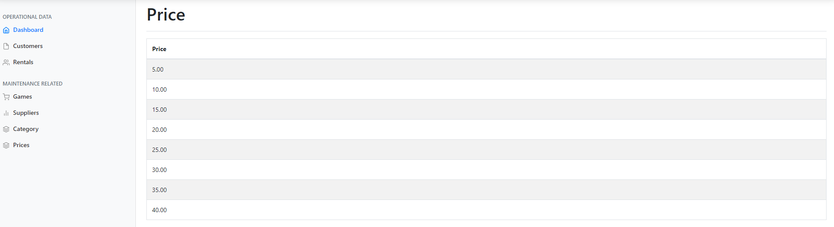

Login (Another user, MichelleW)
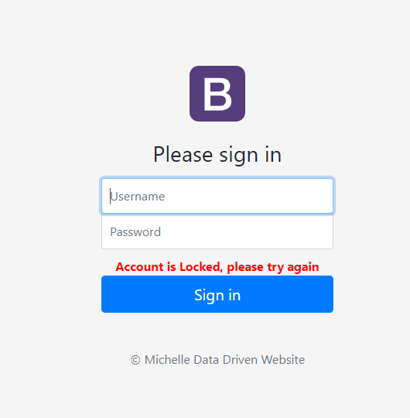

Bibliography

[1] | “PortSwigger,” [Online]. Available: https://portswigger.net/web-security/sql-injection.
[2] | “Contrast Security,” [Online]. Available: https://www.contrastsecurity.com/knowledge-hub/glossary/broken-authentication.
[3] | “Hdiv,” [Online]. Available: https://hdivsecurity.com/owasp-broken-access-control.
[4] | “owasp,” [Online]. Available: https://owasp.org/www-project-top-ten/2017/A10_2017-Insufficient_Logging%2526Monitoring.
[5] | “Security Boulevard,” [Online]. Available: https://securityboulevard.com/2020/04/using-components-with-known-vulnerabilities-2/.
[6] | “owasp,” [Online]. Available: https://owasp.org/www-community/attacks/xss/.
[7] | “Creativebloq,” [Online]. Available: https://www.creativebloq.com/web-design/website-security-tips-protect-your-site-7122853.
[8] | “Dropbox,” [Online]. Available: https://www.dropbox.com/s/42s8mse7ts32hys/index.php?dl=0.

