Student Name: Alexandru Badea  Student ID: 2208275  Module Title: Foreign Languages & Cultural Awareness  Module Code: BMIH5003  Lecturer: Heidi Prosser  Date: 02.02.2024 | 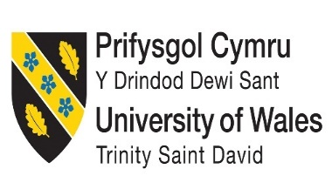

ASSIGNMENT 1: PORTFOLIO

Component 1: Professional Reflection

Scenario
The increasing rate of globalisation caused due to the rise and growth of the tourism industry has led to several instances of misunderstanding between the staff members of a hospitality-based company and foreign guests visiting the company. Since I am a food and beverage employee at Ritz Hotel, situated in London, I have faced several challenges while serving guests belonging from different cultural backgrounds. I was born and brought up in Newcastle, England, my native language is English. Therefore, there were many instances where I had to work with customers who were not fluent in English. For example, on one occasion while I was serving a French guest, there was a huge communication gap between us. This resulted in me serving the guest with a wrong order due to me not properly understanding the requirements of the person. The customer was quite dissatisfied with my service and started screaming at me and this made it quite uncomfortable for me. One other instance of such an occurrence was when a Belgian customer asked for something and I could not properly adjust with the cultural habits of the person as the lifestyle led by the customer was quite unfamiliar for me. The customer asked for their dinner to be served quite late at night and since it was against the hotel policy to serve food at that time, there was a dispute which my manager had to resolve. These instances are quite common due to the misunderstandings caused by the differences in cultural diversity.

Potential reasons for misunderstanding within the hotel industry
Due to the lack of employment of candidates from several different cultural backgrounds, the instances of misinterpretation of information are quite high. Since individuals belonging from other cultural origins are not familiar with the cultural habits of the staff of the hotels can affect the communication process and customer satisfaction levels of the foreign guests (Christiansen et al., 2020). Another reason for this communication gap is that individuals often stereotype guests from various backgrounds and may judge the preferences of the customers based on that stereotype. This can also annoy the customers as they may feel stereotyped and may lack the will to procure their stay at the hotel.

Mitigation techniques required to prevent misunderstanding
These challenges caused by cultural differences can be resolved by developing a certain set of skills. After these occasions, I have started studying and developing other European languages such as French, German and Spanish. This would aid to enhance my communication skills and effectively improve my ability to deal with foreign guests. Another skill that might aid me to serve guests from other cultural backgrounds is to have an open mind (Deresky, 2017). Prior judgement based on stereotypes can lead to occurrences of racism and discrimination. Therefore, having an open mindset can aid me to relegate such instances of racism and cultural discrimination. This can also result in high levels of customer satisfaction. Adaptability is also crucial when it comes to dealing with foreign clients. After effectively observing the cultural habits of a guest I will have to adapt accordingly to provide a much more personalised service to the guests (Gregor et al., 2021).
References
Christiansen, B., Branch, J.D. and Karmowska, J. (2020) Cultural Factors and Performance in 21st Century Businesses. Hershey: IGI Global.
Deresky, H. (2017) International Management: Managing Across Borders and Cultures: Text and Cases. 9th Ed. Harlow: Pearson Education Ltd.
Gregor, M.A., Weigold, I.K., Wolfe, G., Campbell-Halfaker, D., Martin-Fernandez, J. and Pino, H.V.G.D., (2021). Positive predictors of career adaptability among diverse community college students. Journal of Career Assessment, 29(1), pp.115-128.

Component 2: Training Plan

Identified cultural misunderstanding
Miscommunication among personnel who have different cultural backgrounds can have a huge effect towards the hospitality industry. Additionally, cultural misunderstanding may accelerate differences in presenting values between the employees and the customers within the business industry. Nevertheless, the fundamental factors that would be beneficial for the staff to understand the aspect of cultural awareness are discussed below.
Training plan
Objective | Strategies | Advantages | Time-frame
Addressing linguistic barriers | Proper language training is required to eliminate the problems that may arise in the multi-language workforce. Educating the employees of the workforce regarding cultural differences can make them realise to reduce the conflict (Rosa and Flores, 2023). Apart from that, using ordinary language can pre-emptively reduce a lot of issues that may cause by linguistic barriers. | Recognising cultural differences to overcome language barriers boosts the communication in workplace. Along with that, improved communication can also help to foster the standard of the organisation. Cultural awareness will be improved which also makes the business flexible. Apart from that, being capable of connecting with customers in their preferred language also add value towards the customer’s satisfaction. | 4 months will be sufficient to overcome the linguistic barriers in the workforce.
Eliminating stereotypes skills | Education, as well as an awareness training program, is the foremost factor that can combat stereotyping in the workforce. Organisations must establish knowledge through training on insensible biases and the consequences of stereotypes (Braslauskas, 2023). Additionally, hiring a diverse workforce can be fruitful for creating and understanding the importance of cultural value. Implementing policies including anti-discrimination law, and federal law in the workforce would be beneficial to discourage stereotyping toward customers. | Reducing the stereotype mentality towards the customer would be helpful for the organisation to increase innovation as well as productivity. Improving the satisfaction levels of the customer can maximise the growth of the business which would foster the organisational culture. | 3 months of duration will be fruitful for reducing the stereotyping in the workplace.
Establishing feedback procedures | Active listening towards the customer is a crucial way to understand their demands. Introducing a training program for the employees to focus on the problem instead of the customer is an effective way to avoid difficulties. Prioritising the opinions of the customers would be beneficial for encouraging customers for feedback operations. | Feedback procedures help to recognise the demands of the customers about the services of the organisation (Maslova and Burgess, 2023). The morale of the organisation will also be enhanced. | 2 months

Analysis
Establishing a proper training program for upgrading the sense of cultural differences among the staff can improve their perception to eliminate cultural misconceptions. In this significant scenario, it can be stated that this effective training plan for the above-mentioned objectives is sufficient to mitigate the possible challenges towards cultural misunderstanding. Several misconceptions including language obstructions, stereotypical mentality as well as less prioritising customers can be resolved with proper training. Besides that, training procedures will help the staff in the workforce to realise the prospect of maintaining a multicultural workplace. Therefore, adaptation is only the core factor that can assist the employees in handling the customer while keeping a suitable tone. Aside from that, getting feedback from the customer to recognise their demands would also enhance the standard of the organisation. Henceforth, the outlook of the training plan can be followed to prevent such issues that may arise in the workplace while maintaining diversity.
References
Braslauskas, J., (2023). Intercultural stereotypes and the role of critical and creative thinking in overcoming them. Creativity Studies, 16(1), pp.255-273.
Maslova, S. and Burgess, G., (2023). Delivering human-centred housing: understanding the role of post-occupancy evaluation and customer feedback in traditional and innovative social housebuilding in England. Construction Management and Economics, 41(4), pp.277-292.
Rosa, J. and Flores, N., (2023). Rethinking language barriers & social justice from a raciolinguistic perspective. Daedalus, 152(3), pp.99-114.

Component 3: Student Self-Reflection
Using Gibb’s model to reflect the overview of learning is important as the model encompasses various stages of the senses. The model encloses the description of the study, feelings acquired, evaluation as well as analysis and the conclusion while providing an action plan (Neale, 2021). Therefore, the self-reflection of learning the concept of cultural awareness will be based on Gibb’s reflection model.
Description: Primarily, I have recognised the whole aspect of cultural awareness that is crucial for interacting with customers without being judgmental. Hospitality is the foremost element that plays a significant role in the Service industry. I have also understood the effectiveness of diversity in the hospital sector. Diversity creates a positive ambience in the workplace that helps the staff to maintain the cultural differences towards the customers. Additionally, I have interpreted the diverse voices of the employees while meeting the consumers can uplift the standard of the organisation.
Feelings: Cultural Awareness is a noteworthy solution that prevents discrimination in the workforce. However, I have felt that the HR team should train employees working in the organisation to prevent the stereotype mentality. Along with this, I have also realised that introducing proper training procedures to recognise the cultural differences to provide customer satisfaction is essential. Effective feedback operations will also be useful assets to help the staff realise the customer’s demands (Hofstede et al., 2010).
Evaluation: One of the major aspects that impact the organisational culture is dietary requirements. The hospitality sector of the United Kingdom focuses on improving globalisation to enlarge the business. Food is an essential component that has many differences based on the backgrounds of the customers. Therefore, dietary regulations are required to maintain the various regulations of the different cultures in the workforce.
Analysis: I have found out that culture is the unique aspect that reshapes the hospitality industry by improving employee retention. The diverse culture in the workforce drives creativity within the organisation. Therefore, I have realised that cultural awareness is a kind of competitive advantage that higher the standard of the workforce. Lack of knowledge of the employees about the language preferred by customers can initiate conflicts (Maheshkar and Sharma, 2018). Hence, a multicultural workforce is the solution to prevent such issues in the work environment. Apart from that, I have also estimated that having multilingual employees in the organisation is the key to providing services towards the customer without any difficulties. Customers can get healthy services by interacting with employees who have the same cultural backgrounds.
Conclusion: The presence of cultural misunderstanding between the staff and the guests is a negative factor that lowers the position of the hospitality industry. Initially, I had misconceptions about the idea of a diverse workforce that creates discrimination among staff that have improved now after a deep analysis of the topic. I have finally learned that diversity is the ultimate key that can prevent cultural misconceptions.
Action Plan: The consequential experiences that I have gathered from the learning of cultural awareness will help me to establish a strong idea of culture. I have also realised that those above-mentioned factors are essential for preventing cultural misconceptions. I will implement the collected knowledge in future so that I can work efficiently when I am hired as an employee. Understanding as well as appreciating the customer’s beliefs will not affect the organisation. I have understood that respecting the values as well as customs of the customer would be beneficial for improving connections with them. Along with that, this can boost the standard of the hospital industry in a great manner.

References
Hofstede, G., Hofstede, G.J. and Minkov, M. (2010) Cultures and organizations: software of the mind. 3rd Ed. New York: McGraw-Hill.
Maheshkar, C. and Sharma, V. (2018) Handbook of Research on Cross-Cultural Business Education. Hershey: IGI Global.
Neale, P., (2021). Seven Tips For Designing A Leadership Self-Reflection Practice. [Online] Available at: https://www.forbes.com/sites/forbescoachescouncil/2021/12/22/seven-tips-for-designing-a-leadership-self-reflection-practice/?sh=406e2f961ea0 [Accessed 27 January 2024]

Component 4: Training Presentation
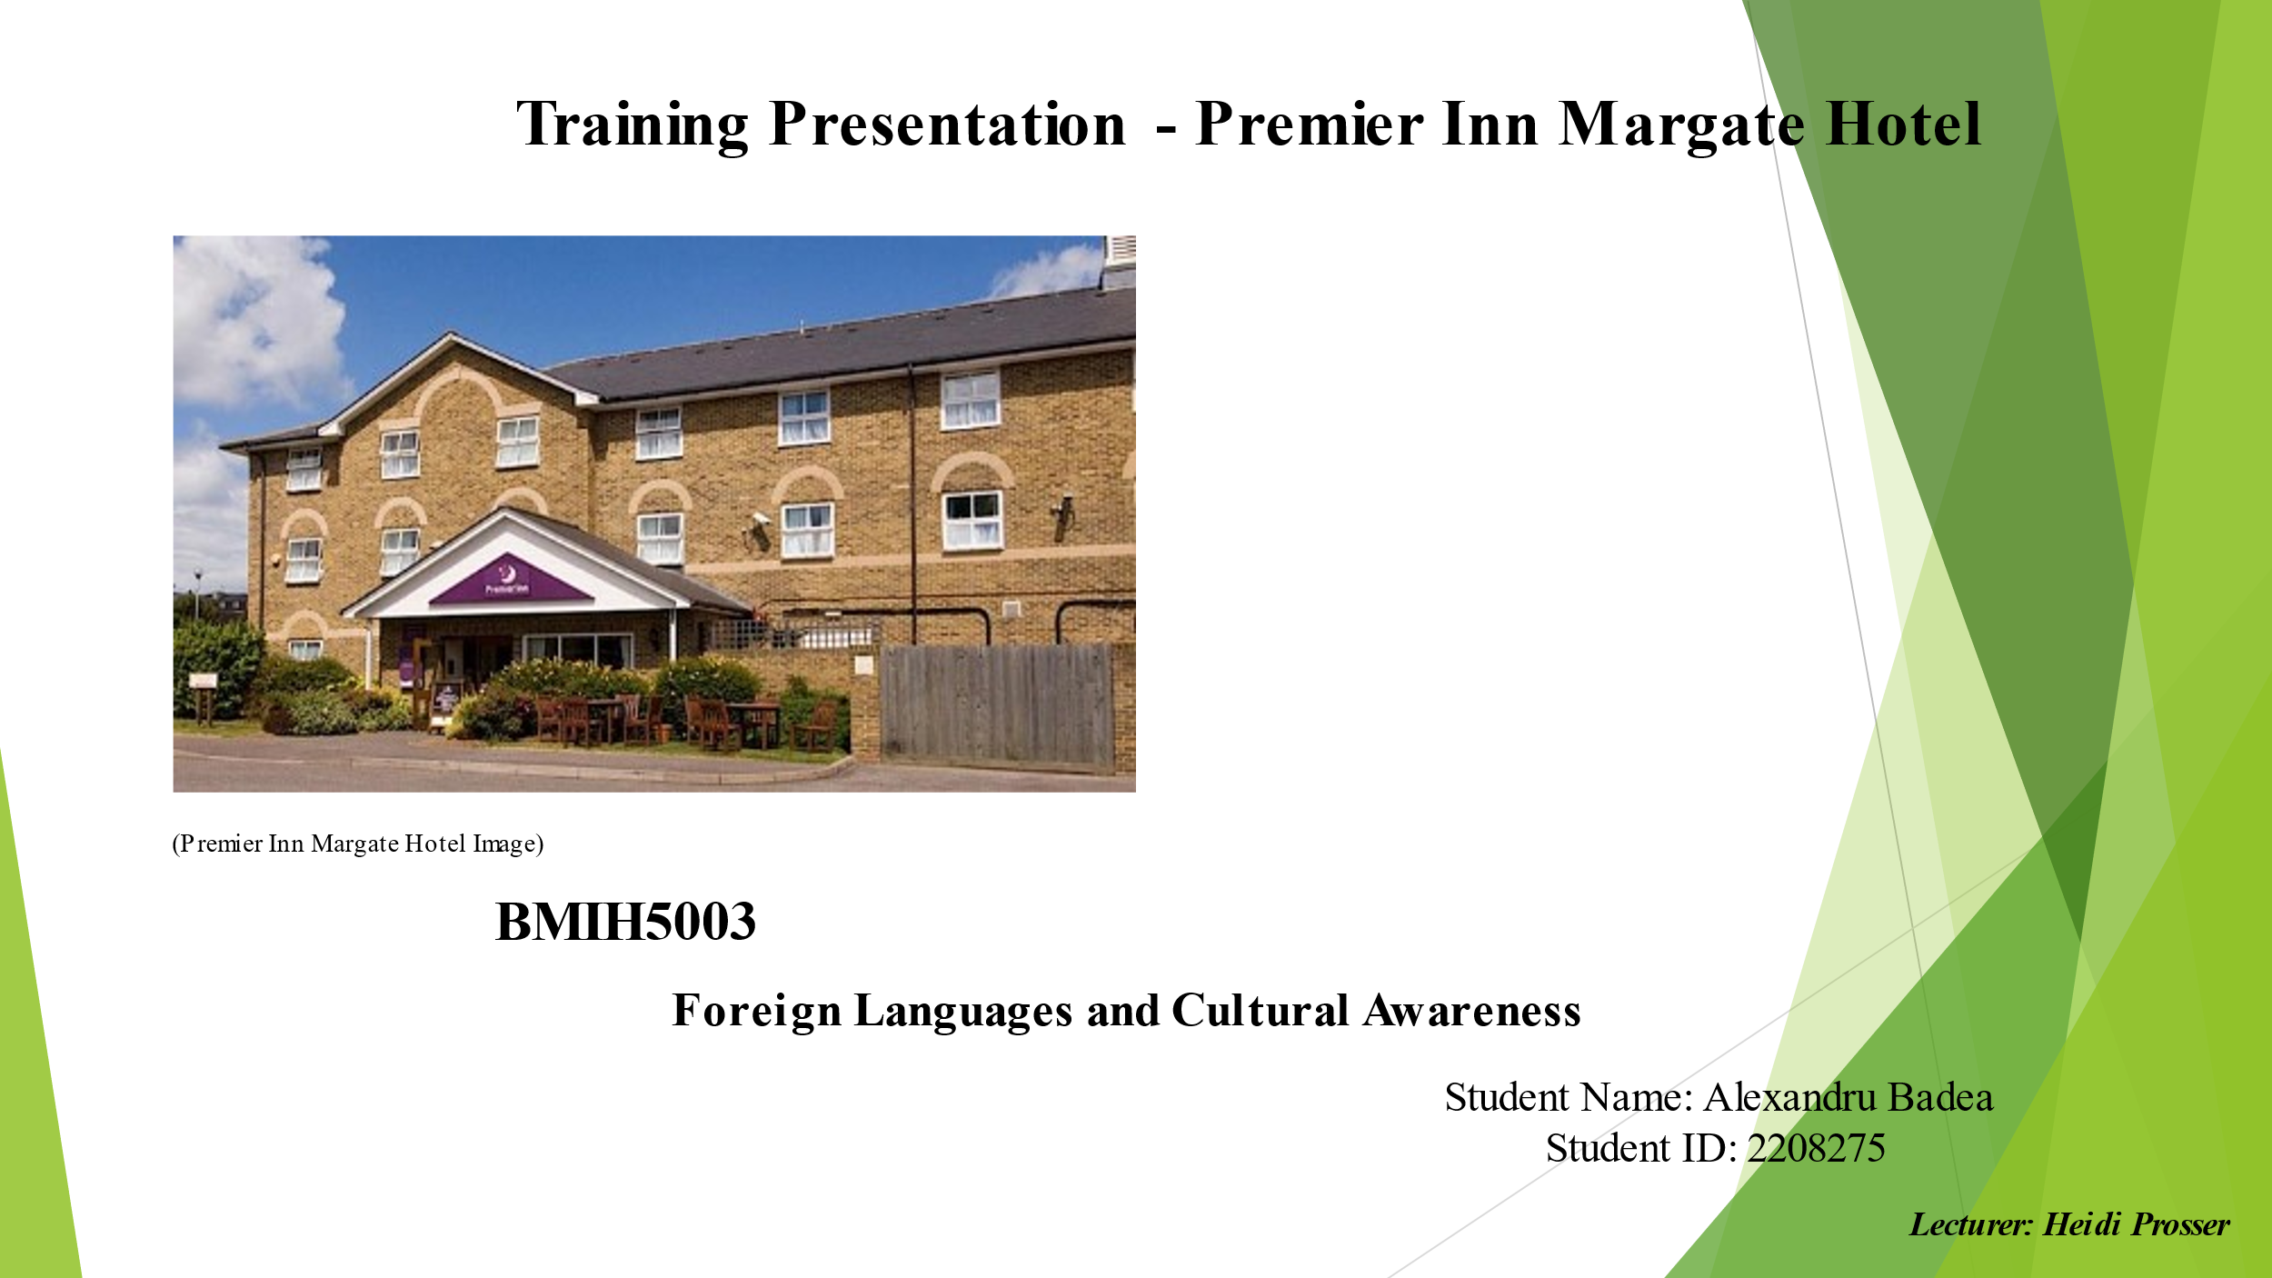
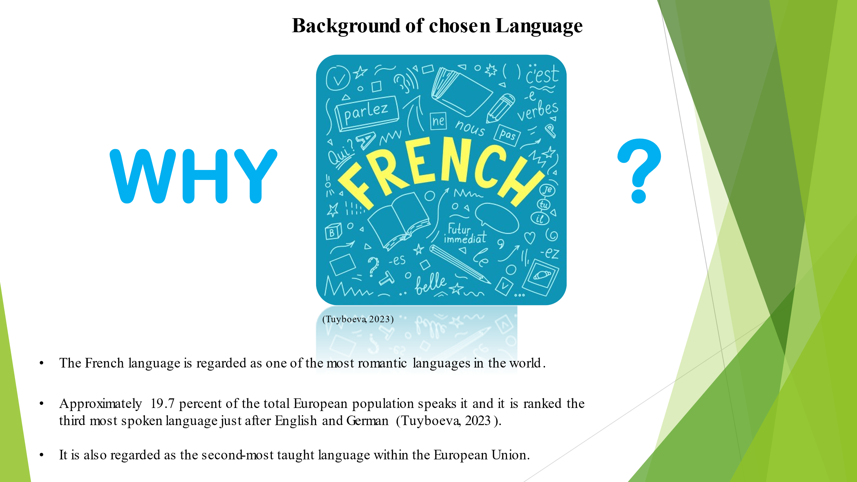

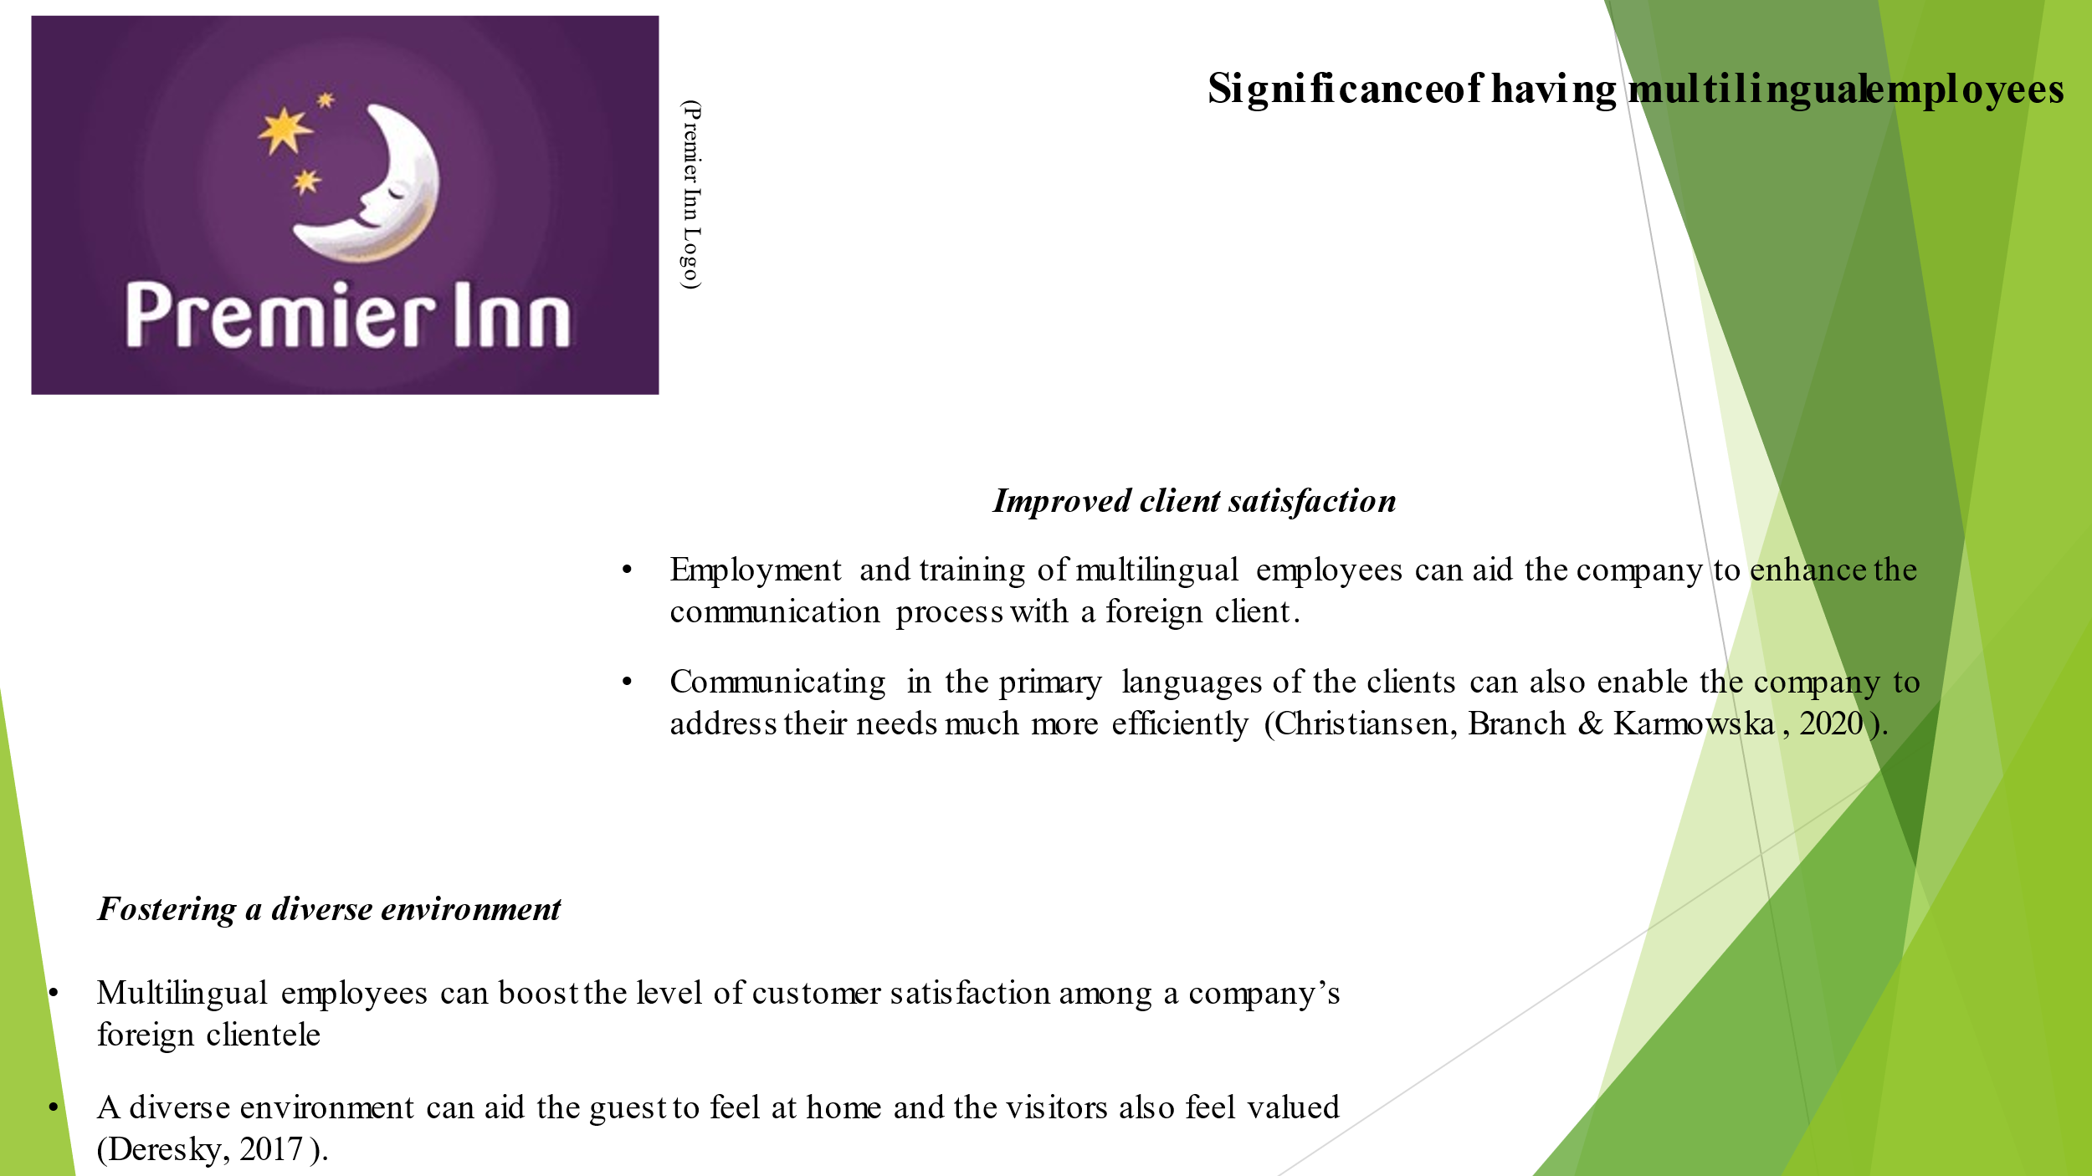

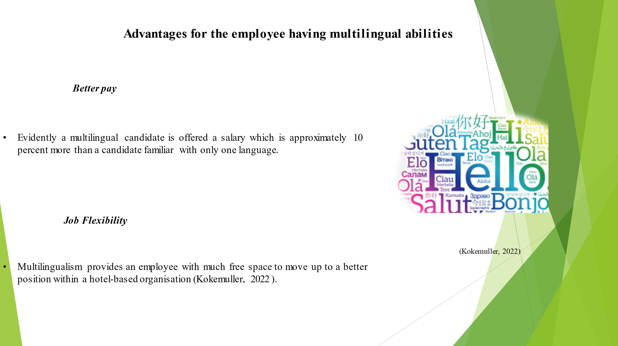

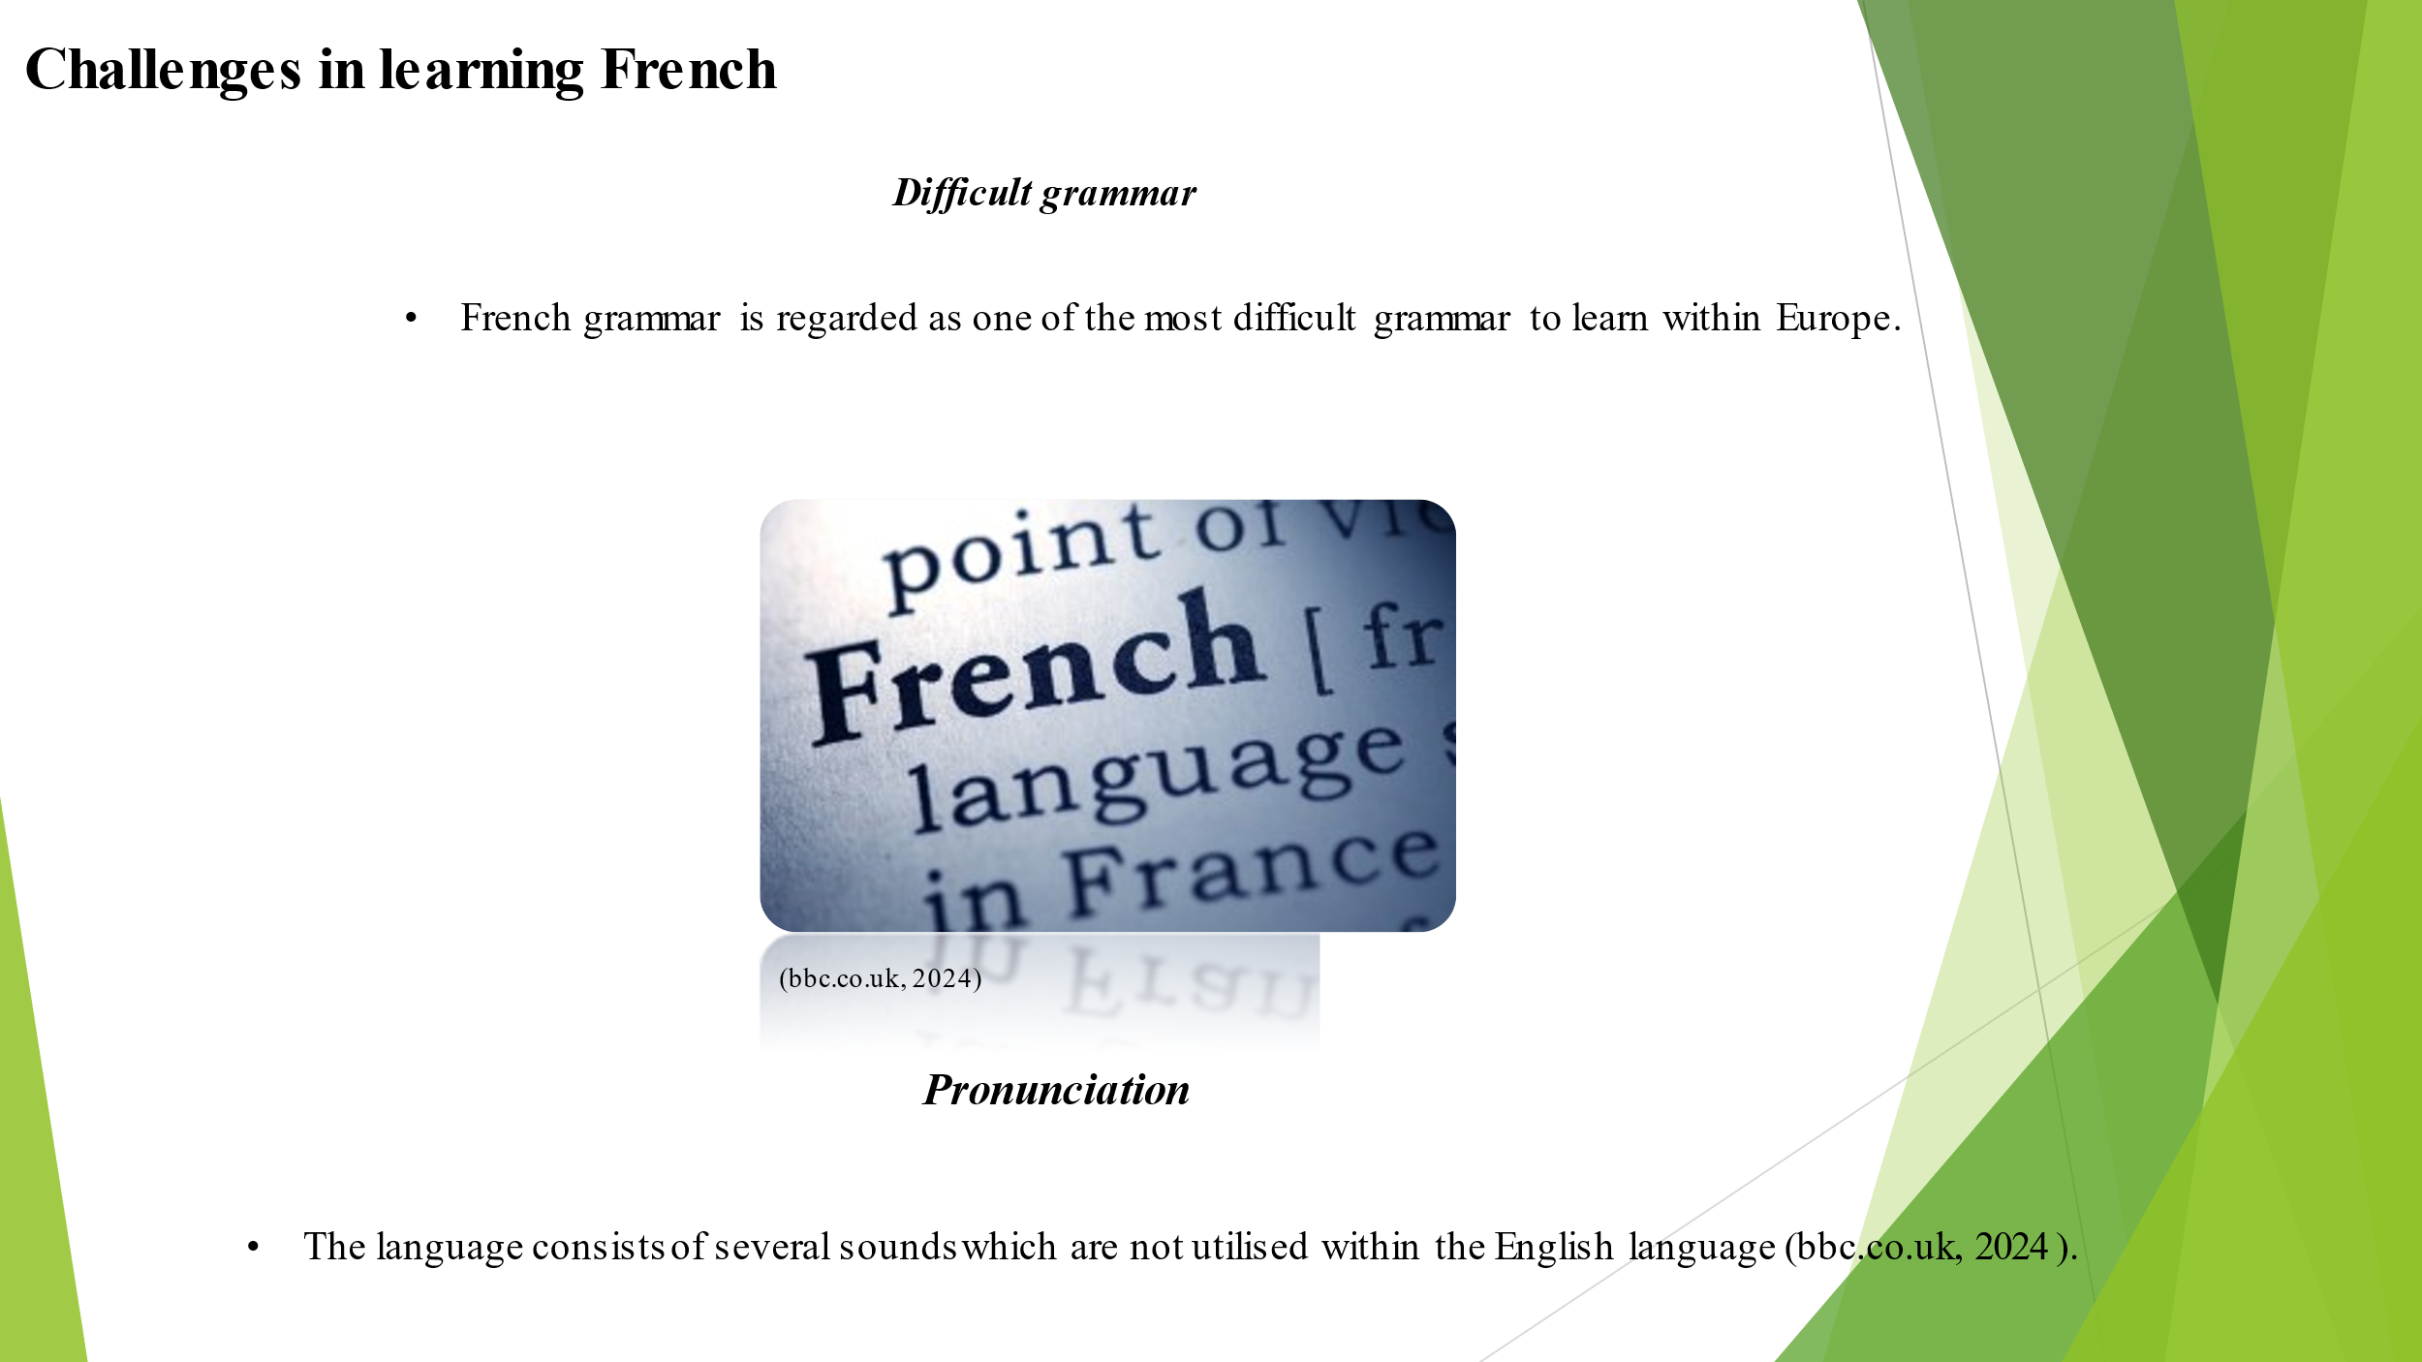

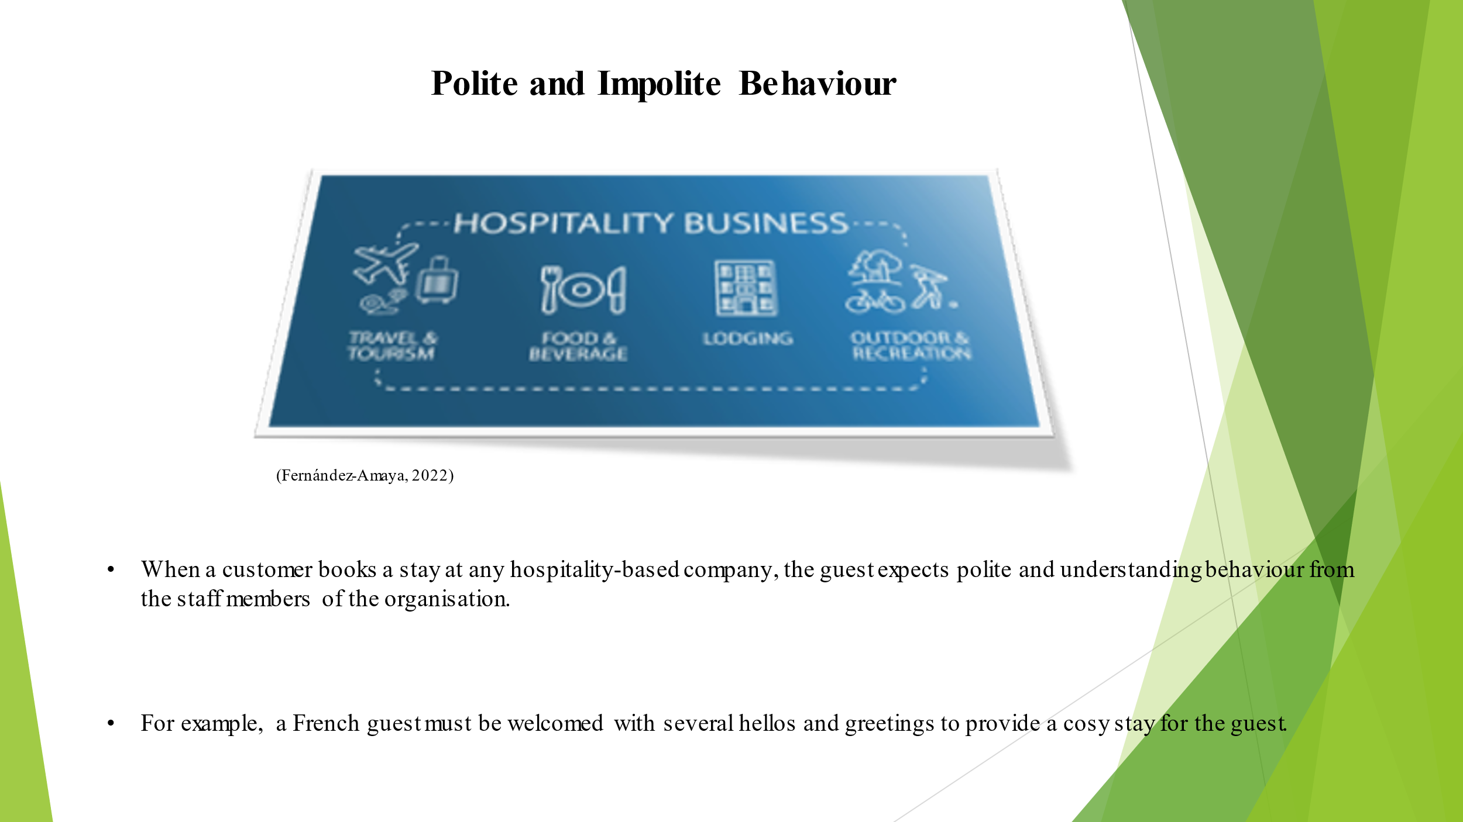

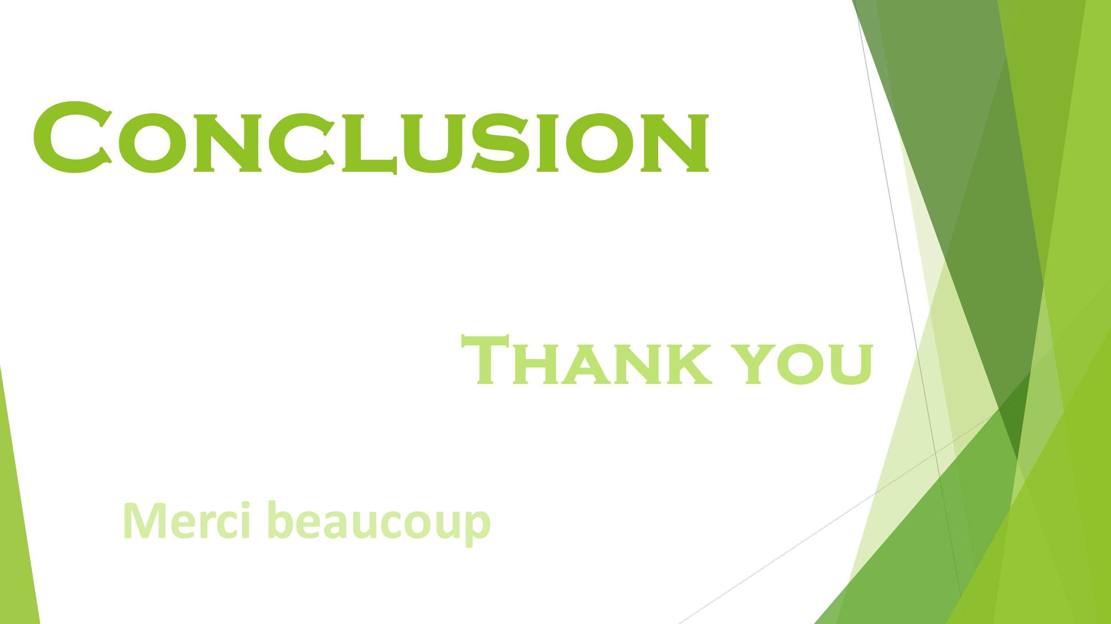
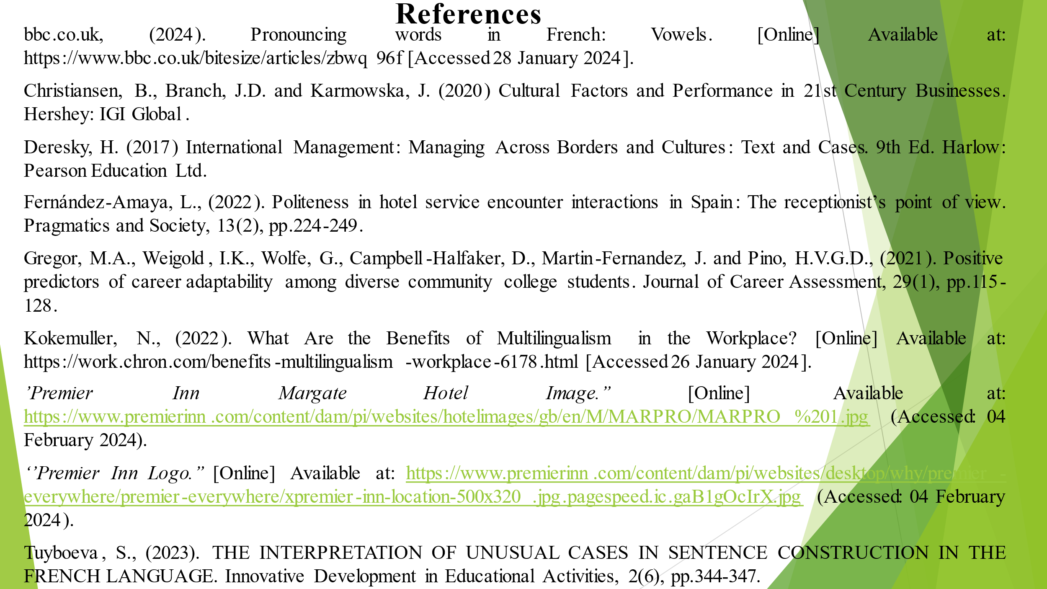

References
bbc.co.uk, (2024). Pronouncing words in French: Vowels. [Online] Available at: https://www.bbc.co.uk/bitesize/articles/zbwq96f [Accessed 28 January 2024].
Christiansen, B., Branch, J.D. and Karmowska, J. (2020) Cultural Factors and Performance in 21st Century Businesses. Hershey: IGI Global.
Deresky, H. (2017) International Management: Managing Across Borders and Cultures: Text and Cases. 9th Ed. Harlow: Pearson Education Ltd.
Fernández-Amaya, L., (2022). Politeness in hotel service encounter interactions in Spain: The receptionist’s point of view. Pragmatics and Society, 13(2), pp.224-249.
Gregor, M.A., Weigold, I.K., Wolfe, G., Campbell-Halfaker, D., Martin-Fernandez, J. and Pino, H.V.G.D., (2021). Positive predictors of career adaptability among diverse community college students. Journal of Career Assessment, 29(1), pp.115-128.
Kokemuller, N., (2022). What Are the Benefits of Multilingualism in the Workplace? [Online] Available at: https://work.chron.com/benefits-multilingualism-workplace-6178.html [Accessed 26 January 2024].
’Premier Inn Margate Hotel Image.’’ [Online] Available at: https://www.premierinn.com/content/dam/pi/websites/hotelimages/gb/en/M/MARPRO/MARPRO%201.jpg (Accessed: 04 February 2024).
‘’Premier Inn Logo.’’ [Online] Available at: https://www.premierinn.com/content/dam/pi/websites/desktop/why/premier-everywhere/premier-everywhere/xpremier-inn-location-500x320.jpg.pagespeed.ic.gaB1gOcIrX.jpg (Accessed: 04 February 2024).
Tuyboeva, S., (2023). THE INTERPRETATION OF UNUSUAL CASES IN SENTENCE CONSTRUCTION IN THE FRENCH LANGUAGE. Innovative Development in Educational Activities, 2(6), pp.344-347.

