Not the full picture

So my piece of writing I was given to look at was The Nose by Nikolai Gogol, and no matter my thoughts on the writing or the man himself I did find an interesting topic of study. Vanity and mirrors, the nose may be a prominent feature of the face, but so is every other feature of the face, our looks however are not the full picture of ourselves. Whenever we look into a mirror we see a version of ourselves, this version is always incomplete as it does not represent the whole of us, a presented reflection or image cannot show the total of a man, he himself is missing, his essence, his personality. So my idea was to have images of myself staring into a mirror, but with parts of my face missing. This is a metaphor to represent the idea that the mirror image or camera image is no the full picture.

Guillaume Amat
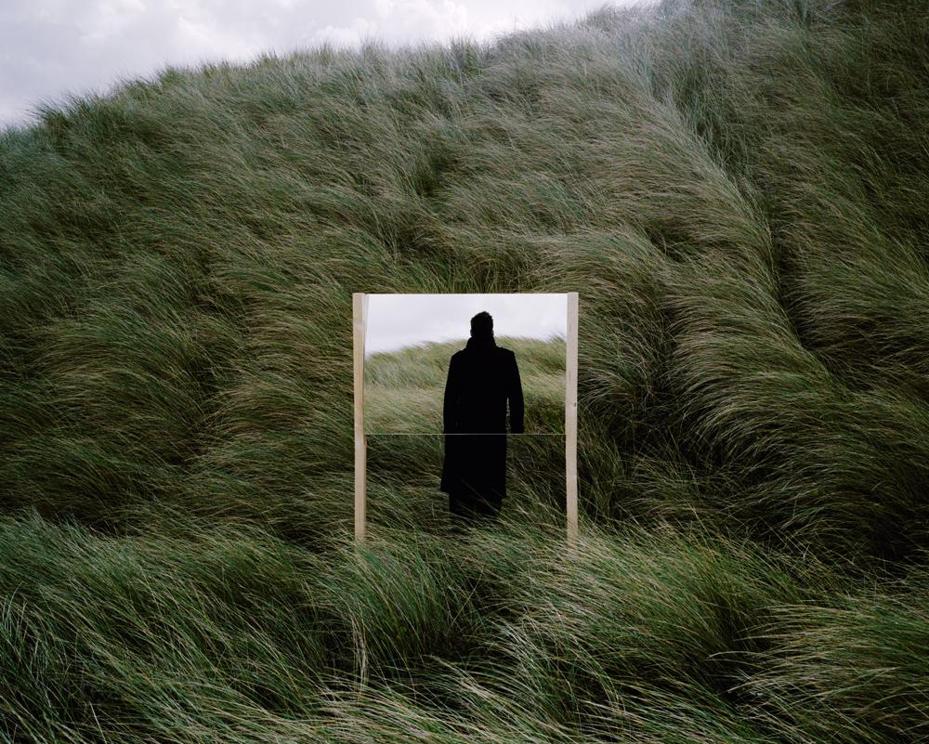
Amat here is also using mirrors but in a different way to the way I chose to. He is placing a subject in the scene without letting us know anything about the subject other than what he is wearing, giving us free reign with our imaginations to explore this enigmatic person, who they are and where they are going is all up to us, our imagination can run wild with possibilities and projections of our thoughts or dreams. The lack of features and knowledge of this person leads to a more interesting image. This showing us there is something missing, this is not the full picture.

Ron Gilad
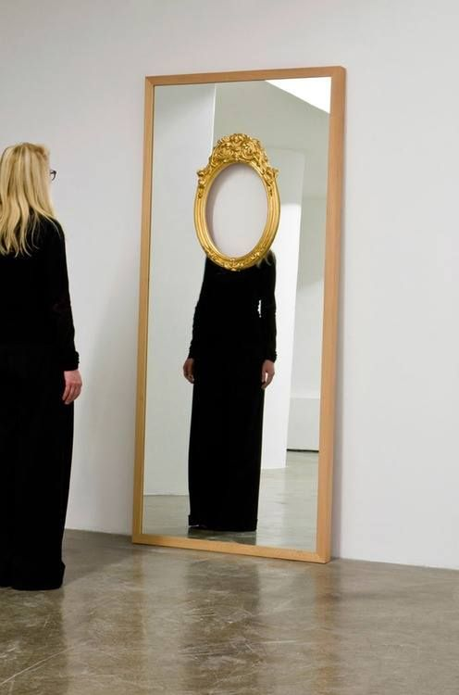
Gilad here is showing the same idea that I’ve been writing about, by taking out the face completely with this piece he’s showing that a mirror cannot truly show you anything but a half formed picture, a hollow version of ourselves with none of our experiences or achievements, a version of us that while clean is also not truth. Parts of you are reflected but your whole, what makes up you never can be. Removing the ability for you to see your face could also be way of telling us that even when trying to look at ourselves we cannot properly know ourselves as we are always biased, we rationalise everything we do and cannot be impartial as it our own actions and life that we are looking at.

Daniel Rozin
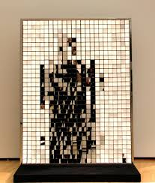
This image even though it does reflect doesn’t reflect anything in a way that lets you understand the image, you get an almost pixelated, mashed up reflection. This could again represent that we can never really know ourselves and that self discovery is a lifelong journey. The small tiles of our life can join together to show us a reflection or map of our lives, however looking at the small tiles put together can give us a different view of what our lives actually look like. This can be very different to what we thought and the resulting map or reflection can be a confusing mesh of truth.

