Task 1: Locating Sources
Identify and locate three different sources (a report, a journal article, and a website) related to the question
“What employability skills do university graduates need to succeed in the workplace?”
Show how you used keywords, search terms, and Boolean operators to find them, and explain how you know which type of source each one is and why it is appropriate for the research question.

Source Type & Why It Is Appropriate | URL/DOI | What search engine did you use? Google/Online Library/Library AI Assistant | Keywords/Boolean Operators Used
Article  Appropriate because the study highlights the significant gap between the skills possessed by Omani graduates and the expectations of employers | https://www.weforum.org/publications/the-future-of-jobs-report-2025/digest/ | Online Library | Employability Skills and Graduates
Website  This website is appropriate because it provides career advice and explains the skills employers look for in graduates, including communication, problem-solving, teamwork and adaptability. | https://www.prospects.ac.uk/careers-advice/applying-for-jobs/what-skills-do-employers-want/ | Google | Employability Skills and Workplace and Graduates

Task 2: Evaluating Information (CRAAP Test)
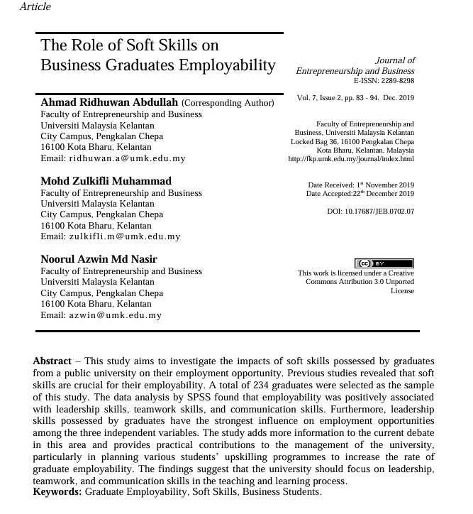
Your colleague has forwarded you a source from a peer reviewed journal, and they are not sure whether it is appropriate to use and has asked for your help. Your task is to evaluate the source by using the CRAAP Test to assess its appropriateness for the following question “What employability skills do business university graduates need to succeed in the workplace?”

CRAAP Test
Currency | The article was published in December 2019. Some information might be a bit outdated because it’s been 7 years since publishing. Workplace requirements may change in short time.
Relevance | This article is relevant for research question because it describes the impact of soft skills for employability of business graduates.
Authority | The article was written by Ahmad Ridhuwan Abdullah, Mohd Zulkifli Muhammad and Noorul Azwin Md Nasir from Universiti Malaysia Kelantan. It was published in the peer-reviewed academic journal.
Accuracy | Information is supported by statistics and previous research. But it comes from only one university, so might be not that useful widely.
Purpose | The purpose of the article is to investigate how soft skills affect graduate employability.
Task 3: Source Analysis
Your manager has provided you with a short extract from a source and has asked you to analyse the source by Identifying one strength, one weakness, and providing a brief explanation of the strength and weakness identified.
If you want to read the article online, please click the following link: https://www.universitiesuk.ac.uk/latest/news/strong-demand-graduates-employers

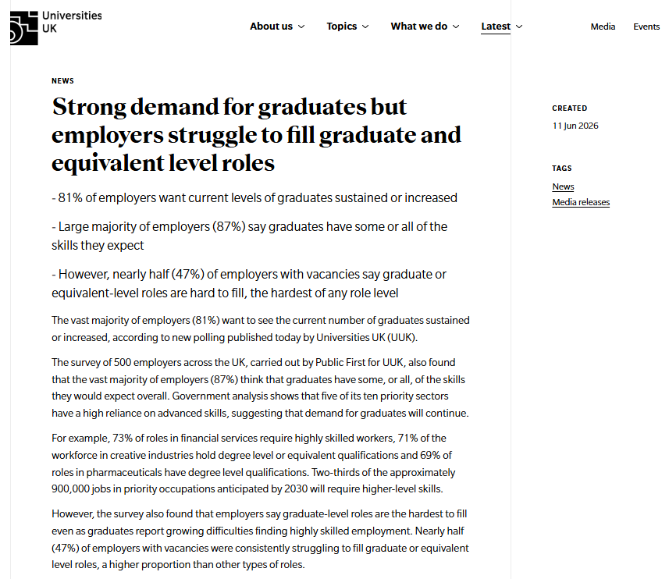
.

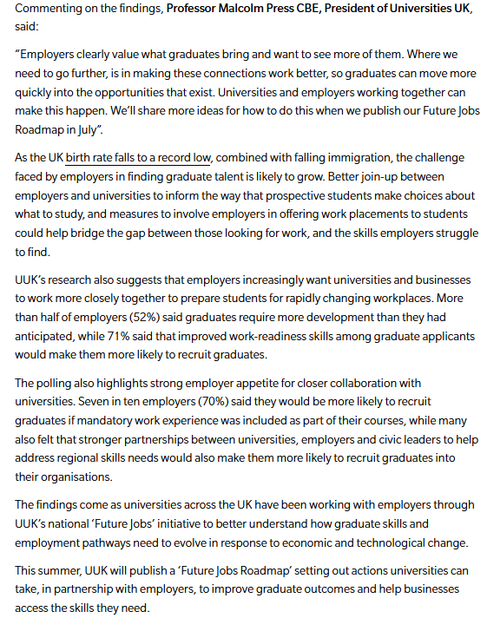

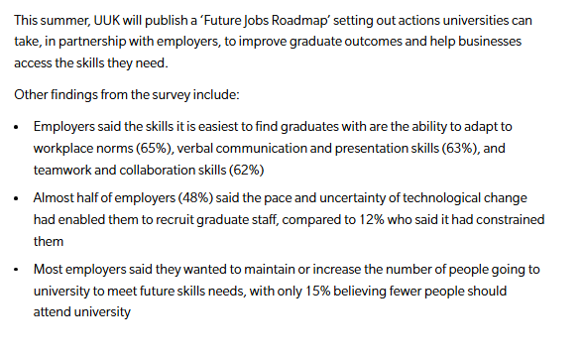

Strength of the Source:

Strength is that this article includes opinions of 500 employers

Weakness of the Source:

Article focuses only on employeers

