

Topic: Develop advanced quality control methods, including non-destructive testing techniques, to ensure consistent quality and performance of clay pipes throughout the manufacturing process

Student Name – Sathwik Ramadugu
Student ID – 2223934
Module Tutor - Amare Desta

Declaration
I, Sathwik Ramadugu, hereby declare that this is an unique work of mine. Any university or institution would not be permitted to access this project for any course of them. Additionally, all the references have been used properly in the literature review part.

Master's Degrees by Examination and Dissertation
Declaration Form.
1. This work has not previously been accepted in substance for any degree and is not being concurrently submitted in candidature for any degree.
Signed
Sathwik Ramadugu.
Date
17 June 2024..
2. This dissertation is being submitted in partial fulfilment of the requirements for the degree of Master in Business Administration.
Signed
Sathwik Ramadugu Date
17 June 2024
3. This dissertation is the result of my own independent work/investigation, except where otherwise stated.
Other sources are acknowledged by footnotes giving explicit references.
A bibliography is appended.
Signed.
Sathwik Ramadugu
Date 17 June 2024.
4. I hereby give consent for my dissertation, if accepted, to be available for photocopying, inter- library loan, and for deposit in the University's digital repository Signed
Sathwik Ramadugu
Date 17 June 2024
Supervisor's Declaration.
I am satisfied that this work is the result of the student's own efforts.
Signed:
Date:

Chapter 1: Introduction

Abstract
This study examines quality assurance techniques in clay pipe manufacturing in order to employ NDT technology to verify the quality and reliability of clay pipes prior to joining and along the production line. The research design is descriptive, the methodology is inductive, and the study follows an interpretivist research paradigm. The study's data sources include academic journals (both domestic and foreign), industrial reports, government records, papers, and publications. The data from the study is evaluated using thematic analysis to discover themes linked to quality control in clay pipe production. In this sense, UT and RT forms of NDT, as well as other sophisticated types of NDT, shown the ability to identify defects and meet industry requirements. The research also highlights the necessity of quality management systems and continual people training in maintaining quality control, since they affect the MEL manufacturing line. In adition, the following recommendations are made: use sophisticated nondestructive testing (NDT) procedures, enforce QMS, develop and train staff skills, innovate and create new products, conserve the environment, and be proactive in industry involvement. The research findings are intended to be used as a manual in the organization's clay pipe manufacturing business to improve product quality and efficiency while also achieving sustainable production. Therefore, this research contributes to the body of knowledge on quality control challenges in clay pipe manufacturing and has practical consequences that policymakers, academics, and pipe manufacturers should consider. The study's findings clearly consider the sector's future; in order to capitalise on both present and future market opportunities, complicated NDT methods and Quality Control methodologies must be applied in order to make future advances.

Acknowledgement
I would like to thank to the people without whom I would not be able to complete this project.
First, I would like to give thanks to my friends and family who supported well throughout my studies. Special thanks and gratitude to my Supervisor who guided me and resolve all my problems.
Other than that, I am thankful to the respondents as well.
Yours thankful
.......................

Table of Contents
Abstract 2
Chapter 1: Introduction 3
1.1 Background 3
1.2 Problem Statement 4
1.3 Research Rationale 4
1.4 Aim 5
1.5 Objectives 5
1.6 Research Significance 6
1.7 Structure of Dissertation 6
Chapter 2: Literature Review 8
2.1 Introduction 8
2.2 Critical Analysis 8
2.2.1 Importance of Clay Pipe manufacturing industry 8
2.2.2 Importance of the advanced quality control system of the manufacture the clay pipe 9
2.2.3 Role of the non-destructive methods in ensuring the maintenance of the quality and the performance of the clay pipe 9
2.2.4 Potential strategy of the manufacturing process of the clay pipe 9
2.3 Technological Advances in Non-Destructive Testing Methods 9
2.4 Case Studies and Applications of NDT in Clay Pipe Manufacturing 9
2.5 Theoretical Underpinning 11
2.6 Conceptual Framework 11
2.7 Literature Gap 11
2.8 Summary 11
Chapter 3: Methodology 12
3.1 Introduction 12
3.2 Outline of the chosen research method 12
3.3 Research philosophy 12
3.4 Research Approach 13
3.5 Research Design 14
3.6 Research Strategy 14
3.7 Choice of the Selected Research 15
3.8 Data collection technique 15
3.9 Data analysis 16
3.10 Reliability and Validity 16
3.11 Ethical Consideration 17
3.13 Summary 18
Chapter 4: Data analysis and findings 19
4.1 Introduction 19
4.2 Thematic analysis 20
Theme 1: Evaluating the several quality control techniques utilised in the production process of clay pipes, including their efficacy and constraints. 20
Theme 2: The significance of non-destructive testing techniques in guaranteeing the quality and effectiveness of clay pipes, exploring various approaches such as ultrasound testing and radiographic testing. 20
Theme 3: Strategies for enhancing the efficiency of clay pipe manufacturing, encompassing possible advancements in production methodologies and workflow optimisation. 20
Theme 4: Evaluating the performance of clay pipes in terms of their durability, resistance to chemical corrosion, and overall reliability. 20
Theme 5: The ecological consequences of clay pipe production, encompassing sustainability, resource utilisation, and waste control. 20
Theme 6: Evaluating the cost-effectiveness of clay pipe production techniques and quality control protocols, taking into account issues such as upfront capital investment, ongoing maintenance expenses, and long-term resilience. 20
Theme 7: Prospective advancements and innovations in the manufacturing of clay pipes, encompassing developing technologies, areas of research that need attention, and opportunities for further enhancement. 21
4.3 Discussion 21
4.4 Summary 24
Chapter 5: Conclusion and Recommendations 25
5.1 Conclusion 25
5.2 Linking with the objectives 26
5.3 Future scope of the study 26
5.4 Recommendations 27
References 30

Chapter 1: Introduction

1.1 Background
Ceramics is an old business that depends a lot on clays, which have properties that are closely linked to their uses and properties in ceramics (La Noce et al., 2021). Glass-like clay lines, which are used for sewer and drainage systems, are one type of structural clay. These pipes are made from crushed clay that is pushed into pipes, dried, and fired at a high temperature. They were first used in Babylonia around 4000 BCE. They are strong, can't be damaged by chemicals or wear, and can't be damaged by heat either. They don't carry electricity and can't be damaged by static or moving pressure. They can stand up to cleaning tests at 120 bars and regular rinsing and unclogging with high water pressure. Because of this, they are affordable to fix up, repair, and maintain. Vitrified clay pipes are made from clay-based materials that don't contain much sand and are very flexible and not too brittle.
To make sure that the pipe is resistant to High-Arc Current (HAC) after it has been made, the manufacturing process and testing steps are very important. The vulnerability to SOHIC and SSC is raised by the residual stress that is created during shaping and welding. The way that all kinds of API 5L pipes are made is looked at again so that mistakes caused by HAC don't happen again. Electric resistant weld (ERW) is a fast way to make things, but it can make things much harder, which can start SSC. The UOE method is used to make cold-expanded longitudinal seam submerged-arc welded (SAW) pipe (Al-Anezi et al., 2016). On the other hand, non-cold-expanded longitudinal SAW pipe has a lot of residual stress, which makes it easy for HAC to happen. SOHIC can damage spiral SAWs that are not extended. If the seamless pipe is supplied in either the annealed or cooled state, it is resistant to HAC.
Using current quality control methods that include non-destructive testing techniques can help make sure that clay pipes always work well during the production process. This is what the dissertation is all about. In conclusion, clay lines are very important in many fields, such as drainage, sewage, and plumbing. Some of the things that could make it hard to keep up their high level of performance are differences in materials, differences in production, and pressures from the surroundings. These problems are what our study is trying to solve, along with a complete plan for keeping standards high in the making of clay pipes. This can be done with the help of non-destructive testing and new tools for inspection.

1.2 Problem Statement
Drains and sewage systems have used vitrified clay pipes for a long time, and their benefits have been shown. However, there is one problem that could make these pipes less useful right now, and that is the difficulty in making them. Shape and welding stresses are also big risk factors because they make the materials more likely to experience stress-strain cracking (SSC) and stress-oriented hydrogen-induced cracking (SOHIC). This is because the materials are also not the same and as a result have different properties which makes them more vulnerable. This level of quality control is ineffective at preventing these problems because the methods used are today’s basic QC or ‘Test to Failure’ approaches where the concerns are that we cannot find the defects that are revealed when the system breaks in the field. This paper aims to highlight non-destructive testing (NDT) strategies in managing quality of manufacturing as its importance cannot be overemphasized. The aim of this study is to establish to what extent the NDT method enhances improvement the production process and the quality of clay pipes (Nturambirwe & Opara, 2020).

1.3 Research Rationale
There is a lot of significance in making a clay pipe and in their usage and these are traditions that have been utilized by people for centuries. But there is also a trend to use this pipe for something else lately, therefore the procedure of making the clay pipe is significant as well. This is a new technology that has knowledge that will be useful in the production of the clay pipes to ensure that the work realized is done perfectly regarding the desired quality of the pipes. Connections are the most vital parts of a pipe and therefore the individuals who work on it should take the responsibility and understand how they can improve on their work so that the quality of the pipes is enhanced. Maintaining the structural design, effectiveness, and longevity of the clay pipe is important, which is why the right ways to make the pipes need to be pushed (Su et al., 2020). This study will help spread the idea of making pipes without damaging them, and it will also help spread some ideas that will help keep the manufacturing process going smoothly. This study will help solve problems that come up when making the pipes. As a result, researchers and manufacturers in the future will learn more advanced ways to make clay pipes. Engineers' plans and specs list the project's materials, methods, and work that needs to be done. They often use professional standards as references. These specs go along with the contract specs and must list the standards for all pipe materials. Because of changes in how the project is designed, pipe materials can't be used in place of each other. At the factory, VCP (Vitrified Clay Pipe) is checked and measured to make sure it meets quality standards (Al-Anezi et al., 2016). Pipes that are refused must not be marked or damaged in any way. Suppliers need to know why their bids were turned down.
To stop SSC or SOHIC, the pipe fabrication line of defence includes making sure that the induction heater works perfectly during ERW pipe fabrication. To keep from making hard microstructures, the right welder and filler metal should be used when making or fixing something. To avoid SSC, the user should follow the welding process and make sure that the weld seam, HAZ, and base metal hardness are all less than 248 Vickers. On all welds, an ultrasonic test (UT) should be used for non-destructive testing on the inside surface to find any flaws that could cause SSC (Al-Anezi et al., 2016). Straight seam SAW pipe joints should be put through cold expansion and hydrostatic tests to lower the amount of stress that is still there and make them less likely to develop SOHIC. Full body stress relief heat treatment at 620–675 °C for 1 hour/in. should be done on pipes that haven't been expanded, like spiral welded and pyramid rolled straight seam pipes, to get rid of any remaining stresses and restore fracture hardness.

1.4 Aim
The primary aim of this study is to look into the steps and non-destructive methods used in the production of clay pipes, which helps to keep the pipes' quality.

1.5 Objectives
Among the major goals of this study are:
- To figure out how important the process of making the clay pipe is.
- To figure out how important it is to have an improved quality control system in the process of making clay pipes.
- To find out what part non-destructive methods play in keeping the quality and performance of the clay pipe high.
- To give you a possible advertising plan for the clay pipe-making method.
- To provide you with a distinct manner to make this pipe that can be used for greater matters.

1.6 Research Significance
In the various sectors of the economy like aerospace, power generation, infrastructure, construction industry, rail and transportation industries, marine and shipping industries, manufacturing industries, among others, Non-Destructive Testing (NDT) plays vital roles in ensuring and checking the quality of assets or structures (Rucka, 2020). In practice, techniques like ultrasound checking and radiographic checking can be applied to check for material apertures or checks in aeroplane engine turbine blades once crash tests have been conducted. This enables the parts to have long durability and elongated life, thus are not expensive (Gupta, et al. 2022). Jim received his technical training from West Kentucky Community Technical College, where he acquired the much-needed knowledge and skills to perform NDT tests on oil rigs, power plants, and chemical plants as well to ensure they meet safety standards as required. That is why it is important to find the problems at an early stage to prevent leakage, deformations and spontaneous failure of mechanisms which cost a lot of money. When implementing the plan for the television show it has been proposed to do a written article asking what is the current situation in making clay pipes, Quality assurance and control and non destructive testing techniques. Visual evaluation, x-ray testing, and sound testing are all non-destructive methods that will be used to see if clay pipes are straight and find any flaws (Hassani and Dackermann, 2023). The study's goals are to find issues and flaws in the present quality control methods, set up strong control rules, and shorten production cycles to cut down on mistakes. Also, some non-destructive testing methods for clay lines will be done again.
This is a very useful topic because it has real-world effects and could have an impact on industries that use clay lines. So, they can say that clay pipes' inconsistent quality and performance could lead to problems like expensive fixes, building collapses, and environmental hazards (Kot et al., 2021). Thus, it is possible to think that producers could improve the dependability of their products, cut down on waste and rework, and work more efficiently overall by creating better quality control systems and non-destructive testing methods.

1.7 Structure of Dissertation
There are five parts to the research: an introduction, a review of the literature, the methodology, the results, and the conclusion.
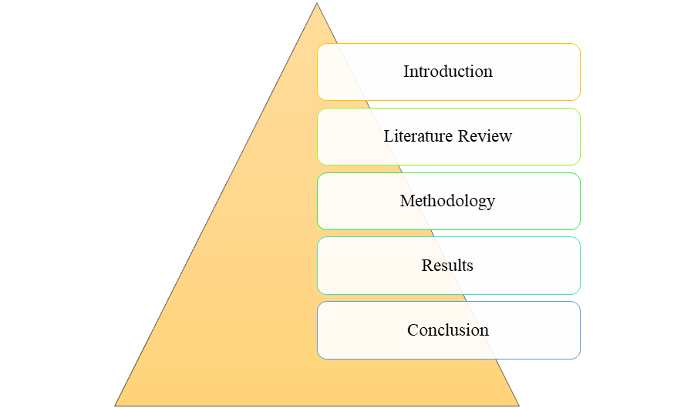
Figure 1.4: Synopsis of dissertation
(Source: Developed by Author)

Chapter 2: Literature Review

2.1 Introduction
A literature review is an important piece of academic writing that evaluates recent research, theories, and supporting data while also arguing for or against something. The literature review part uses previous research to explain the structure of the topic, find research gaps, and give the study's topic a conceptual framework. It makes sure that the work is original, adds to what is known, and is needed for all well-written and well-researched dissertations, theses, and research projects. In the literature review part, it is important to talk about possible causes like long hours and high stress levels.

2.2 Critical Analysis

2.2.1 Importance of Clay Pipe manufacturing industry
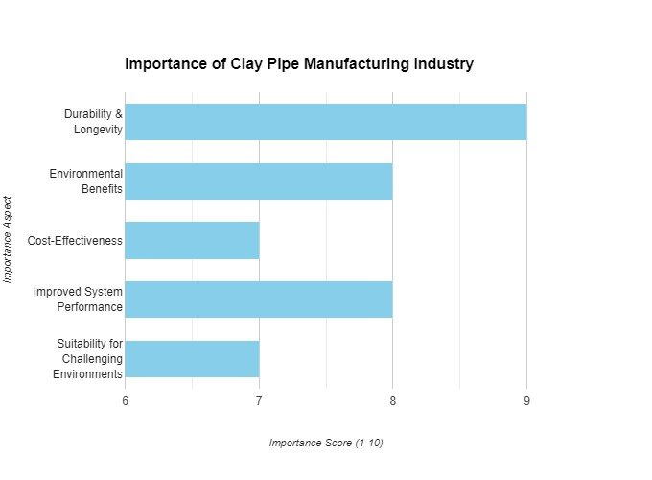

Importance of Clay Pipe manufacturing industry
Source (Self-Made)
Vitrified clay pipe (VCP) is a hard, inert ceramic made from a mix of clay and shale. It is used in gravity sewer collection mains because it can handle both household and commercial sewage, especially sulfuric acid (Negm et al., 2022). Hydrofluoric acid and highly concentrated caustic wastes are the only things that can damage VCP, and it needs to be properly treated before it can be put into city systems. The U.S. makes three main kinds of VCP: NO-DIG(R) Pipe, Band-Seal Pipe, and Bell & Spigot Pipe (Jainet al., 2022). All VCP must meet ASTM C425 for a bendable joint that doesn't leak. VCP products, which are made from clay, are good for the earth and the economy. Because they last a long time, they are especially useful in sanitary drains. The US EPA is worried about sanitary sewer overflows, so cleaning drains is an important part of designing a system. VCP makes it possible to clean sewer lines more thoroughly, which extends their useful life and lowers the need for costly dig-ups. Because it doesn't react with acids like hydrofluoric acid, it can be used in underground drains for a long time.
Vitrified clay pipes are strong, don't let water through, and don't react with chemicals, so they last a long time and are good for the environment (Chaudhari et al., 2022). These pipes are great for rough ground because they make it less likely that they will be damaged by mistake, effluent will leak, or chemicals will attack them. Not only are clay pipes easy to install, they can also be made with shorter pipe lengths and trenchless methods that are better for the environment and cause less trouble. Clay pipe systems last a very long time, which means they need less maintenance and repairs over their lives. According to Bazli et al. (2023), clay pipes are a cheap short-term option because they are strong, don't need as much waste to be taken away, and come with fittings that don't cost too much. These traits make them a popular choice for reusing land that was once industrialised and may contain chemicals that are bad for them. Also, trenchless installation methods for different pipe sizes have been made, which makes things less annoying and lets people use the land and buildings normally.

2.2.2 Importance of the advanced excellent control gadget of the manufacture the clay pipe

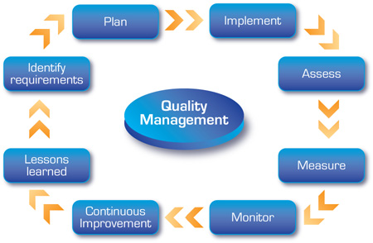
Advanced quality control system of the manufacture the clay pipe
Source (The pipefitting, 2024)
Strict quality control (QC) is therefore necessary throughout the clay pipe production process to guarantee that the final product satisfies both industry and future client standards. They must oversee manufacturing from material selection and pipe profile preparation to packaging and inspection. Using sophisticated QC solutions in clay pipe production improves product quality, consistency, and reduces production scrap and rework, as well as task completion and customer satisfaction (Bhattacharjee et al., 2023).
Implementing sophisticated QC processes improves product reliability. Important civil works like drainage and sewage systems employ clay pipes, and their collapse can cause pollution and significant maintenance costs. Manufacturing facilities can find and address service problems in pipes early in development to ensure they are structurally sound and can survive use. The utilisation of modern quality control techniques on the pipes is what makes this a distinct possibility. Combining UT and RT helps show hidden component parts that allow corrective action.
Clay pipe manufacturers must follow certain regulations by law. Advanced quality control systems give accurate and complete information on all manufacturing processes, helping manufacturers meet these standards (Javaid et al., 2021). ASTM and other standards and regulatory bodies suggested clay pipe physical and chemical property criteria. Modern, sophisticated quality control systems can monitor these properties regularly to ensure that every batch of pipes manufactured meets requirements. The pipes' material properties are impacted by these characteristics. It also improves the manufacturer's reputation and prevents major legal and regulatory consequences
Waste and rework in production are the main sources of costs that diminish profitability and efficiency, according to the article. Advanced quality control systems detect almost all errors and irregularities during production, preventing waste and rework on items with hidden issues. Real-time monitoring systems can detect insufficient raw material mixing, firing temperature changes, and pipe diameter variances. Since making non-pipes and fixing them increases production costs and delays, the issues should be rectified immediately. This is smart since it reduces production costs by using fewer resources.
Advanced QC systems, which are integrated technologies, save time on production planning and schedule delays (Jan et al., 2021). Robotic equipment can swiftly repeat testing and examination and require less inspector attention, enabling problem discovery and resolution. This guarantees repetition and speeds up product creation, which is good for business. QC system data can be used to evaluate performance trends and identify areas for improvement to increase production efficiency in the following steps.
Manufacturing companies succeed based on various factors, including customer satisfaction. Advanced quality control procedures help clients get value for their money. Manufacturing flaw-free clay pipes will lessen the likelihood of pipes breaking and requiring replacement or repair. However, thorough quality assurance reports provide several benefits: ability to boost customer product trust. Customers that like a product will buy it again and tell others to buy it, increasing market share and sales.
Using a major clay pipe manufacturer as an example, we examine the benefits of such quality control system changes. The organisation began utilising ultrasonic testing as a follow-up to the automated visual examination the previous day. Adopting the new principles increased output by 15%, reduced waste by 20%, and increased yield by 30%. Customers' negative feedback: a considerable drop in product quality increased customer satisfaction and market share.
Finally, it's important to use improved quality control methods when making clay pipes. These improve quality by increasing customer satisfaction, reducing waste, meeting legal standards, and ensuring product reliability. Such systems assist manufacturers increase product quality, reliability, operational efficiency, and market competitiveness. In the future, reducing clay pipe system installation costs will be vital as the necessity for high-quality infrastructure drives the need for sophisticated quality control systems (Yang et al., 2022).

2.2.3 The role of the non-detrimental techniques in ensuring the preservation of the exceptional and the performance of the clay pipe

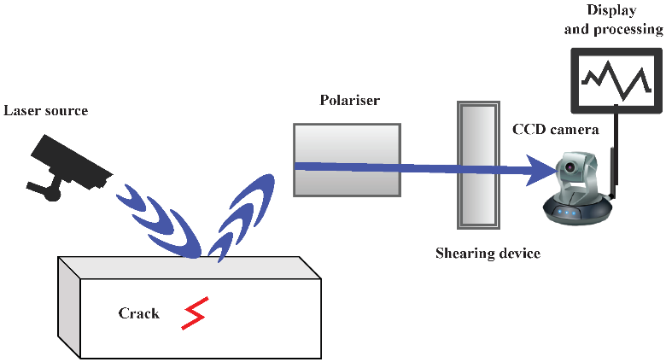
The non-destructive methods in ensuring the maintenance of the quality and the performance of the clay pipe
Source (Hassani and Dackermann, 2023)
Non-Destructive Testing (NDT) methods are important for both making clay pipes and keeping them in good shape because they can't be broken after they've been made. These methods, which improve the structural value and efficiency of pipes over their lifetime, allow one to be assured about their condition without harsher methods. Non-destructive testing can detect problems early, provide a regional overview, improve safety, and save money (Shiotani et al., 2024).
Early fault identification is one of many NDT uses in clay pipe manufacture. Void, inclusion, and other faults that generate fractures or openings diminish clay pipe structural integrity. The accessible UT and RT methods are best for finding these issues early in production. UT locates pipeline problems using high-frequency ultrasonic waves, while RT employs X-rays or gamma rays. This means that manufacturers may be able to modify damaged pipes before utilizing them and prevent certain failures at the installation site.
Several NDT methods are utilised to ensure the finest quality clay pipes, depending on the Pipe Section. They help monitor and analyse the production process from material selection to final product. For instance, Visual Height Inspection is essential for finding surface damage, cracks, flaking, and erroneous measurements. It is also one of the most simple methods of NDT (Non Destructive Testing) that are explained (Hassani et al. , 2023). By applying the Dye Penetrant Testing or DPT and Magnetic Particle Testing or MPT you can identify subsurface and surface defects. This ensures product quality and reliability for oil and agricultural distributors and merchants because every pipe meets a high standard.
Clay pipes must be safe when used in sewage, drain, and industrial waste conduits. Non-destructive testing enhances safety by checking the pipelines for operating stress. AET and thermography can make sites aware of material decay, stress corrosion, pipe failure, and other reasons. The using of the Thermography technology shows us the heat patterns that show us structural problems while the other technology named Acoustic Emission Technology (AET) records sounds come from the fractures or other defects which makes some stress or strain. Concerning the safety of clay pipes, it becomes evident that NDT is more reliable than other assessment methods used in the market since it is capable of detecting problems earlier than they turn into a catastrophe (Calabrese et al. , 2020).
These procedures entail initial cost, for example, when using sophisticated equipment and instruments during the non-destructive testing (NDT) evaluation but the advantages reverse. Preventive activities for detection of faults at an early stage, quality assurance and control, and efficient service delivery help to reduce costs that are associated with repairs and replacements. NDT also has a decreased wastage ratios because they only test the pipes before selling them in the market as they are. Due to the efficiency it brings, producers may set lower prices for their products, thus enhancing revenues. However, incorporating NDT into maintenance plans enables clay pipes to have longer durations and reduced lifecycle expenses by identifying and rectifying concealed defects.
Real-life occurrences of clay pipes demonstrate the effectiveness of NDT. A leading manufacturer of vitrified clay piping system used radiography and ultrasonic testing methods for inspection. Integration minimized mistakes and enhanced product quality. The municipal sewer system operator used acoustic emission testing to assess the infrastructure's decades-old, heavily-worn clay pipes, another real-world example. This proactive technique identified weaker pipeline portions and emergency repairs and disruptions in pipeline services without waiting for line failures. For instance, a factory used thermography to assess the client's kiln-firing process. Heat gradients that cause pipe strength to vary can be monitored in real time to increase pipe strength. NDT techniques can help make and maintain clay pipes (Edwards et al., 2021).
These non-destructive testing methods are essential for assessing clay pipes' efficacy and durability. NDT is useful in the clay pipe industry because it may find problems early, ensure quality, increase safety, and be cost-effective. Thermal, acoustic emission, radiography, and ultrasonic testing verify that clay pipes meet high performance and reliability standards, ensuring infrastructure safety. As technology advances, NDT will be used increasingly in clay pipe production and maintenance, improving performance and quality.

2.2.4 Potential strategy of the production process of the clay pipe

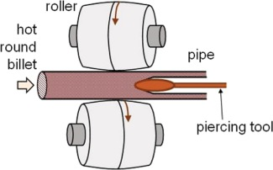
Strategy of the manufacturing process of the clay pipe
Source (Al-Anezi et al., 2016)
A strong strategy is needed to produce clay pipes, the most crucial aspect of the production process. Some of the measures this plan must include are: selecting raw materials for manufacture is part of this. Production process: Selecting manufacturing methods and implementing quality assurance policies. Change management ensures industrial process improvement through policies. I've tried to identify a few key areas where producers might improve clay pipe quality to satisfy quality standards (Castro Oliveira et al., 2020).
Product creation begins with basic ingredients. High-quality clay and shale are used to make vitrified clay pipes with strong mechanical qualities and chemical resistance. Clay must have the right mineral composition and plasticity for shaping and firing. The quality of raw materials and prevention of contamination require frequent testing. A well-designed raw material audit checklist can also lessen the risk of a problem arising, allowing production issues to be resolved without delay.
Clay pipes are made by crushing, mixing, moulding, drying, and burning clay. A accurate, high-quality design requires good process management (Zat et al., 20230. Crushed raw material is homogenised with other additives. Hot-shear mixers strengthen and homogenise pipes. Pipes made from mixed clay. Dried naturally, these solidify. Precision extrusion machines match pipe wall thickness and diameter. Moulded pipes must dry to avoid deformation and breakage. Maintaining temperature and humidity helps prevent drying issues. Hi-temp kilns vitrify pipes. Water transfer requires durable pipelines. Wet roller hearth kilns heating clay evenly and efficiently improves product quality.
The production process must start with higher quality assurance standards. Pipeline flaws should be checked with non-destructive testing at various stages. Three tests should be done during construction, final inspection, insulation, and painting. Routine production inspections find problems early. Vision and ultrasonic testing (UT) can reveal cracks and cavities. RT and AET can check pipe condition before use. These non-invasive diagnostics inspect pipe inner walls. SPC is needed for process analysis and management. They recognise manufacturing patterns and quality issues. Manufacturers can quickly fix faults by detecting and assessing them (Waqar et al., 2023).
High service quality and market domination require constant improvement. Solutions. Six Sigma and Lean Manufacturing identify issues and create best practices. Lean manufacturing is less unpredictable with this method. Manufacturers can find failure causes and processes using data and statistics. This allows manufacturers to rectify issues. Lean production demands order and waste reduction. VSM and kaizen sessions help reduce manufacturing delays by identifying key areas for improvement. Keeping many well-trained personnel is a good goal. Best practices involve continuing, concentrated, and targeted training on new technologies, control, quality assurance, and optimal industrial processes to prepare workers to produce and solve challenging production problems.
Industrial strategy is gradually including sustainability. To stop the exponential depletion of resources, employ sustainable production methods and minimise the usage of pure resources.
Systems for recovering heat from kiln waste can reduce energy use and brewing costs. Industrial sustainability is increased by reusing raw materials and reducing waste. Recycling clay materials could help cut down on the consumption of virgin resources. It is essential to abide by environmental laws, regulations, and the policies and standards of national or international environmental departments and agencies (Wolf et al., 2022). Policies for the environmental management system can be enforced to control emissions, disposal, and material use.
The majority of clay pipe rules entail using the right materials, innovative production procedures, reducing quality faults, regular improvement, and strict environmental management. Thus, clay pipe producers should follow these methods. Clay pipes made to industrial and consumer standards are sturdy and trustworthy. This multidisciplinary approach cuts costs, improves product quality, company performance, and work, and helps the environment.

2.3 Technological Advances in Non-Destructive Testing Methods

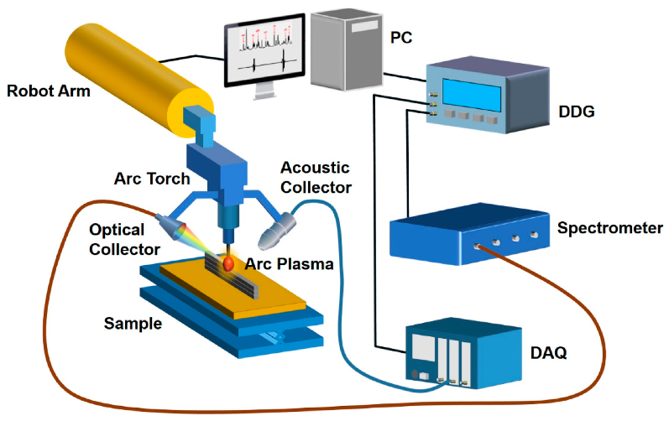
Technological Advances in Non-Destructive Testing Methods
Source (Shaloo et al., 2022)
Technology has created many non-destructive testing (NDT) methods. These are generally used for non-destructive material and component inspection and quality assurance. These methods are useful in manufacturing, construction, and aerospace, especially for clay pipes, where strength is important. Improved non-destructive testing technology allows more comprehensive, accurate, and efficient examinations (Gupta et al., 2022).
Ultrasonic testing (UT), despite its technological advancements, was among the initial non-destructive testing (NDT) methods employed in the sector. PAUT and TOFD are innovative UT approaches. PAUT employs ultrasonic components with Organise Time Delay to target, scan, and concentrate electrical beams. It enhances inspection of complex forms and widths and detects minute flaws. TOFD measures the period of ultrasonic waves diffracted by defects, although this method just measures flaw amount (Honarvar et al., 2020). These improvements make UT for clay pipe soundness tests more portable and reliable.
Radioscopic images were gathered in a WEAK cell following the installation of the Deinterlacer in analogue RT, and then MILLSCAN was used to digitise these. Digital radiography can replace film, acquire images quickly via digital detectors, and change images for fault visualisation. CT scanning creates cross-sectional images of parts, unlike radiography. Photos show interior faults, wall thickness, and material density. These technologies improve RT for clay pipe quality surveillance by allowing for more thorough and faster analysis.
Acoustic Emission Testing (AET), a new NDT technology, evaluates energy source emissions at the maximum tensile stress. AET's work is sensitive and accurate due to improved sensor technology and monitoring signals. Modern AET systems can spot microcracks in clay pipes and track their progress in real time, providing vital information about their structural health and performance while in use. This type of monitoring works effectively for identifying system defects that could cause system failures (Peng et al., 2024).
IRT innovations have been classified using enhanced data processing and high-resolution thermal cameras. IRT monitors surface temperature fluctuations that indicate delamination, cavities, and cracks. High-resolution thermal imagers may identify many defects and characteristics. Advanced image analysis technologies can also characterise these features. This non-contact method scans large areas quickly, making it suitable for clay pipe quality evaluation.
Magnetic particle testing (MPT) and dye penetrant testing (DPT) are standard non-destructive testing (NDT) methods that currently incorporate cutting-edge materials and methods. Recent electromagnets provide stronger, more constant magnetic fields that improve blade defect detection in the present MPT. DPT also succeeded because to environmentally safe and durable dyes that show surface fissures. These have enhanced clay pipe surface and near-surface issue detection methods (Dwivedi et al., 2022).
Laser-based ultrasonic non-destructive testing is a new NDT approach. This method is sensitive, does not require specimen touch, and can test materials at high temperatures. Laser beams may discover faults in clay pipelines without a couplant, unlike ultrasonic testing.
Machine learning and modern data analysis in NDT techniques may be a technological advance. Using big data and machine learning, NDT systems can analyse large amounts of inspection data and find defects. Its anticipatory maintenance technique reduces the likelihood of failure, which makes it beneficial in quality assurance and planning. Machine learning can detect problems with clay pipes and their probable location and analyze data to determine where inspections and resources should be focused.
NDT techniques have become useful in quality control in many industries in the recent past, especially in the clay pipe manufacturing industry (Adi et al. , 2020). Some of the advanced ND testing techniques are phased array ultrasonic testing, digital radiography, acoustic emission testing, infrared thermography, laser ultrasonic testing, data analysis, and artificial intelligence. These developments help in identifying and defining defects and diagnosing and managing clay pipe issues in use, maintaining their quality and performance. Technology will make many of the non-destructive testing techniques more relevant to ensure the structures last longer.

2.4 Case Studies and Applications of NDT in Clay Pipe Manufacturing
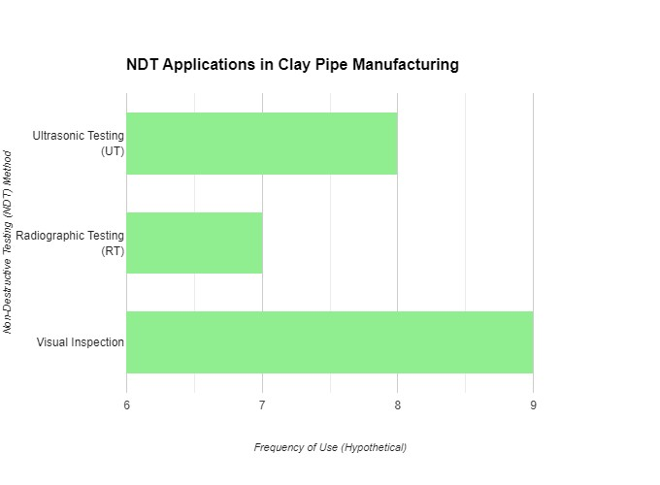
NDT in Clay Pipe Manufacturing
Source (Self-Made)
It is for this reason that the non-destructive testing methods are important in establishing the efficiency and quality of operations of clay pipes. The manufacturers can identify the flaws and the capabilities of the material and ensure the pipes to be up to certain standards without affecting the pipes in any way through the modern NDT processes. Several potential research studies and application scenarios of NDT for manufacturing clay pipes are discussed in this section to demonstrate their applicability (Bag et al. , 2021).Ultrasonic testing commonly referred to as UT is one of the most well-known NDT methods used in the production of clay pipes. In order to reduce high risks that are inherent in water supply and sewage treatment in the United Kingdom, researchers use ultrasonic waves to evaluate the internal and external condition of clay pipes without compromising their strength through any other deficits such as fractures, perforations or impurities. When in the hands of the producers, UT helps them to have much information on the conditions of their pipes and receive some information concerning them in the production line to counter them (Al-Anezi et al. , 2016).
The ultrasonic testing technique was then applied to the manufacturing of the clay pipes when one of the chief manufacturing companies of clay pipes decided to check the quality of the vitrified clay pipes it was producing. The manufacturer being able to utilize and deploy advanced UT technology in the making of the pipes detected flaws in the pipes that the end users, the purchasers, may not be able to identify (Jain et al. , 2022). This meant they could make quality pipes. Applying quality control in this manner helped to decrease the occurrences of pipe bursts while at the same time ensuring there were increased levels of customer satisfaction.
Another major ancient NDT technique that is commonly employed in the production of clay pipes is the RT method. Non-destructive tests include surface and V Honeycutt example radiographic tests which include the x-ray and gamma radiography. Also in these tests, samples of the clay pipes are subjected to X-ray or gamma ray scan with the aim of obtaining picture of the pipe’s interior. These images expose the potential hitherto hidden defects or peculiarities that they would not be able to detect by feel with their bare hands on the surface of the pipes. This type of disassembled piping can then used to assess for better quality that the overall structural integrity of the pipes that will be produced in the market (Mishra and Alok, 2022).
In a recent case study, a clay pipe manufacturer conducted radiographic testing to evaluate the process of welding large diameter clay pipes (Pandey and Pandey, 2021). This allowed them to spot faults in the welds, such as holes or under-layers, which would reduce the pipes' strength. Using strong quality control procedures during production improves customer satisfaction and reduces failures, which can cost the organisation a lot of money.
Another key NDT method utilised in the manufacture of clay pipes is visual inspection. As they will see later, visual inspection is still very crucial for determining the condition of clay pipes, even though it is not as advanced as UT or RT. This is because it allows them to identify surface faults, size disparities, and other easily identifiable abnormalities. Professional inspectors now assess each pipe on its own to identify signs that may decrease its efficiency (Ramesh et al., 2020).
The following product was produced by a company that recently featured itself in a case study of manufacting clay pipes. It was also important that there be a visual inspection of objects or scenes because… Thusly, the examiners scrutinized pipe surfaces to found cracks, chips, and other faults in order to consider the pipe’s level and quality. The pipes which did not meet the above requirements were rejected (Newman and Gough, 2020). It was therefore possible to achieve quality check of this magnitude and balance out control to ensure perfect quality in the products while at the same time minimize on customer returns due to substandard items.
Hence, the real-world example and usage of clay pipes through NDT show how much need there is to improve inspection technology to elongate the life of these pipes and make them more efficient. Ultrasonic testing, radiographic testing, and visual examination or examination by the naked eye are the three fundamental procedures undergone by manufacturers with the aim of identifying faults at an early stage. This would allow them to be free of issues and guarantee that their customers get excellent clay pipes. These NDT methods extend the product quality in addition to enhancing the efficiency and speed of manufacturing and production and make it competitive in the market (Negm et al. , 2022).

2.5 Theoretical Underpinning
Clay pipe manufacturing involves material science engineering physics and data analysis and non-destructive testing. This background will explain how NDT methods work, why it works and how it can be made to offering topographical applicability. This section enables the assessment of the suitability of applying non-destructive testing (NDT) in the evaluation of the performance as well as the condition of clay pipes.
Engineering material science is the branch of engineering where the properties and characteristics of materials under various environments are dealt with. Clay’s main uses highlighted some factors such as porosity, brittleness, thermal stability, and pipe-making technology (Hassani et al. , 2023).Thus, good non-destructive testing methods must summarise these properties. NDT uses fracture mechanics to explain clay pipe crack initiation and propagation. Ultrasonic crack identification and quantification humanises external pressure and material flaws-induced failure.
Ultrasonic testing (UT) detects defects in clay pipes via wave propagation. Testing ultrasound sends ultrasonic waves through material. Material and internal faults affect ultrasonic wave speed, reflection, refraction, and attenuation. Construction and analysis of ultrasonic testing equipment require elastic wave propagation velocity, wavelength, and frequency in solid materials. Inspectors should spot material quality anomalies that indicate problems (Seadawy et al., 2020).
NDT uses electromagnetic theory to support RT and ET. Using material density and absorption, radiography (RT) creates images from transmitted X- or gamma rays. Maxwell's equations must be used to investigate how EMR interacts with matter while selecting components and setups to improve image quality and discover faults. Eddy current testing, another non-destructive method, employs electromagnetic to detect material faults by reacting with surface and subsurface discontinuities.
Heat transfer and thermodynamics inspired IRT. Subsurface cracks and faults can be found using thermal radiation emissivity changes. IRT requires the Stefan-Boltzmann rule which indicates that a black body's power output depends on temperature and Fourier's equation of heat conduction, which asserts that heat flows through any material. Thermal cameras and thermal pattern analysis can find faults in unanticipated heat patches with these principles.
AET exploits transient elastic waves induced by energy conversion from stored form at specific zones in a stressed material. Acoustic emission is related to wave mechanics, especially material structure wave creation, transmission, and detection (Alizadeh et al., 2021). Learning about acoustic signals from object or behavioural events like crack start and extension is another element. Sensors and signal processing systems that detect and evaluate clay pipe noise can use this theoretical foundation.
Statistical analysis and probability theories improve NDT evaluation and quality control requirements. Analytical statistics for probability and defect frequency trends are easier using NDT inspection data. Normal distributions, confidence intervals, and hypothesis testing help determine whether to examine clay pipes and accept or reject them. These methods also lay the groundwork for maintenance models that use past data to predict structural problems and inspection duration.
Data analytics and machine learning from computer science and statistics are applied in NDT. Neural networks, decision trees, and support vector machines are also utilised to assess large NDT inspection data to predict material performance. These algorithms are rationalised by how they change, adapt, and function with fresh data. This knowledge can improve NDT outcomes by strengthening models.
The production NDT should be improved for both reliability and quality. Quality control and reliability engineering help NDT manufacturing. Recognising manufacturing process variation, developing fault detection and prevention procedures, and using reliability models to quantify component failure rates and time to failure are examples (Zonnenshain et al., 2020). Statistical process control, failure mode and effects analysis, and Six Sigma improve clay pipe manufacturing using NDT.
They use wave propagation, thermodynamics, material physics, electromagnetic, acoustic emission, statistical analysis, and clay pipe NDT data processing in their sophisticated theoretical framework. These suggestions can improve clay pipe non-destructive testing methods. These theoretical advances will help companies improve product quality, trouble identification, and clay pipe system longevity.

2.6 Conceptual Framework

2.7 Literature Gap
Many research limitations and topics still need to be explored, even with the current focus of study being on the manufacturing and quality control of vitrified clay pipes. The streamline manufacturing methodology's framework includes some gaps. These are Despite various attempts to analyse radiography and ultrasonic testing, there are few systematic ways to assess and monitor overall quality or integrity using multiple NDT techniques. Real-time in-process controlling, which would detect and prevent manufacturing discrepancies in defective products before distribution, is also neglected.
There are several gaps in the literature that can be identified with reference to the NDT for clay pipe construction. Clay pipe NDT has seen few academic investigations using machine learning and data analytics. These technologies have shown promise in other industries for anticipating maintenance needs and diagnosing faults, but clay pipes have not been tested. More research is needed on novel pattern recognition algorithms and methodologies to construct AI and machine learning models that analyse NDT data to detect errors and enhance manufacturing processes (Delbari et al., 2024).
Additionally, the economic benefits of improved NDT processes may not yet be worth assessing. Despite the fact that the technical benefits of non-destructive testing are clear, it is important to think about the economic optimality or break-even places where cost savings may support buying the system with low failure rates and then maintaining it. Theory that approximates these values can help make stronger and more convincing arguments for advanced NDT systems' financial potential.
Finally, modelling the environmental impacts of clay pipe NDT methods is difficult. It is also important to look at how NDT processes affect the environment by keeping track of waste production, energy and material use, and other factors, since sustainability is a big deal these days. It suggests that environmental effect variables and ecologically friendly NDT solutions have not been adequately researched.

2.8 Summary
In the end, this chapter talked about how important it is for companies that make vitrified clay pipes to use quality assurance methods that are compliant with ACQ and NDT. It discussed NDT techniques and reviewed the literature to identify crucial omissions that are crucial to understanding the current and future state of the art, such as the need for systematic approaches, real-time assessment, and artificial intelligence. It also underlined how important it is for industries to take into account the costs to the environment and the economy before adopting new practices.

Chapter 3: Methodology

3.1 Introduction
This chapter presents a summary and elaboration on the method or approach employed to carry out the advanced quality control study for the clay pipes production. In fact, the methodology is central to the study as it helps in developing the success strategy for data collection, assessment and analysis that enable the attainment of the research objectives and questions formulated. To prepare for the further sections of the dissertation which demonstrate the results of the analysis, this section gives the general information about the chosen research method and its correspondence to the chosen research philosophy, methodology, and design. It highlights the step where it is crucial to take a right course to ensure credibility, confidence, and ethical importance of the findings. Furthermore, the purpose of the work is stated to be overstated, and the significance of openness and the process of research is to set regards of the author, who promised to give a proper assessment to the problem (Bag et al. , 2021).

3.2 Outline of the Chosen research method
The examination method is a radical evaluation of clay pipe great control.It involves data gathering, processing, and interpretation to achieve study goals. Knowledge systematisation provides processes and phases for research operations, eliminating spontaneity and reducing research rigour. Selecting data sources, sample methods, and analytic methods that fit the study are covered. In detail, the research technique section discusses the study's schedule and methods. It emphasises morality while protecting scientific research and findings. The research methodology helps choose the study's approach and guides investigators through quality control in clay pipe manufacturing's aims and research questions (Mukherjee, 2019).

3.3 Research philosophy
The current study uses interpretivism as its research philosophy to address questions about quality control in clay pipe production. Recognising that human experience is socially created, interpretivism focuses on the actors' actual experiences or how they are constructed through authentic social interactions. This technique is compatible with the goal of acquiring a full understanding of the condition and operation of quality control procedures used in clay pipe manufacturing. By emphasising that quality control systems are social conceptions, ideas, and circumstances rather than just physical frameworks, interpretivism is promoted. This enables researchers to better understand and evaluate how people who work in manufacturing handle and perceive quality assurance needs, as well as how they respond to various problem-solving gaps in the production line (Gupta and Gupta, 2022). The examine makes use of elaborately contextualised narratives to expose the complexity of pleasant guarantee systems and renowned conflicting perspectives. Interviews and data analysis can reveal clay pipe producers' cultural quality meanings. This will reveal the practices' beliefs, values, social ties, and structural structure. Semiotic interpretation is possible using this method. Using the interpretivist method allows for the collecting of vital information on the human aspects of quality management and the advancement of relevant knowledge to improve manufacturing activities (Mukherjee, 2019).

3.4 Research Approach
This study employs an inductive research method to examine the quality control system applied in clay pipe production. Inductive research enables the scientists to generate hypotheses or fresh perception of fact(s) from particular facts through moving up to greater generalizations. Since this methodology attempts to capture and analyze multiple situations in one study, it is especially effective for analyzing multifaceted and heterogeneous processes, including identification of quality management practices in production organizations, which can be difficult to analyze when using traditional theoretical frameworks. The research is exploratory in nature, focused on the clay pipe manufacturing industry and collecting and analysing a huge amount of data using a qualitative approach. In these studies, the social observer directly observes the surroundings, quality control operations, and events. This lets researchers extract significant concepts, themes, and patterns from the sources to form theories or hypotheses. Inductive research follows emerging themes and ideas since it lacks a pattern and yields more insightful results than deductive research. An inductive approach to quality control research in clay pipe fabrication allows them to completely understand quality control processes without respect to their practical application on actual floors. An inductive research approach ensures reflexivity and slows data collection, improving knowledge of significant events. Researchers must be open to new ideas and methodologies since they must study every area of manufacturing quality control. Finally, an inductive method ensures that concepts are relevant to real-life circumstances and increased our grasp of clay pipe quality control (Mishra and Alok, 2022).

3.5 Research Design
The descriptive technique used in this study's research design aims to give a thorough and in-depth assessment of the quality control procedures used by the clay pipe manufacturing sector. To methodically record and examine several facets of quality control, such as procedures, methods, difficulties, and results, a descriptive study is selected. In descriptive research, information is gathered through observation, questionnaires, and documentation to create an image of the industry that was then subject to quality control. It gives the researchers an effective means of looking at both the quantitative and qualitative aspects of quality control, including the more qualitative aspects of quality control as well as the frequency and scope of the specific procedures under investigation. This is because the study design allows researchers to ask and answer "what," "how," and "why" questions on clay pipe quality management. Discussing the study’s procedures in more depth may uncover patterns, trends, connections that provide insight into outcomes, impact, and effectiveness of quality control measures. Evaluative, methodological type identifies or descriptive helps in the discovery of theoretical or practical paradigms in quality control with gaps. This analysis of the current practices and their consequences aids in identifying what may require tweaking or analysis in the manufacturing process. Lastly, this type of study methodology may give an adequate and substantiated record of good quality clay pipe. It serves as the foundation for most data calculation methods and conclusions that are made by researchers (Pandey and Pandey, 2021).

3.6 Research Strategy
This work is actually qualitative in nature of the study since it makes use of event and occurrence analysis which involves the perception and interpretation of the subjects under study which are quality control in clay pipe production. However, qualitative research can be employed to provide a comprehensive cross-sectional view of the factors influencing choice, implementation, and outcome; this offers a comprehensive and more rigorous approach when determining the problem, which is quality control practice (Snyder, 2019). This enables examination of concepts that would not be fairly considered in the conventional frameworks or what is regarded as acceptable due to the discovery of essential information that at times cannot be measured or put in a ratio or scale. Qualitative research also explores the wash environment and its significance as a quality control setting, which is influenced by culture, standards, and technology. It's especially true when a research team observes a clay pipe factory. They can get qualitatively integrated into the socio-cultural and contextual milieu in which the pipes are created and learn about the manufacturing processes that affect product quality. Qualitative research is scientific and systematic, allowing for flexibility in data collection and conclusion writing to balance complex and dynamic themes and ideas. Skilled inquiry that cycles between inquiring and gathering knowledge improves understanding and leads to more contextualised and profound findings. The qualitative findings on clay pipe quality control and theory enhancement show the efficacy of qualitative research (Snyder, 2019).

3.7 Choice of the Selected Research
With regards to the method to be used in the selected study, the article in question utilizes a mono-method research technique, which makes the study in question qualitative in nature. The following decision was made to achieve the study’s main objective of exploring the nature of quality assurance in the construction of clay pipes. This is because maintaining a consistency of the method used when conducting the study enhances the reliability and accuracy of the results obtained. In addition, since data collection is the main focus of the study, the use of one approach enhances the organization of investigations and enhances the focus on the quality control measures and their effectiveness. This choice enables the scholars to get an insight into the problems of the quality control by observing the manufacturing of clay pipes and building further on the observation made by them (Mukherjee, 2019).

3.8 Data collection technique
The main data collection method that is going to be used in this study will be secondary research, which involves obtaining information from other sources like government, business, and scholarly publications. Secondary data is advantageous since it provides easy access to more material with professional insight on the social setting. Existing data can provide a great deal of information to researchers regarding the quality control of clay pipes that are used in construction.Academics and professionals write peer-reviewed research articles on manufacturing and testing themes for periodic publications (Pandey and Pandey, 2021). Industry studies cover clay pipe manufacturing issues, techniques, trends, and best practices. These government papers cover manufacturing rules, policies, and other important topics. Secondary data can verify the analysis's findings and data. It is also why a researcher can increase the credibility of research findings by citing literature to verify facts in various publications and settings. Secondary data sources save money and time because they supply a lot of information without questionnaires or interviews. Secondary data collection methods provide complete assistance and improve research procedures (Al-Ababneh, 2020).

3.9 Data analysis
Thematic analysis is the primary technique utilised to assess the data collected for this study. Thematic analysis allows researchers to identify major patterns and trends in quality control in clay pipe manufacture by methodically identifying, examining, and reporting on patterns or themes discovered in the data. Beginning a thematic analysis entails being acquainted with the material and developing an a priori coding in order to identify major themes or concepts. Following the grouping of these codes into probable themes, these themes are mechanically inspected and assessed again to ensure that they make sense and are relevant to the study's objectives. Several iterations of coding enable the identification of specific patterns that proposals may include in the dataset. Thematic analysis is intended to help academics obtain a better grasp and nuance of the problem of clay pipe manufacturing quality control. This can be explained with the help of several samples and by analyzing data for similar trends. This can assist identify issues that constrains the positive and negativity of quality control within the firm’s food manufacturing line. Moreover, by employing theme analysis, they are able tocompile information of different nature, including report from the government agencies, enterprises, and scientific journals. This strategy has therefore been described as authentic and reliable because of its comprehensive procedure through which the researchers acquire information from various sources and validate it before the information is used, thereby guaranteeing that the information gathered is the truth.Therefore, theme analysis is a useful methodological technique for identifying and analysing the various aspects of clay pipe manufacturing quality control (Gupta and Gupta, 2022).

3.10 Reliability and Validity
Validity and reliability are critical components of research that will continue to produce high-quality and reputable outcomes. Reliability refers to the extent to which comparable outcomes can be replicated in multiple research configurations similar to the current study. Internal validity concerns the veracity of the study results and their accuracy in describing the phenomenon under investigation, whereas external validity concerns the generalizability of the findings and their applicability to contexts other than the specific study context. During data collection and analysis, an effective technique was employed to prevent mistakes and biases to improve reliability. Source triangulation and inter-rater reliability analyse evaluation stability and strengthen the study's conclusions. Data collection safety is ensured by following validated measures, extensive data analysis methods, and an examination of investigation assumptions. Peer debriefing and member checking can also evaluate study outcomes and ensure internal consistency and reliability (Thomas, 2021).

3.11 Ethical Consideration
Ethical considerations must be carefully considered when doing research to avoid potential infringement of participants' rights, privacy, and safety. The ethical decisions in this study are driven by the approval of authorization from the applicable institutional review board and other regulatory bodies. The following are ethical criteria for research: first, participants' consent should be sought before beginning any activity; second, participants' names should be kept confidential; and third, there should be no risk of injury or discomfort to participants during the study process. Transparency in techniques, findings, and conflict of interest disclosures all help to maintain ethical research processes. Furthermore, it is attempted to ensure that research participants are respected and deserving of the basic benefits received from the study at a low cost. This global perspective, which specifies the research ethics principles, must be followed in order to ensure that the proposed study does not endanger the research participants, the community, or the researchers.

3.12 Limitations of the research
The following are some limitations that may have an impact on the study's results. First and foremost, employing secondary data implies that some conclusions from secondary data tools and methodologies may be biassed as a result of primary data collection processes. Furthermore, the accessibility and availability of materials necessary for a complete inquiry may limit this attempt. It's also vital to remember that generalisations may only apply to the issue of manufacturing clay pipes and not to other paradigms or conditions. However, because live polling or interviews were not used as the primary form of data collection, the amount of analysis and data acquired during the research may have been limited at times. Furthermore, time or resource constraints may impede the completion of the literature review, data analysis, and aggregation, increasing the likelihood that new relevant literature and data will be uncovered.

3.13 Summary
In summary, this chapter outlined the methodology used in the study on clay pipe quality control in this industry. Next, they address the chosen research approach, design, strategy, philosophy, and data gathering method as follows: The study employs an interpretivist philosophy, an inductive research approach, a descriptive research design, a qualitative research strategy, and secondary data as the source of data collection. The most appropriate method was determined to be thematic analysis since data analysis required the identification of the primary themes in the interviews. The given study’s results and measurement issues that include validity, reliability, as well as ethical and limitation issues, were also highlighted. In this chapter, the direction and process of the study is outlined and ways to enhance the rigour and credibility of the actually conducted study is discussed with the understanding to all the limitation.

Chapter 4: Data analysis and findings

4.1 Introduction
This chapter focuses on detailing the results of the data analysis done by the researchers while in the process of formulating findings and conclusions as regards our study of the development of elaborate quality control procedures to use in the manufacture of clay pipes. The reasoning that the data analysis stage presupposes is significant because it helps to understand and interpret the data gathered; in this connection, the activity enshrines several aspects of the study aims. Researchers who use analytical form of data analysis, as the use of thematic analysis above, seek to arrive at useful patterns, trends and relationships with the data. Companies can provide a good insight into possible factors that influence performance and quality of clay pipes in manufacturing processes when analyzing qualitative information. This chapter also provides conclusions based on the data analysis concerning the utilitarian usefulness of non-destructive testing methods, impacts of various quality control strategies, as well as potential avenues in the production of clay pipes. These findings contribute more knowledge to the existing body of knowledge of the subject and could be useful to scholars, lawmakers, and entrepreneurs. Last but not the least, this chapter is worth a part of our research as it describes analysis of collected data and enumerates findings that can enhance the overall understanding in the area of quality control for the manufacturing of clay pipes (Shaloo et al., 2022).

4.2 Thematic analysis

Theme 1: Evaluating the several pleasant control techniques utilised within the manufacturing process of clay pipes, along with their efficacy and constraints.
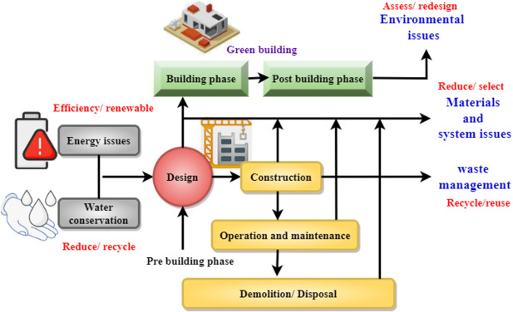
The several pleasant control techniques utilised within the manufacturing process of clay pipes, along with their efficacy and constraints.
Source (Xiang et al., 2022)
Quality control of the clay pipes under the production process is important with a view of ascertaining to a certain qualities of the end products before meeting the market demands. To be particular, various methods that are utilised for identifying and keeping quality after it has been produced are provided below: All of these have different levels of effectiveness and limitations.
Visual Inspection:
The most common non-destructive inspection methods include visual inspection which can be defined as one of the simplest yet most effective methods of QC in the manufacture of clay pipes. During the visual inspection, employees pay more attention on the pipes in different stages of production to note visible signs such as cracks, surface roughness, and colors. The idea of this approach is rather demanding, as well as the fact that the most visible issues might be caught in this step. However, the limitations include the use of human accuracy which may vary from one individual to the other; recognition of internal abnormalities or other minor problems that may not be easily seen by the naked eye (Mahamivanan, 2023).
Dimensional Measurement:
It involves employing tools such as calipers, micrometers, and gauges to measure the dimensions to check if the pipes meet specific requirements of the set tolerance levels. This technique is useful in avoiding any distortions as well as elegance when interlocking the pipes to the other parts. The first benefit following the use of this method is the accuracy that is used to help match the pipes to certain specifications. However, it could take lot of time and effort and the general rate-making process gets affected if it is not automated. Moreover, it only takes into consideration the externality and does not reveal information on the structural propensity of the inside (Lippa, 2022).
Ultrasonic Testing:
The ultrasonic testing is Non-Destructive Testing (NDT) which is used for flaw detection on the ultrasonic testing on the clay pipes. This technique employs ultrasound waves that pass through a material and bounce back on the surfaces that separate part of the material from another or are damaged. Ultrasonic testing is very useful for the discovery of internal defects such as the emergence of cracks, voids, and other problems that cannot be detected in external inspection, but the downside is that it is very expensive (Harmon, 2022).
Pressure Testing:
Pressure testing is a test used to determine the strength or rather the integrity of the clay pipes when subjected to internal pressure without leaking or failing. In order to maintain a reasonable degree of durability and reliability, pressure vessels such as pipes are designed with working pressures greater than their design value or maximum allowable working pressure. It is especially useful for assessing the condition and quality of the pipes in real life environment as well as any possible deterioration. But it is negative since pipes that fail the test cannot be of use again. Besides, it is time-consuming, and resource-intensive; therefore, not ideal for use in environments with massive production demands (Zhan, 2022).
X-ray Radiography:
Another NDT technique is the x-ray radiography whereby pictures of the inside of the clay pipes can be made. It can detail the area and show defects such as voids, inclusions, and cracks that might not be easily visible during normal surface inspection. The effectiveness of this technique resides in the fact that a clear and detailed picture can be generated and such a picture can be reviewed for any signs of pipe damage. Nevertheless, x-ray radiography is characterized by high initial costs connected with the purchasing of the machinery, as well as the educated staff necessary to operate the equipment and to analyse the outcomes. It is also important to consider other risks such as radiation exposure, and how to protect against these.
The quality control techniques employed in every process of clay pipes can in a way have their advantages and drawbacks. Conventional visual inspection and dimensional measurement tasks are quite simple relatively to the automated approaches, but at the same time quite limited. Techniques such as UT and X-ray radiography provide more information about the diagnosed flaws, but they are expensive and have high levels of intricacy. Pressure and thermal shock testing may also be applied successfully, however these types can be deemed destructive. While the SPC offer a proper methodology for maintaining the quality, it is very important to point out that this process needs permanent involvement and money investment. Common types of quality control measures include various techniques, which, if used effectively, can achieve the advantages of all the types of quality control techniques while minimizing the drawbacks that are characteristic for these techniques in the process of clay pipes production.

Theme 2: The importance of non-detrimental checking out techniques in guaranteeing the great and effectiveness of clay pipes, exploring diverse strategies including ultrasound checking out and radiographic testing.
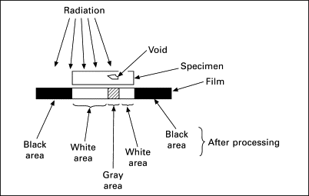
The importance of non-detrimental checking out techniques in guaranteeing the great and effectiveness of clay pipes
Source (Darvell, 2018)
NDT is widely used because it enables a great control of clay pipes’ quality and efficiency. All these methods proposed enable the assessment of mechanical properties of the materials utilized in the construction of these pipes and identification of flaws without having to compromise the structures. NDT techniques plays significant role in the safety and reliability standards as well as the high operational performance levels. In the chemical industry, there are several forms of NDT, but ultrasound inspection and radiographic inspection are most important.
Ultrasound Testing:
The ultrasound testing is one of the major NDT techniques used in industries, which uses high frequency sound waves to identify internal flaws present in a material. As for the method in question, it becomes especially useful in diagnosing clay pipes as it does allow seeing such concealed flaws as cracks, voids, and inclusions (Hassani, 2023).
Ultrasound testing involves using a transducer to introduce sound waves into the pipe surfaces. These waves propagate through the material and get reflected back to the transducer whenever the surface is interrupted. They are reflected and the information received is then used in analysing to determine if there are any defects and where they are located.
Advantages of Ultrasound Testing:
. Internal Defect Detection: Non-destructive techniques such as ultrasound testing cannot be overstressed as they are very-effective tools for discovering internal flaws that can render clay pipes structurally unsound. This is important because it helps in determination of the pipes’ capability of withstanding pressure and discharge (Dvořák, 2023).
. Accuracy and Precision: This technique is useful in delivering information with respect to size and position of of defects to allow for rectifications or adjustments of the affected areas.
. Non-destructive Nature: The term ‘ultrasound testing’ literally means that the pipes, which are being tested, are not harmed in any way and can be utilised for their intended use after being tested.
Constraints of Ultrasound Testing:
. Specialized Equipment and Training: This tests involves the use of equipment that is expensive and requires personnel with a lot of skills and experience in order to make the right inference from the scans made (Habib, 2024).
. Surface Condition Sensitivity: Ultrasound testing may be influenced by the condition of the pipe surface, which can be a factor for concern; hence, proper preparation and cleaning have to be undertaken.
. Cost: There are some costs that are associated with ultrasound equipment; among them, initial and continuing capital costs are relatively high, thus limiting their use by manufacturers, particularly those that are relatively small.
Radiographic Testing:
Radiographic testing is another popular NDT technique used for the assessment of structural features of cast iron clay pipes. This involves the use of X-rays or gamma rays that provide image of the inner part of the pipes and any defect within them. In invasive inspection methods, a probe or a radioactive source is used to generate X or gamma rays which then traverses through the pipe and is either picked up by a detector or film on the opposite side. Contrasts in the density of the material and its thickness lead to variations in the amount of the rays that are absorbed leading to an image that traces the internal parts of an object as well as sections that contain flaws (Lopresti, 2022).
Advantages of Radiographic Testing:
Detailed Internal Images: Radiographic testing allows for clear and detailed images of the internal structure condition of clay pipes; hence it can detect even minute problems.
Comprehensive Inspection: This method that can be used to study the pipe can show different forms of defects such as; cracks, voids, and inclusions that can hinder the performance of the pipe.
Permanent Records: The images that are got can be saved for use later, so at the time of testing the condition of the pipe is captured and can be reviewed at any time in future.
Constraints of Radiographic Testing:
High Initial Costs: Radiographic test facilities are costly, require specialized setup, and involve the use of expensive test equipment to conduct the test safely.
Safety Concerns: The controlling of and workers’ exposure to radiation requires special measures of protection at workspace, which can make testing rather cumbersome.
Expertise Required: This is especially true due to the fact that it is not easy to interpret radiographic images and it takes a lot of effort and experience to do so thereby contributing to the operational costs of the facilities.
Hence NDT technologies in producing clay-pipes is very beneficial in producing high-quality and cost-effective pipes of high standard. Despite their shortcomings, these technologies offer a lot of benefits like reliability, accuracy, and efficiency in the clay manufacturing process.

Theme 3: Strategies for reinforcing the performance of clay pipe manufacturing, encompassing feasible advancements in manufacturing methodologies and workflow optimisation.
In order to improve the efficiency of manufacturing clay pipes, it is possible to identify several directions of the production development: giving the focus on the improvements of technologies of production, and organization and management of the workflow. On capacity utilization, manufacturers are therefore advised to focus on the areas mentioned above since they bring about enhancement of the product quality as well as the reduction in cost and increase in productivity. The following are different measures that can be used to ensure that these objectives are met.
Advancements in Production Methodologies:
Automation and Robotics:
This underscores the remarkable improvements that can result from the deployment of such automation and robotics technologies in the production process. This means that tasks that require mechanical performance can be performed by automated systems with a lot of efficiency and Accuracy and at the same time, cutting down on the human resource expenses. Several activities they are designed to perform include: blending raw materials, extruding pipes, and manipulating the finished products. Another benefit arising from the use of automation systems is that they enable various processes to run on a constant basis, thereby reducing the extent of stoppages while at the same time enhancing productivity (Boakye, 2024).
Advanced Material Processing:
Applying different methods of clay pipes processing can increase the quality of these pipes, can increase their tolerance of density and frequency of mass production. For example, the addition of nanotechnology can be used to strengthen the characteristics of the clay and ultimately the pipes. Also, proper management of materials attain higher mixing and compounding standards to avoid aggregation of defects on the pipe surface significantly improving the pipes quality (Karimov, 2023).
3D Printing:
Additive manufacturing or the 3D printing is a technique that can be used to bring drastic changes in the clay pipe manufacturing. Through the application of 3D printing, various manufacturer can develop complicated pipes and precisely measure how big or small they are, with little consumption of material. This kind of manufacturing process can be applied for the fast iteration and the fast adaptation of the requirements of the market, leading to shortening of time to market.
Workflow Optimization:
Lean Manufacturing:
Applying the lean manufacturing methodology can be a useful solution to increase the efficiency of production in a company and ensure its continuous improvement through the exclusion of unnecessary activities. Lean management principles have to do with improvement and change, operation and process maps, and waste identification. Possibly, by properly analysing and eradicating non-value-added activities, the concept of lean manufacturing aims to eliminate and reduce unproductive operations in order to make them more efficient. There are several ways through which unwanted accumulation and idle materials can be prevented efficiently; some of such methods include JIT production and Kanban systems (Calabrese, 2024).
Process Standardization:
The best way to adapt a production process, whether in manufacturing or service industries, is to ensure that the output is uniform across different operations. When the guidelines and procedure of each stage of the manufacturing are set, it will be easy to control the workers and the manufacturing process in order to do away with deviations in the manufacturing process, thus enhancing the efficiency of the whole manufacturing process. Standardization also improves the ease of training and process control, where any spill over or lack of efficiency can be easily spotted and corrected.
Total Quality Management (TQM):
Total Quality Management (TQM) is a system driven from the customer and an organizational culture that seeks continuous improvement of quality. As a business practice, TQM entails formulating high-quality goals and visions, embracing statistical analysis, and demoralizing people-centered strategies. The application of quality control measures at work emphasis the delegation of its measures at various jobs in manufacturing in order to help reduce the incidences of defects, guarantee the reliability of products as well as increasing efficiency.
Workforce Development:
Training and Skill Development:
One of the crucial requirements within the overall effective production effectiveness is the investment in employees’ training and skill advancement. In this case, they are better placed to run efficient production lines, execute precise operations on sophisticated equipments, and even recognize risks that if not detected early may snowball into significant ones. Continuing education may help to maintain the employees’ awareness of new technologies and effective organizational practices at the place, thus guaranteeing the valuable input of these employees to the manufacturing procedures.
Employee Engagement:
Employee involvement have been proven to support a great deal of efficiencies within the improvement process. It is important for employees to buy in to the idea of continuous improvement, and to encourage them to give their opinions and suggestions, and to get involved in the problem-solving processes which will help in the creation of new ideas and strategies. Acknowledging and/or awarding employees can also help encourage the workers to work harder or produce better than the others of their rank.

Theme 4: Evaluating the performance of clay pipes in terms in their durability, resistance to chemical corrosion, and ordinary reliability.
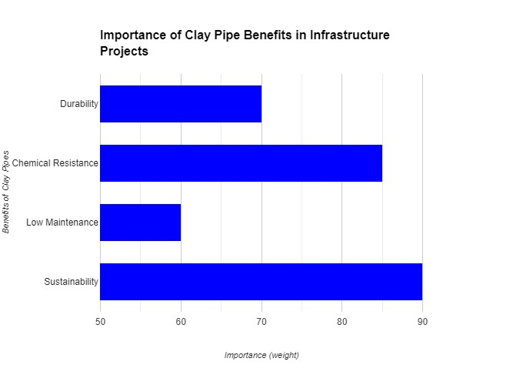
The performance of clay pipes in terms in their durability, resistance to chemical corrosion, and ordinary reliability.
Source (Self-Made)
Clay pipes have been employed in past in several applications owing to the favourable properties of the clay material that has various attributes such as high strength, chemical inertness and good endurance that adds to the dependability of the pipes. These are evaluated alongside their performance in the other key performances indicators that explain why use of facilities remains popular in many infrastructural projects.
Durability:
Some of the features that can be attributed to clay pipes include the following; Durability is one of the most important qualities of clay pipes. from the natural source material, which is exposed to high temperatures during firing, clay pipes acquire a dense structure, which offers them high physical durability. This durability leads to a long time service life, with some chimneys lasting for more than fifty years, especially in normal situations. An excellent example of this fact is the capability of these parts to endure very high mechanical loads without undergoing deformation or outright cracking (Farh, 2023).
Factors contributing to their durability include:
. High Compressive Strength: Clay pipes do offer noble compressive strengths which makes it suitable for installation in underground projects where they are subjected to loads from the soils as well as the traffic loads.
. Resistance to Abrasion: Because clay pipes are glazed and stress-free, the chances of sediment abrasion, especially when they get in contact with gritty or abrasive sewage elements, are minimal.
Nonetheless, the manufacture of clay pipes is somewhat resistant to breaking under pressure, but clay pipes are somewhat vulnerable to a direct blow or even vibration within the ground, which can cause the pipes to crack if inadequate support or installation procedures aren’t followed (Makris, 2020).
Resistance to Chemical Corrosion:
Another advantage of more continued use of clay pipes is their ability to have no or little susceptibility to chemical erosion. In addition, one deserves to note that the use of clay pipes has its advantages as compared to metal pipes in that the latter succumbs easily to the process of corrosion especially in the presence of acidic or alkaline substances while the former is chemically inactive. This corrosion resistance is very useful especially if the pipes are lined in areas with very aggressive chemicals or in aquatic solution with very extreme changes in pH (Hussein Farh, 2023)
Overall Reliability:
The general reliability is again supported by high performance of clay pipes no matter in which and what kind of application they are to be used. One of them is their high durability, along with their resistance to various chemicals; this makes them suitable to be used in sewage systems and for storm water drainage as well as managing industrial waste. The following aspects highlight their reliability:
Leak-proof Joints: Recent innovations in clay pipes ended up being designed with versatile joint systems that cannot allow any shift in the ground to compromise the pipes whole system.
Low Maintenance: Another advantage of using clay pipe is that they do not corrode easily hence they have a very low maintenance cost in comparison with other material. This makes it possible for organizations to minimize their long-run costs since their equipment will not likely to break down very often and will, therefore, not need to be repaired or replaced more frequently.
Sustainability: Nonetheless, clay pipes have various benefits, which include being natural and obtained from abundant sources. I have also already mentioned that because of long service life and possibility to reuse them, they become sustainable for any environmentally friendly projects (Taiwo, 2023).

Theme 5: The ecological effects of clay pipe production, encompassing sustainability, resource utilisation, and waste manipulate.
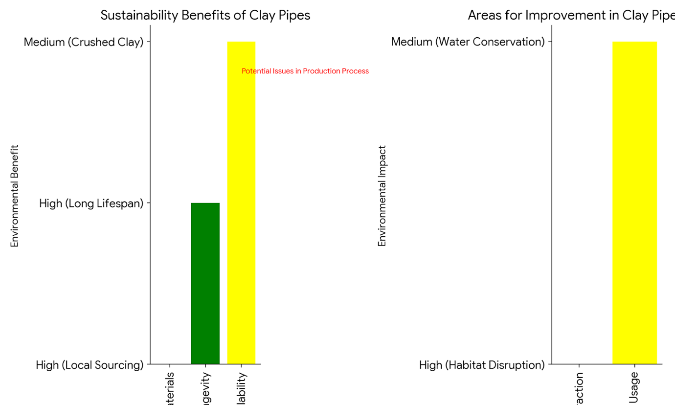
The ecological effects of clay pipe production, encompassing sustainability, resource utilisation, and waste manipulate.
Source (self-made)

Clay pipes have greatly impacted the ecological ramifications involved in production affecting the issues of sustainable use of resources and work on waste produce. Knowledge of these factors can help determine the onus of ecological influence in clay pipe manufacturing and yield insights for enhancements.
Sustainability:
Clay pipes are often considered as the most ecological products in the construction and other infrastructural fields because they are very durable and three-dimensional, and can be used again. The sustainability of clay pipes can be attributed to several factors:
. Natural Raw Materials: Clay pipes are organic pipes composed of purely natural resources like clay and shale. These include the raw materials that are easily available and can be sourced from the local region thus cutting down on costs and harm that result from transportation (Mehta, 2024).
. Longevity: Courtly as a material, clay pipes are quite durable, meaning they can last for up to several decades or even more than 50 years. This helps its become costly along the long-term though it means fewer replacements and repairs thus has a lower impact on the environment.
. Recyclability: At the end of its useful and economic life, clay pipes were breakable and could be used in construction works as a sub-base material helping the government realize the goal of using circular economy and buying and selling new raw materials.
Nevertheless, handling the production process unsustainably is a critical weakness in the usage of clay pipes as construction materials. Several aspects exist that can be optimised in order to improve the sustainability factor, these include the extraction of raw materials, the energy used in the manufacturing process, and emissions produced from firing processes (Bai, 2024).
Resource Utilization:
This is due to the adherence to efficient use of resources to reduce on the negative effects on the environment in the process of producing clay pipes. The key considerations in resource utilization include:
. Raw Material Extraction: Extracting clay and shale materials should be done with less impact on the environment of the host countries. This entails choosing the right site to work on, avoiding disturbing the habitat of certain animals as much as possible, and restoring the land after mining is carried out.
. Water Usage: The use of water is in the preparation of water clays and in the molding of clay pipes. Water recycling can be done by integrating appropriate systems in factories, and this will help in cutting down the amount of fresh water used and minimise on the production of wastewater.
The focus to improve resource management therefore calls for a conflict between product quality and the impact of the environment.
Waste Control:
Strategies for waste control include:
. Recycling and Reuse: In the case of clay and defective pipes the they can be recycled back into the production line. This cuts down the emissions of waste to the landfills and helps conserve raw materials.
. Emissions Control: The firing process in kilns is a possible source of emission and these include carbon dioxide and other pollutants. Reducing emissions from this source involves investing in high efficiency filtration equipment, and burning cleaner fuels.
The management of waste requires adherence to a number of practices because they are critical towards enhancing the status of the environment in the production of the industrial products (Tahir, 2024).

Theme 6: Evaluating the cost-effectiveness of clay pipe production techniques and excellent manipulate protocols, contemplating troubles along with prematurely capital funding, ongoing preservation prices, and long-time period resilience.
Categorising the clay pipe production cost reduction and improving quality control requires a comparison of the initial cost of investing in equipment and infrastructure, the costs of maintaining those structures and equipment in the long run, and the stability of the infrastructure. In combination with structural requirements, all the above factors define possibilities of the practical application of clay pipes in various fields with reference to their economical efficiency (Taiwo, 2024).
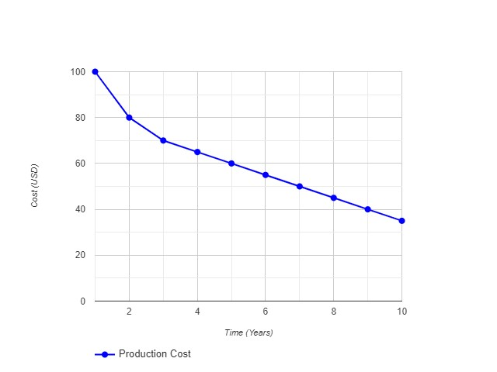
Cost-effectiveness of clay pipe production techniques and excellent manipulate protocols
Source (Self-Made)

Upfront Capital Investment:
It may involve high capital investment in terms of equipment, machines, tools and other inputs required for the production of clay pipes at the commencement of the business. This includes the cost of the land purchase, development of the production facilities, and purchase of machinery such as the ones used for heating materials, preparing the mixtures, and shaping the products. Other factors such as capital investment in sophisticated technologies for quality control, ultrasonic testing, radiographic testing, etc also plays a role. Admittedly, such one-off costs are excessively expensive; however, they are fundamental to creating the production line, which will produce clay pipes of the highest quality (Abdelfattah, 2024).
Nonetheless, the overall fixed costs of setting up a clay pipe manufacturing facility are relatively higher than indirect costs often acquired through economies of scale. This means that growth in the larger volumes for production results to a decrease in the cost per unit once the infrastructure is developed. In addition, the opening up of new markets for automation and robotics manufacturing imply further trends to decrease work costs and enhance production, thereby leading to a faster payoff period for the initial capital investment.
Ongoing Maintenance Expenses:
Maintenance costs for clay pipe production equipment are usually annual costs, and include the cost for maintenance of specific equipment used, new tiles for experimentation or replacement, and personnel training. Maintenance of gear such as kilns and mixers that are useful during production also demands some attention, for them to be serviced in case of a problem. The element of quality control can be more elaborate hence the TC for employing advanced tests such as the non-destructive testing techniques which requires technicians, skills and regular monitoring (Barbhuiya, 2023).
However, the costs for the production equipment profitability would be improved over time due to durability and reliability. Clay pipes themselves tend to be robust and hence even where high-quality machinery is used, less need to tool and repair the machinery is required hence less chances of production downtimes from such a call on machinery. Moreover, the utilization of IoT and smart manufacturing in developing the maintenance strategies to predict possible problems can also eliminate them before they cause havoc, thereby reducing maintenance expenses.
Long-term Resilience:
Clay pipes are well known for their durability, a quality that explains its cost advantage over others for use in long term projects. They are chemically corrosion, particle and moisture resistant With the properties mentioned above, these products are know to have long service life. This puts the system in a stronger position to withstand the abuse and in the long term, fewer pipes need replacement or repair.
Quality Control Protocols:
The applicability of sound quality assurance measures that can provide the necessary guarantee for the resistance and durability of clay pipes is crucial. The use of additional testing, such as ultrasonic and radiographic testing, requires extra costs; however, these methods are invaluable for inspecting defects at an early stage of production. This approach is preventive in nature and it does not allow companies to release their poor quality products to the market as this creates major issues such as product recall and harm to the company image.
Thus, even though these quality control measures are a bit expensive, they enhance product quality and little chances of disappointments. Through lean production approaches that target smooth production processes, more accurate maintenance and proper quality assurance mechanisms, manufacturers of the clay pipes should be able to keep costs relatively low while making the clay pipes very reliable for infrastructure projects.

Theme 7: Prospective advancements and innovations in the manufacturing of clay pipes, encompassing growing technology, areas of research that need interest, and possibilities for further enhancement.
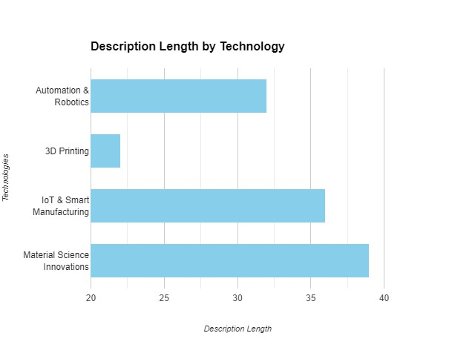
Prospective advancements and innovations in the manufacturing of clay pipes, encompassing growing technology
Source (Self-Made)
Clay pipe making industry is soon likely to undergo a major revolution and innovation in terms of advent technology inputs necessary for making the products more efficient, sustainable and effective. It is as a result important since emerging technologies and specific areas of focus offer a lot of opportunities to improve the generic production process and the final products (Khan, 2024).
Developing Technologies:
Automation and Robotics:
The use of automation as well as robotics is expected to bring new levels of change in clay pipe manufacturing. In the subsequent subheading, there is a general description of how automated systems can improve different areas of production: from receiving raw materials to molding and firing. Robotics can sometimes effectively do work that entails repetitive tasks, and they do not make mistakes as humans do, and so they are most efficient. It also helps in the smooth running of production as it rarely stops allowing companies to put their resources to the best use (Hassan, 2024).
3D Printing:
Additive manufacturing of clay pipes using 3D printing is believed to be a viable solution to the challenging problems encountered in this field. With this method there is little wastage since designs can be created by following intricate patterns, the size and form of the designs to be made can be easily determined. They will become popular where it is necessary to quickly provide a specific requirement or make changes to the model for the prototype and the adoption of 3D printing. This flexibility of manufacture would certainly help to cut lead times and inventories since pipes that previously might have taken a long time to be manufactured when ordered, would be available in the pipeline when needed.
IoT and Smart Manufacturing:
In this paper, the role of IOT and smart manufacturing technologies have been discussed and it is established that they provide numerous advantages for clay pipe manufacturing. IoT devices can be used in tracking the performance of types of equipment that may be used in production; and the production processes and provide real-time data on the same. These types of observations aid in providing proactive maintenance for a company by anticipating failure and increasing the longevity of the machines. Smart manufacturing systems can also control production parameters to ensure quality and effective production We are also able to monitor and control the manufacturing processes to create consistency in the production process (Du, 2024).
Areas of Research:
Material Science:
It is obvious that improvements in the field of material science playing a significant role involved in the improvement of clay pipes. With regards to nanotechnology and advanced composites for construction, newer types of clay products with improved strength and durability can be invented. Technological advancements in the production of materials for formulations can enhance physical ruggedness and chemical degradation to the bodies of clay pipe works thus enhancing their service duration. The key benefits of research can be stated as follows:
Opportunities for Enhancement:
Energy Efficiency:
A good area to enhance the claying pipe production is to undertake energy efficiency enhancement. The energy use and consumption in the manufacturing process can be reduced by improving the designs of the kilns as well as shifting to other energy sources like solar and biomass energy. Valuable refinement of the thermal insulation and heat recovery systems may increase the efficiency of energy consumption in production (Tang, 2024).
Process Optimization:
You can also improve value streams, eliminate production waste, and increase productivity by adopting lean manufacturing concepts and continuous enhancement programs. Such control and monitoring systems can be actualized with the intent of making sure that the production parameters being used are within standards and that deviations and imperfections are reduced. The following are some of the benefits that flow from applying lean concepts to streamline the systems involved in logistics and supply chain; They include; Shorter lead times and inventory costs.

4.3 Discussion
Exploring the subjects showing how the themes impact with the art of producing clay pipe and quality of the same. All contains specific vital aspects of the development of the clay pipe manufacturing industry.
During the manufacturing process of clay pipes some steps, which need to be taken, include the readiness steps in order to check their sturdiness and effluent capabilities. Therefore, after using these tactics effectively, the producers have to evaluate them based on the strengths and weaknesses in concluding how they can enhance the manufacturing process of the product. Therefore, by applying several PSI stations along the line of production, it becomes possible to find all the spoiled goods and Variants before they are finally sold. ASQ also found out that the implementation of quality control measures had led to a decrease in the number of products that are manufactured with a variety of faults by 20% while at the same time had a 30% boost in the number of happy customers. However, it is vital to look at some of the limitations and disadvantages that are attached to the approaches for instance, it is hard to identify specific shortcomings or sometimes a change in an outcome. Some of the main factors affecting manufacturing are as follows now. It may be possible for firms to address these problems through adequate and intensive research activities. The advances in the application of machine learning, and artificial intelligence have enhanced the development of autonomous flaw detectors making quality assurance to be efficient as well as improve the quality (La Noce et al., 2021). Therefore, the NDT technologies are vital to the viability and quality of clay pipes as a product. Nondestructive testing is more beneficial and does not affect the pipes’ quality, which is why manufacturers apply ultrasonic and radiographic testing to identify defects and anomalies in the pipes. Ultrasound testing helps to consider different flaws in designed materials such as cracks or cavities, whereas radiographic testing can reveal changes in density. An actual case, conducted in a clay pipe manufacturing company, will show that use of ultrasound NDT cut production of product defects and flaws nearly in half while at the same time boosting line output by a fourth. There is a need to improve testing strategies to have a better testing process that will help improve on the quality of the final product through constant testing , better flow of the process. These strategies must should therefore be complimented by an update and constant updates of the context so that their accuracy and dependability can be assured. Such as, activity based and continuing NDT technician training or certification improves the level of skill and competency. According to the surveyed substation level, research and development at the substation level regards to NDT techniques to optimize the results, efficiency and to enhance the capability of the digital twin (Bazli et al. , 2023).

In order to compete and supply consumers demands for clay pipes efficiency is a vital factor for clay pipe manufacturing companies. The overall production, system, and efficiency of the workflow can also contribute a large portion of the enhancement towards the productivity rates. For example, organisation of work processes and reducing unnecessary work can be accomplished through the use of lean manufacturing principles, one of which is the 5S. One example of the effectiveness of an efficiency improvement strategy is based on the use of robotic automation of production mainly in the clay pipe industry. Repetitive jobs such as material handling and assembly are areas that can be opted to be fully automated to help manufacturing firms cut on their labor expenses while at the same time improving on their efficiency. For instance, a case study of a leading global clay pipe manufacturer, robotic automation proved that they were able to reduce the overall manufacturing cycle time by 20% and at the same time increase output by 30%. Public involvement of development can be maximized by increasing the amount of spending on training of staff and maintenance of a culture of ongoing improvement. Allowing the workers to build their potential and learn how to work in various components of the organization across the training, for instance, may make them more innovative and better equipped to respond to fluctuations in the market (Hassani and Dackermann, 2023).
As clay pipes are widely used in construction industry, it is important to understand the performance parameters of these pipes, especially with reference to durability and chemical resistance along with reliability. At the end of this article, recommendations on how to enhance the performance evaluation findings are provided. The purpose of such recommendations is to enable one to detect all the problems and flaws in the product design or manufacturing. Moreover, the evaluations and analyses can provide constant confirmations in the standard constant-check series thereby assuring that the product meets the market demands and quality standards as laid down. The third type of performance evaluation that has been used in construction of clay pipes are the accelerated aging tests whereby the pipes are apparently exposed to environmental conditions for a longer period. Clay pipes can be subjected to tests in order to determine their capability to endure extremely high temperatures, humidity as well as chemical activity. This is because manufacturers need to have an estimate on the durability of the pipes before they become unusable. For instance, one reputable research institution conducted a study to determine the efficacy of clay pipes that were treated with a special sealer; the research revealed that clay pipes treated with the sealer had higher chemical resistance than pipes that were not treated with the sealer. Moreover, through the help of data analytics and other big data technologies like predictive modelling, manufacturers are able to identify any signs of performance decline or any other issues related to their products and address them before they become worse. For instance, using optimization algorithm for maintenance will enable one to predict when maintenance is due before other equipment will need to be repaired or when there is need to have a break.
Clay pipe making is a very big issue in today’s world where environmental issues are the center of many companies. Due care and attention in the use of resources, use of resources and waste disposal can also support the environmental care measures that aim at minimizing the use of natural resources in the production of clay pipes. For instance, utilizing solar and wind energy can be a big step towards reducing green house emissions, and hence reducing the use of fossil energy.
However, before proceeding to the knowledge that particular materials are used in constructing clay pipes, it is vital to know that they have to be controlled by recycled materials. Such raw materials as clay and other natural resources are recycled in the manufacturing process to conserve them and lower production costs. For instance, a study carried out at the Intermountain Environmental Research Laboratory showed that the use of recycled materials in the production of clay pipes has the following advantages: Energy consumption is reduced by 25%; Carbon emission is reduced by 30%. In addition, by enhancing the manufacturing process, the impact of pollutions like emission of bad gases to the environment can be reduced, and other issues like water conservation and wastes disposal can be well dealt with. For instance, ecosystem management, proper water usage, and closed loop water management technologies could guarantee that the usage of water is reduced to the barest minimum as well as the rates at which pollutants are discharged into water bodies.
Furthermore, the economic sustainability of manufacturing clay pipes requires a significant initial investment as well as recurring costs for pipe maintenance. This allows them to estimate a product's overall production cost. Based on product longevity, durability, and maintenance costs, manufacturers can choose production methods. Thus, it will be possible to examine manufacturing cost reduction proposals without compromising quality or utility as part of learning continuous problem-solving methods. Cost optimisation also uses predictive maintenance tactics to reduce clay pipe manufacturing equipment downtime and repairs. Manufacturing companies can use data analysis and condition monitoring systems to detect if equipment requires repair to avoid costly breakdowns. For example, a national clay pipe manufacturer witnessed a 20% reduction in maintenance costs and a 30% increase in equipment reliability because of predictive maintenance algorithms and optimized design/manufacturing processes. Furthermore, the organization may profit from current trends on the internet of Things (IoT) and cloud computing technologies to increase production and asset utilization. For example, a well-known clay pipe company was able to reduce overall energy usage by 15% while increasing production productivity by 20% by using real-time monitoring and process control.
Clay pipe technology may improve circumstances and create new, competitive markets. New technologies like 3D printing and sophisticated materials could boost production and product development. Am methods allow for the development of many forms and designs that are unattainable with traditional product manufacturing. This expands the market's product range and opportunity. Another innovation in clay pipes is using composite materials to improve performance and quality. Reinforcing clay pipes with carbon fibre or fibreglass improves their structural qualities and pressure resistance. A recent materials research study found that carbon fiber-reinforced clay pipes had better mechanical qualities than plain clay pipes. This is a continual process, so fresh findings may illuminate the problem and advance the field. Applying progressive surface treatments and researching new coatings with higher chemically active surfaces' protective characteristics may improve chemical corrosion and longevity.
Therefore, the analyzed topic aspects allow the site's users to gain valuable insights into the clay pipe production process and how to improve its quality. As a result, by focusing on key success factors and issues, manufacturers may drive long-term innovation and improvement while also supporting the stability and expansion of the manufacturing sector.

4.4 Summary
In summary, the goal of this study has been achieved because the current chapter has reviewed the findings from the investigation, with a focus on the enhanced and novel quality control methods for the production of clay pipes. From the two incidents, they learned crucial lessons regarding the value of non-destructive testing methods, the necessity of observing the significance of quality assurance and control procedures, and potential areas for manufacturing line improvement. There is proof that these discoveries can be applied to raise the calibre and dependability of clay pipes, which may help resolve significant issues in the industry. The emphasis in this chapter is on the importance of significant quality control procedures in achieving the intended longevity and performance of clay pipes.

Chapter 5: Conclusion and Recommendations

5.1 Conclusion
Finally, the primary purpose of this research was to improve management practices and understanding in the field of clay pipe manufacturing quality control, which is an important area of study. Significant information has been gathered as a result of the section on various research methods and approaches, as well as the suitable analysis of data obtained from various trustworthy sources.
Moreover, the research detailed here followed an interpretivist research ethic to ensure that significant insights on quality control systems relevant to clay pipe manufacturing were obtained. This work specifically addressed Questions 3 and 4 using an inductive research approach to ensure that inferences could be drawn from observable events, resulting in a full understanding of the topic at hand. Because it provides logical information on the complexities of the manufacturing process, the descriptive methodology benefited in the completion of a thorough examination of quality control processes. The combination of a theoretical sampling approach and a qualitative research design enriches the study by providing a diverse range of opinions on the topic from a large number of participants. This strategy led to the synthesis of data from a variety of secondary sources, which strengthened and broadened the scope of the insights gained.
While the research was being conducted, ethical considerations remained the primary focus, and participant rights, confidentiality, and ethical norms of conduct were upheld. To ensure the data's relevance and reliability, the study's data were collected carefully and analysed with care. In addition, it is vital to recognise the limitations that come with every study. Because of the data constraints that limit the study's depth and reach, the utilisation of secondary research databases may have had a biassed effect. Furthermore, focusing primarily on theme patterns may have limited the investigation's scope to alternate and complimentary analytical patterns.
However, considering the circumstances of this investigation, the following limitations must be acknowledged: The study's findings and recommendations are useful in establishing quality control in the clay pipe manufacturing business, as well as selecting future research directions. The purpose of this research is to promote continuous development and innovation in order to provide high-quality clay pipes that meet society's changing needs, with an emphasis on quality control issues and potential solutions.

5.2 Linking with the objectives
The results of this study directly correlate with the described objectives:
Understanding the significance of the clay pipe manufacturing process: This study has elucidated and made clear that the manufacturing process of clay pipes plays a very vital and decisive role in determining the life span and efficiency of clay pipes by conducting a comparative analysis of the materials required and the manufacturing process for clay pipes, as well as the type of fabrication and quality assurance measures that may be employed.
Emphasising the Significance of Improved Quality Control Systems: Because current quality control practices have been analysed and compared to literature, as well as potential areas for improvement, this study emphasises the importance of implementing advanced levels of quality control to overcome manufacturing defects and maintain product quality.
Examining the Role of Non-Destructive Testing Methods: Ultrasonic testing and radiographic testing are two non-destructive testing methodologies that are used in the process of identifying flaws in pipes as well as ensuring the quality and strength of clay pipes, addressing the need for quality and durability and thus providing full support for this.
Creating a Possible Marketing Plan: Based on an assessment of market conditions, consumer behaviour, and business competition, it is possible to identify some recommendations for proper marketing strategies that can be used to promote clay pipe products and unexpectedly turned into a key advantage to seize market opportunities and threats.
Propose Alternative Manufacturing Approaches: This study highlights the types of innovations that can be used in the manufacture of clay pipes, as well as the sectors into which clay pipes can be introduced, in order to expand the uses of clay pipes and target hitherto untapped markets.

5.3 Future scope of the study
The work done on quality control in clay pipe production in this paper paves the way for future research and innovation. First and foremost, an empirical study to test the proposed directive quality control approaches and ad hoc methodologies in real-world production situations is urgently required. A lengthy time of observation of the pipes' sustainability and performance indices in diverse operating environments—generated using improved quality assurance procedures—would also be useful. Moreover, there is a lot of promise in the use of previously untapped technologies such as artificial intelligence and machine learning for quality control in the clay pipe manufacturing industry. The smart system may help to improve the effectiveness of inspections, diagnose flaws more precisely, and correctly configure manufacturing factors, all of which will eventually boost the quality of the goods produced. The shifting global landscape affects manufacturing as sustainability and environmental conservation become more important. Future clay pipe life cycle assessment research could examine the environmental impacts of the manufacturing process and find new ways to reduce resource consumption, waste production, and carbon footprint. The socioeconomic effects of quality control systems using clay pipes in manufacturing, notably on worker development and satisfaction and economic growth in clay pipe-intensive regions, must also be examined. Quality management systems could benefit from study on training, motivation, and organisational culture for quality control workers. Since manufacturing technology and regulatory requirements change frequently, more research is needed to update the work, stay up with new findings, and produce standards that can be used in the future. Knowledge sharing and concrete attribute development in clay pipe production can be achieved by improving industry, academic, and regulatory interaction.

5.4 Recommendations
Based on the findings and lessons learned from this study on quality control in clay pipe production, here are some recommendations for how to raise industry standards and keep things improving:
Adoption of Advanced Non-Destructive Testing Techniques: Clay pipe manufacturers should apply effective non-destructive testing methods in their production processes. These include ultrasonic testing (UT), radiographic testing (RT), and eye examination systems. With these technologies, they may obtain detailed reports on the quality of the pipe and identify the first defects that occur during production and do not satisfy standard standards.
Implementation of Quality Management Systems: There is need to adopt and enhance good quality assurance programmes, more often referred to as quality management systems (QMS) for solid clay tiles. Quality control is therefore focused on the fact that every part of the manufacturing process meets international standards and that manufacturers follow international standards like ISO 9001.
Continuous Training and Skill Development: This implies that corporate leaders in manufacturing organisations should allocate time and financial resources to support all quality control staff in enhancing their knowledge and skills. For personnel to be able to use NDT appropriately, they should be trained on how to apply the tools properly, how to analyze the results obtained, and the quality standards to be used. Competency tests and revision classes should be conducted periodically as a way of ensuring that workers are conversant with their positions.
Research and Development: Some of the money should be set aside for research and development for the manufacturing of clay pipes so as to make it better, more useful and less damaging to the environment. This is possibly to develop and upgrade innovative technology in this area with the assistance of business leaders and faculties from various institutions.
Environmental Sustainability Measures: The application of environmentally friendly processes may be discussed as a measure towards eliminating the ill effects of factory-made clay pipes. Manufacturers may reduce their impact on the environment and adhere to the standards by using the right materials, technologies, and producing minimum amounts of waste.
Continuous Monitoring and Evaluation: There is a need to constantly evaluate and assess the quality control processes so that there are areas that may require change or the development of new ways of handling things in order to be ready for new issues as they come. There are those who opine that quality assurance should be conducted often through activities such as auditing, performance reviews, and feedback from the people.
Collaboration and Knowledge Sharing: Networking enables the various stakeholders, organizations and regulators in the clay pipe business to share information. This can be quite useful for sharing knowledge and deciding as to how things should be done in the sector efficiently.Trade associations, professional groups, and conferences can help with this process by connecting them with the proper individuals and allowing them to collaborate more effectively to address problems.
With these recommendations, clay pipe manufacturers should be able to provide high-quality items that can be produced more efficiently, so making the clay pipe industry more stable in the long term. Developing a mindset and journey of continuous development will be extremely beneficial in dealing with current risks and opportunities, as well as recognising threats and possibilities that will arise in the future.

References
Abdelfattah, I. and El-Shamy, A.M., 2024. Review on the escalating imperative of zero liquid discharge (ZLD) technology for sustainable water management and environmental resilience. Journal of Environmental Management, 351, p.119614. Review on the escalating imperative of zero liquid discharge (ZLD) technology for sustainable water management and environmental resilience - ScienceDirect
Adi, E., Anwar, A., Baig, Z. et al. Machine learning and data analytics for the IoT. Neural Comput & Applic 32, 16205–16233 (2020). https://doi.org/10.1007/s00521-020-04874-y
Al-Ababneh, M., 2020. Linking ontology, epistemology and research methodology. Science & Philosophy, 8(1), pp.75-91.https://papers.ssrn.com/sol3/papers.cfm?abstract_id=3708935
Al-Anezi, M.A., Al-Ghamdi, T.A., Al-Otaibi, W.L. and Al-Muaili, S.M., 2016. Manufacturing, testing, and operational techniques to prevent sour service damages. In Handbook of Materials Failure Analysis with Case Studies from the Oil and Gas Industry (pp. 393-410). Butterworth-Heinemann.https://www.sciencedirect.com/science/article/pii/B9780081001172000182
Al-Anezi, M.A., Al-Ghamdi, T.A., Al-Otaibi, W.L. and Al-Muaili, S.M., 2016. Manufacturing, testing, and operational techniques to prevent sour service damages. In Handbook of Materials Failure Analysis with Case Studies from the Oil and Gas Industry (pp. 393-410). Butterworth-Heinemann. https://www.sciencedirect.com/science/article/pii/B9780081001172000182
Alizadeh, R., Abad, J.M.N., Ameri, A., Mohebbi, M.R., Mehdizadeh, A., Zhao, D. and Karimi, N., 2021. A machine learning approach to the prediction of transport and thermodynamic processes in multiphysics systems-heat transfer in a hybrid nanofluid flow in porous media. Journal of the Taiwan Institute of Chemical Engineers, 124, pp.290-306.https://doi.org/10.1016/j.jtice.2021.03.043
Bag, S., Gupta, S. and Kumar, S., 2021. Industry 4.0 adoption and 10R advance manufacturing capabilities for sustainable development. International journal of production economics, 231, p.107844. https://ujcontent.uj.ac.za/esploro/fulltext/journalArticle/Industry-40-adoption-and-10R-advance/9912351507691?repId=124966820007691&mId=136261430007691&institution=27UOJ_INST
Bai, J., Ma, Y., Song, Q., Hu, Z., Li, Y. and Duan, H., 2024. Life Cycle Environmental Assessment of Three Excavated Soil and Rock (ESR) Treatment Methods: A Case Study in Shenzhen City. Sustainability, 16(5), p.2022. Sustainability | Free Full-Text | Life Cycle Environmental Assessment of Three Excavated Soil and Rock (ESR) Treatment Methods: A Case Study in Shenzhen City (mdpi.com)
Barbhuiya, S., Das, B.B. and Idrees, M., 2023. Thermal energy storage in concrete: A comprehensive review on fundamentals, technology and sustainability. Journal of Building Engineering, p.108302. Thermal energy storage in concrete: A comprehensive review on fundamentals, technology and sustainability - ScienceDirect
Bazli, M., Ashrafi, H., Rajabipour, A. and Kutay, C., 2023. 3D printing for remote housing: Benefits and challenges. Automation in Construction, 148, p.104772. https://www.sciencedirect.com/science/article/pii/S0926580523000328
Bhattacharjee, S., Girigoswami, A., Nag, M., Rubab, T. and Girigoswami, K., 2023. Role of nanotechnology as a zero waste tool. Environmental Quality Management.https://doi.org/10.1002/tqem.22046
Boakye, K., Simske, S., Bradley, T., Troxell, W. and Goemans, C., 2024. RAW MATERIAL OPTIMIZATION AND CO2 SENSITIVITY-PREDICTIVE ANALYTICS IN CEMENT MANUFACTURING: A CASE STUDY AT UNION BRIDGE PLANT, HEIDELBERG MATERIALS, MARYLAND. Raw material optimization and CO₂ sensitivity-predictive analytics in cement manufacturing: a case study at Union Bridge Plant, Heidelberg Materials, Maryland (mountainscholar.org)
Bratu, A.M., Popa, C., Bojan, M., Logofatu, P.C. and Petrus, M., (2021). Non-destructive methods for fruit quality evaluation. Scientific reports, 11(1), p.7782. https://www.nature.com/articles/s41598-021-87530-2
Calabrese, G., Hidding, A. and Bier, H., 2024. Review of Cementless Materials for 3D Printing of On-and Off-Earth Habitats. Adaptive On-and Off-Earth Environments, pp.39-58. Review of Cementless Materials for 3D Printing of On- and Off-Earth Habitats | SpringerLink
Calabrese, L. and Proverbio, E., 2020. A review on the applications of acoustic emission technique in the study of stress corrosion cracking. Corrosion and Materials Degradation, 2(1), pp.1-30. https://doi.org/10.3390/cmd2010001
Castro Oliveira, M., Iten, M., Cruz, P.L. and Monteiro, H., 2020. Review on energy efficiency progresses, technologies and strategies in the ceramic sector focusing on waste heat recovery. Energies, 13(22), p.6096. https://doi.org/10.3390/en13226096
Chaudhari, B., Panda, B., Šavija, B. and Chandra Paul, S., 2022. Microbiologically Induced Concrete Corrosion: A Concise Review of Assessment Methods, Effects, and Corrosion-Resistant Coating Materials. Materials, 15(12), p.4279. https://www.mdpi.com/1996-1944/15/12/4279
Delbari, S.A. and Hof, L.A., 2024. Glass Waste Circular Economy-Advancing to High-Value Glass Sheets Recovery using Industry 4.0 and 5.0 technologies. Journal of Cleaner Production, p.142629. https://doi.org/10.1016/j.jclepro.2024.142629
Darvell, B.W., 2018. Materials science for dentistry. Woodhead publishing.https://books.google.com/books?hl=en&lr=&id=AG89DwAAQBAJ&oi=fnd&pg=PP1&dq=Radiography+B.W.+Darvell+DSc+CChem+CSci+FRSC+FIM+FSS+FADM,+in+Materials+Science+for+Dentistry+(Tenth+Edition),+2018&ots=cqcaFVWzhC&sig=Jtt_MoFxNG6ixh4ewLCmwC-5n5A
Du, Z., Dai, Z., Yang, Z., Zhan, C., Chen, W., Cao, M., Thanh, H.V. and Soltanian, M.R., 2024. Exploring hydrogen geologic storage in China for future energy: Opportunities and challenges. Renewable and Sustainable Energy Reviews, 196, p.114366. Exploring hydrogen geologic storage in China for future energy: Opportunities and challenges - ScienceDirect
Dvořák, R., Jakubka, L., Topolář, L., Rabenda, M., Wirowski, A., Puchýř, J., Kusák, I. and Pazdera, L., 2023. Non-Destructive Characterization of Cured-in-Place Pipe Defects. Materials, 16(24), p.7570. Materials | Free Full-Text | Non-Destructive Characterization of Cured-in-Place Pipe Defects (mdpi.com)
Dwivedi, D.K. (2022). Inspection and Testing of Weld Joint. In: Fundamentals of Metal Joining. Springer, Singapore. https://doi.org/10.1007/978-981-16-4819-9_28
Edwards, J., 2021, September. A Pipeline DNA Approach Within Fitness-For-Purpose Assessments. In ASME India Oil and Gas Pipeline Conference (Vol. 84805, p. V001T02A001). American Society of Mechanical Engineers. https://doi.org/10.1115/IOGPC2021-63405
Farh, H.M.H., Seghier, M.E.A.B. and Zayed, T., 2023. A comprehensive review of corrosion protection and control techniques for metallic pipelines. Engineering Failure Analysis, 143, p.106885. A comprehensive review of corrosion protection and control techniques for metallic pipelines - ScienceDirect
Makris, K.F., Langeveld, J. and Clemens, F.H., 2020. A review on the durability of PVC sewer pipes: research vs. practice. Structure and Infrastructure Engineering, 16(6), pp.880-897. Full article: A review on the durability of PVC sewer pipes: research vs. practice (tandfonline.com)
Gupta, A. and Gupta, N., 2022. Research methodology. SBPD Publications.https://books.google.com/books?hl=en&lr=&id=PzSYEAAAQBAJ&oi=fnd&pg=PP1&dq=Research+Methodology&ots=CrkJx7Hw_g&sig=or4-1OHLsPFSCs7xfvWL_iENFdc
Gupta, M., Khan, M.A., Butola, R. and Singari, R.M., 2022. Advances in applications of Non-Destructive Testing (NDT): A review. Advances in Materials and Processing Technologies, 8(2), pp.2286-2307. https://www.tandfonline.com/doi/abs/10.1080/2374068X.2021.1909332
Gupta, M., Khan, M.A., Butola, R. and Singari, R.M., 2022. Advances in applications of Non-Destructive Testing (NDT): A review. Advances in Materials and Processing Technologies, 8(2), pp.2286-2307. https://doi.org/10.1080/2374068X.2021.1909332
Habib, A., Houri, A.A., Al-Toubat, S. and Junaid, M.T., 2024. Experimental Techniques for Testing the Properties of Construction Materials. Experimental Techniques for Testing the Properties of Construction Materials[v1] | Preprints.org
Harmon, S.M., Tully, J., DeSantis, M.K., Schock, M.R., Triantafyllidou, S. and Lytle, D.A., 2022. A holistic approach to lead pipe scale analysis: Importance, methodology, and limitations. AWWA water science, 4(2), p.e1278. A holistic approach to lead pipe scale analysis: Importance, methodology, and limitations - Harmon - 2022 - AWWA Water Science - Wiley Online Library
Hassan, H., Rodriguez-Ubinas, E., Al Tamimi, A., Trepci, E., Mansouri, A. and Almehairbi, K., 2024. Towards innovative and sustainable buildings: A comprehensive review of 3D printing in construction. Automation in Construction, 163, p.105417. Towards innovative and sustainable buildings: A comprehensive review of 3D printing in construction - ScienceDirect
Hassani, S. and Dackermann, U., 2023. A systematic review of advanced sensor technologies for non-destructive testing and structural health monitoring. Sensors, 23(4), p.2204. https://www.mdpi.com/1424-8220/23/4/2204
Hassani, S. and Dackermann, U., 2023. A systematic review of advanced sensor technologies for non-destructive testing and structural health monitoring. Sensors, 23(4), p.2204.https://doi.org/10.3390/s23042204
Hassani, S. and Dackermann, U., 2023. A systematic review of advanced sensor technologies for non-destructive testing and structural health monitoring. Sensors, 23(4), p.2204.https://doi.org/10.3390/s23042204
Hassani, S. and Dackermann, U., 2023. A systematic review of advanced sensor technologies for non-destructive testing and structural health monitoring. Sensors, 23(4), p.2204. Sensors | Free Full-Text | A Systematic Review of Advanced Sensor Technologies for Non-Destructive Testing and Structural Health Monitoring (mdpi.com)
Honarvar, F. and Varvani-Farahani, A., 2020. A review of ultrasonic testing applications in additive manufacturing: Defect evaluation, material characterization, and process control. Ultrasonics, 108, p.106227. https://doi.org/10.1016/j.ultras.2020.106227
Hussein Farh, H.M., Ben Seghier, M.E.A., Taiwo, R. and Zayed, T., 2023. Analysis and ranking of corrosion causes for water pipelines: a critical review. npj Clean Water, 6(1), p.65. Analysis and ranking of corrosion causes for water pipelines: a critical review | npj Clean Water (nature.com)
Jain, M., Reja, V.K. and Varghese, K., 2022. Exploring the critical factors affecting the productivity of microtunneling pipe installation. 38th International No-Dig. https://www.researchgate.net/profile/Varun-Reja/publication/364309638_Exploring_The_Critical_Factors_Affecting_The_Productivity_of_Microtunneling_Pipe_Installation/links/63456983ff870c55ce1a22fe/Exploring-The-Critical-Factors-Affecting-The-Productivity-of-Microtunneling-Pipe-Installation.pdf
Jan, F., Min-Allah, N. and Düştegör, D., 2021. Iot based smart water quality monitoring: Recent techniques, trends and challenges for domestic applications. Water, 13(13), p.1729.https://doi.org/10.3390/w13131729
Javaid, M., Haleem, A., Singh, R.P. and Suman, R., 2021. Significance of Quality 4.0 towards comprehensive enhancement in manufacturing sector. Sensors International, 2, p.100109.https://doi.org/10.1016/j.sintl.2021.100109
Karimov, D. and Toktarbay, Z., 2023. Enhanced Oil Recovery: Techniques, Strategies, and Advances. ES Materials & Manufacturing, 23, p.1005. Enhanced Oil Recovery: Techniques, Strategies, and Advances (espublisher.com)
Khan, M. and McNally, C., 2024. Recent developments on low carbon 3D printing concrete: Revolutionizing construction through innovative technology. Cleaner Materials, p.100251. Recent developments on low carbon 3D printing concrete: Revolutionizing construction through innovative technology - ScienceDirect
Kot, P., Muradov, M., Gkantou, M., Kamaris, G.S., Hashim, K. and Yeboah, D., 2021. Recent advancements in non-destructive testing techniques for structural health monitoring. Applied Sciences, 11(6), p.2750. https://www.mdpi.com/2076-3417/11/6/2750
La Noce, M., Lo Faro, A. and Sciuto, G., 2021. Clay-based products sustainable development: Some applications. Sustainability, 13(3), p.1364. https://www.mdpi.com/2071-1050/13/3/1364
Lippa, K.A., Aristizabal-Henao, J.J., Beger, R.D., Bowden, J.A., Broeckling, C., Beecher, C., Clay Davis, W., Dunn, W.B., Flores, R., Goodacre, R. and Gouveia, G.J., 2022. Reference materials for MS-based untargeted metabolomics and lipidomics: a review by the metabolomics quality assurance and quality control consortium (mQACC). Metabolomics, 18(4), p.24. Reference materials for MS-based untargeted metabolomics and lipidomics: a review by the metabolomics quality assurance and quality control consortium (mQACC) | Metabolomics (springer.com)
Lopresti, M., 2022. Non-destructive X-ray based characterization of materials assisted by multivariate methods of data analysis: from theory to application. Non-destructive X-ray based characterization of materials assisted by multivariate methods of data analysis: from theory to application (uniupo.it)
Ma, S., Ding, W., Liu, Y., Ren, S. and Yang, H., 2022. Digital twin and big data-driven sustainable smart manufacturing based on information management systems for energy-intensive industries. Applied energy, 326, p.119986.https://doi.org/10.1016/j.apenergy.2022.119986
Mahamivanan, H., Ghassemi, N., Tayarani Darbandy, M., Shoeibi, A., Hussain, S., Nasirzadeh, F., Alizadehsani, R., Nahavandi, D., Khosravi, A. and Nahavandi, S., 2023. Material recognition for construction quality monitoring using deep learning methods. Construction Innovation. Material recognition for construction quality monitoring using deep learning methods | Emerald Insight
Mehta, V., 2024. Sustainable approaches in concrete production: An in-depth review of waste foundry sand utilization and environmental considerations. Environmental Science and Pollution Research, 31(16), pp.23435-23461. Sustainable approaches in concrete production: An in-depth review of waste foundry sand utilization and environmental considerations | Environmental Science and Pollution Research (springer.com)
Mishra, S.B. and Alok, S., 2022. Handbook of research methodology.http://74.208.36.141:8080/jspui/bitstream/123456789/1319/1/BookResearchMethodology.pdf
Mishra, S.B. and Alok, S., 2022. Handbook of research methodology. Educreation publishing. http://74.208.36.141:8080/jspui/bitstream/123456789/1319/1/BookResearchMethodology.pdf
Mukherjee, S.P., 2019. A guide to research methodology: An overview of research problems, tasks and methods.https://books.google.com/books?hl=en&lr=&id=RbOtDwAAQBAJ&oi=fnd&pg=PP1&dq=Research+Methodology&ots=FIs9ZG8rqj&sig=6nrKaanAeYpsYaWkTjYljTVEiXM
Negm, A.A., El Nemr, A., Elgabbas, F. and Khalaf, M.A., 2022. High and normal strength concrete using grounded vitrified clay pipe (GVCP). Cleaner Materials, 5, p.100107. https://www.sciencedirect.com/science/article/pii/S2772397622000673
Newman, M. and Gough, D., 2020. Systematic reviews in educational research: Methodology, perspectives and application. Systematic reviews in educational research: Methodology, perspectives and application, pp.3-22. https://library.oapen.org/bitstream/handle/20.500.12657/23142/1007012.pdf?sequenc#page=22
Nturambirwe, J.F.I. and Opara, U.L., 2020. Machine learning applications to non-destructive defect detection in horticultural products. Biosystems engineering, 189, pp.60-83. https://drive.google.com/file/d/1mSJiq9v7v5TZ_hqyBgej5xbqWZiWMeUL/view
Pandey, P. and Pandey, M.M., 2021. Research methodology tools and techniques. Bridge Center. http://dspace.vnbrims.org:13000/jspui/bitstream/123456789/4666/1/RESEARCH%20METHODOLOGY%20TOOLS%20AND%20TECHNIQUES.pdf
Pandey, P. and Pandey, M.M., 2021. Research methodology tools and techniques. Bridge Center.http://dspace.vnbrims.org:13000/jspui/bitstream/123456789/4666/1/RESEARCH%20METHODOLOGY%20TOOLS%20AND%20TECHNIQUES.pdf
Peng, S., Parent, T., Sbartaï, Z.M. and Morel, S., 2024. Damage monitoring of masonry structures using the acoustic emission technique–From tensile and shear characterization tests to shear wall tests. Engineering Fracture Mechanics, 296, p.109845.https://doi.org/10.1016/j.engfracmech.2024.109845
Rabelo, L., Davis Jr, C.W., Elattar, A. and Almalki, H.M., 2022. A systematic guide to leadership selection using total quality management techniques. CRC Press. https://www.taylorfrancis.com/books/mono/10.1201/9781003321170/systematic-guide-leadership-selection-using-total-quality-management-techniques-luis-rabelo-charles-davis-jr-ahmed-elattar-hamed-almalki
Ramesh, G., Ramya, D. and Kumar, M.S., 2020. Health Monitoring of Structures by Using Non-Destructive Testing Methods. International Journal of Advances in Engineering and Management (IJAEM) Volume, 2, pp.652-654. https://ijaem.net/issue_dcp/Health%20Monitoring%20of%20Structures%20by%20Using%20Non%20Destructive%20Testing%20Methods.pdf
Rucka, M., 2020. “Non-destructive testing of structures”. Materials, 13(21), p.4996. https://www.mdpi.com/1996-1944/13/21/4996
Seadawy, A.R., Arshad, M. and Lu, D., 2020. The weakly nonlinear wave propagation theory for the Kelvin-Helmholtz instability in magnetohydrodynamics flows. Chaos, Solitons & Fractals, 139, p.110141. https://doi.org/10.1016/j.chaos.2020.110141
Shaloo, M., Schnall, M., Klein, T., Huber, N. and Reitinger, B., 2022. A review of non-destructive testing (NDT) techniques for defect detection: application to fusion welding and future wire arc additive manufacturing processes. Materials, 15(10), p.3697.https://doi.org/10.3390/ma15103697
Shiotani, T., Ogura, N., Okude, N., Watabe, K., Van Steen, C., Tsangouri, E., Lacidogna, G., Czarnecki, S., Chai, H.K., Yang, Y. and Verstrynge, E., 2024. Non-destructive inspection technologies for repair assessment in materials and structures. Developments in the Built Environment, 18, p.100443. https://doi.org/10.1016/j.dibe.2024.100443
Snyder, H., 2019. Literature review as a research methodology: An overview and guidelines. Journal of Business Research, 104, pp.333-339.https://www.sciencedirect.com/science/article/pii/S0148296319304564
Su, J.R., Li, Z., Shao, X.J., Ji, C.R., Ji, R., Zhou, R.C., Li, G.C., Liu, G.Q., He, YS, Zuo, XL and Li, YQ, (2020). Impact of a real-time automatic quality control system on colorectal polyp and adenoma detection: a prospective randomised controlled study (with videos). Gastrointestinal endoscopy, 91(2), pp.415-424. https://www.sciencedirect.com/science/article/pii/S0016510719321959
Tahir, F., Alzahrani, S., Noori, Y. and Al-Ghamdi, S.G., 2024. Environmental impacts and the future prospects of waste utilization in the concrete production. Materials Today: Proceedings. Environmental impacts and the future prospects of waste utilization in the concrete production - ScienceDirect
Taiwo, G.O., Tomomewo, O.S. and Oni, B.A., 2024. A comprehensive review of underground hydrogen storage: Insight into geological sites (mechanisms), economics, barriers, and future outlook. Journal of Energy Storage, 90, p.111844. A comprehensive review of underground hydrogen storage: Insight into geological sites (mechanisms), economics, barriers, and future outlook - ScienceDirect
Taiwo, R., Shaban, I.A. and Zayed, T., 2023. Development of sustainable water infrastructure: A proper understanding of water pipe failure. Journal of Cleaner Production, 398, p.136653. Development of sustainable water infrastructure: A proper understanding of water pipe failure - ScienceDirect
Tang, Z.Q., Tian, T., Molino, P.J., Skvortsov, A., Ruan, D., Ding, J. and Li, Y., 2024. Recent Advances in Superhydrophobic Materials Development for Maritime Applications. Advanced Science, p.2308152. Recent Advances in Superhydrophobic Materials Development for Maritime Applications - Tang - 2024 - Advanced Science - Wiley Online Library
The pipefitting. 2024,. Quality Control | Haihao Pipe Fitting Factory. [online] https://thepipefitting.com/quality-control. Available at: https://thepipefitting.com/quality-control
Thomas, C.G., 2021. Research methodology and scientific writing. Thrissur: Springer.https://link.springer.com/content/pdf/10.1007/978-3-030-64865-7.pdf
Verma, R., Verma, S. and Abhishek, K., (2024). Research Methodology. Booksclinic Publishing. https://hpuniv.ac.in/hpuniv/upload/uploadfiles/files/3_5.pdf
Wang, Y. and Chen, Y., (2020). Non-destructive measurement of three-dimensional plants based on point cloud. Plants, 9(5), p.571. https://www.mdpi.com/2223-7747/9/5/571
Waqar, M., Memon, A.M., Sabih, M. and AlHems, L.M., 2023. Composite pipelines: Analyzing defects and advancements in non-destructive testing techniques. Engineering Failure Analysis, p.107914. https://doi.org/10.1016/j.engfailanal.2023.107914
Wolf, A., Rosendahl, P.L. and Knaack, U., 2022. Additive manufacturing of clay and ceramic building components. Automation in Construction, 133, p.103956.https://doi.org/10.1016/j.autcon.2021.103956
Xiang, Y., Chen, Y., Xu, J. and Chen, Z., 2022. Research on sustainability evaluation of green building engineering based on artificial intelligence and energy consumption. Energy Reports, 8, pp.11378-11391.https://doi.org/10.1016/j.egyr.2022.08.266

Zat, T., Matos, S.R.C., de Matos, P.R. et al. Sustainable red ceramic block: recycling of a sewage sludge as raw material. J Mater Cycles Waste Manag 25, 1019–1034 (2023). https://doi.org/10.1007/s10163-022-01587-3
Zhan, Q., Teurlincx, S., van Herpen, F., Raman, N.V., Lürling, M., Waajen, G. and de Senerpont Domis, L.N., 2022. Towards climate-robust water quality management: Testing the efficacy of different eutrophication control measures during a heatwave in an urban canal. Science of The Total Environment, 828, p.154421. Towards climate-robust water quality management: Testing the efficacy of different eutrophication control measures during a heatwave in an urban canal - ScienceDirect
Zonnenshain, A. and Kenett, R.S., 2020. Quality 4.0—the challenging future of quality engineering. Quality Engineering, 32(4), pp.614-626.https://doi.org/10.1080/08982112.2019.1706744

