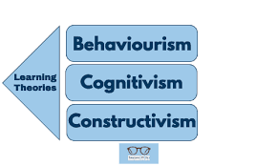
“A child’s experience between
the ages of 0 – 5 years will
affect the rest of their lives”
Mariana Simona Pacuraru,1918143
Practical example
Bethan (5 months) reaches over her cot towards the mobile hanging, curious to explore it. Bethan manages to hit the cellphone after many tries. The handset shifts softly as she taps it and makes a tinkling sound. For a few minutes, Bethan looks at the mobile and then searches for it once more. Bethan's reality is now evolving through her acts and encounters of the natural world to integrate objects that move and objects.that produce a sound as they move (Halpenny, A. M., & Pettersen, J. 2013).

According Davies, D. (2010), development is the result of transactions between the child and environment. A complicated and dynamic truth is accepted by this simple definition. Development is based on the genetically influenced characteristics of the infant, unfolds according to maturation schedules, and moves forward through a series of increasingly complex tasks and challenges that the child must master in order to expand its ability to work within itself and within its environment. From a maturational point of view, the course of development appears to be inevitable. Dependent on the evolution of the brain and body structures, new skills and higher-level capacities for organizing information develop over time.

Introduction
According to Irwin, L. G., Siddiqi, A., & Hertzman, G. (2007) the early childhood period is known to be the most important developmental phase in the lifespan of a person. Physical, social-emotional and cognitive language is necessary not only for the duration of childhood, but for the life course of accomplishment and fulfilment. This work includes theories relating to infants and children from maternal infancy to five years of age, specifically considering how the rest of their lives would be influenced by various interactions. Each theorist looks at various elements of an entire reality. The ideas have a surprising degree of similarity. For the most part, it is possible to group the theories into stages.A practical example explains how heuristic play (discovery learning) helps children learn to find things themselves.

In the 20th century, Jean Piaget (1896-1980) was one of the most influential researchers in the field of developmental psychology. During his research at the Binet IQ Test Lab in Paris, Piaget became interested in how children learn. He observed that young children's answers were qualitatively different than older children, suggesting that younger children were not dumber (a quantitative position because they got older and had more information that they would get smarter), but simply answered questions differently than older peers because they thought differently. Piaget identified four stages of cognitive development. One of them is called the Sensorimotor phase (infancy). In this process, knowledge is expressed by the action of the motor without the use of symbols. Environmental awareness is minimal (but developing) as it relies on physical interactions/experiences.Another stage is called pre-operational stage (toddler and early childhood) and Intelligence is seen in this period in the use of symbols, the use of mature language, and the development of memory and imagination, but reasoning is carried out in a non-logical, non-reversible manner (Huitt, W, & Hummel, J. 2003).

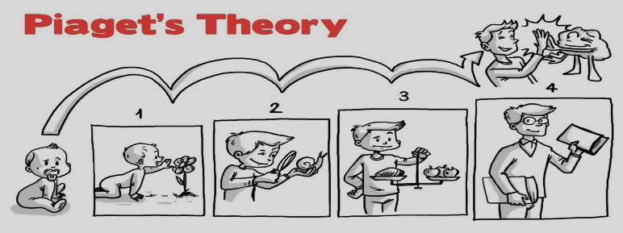
The theory proposed by psychologist and psychoanalyst Erik Erikson in the 1950s is the Period of Erikson's Psychosocial Development. It built on the theory of psychosexual development of Freud, drawing parallels in infancy and expansion into the impact of social dynamics and the extension of psychosocial development into adulthood.. It posits eight sequential phases of individual human development influenced by biological, psychological, and social factors throughout the entire life span( Whitbourne, S. K., Zuschlag, M. K., Elliot, L. B., & Waterman, A. S. 1992).Trustvs.Mistrust Mistrust (infancy). For babies to establish a perception that their caregivers and surroundings are sensitive, trustworthy, and consistent is the central and fundamental psychological mission. Autonomy vs Shame,doubt (toddlerhood). Childhood is distinguished by the initial step to emerge as an individual person, that is, to establish a sense of autonomy, after the perception of a predictable environment by infants that they can rely on others. Initiative vs.Guilt(earlychildhood). The third tension takes autonomy one step further. Kids learn to take greater chances in early childhood by withdrawing from their caregiver, consciously communicating on their own terms with their surroundings, taking action (Syed, M., & McLean, K. C. 2017).

Conclusion
Piaget and Erikson have ideas that have a huge influence on the way we see the development of children. It is important to note the effect they all have on our understanding of children's cognitive and emotional development. However, there is no correct or incorrect interpretation.The works, theories, and expressions of Piaget and Erikson are particularly useful in teaching pedagogical techniques. Using both principles to explain how best to educate, guide, and train children is the best way to get a holistic understanding of childhood development. Piaget and Erikson have highly valuable and significant outcomes, taking into account that many factors can affect cognitive and emotional development and there are several phases that take place.

Annotated Bibliography

1. Halpenny, A. M., & Pettersen, J. (2013). Introducing Piaget: A guide for practitioners and students in early years education. Routledge.
Jean Piaget was one of the most important contributions to our current conception of how children think and learn, from birth through to adolescence. In this comprehensive and open new book, Ann Marie Halpenny and Jan Pettersen catch the key concepts and principles of Piaget's fascinating work on children's thought, and explore how understanding advances and evolves from infancy to the early years and beyond.
It is credible because it is found in the University reading list;
This source helped me in my work by using it as a practical example;

2.Davies, D. (2010). Child development: A practitioner's guide. Guilford Press
This book on child development offers a major foundation for all people who deal with kids. Douglas Davies has the rare opportunity to discuss complicated theoretical material on child development in a very understandable way with many in-depth explanations of how these theories come alive in the developmental trajectory of developing kids. The book is not only a treasure trove of data, it is also a pleasure to read.
The source is credible because it was published in 2013;
The source provides a good definition of what development means.

3.Huitt, W., & Hummel, J. (2003). Piaget's theory of cognitive development. Educational psychology interactive, 3(2), 1-5.
In simple terms, Piaget discusses the main principles and concepts of cognitive development from birth to adulthood in relation to education and learning.This source explains Piaget’s Four Stages (cognitive constructionism)
The source is credible because it is published by an Educational website;
This source helped me to explain one of the theories from my poster;

4.Irwin, L. G., Siddiqi, A., & Hertzman, G. (2007). Early child development: a powerful equalizer. Vancouver, BC: Human Early Learning Partnership (HELP).
This source is about the early childhood period development and its importance for a person;
This is a credible source because it is a book and it was published in the past 20 years;
It helped me with my introduction within the poster;

5.Syed, M., & McLean, K. C. (2017). Erikson’s theory of psychosocial development.
However, the theory of Erikson described the effect of social experience over the entire lifetime, unlike Freud's theory of psychosexual stages. Erikson was interested in how social contact and interactions played a part in the development and growth of human beings.
This source is about Erikson theory and the stages of psychosocial development
This source is credible because it is a book and a good starting point for those interested in engaging in his idea.
This source helped me with my second theory.

6.University of Wales Trinity Saint David (2021) Psychodynamic Approach - Week 4 - w/c 8th Feb 2021 [web] available at: https://moodle.uwtsd.ac.uk/course/view.php?id=9485 accessed:23/02/2021.
This source is about a picture with Erikson s stages of psychosocial development
This source is credible because it was published by the University website
It helped me in creating my poster.

7.Whitbourne, S. K., Zuschlag, M. K., Elliot, L. B., & Waterman, A. S. (1992). Psychosocial development in adulthood: A 22-year sequential study. Journal of Personality and Social Psychology, 63(2), 260.

The present research was a study of such mutual relationships using a measure of personality rooted in the psychosocial life cycle of Erikson's personality development hypothesis.
It is a credible source because it is found in the University Library Resources
I used this source in finding informations about Erikson s theory.

