Development Plan Report
Dylan samuel
2119913
8 May 2026

Contents

1. Introduction
2. Site Location and Context
3. Existing Site Considerations
4. Proposed Development
5. Capital Expenditure and Cost Planning
6. Market Analysis and Comparable Evidence
7. Risk Register and Mitigation
8. Return on Investment
9. Recommendations
10. Conclusion
References

1. Introduction
This development plan assesses the feasibility of a proposed residential scheme at Haere-Mai, Slade, Oxwich, Swansea. The proposal is to demolish the existing dwelling on the plot and replace it with two high-quality detached houses. The purpose of the report is to provide a clear appraisal of the site, the proposed works, the likely capital expenditure, the expected market value and the return that may be achieved if the project is delivered successfully. As the company is considering entering the property development market, the appraisal must consider more than profit alone. It must also consider planning risk, environmental constraints, reputation, funding pressure and the long-term strategic benefit of completing a first development.
The report has been prepared from the position of a project manager advising the company director. It reviews the existing site conditions, explains the proposed design approach, sets out a cost plan, compares the development with similar properties and identifies the main risks that could affect cost, programme or value.

2. Site Location and Context
The site is located at Haere-Mai, Slade, Oxwich, Swansea, SA3. It extends to approximately 0.42 acres, or around 1,699 square metres. The plot sits within the Gower Peninsula, which is a highly desirable coastal area and is also designated as an Area of Outstanding Natural Beauty. This designation increases the planning sensitivity of the scheme, but it also supports the market appeal of the completed properties. Buyers seeking premium homes often place significant value on privacy, scenery, coastal access and a high-quality environment, all of which are features associated with Oxwich and the wider Gower area. (Zoopla, 2026)
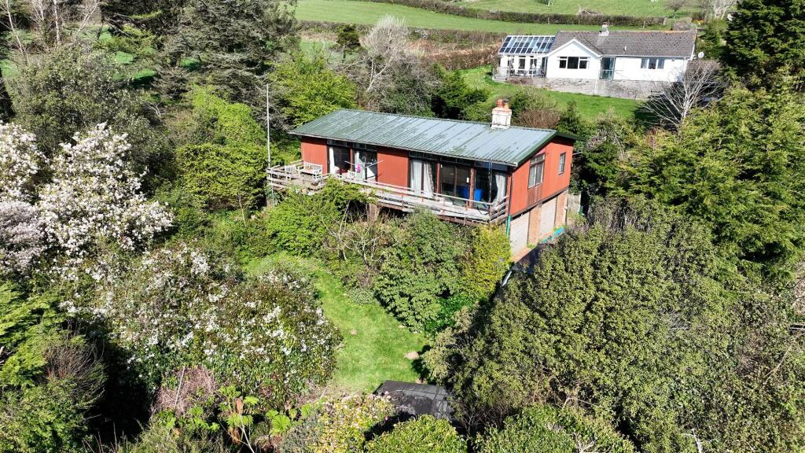
The surrounding area is characterised by detached residential properties, rural land and access to beaches, walking routes and local amenities. The site also benefits from reasonable connections to Swansea, which provides employment opportunities, schools, retail facilities and wider transport links. These factors create a strong residential market and support the argument that a carefully designed pair of luxury dwellings could achieve high sale values.
The existing plot includes a residential structure that is in poor condition. The current building does not appear to provide a practical refurbishment opportunity because the cost of bringing it up to a modern standard would be high and the resulting accommodation would not maximise the value of the land. Demolition and redevelopment therefore provide a stronger development route. The plot size is suitable for two dwellings of approximately 200 square metres each, subject to planning, access, drainage and environmental requirements being satisfied.
(house, 2026)

3. Existing Site Considerations
A clear understanding of the site is important before spending money on buying and developing it. One of the first things to consider is the condition of the existing house. It is assumed that the building is in very poor condition and would cost too much to repair, so demolition is likely to be the best option. Before any demolition takes place, the developer must carry out surveys, such as an asbestos survey. If asbestos is found, it must be removed by qualified specialists, which will increase costs and could delay the project.
The site already has services like water, electricity, drainage and heating. However, these may not be suitable for two new modern houses, as they will have higher energy and drainage needs. This means upgrades will probably be required. It is important to contact utility companies early to avoid delays and unexpected costs. Drainage is especially important in Wales because new developments must meet sustainable drainage (SuDS) requirements. The developer should speak to the SuDS Approving Body early in the process.
Ground conditions are another key factor. There could be issues such as contaminated land, flooding, radon gas, weak soil, or old mining activity. These risks should not be assumed to be safe without proper checks. A Phase 1 desk study, a topographical survey, and possibly ground investigations will provide more accurate information. The rural location may also create ecological issues. For example, there could be protected species, nesting birds, invasive plants, or habitats that need to be protected. These could affect the design or timing of the project.
Planning is also very important. The site is located in an Area of Outstanding Natural Beauty, which means the design, size, materials and landscaping must fit in with the surrounding environment. Although there is no Tree Preservation Order and the site is not a Site of Special Scientific Interest, the design must still be sensitive to the local area. Access is another key issue, including safe entry and exit for vehicles, space for construction traffic, and enough off-road parking for future residents

4. Proposed Development

The proposal is to demolish the existing building and construct two detached, two-storey houses. Each house is expected to have around 200 square metres of internal floor space, giving a total of 400 square metres. The design will be modern but should still fit in with the local character of the Gower area. Features such as pitched roofs, natural materials and good landscaping will help the development blend in with its surroundings.
The houses should be designed for the higher end of the local housing market. External materials could include timber cladding, slate roofs and aluminum window frames. Inside, the layout should include large open-plan living spaces, plenty of natural light, and high-quality kitchens and bathrooms. There should also be flexible rooms that can be used as home offices or guest bedrooms. Adding outbuildings or workshops would increase the value, especially for buyers who need extra storage, workspace or hobby areas.
Sustainability should be an important part of the design, not just an extra feature. Good insulation, airtight construction and energy-efficient systems will help reduce running costs. Features such as solar panels, air source heat pumps and electric vehicle charging points would also make the houses more attractive to buyers. These improvements can increase the Energy Performance Certificate (EPC) rating, which is becoming more important due to rising energy costs and environmental concerns.
External works are also very important. The project will need landscaping, retaining walls, improved access, parking areas and possibly upgrades to services. These should be planned from the beginning, as they affect both the cost and the overall appearance of the development. A well-designed outdoor space can increase the value of the properties and reduce the risk of them not selling after they are completed.
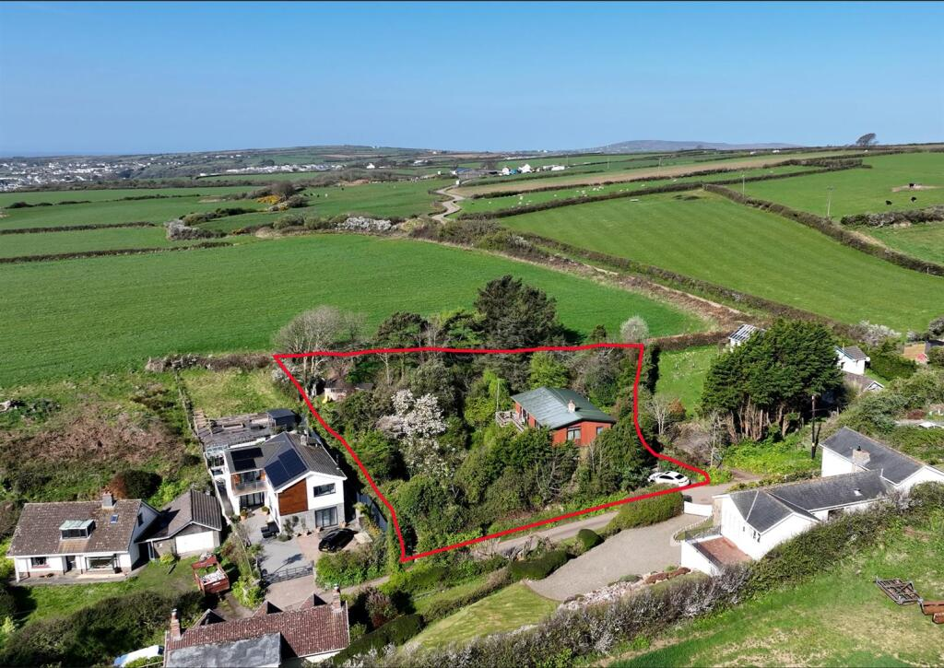

(house, 2026a)

5. Capital Expenditure and Cost Planning

The cost plan is based on a high-specification private residential build. A rate of £2,597 per square metre has been used after applying regional adjustment. For 400 square metres of total floor area, this gives an initial construction cost of £1,038,800. This figure is then adjusted to reflect location, inflation and additional allowances. After these adjustments, and after including allowances for external works and risk, the indicative construction works cost is estimated at £1,361,446. (BCIS, 2025)
This construction figure does not represent the full development cost. A developer must also account for land acquisition, professional fees, surveys, planning fees, legal costs, finance costs, sales costs, VAT implications and contingency. When these additional items are included, the total development cost is estimated at £2,166,254. This figure is critical because it forms the investment base for the return calculation.
Cost certainty at this stage is limited because the project remains in the early development phase. The cost plan should therefore be treated as an appraisal estimate rather than a fixed budget. To improve reliability, the company should appoint a quantity surveyor to prepare a more detailed elemental estimate. Early contractor input may also help identify buildability issues, access constraints and opportunities to reduce cost without reducing quality. Value engineering should focus on improving efficiency, not simply lowering the specification, because reducing visible quality could damage the expected sale value.
Inflation remains a major risk for residential development. Materials, labour and subcontractor availability can change between appraisal and construction. The inclusion of a risk allowance is therefore appropriate, but the allowance must be actively managed. A clear procurement strategy, realistic programme and strong cost reporting process will be necessary to protect the margin.

Table 1: Indicative Development Cost Summary
Cost Item | Basis | Estimated Cost | Comment
Base build cost | 400m2 x £2,597/m2 | £1,038,800 | Initial adjusted rate for high-specification dwellings
Inflation and location adjustments | Tender, construction and regional factors | Included | Reflects expected price movement and Welsh regional factor
External works | 15% allowance | £158,553 | Landscaping, access, retaining walls and parking
Risk allowance | 12% allowance | £145,869 | Contingency for unknowns at appraisal stage
Indicative construction cost | Adjusted total | £1,361,446 | Excludes land and wider development fees
Total development cost | Construction, land, fees and associated costs | £2,166,254 | Used for ROI calculation

6. Market Analysis and Comparable Evidence
The projected sale value is based on the assumption that each completed dwelling can achieve approximately £1,200,000. This produces a total gross development value of £2,400,000. For this assumption to be credible, the development must be compared with similar properties in coastal or high-value residential locations.
Comparable evidence indicates that modern, detached properties in desirable coastal areas can achieve values above £1 million, especially where they offer strong design, privacy, energy efficiency and good internal space. One relevant comparison is a detached property at Higher Lane, Mumbles, which demonstrates the strength of the Swansea coastal market. Another useful comparison is Long Park, Manorbier, which shows how a high-specification detached property near a desirable beach location can command a premium asking price. Although no two properties are identical, these examples support the view that buyers are prepared to pay for location, design quality and lifestyle benefits.
The proposed dwellings are smaller than some comparable examples, but they benefit from being new-build properties with the potential for improved energy performance and modern layouts. New homes can attract buyers who want lower maintenance costs, better insulation, contemporary interiors and more efficient heating systems. These factors may support a higher price per square metre than older stock, provided the design and finish meet expectations.
However, the market assumption should be treated with caution. A sales value of £1.2 million per dwelling is achievable only if the final product is positioned correctly. Poor specification, weak landscaping, planning compromises or reduced views could lower the achievable value. The developer should therefore obtain updated valuations from local agents before purchase and again before construction starts. The sales strategy should also be considered early, including whether to sell off-plan, appoint a specialist agent or stage the release of the properties.

(OnTheMarket, n.d.)

7. Risk Register and Mitigation+
Residential development involves a range of risks that can affect cost, programme, quality and profit. The most significant risk for this project is planning sensitivity due to the Area of Outstanding Natural Beauty designation. The development must show that it respects the landscape and does not harm the character of the area. Early engagement with planners, careful material selection and a strong design statement would reduce this risk.
Environmental and ground risks are also important. If surveys identify contamination, protected species, poor ground or drainage problems, additional mitigation may be required. These issues can delay the start of works and increase cost. The most effective response is to complete surveys before committing to full construction expenditure.
Financial risk is another key issue. The margin between total development cost and gross development value is relatively narrow. A moderate cost overrun or a small reduction in sales value could significantly reduce the return. For example, if construction costs increased by £100,000 or if the properties sold for less than expected, the project could become unattractive. This makes cost control, procurement and market testing essential.
Programme risk must also be managed. Delays in planning, surveys, utility upgrades or construction can increase finance costs and push sales into a weaker market period. The project manager should prepare a realistic programme with allowances for approvals and seasonal constraints. Clear reporting to the director will ensure that risks are reviewed regularly and decisions are made promptly.

Table 2: Risk Register
Risk | Likelihood | Impact | Potential Effect | Mitigation
Planning objection | Medium | High | Redesign, delay or refusal | Pre-application advice, sensitive design and landscape statement
Asbestos in existing structure | Medium | Medium | Extra demolition cost and delay | Commission asbestos survey before demolition tender
Poor ground or contamination | Medium | High | Foundation redesign or remediation | Phase one desk study and targeted ground investigation
Drainage constraints | High | Medium | Approval delay and extra infrastructure cost | Early SuDS consultation and drainage strategy
Construction inflation | Medium | High | Reduced profit margin | Contingency, fixed-price packages where suitable and cost reporting
Sales value below forecast | Medium | High | Lower ROI or reduced profit | Updated valuations, premium specification and robust marketing

8. Return on Investment
The estimated total development cost is £2,166,254. The estimated gross development value is £2,400,000. The difference between these figures gives an estimated profit of £233,746. The return on investment is calculated by dividing the profit by the total cost and multiplying by 100. This gives an ROI of 10.79%.
If the project takes two years from acquisition to sale, the annualised return is approximately 5.26%. This is lower than the target returns often expected by experienced residential developers, who may seek higher margins to compensate for planning, construction and sales risk. On financial grounds alone, the project is therefore not especially strong. The margin is positive, but it does not provide a large buffer against cost increases or value reductions.
Despite this, the project may still be strategically worthwhile. As a first development, it could allow the company to build a track record, develop relationships with consultants and contractors, understand the planning process and demonstrate delivery capability. These benefits may improve access to funding and opportunities on future schemes. The director must therefore decide whether the modest financial return is acceptable when balanced against the experience and reputational value gained.
A sensitivity analysis should be undertaken before final approval. This should test lower sale prices, higher construction costs and longer programme durations. If the scheme remains viable under cautious assumptions, confidence in the project would increase. If the profit disappears under small changes, the company should renegotiate the land price, reduce costs, improve the sales strategy or reconsider the development.

Table 3: Return on Investment Summary
Item | Value | Explanation
Total development cost | £2,166,254 | Investment required including construction, land and associated costs
Gross development value | £2,400,000 | Two dwellings at an estimated £1.2 million each
Estimated profit | £233,746 | GDV minus total development cost
ROI | 10.79% | Profit divided by total development cost, multiplied by 100
Annualised ROI | 5.26% | Approximate annual return over a two-year project duration

9. Recommendations
Several recommendations are made to strengthen the project. First, the company should complete all key surveys before committing to construction. These should include asbestos, ecological, topographical, drainage and ground investigations. This will reduce uncertainty and allow the cost plan to be updated with greater accuracy.
Second, the design should focus on high-value features that buyers in this location are likely to recognise. These include energy efficiency, strong coastal character, quality materials, flexible internal layouts, outdoor space and private parking. The specification should not be reduced without considering the effect on sales value.
Third, sustainability should be used as a selling point. Air source heat pumps, solar panels, electric vehicle charging, enhanced insulation and smart controls can improve EPC performance and help the properties stand out. These measures may increase initial cost but can support stronger buyer interest and higher values.
Fourth, the company should appoint a quantity surveyor and obtain updated market valuations. The current profit margin is not large enough to rely on rough estimates. Professional cost control and local sales advice are necessary to protect the return.
Finally, the project should only proceed if the director accepts that the scheme is both a financial investment and a learning opportunity. If the company expects a high developer margin, the current figures may not be sufficient. If the aim is to enter the development market carefully, the project has merit, provided risks are actively managed.

10. Conclusion
The proposed development at Haere-Mai, Slade, Oxwich has strong potential because it is located in a desirable coastal setting and offers the opportunity to create two high-quality detached homes. The site has several constraints, including demolition, drainage, environmental matters and planning sensitivity, but none appear to make the project impossible at appraisal stage.
The financial appraisal indicates a total development cost of £2,166,254 and a gross development value of £2,400,000. This produces a profit of £233,746 and an ROI of 10.79%, or approximately 5.26% per year over two years. This is a modest return, particularly when compared with the risks involved in residential development. However, the project could still be justified because it provides the company with experience, credibility and a foundation for future development work.
The scheme should proceed only if further surveys, updated valuations and a more detailed cost plan confirm that the assumptions remain realistic. Strong project management, cost control and design quality will be essential. If these measures are implemented, the development can become a valuable first step into the residential development market.

References
BCIS. (2025). Construction. [online] Available at: https://www.bcis.co.uk/products/construction/.
house (2026a). aerial image . [online] Rightmove.co.uk. Available at: https://www.rightmove.co.uk/properties/87722721#/media?activePlan=1&id=media3&ref=photoCollage&channel=RES_BUY [Accessed 6 May 2026].
house (2026b). Check out this 3 bedroom detached house for sale on Rightmove. [online] Rightmove.co.uk. Available at: https://www.rightmove.co.uk/properties/87722721#/media?id=media0&ref=photoCollage&channel=RES_BUY [Accessed 5 May 2026].
OnTheMarket. (n.d.). OnTheMarket | Property, Houses & Flats for Sale & to Rent. [online] Available at: https://www.onthemarket.com/.
Zoopla. (2026). 3 bed detached house for sale Slade, Oxwich, Swansea SA3. [online] Available at: https://www.zoopla.co.uk/for-sale/details/72727373/.

