Illustration and example of Vigenere algorithm based on R language
Question 1
Firstly, define a function named 'create_vigenere_matrix'. In Step 2, create a vector containing English letters to construct the Vigenere matrix. Step 3 involves specifying a matrix size of 26 since the Vigenere cipher employs a 26-letter key. In the fourth step, initialize an empty 26x26 matrix and allocate row and column names corresponding to the letters of the alphabet, 'dimnames' in R allows you to assign names to the dimensions of a matrix, and 'list(letters, letters)' specifically creates a list with two elements. The first element 'letters' is utilized as the row name for the matrix, and the second element 'letters' serves as the column name for the matrix. Moving to Step 5, utilize two nested loops to populate each matrix element based on the rules of the Vigenere cryptographic algorithm. The row and column indices of the matrix iterate 26 times each, with 'i+j-2' representing the intermediate value of each matrix element, computed according to the Vigenere cryptographic algorithm's principles. '%% matrix_size + 1' ensures that the result falls within the range of 1 to 26 to align with the alphabet's index range. Subsequently, map the calculated index to the corresponding alphabet letter and assign this letter to 'vigenere_matrix[i, j]'. In Step 6, return the populated Vigenere matrix. Lastly, Step 7 involves invoking the 'create_vigenere_matrix' function, storing the result in 'vigenere_matrix', and printing the resulting Vigenere matrix. In question 1, I used chatGPT to explain the meaning of passwords and express them in my own language. The above is an explanation of how the code works, and the flow chart is shown below.
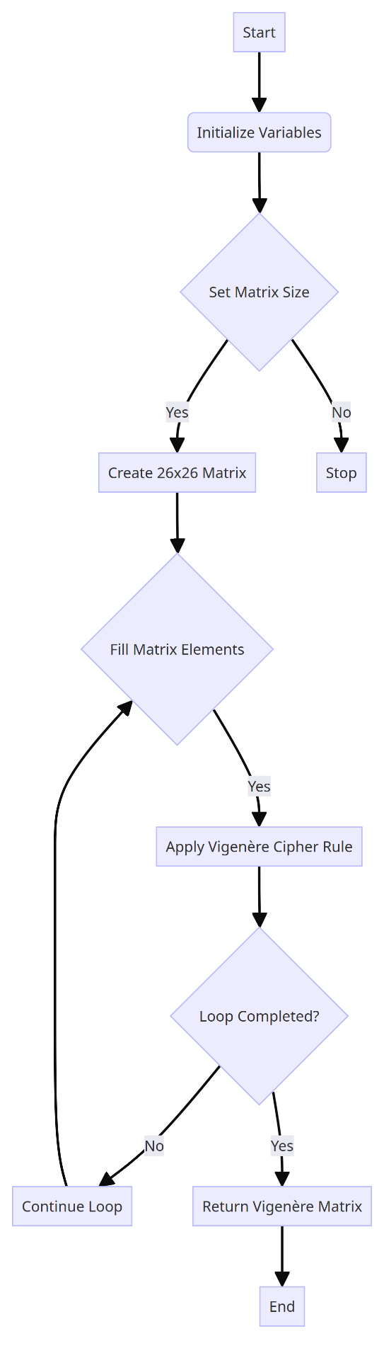
Fig 1. Create a Vigenere matrix flowchart.
Question 2
First: Create a vector containing the uppercase letters 'A' to 'Z'. Step 2: Define a function called 'vigenere_encrypt' that accepts the plaintext and keyphrase as input and returns the encrypted ciphertext. Step 3: Get the length of the keyphrase and the plaintext, 'nchar' is used to calculate the number of characters in a string, that is, to calculate the number of characters in 'keyphrase' and 'plaintext' and assign the result to the variable 'key_length'. Step 4: Convert the plaintext and keyphrase to uppercase letters, 'toupper' is to convert alphabetic characters in a string to uppercase form. Step 5: Create a character vector of length 'plain_length' to store the encrypted text. Step 6: Enter the loop process and operate on each character of the plaintext. The corresponding plaintext character and key character are obtained by the 'substr' function, and the key phrase is cycled through the '((i-1) %% key_length)' calculation. Check whether the plaintext character is in the alphabet. If it is, the 'match' function is used to find the index of the plaintext character and key character in the alphabet. Then, the Vigenere cipher algorithm is used to calculate the encrypted index, and the calculated encrypted character is stored in the corresponding position of the ciphertext vector. If not, the character is directly added to the ciphertext vector without encryption. Finally, the loop ends, and the encrypted text is returned. Step 7: Define the given keyphrase and plaintext; Step 8: Call the 'vigenere_encrypt' function, pass the plaintext and keyphrase to the function, and store the encrypted result in 'ciphertext'; Step 9: Print the plaintext and ciphertext to the console. In question 2, I also used chatGPT to explain the meaning of passwords and express them in my own language. The above is an explanation of how the code works, and the flow chart is shown below.

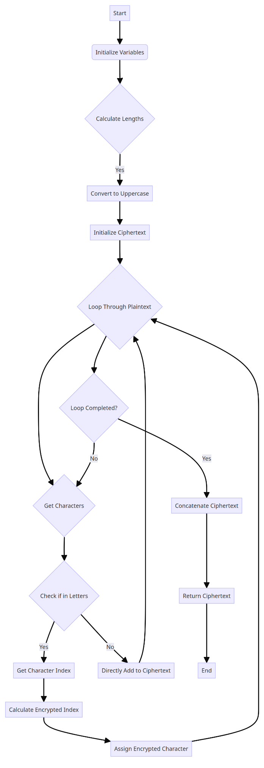
Fig 2. Solve the ciphertext flow chart
Question 3
First: Create a vector containing the capital letters 'A' through 'Z' to construct the alphabet. Step 2: Define a function for Vigenere decryption. It takes the ciphertext and keyphrase as inputs, returning the decrypted plaintext. Step 3: Retrieve the lengths of the keyphrase and ciphertext. Step 4: Convert both the ciphertext and keyphrase to uppercase letters. Step 5: Initialize an empty character vector, 'plaintext,' to store the decrypted text. Step 6: Enter the cyclic process to decrypt each character of the ciphertext. Check if 'cipher_char' is in the alphabet 'letters.' If yes, perform decryption; if not, add the character to 'plaintext' without decrypting it. If 'cipher_char' is in the alphabet, first find the index of 'cipher_char' and 'key_char' in the alphabet. Then, use the Vigenere decryption algorithm to compute 'decrypted_index' and store the decrypted character in the corresponding position of the 'plaintext' vector. Finally, the 'plaintext' vector contains the fully decrypted text. The entire loop continues to process each character of the ciphertext until the entire text has been decrypted. Step 7: Concatenate the decrypted character vector into a string and return it as the final decrypted text, 'plaintext' is a character vector containing the decrypted characters, with each element representing one of the decrypted characters. The elements in 'plaintext' are concatenated using the 'paste' function. The 'collapse=""' parameter specifies the delimiter when joining, and using the empty string '""' means that all elements are joined together without delimiters. Step 8: Define the ciphertext to be decrypted and the keyphrase used for decryption. Step 9: Call the decryption function with the given ciphertext and keyphrase and store the decrypted result in 'decrypted_text.' Finally: Display the original ciphertext and decrypted text on the console. In problem 3, I used chatGPT to edit the loop code with the 'substr','match' functions, making minor adjustments based on understanding. The above is the code flow, and the following is the flowchart
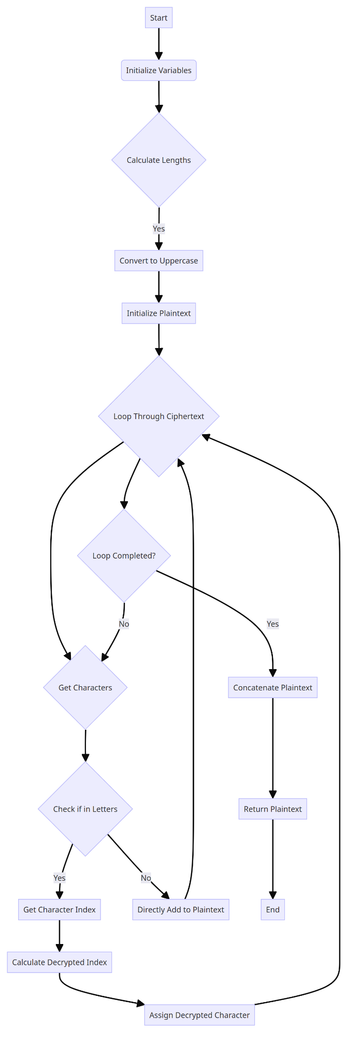
Fig 3. Flowchart of decrypting ciphertext
Conclusion
During the entire process of contemplating and editing code, I have come to realize the paramount importance of loops. In problem 1, nested loops, specifically 'for (i in 1:matrix_size)' and 'for (j in 1:matrix_size)', are employed to populate a 26x26 matrix in accordance with Vigenere cipher rules. In problem 2, the loop 'for (i in 1:plain_length)' is utilized to iterate over each character in the plaintext. Similarly, in problem 3, the loop 'for (i in 1:cipher_length)' is instrumental for decryption. Therefore, nested loops are integral to both Vigenere matrix generation and encryption/decryption processes, obviating the need to manually scribe distinct code blocks for each matrix element, thereby enhancing code conciseness. These loops circumvent repetitive encryption/decryption logic for individual characters, elevating code readability.
A series of string operations have been assimilated through the examination of string processing data, such as the 'substr' function for substring extraction, the 'paste' function for string concatenation, and the 'toupper' function for string capitalization. The 'match' function is judiciously applied to ascertain the index of characters in the alphabet.
The primary challenge in this assignment was encountered during the Vigenere matrix generation process. Owing to the presence of two loop variables 'i' and 'j', the '%% matrix_size' modulo operation is employed to ensure that the result lies between '0' and 'matrix_size - 1'. Initially, this was overlooked, and the problem persisted until the result was adjusted from '1' to 'matrix_size'.
Concerning the code that displays plaintext and ciphertext, understanding the disparity between 'print' and 'cat' is imperative. 'Cat' is predominantly used to print multiple objects without automatically appending line breaks, while 'print' is conventionally used for single-object printing, automatically adding line breaks afterward. The utilization of 'cat' in this task aims to output 'plaintext' and 'Ciphertext' alongside their corresponding textual contents, facilitating a comprehensive display of both 'plaintext' and 'ciphertext'.
Since this assignment marked my inaugural attempt at independently tackling complex coding, I grappled with unfamiliar syntax and structural aspects of the programming language, leading to grammatical errors and code structure confusion. Grasping algorithmic logic took more time, and troubleshooting errors proved challenging. Ultimately, it became apparent that mastering R alone was insufficient, and ample independent practice with a plethora of examples will be pursued in the future.
Appendix


