MODULE CODE: ACCA5024
Advance Networking Final Exam Answer Sheet

Student Name: Carol Cernea

Student ID: 2113437

Date: 09:50

I- IPv4 Addressing Table
Specification | Subnet A | Subnet B
Subnet IP address | 192.168.202.0 | 192.168.202.128
Subnet mask (slash notation) | /26 | /25
Subnet mask (dotted decimal) | 255.255.255.192 | 255.255.255.128
1st Host IP address | 192.168.202.1 | 192.168.202.129
Last Host IP address | 192.168.202.62 | 192.168.202.254
Number of usable hosts per subnet | 62 | 126
Broadcast address | 192.168.202.63 | 192.168.202.255

II- IPv4 Address assignment
Device | IP address | Subnet Mask | Gateway
PC-A | 192.168.202.62 | 255.255.255.192 | 192.168.202.1
R1-G0/0/0 | 192.168.202.129 | 255.255.255.128 | 192.168.202.129
R1-G0/0/1 | 192.168.202.1 | 255.255.255.192 | 192.168.202.1
S1 | 192.168.202.2 | 255.255.255.192 | 192.168.202.1
PC-B | 192.168.202.254 | 255.255.255.128 | 192.168.202.129

III- IPv6 Addressing Table
Assigned to Interface | IPv6 Subnet Address | Prefix Length
R1-G0/0/1 | 2001:db8:acad:0001::0 | /64
R1-G0/0/0 | 2001:db8:acad:0002::0 | /64

IV-IPv6 Address assignment
Device | IPv6 address | Prefix Length | Gateway
R1-G0/0/0 | 2001:db8:acad:0002::1 | /64 | FE80::1
R1-G0/0/1 | 2001:db8:acad:0001::1 | /64 | FE80::1
S1 | 2001:db8:acad:0001::2 | /64 | 2001:db8:acad:0001::1

Task 2: Device Configuration
- Hostname

- Encrypted privileges EXEC password

- Secure the console access password

- Minimum length passwords

- Create an administrative user

- Configure an MOTD banner

- Encrypt all passwords

- Disable IP domain lookup

- Enable synchronous logging

- Configure router’s interfaces

- Configure switch’s management (SVI) interface

Task 3: Verify Network connectivity

From | To | Protocol | IP Address | Ping Results
PC-A | R1 G0/0/0 | IPv4
tftttttttPC-A | R1 G0/0/0 | IPv6
PC-A | R1 G0/0/1 | IPv4
PC-A | R1 G0/0/1 | IPv6
PC-A | S1 VLAN 1 | IPv4
PC-A | S1 VLAN 1 | IPv6
PC-A | PC-B | IPv4
PC-A | PC-B | IPv6
PC-B | R1 G0/0/0 | IPv4
PC-B | R1 G0/0/0 | IPv6
PC-B | R1 G0/0/1 | IPv4
PC-B | R1 G0/0/1 | IPv6
PC-B | S1 VLAN1 | IPv4
PC-B | S1 VLAN1 | IPv6

Commands used for task!

Set router hostname R1
Set Switch hostname S1

Router>enable
Router>conf
Router(config)# hostname R1
R1(config)#security password min-length 10
R1(config)#enable secret ccnaenpass
R1(config-line)#password ccnaenpass
R1(config-line)#login
R1(config-line)# exec-timeout 1
R1(config)# username admin password admin1pass

Banner:
R1(config-line)# banner motd #No Unauthorised Access!#
S1(config-line)# banner motd #No Unauthorised Access!#
R1(config)#service passworwd-encryption
R1(config)#exit

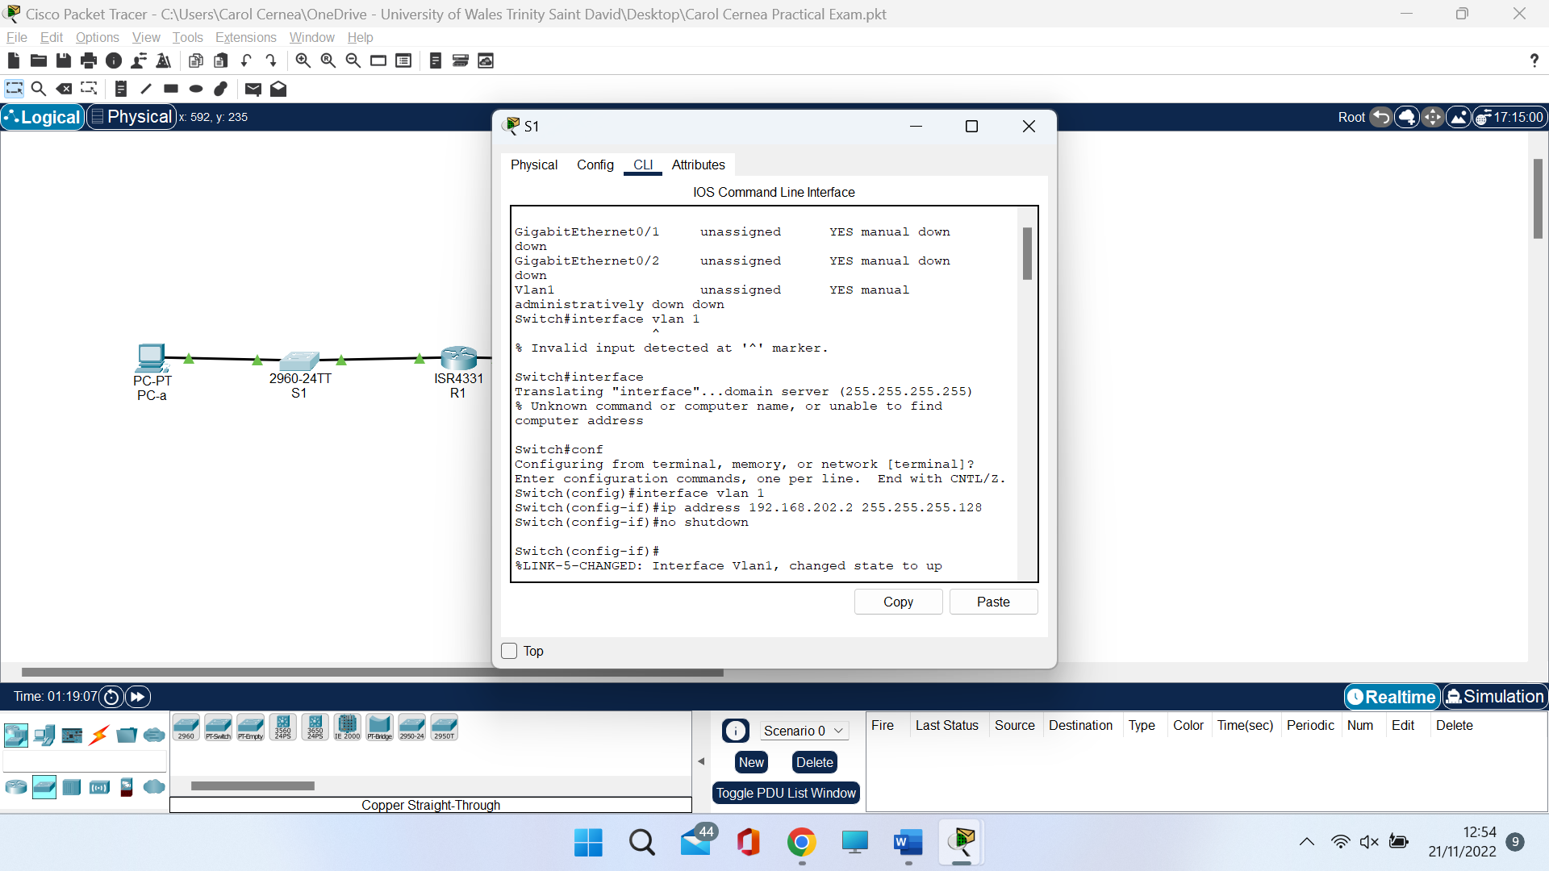

PING the Router R1
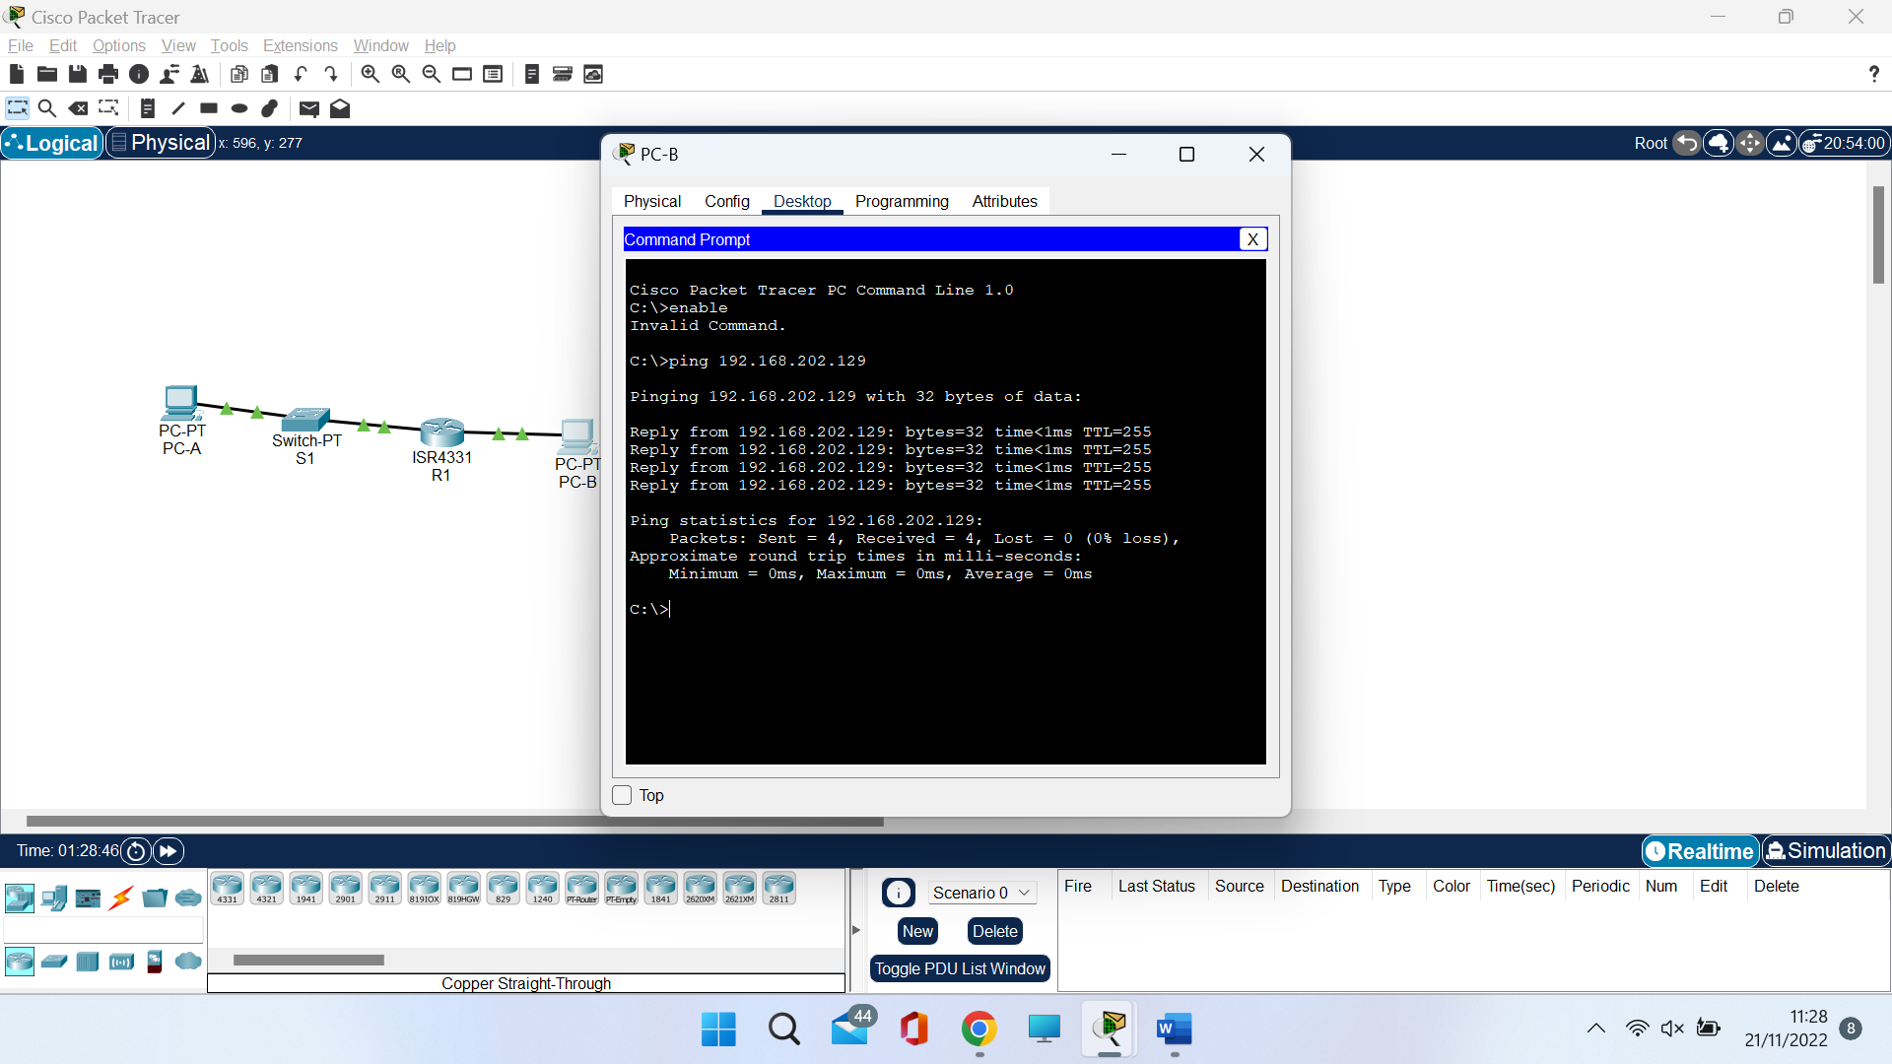

PING the S1


