

Written Business Plan

Student name: Vasilka Sarandalieva
Julia Petrencikova
Liliana Costache
Albert Sefa
Emanuel Adewale
Student number: 2113113
2110746
2111821
2112523
2107386
Module: Managing Enterprise in the 21st Century
Modul code: BMSW 4006
Lecture name: Rajesh Kumar

Contents
Executive summary 3
Business overview 3
Company name 4
Services 4
Legal structure 4
Location 4
Mission and vision 4
What do we offer and why are we unique? 5
Our packages 5
Market Audit and Competitors analysis 5
PESTEL ANALYSIS 6
SWOT ANALYSIS 7
Target markets 7
Marketing plan 8
Management team 10
Financial plan 10
Conclusion 13
References: 14

Executive summary

This business plan was developed with the main purpose of evaluating the profitability of a business idea. This idea refers to a business in the field of service provision, more precisely the decoration of events, whether this yours first wedding, a renewal of vows or anniversary. Weddings are essential events in people's lives and represent a starting point in the couple's life. At the same time, it is a widespread universal custom, with a continuity of the millennia and is unlikely to disappear. Therefore, weddings are events that will last forever, and our company aims to decorate them in an impeccable manner and to a high quality standard.
“Your dream wedding” is unique in that we give our clients our undivided attention. Taking the time to listen to their needs, we create the event they have always envisioned. We obey our clients' wishes. So whether our client wants a Western, Tropical, Las Vegas or more traditional wedding or anniversary party, we can help. We provide high quality service, a diverse range of choices of decoration (mix-and-match), as well as the option to buy or hire. We offer tree packages that come with an avalanche of services and products to ensure that our customers get the best value!



Business overview

We discovered a gap in the market for wedding decorations services after being inspired by one of our partners' future weddings and performing extensive market research. To provide clients with the right service on their memorable day, we created our company because she struggled to find the perfect decoration and less expenses.


Company name
“YOUR DREAM WEDDING” -Tailored decoration for your special day.
As we guarantee a high level of customer service, we provide a variety of options for your event. Our services contribute to creating a unique event that is incredible and one-of-a-kind, which makes us different from our competitors.

Services
Three incredible packages are available to you (Golden, Silver, and Bronze), bringing simplicity to users tired of searching through a myriad of options. As part of each package, there is a free consultation available, which can be held online (Covid-19, for those who have a busy working day) using What's App, Messenger or any other alternative available.

Legal structure
As a partnership of five people, each with a different background, education, and work experience, the company can be managed by the five of us in the first year with no payroll expense. In addition to our equal investments of £6000 each, we will receive £50 000 from the UK Lottery to start up a business that will be very profitable.

Location
As part of our first year of operations, our company will have a homebased office in Birmingham, Solihul, Newtown Road 12, with a garden showroom where our clients will be able to view and touch a variety of decorations.

Mission and vision
It is our mission to establish ourselves as one of the most trusted wedding service providers in the industry. The company will expand nationally and globally, increasing the variety of services it offers. “Your Dream Wedding” is expected to have a very positive market impact and will be highly profitable.

What do we offer and why are we unique?

• For the customers tired of searching through thousands of options, hundreds of pages and ending up with their online basket full of decorations they cannot even remember, with Your Dream Wedding everything is nice and simple.
• We offer 3 packages, and these are tailored to suit our customers’ needs and budgets. So instead of tired and stressed customers, we have relaxed and happy customers which don’t need to scroll over our selection for hours as we offer free consultation, where everything will be discuss. They can even choose from free face-to-face consultation in our Office in Birmingham, where they can see and feel our products, or they can just simply attend online free consultation via their preferred social platform. After that, they can just sit and relax, as all the hard work is done by us.
• We can come to any place in the UK to decorate your special day.

Our packages

Gold package
For those who want it all. Our gold package includes free consultation, hire or purchase of the wedding decoration (table decoration and all other decoration such as centrepieces, love letters), dressing and removal of the venue decoration. We offer free alteration if our customers change their minds about something during preparations. Popular Sweet Car/Fromage is also included in this package. Lastly, we offer real/artificial flowers for the venue and bouquets for the bride, and bridesmaids as well as buttonholes for gents. This is the only package where customers can pay monthly.
Silver package
Our silver package includes free consultation, hire of the wedding decoration (table decoration and all other decorations such as centrepieces, love letters), dressing and removal of the venue decorations and lastly artificial flowers for the venue, bouquets for the bride and bridesmaids as well as buttonholes for gents.
Bronze package
Our bronze package for those on a budget or those who like to decorate their special day themselves offers free consultation and hire of the wedding decoration only(table decorations and all other decorations such as centrepieces, love letters).

Market Audit and Competitors analysis

Market audits and competitor analyses are crucial to the success of our business. A market audit is a comprehensive assessment of an organization. An organization's SWOT and PESTEL analysis can be used to identify a company's strengths and weaknesses based on its current market program. This analysis identifies a company's strengths and weaknesses based on the current state of the market program.
As part of our competitor analysis, we selected three business models to help us grow and improve our company.
• Audrey Ametis Weddings: This wedding decoration company was officially launched in 2017. They have been delivering weddings in luxury venues ever since. The company specializes in modern yet elegant weddings, and its mission is to take the stress off its client’s shoulders so they can enjoy their big day.

• Katrina Otter Weddings: This company has been in the wedding decoration industry for over 15 years. They know every aspect of the wedding decoration business. The company is very organized, and they have worked on many weddings and events around the globe.
• Wedding by Mary: This company has 20 years of experience. Their business is so successful due to the fact that their approach is always centred around getting to know the clients and ensuring that they enjoy wedding planning.

PESTEL ANALYSIS
Political factors: With regards to this factor, we examined how the law has increased the benefits of marriage, such as inheritance rights, marriage tax breaks, and joint ownership of assets. As a result of all these legal benefits, we won't have any difficulty finding clients for our business. Following the legalization of gay marriage in the United Kingdom on June 17, 2014, same-sex marriage has become increasingly popular.
Economic Factors: Our company has to keep in mind that the inflation rate is affecting the whole world, and not many people will be able to afford our decorations and service. We must also ensure that the products we import from our suppliers are of good quality and not too expensive.
Sociological Factors: Back in the day traditional weddings were more discreet and it used to be just the family and a few friends that were guests. As social media has become more popular, everyone wants to be seen and noticed. It has become more sophisticated and glamorous to share wedding photos on social media. As a result, we will have clients unintentionally advertising for us, which is great for our business.
Technological Factors: E-commerce is great for our business due to the fact that it focuses more on the buying and selling aspects of our company. Through our online invitations, we'll have a website where customers can create an account and from there we can send them event invitations to showcase our products, discounts, and keep them up to date on what we're doing. As a new company, we have to keep up with new technologies, such as a digital guestbook app where you can record videos and have a collage of pictures to share with your guests.
Legal factors: Considering Covid19 is still out here, the government might restore a lockdown if there is another outbreak, which could mean the business would have to find a new way to operate. We should also conduct thorough research before importing products from other countries in order to comply with all health and safety regulations before entering the market.
Environmental factors: Since we are a new company, we are very committed to recycling and using eco-friendly products.

SWOT ANALYSIS
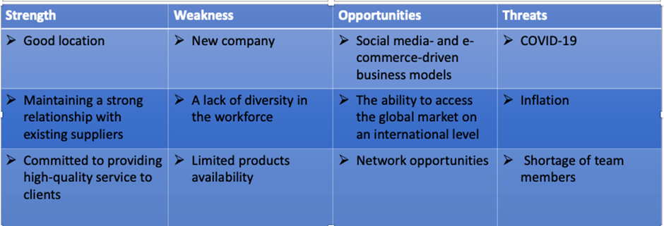
Our main goal is to minimize the weaknesses and threats in this SWOT analysis. Situations must be recognized and handled as soon as possible before they spiral out of control.
Since we don't control the economy, we have no choice but to adapt to the changes in prices to deal with threats like inflation.

Target markets
The average age of marriage in the modern day
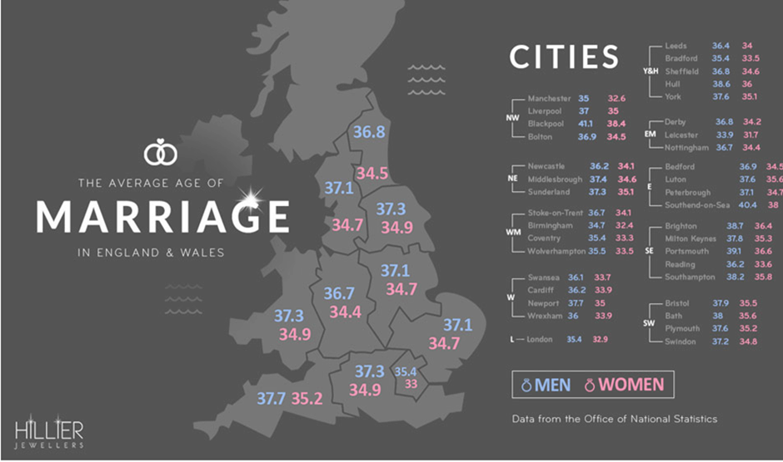

According to Nikki, (2017), the study showed that the average year of marriage over 40 years increase by 8,4 years for men and 5.1 years for women. People are simply cohabiting with their partners before getting married which was not so common in the past. It can be also financially draining, hence why people take longer to get married.
Therefore, our average age customers are men and women between 33-38 years old. The marriage age of men and women in coastal areas is higher than in Midlands.

What is the percentage of people being married?
Survey shows that most people still want to get married. Out of all Britons, 43% are currently married, 12% were married previously (separated, widowed etc.), 18% want to marry, 13% prefer not to say and 12% do not want to marry.
Needless to mention is that out of all age groups, 49% of people aged 18-34 want to marry (yougov.co.uk, n.d.).
In conclusion, our target market is therefore almost 50% of Britons aged between 18-34. This is a huge number of customers we can offer our services.

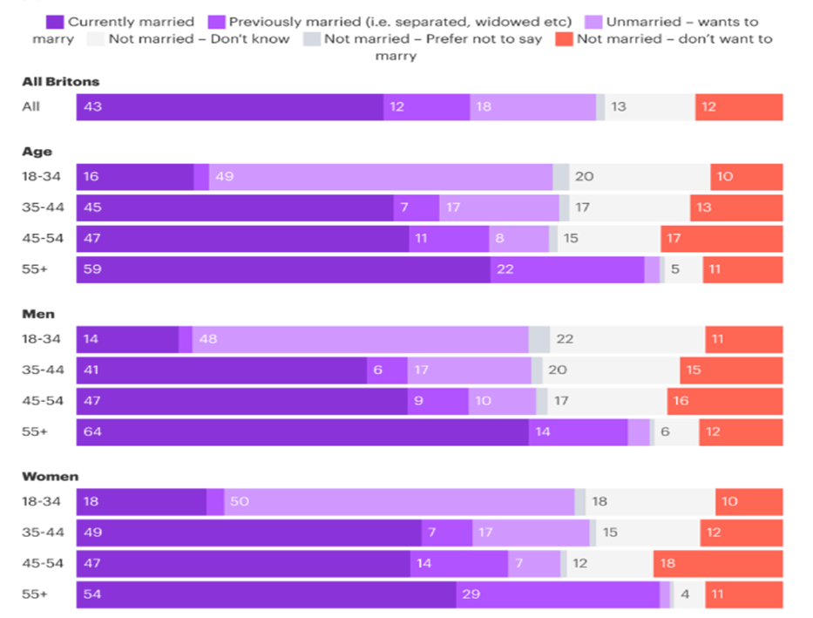

Marketing plan

Product
The new start-up business will offer wedding decoration services to the customers. In that case, this company will try to create more space for the clients to celebrate their love in a more attractive way.
Price
The management team of this new start-up business will apply value-based pricing within their customer services. usage of this rising strategy within marketing activities must allow this company to create values among customers regarding their exclusive services (Kienzler, 2018).
Place
Customers of the UK and especially in Birmingham and surroundings will offer wedding decoration services from this start-up business.
Promotion
Promotional activities of the business services will be performed based on the usage of social media marketing. In that case, different social media platforms will be used. It will help this business to create consumer attractiveness within the business based on the presentation of developed pictures of their wedding decorations in front of the customers (Li et al., 2021).
Advertising opportunities
Facebook
• Opportunity to get brand name out to customers and to join community groups
Instagram
• We can showcase our events to potential clients
Twitter
• Great way to reach new clients and promotions for our service
Snapchat
• Ability to create customised filters for the clients benefit that can be rewarded as a bonus for engagement parties, bridal showers, bachelorette parties and bachelor parties.
Holding accountability for our social media throughout the first year, it is important to gain client trust and show the quality of our services by receiving positive feedbacks. It is essential that we emphasise the freshness of our company with sophisticated and clique decorations. In order to reach our success, we will continuously adapt and improve our marketing materials for our business and clients to keep on a new trend.
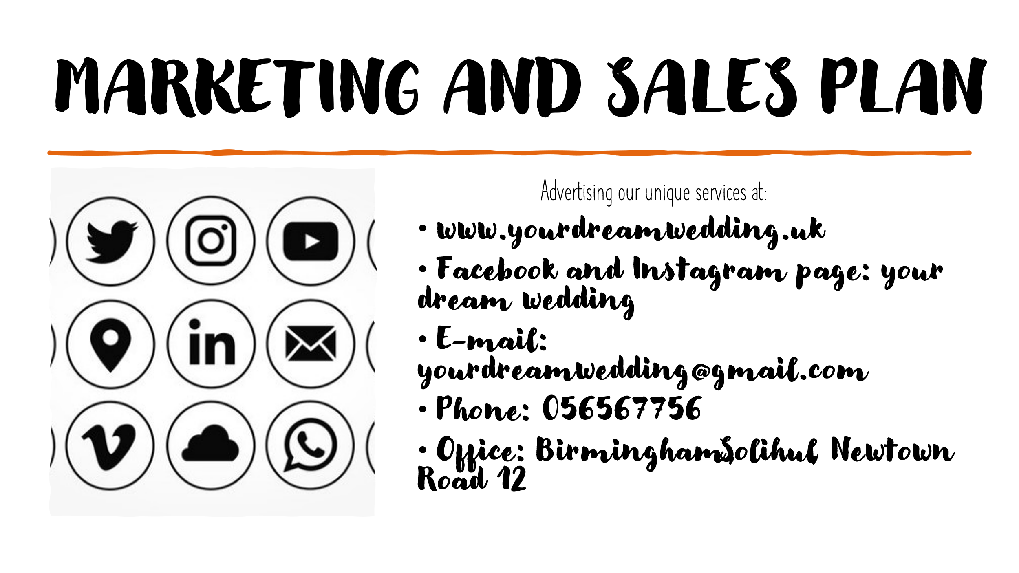

Management team

The management team will have members each tasked with overseeing different components of the business such as finance, customer service, supply and material sourcing, and the execution team manager. Being a wedding décor company we will have multiple people overseeing different sectors for example one person may manage the finance side of the business, including monitoring the business accounts and tracking revenue. Such as the profit and loss spread sheets and analyse the quarterly business performance, another person will be tasked with managing the customer service side of the business. This is important due to the fact most clients will be newlyweds and engaged couples and each consumer will have different preferences and wishes to make their wedding day unique to them through one to one consultations where they choose their package. Another facet will manage and oversee the sourcing of goods and materials needed to fulfil the obligations of the client and will contact suppliers in order to make sure all the necessary stock (e.g. balloons and banners )is available and can be sourced in a timely manner to appease the clients. And some may have more extravagant ideas and some may have simpler visions and this person will be tasked on bringing in exactly what is needed and providing the tools needed. Finally there will be someone to oversee the set-up team and the on day delivery and play a part in setting up the wedding to make sure everything operates smoothly and the clients have the wedding of their dreams.

Financial plan
A financial plan is vital when you apply for funding. The main purpose of a financial plan is understanding and reflecting on your business. It is a critical point for both entrepreneurs and potential investors to assess the business model and take steps to enhance the business. Validating our business plan, business model, assumptions and vision, we will be able to find out if we can turn our ideas into a sustainable operation. A financial plan is an essential part of our funding strategy. Providing relevant data and more details will give a clear view on how much external finance you will need in order to grow the business. A financial plan provides for both entrepreneurs and investors with a parameter for evaluating the business and this plan.
Any decent financial model includes a forecast of three financial statements:
Cash flow statement
Profit and loss
Investments & Start-up costs
These financial statements are generally accepted like a way of communications for the financial information across both entrepreneurs and investors. The financial statements will show the business needs and will help you the financial performance of a business in order to obtain money.
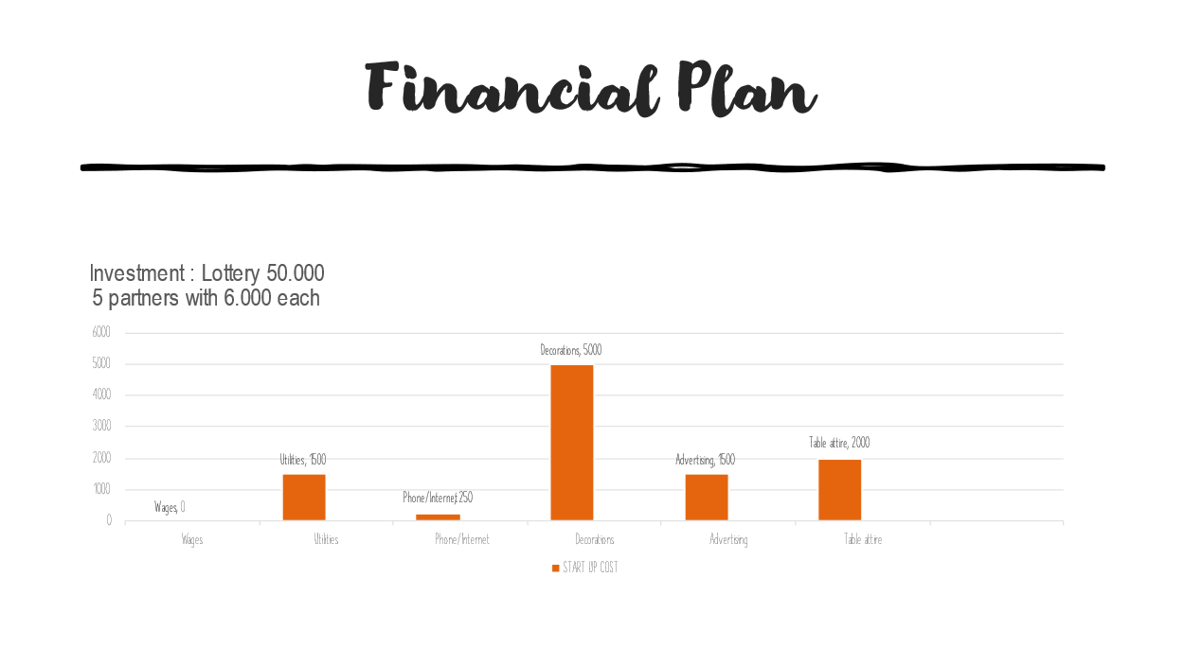

A financial plan is crucial when applying for funding. The main goal is to understand how business finance works. It’s very important for entrepreneurs and investors as well. It is an essential element for obtaining development funds.
At the beginning of the business, we will have a grant of 50.000£ and we will also invest 6.000£ each partner. The start-up costs will be mainly spent on decorations, advertising and table attire because these are the most important assets to focus on our field.
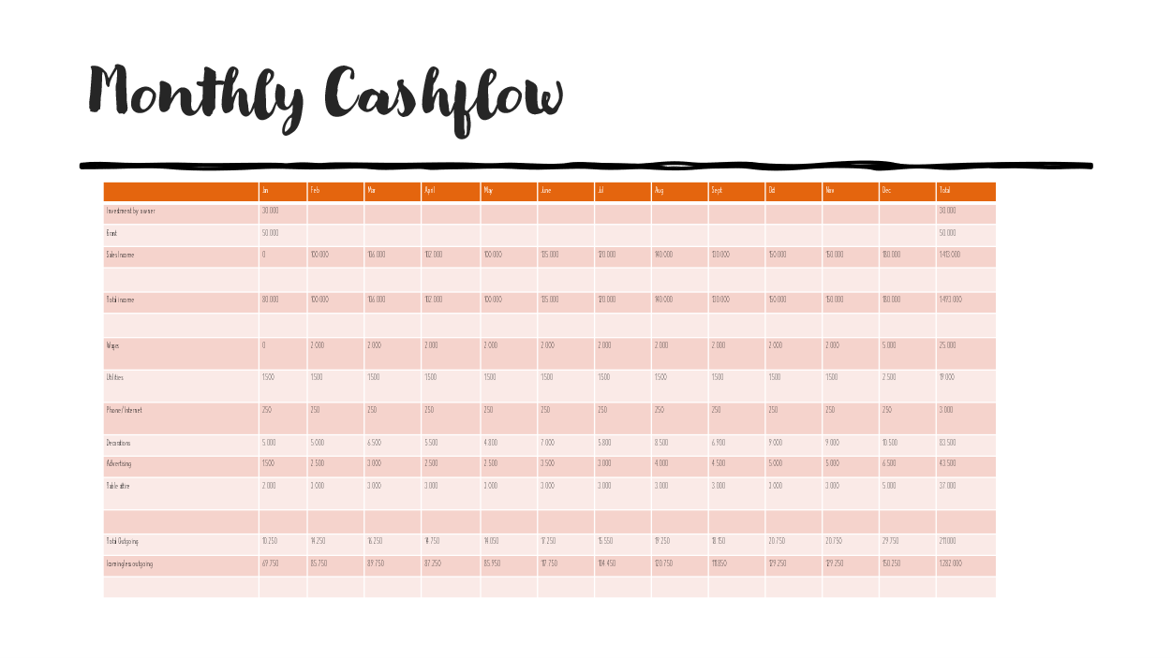
The aim of the monthly cash flow is to represent an overview of the financial activity. Business is relying on monthly cash flow statements to closely monitor their income and outcome and profit. This report is of an outmost importance because it enables you to meet the financial obligations and allows you to plan.
As you can see from the table, the cashflow is positive and that means that our business is successful with a high rate of expansion in the future. The cash flow statement will allow us to decide regarding the future of the business operations and will also provide us with a way to prevent and monitor the business debt. It will also help us to define our company needs regarding investment and supports the timely payment of expenses and debt.
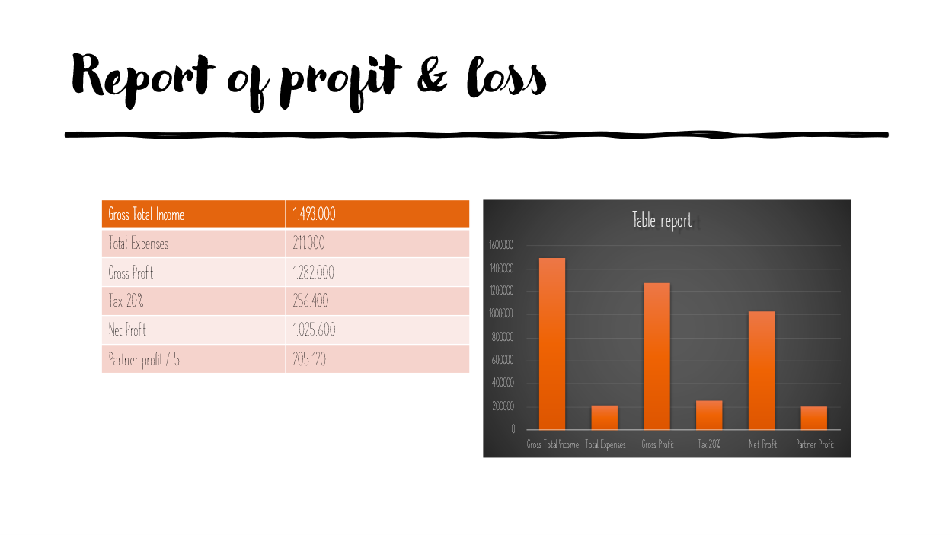
The Profit & Loss account will show you the total income and expenses and whether your business has earned more income than expenditure for running costs. In my case, according to the table and the amounts obtained, our business is productive. As you can see, our net profit is high, and the partner profit is consistent. The profit and loss statement represent all revenue and cost and the difference between these is our profit.

Conclusion
We believe we have done the necessary research and have highlighted the necessary steps and constructed a business plan that will lead to a successful business as we have highlighted the gap in the market through, and the need for wedding planners in the current generation of social media and the need for a grand and memorable wedding. As a team analysed the pros and cons and obstacles we may face as a small business by including a SWOT and PESTEL analysis. We know that by offering a human connection with clients through the one to one consultations we offer for free our clients feel more involved and giving more control of making their dream wedding reality. Also the management team will oversee all aspects of the business to make sure everything is operating accordingly in order to give our clients the best possible experience.

References

Bendle, N and Campana, R. (2018) Nouveau Event Planning: The Wedding Extravaganza Harvard Business Review Case Study Available at: https://embapro.com/frontpage/pestelcase/17766-wedding-extravaganza
Cradduck, P. (2018) Social: 3 Ways Sociological Factors Can Impact The Events Industry Available at https://grapevineeventmanagement.co.uk/news/2018/11/6/social-3-ways-sociological-factors-can-impact-the-events-industry
Deane, E. (2020) The UK’s Best Weddings Planners: 22 Planners to Know About Available at https://www.hitched.co.uk/wedding-planning/organising-and-planning/best-uk-wedding-planners/
Kienzler, M., 2018. Value-based pricing and cognitive biases: An overview for business markets. Industrial Marketing Management, 68, pp.86-94.
Li, F., Larimo, J. and Leonidou, L.C., 2021. Social media marketing strategy: definition, conceptualization, taxonomy, validation, and future agenda. Journal of the Academy of Marketing Science, 49(1), pp.51-70.
Nicholson, L. (2019) What are the legal Benefits of Being Married? Available at: https://www.simpsonmillar.co.uk/media/what-are-the-legal-benefits-of-being-married/
Nikki (2017). What’s the average age of marriage in the UK? [online] Vows and Venues Magazine. Available at: https://www.vowsandvenues.org.uk/what%E2%80%99s-average-age-marriage-uk.
yougov.co.uk. (n.d.). Do Britons still want to get married? | YouGov. [online] Available at: HTTPs://yougov.co.uk/topics/lifestyle/articles-reports/2022/06/28/do-britons-still-want-get-married?utm_source=twitter&utm_medium=social&utm_campaign=website_article [Accessed 4 Aug. 2022].

