

Submitted By: Neelam Sasi Kiran
Student ID: 2126477
Module: Strategic Management
Module Code: LCMB7003

Executive Summary:
The Aim of the report is to analyze the current strategic movements and implementations of Microsoft, which is an American Multinational company producing computer software, computer electronics, and other Services related to Business and technology. This report was prepared based on the Strategic management Framework which consists of four series of steps, analyzing the Strategic Analysis, Strategic choices, and implementation of strategy and Reviews. By Doing the Internal and external analysis, SWOT, PESTLE, and Porter’s five force analysis is accessed to understand the key concepts and condition of Microsoft in a competitive technological world. As a global leader in innovative organizational practices, the importance of financial analysis and the revenue generated in Previous Financial years are furnished in the report, followed with that there are sub-sections and sections with strategic Choice of Microsoft by analyzing with Ansoff Matrix, and Strategic implementation of Microsoft at various levels in their growth stage and understanding the change management of Microsoft By applying ADKAR model and explaining their Organizational structure and transparency, and finally the importance of Strategic review is explained in the last sections by implementing a SMART goals tool that helps to measure the performance of Company. This overall strategic framework of Microsoft discusses various stages of how Microsoft achieves a competitive advantage in the Technological Sector.

Table Of Contents
Executive Summary……………………………………………………………………………….…2
Introduction………………………………………………………………………………………….…4
Strategic Management Framework……………………………………………………….….5
Strategic Objectives and analysis…………………………………………………………….…
1. Vision and Mission of Microsoft…………………………………………………………6
2. pestle analysis……………………………………………………………………………………7
3. SWOT analysis……………………………………………………………………………….…10
4. Porter’s Five force analysis……………………………………………………………….12
Internal analysis
- Value Chain Analysis…………………………………………………………………….…….13
- financial analysis…………………………………………………………………………….….14
- Microsoft segmentation breakdown…………………………………………..……. 14
Strategic Choice
- Ansoff matrix for explaining options and choice……………………………….16
Strategic Implementation………………………………………………………………………….
- Organizational structure……………………………………………………………………..17
- Resources planning…………………………………………………………………………….18
- ADKAR change management……………………………………………………………..18
Strategic Review
- SMART goals to performance Management………………………………….20

Competitive Advantage of Microsoft……………………………………………………..21
Recommendations……………………………………………………………………………………23
Conclusion………………………………………………………………………………………………..24
References……………………………………………………………………………………………….25

Introduction
In the year 1975 April 4th Microsoft is established, by Bill gates and Paul Allen in Redmond, Washington, USA. Started by Providing software licensing and services to organizations all over the world for Business and Personal Computing, later they become the Leader in Innovation in various aspects of Software services. (Gabriele, 2006) the company’s overall revenue in the financial year 2022 is 198.27 billion USD (Statista, 2022). There are some Key points in history to be remembered, those initiatives make them world leaders, those are. In the year 1998, Microsoft launched ‘windows 98’ one of the most famous Operating systems up to now. (Gabriele, 2006) In the year 2000, Bill Gates becomes the Chairman of Microsoft. The recent timeline of Microsoft portrays its commitment to its mission, over the past five years, the innovation has reached the advanced stage. In 2014 Satya Nadella becomes the CEO of Microsoft, and, in 2018 Microsoft unveiled the Xbox new gaming console which rules the gaming industry. (Microsoft, 2022) In 2020 Opens its flagship store in London, and they care about the Environment to protect bio-diversity and attain net zero by the year 2030 (Microsoft, 2022)
While coming to the vision and mission statements of Microsoft they kept it clear and simple, it says the organization is mostly focused on empowering every organization and every person on the planet to achieve more. (Microsoft, 2022) they are leaders in Innovation, Corporate Social responsibility, business, sustainability, and Trustworthy Computing.
As a multinational company, they run their operations from different parts of the world. From the source, they have 183 locations with 221000 employees all over the world (Statista, 2022)

STRATEGIC MANAGEMENT FRAMEWORK:

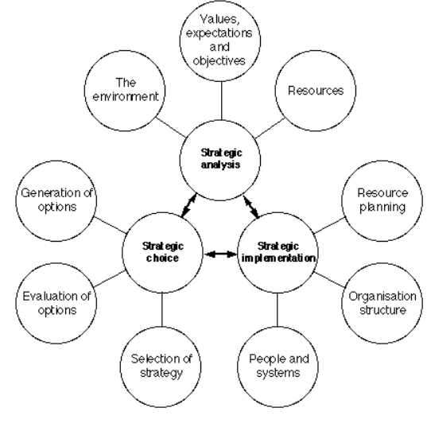
Source: (Johnson G et.al 2022)
Strategy is a word derived from the Greek Language in the military field, it is called “Strategos” and this word is evolving over various centuries, and become a normal word that is used in various human and business activities all over the world (Fuertes, 2019). The concept of strategy is evolved and been addressed by various authors, and Dr. Alfred chandler an American historian states that strategy is the long-term goal and objective of an organization by adopting necessary actions and allocating the resources to achieve the goals of the organization. (Fuertes, 2019). For Porter’s, it is a set of activities adopted to stand out and achieve sustainable growth in the market (Fuertes, 2019)
A strategic framework is a detailed process to gives an overview of the strategy process adopted by the organizations, mostly small and big organizations follow this framework to attain a corporative advantage. There are some tools to be used to analyze the various steps of this framework.

The overall strategy framework is divided into four stages. Each stage has specific importance for achieving growth, (Fuertes, 2019) stages namely vision, mission objectives, strategic analysis, strategic formulation, strategic implementation, and the final step is monitoring and evaluation. This result shows the right business plan to guide business operations. (Zegers, 2004)

Strategic Objectives and analysis:
Vision and Mission
In this stage company set up a clear vision and mission which means the organizational identity is called vision, and where they want to, is called mission (Quezada, 2009) for Microsoft, the statements are kept clear, and the vision statement is to help the people and business throughout the world realize their full potential (Microsoft, 2022) and mission is to empower every organization and every person on the planet to achieve more. (Microsoft, 2022) mostly the general objective is, to strengthen the success factors, integrate employees, satisfy the clients, and Improve return on investment (ROI) (Quezada, 2009)
The most important objective for any company is to increase customer satisfaction when compared to its rivals, increase its ROI, and be upfront in innovation, and availability of products and services to various markets. (Quezada, 2009) Microsoft achieved mission and vision status
Internal and external Analysis of Microsoft:
To know the key industry factors of Microsoft we need to perform an internal and external analysis to know more about the company’s competitive advantage and
PESTLE ANALYSIS:
Pestle Analysis helps businesses to learn and gives an oversight of what is happening around the business environment, mostly it is an external environment analysis tool to find out what are the effects on business. PESTLE can be used in many streams of business such as Strategic business planning, Marketing planning, organizational change, and workforce planning. (CIPD, 2021)
The components in this model focus on the external environment, which are POLITICAL, ECONOMIC, SOCIO-CULTURAL, TECHNOLOGICAL, LEGAL, and ENVIRONMENTAL, by performing this analysis the organizations can eliminate the risk to business by making informed decisions. (Perera, 2020) This model is useful and more supportive for any organization or any type of business, not only small but also global companies. (Perera, 2020)
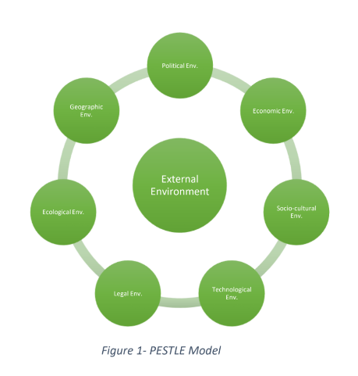
POLITICAL:
Political factors play a key role in business operations for any company, the factors include political instability, consequences, monetary policy, government change, taxation, and support of government towards the industry all influences the political factors for a company (Perera, 2020) recent UK political factors has some instability, recent times the company faces several political issues in Europe due to its anti-trust policy (CNN, 2022). The tax policy and Data protection are kept clear in their privacy policy agreement on the website, they claim that data protection is their major concern (Microsoft, 2022), and Microsoft has a positive political circle in different countries in political lobbying, recently Microsoft collaborated with UK GOV for providing software for (NCSC), these states that the relationship of Microsoft with different organizations at different countries is in the positive side for doing ease of business.
ECONOMIC:
Recent economic disturbance creates a huge impact on tech industries to invest more in the United Kingdom, recent Geopolitical changes and cost of living rise and growth Inflation, (pwc, 2022) due to covid, but Microsoft claims that they are successful in creating a digital economy, it shows that the ability of consumer power is increased for Microsoft products like windows operating systems, and other computer devices.

SOCIAL:
Microsoft sets a vast platform for the Sociocultural dimension, the growing technology in the current world needs to satisfy the various cultural aspects, perceptions attitudes, toward the business. (Perera, 2020) Most of the business is linked with the cultures and traditions of particular countries, and adapting those cultures adds more benefit to the company (Perera, 2020). Microsoft products and software are more efficient adding to improve the productivity of each individual and it also satisfies the organization’s mission statement. In a recent report, Microsoft has made a partnership with NHS UK and uses Microsoft Teams workers to communicate during the pandemic time. (Microsoft, 2022), along with Microsoft mostly focus on educational institutions, with their new program called Educonnect. (Microsoft, 2022)
TECHNOLOGY:
This term technology is most relevant for Microsoft because it’s a technology-based company, therefore the importance of the technical environment is more, (Perera, 2020) this factor is considered one of the key strengths for Microsoft, in a recent pandemic, the usage of online communication is increased, most of the educational and organizations use online tools to perform their operations, this became one of the most utilized opportunities for Microsoft (Paul, 2020) Microsoft teams and other innovative products used mostly for communication, However, the switching of Microsoft products to other available products is observed like zoom, Google Meet, etc this problem became the major threat for the company. (Paul, 2020)
LEGAL:
The law of government, rules, regulations, and acts are considered a Legal force (Perera, 2020) in most countries intellectual property rights are hard to protect, and Microsoft makes necessary proper evaluations while entering into such markets. Such as the Anti-trust policy of Software Licensing, discrimination law, copyrights, and employment law, (Dudovskiy, 2019) the EU and US commissions laid an argument on Microsoft on Anti-trust policy and made a fine 497 million euros (Genakos, 2022) and recent time the piracy of software reduces the global growth of Microsft this is a major threat.
ENVIRONMENT:
Environmental concerns are the biggest challenge facing most businesses in the world, due to global warming and climatic changes, etc (Perera, 2020) and most manufacturing companies have more responsibility to reduce their carbon footprints, Microsoft practices environment sustainability (Microsoft, 2022) to tackle the climatic changes, By the year 2050 they cut supply chain and operations emissions into Half (Forbes, 2022), this creates an opportunity to capture the market and become the leader in the software industry.

SWOT ANALYSIS:
Strengths  Organizational Reputation:  Microsoft is considered one of the leading technology companies in the world, based on revenue, and market share, the company stands in second place competing with Apple and Google, (Reiff, 2022)  Market share:  In terms of operating systems windows laid a strong milestone back in 1975, the market share is around 75 percent in terms of OS for PC and desktops, beating Apple (Statista, 2022) most of the OS adoption activities is low but the number of users is high.  High Market Capital:  The market capitalization of Microsoft In the FY year 2021-22 is 1.9 trillion USD and generated revenue of 192.6 billion USD, most of the revenue generated from OS windows, and continued with Skype, Xbox, and Microsoft Suite (Statista, 2022 ).  Strong Brand Recognition:  Microsoft creates its own identity in the world in the Software and technology sector, as per recent reports Microsoft stands in 3rd place among the world’s top companies (Statista, 2022)  R&D, Huge supply chain: Microsoft spends almost 15 billion USD on R&D to innovation and with-stand the large market competition, | Weakness  Less involvement in Hardware:  Mostly Microsft relays on software production, they depend on other manufacturers for hardware manufacturing, which becomes a major threat as well as a weakness for Microsoft.  Cyber Threats:  This is one of the critical challenges Microsoft in recent data breaches faces high criticism, hacking of personal information, and security for data is getting harder for Microsoft, (Heiligenstein, 2022).  Lack of internet Search engine:  Mostly Google creates a strong search engine platform on the internet, but Microsoft internet explorer is not up to the mark for preferences. According to (Statista 2022), the global percentage use of google is 86.5 and bing is 8 percent followed by other search engines.
OPPORTUNITIES  Low Involvement in smartphones:  Microsoft faces several failures in the mobile industry, in the early time Microsoft is a great player in the mobile industry, making a smartphone strategic acquisition with Motorola, (CNBC, 2022) Nokia, with Windows OS. At the same time, android came up with a strong business model and acquired all third-party markets. (CNBC, 2022)  Gaming Industry:  The gaming console named Xbox is a great and well know the product from Microsoft, controlling the gaming industry with an overall revenue of 2.3 billion US dollars with whooping sales of 37 million consoles all over the world. (Statista, 2021) but still stands behind Sony. As an MNC Microsoft has more capacity to capture more markets with the right product strategy.  Cost Leadership strategy:  When compared to other organizations the company’s products are much more affordable for consumers, which leads to the gain of valuable customers, due to the high pricing of products and a lot of substitutes available in market, this needs to eliminate by providing affordable product subscriptions.  Increase in Remote work:  The recent pandemic made a huge difference in the working environment, most people looking to work from home (forum, 2022) create a big opportunity for Microsoft to develop more software for productivity. | THREATS  RIVALRY and COMPETITION:  In this modern market lot of competitors are looking for an opportunity, the biggest competitors are Google and Apple, for example, Google is strong with a search engine usage of 86 percent(Statista,2021), whereas Microsoft bing is less involved, while Apple has updates day-by-day by macOS, and Safari, Microsoft is still struggling to compete with them in these sections.  Piracy and Counterfeit:  This is a major threat, to be considered Microsoft products are facing piracy issues (Linda, 2001) these need to be tackled by Organization. The organization made a strict rule against criminal counterfeits in 22 countries removing 47000 illegal software piracy. (Microsoft, 2001) The availability of piracy and cheaper subscription of products leads to loss of customers and revenue.  Uncertainty in the Market:  The usage of Personal computers is reduced, and replaced with smartphones while most of the products from Microsoft are linked with PC, so this threat needs to be counter-attack by developing strong R&D and investing in smartphone technologies, most companies like Dell, and HP, are associated partners with Microsoft, in case any failure of their products shows severe indirect effects on Microsoft.

PORTER’S FIVE FORCE ANALYSIS:
Porter’s five force analysis is one of the tools to analyze the competitive environment, it gives a clear view of the competition within the industry and improves business strategy development, this analysis is innovated by, principal Michael E Porter from Harvard University (Porter, 2008) He referred to these forces as the micro-environment, these forces are close to the organizations. Mainly porter developed this framework concerning SWOT analysis, these five forces are the
- Rivalry
- The threat of new entrants
- Bargain power of suppliers
- Bargain power of consumers
- Threat of substitutes
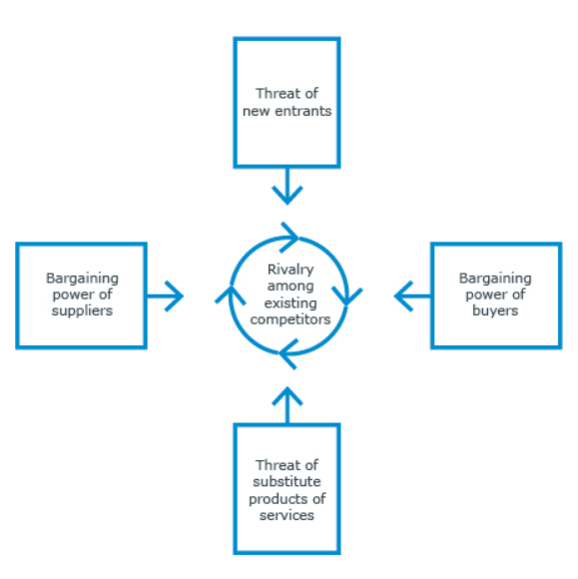
Microsoft Porter’s five force analysis:
RIVALRY: we all know that Microsoft is a tech giant in the world, although faces a lot of rival competitors, like Apple, Google, Oracle, SAP, and IBM along with some local manufacturers in mobile and app development sectors. (Dudovskiy, 2019) This shows Microsoft facing a strong competitive rivalry.
Bargaining Power of Customers: The role of customers in the tech industry is dynamic, the impact on customers in the software and hardware environment is changing day by day because of the low availability of non-computer network solutions customers face less difficult to get the same effective products like Microsoft, (Dudovskiy, 2019) however, the company follows (Ferguson, 2017)its vision and mission statements for continue innovation in their products, to lower the bargaining power of consumers.
Bargaining power of Suppliers: The power of suppliers is low for Microsoft, the technology giant has made strict rules on suppliers, and a strong supplier code of conduct is the major concern to ease of doing business with (Microsoft, 2022) suppliers, and Microsoft doesn’t switch his suppliers for little.
The threat of Substitutes: this is the major factor that any company needs to focus on, Microsoft direct substitutes are low, and the range of products like operating systems, servers, apps, and business solution applications, giving diversified products reduces the switching cost of customers, along with the intensity of substitution the propensity or willingness to choose products over Microsoft also low, the reason behind is Microsoft stands with its vision and mission statements, to empower organizations and every person with their innovations.
Threats of New entrants: The entrants in the technology industry are high but Microsoft restricted the new entrants by developing a high brand identity (Ferguson, 2017) this is one of the major advantages, but the chance of new entrants is moderate in software and hardware Market, Microsoft has huge R&D infrastructure, and diversified products, and has a market share of 67.12%, (Statista, 2022) and the financial resources also well managed, it’s very hard for a new entrant to give competition for Microsoft.
INTERNAL ANALYSIS
VALUE CHAIN ANALYSIS:
Porter introduced the value chain analysis in the year 1985, it describes the full range of activities where the primary phase of a product to distribution to customers and final disposal after use, (Zomora, 2016)
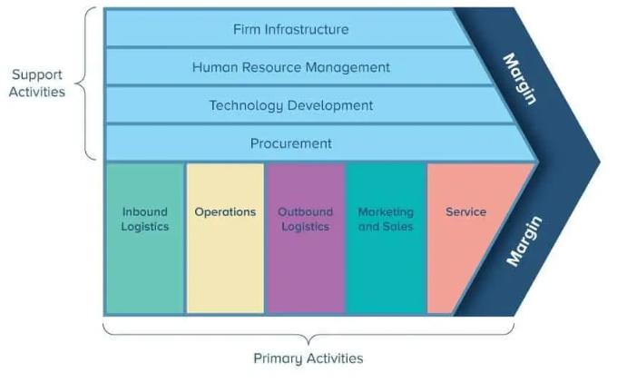
The supply chain for Microsoft Is huge and they got suppliers from different parts of the globe, the company runs all its operations without any disruptions because of its strong Microsoft supplier code of conduct (Microsoft, 2022) the main source of value for Microsoft includes the economic of scales, clear strategic partnership with suppliers and more awareness about their supply chain. (Duduvoskiy, 2019) the operations of Microsoft are carried out in 3 stages according to (Duduvoskiy, 2019) productivity and business processes, cloud technology, and Personalised computing. most of the operations are carried out from various parts of the world (Microsoft, 2022)
While coming to Outbound Logistics the original equipment manufacturer is one of the most important distribution channels for Microsoft, the companies like Acer, Dell, HP, and other PC manufacturers made pre-installing Microsoft OS, (Duduvoskiy, 2019) this is one of the major advantages of OME’s distribution channel for Microsoft along with that distribution to sellers, online and direct stores.
Mostly Microsoft sales and marketing activities are held effectively movement by ongoing viral activities, the sales and marketing are done in enterprise agreements licensing, MS products licensing, and selected, open licensing. (Duduvoskiy, 2019)
FINANCIAL ANALYSIS:
Microsoft is one of the world’s best technological companies doing business by selling cloud computing, PC, and other electronic devices, (Reiff, 2022) Microsoft announced its financial results for the fiscal year 2022, and the net income raises from 21.4% to 18.8 billion and the quarterly revenue increased from 20.1% to 51.7 billion, Microsoft global revenue in the year 2021-22 increased by 18% which is around 198 billion USD. In the year 2019, the overall revenue is 125 bn USD which is quite impressive. By observing the graph we can conclude that the performance of Microsoft after Covid, is constantly increasing
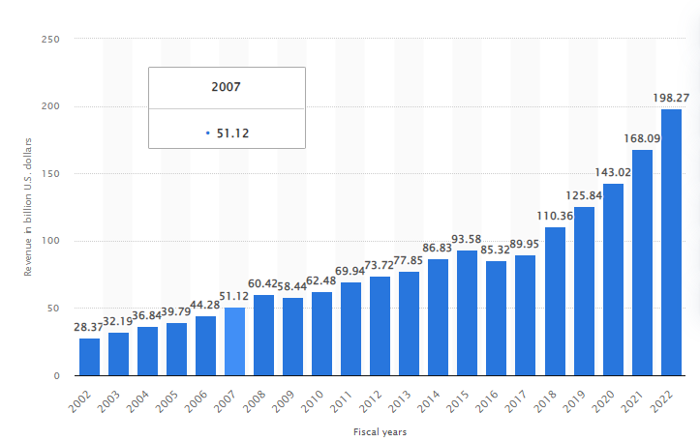
Source: (Statista, 2022)
The market Capitalization of Microsoft is 2.64 trillion USD in the respective year of 2021, according to stock exchanges like the London stock exchange, (Statista, 2022)
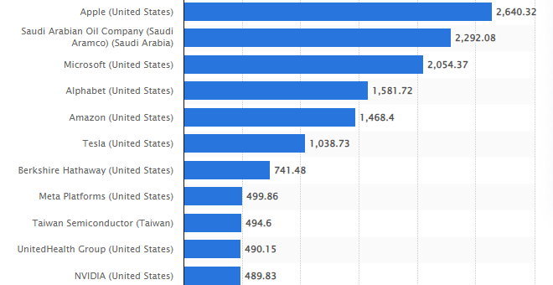
Source: (Statista, 2022)
Mostly Microsoft divides its income into three segments, revenue and operating income, cloud computing, business processes, and personal computing, (Reiff, 2022) In the year 2022 the second quarter of the business processes and productivity income generated 15.9 bn USD in revenue which covers almost 21% in total revenue this shows Microsoft relay on business segmentation rather than other areas while coming to operational income has a revenue of 7.7 bn USD (Reiff, 2022)
Now the technical side of Microsoft has Intelligent cloud technology, Microsoft Azure, and SQL servers, in FY 2022 the intelligent cloud generated a revenue of 18bn USD which accounts for overall 35% revenue, up to a 25% increase from year ago, (Reiff, 2022) In the FY 22 the personal computing generated a revenue of 17.5 billion USD, which has a 34% in overall, while observing these financial ratios the company mostly focus on emerging new technologies to add more value to their company reputation. 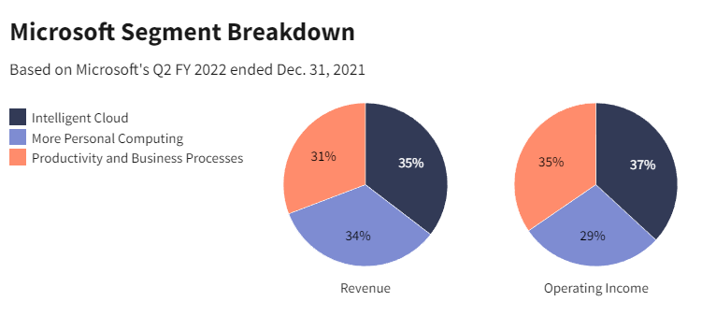
Source: (Nathan, 2022)
STRATEGIC CHOICE:
Ansoff Matrix is one of the tools used to find out various strategic options or choices available for organizations to use as a strategic choice in the strategic planning process, (Kaplan, 2012)
Market Penetration: This is the primary strategy that Microsoft uses to increase its business, it involves selling up more products in existing markets. (Dudovskiy, 2019) Microsoft mostly sells cloud systems, software, and other products in 116 stores worldwide(Statista, 2022) through online channels and authorized distributors. Organizations mostly follow a penetration strategy that provides more unique products to satisfy more customer needs.
Product Development: Microsoft uses a product Development strategy as its secondary strategy, this strategy mostly revolves around new products and innovation in products, we all know that Microsoft innovates its products to higher its revenue. The Research and development expenditure is 25 billion USD in 2022 which is relatively higher than in 2021.
Microsoft mostly works with engineering groups to innovate their products:
Applications and servers are used for education, communication, and other informal sectors. (Dudovskiy, 2019)
Cloud technology: Mostly focuses on cloud-based computing, CRM tools, product and work planning, management tools, databases, etc. (Dudovskiy, 2019)
Market Development: it refers to finding new markets for existing products and introducing different products and services where the scope is more, recently the hololens product is firstly available in selected countries like the USA, Canada, the UK, and other countries (Dudovskiy, 2019) and slowly the demand is getting increased they made the product available for other global countries.
Diversification: This strategy is considered a risky one when compared to other strategies, anyways Microsoft used a diversification strategy by introducing new products to new markets, Microsoft entered into the (Dudovskiy, 2019) cloud business in 2006 by diversifying its products and enters new markets, and giving tough competition to amazon web services, and successfully surpassed became the leader in global cloud technology. (Dudovskiy, 2019)

STRATEGIC IMPLEMENTATION:
The Main aim of organizations is to achieve their goals by implementing the right choices of strategies to identify and increase their growth opportunities (Rani, 2019), successful organizations like Microsoft, Google, coco-cola implement strategic plans to run operations effectively. Some factors support strategy implementation.
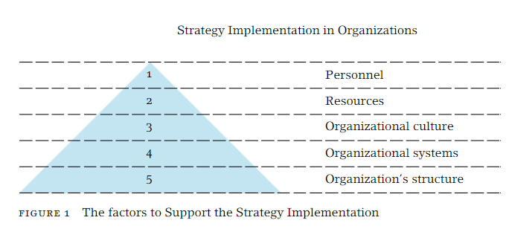
Organizational structures of Microsoft:
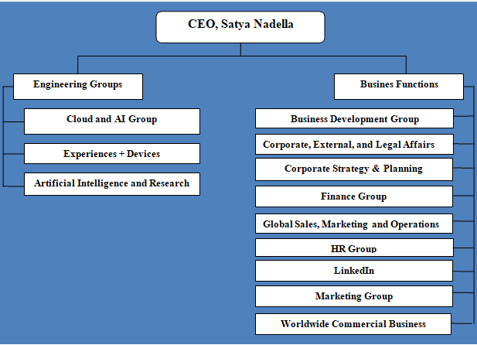
Source: (Duduvosky, 2019)
The organizational structures add more advantages to the Organizations and their business. Firstly the Head of engineering groups can report directly to the CEO Satya nadella about new implications and new innovation ideas shared directly with CEO. Both Engineering groups and Business teams Work together to maintain clear transparency in the organization. (Duduvosky, 2019), and secondly, the organization focuses on eliminating the hierarchy in business and tech activities to adapt to the new market changes quickly.
Microsoft is a product-type divisional structure, based on certain computer products like Software, and Hardware manufacturers.(Jessica, 2020) There are 3 main features in Microsoft’s corporate organizational structure, those are product type divisions, global corporate groups, and geographical segments.
Resource Planning:
Microsoft is the biggest company with a lot of suppliers all over the world, they have a wide range of resources from, Hardware to packaging and Human resource to perform global operations. Microsoft has strict rules in sourcing their Suppliers, the company upholds Human rights rules, labor rules, and health and safety. These are all to be prescribed in the supplier code of conduct. (Microsoft, 2022). The company can focus on major commitments while resource planning those are. Analysis of risk, Assurance and accountability, capability building, and Creating shared values. (Microsoft, 2022) while coming to Human resource planning, they provide eligibility Criteria, and the necessary skills for the Job role, the Microsoft HR practices are decent and consists of 3 round of hiring, firstly Online assessment, a Technical Interview, and HR Interview, after successful clearing of all round the desired candidates are open for training and Development. (Joever, 2020)
Change management:
In a tech Industry, change is a common and regular practice to adapt the new technologies and markets, Microsoft uses the ADKAR change management model, to adapt the new internal changes in the company, and a brief discussion tells about how change management is achieved By Microsoft by adopting ADKAR model.
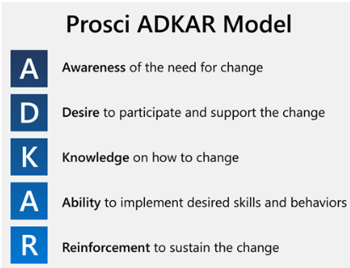
Microsoft used the prosci-ADKAR model for change management for the adoption of new business intelligence tools within the organization(Microsoft, 2022)
The emergence of data analytics within the organization is raised, the old system is an abundance of data, which makes it hard and costly for Microsoft to automate the process so managers need to be more aware of new technology, and leaders and other managers trying to support the change. Changing to new technology and convincing their staff to switch to new technology is not an easy task, and they started weekly and bi-weekly sessions of training to gain knowledge about the new change. They worked daily to monitor the change and find out the lack of technical training and executive sponsorships (Delani, 2022) and they slowly started to implement the strong skills that were necessary. And finally, now there are 14 regions with 30000 users of the business intelligence tool, this is how they used the ADKAR model of change management to launch a new business platform in Microsoft.
STRATEGIC REVIEW:
Microsoft recently ranked top in company culture among other tech giants, the reasons might be a fair work environment and trustworthy management, these two factors play a key role in performance management and are one of the success reasons.
The process of measuring the performance of an organization’s SMART goals is used to measure the performance and feedback progress of an employee to put them in the right direction to achieve the goals (Cot, 2020) there are several tools used to formulate strategy, and the SMART tool is one of the major tools used for strategic formulation. SMART goals developed by George Doran in 1981 a way to write the goals and objectives of an organization (Doran, 1981)
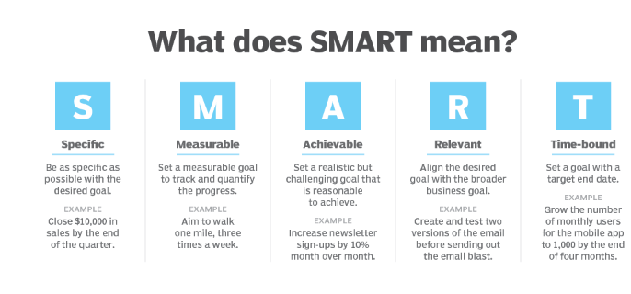
Applying SMART to Microsoft
Specific: This step indicates, what is organization trying to do, the role of the team, and accountability towards the work (Doran, 1981). Microsoft has a rigid goal towards innovation, they specifically focus on innovation to achieve their vision, and their R&D efforts focus on 3 major areas of business. (Microsoft annual report, 2022)
- Reinvent productivity and improve business process
- Work on cloud intelligent platform
- Build more personalized computing.

Measurable: it defines how will you measure what you are doing (Doran, 1981) the overall net consumer satisfaction (NSAT) is the main measuring metric index along with business Online services (BOS), Scorecards, BPOS, and server applications (Foley, 2011)
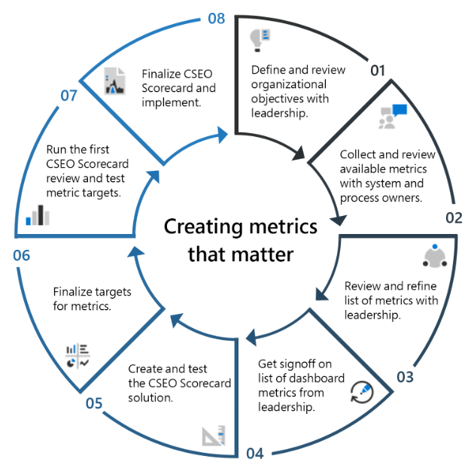
Source: Microsoft metrics for measuring performance
Achievable: It is mostly related to the infrastructure and financial resources of the company to achieve the targets, recent studies show the company spends 25bn USD(Statista, 2022) in R&D, which shows the company has abundant financial resources to achieve their targets. Training and development activities are held to improve productivity (Microsoft, 2022) include.
- Classroom learning and sharing of learner boards.
- Coaching and career development training programs.
- New employment orientation and training, introducing company values and business conducts.
- Promotions and job stretch facilities.
Realistic: it tells about, whether we meet the goals we set (Doran, 1981) under realistic conditions Managers of Microsoft focus on the project timeline, taking necessary feedback from employees, and the company adopts a new tool replacing the old numerical rating scale model to approaching employees with a set of qualitative and quantitative based real-world questions (Dixit, 2018) for better improvement, managers are well trained to give coaching to employees in a non-threatening way
While going through strategic Review the application of smart tools adds more value to Microsoft, By applying SMART to Microsoft it concludes how they are implementing and successfully carrying out their performance management process to achieve more to satisfy their vision and future mission.
Understanding Microsoft Competitive advantage:
The basic task of strategic management is to build and maintain a strong competitive advantage for the organization. (Pawel, 2017) Competitive studies are mostly used in management science, but most organizations use them to gain success in their respective fields, these studies are coined by the porter in 1985 to understand more about the theoretical analysis of competitive advantage, Mostly competitive advantage sets attributes or sets of actions for better performance of organizations rather than competitors.
The competitive advantage allows organizations to produce quality and affordable products than their rivals, the key concepts include branding, cost leadership, brand equity, Innovation property, and services are the factors. Microsoft has strong competitive advantages which are discussed.
Microsoft’s MOAT: in strategy MOAT is used by many authors to represent the competitive advantage and the ability of the company to secure itself from the competition, according to a (Fobes, 2021) recent article, Microsoft has a large user base on different platforms, for example, Microsoft 365 is one of the major tools which has 54 million active subscriptions in 2022, and Microsoft teams used by 250 million users all over the world, the company generates revenue of 98.3 billion USD free cash flow from past 3 years, by considering all these factors, Microsoft has large MOAT in terms of finance, technology, sales and marketing, and from recent years the moat is getting bigger.
Brand Equity: Unique and strong brand name is a major competitive advantage for Microsoft, and it successfully delivers its business over the past 40 years, the company gets its brand image by giving quality and efficient products to its customers to earn their trust. Based upon their pricing, marketing, and other factors too, they created a strong impact on customers as a technological brand, (Abhijeet, 2018) maintaining a healthy relationship with customers and focusing on more innovation added more good signs for the company.
Leadership: This is a proven source of competitive advantage, most technological companies like Apple to Microsoft used Leadership theory as a competitive advantage to improve organizational performance,(Abhijeet, 2018) Microsoft was founded by visionary individual Bill gates, and the current CEO is Satya Nadella, who helped to put them back in the right direction after facing difficult challenges. Nadella focuses on improving innovation at an early age, improving Microsoft's acquisition, and moving into new areas to increase the new customer base.
Range of Products: In Recent years Microsoft’s product range has developed a lot, the product variants are hardware, software, gaming products, web, and cloud services. Windows Operating system is one of the most used OS in the world, (Abhijeet, 2018) Microsoft Azure performing well in recent times in cloud technology Recent acquisitions with Linkedin, increased more chances to promote their products to reach more customers.
Marketing: In the fiscal year 2022 Microsoft’s total expenditure on Marketing is 22 bn USD which stands top on the list of highest expenditures till now. (Statista, 2022) Microsoft uses a traditional marketing Mix for the promotion of its products effectively. It uses digital and web are the major channel of advertisement and direct and indirect distribution networks play a key role in the growth of the company.
Innovation: Another important competitive advantage factor for Microsoft to consider, every year company invests more in Research and development, in the year 2022 company spend 25bn USD, and Microsoft stands as the second largest company to spend more on Research and development in terms of software and computer service organization (Statista, 2022) the competition almost high for Microsoft so mostly focus on to build a strong R&D department to bring great values and results, the need of AI and advance technology is evolving so Microsoft needs to be more focus on their developments, so that can control the retain and switching of customers, that’s why most of the leading companies to invest more on Technology.

Recommendations:
While examining the Internal and external analysis, there are some points not working well in the organization, the company needs to focus on these points to improve its market share, there are some recommendations for Microsoft mentioned below, and the weakness and threats are the strategic reforms in the business. The company must follow its strong innovation policy to develop its products to counterfeit cybercrimes,
While coming to Hardware production Microsoft depends on other organizations for the manufacture of components, to improve their manufacture of hardware leads to an increase in revenue and market segment. Mainly the company faces a strong Piracy problem in different countries, so the company needs to tackle this situation by giving affordable subscriptions, like monthly, weekly, and yearly subscriptions to all their apps, by giving various variants of subscriptions for students, Working professionals.
Most of the rivals of Microsoft are performing well in Smartphone Market, for example, Google has mobile technology called Google Pixel, and apple has iPhone, but Microsoft has low involvement in smartphones, even though they have acquired Nokia, so the recommendation to Microsoft is to come up with a new smartphone to create a new revolution in the mobile phone industry. Recent Acquisitions are not successful for Microsoft they are trying to give competition to Amazon to improve the cloud services.

Conclusion:
There are more opportunities to explore by the tech giant Microsoft, Range of products is the major important factor for the company to survive in the technology sector, future strategy is to improve Innovation in their products and regular updates with their products, the whole strategic management framework discuss in detail about how management is performing and controlling key factors. The company mostly focuses on Customer Service, and target marketing which improves there customer base, Microsoft’s Continuous addition of tools and new features and introducing new apps to their software increases the customer base, and the Diversification strategy is the risky one yet successful for Microsoft, at the initial stage of expanding their business into Cloud Technology, providing affordable cloud services all over the world. From recent news, the company is planning to buy the Entertainment gaint in an OTT platform called Netflix in FY 2023. These actions and strategic approaches made Microsoft company became the biggest company in recent years in this huge competitive world.

References:
Abhijeet, P. (2018) Microsoft source of competitive advantage. Available at: https://www.notesmatic.com/microsoft-sources-of-competitive-advantage/ (Accessed: 19 Dec 2018).
Bansal, T. (2022) How Microsoft is leading the response to the climate crisis. Available at: https://www.forbes.com/sites/timabansal/2022/06/22/how-microsoft-is-leading-the-response-to-the-climate-crisis/?sh=1af896f850a1 (Accessed: June 22 2022).
CIPD (2021) pestle analysis. Available at: CIPD (2021) Pestle analysis. Available at: https://www.cipd.co.uk/knowledge/strategy/organisational-development/pestle-analysis-factsheet#gref (Accessed: Dec 6 2021).
Duduvosky, J. (2019) Microsoft Organizational structure. Available at: https://research-methodology.net/microsoft-organizational-structure-divisional-structure-with-focus-on-innovation/ (Accessed: 31 Jan 2019).
Debajyoti, P. (2020) 'Usage of Microsoft teams as an online learning platform during covid, children and Youth services review, 119, pp. 10-12 Available at: https://doi.org/10.1016/j.childyouth.2020.105535
David, T. (2021) Microsoft Incumbent Advantage creates a large Moat. Available at: https://www.forbes.com/sites/greatspeculations/2021/11/15/microsofts-incumbent-advantage-creates-a-large-moat/?sh=4d74a44f65a8 (Accessed: 15 Nov 2021).
Flores, Joever & Joseph, & Flores, JoJo. (2020). Human Resource Management Practice in Microsoft Corporation. 10.13140/RG.2.2.36246.70729.
Foley, M. (2011) How Microsoft measures its success. Available at: https://redmondmag.com/articles/2011/03/01/how-microsoft-measures-its-success.aspx (Accessed: 03 Jan 2011).
Foley, M. (2011) Scorecard: how Microsoft measures its own success. Available at: https://redmondmag.com/articles/2011/03/01/how-microsoft-measures-its-success.aspx (Accessed: 03 Jan 2001).
Gabriele, G. (2006) 'Microsoft a case in cross-company transformation ', Thunderbird international review, 48(4), pp. 555-596 Available at: https://onlinelibrary-wiley-com.ezproxy.uwtsd.ac.uk/doi/pdf/10.1002/tie.20109 (Accessed: 22-11-22).
Guillermo, F. (2020) 'Conceptual framework for the strategic management, A literature review, vol 2020, pp. 1-4. Available at: https://doi.org/10.1155/2020/6253013
George, D. (1981) 'smart way to write management goals and objectives, journal of management, 70, 32-36. Available at: Doran, G. (1981) 'There is a smart way to write management goals and objectives', Journal of management review, 70, 35-36. Available at: https://community.mis.temple.edu/mis0855002fall2015/files/2015/10/S.M.A.R.T-Way-Management-Review.pdf
Haselton, T. (2018) Departing windows chief explains why Microsoft fails in the smartphone. Available at: https://www.cnbc.com/2018/03/29/why-microsoft-failed-in-phones.html URL (Accessed: 29 March 2018).
John, D. (2019) Microsoft Ansoff matrix. Available at: https://research-methodology.net/microsoft-ansoff-matrix/ (Accessed: 4 Feb 2019).
Jessica, L. (2018) Microsoft corporate organizational structure and its analysis. Available at: https://panmore.com/microsoft-corporation-organizational-structure-characteristics-analysis (Accessed: 08 Sep 2018).
Johnson, G., Whittington, R., Regnér, P., Angwin, D. and Scholes, K., 2020. Exploring strategy. Pearson UK.
Kaplan (2022) Kaplan financial Knowledge bank. Available at: https://kfknowledgebank.kaplan.co.uk/business-strategy/strategic-choice/ansoff's-matrix#:~:text=Ansoff's%20matrix%20is%20a%20very,of%20the%20strategic%20planning%20process . (Accessed: 2022).
Lionel, V. (2022) Microsoft expenditure on research and development. Available at: https://www.statista.com/statistics/267806/expenditure-on-research-and-development-by-the-microsoft-corporation/ (Accessed: 28 July 2022).
Lionel, V. (2022) Microsoft statistics and facts. Available at: https://www.statista.com/topics/823/microsoft/#topicOverview (Accessed: 14 Nov 2022).
Microsoft (2022) How Microsoft used change management best practice to launch a new business intelligence platform. Available at: https://www.microsoft.com/insidetrack/blog/how-microsoft-used-change-management- best-practices-to-launch-a-new-business-intelligence-platform/ (Accessed: 27 Jun 2022).
Microsoft (2001) Microsoft intensifies its worldwide campaign against internet piracy and counterfeiting. Available at: https://news.microsoft.com/2001/04/02/microsoft-intensifies-worldwide-campaign-against-internet-piracy-and-criminal-counterfeiting/ (Accessed: 1 April 2001).
Magretta, J. (2012) Understanding Michael Porter the essential guide to competition and strategy. Boston, Mass: Harvard Business Review P.
Microsoft (2022) how we track our digital transformation. Available at: https://www.microsoft.com/en-us/insidetrack/metrics-that-matter-how-we-track-our-digital-transformation (Accessed: 01 Jun 2020).
Microsoft (2022) Microsoft annual report. 25 July: Publisher or Available at: https://www.microsoft.com/investor/reports/ar22/index.html (Accessed: 25 July 2022).
Microsoft (2022) Timeline of Microsoft. Available at: https://www.microsoft.com/en-gb/about/timeline/ (Accessed: 18 May 2022).
Microsoft (2022) Microsoft privacy statement. Available at: https://privacy.microsoft.com/en-gb/privacystatement (Accessed: Sep 2022).
Microsoft (2022) Uk impact overview. Available at: https://query.prod.cms.rt.microsoft.com/cms/api/am/binary/RWCW3f (Accessed: 2022).
Nathan, R. (2022) 10 biggest software companies. Available at: https://www.investopedia.com/articles/personal-finance/121714/worlds-top-10-software-companies.asp (Accessed: 24 May 2022).
Porter, M. (2008) 'The five competitive forces that shape strategy, Harvard Business Review, 86, pp. 79-93
Pawel, C. (2017) 'The concept of competitive advantage', journal of positive management, 7(3), pp. 57-70 Available at: 10.12775/JPM.2016.016 (Accessed: May 2017).
Pushpa, R. (2019) 'Strategy implementation in organization', journal of management, 14(3), pp. 205-218 Available at: 10.26493/1854-4231.14.205-218 (Accessed: 14 Sep 2019).
Reiff, N. (2022) How Microsoft makes money. Available at: https://www.investopedia.com/how-microsoft-makes-money-4798809#citation-31 (Accessed: 22 Dec 2022).
Ryan, D. (2022) Microsoft's competitive advantage. Available at: https://www.investopedia.com/articles/insights/072516/microsofts-competitive-advantage-inside-look.asp (Accessed: 06 Dec 2022).
Rashain, P. (2017) The Pestle analysis. Available at: https://books.google.co.uk/ (Accessed: 19 Sep 2017).
Sujay Valishery, L. (2022) Microsoft's Global revenue. Available at: Microsoft (2022) Timeline of Microsoft. Available at: https://www.microsoft.com/en-gb/about/timeline/ (Accessed: 18 May 2022). (Accessed: 28 July 2022).
Sujay valishery, L. (2022) Microsoft annual revenue from FY 2002 22. Available at: https://www.statista.com/statistics/267805/microsofts-global-revenue-since-2002/ (Accessed: 28 Jul 2022).
Statista (2022) The 100 largest companies in the world by market capitalization. Available at: https://www.statista.com/statistics/263264/top-companies-in-the-world-by-market-capitalization/ (Accessed: 19 Aug 2022).
Robert, Z. et al (2004) 'expand your business', Strategic Management by Jordan American business association, pp. 8-9. Available at: https://pdf.usaid.gov/pdf_docs/Pnade297.pdf
world economic forum (2022) Employers are giving work from days they want. Available at: https://www.weforum.org/agenda/2022/07/work-from-home-employers-workers-work-life/ (Accessed: 26 July 2022).

