Ryan Hopkins (2221956)
2221956@student.uwtsd.ac.uk
Abstract
Maze pathfinding using algorithms
Advanced Software Development
ACCB5011

Contents
Task – 1 discussion on pathfinding algorithms 2
Time complexity 2
Big O notation 2
Pathfinding algorithms 2
What is Dijkstra's Algorithm? 2
What is A Algorithm? 3
Task 2 – Implementing code to sort through a maze 3
My approach 3
Conclusion 5
Bibliography 5

Task – 1 discussion on pathfinding algorithms

Time complexity
Time complexity is a description of how the runtime of an algorithm increases with the complexity of the algorithm; this theory helps with understanding how efficient a piece of code is while processing larger data sets.

Big O notation
The big O notation is used to describe the worst-case scenario, or the slowest case scenario of an algorithm and its input size, it provides the developer with an understanding of how the algorithm scales with larger input sizes. Aditya Kumar Listed one advantage of using big O notation as “Resource Management: Big O notation is also relevant for resource management, especially in resource-constrained environments such as embedded systems or server environments. It helps developers make informed decisions about memory usage, processing power, and other resources.” [1] while often overlooked, resource management in large scale applications is a requirement without optimisations being made you could corrupt vital infrastructure from over spending the available resources.

Pathfinding algorithms
Alexander Gillis described algorithms as [2]” a procedure used for solving a problem or performing a computation. Algorithms act as an exact list of instructions that conduct specified actions step by step in either hardware- or software-based routines.”. The main reason to use pathfinding in software engineering is the optimised resource allocation, this is only applicable when the dataset is massive, as it might cost more for in resources and a higher time complexity than just running a simple sorting algorithm, however the efficiency cost is negligible on modern day computers, the only time when this would be necessary is when developing a program for a system on a chip where memory onboard memory is incredibly low.

What is Dijkstra's Algorithm?
Dijkstra’s algorithm, is a pathfinding algorithm which finds the shortest path in a graph, it will determine find the shortest path to all nodes from the starting point, when applied to computer science it is typically used in networking, where network packets are split up to reduce network latency, however can have some applications in software engineering, such as finding the shortest path to each entry in a data structure. The formula for Dijkstra’s algorithm is f(n) = g(n)
The process starts with designating a start point for this example its designated number is 0, this would, and ever other node has been set to an unvisited class. Dijkstra’s algorithm will pick from the smallest path and traverse it, until it cannot continue, when all possible nodes have been traversed then the data has been sorted for the shortest path to each node, using a priority queue to dictate the sorting done, whether its high to low or vice versa.
When sorting dijkstra’s algorithm, it searches from lowest to highest, for example, in figure 1 we have a 7 nodes, the algorithm would go 0 -> 0| 1 -> 2| 2 -> 6| 3 -> 7| 4 -> 17| 5 -> 22| 6 -> 19, the reason for this path is due to the traversal length being shortest to highest, however step 5 needs to be checked just incase step 6 has a cheaper path than 5-> 6, from 4->6.
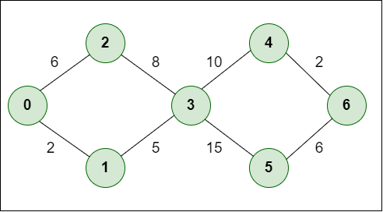
Figure 1 Dijkstra nodes, from geeks for geeks [3]

What is A Algorithm?
The a* algorithm is an extension of Dijkstra’s algorithm g or the distance travelled in Dijkstra has a heuristic function is added to guess the shortest route without calculating all the nodes in the set. The full equation is: f(n)= g(n)+h(n). f in this equation is the total distance to a node, g is the total distance travelled, and h is the heuristic is the estimated distance to future nodes. As Abinaya Subramaniam says “A* ensures the best balance between exploration and cost, making it both complete and optimal.” This statement is inherently true due to the use of heuristics the time complexity of a* is slightly dependent on the input from the user.
Mahattan distance, is the distance traversed without diagonal representation, this is the shortest distance without using a diagonal node, this means that to turn you must go through a node and then take that turn. See figure 2 for a visual representation on how Manhattan distance works.
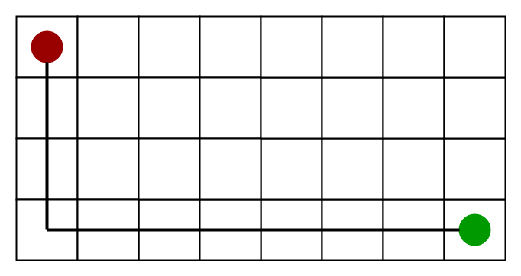
Figure 2 a* algorithm from geeks for geeks [4]

Task 2 – Implementing code to sort through a maze

My approach
The approach taken used a* pathfinding, this pathfinding technique is incredibly complex however the performance gain is worth the complexity. The results from the application, provide concrete evidence that the a* algorithm works see figure 3 for the resulting code.
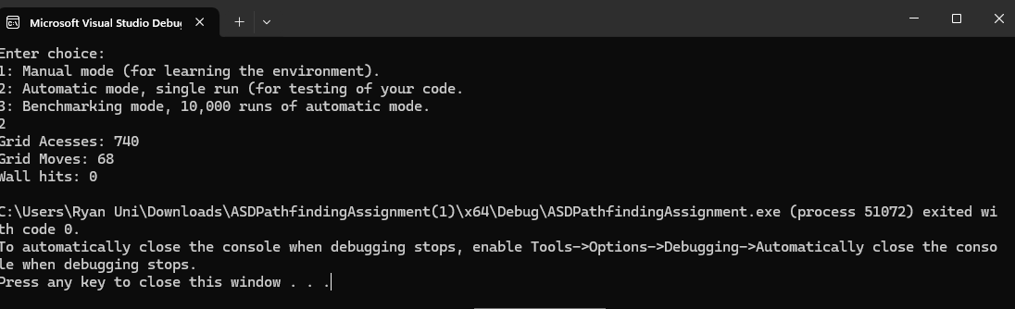
Figure 3. the displayed results from running the application
During the development of the application, I tried to keep to the same naming conventions, this minimises the mistakes in using the incorrect variable, as AbuBakar Memon says “Code Maintenance: Inconsistent naming conventions can lead to maintenance nightmares. As developers work on various parts of the project, they might unknowingly introduce new naming conventions, making it difficult to ensure consistency over time.” [5], in this application, the naming conventions tried to keep to camalcasing, however some variables did not use camalcasing such as dx and dy, the reason why I used dx and dy as this is a local variable only used for a specific function. See figure 4 for the variable declaration.
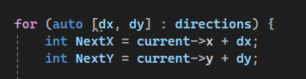
Figure 4 variable declaration, showing the next y and x variable declaration.
The benchmark for the application runs the pathfinding ten thousand times, in previous tests throughout the day, this would not work, however when a* was fully implemented the benchmark worked, while using other methods such as BFS or dijkstras the maximum grid accesses would be in excess of 2000 times, the result of a* implementation is seen by the amount of grid accesses as can be seen figure 5 for the end result.
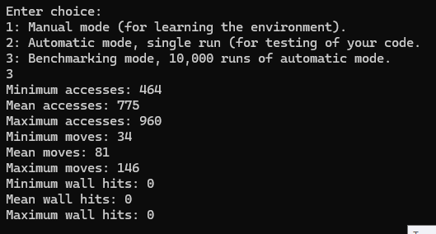
Figure 5 the benchmark running ten thousand times result.

Code breakdown
The code seen in figure 6, is creating and using the neighbour nodes, the newG is finding the cost of the move, from the previous node, so it would get the current gCost from the node and add 1 on top of that number. The comments were previous tests that could help other developers understand the code, whilst the else { in figure 6, has no purpose in the running code it helps debug the code, checking if the code is rejecting nodes for any specific purpose.
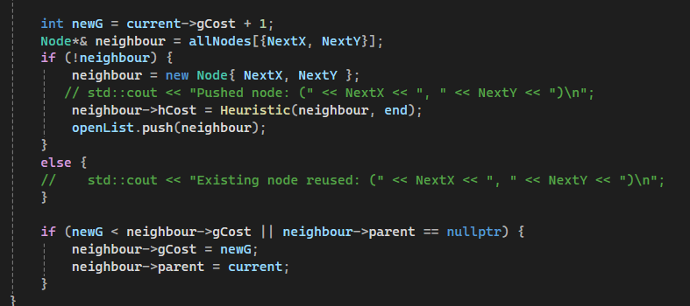
Figure 6 this shows the check for the incorrect position.

Conclusion
in this project, we implemented the a* pathfinding algorithm to navigate the player across a 20x20 grid, starting from the bottom left to the top right corner, whist trying to avoid obstacles along the way, using estimated distance from the target the heuristic, from the start or previous nodes, in this application we were restricted to using Manhattan distance for the heuristics, as the player can only move in north, east, south or west directions, the future uses of Manhattan distance as discussed by Vinod Chugani is “In grid-based environments, Manhattan distance provides a quick and effective heuristic for estimating the distance between two points. It's particularly useful in the A* algorithm, where it can help guide the search towards the goal more efficiently in scenarios where movement is restricted to horizontal and vertical directions. Think about routing in city streets, maze-solving algorithms, and certain types of video game AI pathfinding.” [6]
Based on the benchmark tests the performance of the application has enhanced performance as it does the searching based off the heuristics provided through the Manhattan distance theory, when compared to BFS it is understandable why the time complexity of A* is better than BFS as Abinaya Subramaniam said “BFS is complete because it explores all possible states layer by layer, guaranteeing a solution if one exists. It is also optimal in cases where all actions have the same cost, as it finds the shallowest goal node first.” [7]

Bibliography

[1] | A. Kumar, “Big O Notation: Time Complexity & Examples Explained,” SimpliLearn, 4 May 2025. [Online]. Available: https://www.simplilearn.com/big-o-notation-in-data-structure-article. [Accessed 9 May 2025].
[2] | A. S.Gillis, “What is an algorithm?,” TechTarget, 1 Jul 2024. [Online]. Available: https://www.techtarget.com/whatis/definition/algorithm. [Accessed 14 Jan 2025].
[3] | geeks for geeks, “ What is Dijkstra’s Algorithm? | Introduction to Dijkstra’s Shortest Path Algorithm,” Geeks for geeks, 24 Dec 2024. [Online]. Available: https://www.geeksforgeeks.org/introduction-to-dijkstras-shortest-path-algorithm/. [Accessed 14 Jan 2025].
[4] | Geeksforgeeks, “ A* Search Algorithm,” Geeksforgeeks, 30 Jul 2024. [Online]. Available: https://www.geeksforgeeks.org/a-search-algorithm/. [Accessed 1 Jan 2025].
[5] | A. Memon, “Importance of Consistency in Naming Conventions,” Medium, 2 November 2023. [Online]. Available: https://medium.com/@abubakarmemon/importance-of-consistency-in-naming-conventions-86d5c1da19d3. [Accessed 29 APRIL 2025].
[6] | V. Chugani, “What is Manhattan Distance?,” Datacamp, 17 July 2024. [Online]. Available: https://www.datacamp.com/tutorial/manhattan-distance. [Accessed 8 May 2025].
[7] | A. Subramaniam, “AI Search Algorithms: Uninformed Vs Informed Search Explained with Real World Examples,” Medium, 11 February 2025. [Online]. Available: https://medium.com/ai-simplified-in-plain-english/ai-search-algorithms-uninformed-vs-informed-search-explained-with-real-world-examples-1e73ea9d5905. [Accessed 08 May 2026].

