Nicola Dunne
Student Number 1502647
SJIE6003 Assessment 2
The impact of an intervention strategy using a growth mindset on a child with an additional learning need (ALN)
Introduction
This case study has been carried out in a rural school in mid-Wales. The school has been open for more than one hundred years and has strong community links. Many of the families of the children who attend are former pupils, and community support comes in many forms, such as offering time to read with the children, attending social events, and volunteering time and/or resources for maintaining the upkeep of the school grounds and the community area which is located next to the school playground.
The school currently comprises two classes, one which houses children in Reception Class, Primary 1 and 2, with the other class being Years 3 to 6. There is no hall attached to the school so children eat together in the classroom and much use is made of the outside space for learning, including but not restricted to PE. The children who attend come mainly from farming backgrounds, though in recent years children from more diverse backgrounds have enrolled, settled well and are enjoying rural school education.
One of the children in Class One has been identified as having a difficulty with learning, with progress being notably far behind that of his peers. As the child is due to progress with his year group to Class Two at the start of the next academic year, this case study will investigate whether 1:1 learning intervention with a growth mindset can enable him to transfer skills for working independently in the classroom. The current strategies used are Nessy, which he works on independently, and Precision Teaching, currently aimed at improving his literacy by helping him to learn and retain the first hundred high frequency words, transfer his knowledge into the classroom, and apply his knowledge through reading and spelling independently. He currently works with a teaching assistant for 1:1 intervention and the Class Teacher otherwise, though is sometimes referred back to the teaching assistant for additional support in the classroom. The hypothesis is that by teaching him individually about the five habits of mind for growth mindset, which is currently embedded in the School Development Plan, so that he can apply this mindset to his learning as a strategy to be used in his 1:1 time, that he will become able to transfer the strategy to apply his skills more independently in the classroom, the theory being that he will in time not have to rely as heavily on staff for support with his learning. The five habits of mind which the school have adopted are Inquisitiveness, Collaboration, Self-Discipline, Imagination and Perseverance, to embed a growth mindset for children’s learning, based on Carol Dweck’s Growth Mindset theory (Dweck, 2000).
Methodology
I began by carrying out an initial self-assessment of how I worked with Child A during 1:1 intervention, considering how I delivered the intervention and comparing it to how he retained and used the information he was learning. I also reviewed past evidence to track his progress since the previous year. On reflection, I noticed that although he was progressing, his progression was quite slow, and his ability to transfer skills was poor, also he was happy to rely heavily on staff for support. I pondered whether this was due to perhaps a fear of failure or negative judgement by his peers, and the effect it may have on his self-esteem. When considering the Well-Being of Future Generations Act (2015) it is important for staff to nurture children to retain their self-esteem in order that they maintain a resilience to failure and a desire to continue in their learning.
In the school’s Development Plan (SDP) (appendix 1) the growth mindset and the five habits of mind are part of the plan for improving well-being and attitudes to learning, and care, support and guidance. Further investigation revealed that one habit becomes the main focus each term, and that parents are made aware of it and reminded via the school’s weekly newsletter. However it is worth noting that although children were regularly made aware of the current habit of mind during assembly times, (appendix 2) they were used more openly and consistently in Class Two than in Class One, for example, a chance observation in passing Class Two highlighted one child collaborating with another who was struggling with a piece of work, which helped the second child to persevere with the task. (no evidence available for proof or disproof).
I then designed a small questionnaire directed at staff who work in Class Two to gain some insight as to how effective they perceived Precision Teaching and Growth Mindset to be (appendix 3). The class teacher is also the school’s headteacher, and there is a part-time Teaching Assistant who works with children providing 1:1 teaching such as Precision Teaching. With the previous knowledge of Child A’s memory issues for retaining information I taught him about collaboration and perseverance by simplifying the language, such as ‘let’s work this out together’ and ‘I know you are finding it difficult, but I can see you’re trying really hard’. Each time we started a new Precision sheet I wrote down his new set of words in his reading record to practise at home, with family, we collaborated to give him actions, phrases, or sentences to help him remember each word. I showed him a resource he could use in class if he found something difficult, an idea borrowed from Class Two called the 5 Bs (appendix 4). Class Two children use it daily, alongside the five habits of mind and it reduces the need for constant teacher interaction by encouraging the children to use every means necessary for assistance before asking the teacher, therefore promoting independent thinking and learning. The 5 Bs are Brain Board Book Buddy Boss which support the wishes of the new Curriculum for Wales (2017) that children be ‘ambitious, capable learners’, as it encourages more independent thinking for problem-solving and determination for finding solutions independently.
I also made a keyring resource he could use both during Precision Teaching and in the classroom, to give him a tool for promoting independent thinking (appendix 5) The resource encourages him to rely more on memory recall to identify what he needs for reading or spelling, with scope to add to it more resources for areas of learning he finds difficult.
Towards the end of the study I began evidence-gathering to compare levels and progress. (appendix 6) Filming progress was not permitted for the study or evidence gathering, however the class teacher and I both agreed there was an improvement in his learning and in how he performed in the classroom environment.
Findings
Initial findings were surprisingly not related to Child A but to how I was delivering the learning intervention. Analysing a child’s progress is a procedure done on a daily basis to measure progress, but critically thinking about how I was teaching the content and its impact on the engagement of the child was more difficult than originally anticipated.
Critically analysing and comparing past failures with the child on how he retained information changed the way in which I helped him to remember things correctly, and by simplifying language he could understand the habits of mind well enough to begin applying them to his Precision Teaching.
A comparison between his Precision Teaching score sheets revealed that in six months Child A has progressed from learning single phonemes to working on high frequency words. (appendix 7) By mixing VC (vowel consonant) and CVC (consonant vowel consonant) words in with trickier words I found that being able to read or sound out some of the words successfully encouraged rather than discouraged him to try harder with the tricky words, it also meant his score was never low enough to affect his self-esteem negatively. Also by reinforcing the five habits of mind, in particular perseverance, self-discipline and collaboration I found he was more focussed on his Precision Teaching. Although progress is still slow with Child A, by applying the five habits of mind first to his Precision Teaching following up with application in the classroom he is now able to sit with his peers to work, is more focussed on the task, and is beginning to rely less heavily on support from staff. I also noticed that Child A is beginning to recognise his Precision words with his reading, which is improving not only his reading skills but also his spelling skills, and that peer interaction without negative behaviour during playtime has begun to improve. When considering how his learning has changed from being fully reliant on staff, to being able to work and interact with peers it could be viewed that how he learns is changing from Piaget’s theory of Cognitive Deveploment (1936) to Vygosty’s Social Development theory (1962). Child A’s learning had been by repetition over long periods of time, whereas he is now able to collaborate with peers or staff to help him to gain knowledge.
I compared Child A’s end of year Phonics and Spelling assessment against a phonics check using his rainbow alphabet, and current scores for Spelling tests conducted weekly by the class teacher, and noted that both have made an improvement (appendix 8)Analysis of the questionnaires for both staff and children in Class Two revealed that both groups were in agreement of each other that Precision Teaching, using the habits of mind had a positive effect on the children’s self-esteem and learning enthusiasm for learning, though the children were in agreement that not all habits of mind were required for Precision Teaching. Also the Class Two teacher commented positively on the improvement of engagement of those children who struggled with skills such as self-discipline in the classroom.
However, I feel that to measure his progress when applying the five habits of mind and the 5 Bs further assessment would be required over a longer time period. To show how far he has progressed will require a re-assessment of his phonics and spelling level at the end of term. The case study also is not able to predict if other children would respond to the principles in the same way, or if there would be a more positive or negative response. One of the difficulties I came across was not being able to assess whether I could prove or disprove if it helped to speed up his learning, though his attitude to learning is beginning to change. Further study will be required to ascertain if it helps with his transition to the Junior Class or whether the change in teaching methods will have a negative effect on his attitude.
Conclusion
Even though Child A does not have an official diagnosis of a specific learning difficulty, it is important to ensure he is supported in the classroom as assessment has proven his literacy and numeracy skills to be much lower than where an average child of his age would be expecting to achieve according to the National Literacy and Numeracy Framework (2014) (WG,2016).Therefore Child A requires an Independent Education Plan (IEP) (appendix 9) which support his learning by setting targets which are both achievable and support his self-esteem. The staff in his classroom work together closely to discuss where his strengths and weaknesses are so they may keep parents involved of his progress and set realistic targets when his IEP is updated. When comparing his most recent IEP with the previous one teaching staff were able to agree that he has made progress. Giving Child A tools for a growth mindset has led him to begin to believe that he does have a capacity for learning and that even though it is sometimes difficult for him there are resources all around him that can help him achieve, including the five habits of mind and the 5 Bs. Not only that, but his self-esteem has improved, and his frustrations and lack of work ethic appear to be diminishing. The case study has shown that there was a positive effect on Child A’s learning, though it cannot measure the timescale for this as every child’s learning capacity and style are different, however, it has shown that, even for seemingly unwilling learners, teaching them and helping them to apply a growth mindset does have a positive effect on their outlook towards learning. At the moment he and his peers are the oldest in Class One and support for learning may be thought to be more limited, butwhen he makes the transition to the Junior Class it could be conceived that peer support from older, more knowledgeable children, such as the Year 6 group may be better equipped for peer support. Child A may never have the capacity to be on the same educational level as his peers but he has shown a capacity for learning and an ability to change how he learns to enable him to make the best progress he can. One thing the study has revealed is that a whole school approach to a strategy for learning, in this case having a growth mindset is adoptable by all learners whether or not they need additional support for learning.

References
Dweck, C. S. (2000). Self theories: Their role in motivation, personality, and development. New York, NY: Taylor & Francis Group.
DfES (2016) Inclusion and Pupil Support. Available at: https://beta.gov.wales/sites/default/files/publications/2018-05/guidance-inclusion-and-pupil-support_0.pdf (Accessed: 1 March 2019).
DfES (2014) National Literacy and Numeracy Framework. Available at: https://learning.gov.wales/resources/browse-all/nlnf/framework?lang=en (Accessed: 25 Febraury 2019)
DfES (2017) New School Curriculum: Overview. Available at: https://beta.gov.wales/new-school-curriculum-overview (Accessed: 20 February 2019).
Future Generations Commissioner for Wales (2015) Well-being of Future Generations Act. Available at: http://futuregenerations.wales/ (Accessed: 25 February 2019).
Piaget, J. (1959). The language and thought of the child ( 5). Psychology Press. Chicago
Vygotsky, L. S. (1980). Mind in society: The development of higher psychological processes. Harvard university press.
Wales: Department for Education and Skills (2016) Inclusion and Pupil Support, Cardiff: Welsh Assembly Government. Available at: http://gov.wales/topics/educationandskills/schoolshome/pupilsupport/inclusionpupilsupportguidance/?lang=en (Accessed 20 February 2019).

Appendices
Appendix 1:
Images taken from the current School Development Plan to outline the Growth Mindset embedded within.
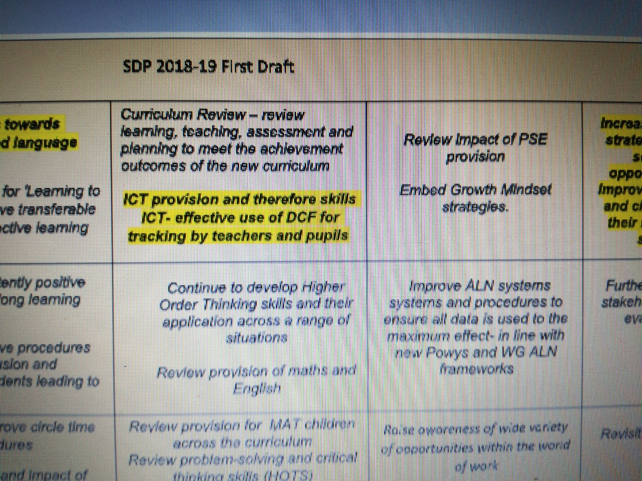
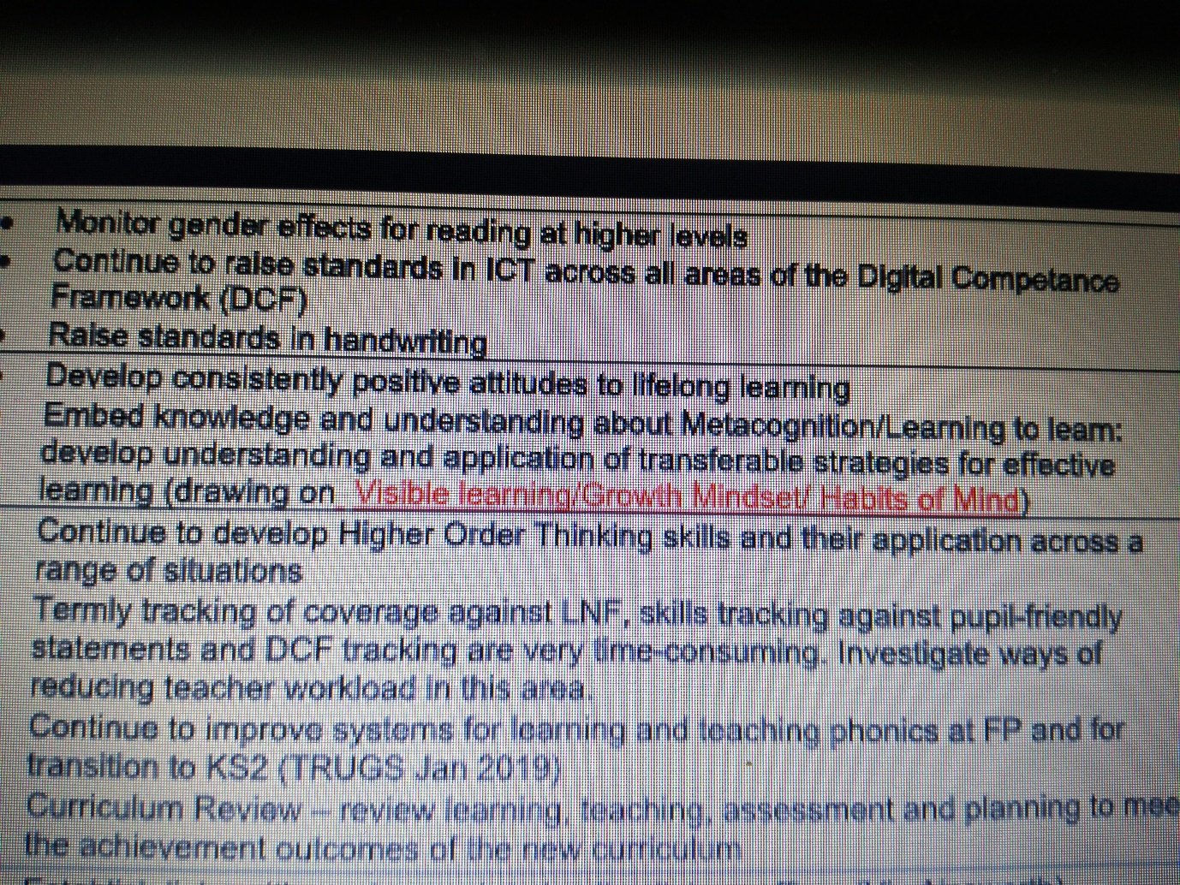
Appendix 2:
Notice board for public viewing and reminding children.
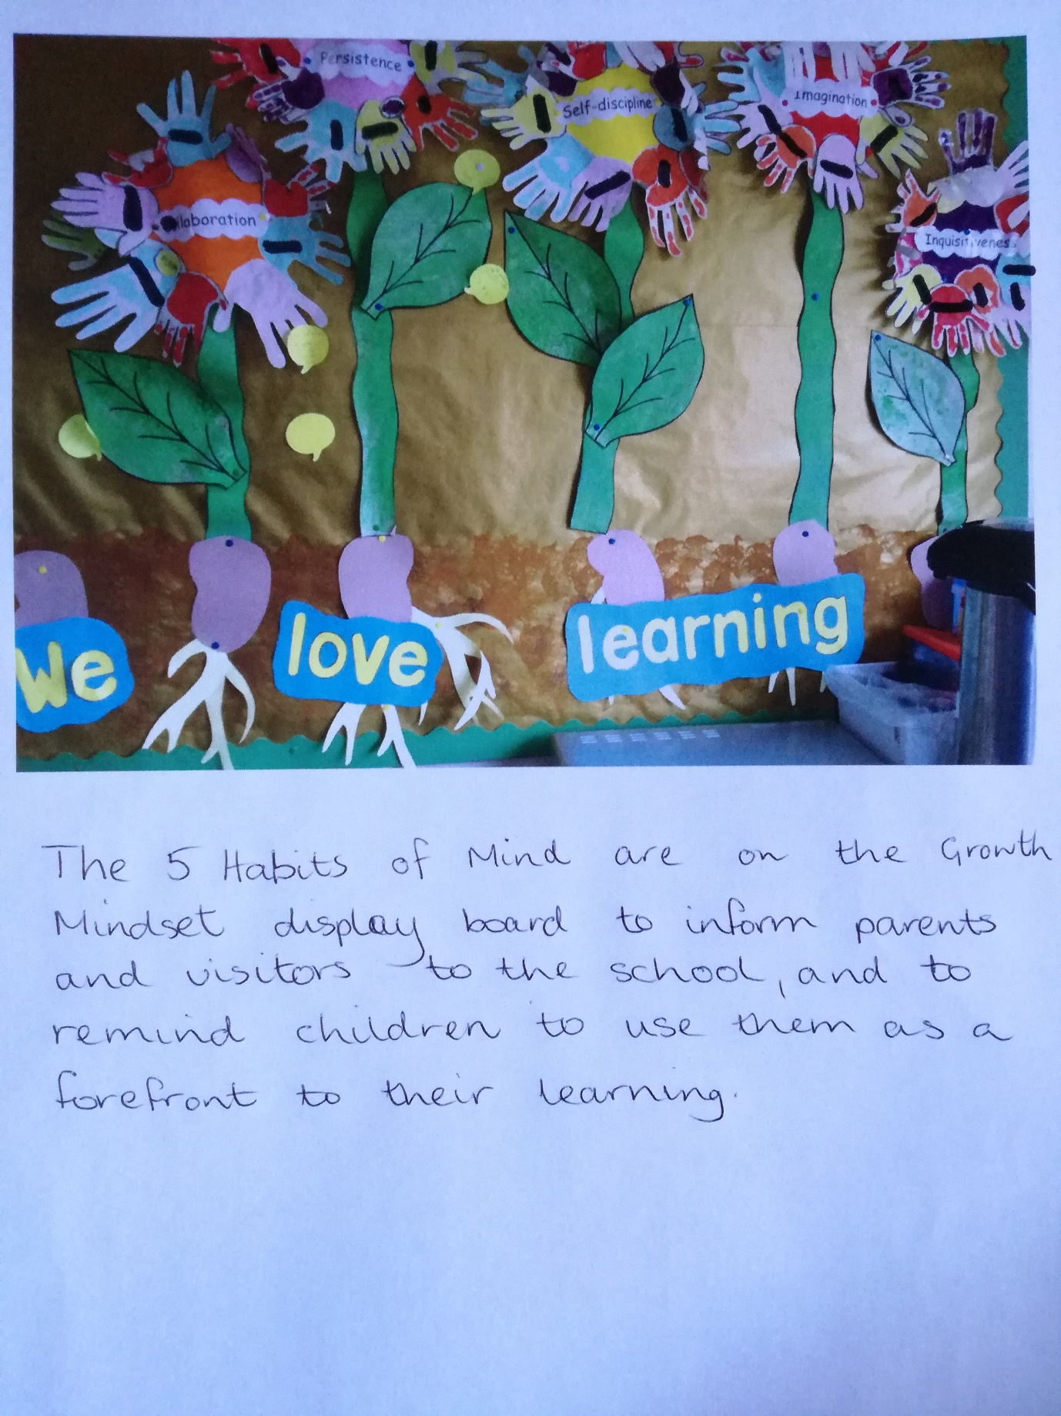

Appendix 3:
Questionnaires for Staff and Children-
Staff Questionnaire
- How valuable do you view Precision Teaching as a 1:1 strategy for learning intervention?
A1 Analysis of intervention/impact suggests that the Precision Teaching (PT) intervention is effective. Also it only involves very short times so the children are not missing large chunks of lessons.
A2 Very valuable as the evidence is clear that learning progress is made in short spaces of time which is also good for the children’s understanding of their own progress. The children are engaged as they like to see their scores and are encouraged to persevere and rewarded by seeing how their perseverance has paid off in 1 or 2 weeks of targeting the same learning outcome.
- What evidence do you have (if any) that it improving the children’s learning in the classroom?
A1 PT spelling improved weekly results, spelling transferred to work. PT reading improved word recognition, improved fluency. PT Maths faster recall of number facts, eg doubles/halves/bonds
A2 Not applicable
- Do you believe that embedding the five habits of mind has improved the children’s progress/performance when using the interventions?
A1 The five habits of mind seem to be of benefit across the curriculum for all children. However there is also correlation in many cases between those receiving intervention and those who struggle with self-discipline, perseverance and collaboration so these children benefit even more from habits of mind development
A2 Not all the habits of mind are applicable to PT but after discussion with the learners the consensus was that the habits of mind they do apply in PT are perseverance, self-discipline and inquisitiveness. I would reflect that these are reflected in their attitude to PT learning and likely enhance their performance
- Do you believe it has helped them transfer their skills for more independent earning in the classroom?
A1 Yes, children often use 5 Bs in class and draw on five habits of mind to solve problems/ debug situations.
A2 Not applicable
- Do you think it has had any impact on their self-esteem?
A1Yes, understanding that there are tools/ skills that can refined and used to help them learn has been positive-strong links with growth mindset and understanding that it may not be easy but it will be worth it
A2PT learning has a positive impact on the children’s self-esteem. This is reflected in their enthusiasm to take part and their overall engagement with their self-evaluation of progress and determination to show improvement on a target learning outcome.

Appendix 4:
Poster of the 5 Bs which are displayed in both classes
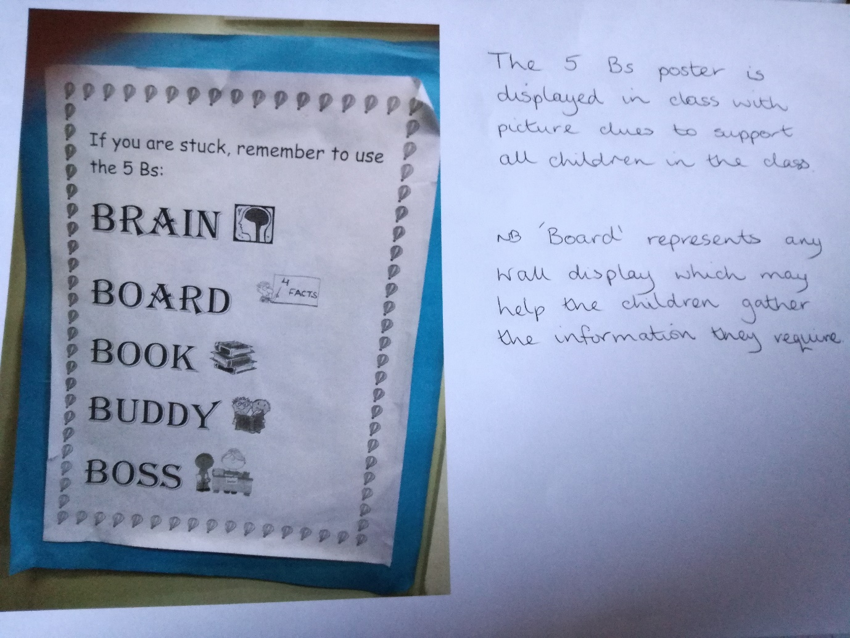

Appendix 5:
Child A’s keyring resource can be added to, making it easier to tailor it to his needs, and is easily portable for use around the classroom
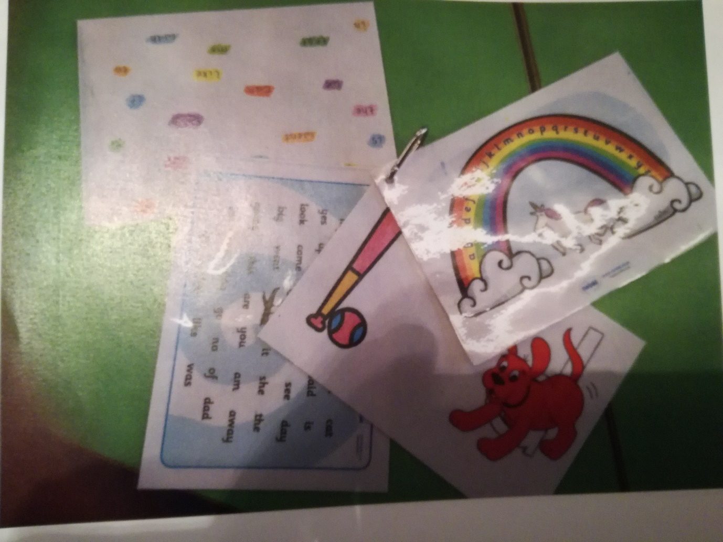

Appendix 6

An example of what Child A is achieving now
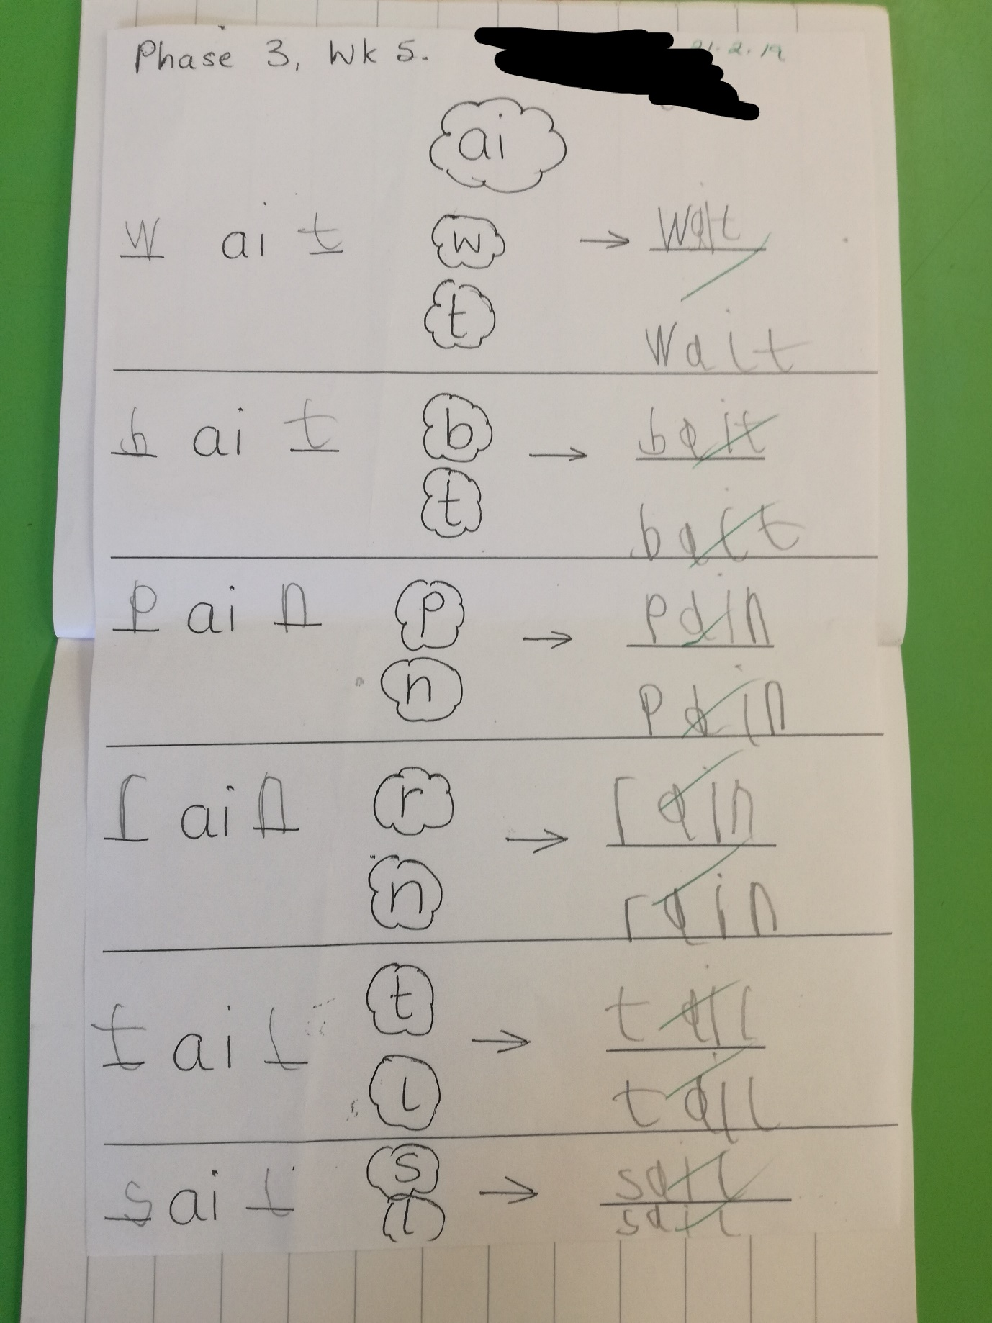

An example of what Child A was achieving six months ago when trying to spell CVC words
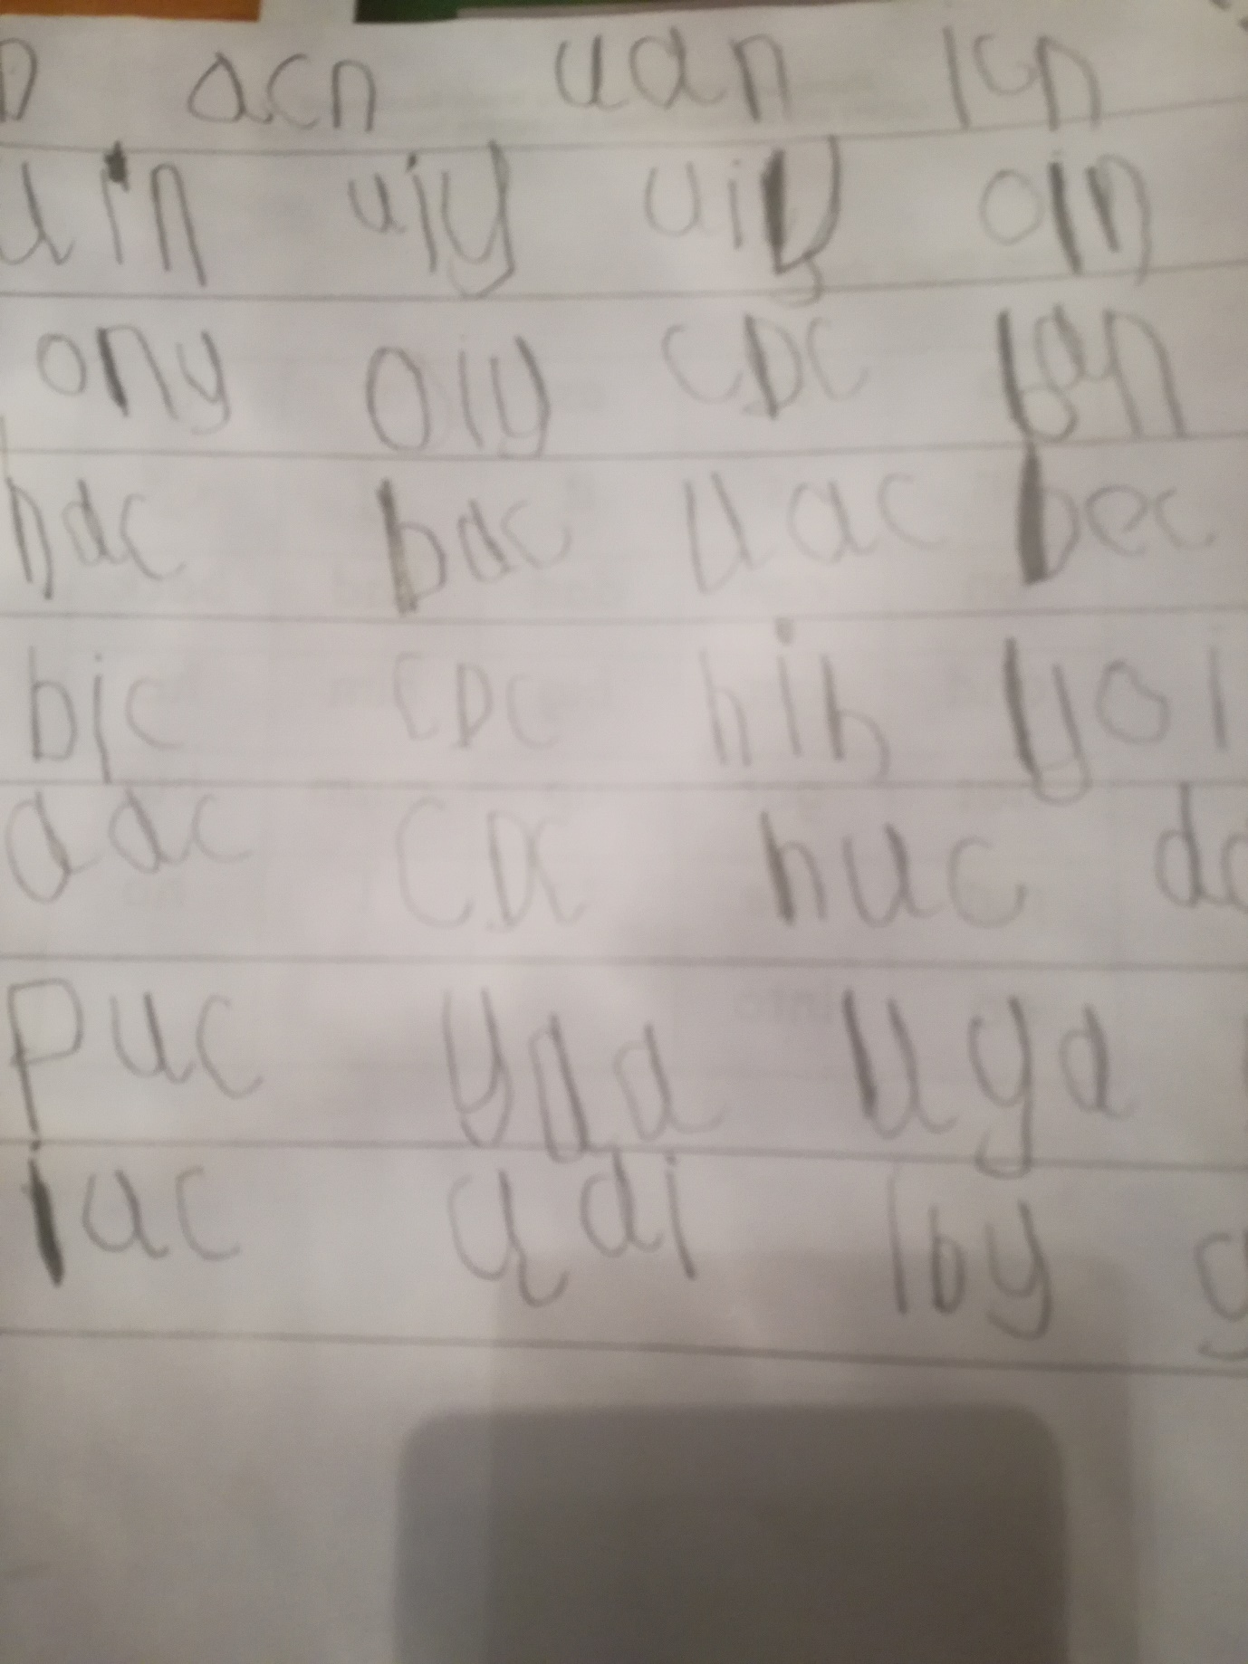

Appendix 7:
Child A’s targets for PT six months ago vs last week’s targets
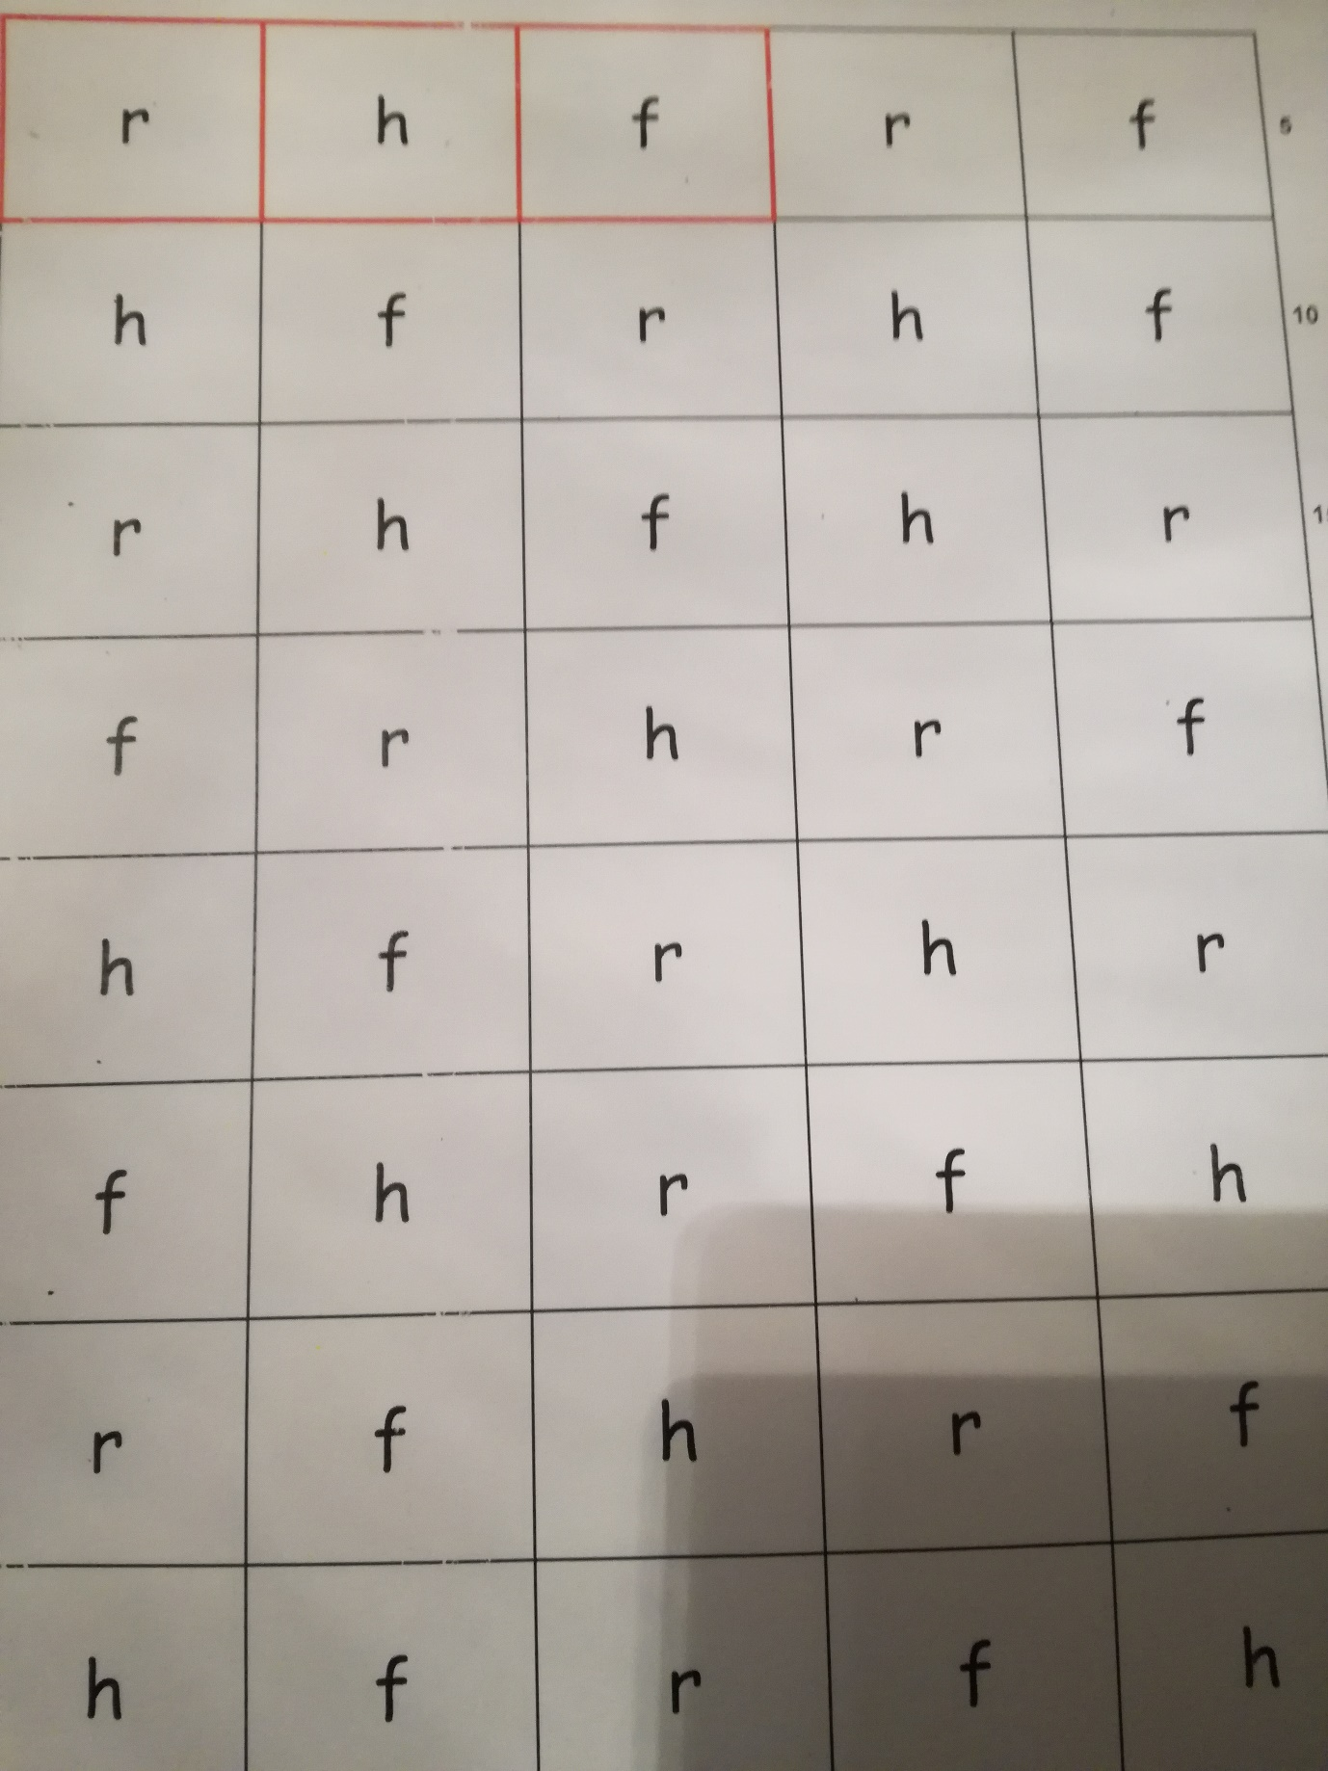
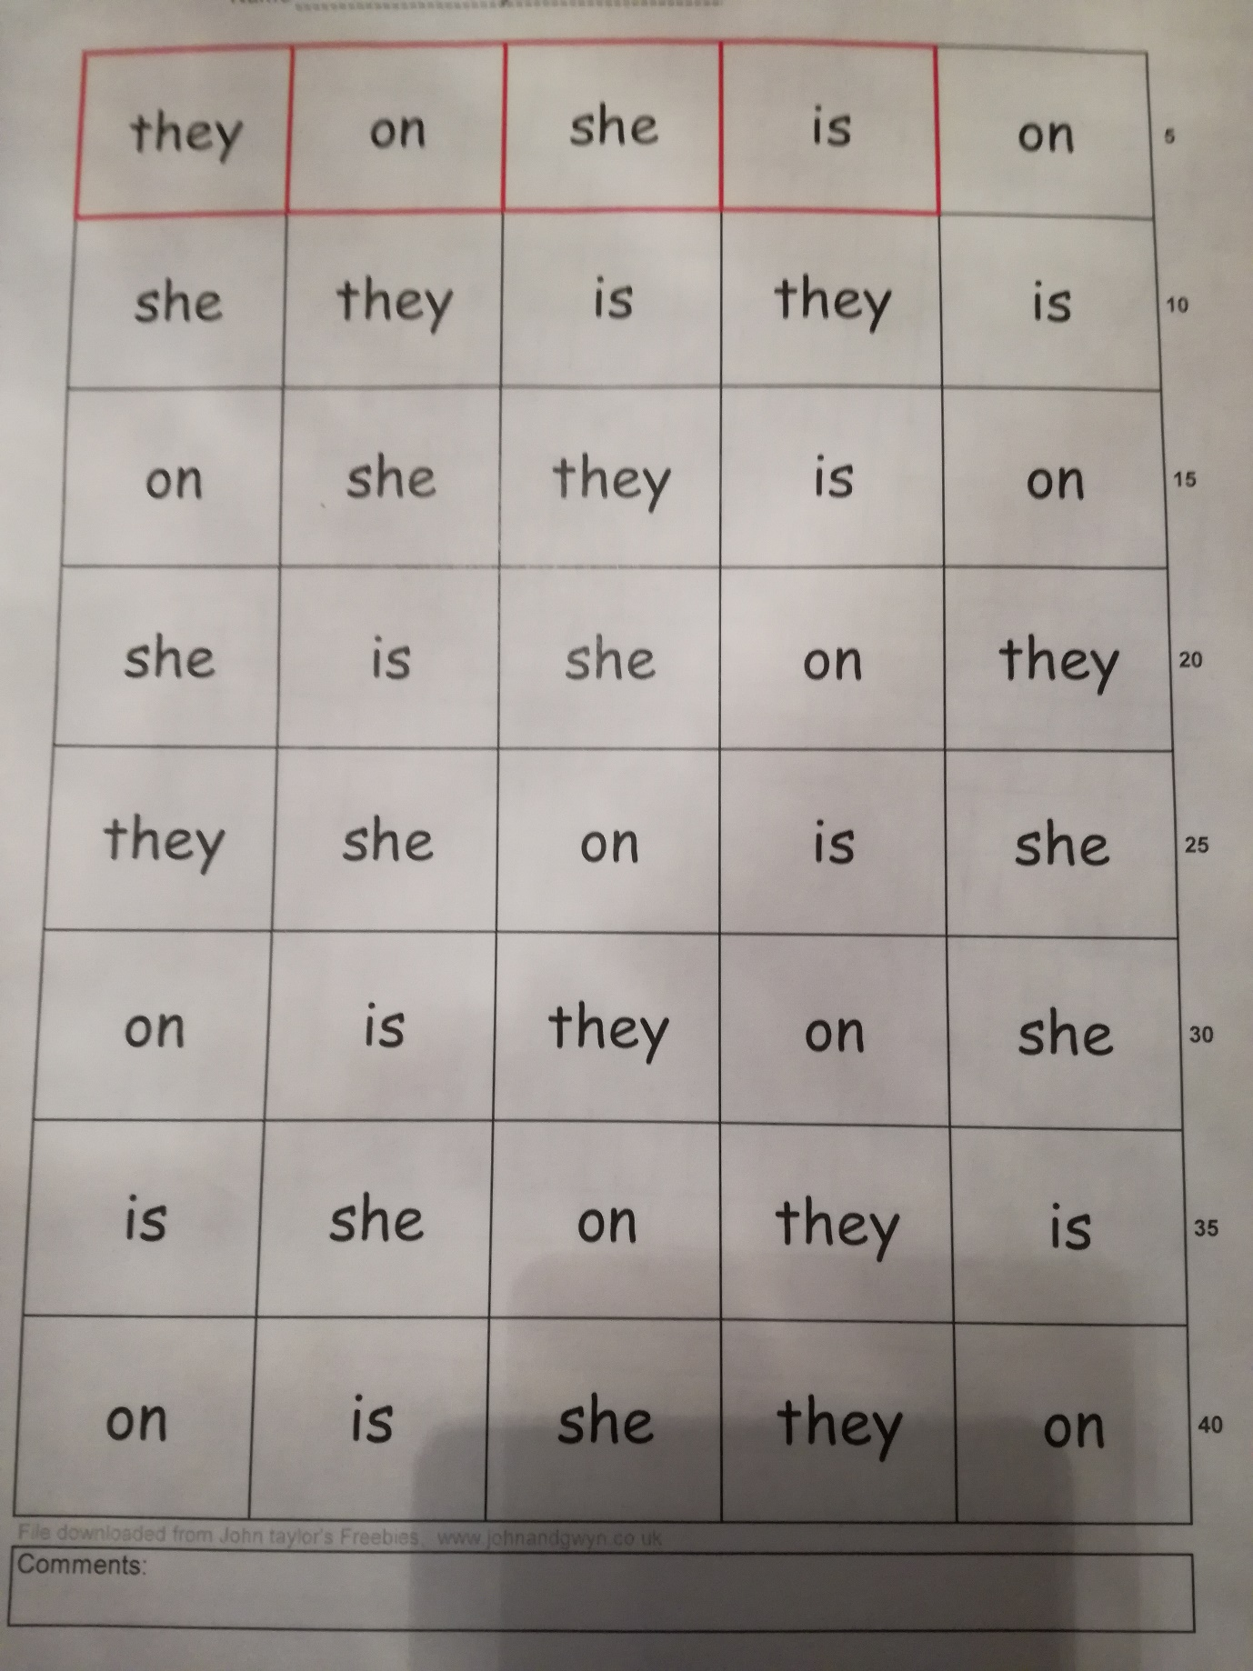

Appendix 8:
Child A’s recent spelling results
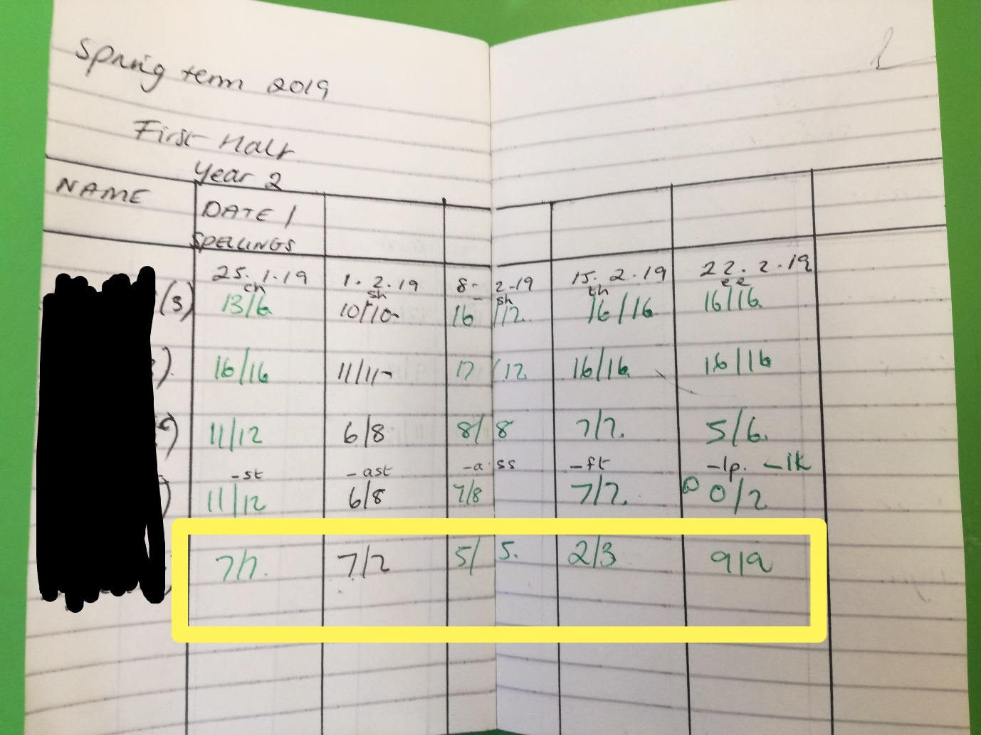

Appendix 9:
An extract from Child A’s IEP


