

A Study of the DIFFRENCE TYPES OF CYBER ATTACKS IN CYBER SECURITY
by
MEHUL GOSWAMI

Supervisor: Dr. Nitesh Kaliyamurthy

Second Marker: Munyaradzi N Murira

Project submitted as part of the requirements for the award of MSc (COMPUTER NETWORKS AND CYBER SECURITY)

FEBRUARY 2024

Table of contents
1 ABSTRACT 7
2 INTRODUCTION 8
2.1 Meaning of digital assault according to the experts' perspective: 9
2.2 Fundamental digital assaults types 10
2.3 Below is a brief description of various types of cyber attacks 11
2.3.1 Malware Attacks: 11
2.3.2 Phishing Attacks: 11
2.3.3 Denial-of-Service (DoS) and Distributed Denial-of-Service (DDoS) Attacks: 11
2.3.4 Social Engineering Attacks: 11
2.3.5 Insider Threats: 11
2.3.6 Advanced Persistent Threats (APTs): 11
2.3.7 Ransomware Attacks: 11
2.3.8 Cross-Site Scripting (XSS) and SQL Injection Attacks: 12
2.3.9 Effect of Digital Assaults: 12
2.3.10 Protection and Abatement: 12
3 Safeguarding against different kinds of digital assaults requires a diverse methodology including both specialized arrangements and client mindfulness. 13
3.1.1 The following are some general methods for preventing cyberattacks: 13
3.1.2 2.Firewalls and Intrusion Detection/Prevention Systems: 13
3.1.3 3.Secure Network Configuration: 13
3.1.4 4.User Education and Training: 14
4 Aims & objective 16
4.1 Monetary benefit 17
4.2 Undercover work 17
4.3 Harm or Interruption 17
4.4 Notoriety Harm 17
4.5 Philosophical or Political Objectives 17
5 Methodology 19
5.1 Design and architecture of a Cyber Attack: 22
5.2 Post-Exploitation Phase: 23
5.3 Conclusion: 23
6 Data collection methods and sources of threat data in cyber-attacks vary widely, encompassing both technical and non-technical sources. Here's an overview: 24
6.1 25
6.2 Network Traffic Analysis: 25
6.3 Endpoint Logs: 25
6.4 Security Information and Event Management (SIEM) Systems: 25
6.5 Threat Intelligence Feeds: 25
6.6 Malware Analysis: 25
6.7 Incident Reports and Case Studies: 26
6.8 Dark Web Monitoring: 26
6.9 Human Intelligence (HUMINT): 26
7 Cooperation with network protection scientists, industry peers, policing, and government associations to share danger knowledge, trade experiences, and team up on danger location and relief endeavors.Information handling and examination with regards to digital assaults include different methods to assemble, pre-process, dissect, and decipher information connected with security occurrences. Here are a few normal procedures utilized in network protection: 26
8 27
Techniques for data processing and analysis in cyber-attacks 27
9 When it comes to identifying and mitigating security threats, incorporating machine learning (ML) and artificial intelligence (AI) techniques into cyberattack threat detection offers significant advantages. This is the way ML and simulated intelligence can be utilized for danger identification: 30
9.1 Integration of machine learning and artificial intelligence for threat detection: 30
10 Implementation 33
10.1 33
10.2 Description of the technical infrastructure: 33
10.3 Integration with existing security systems and tools. 36
10.4 36
10.5 Challenges encountered during implementation and their solutions 37
11 Case Studies 40
11.1 Presentation of real-world examples where the CTI platform 40
11.2 Microsoft Exchange Server Hafnium Attack (2021) 40
11.3 SolarWinds Orion Software Attack (2020) 42
11.4 42
11.5 43
11.6 WannaCry Ransomware Attack (2017) 43
11.7 NotPetya Malware Attack (2017) 44
11.8 45
11.9 Operation Cloud Hopper (Reported in 2017) 45
12 detected and prevented cyber-attacks. 48
12.1 Use of Artificial Intelligence and Machine Learning 48
12.2 Threat Intelligence Sharing 48
12.3 Endpoint Detection and Response (EDR) Solutions 48
12.4 Security Awareness Training 49
12.5 Network Segmentation 49
12.6 Multi-Factor Authentication (MFA) 49
13 LITRETURE REVIEW 50
13.1 Known ransomware assaults by industry area in the UK, April 2022 - Walk 2023 52
13.2 Known assaults by the ten most utilized ransomware in the UK, April 2022 - Walk 2023 53
13.3 53
13.4 Known ransomware assaults by month on the UK schooling area, by posse, April 2022 - Walk 2023: 54
13.5 Outcomes: 55
14 How to prevent form cyber attacks 56
15 future Directions 57
15.1 potential enhancements and additions to the CTI platform. 57
15.2 Mechanized Danger Examination: 57
15.3 Social Examination: 58
15.4 Context oriented Enhancement: 58
15.5 Danger Knowledge APIs: 58
15.6 Emerging trends in cyber attacks and defense mechanisms 59
15.7 Emerging Trends in Defense Mechanisms: 60
16 Implications for the future of cybersecurity 62
17 Conclusion 65
18 Reference list 67
19 NOTE: 69
19.1 Hacking Rules and Guidelines 69

DECLARATION

I, MEHUL ASHVIN GIRI GOSWAMI declare that I am the sole author of this Project; that all references cited have been consulted; that I have conducted all work of which this is a record, and that the finished work lies within the prescribed word limits.

This work has not previously been accepted as part of any other degree submission.

Signed : Mehul Goswami
Date : 23/02/2024

FORM OF CONSENT

I, MEHUL ASHVINGIRI GOSWAMI hereby consent that my Project, submitted in candidature for the M.Sc. COMPUTER NATWORK AND CYBER SECURITY degree, if successful, may be made available for inter-library loan or photocopying (subject to the law of copyright), and that the title and abstract may be made available to outside organisations.

Signed : MEHUL GOSWAMI
Date : 23/02/2024

ABSTRACT

Digital assaults address a critical and developing danger in our undeniably digitized world. These assaults envelop many noxious exercises pointed toward taking advantage of weaknesses inside PC frameworks, organizations, and computerized foundation. They can appear in different structures, including malware contaminations, phishing tricks, refusal of-administration (DoS) assaults, and ransomware episodes. Digital aggressors, going from individual programmers to modern criminal associations and state-supported entertainers, continually try to break safeguards for monetary benefit, political intentions, or surveillance purposes. The outcomes of digital assaults are sweeping, enveloping monetary misfortunes, compromised individual and delicate information, disturbance of basic administrations, and, surprisingly, potential public safety chances. Moderating digital dangers requires a complex methodology, including vigorous network protection measures, client mindfulness preparing, coordinated effort among public and confidential areas, and persistent transformation to arising dangers. As innovation progresses, so too should our guards against digital assaults to defend the uprightness, classification, and accessibility of computerized resources and foundations.

INTRODUCTION

Introduction:
Network safety is a basic part of current computerized life, as the expansion of innovation has opened roads for different types of digital dangers. It is essential for individuals, governments, and organizations to comprehend the various types of attacks in order to protect sensitive information and defend against potential breaches. This presentation gives an outline of the different scene of digital assaults, going from normal dangers to modern, designated assaults.
1.Background:
Communication, commerce, and connectivity have all been reshaped by digital technologies and the internet. Be that as it may, alongside these progressions come inborn dangers, as cybercriminals continually look for weaknesses to take advantage of for malevolent purposes. From taking individual information to disturbing basic framework, digital assaults present huge dangers to people, organizations, and countries.
2.Cybersecurity's significance:
As society turns out to be progressively dependent on computerized frameworks and organizations, the significance of network protection couldn't possibly be more significant. A fruitful digital assault can prompt monetary misfortunes, reputational harm, and even risk public safety. Also, the interconnected idea of present-day innovation implies that the effect of digital assaults can swell across boundaries and enterprises, influencing different partners.
Sorts of Digital Assaults:
Digital assaults come in different structures, each with its own qualities and goals. Probably the most well-known types include:

•Malware: Malicious software designed to infiltrate systems, steal data, or cause damage.
•Phishing: Deceptive techniques used to trick individuals into revealing sensitive information such as passwords or financial details.
•Denial-of-Service (DoS) and Distributed Denial-of-Service (DDoS) attacks: Overwhelming a target system or network with traffic to disrupt its normal functioning.
•Ransomware: Encrypting files or systems and demanding payment for their release.
•Man-in-the-Middle attacks: Intercepting communication between two parties to eavesdrop or manipulate data.
•SQL Injection: Exploiting vulnerabilities in web applications to execute malicious SQL commands.
•Advanced Persistent Threats (APTs): Coordinated and targeted attacks by sophisticated threat actors aiming to gain long-term access to systems or networks.

Meaning of digital assault according to the experts' perspective:

Clark Richard: Motsch et al. say that, Digital assaults are moves initiated by countries to invade the PCs or PC organizations of some country to inflict damage or interruption. 2020). It is feasible to state that the aggressor, the reason, and the aim of the assault were utilized as measures in this definition's examination and study (Cao et al., 2019). Moreover, to the extent that the guilty party of the attack, just countries are referred to in general. Regardless, expecting individuals complete an attack in the novel circumstance and land district impaired and ward of a country (the web of associations vigorously impacted by countries), as well like non-regulative and classified get-togethers do an attack against a third country, it will essentially fall outside the degree of the definition that was referred to and wo bar them. Subsequently, there should be a void in the general set of laws. Considering this, it is feasible to contend that the first definition is generally deficient, leaves out a critical piece of the assaults committed by private and non-legislative associations, and results in a void (Zhang, 2017).

Fundamental digital assaults types

Used a cunning scale CNN to process ridiculing data from two scales to take a gander at the impact and risk of organization security in WAMS-based FFR (Fractional stream hold) control. In addition, they explored the FFR structure's time-repeat based network security assurance framework. The outcome was more solid and exact while utilizing real synchrophasor information. Lee and others As per a data based secret Makrove exhibit, 2021) upheld a technique for uniting a computerized assault reaction process. They likewise investigated another All around based security state assessment strategy. The fostered technique's legitimacy has been exhibited by a contextual investigation. Zhang and Malacaria (2021) gave a network safety choice emotionally supportive network for choosing the best security portfolio to battle multistage cyberattacks. This system had both on the web and precaution estimates upheld by a LM to recognize progressing assaults. They likewise investigated another Very much based security state assessment technique. The fostered technique's legitimacy has been exhibited by a contextual investigation. Zhang and Malacaria (2021) gave a network protection choice emotionally supportive network for choosing the best security portfolio to battle multistage cyberattacks. This structure had both on the web and protection estimates upheld by a LM to distinguish continuous assaults.
Image by Security triangle (CIA)

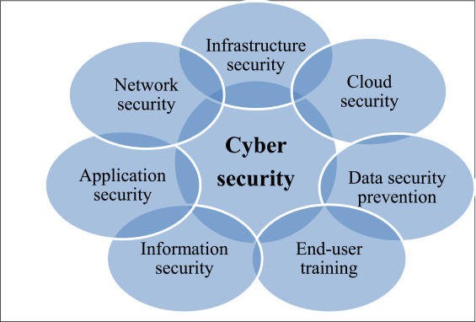

Below is a brief description of various types of cyber attacks

Malware Attacks:
Malware, short for malicious software, encompasses a wide range of malicious programs designed to disrupt, damage, or gain unauthorized access to computer systems. This includes viruses, worms, Trojans, ransomware, and spyware.

Phishing Attacks:
Phishing attacks involve the use of deceptive emails, messages, or websites to trick individuals into disclosing sensitive information such as login credentials, financial details, or personal data.

Denial-of-Service (DoS) and Distributed Denial-of-Service (DDoS) Attacks:
DoS attacks flood a target system or network with excessive traffic, causing it to become unavailable to legitimate users. DDoS attacks amplify this effect by coordinating multiple compromised devices to target the victim simultaneously.

Social Engineering Attacks:
Social engineering attacks exploit human psychology to manipulate individuals into divulging confidential information or performing actions that compromise security. Examples include pretexting, baiting, and tailgating.

Insider Threats:
Insider threats involve individuals within an organization who misuse their access privileges to steal data, sabotage systems, or facilitate external attacks. These individuals may be employees, contractors, or partners.

Advanced Persistent Threats (APTs):
APTs are stealthy and continuous cyber-attacks orchestrated by highly skilled threat actors with specific objectives, such as espionage or data theft. APT campaigns typically involve multiple stages and can persist over extended periods.

Ransomware Attacks:
Ransomware is a type of malware that encrypts a victim's files or locks them out of their system until a ransom is paid. These attacks can have severe consequences for individuals and organizations, leading to data loss, financial extortion, and operational disruption.
Supply Chain Attacks: Supply chain attacks target vulnerabilities in the software or hardware supply chain to compromise trusted vendors or third-party suppliers. Attackers exploit these weaknesses to infiltrate target organizations and gain unauthorized access to their systems or data.

Cross-Site Scripting (XSS) and SQL Injection Attacks:
XSS and SQL injection are common web application vulnerabilities that allow attackers to inject malicious scripts or SQL code into web pages or databases. These vulnerabilities can be exploited to steal sensitive information or perform unauthorized actions on the affected web application.IoT Exploitation:
With the proliferation of Internet-connected devices in the Internet of Things (IoT), attackers increasingly target vulnerabilities in IoT devices and networks to launch cyber-attacks.

Effect of Digital Assaults:

Digital assaults can have broad outcomes, going from monetary misfortunes to compromising individual protection and in any event, imperilling lives. The effects might include: Monetary misfortunes because of burglary of assets or protected innovation. disruption of essential services like energy, transportation, or healthcare. Compromising delicate data prompting data fraud or extortion. Harm to notoriety and confidence in associations or foundations.

Protection and Abatement:

Combatting digital dangers requires a diverse methodology, integrating specialized arrangements, strong strategies, and client schooling. Powerful safeguard techniques might include: Executing network safety best practices, for example, normal programming refreshes major areas of strength for and approaches. Conveying security advances like firewalls, antivirus programming, and interruption discovery frameworks. Directing customary gamble appraisals and entrance testing to recognize and address weaknesses. educating users and employees about cybersecurity so they can effectively identify and respond to threats.
In conclusion:
the scene of online protection dangers is dynamic and advancing, requiring consistent cautiousness and proactive measures to shield against likely assaults. Individuals and businesses alike can better prepare for and mitigate risks in an increasingly digital world by comprehending the various cyber threats and their effects.

Safeguarding against different kinds of digital assaults requires a diverse methodology including both specialized arrangements and client mindfulness.

The following are some general methods for preventing cyberattacks:

1.Install and Update Security Software:
Utilize respectable antivirus and hostile to malware programming to distinguish and keep malignant projects from undermining your frameworks. Keep all security programming and working frameworks fully informed regarding the most recent fixes and updates to address known weaknesses.

2.Firewalls and Intrusion Detection/Prevention Systems:
Execute firewalls to screen and control approaching and active organization traffic, and think about utilizing interruption identification and anticipation frameworks (IDPS) to recognize and obstruct dubious movement continuously.

3.Secure Network Configuration:
Design network gadgets safely, including switches, switches, and passages. To lessen the impact of potential breaches, change default passwords, disable services that aren't needed, and segment network traffic.

4.User Education and Training:
Users should be taught about common cyber threats like phishing and social engineering, as well as how to recognize and respond to emails, messages, or websites that look suspicious. Energize great security rehearses, like areas of strength for utilizing, passwords and trying not to tap on new connections or connections.
5.Access Control and Least Privilege:
Carry out access control measures to confine client honors and limit admittance to delicate information and frameworks just to approved faculty. Give users only the minimum amount of access they need to carry out their responsibilities in accordance with the principle of least privilege.
6.Data Encryption:
Encode delicate information both on the way and very still to safeguard it from unapproved access in case of a break. Use encryption conventions, for example, HTTPS for web traffic and encryption calculations like AES for put away information.

7.Regular Data Backups:
Execute normal reinforcements of basic information to guarantee that it tends to be recuperated in case of a ransomware assault or different information misfortune episode. Store reinforcements safely, ideally disconnected or in a different, disengaged climate.
8.Incident Response Plan:
Create and routinely test an occurrence reaction intend to guarantee an opportune and compelling reaction to network protection episodes. Characterize jobs and obligations, lay out correspondence channels, and diagram systems for containing, examining, and recuperating from security breaks.

9.Continuous Monitoring and Auditing:
Carry out constant checking apparatuses and lead ordinary security reviews to proactively identify and moderate potential security weaknesses and dangers. Screen network traffic, framework logs, and client movement for indications of dubious way of behaving.
10.Stay Informed and Adapt:
Remain informed about arising digital dangers and security best practices through industry distributions, security sites, and danger knowledge sources. Persistently adjust your safety efforts to address developing dangers and weaknesses.
By executing these systems and remaining careful against digital dangers, people and associations can altogether decrease their gamble of succumbing to digital assaults and safeguard their significant resources and information.

Aims & objective

Digital power is turning into an undeniably significant switch of public power and a wellspring of competitive edge in this unique circumstance. Computerized power is the ability to get and propel public interests in and through the web. Later on, countries that are the most skilled at exploring the amazing open doors and difficulties introduced by the computerized age will be safer, versatile, and prosperous. This administration has an aggressive innovation plan, both locally and globally, and the UK is quite possibly of the most carefully progressed country on the planet. This shows that while we are exceptionally situated to lead the manner in which in jumping all over the chances presented by the internet to serve our residents and humankind all in all, we are likewise especially defenseless against the challenges presented by it. The web, advanced innovation, and the framework that upholds it will turn out to mean a lot to both our and our foes' advantages throughout the following decade. Reinforcing our digital power will empower us to lead industry and different countries in a more serious age, remain in front of future mechanical turns of events, moderate dangers, and gain an upper hand over our enemies and opponents as we produce another job for the UK. It will make the UK one of the advanced economies that is most secure and generally interesting to live in, work with, and put resources into.

Monetary benefit

Objective: To straightforwardly take cash or data that can be adapted, for example, Visa subtleties, banking certifications, or individual character data for misrepresentation.
Techniques: Phishing, ransomware, sending banking Trojans, and leading business email split the difference (BEC) tricks.

Undercover work

Objective: To accumulate delicate, private, or characterized data for political, military, or business advantage.
Techniques: High level Tenacious Dangers (APTs), skewer phishing, and taking advantage of weaknesses in programming utilized by the objective association or person.

Harm or Interruption
Objective: To disturb, corrupt, or obliterate framework, frameworks, or information as a type of assault against a contender, foe, or as a demonstration of dissent.
Techniques: Circulated Forswearing of Administration (DDoS) assaults, malware intended to wipe information or harm frameworks, and assaults on basic foundation.

Notoriety Harm
Objective: To hurt the standing of a substance (individual, association, or state) through the arrival of delicate, dubious, or harming data.
Strategies: Doxxing, destruction of sites, and spilling taken information.

Philosophical or Political Objectives
Objective: To advance or upset political plans, social developments, or philosophical convictions.
Strategies: Digital promulgation, hacking and spilling data, disfigurement, and DDoS assaults against philosophical rivals.
6. Digital Fighting
Objective: To debilitate a country's security, economy, or social design as a feature of more extensive military or international goals.
Techniques: Focusing on basic foundation, reconnaissance, spreading deception, and upsetting military tasks.
7. Licensed innovation Robbery
Objective: To take thoughts, developments, and inventive works for upper hand or monetary benefit.
Strategies: Designated assaults on associations to remove outlines, equations, and exclusive programming codes.
8. Innovative work
Objective: To test new digital assault strategies or instruments, frequently focusing on irregular or explicit elements without a direct quick advantage.
Strategies: Sending new malware strains, trying different things with social designing procedures, and testing networks for weaknesses.

Methodology

The extent of the harm caused by cyberattacks determines how they should be depicted and arranged, as should be obvious. To put it another way, the order in which these kinds of attacks are grouped depends on how much of an impact they have, either in terms of killing people or destroying significant infrastructure. Thusly, the level of a cyberattacks recognizable and long stretch effects is a pressing figure choosing its organization. The likelihood that an assault will be categorized as a "utilization of power" or, surprisingly and more horrifyingly, as an "equipped assault" when its size is sufficient to cause the deficiency of human existence increases with the level of its effect. As a result, the most pressing issue at hand is how to measure the impact of a cyberattack. Sadly, the Global Group of Experts' important measures have not been able to precisely determine the extent of a cyberattacks impact because its components are typically difficult to evaluate in a short amount of time. Timeframe and are every now and again dependent upon emotional understanding. As has proactively become clear, It very well may be a lot easier to group and classify cyberattacks in light of the standards of Global Philanthropic Regulation in the event that the effect level could be resolved utilizing subjective and quantitative models.
Then again, it is not difficult to see that a similar effect factors that were recommended by the Global Gathering of Specialists for the grouping and portrayal of digital assaults are likewise utilized as standards in risk criticality examination systems to rank resources and foundations arranged by significance. For example, the accompanying standards were distinguished as the base arrangement of models that ought to be considered by part states while endeavoring to evaluate their basic frameworks at the European level by the Gathering Mandate , "on the ID and assignment of European basic foundations and the appraisal of the need to work on their security" following a pertinent European Commission Correspondence (I) public wellbeing, which incorporates worries about the impacted populace, passings, serious wounds, and clearings; (ii) financial impact, which produces into account the Gross domestic product results, the meaning of monetary misfortune, or potentially the debasement of items or administrations; (iii) ecological impact, which incorporates people in general's and the climate's belongings; (v) political impacts, which remember certainty for the public authority; and (vi) mental impacts, which incorporate the populace's mental impacts. The extension (neighborhood, territorial, public, and worldwide) and time (during and after the episode) of these models are utilized to assess them.

The U.S. Public Foundation Assurance Plan recognizes the accompanying worldwide rules for assessing results: I) general wellbeing and wellbeing, which remembers their effect for human existence and actual prosperity; ii) monetary, which incorporates immediate and circuitous financial misfortunes; iii) mental, which remembers their effect for public spirit and the level of individuals' trust in financial and political establishments; and iv) administration/mission, which remembers their effect for the limit of the public authority or industry to keep everything under control, offer fundamental types of assistance, guarantee general wellbeing and security, and complete related missions connected with public safety.

Clearly the evaluation principles used for studying essential ICTs, are revolved more around surveying bets with associated with outside impacts that is, impacts related with monetary outcomes and their effect on occupants, since they are directly associated with the essential systems influenced in a general sense and indirectly connected with the consequences of the breakdown or degradation of these fundamental ICTs for the flourishing of the inhabitants. As opposed to the conventional gamble investigation strategies, this one zeros in erring on the inward outcomes (inward effects) of framework breakdown or crumbling inside the division or organization that connects with it than on the outer results (outside influences) for residents. Thus, digital assaults and the gamble criticality investigation techniques used to assess basic foundation and organizations (ICTs) are exceptionally associated on the grounds that both are described by a similar effect factors during their assessment.

Utilizing subjective and quantitative factors like those suggested by the Worldwide Gathering of Specialists in the Tallinn Manual and conceivably taking on different rules, this criticality examination strategy can likewise act as a scale for estimating the power of digital assaults to empower a measurement of the "scale and impact" standards. This makes it simpler to distinguish when such demonstrations verge on the supposed "utilization of power" standard, which is utilized to decide if a State has disregarded Article 2(4) of the Unified Countries Sanction and the connected custom.

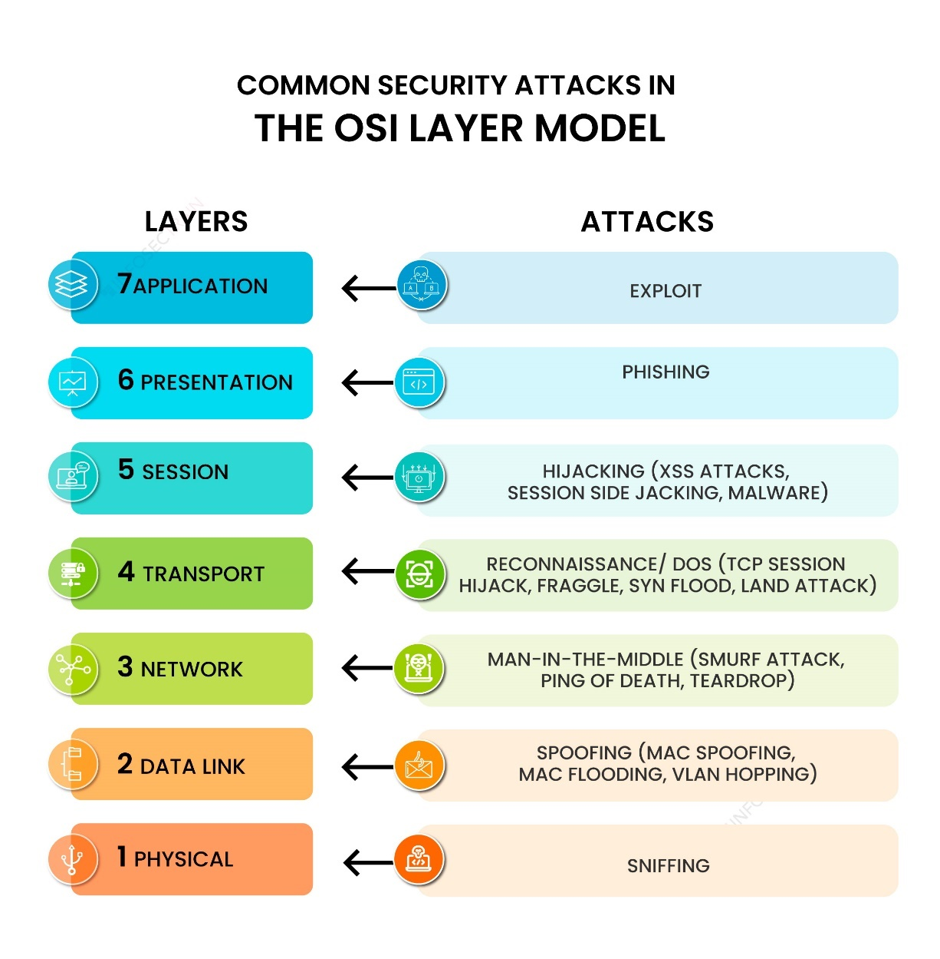

Design and architecture of a Cyber Attack:

Objective:
Exploiting vulnerabilities in a target system or network to gain unauthorized access, steal sensitive information, disrupt operations, or cause damage is the goal of a cyber-attack.
Preparation phase:
The assailant assembles data about the objective framework or organization, including its foundation, programming, and possible shortcomings. Weakness Examination: Recognizing weaknesses, for example, unpatched programming, misconfigurations, or frail verification instruments. Tool Preparation: Getting the tools and malware for the attack, like penetration testing frameworks, exploit kits, and remote access Trojans (RATs), and setting them up.
Execution phase:
Beginning Access: Taking advantage of a weakness to acquire starting admittance to the objective framework or organization. Phishing emails, exploiting software flaws, or making use of weak passwords are all examples of this. Honora Heightening: When inside the framework, the assailant tries to raise their honours to acquire more significant levels of access, permitting them to control basic assets and execute additional harming activities. Horizontal Development: Moving along the side inside the organization to investigate and think twice about frameworks or sections. Utilizing known vulnerabilities in connected systems, compromising credentials, or taking advantage of trust relationships are all examples of this. Information Exfiltration: Separating delicate information from the compromised frameworks or organization. This could incorporate protected innovation, monetary data, individual information, or other important resources. Payload Conveyance: Sending extra malignant payloads or instruments to keep up with determination, sidestep recognition, or complete further phases of the assault.

Post-Exploitation Phase:
Endeavouring to eradicate or muddle proof of the assault to keep away from location and attribution. This might include erasing logs, altering timestamps, or utilizing against legal methods. Laying out Secondary passages: Making persevering passageways or indirect accesses into the compromised framework or organization for future double-dealing. Surveillance for Future Assaults: Social affair knowledge on the objective climate and likely future focuses for ensuing assaults.
Architecture:
Order and Control (C2) Foundation: A unified server or organization of servers used to oversee and control the compromised frameworks, issue orders to malware, and exfiltrate information. Malware Parts: Different sorts of malware, including Trojans, rootkits, ransomware, and botnets, intended to do explicit undertakings as a feature of the assault. Communication Channels: To evade detection by security mechanisms, secure and obfuscated communication channels are used between the infrastructure controlled by the attacker and compromised systems. Security controls like firewalls, intrusion detection/prevention systems (IDS/IPS), antivirus software, and endpoint protection platforms can be evaded using evasion techniques. Payload Conveyance Components: Techniques for conveying vindictive payloads to target frameworks, including email connections, pernicious sites, USB drives, or taking advantage of programming weaknesses. Diligence Instruments: Strategies for keeping up with admittance to compromised frameworks over the long haul, for example, making vault passages, planned errands, or introducing rootkits.

Conclusion:
The plan and design of a digital assault require cautious preparation, execution, and the executives of different parts to accomplish the aggressor's targets while limiting the gamble of recognition and attribution. It highlights the significance of hearty network safety measures and proactive guard procedures to alleviate the danger of digital assaults.

Data collection methods and sources of threat data in cyber-attacks vary widely, encompassing both technical and non-technical sources. Here's an overview:

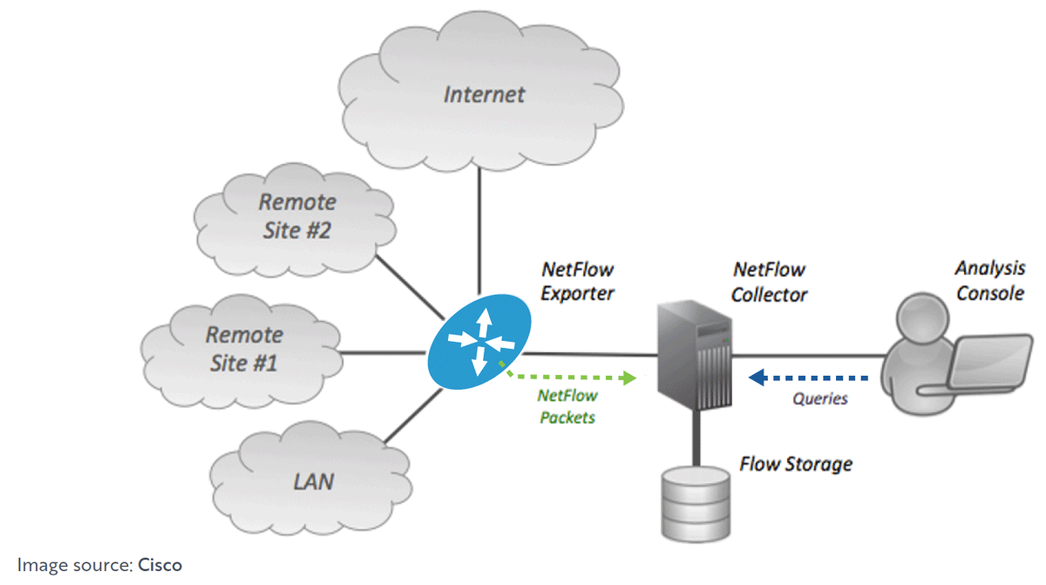

Network Traffic Analysis:
Packet Capture: Using tools like Wireshark or tcpdump to collect data about network traffic to examine communication patterns, spot anomalies, and spot suspicious activity. NetFlow/SFlow: Removing stream information from network gadgets to comprehend traffic examples, volume, and source/objective IP addresses.

Endpoint Logs:
Framework Logs: Get-together logs produced by endpoint gadgets like workstations, servers, and IoT gadgets. These logs give data about framework occasions, client exercises, and programming executions. Endpoint Identification and Reaction (EDR) Arrangements: Using specific endpoint security arrangements that screen and record exercises on endpoints, including process executions, document changes, and organization associations.

Security Information and Event Management (SIEM) Systems:
identifying potential security incidents and threats by gathering and integrating log data from a variety of sources, such as network devices, servers, and security instruments. Mix with danger knowledge feeds to improve gathered information with data about known malignant entertainers, signs of give and take (IOCs), and arising dangers.

Threat Intelligence Feeds:
identifying potential security incidents and threats by gathering and integrating log data from a variety of sources, such as network devices, servers, and security instruments. Mix with danger knowledge feeds to improve gathered information with data about known malignant entertainers, signs of give and take (IOCs), and arising dangers.

Malware Analysis:
Sandbox Conditions: Running dubious records or executables in controlled conditions to notice their way of behaving, dissect their usefulness, and concentrate signs of give and take (IOCs). Picking apart: Dismantling and examining malware tests to comprehend their code design, usefulness, and abilities.

Incident Reports and Case Studies:
Concentrating on freely accessible episode reports, security warnings, and contextual analyses to gain from past digital assaults, strategies, methods, and methodology (TTPs) utilized by danger entertainers.

Dark Web Monitoring:
Checking underground discussions, commercial centers, and other unlawful web-based networks to accumulate knowledge on cybercriminal exercises, including offer of taken information, exploit packs, and hacking administrations.

Human Intelligence (HUMINT):

Cooperation with network protection scientists, industry peers, policing, and government associations to share danger knowledge, trade experiences, and team up on danger location and relief endeavors.
Information handling and examination with regards to digital assaults include different methods to assemble, pre-process, dissect, and decipher information connected with security occurrences. Here are a few normal procedures utilized in network protection:

Techniques for data processing and analysis in cyber-attacks.

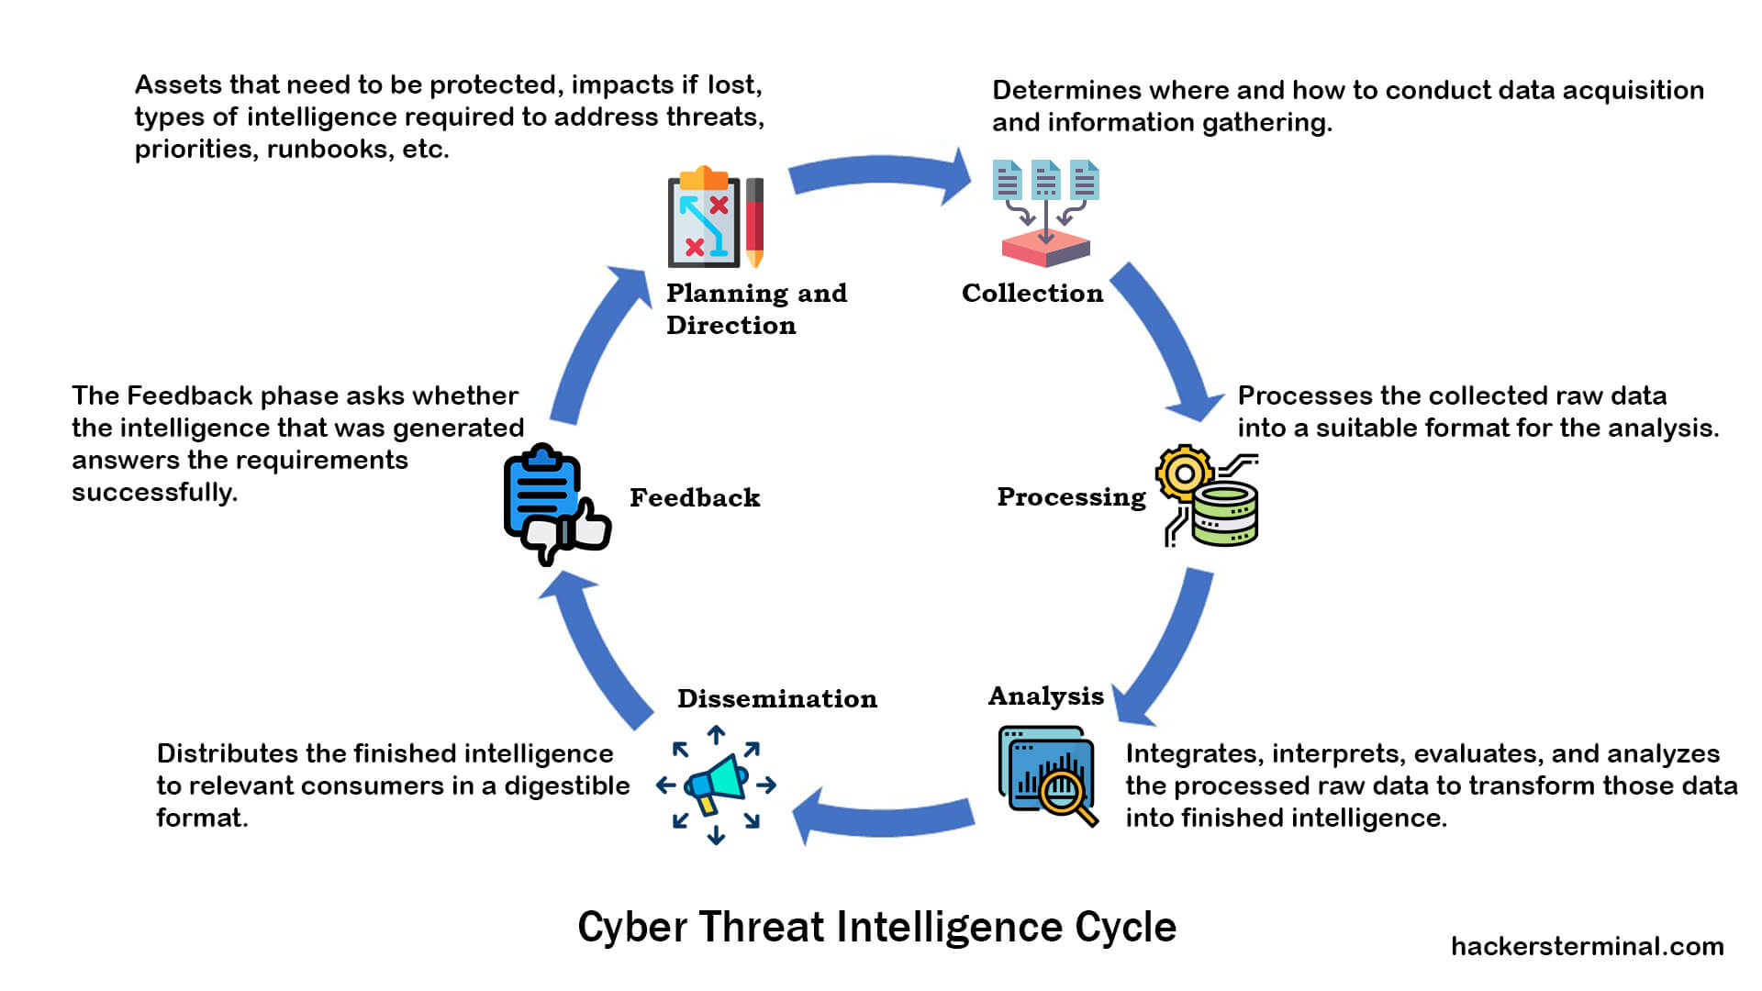

Log analysis:
Logs created by different frameworks, like firewalls, interruption identification frameworks, and servers, contain significant data about network traffic, framework occasions, and client exercises. Dissecting log information can assist with distinguishing abnormal way of behaving, security occurrences, and possible dangers
Traffic analysis:
Checking and dissecting network traffic examples can uncover dubious or malevolent action, for example, unapproved access endeavors, information exfiltration, or correspondence with known malignant spaces. Anomaly detection, flow analysis, and packet capture are some of the methods.
Behaviour analysis:
Conduct examination includes concentrating on the way of behaving of clients, applications, and gadgets to recognize deviations from typical examples. This might incorporate examining client action logs, application conduct, and endpoint telemetry information to distinguish indications of give and take or insider dangers.
Signature-based Detection:
Signature-based location includes contrasting noticed information or movement against known examples or marks of known digital dangers. This method is usually utilized in antivirus programming, interruption recognition frameworks (IDS), and interruption avoidance frameworks (IPS) to distinguish and obstruct vindictive documents, code, or organization traffic.

Machine learning and AI:
AI and man-made reasoning (computer-based intelligence) strategies can be applied to network protection for abnormality location, danger insight investigation, and prescient displaying. These strategies can assist with recognizing beforehand obscure dangers and adaptively answer developing assault strategies.
Threat intelligence analysics:
Danger insight implies gathering, breaking down, and deciphering data about known and arising digital dangers, including marks of give and take (IOCs), malware marks, and aggressor strategies, methods, and techniques (TTPs). Danger insight investigation assists associations with remaining informed about likely dangers and proactively safeguard against them.
Forensic Analysis:
Scientific investigation includes gathering and dissecting advanced proof from compromised frameworks or organizations to figure out the degree, effect, and main drivers of safety occurrences. Legal procedures might incorporate circle imaging, memory investigation, timetable reproduction, and chain of guardianship documentation.
Data Visualization:
Analysts can use data visualization tools like heatmaps, charts, graphs, and trends to better understand large datasets and their relationships. Picturing network protection information can support figuring out complex assault situations and conveying discoveries to partners.
Incident Response Orchestration:
Episode reaction organization includes mechanizing and arranging the reaction to security occurrences, including information assortment, examination, control, and remediation. This might include incorporating security instruments, work processes, and playbooks to smooth out occurrence reaction processes and further develop effectiveness.
Threat Hunting:
Danger hunting implies proactively looking for indications of give and take or vindictive action inside an association's organization and frameworks. To identify and mitigate potential threats before they
cause harm, this may require utilizing a combination of manual analysis, automated tools, and threat intelligence.

→By utilizing these strategies for information handling and examination, network safety experts can successfully recognize, research, and answer digital dangers, in this way upgrading the security stance of associations and safeguarding against digital assaults.

When it comes to identifying and mitigating security threats, incorporating machine learning (ML) and artificial intelligence (AI) techniques into cyberattack threat detection offers significant advantages. This is the way ML and simulated intelligence can be utilized for danger identification:

Integration of machine learning and artificial intelligence for threat detection:
Anomaly Detection:
ML calculations can examine huge measures of information from different sources, for example, network traffic, framework logs, and client conduct, to distinguish abnormalities that might show pernicious action. Rather than depending on predefined marks, irregularity identification strategies learn typical examples and banner deviations that could mean possible dangers.
Behavioral Analysis:
ML models can be prepared to perceive examples of conduct related with various sorts of digital dangers, including insider dangers, malware diseases, and phishing assaults. By breaking down client movement, application conduct, and organization traffic, computer-based intelligence driven frameworks can distinguish dubious way of behaving that might warrant further examination

Predictive Analytics:
ML algorithms can spot trends and patterns in security incidents and historical data that could point to future cyber threats. By recognizing early advance notice signs and foreseeing potential assault vectors, associations can go to proactive lengths to relieve chances and forestall security breaks.
Threat Intelligence Integration:
ML and man-made intelligence strategies can be incorporated with danger knowledge feeds to advance information investigation and further develop danger location capacities. By corresponding inner telemetry information with outside danger knowledge sources, associations can recognize signs of give and take (IOCs) and arising dangers all the more successfully.
Advanced Malware Detection:
ML-based malware recognition frameworks can examine document ascribes, conduct, and code examples to recognize beforehand obscure malware variations. AI-driven systems are able to detect and classify new strains of malware with high accuracy by training models on labeled datasets containing known malware samples.
Natural Language Processing (NLP):
Textual data, such as emails, chat logs, and social media posts, can be analyzed using NLP techniques to look for signs of phishing, social engineering, or other malicious activities. NLP models can remove important elements, distinguish dubious language designs, and characterize messages in view of their gamble level.
Deep Learning for Image Analysis:
Profound learning calculations, for example, convolutional brain organizations (CNNs), can dissect pictures and sight and sound substance for indications of malignant action, for example, visual marks of phishing sites, malware payloads, or unapproved access endeavors. Profound learning models can naturally remove includes and group pictures in light of their aggressive statement pertinence.

Adaptive Threat Detection:
ML and AI systems can adapt and evolve over time to keep pace with evolving cyber threats. By continuously learning from new data and feedback loops, adaptive threat detection models can improve their accuracy and effectiveness in identifying and mitigating emerging threats.
Automated Response Orchestration:
ML and simulated intelligence driven security stages can mechanize occurrence reaction processes, including ready emergency, danger examination, and remediation activities. By incorporating with security coordination, mechanization, and reaction (Take off) apparatuses, man-made intelligence driven frameworks can smooth out episode reaction work processes and diminish reaction times.
Scalability and Efficiency:
ML and simulated intelligence procedures empower versatile and effective danger identification across huge scope, dispersed conditions. Via robotizing redundant errands and focusing on alarms in light of their gamble level, artificial intelligence driven frameworks can help security groups center their assets around the most basic dangers and weaknesses.
In general, the combination of AI and man-made reasoning for danger location in digital assaults offers associations a strong stockpile of devices and methods to upgrade their network safety act, identify progressed dangers, and answer really to security episodes.

Implementation

Description of the technical infrastructure:

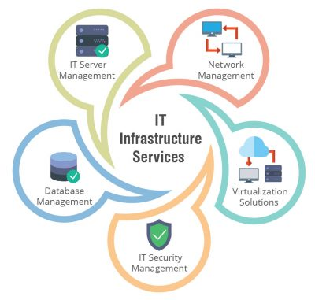

The specialized framework in digital assaults alludes to the organization, frameworks, devices, and assets used by danger entertainers to send off and execute their noxious exercises. Here is a depiction of the key parts regularly engaged with the specialized framework of digital assaults
Command and Control (C2) Servers:
Order and control servers are focal parts of numerous digital assaults, filling in as correspondence centers between the aggressor and compromised frameworks. These servers issue orders to tainted machines, get taken information, and give directions to additional malignant activities.
Botnets:
Botnets are organizations of compromised PCs (bots) that are controlled from a distance by assailants. Botnets can be utilized to do different noxious exercises, including circulated refusal of-administration (DDoS) assaults, spam missions, and information exfiltration. Botnets frequently depend on order and control servers to arrange their activities.
Malware:
Malware, short for pernicious programming, is a typical device utilized in digital assaults to think twice about and take information. Malware comes in different structures, including infections, worms, Trojans, ransomware, and spyware, each intended for explicit malignant purposes like taking passwords, scrambling documents, or giving secondary passage admittance to frameworks.
Exploit Kits:
Take advantage of units are pre-bundled programming apparatuses that contain takes advantage of focusing on weaknesses in programming applications and working frameworks. Assailants use exploit units to consequently output and compromise weak frameworks, frequently conveying malware payloads or introducing secondary passages for additional entrance.
Phishing Infrastructure:
Phishing assaults depend on misleading messages, sites, or messages to fool clients into uncovering delicate data, for example, login qualifications or monetary information. Phishing framework incorporates email servers, phishing sites, and order and control servers used to have and disseminate phishing content.
Ransomware Infrastructure:
Ransomware attacks encrypt victims' files and demand ransom payments in exchange for decryption keys. Ransomware infrastructure includes distribution channels, payment portals, and command and control servers used to communicate with victims and manage ransom payments.
Data Exfiltration Channels:
Assailants utilize different strategies to exfiltrate taken information from compromised frameworks, including clandestine correspondence channels, encoded passages, and document move conventions. Information exfiltration foundation incorporates servers, distributed storage, and far off endpoints used to safely store and communicate taken information.
Proxy Servers and VPNs:
Assailants frequently use intermediary servers and virtual confidential organizations (VPNs) to anonymize their exercises and jumble their actual personalities. These apparatuses assist assailants with sidestepping discovery and attribution by covering their IP addresses and directing their traffic through delegate servers situated in various geographic areas.
Infrastructure as a Service (IaaS) Platforms:
Foundation as a Help (IaaS) Stages: Distributed computing stages, for example, Amazon Web Administrations (AWS), Microsoft Purplish blue, and Google Cloud Stage (GCP), furnish assailants with versatile and adaptable framework assets for facilitating malevolent substance, sending off assaults, and disseminating malware. Assailants can lease virtual servers, stockpiling, and organization assets on-request to help their pernicious exercises.
Framework for Insider Dangers:
In instances of insider dangers, aggressors might use authentic interior foundation and assets to do their malignant exercises. This might incorporate getting to delicate information, mishandling authoritative honors, or taking advantage of weaknesses in interior frameworks to exfiltrate information or cause harm from inside the association's organization.

Understanding the specialized framework utilized in digital assaults is vital for network safety experts to recognize, dissect, and alleviate dangers actually. By observing and investigating the attributes and ways of behaving of malignant foundation, associations can all the more likely safeguard against digital assaults and shield their resources and information from split the difference.

Integration with existing security systems and tools.

At the point when danger entertainers execute digital assaults, they frequently look to incorporate with existing security frameworks and instruments to work with their noxious exercises. This is the way combination with existing security frameworks and devices can happen in digital assaults

Exploiting Vulnerabilities in Security Systems:
Danger entertainers might take advantage of weaknesses in existing security frameworks and apparatuses to acquire unapproved admittance to organizations or compromise security controls. This could include taking advantage of weaknesses in firewalls, interruption location/avoidance frameworks (IDS/IPS), or security the executives stages to debilitate or sidestep safety efforts.
Evading Detection by Antivirus and Anti-Malware Software:
Assailants frequently utilize strategies to dodge discovery by antivirus and against malware programming introduced on track frameworks. This might incorporate utilizing polymorphic malware, obscurity methods, or fileless malware assaults that can sidestep conventional mark based location instruments.
Abusing Privileged Access:
Assuming that danger entertainers gain unapproved admittance to managerial records or special client accounts inside existing security frameworks, they can mishandle these honors to heighten their entrance, alter security arrangements, or impair security controls. This can empower them to direct greater and harming assaults without discovery.
Misusing Security Monitoring Tools:
Aggressors might abuse security checking devices and stages to dodge discovery or cover their tracks during digital assaults. For instance, they might change or erase log records, adjust review trails, or control security occasion information to conceal their exercises from security examiners and agents.
Exploiting Misconfigurations and Weaknesses:
Danger entertainers might take advantage of misconfigurations or shortcomings in existing security frameworks and devices to acquire unapproved access or accomplish their goals. This could include taking advantage of default passwords, shaky setups, or unpatched weaknesses in security programming or equipment apparatuses.
Leveraging Insider Threats:
Insider dangers, whether deliberate or accidental, can work with digital assaults by giving danger entertainers admittance to delicate data, frameworks, or security controls. Insiders might be constrained, split the difference, or accidentally controlled by assailants to help with completing malignant exercises.
Subverting Multi-Factor Authentication (MFA) Systems:
Danger entertainers might endeavor to undermine multifaceted validation (MFA) frameworks carried out by associations to upgrade security. This could include phishing assaults to take MFA tokens or taking advantage of shortcomings in MFA executions to sidestep verification checks.

Generally, danger entertainers might take advantage of shortcomings, misconfigurations, or weaknesses in existing security frameworks and apparatuses to work with their digital assaults. It is fundamental for associations to persistently screen and update their security foundation, execute best practices for security design and the board, and lead standard security appraisals to distinguish and moderate likely dangers. Furthermore, client schooling and mindfulness projects can help workers perceive and report dubious exercises that might demonstrate unapproved access or abuse of safety frameworks.

Challenges encountered during implementation and their solutions

Complexity of Security Solutions:
Executing and dealing with a perplexing cluster of safety arrangements, like firewalls, interruption location frameworks, antivirus programming, and encryption devices, can dismay.
Arrangement: Execute coordinated security stages that deal concentrated administration and robotization capacities to smooth out security tasks and decrease intricacy. Furthermore, ordinary preparation and schooling for IT staff can assist with guaranteeing that they have the essential abilities to successfully oversee security arrangements.
Resource Constraints: Challenge:
Challenge: Numerous associations face asset limitations, including restricted spending plans, staff deficiencies, and contending needs, which can upset their capacity to carry out and keep up with strong network safety measures.
Arrangement: Focus on network safety ventures in light of chance appraisals and designate assets decisively to address the most basic weaknesses and dangers. Consider rethinking specific network safety capabilities, for example, danger checking and episode reaction, to oversaw security specialist organizations (MSSPs) to enhance inward assets.

Rapidly Evolving Threat Landscape:
The network safety danger scene is continually developing, with assailants utilizing progressively complex strategies and procedures to evade security safeguards.
Arrangement: Remain informed about arising digital dangers and patterns through danger knowledge sharing, industry distributions, and security research reports. Execute a proactive way to deal with network protection that incorporates consistent observing, danger hunting, and standard security evaluations to recognize and answer developing dangers progressively.
Compliance and Regulatory Requirements: Challenge:
Consistence with administrative prerequisites, like GDPR, HIPAA, PCI DSS, and others, can introduce difficulties for associations, especially those working in profoundly controlled businesses.
Arrangement: Lay out a far reaching consistence program that incorporates normal reviews, risk evaluations, and documentation of safety strategies and systems. Execute security controls and practices that line up with administrative prerequisites and industry best practices to guarantee consistence and relieve lawful and monetary dangers.
User Awareness and Training:
Client Mindfulness and Preparing: Challenge: Workers and end-clients are many times the most fragile connection in network protection safeguards, as they may accidentally succumb to phishing assaults, social designing strategies, or different types of control by aggressors.
Arrangement: Carry out a thorough security mindfulness and preparing system to instruct workers about online protection best practices, for example, perceiving phishing messages, areas of strength for utilizing, and revealing dubious exercises. Lead standard phishing recreations and give continuous preparation to support security mindfulness and advance a culture of online protection.

Legacy Systems and Technologies:
Heritage Frameworks and Advancements: Challenge: Heritage frameworks and advancements might need worked in security highlights, making them powerless against digital assaults.
Arrangement: Foster an arrangement to get rid of or update inheritance frameworks and innovations to safer other options. Meanwhile, carry out remunerating controls, like organization division, interruption recognition frameworks, and standard fixing, to relieve security chances related with heritage frameworks.
Vendor and Supply Chain Risks:
Seller and Production network Dangers: Challenge: Associations might confront online protection gambles related with outsider merchants, providers, and specialist co-ops who approach delicate information or frameworks.
Arrangement: Carry out seller risk the executives cycles to evaluate the security stance of outsider merchants and providers. Expect merchants to stick to network safety principles and authoritative commitments, like information security necessities and occurrence reaction conventions. Screen seller exercises and lay out instruments for rapidly tending to any security issues or penetrates that might emerge.
Insider Threats:
Insider Dangers: Challenge: Insider dangers, whether purposeful or unexpected, represent a huge gamble to associations, as insiders might mishandle their entrance honors to take information, harm frameworks, or work with digital assaults.
Arrangement: Execute client access controls, checking, and inspecting systems to distinguish and forestall insider dangers. Lead representative historical verifications, give security mindfulness preparing, and lay out clear arrangements and methods for taking care of delicate information and access honors. Carry out social examination and peculiarity recognition answers for recognize dubious conduct demonstrative of insider dangers.
Tending to these difficulties requires a comprehensive and proactive way to deal with network protection that envelops individuals, cycles, and innovation. By executing fitting safety efforts, utilizing best practices, and remaining cautious against arising dangers, associations.

Case Studies

Presentation of real-world examples where the CTI platform

The utilization of Digital Danger Knowledge (CTI) stages in digital assaults has become progressively significant in the computerized age. These stages assume a critical part in understanding, forestalling, and answering digital dangers. By providing insights into the threat actors' tactics, techniques, and procedures (TTPs), they enable a defense strategy that is more proactive. The following are true models where CTI stages play had a crucial impact in distinguishing, relieving, and understanding digital assaults.

Microsoft Exchange Server Hafnium Attack (2021)

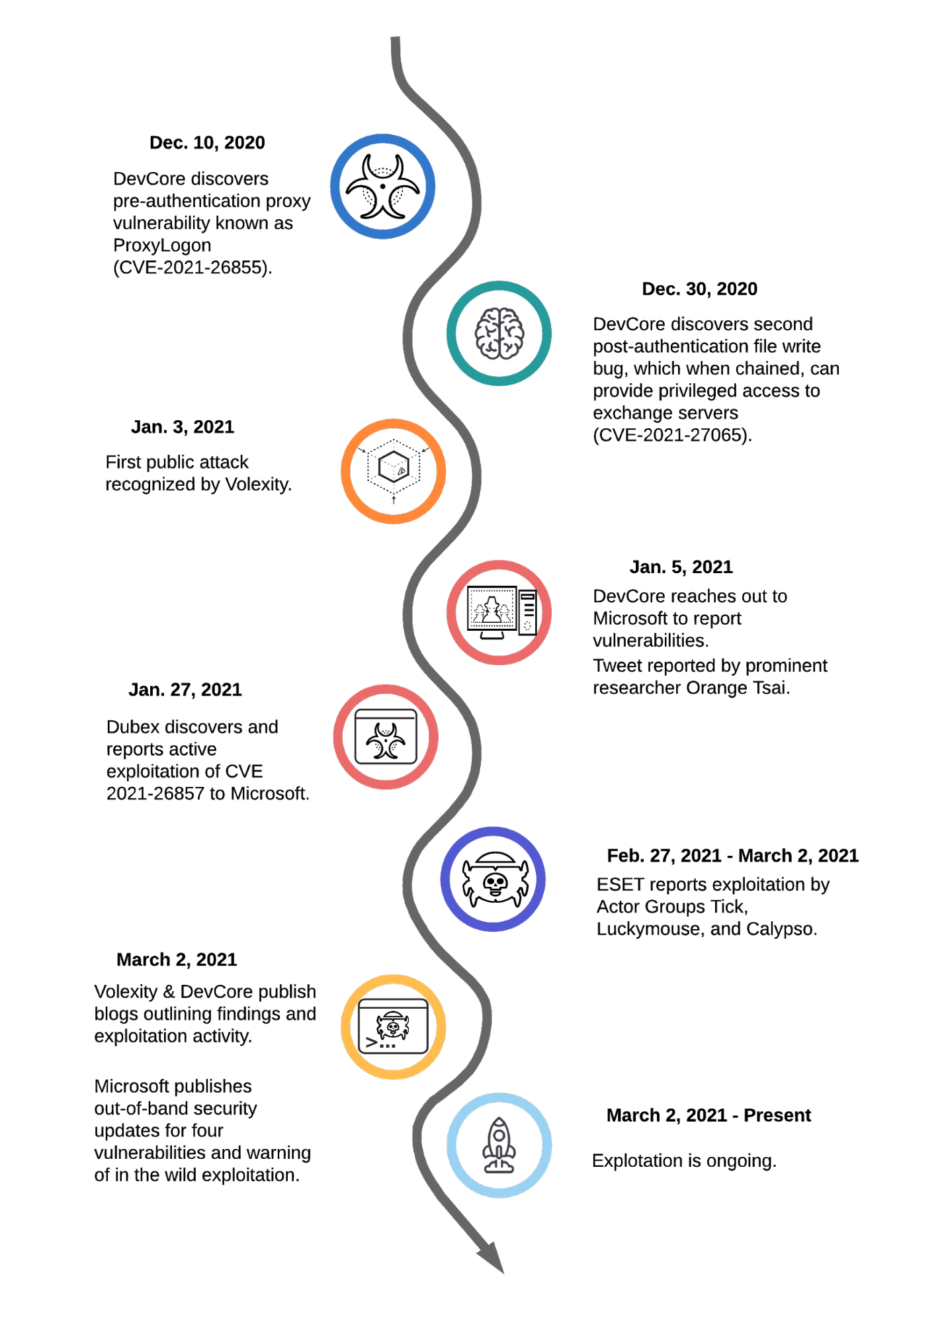

Outline:
Hafnium, a state-supported bunch, took advantage of weaknesses in Microsoft Trade Server programming to get to email accounts, introduce malware, and work with long haul admittance to casualty organizations.
Job of CTI:
The fast sharing of specialized insights concerning the weaknesses and assault marks through CTI stages empowered associations overall to rapidly distinguish compromised frameworks and apply vital patches. CTI experiences likewise helped in figuring out the essential goals of the assailants, directing a more educated reaction.

SolarWinds Orion Software Attack (2020)

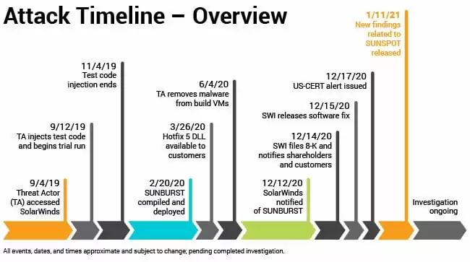

Outline:
The SolarWinds assault was a refined and designated digital reconnaissance crusade that compromised the Orion programming inventory network, influencing huge number of public and confidential associations internationally.
Job of CTI:
CTI stages were instrumental in revealing the degree of the assault. CTI assisted in the identification of the affected systems and provided guidance on how to mitigate the threat by analyzing the indicators of compromise (IoCs) and TTPs associated with the attack. Knowledge dividing among associations through CTI stages was pivotal in quickly scattering data about the assault.

WannaCry Ransomware Attack (2017)

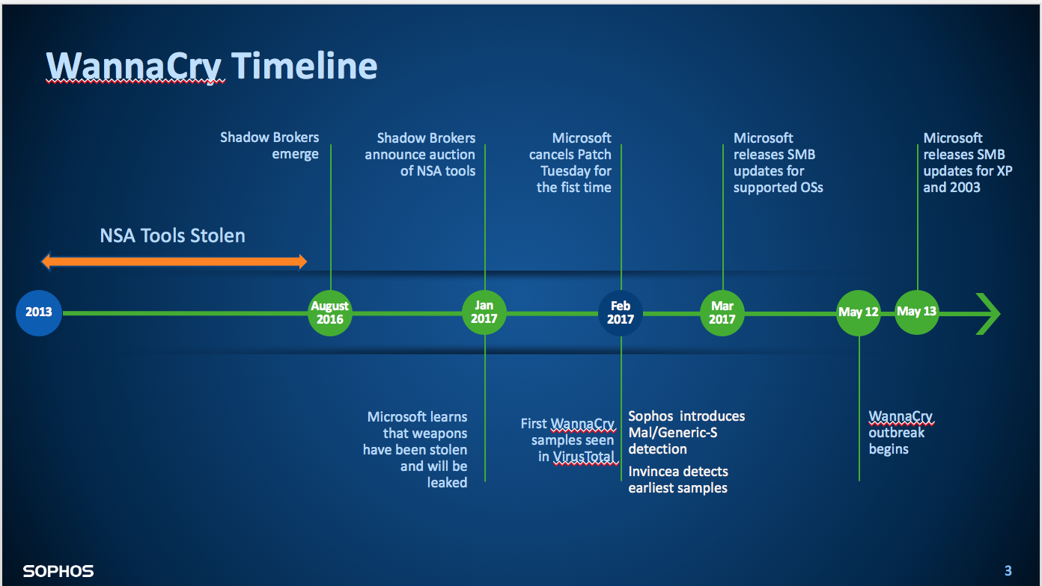

An overview:
WannaCry was a global ransomware attack that took advantage of a vulnerability in Microsoft Windows and affected more than 200,000 computers in 150 countries.
CTI platforms quickly spread information about the ransomware, including its behavior, IoCs, and exploited vulnerabilities (such as EternalBlue). This data was essential for associations to rapidly fix weak frameworks and forestall the spread of the ransomware. CTI was also involved in real-time tracking of WannaCry's spread and impact.

NotPetya Malware Attack (2017)

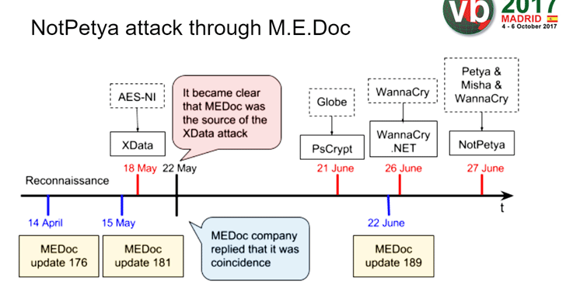

Outline:
NotPetya was at first seen as a ransomware assault however was subsequently recognized as a state-supported digital weapon pointed toward causing disturbance. It spread through a compromised Ukrainian duty programming update instrument.
CTI's role:
CTI platforms distinguished NotPetya from typical ransomware by analyzing the malware's source code and propagation strategies. This insight assisted associations with understanding that information recuperation probably won't be imaginable, moving the concentration to control and counteraction of spread to unaffected frameworks.

Operation Cloud Hopper (Reported in 2017)

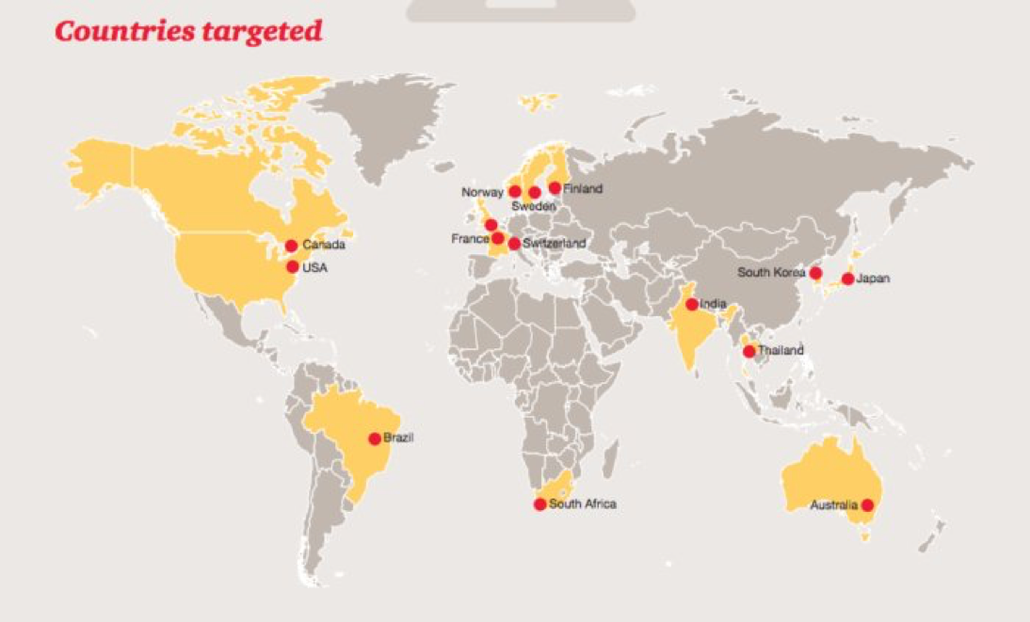

Outline:
This was a digital undercover work crusade focusing on oversaw specialist organizations (MSPs) to get sufficiently close to MSPs' organizations and their clients' organizations. It was credited to a state-supported entertainer.
CTI platforms and collaborative networks played a crucial role in determining the campaign's scope and TTPs. Divided knowledge between impacted associations and security scientists assisted in crediting the assault to the APT10 with gathering. The development of defensive strategies that were tailored to the sophisticated techniques utilized in the operation was made possible by this collective intelligence.

1. Financial Sector Attack Prevention
In the monetary area, a significant bank used a CTI stage to distinguish a phishing effort focused on at its clients. The stage distinguished marks of give and take (IoCs) connected with the mission, including vindictive IP locations and URLs, which were then used to refresh the bank's safety efforts, for example, firewall rules and email channels. By taking a proactive approach, the phishing emails were unable to reach a large number of customers, preventing financial losses and data breaches.
2. Healthcare Ransomware Attack Mitigation
A medical care association was designated by a ransomware assault planning to scramble patient information for blackmail. By utilizing a CTI stage, the association's security group immediately distinguished the ransomware variation in light of shared IoCs and TTPs from comparative episodes revealed by different elements. This knowledge permitted them to seclude the impacted frameworks and apply explicit decoding instruments that were suggested by the CTI stage, limiting the effect of the assault and reestablishing basic administrations a lot quicker than would somehow have been conceivable.

3. Energy Sector Espionage Detection
An energy organization distinguished strange organization movement through its CTI stage, which related the action with realized designs related with a state-supported digital reconnaissance bunch. The company was able to identify the attacked systems and data thanks to the platform's analysis of the threat actor's TTPs. With this data, the organization had the option to rapidly get the impacted frameworks, eliminate the aggressors' entrance, and execute extra safety efforts to safeguard against future occurrences of a comparable sort.
4. Retail Industry Supply Chain Attack Prevention
In the retail business, a CTI stage was utilized to distinguish a store network assault focusing on the money of-offer (POS) frameworks through a compromised programming update. The stage gave early admonitions about the assault by examining danger knowledge takes care of and seeing inconsistencies connected with the product supplier's space and IP addresses. This permitted the retailer to end the product update process, direct a careful examination, and apply important patches without undermining their POS frameworks or client information.
5. Government Phishing Campaign Exposure
An administration organization used a CTI stage to reveal a refined phishing effort pointed toward getting delicate data from workers. The stage recognized dubious email designs and connected them to a known danger entertainer bunch. By dispersing this data rapidly inside the association, the organization had the option to teach its representatives about the particular strategies being utilized, prompting a critical decrease in the achievement pace of these phishing endeavors.

These models show the fluctuated uses of CTI stages across various areas, featuring their significance in recognizing, forestalling, and relieving digital assaults. By giving opportune and significant data about dangers, CTI stages empower associations to take on a more proactive and informed way to deal with network protection.

detected and prevented cyber-attacks.

Digital assaults are an always present danger in the advanced age, focusing on people, enterprises, and states around the world. Discovery and avoidance of these assaults are basic to safeguarding delicate data and keeping up with functional progression. Here are a few instances of how digital assaults have been recognized and forestalled, exhibiting the viability of different network safety systems and innovations

Use of Artificial Intelligence and Machine Learning

An advanced security system that uses algorithms from artificial intelligence (AI) and machine learning (ML) to monitor and analyze network traffic in real time was implemented by a global financial institution. This framework had the option to identify a modern lance phishing assault focused on significant level chiefs. The AI system flagged the threat before any users clicked on the malicious links, preventing potential data breaches and financial loss by spotting unusual email patterns and suspicious links.

Threat Intelligence Sharing

For instance, sharing platforms for cyber threat intelligence (CTI) have been instrumental in preventing attacks. For example, associations inside the energy area have shaped an alliance to share continuous danger knowledge. At the point when one organization recognized a high level constant danger (Well-suited) focusing on its functional innovation (OT) organization, it shared the marks of give and take (IoCs) with the alliance. Accordingly, a few different organizations had the option to utilize this knowledge to reinforce their protections, effectively forestalling comparative assaults on their organizations.

Endpoint Detection and Response (EDR) Solutions

An illustration of this would be a global multinational corporation that utilized an Endpoint Detection and Response (EDR) solution. On a few devices, this tool recognized the early stages of the encryption process, which helped identify an attempted ransomware attack. The EDR arrangement consequently disconnected the impacted gadgets and moved back the records to their pre-encryption state, really invalidating the assault and saving the trustworthiness of the organization's information.

Security Awareness Training
Model:
An instructive establishment figured out how to impede a phishing assault through thorough security mindfulness preparing. By consistently preparing staff and understudies on the most proficient method to perceive phishing messages — zeroing in on dubious email addresses, language botches, and spontaneous connections — the organization made a human firewall. Several recipients noticed a phishing attempt and reported the suspicious email to the IT department. The IT department quickly blocked the sender and stopped the phishing attempt from spreading.

Network Segmentation

A healthcare provider used network segmentation to effectively safeguard patient data. At the point when aggressors accessed the organization through a compromised gadget, the division restricted their development across the organization, keeping them from getting to delicate regions where patient records were put away. The division limited the effect of the assault as well as permitted the IT group to recognize and kill the danger rapidly, defending basic information and keeping up with administration progression.

Multi-Factor Authentication (MFA)
Model:
An innovation organization credited its powerful execution of multifaceted confirmation (MFA) for halting unapproved admittance to its inward frameworks. An aggressor who had gotten a bunch of client certifications through a past information break was obstructed while endeavoring to sign in light of the fact that they couldn't sidestep the MFA challenge. This extra security layer demonstrated fundamental in forestalling a possibly harming information break. These true models feature the significance and viability of a diverse security approach in identifying and forestalling digital assaults. By utilizing innovation, sharing data, and teaching clients, associations can essentially upgrade their network safety stance and versatility against dangers.

LITRETURE REVIEW

A writing survey on digital assaults includes looking at insightful articles, books, and other scholastic sources to grasp the degree, procedures, effects, and countermeasures related with digital dangers. This outline plans to combine key discoveries from different examinations, featuring patterns, difficulties, and future bearings in the field of online protection. Given the limitlessness of this point, this audit will zero in on huge areas of interest inside the space of digital assaults.
Scope and Nature of Cyber Attacks
Digital assaults have advanced essentially, turning out to be more modern, successive, and harming. Studies classify these assaults in light of their targets, for example, information breaks, monetary robbery, surveillance, and disturbance of administrations. A vital area of examination includes breaking down assault vectors, including phishing, malware, ransomware, Circulated Disavowal of Administration (DDoS) assaults, and High level Relentless Dangers (APTs). Researchers like Kaspersky and Symantec give yearly reports that detail these patterns, offering significant experiences into how digital dangers advance.
Methodologies of Cyber Attacks
Research in network safety systems frequently centers around the specialized components aggressors use to take advantage of weaknesses. Social engineering, exploiting software and hardware flaws, and utilizing compromised credentials are all examples of this. The Miter ATT&CK structure is habitually refered to in writing as a complete framework of strategies and procedures utilized by danger entertainers, filling in as a basic device for figuring out assault techniques.
Impacts of Cyber Attacks
The effects of digital assaults are different and extensive, influencing people, associations, and countries. Studies have investigated the immediate and circuitous expenses related with these assaults, including monetary misfortunes, reputational harm, administrative fines, and mental effects on casualties. The Ponemon Establishment's yearly Expense of an Information Break Report gives exact information on the monetary ramifications, while different investigations dig into the socio-political outcomes of digital surveillance and digital fighting.
Countermeasures and Cybersecurity Practices
A huge part of network protection writing is committed to investigating countermeasures and best practices for moderating the dangers of digital assaults. Security awareness training, encryption technologies, intrusion detection systems (IDS), and cybersecurity frameworks like NIST are all examples of this. Research likewise stresses the significance of a proactive and versatile security act, consolidating danger insight, risk evaluation, and occurrence reaction arranging.
Future Directions and Emerging Threats
Blockchain, the Internet of Things (IoT), and other emerging technologies present cybersecurity professionals with both opportunities and challenges. Researchers examine how these advances can improve safety efforts yet in addition how they present new weaknesses. For example, AI-driven security tools can make it easier to spot threats, but hackers can also use AI to create more sophisticated malware or carry out large-scale social engineering attacks.

As per the Public Digital System, the Network protection Breaks Review is a compelling exploration study for the UK's digital flexibility. It is mostly used to make the UK's cyberspace a safe place for business and to help the government make cyber security policies. The study looks at how organizations, charitable organizations, and educational institutions approach digital security in terms of procedures, cycles, and strategies. It similarly considers the different computerized attacks these affiliations face, as well as how these affiliations are impacted and reply.

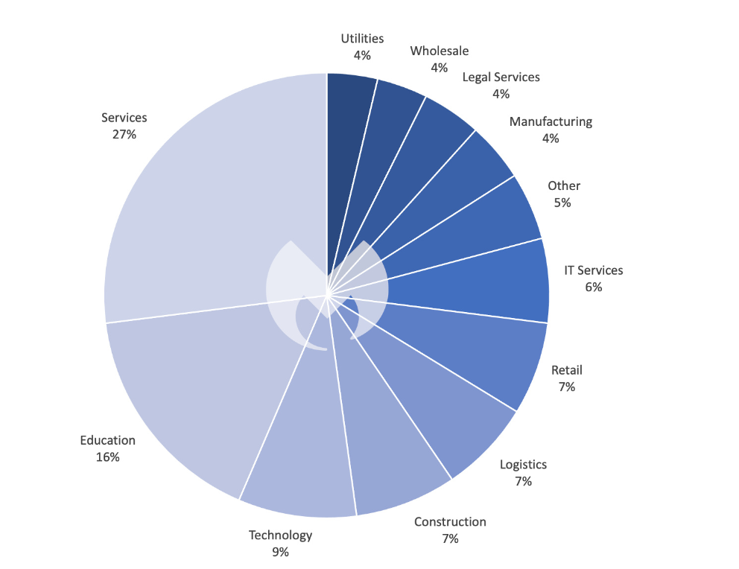

Known ransomware assaults by industry area in the UK, April 2022 - Walk 2023

Our information show that Bad habit Society, a profoundly hazardous gathering that circulates ransomware and has a strong fascination with the instructive area, is a significant supporter of this.In 2022, LockBit was utilized in 3.5 times as many referred to assaults overall as its nearest rival, ALPHV. In our 2023 Province of Malware report, you can get more familiar with why LockBit represents the best danger to your business.) Given its worldwide strength, it ought to shock no one that LockBit was the most often utilized ransomware in the UK throughout the last year.

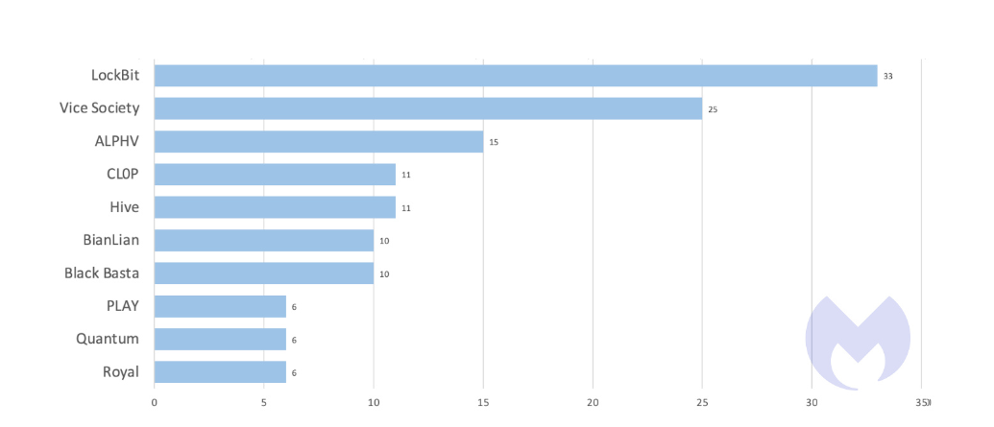

Known assaults by the ten most utilized ransomware in the UK, April 2022 - Walk 2023

Truly, the UK is one of Vice Society's main targets, addressing 21% of the get-together's known attacks over the latest a year, a close by second to the USA which addressed 23%, and limitlessly more than the accompanying country, Spain, which addressed 8%.Sadly, Negative behavior pattern Culture's unbalanced interest in the UK lands unequivocally on the preparation sector.76% of Unfortunate behavior pattern Culture's known attacks in the UK all through ongoing months hit the tutoring region, and Unfortunate behavior pattern Culture was obligated for 70% of known attacks on UK guidance associations.

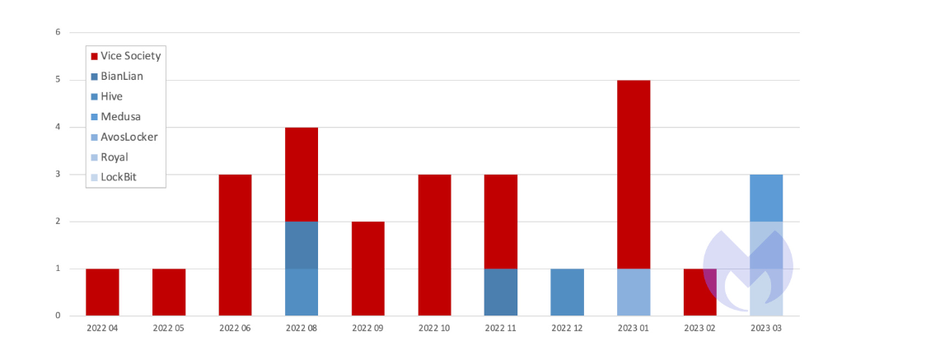

Known ransomware assaults by month on the UK schooling area, by posse, April 2022 - Walk 2023:

In 2023, the BBC gave a record of 14 schools in the UK that were pursued by Vice Society including Carmel School, St Helens, Durham Johnston Exhaustive School (hacked in 2021, chronicles posted online in January 2022), and Frances Ruler School of English, London/Dublin.

As far as how it enters the organizations of its casualties, Bad habit Society doesn't develop the wheel. It uses conspicuous procedures, for instance, phishing, compromised capabilities, and exploits to spread out a foothold.

To stay away from location by security devices, Bad habit Society is additionally known to involve real programming in its assaults. This system, known as "living off the land", allows the gathering to stay inconspicuous by simply being easygoing on setback's associations. Windows The board Instrumentation (WMI), which permits chairmen to remotely oversee and screen PCs, is one of its #1 apparatuses. EDR programming worked via prepared security faculty or a help like MDR are the main powerful techniques for spotting assailants who live off the land.
We don't have the foggiest idea why Bad habit Society is so keen on UK schools and colleges, however we really do realize that the business isn't precisely loaded. As per the non-hardliner Training Strategy Organization, "between 2009-10 and 2019-20, spending per student in Britain fell by 9% in genuine terms," schooling subsidizing in the UK has diminished altogether over the course of the last 10 years.
Following a spike in extension in 2022, the UK's greatest showing affiliation projected a voting form to strike for better remuneration for its people. While the actual strikes don't straightforwardly add to the weakness of training to ransomware, they truly do act as a sign of the falling apart monetary circumstance of UK schooling.
This creator led interviews in 2021 with various individuals engaged with giving UK schools cyber-protection. The picture in each was something almost identical: One of the numerous obligations being conveyed by few IT staff individuals was network protection. These staff individuals were under a ton of strain and unprepared to oppose the considerations of a ransomware pack like Bad habit Society.

Outcomes:

Over the latest a year there was no hiding spot for relationship in the UK. Our assessment of outright known attacks, known attacks per $1T of GDP, and known follows per capita, shows that ransomware groups treated the entire Anglosphere, notwithstanding the USA, as their amazing hunting ground. The Unified Realm was and very likely will keep on being on the forefronts of the battle against ransomware as a component of that gathering.

The training area in the UK was excessively impacted. It was the objective of undeniably more known assaults than training was in France or Germany, and it was the reason for definitely more known assaults than schooling was in the US. The shortcoming of the preparation region was revealed by Negative behavior pattern Culture, a savage ransomware gang with an outsized hankering for tutoring targets. Bad habit Society was similarly as dynamic in the UK as it was in the US over the course of the last year. While LockBit is as yet the most hazardous ransomware for practically all areas and practically all nations, Bad habit Society is the most perilous hunter for the destitute training area in the UK.

The way that ransomware groups have picked the training area in the UK over an immense range of different targets ought to be reason to worry. It should reconsider, retrain, and retool its way to deal with ransomware more than some other industry to avert the decided consideration of aggressors who sense an open door.

How to prevent form cyber attacks
Forestalling digital assaults requires a diverse methodology that includes different proactive measures and best practices. First and foremost, associations and people ought to focus on the utilization of solid confirmation techniques, for example, multifaceted verification (MFA), to reinforce access controls and relieve the gamble of unapproved access. Moreover, staying up with the latest with standard fixes and updates is significant for tending to known weaknesses and defeating likely abuse by digital enemies. Utilizing hearty security programming, including antivirus, hostile to malware, and firewall arrangements, can additionally strengthen guards by recognizing and killing noxious dangers. Moreover, instructing representatives about network safety best practices is foremost. Preparing projects ought to zero in on bringing issues to light about normal assault vectors like phishing messages, social designing strategies, and pernicious sites, enabling people to perceive and stay away from possible dangers. Getting network foundation through encryption, virtual confidential organizations (VPNs), and severe access controls helps defend information transmissions and forestall unapproved admittance to delicate data. Routinely backing up basic information and frameworks guarantees versatility against ransomware assaults and information breaks, empowering quick recuperation and limiting likely misfortunes. In addition, conveying interruption discovery and anticipation frameworks (IDS/IPS) empowers associations to screen network traffic for dubious movement and answer immediately to expected dangers. Creating and practicing an occurrence reaction plan gives an organized system to answering digital episodes really, including correspondence conventions and techniques for relieving harms. Ultimately, leading standard security reviews, infiltration testing, and weakness evaluations permits associations to proactively distinguish and remediate shortcomings before they can be taken advantage of by malignant entertainers. Organizations can significantly increase their resilience against cyber-attacks and better safeguard their digital assets and sensitive information by adopting a holistic approach that combines technical safeguards, employee training, and proactive monitoring.

future Directions

potential enhancements and additions to the CTI platform.

In the context of cyberattacks, enhancements and additions to a Cyber Threat Intelligence (CTI) platform can significantly enhance its effectiveness in threat detection, response, and mitigation. Here are a few expected upgrades and increase.

Mechanized Danger Examination:
Execute AI and man-made reasoning calculations to naturally dissect approaching danger information, distinguish designs, and focus on dangers in light of their seriousness and pertinence to the association.
Reconciliation with Outside Danger Feeds:
Incorporate the CTI stage with outer danger insight takes care of from respectable sources like ISACs (Data Sharing and Investigation Focuses), business danger knowledge suppliers, and government organizations to enhance the stage's information and give a more extensive perspective on the danger scene.

Social Examination:
Consolidate conduct investigation capacities to identify strange exercises and expected marks of give and take (IoCs) inside the association's organization, frameworks, and applications.
Danger Hunting Devices:
Incorporate danger hunting apparatuses and abilities inside the CTI stage to enable security examiners to proactively look for dangers and IoCs that might sidestep mechanized location systems. Coordinated
effort and Data Sharing:
Empower cooperation and data sharing highlights inside the CTI stage to work with correspondence and information trade among security investigators, occurrence responders, and other applicable partners.

Context oriented Enhancement:
Naturally improve danger information with logical data, for example, danger entertainer profiles, assault strategies, and verifiable patterns to furnish examiners with a more thorough comprehension of the dangers they are confronting.
Episode Reaction Coordination:
Incorporate the CTI stage with occurrence reaction organization instruments to mechanize and smooth out the reaction interaction, taking into consideration quicker control and moderation of digital assaults.

Danger Knowledge APIs:
Give APIs (Application Programming Points of interaction) to permit consistent combination of the CTI stage with other security devices and frameworks inside the association's current circumstance, like SIEM (Security Data and Occasion The board) arrangements, firewalls, and endpoint recognition and reaction (EDR) frameworks.
Persistent Observing and Cautioning:
Carry out ceaseless checking capacities to screen the association's organization and frameworks for dubious exercises progressively, and give ideal alarms to security groups for brief activity.
Adaptable Dashboards and Reports:
Offer adjustable dashboards and reports inside the CTI stage to empower security groups to picture and present danger knowledge information in an organization that is important and significant for various partners, including leaders and board individuals.

Emerging trends in cyber attacks and defense mechanisms

Arising patterns in digital assaults and guard components keep on developing as innovation advances and danger entertainers adjust their strategies. Here are a few striking patterns in both digital assaults and guard components.
Emerging Trends in Cyber Attacks:
Ransomware-as-a-Administration (RaaS):
Ransomware assaults are progressively being led through RaaS models, where cybercriminals lease or buy ransomware variations to send against targets, bringing the obstruction down section for hoping for aggressors.
Supply Chain Attacks:
Threat actors can compromise multiple organizations with a single compromise by targeting the software supply chain to compromise widely used applications or services, as was the case with the SolarWinds supply chain attack.
Zero-Day Exploits and Weakness Abuse:
Complex aggressors influence zero-day weaknesses or take advantage of known weaknesses in programming and equipment to acquire unapproved admittance to frameworks, accentuating the significance of convenient fixing and weakness the board.
Deep fake Innovation:
Deep fake innovation is by and large progressively used to make persuading counterfeit sound, video, or text content, prompting potential falsehood crusades, social designing assaults, and pantomime endeavours.
Cloud-based Assaults:
As associations progressively relocate to cloud conditions, aggressors are focusing on cloud foundation, applications, and administrations with strategies like misconfigurations, information breaks, and cloud-explicit weaknesses.
Both attackers and defenders are looking into how to use AI and machine learning (ML) technologies in their attacks and defenses. Aggressors might utilize artificial intelligence to robotize and upgrade assaults, while safeguards influence computer-based intelligence for danger identification, abnormality recognition, and conduct examination.
Exploitation of IoT Devices:
The proliferation of Internet of Things (IoT) devices opens up new attack vectors because many of them lack adequate security, making them susceptible to exploitation for botnets, distributed denial of service (DDoS) attacks, or data theft. Attackers are targeting smartphones and tablets with malware, phishing attacks, and malicious apps designed to steal sensitive information or commit financial fraud as a result of the growing use of mobile devices.
Digital money and Blockchain Double-dealing:
Cybercriminals exploit cryptographic forms of money and blockchain innovation for different pernicious exercises, including ransomware instalments, illegal exchanges, cryptographic money mining malware, and brilliant agreement weaknesses. Cyber espionage, sabotage, and influence operations by nation-state actors that target governments, critical infrastructure, and organizations present significant challenges for defence and attribution.

Emerging Trends in Defense Mechanisms:
Zero Trust Engineering:
Zero Trust standards, which accept that dangers might exist both inside and outside the organization edge, are acquiring prevalence. This approach stresses severe access controls, constant verification, and miniature division to alleviate the gamble of horizontal development by assailants.
Broadened Identification and Reaction (XDR):
XDR stages incorporate and connect information from numerous security items, including endpoint recognition and reaction (EDR), network location and reaction (NDR), and cloud security devices, to give comprehensive danger discovery and reaction capacities.

Trickiness Innovation:
Duplicity innovation conveys distraction resources, like phony certifications, records, or organization endpoints, to misdirect and draw aggressors into uncovering their presence, empowering early location and reaction to interruptions.
Threat Intelligence Sharing and Collaboration:
To exchange information about emerging threats, indicators of compromise (IoCs), and best practices, organizations are increasingly participating in threat intelligence sharing initiatives like ISACs (Information Sharing and Analysis Centers) and threat intelligence platforms.
Social Investigation and Client Substance Conduct Examination (UEBA):
Social examination arrangements dissect client and element conduct to identify irregularities characteristic of malevolent action, like insider dangers, compromised records, or parallel development by assailants.
Endpoint Security Improvements:
Endpoint security arrangements are developing to integrate progressed highlights like fileless malware identification, memory abuse avoidance, and endpoint discovery and reaction (EDR) abilities to more readily safeguard against refined assaults.
Cloud Security Posture Management (CSPM):
CSPM solutions improve visibility and control over cloud security posture by assisting businesses in identifying and resolving misconfigurations, compliance violations, and security risks in their cloud environments.
Quantum-Safe Cryptography:
With the looming danger of quantum figuring breaking customary cryptographic calculations, innovative work endeavors are in progress to foster quantum-safe or quantum-safe cryptographic calculations to guarantee the drawn out security of delicate information.
Security Awareness Training with a Focus on Human Factors:
In order to educate employees about cybersecurity best practices, phishing awareness, and incident response procedures, businesses are making investments in security awareness training programs. Security teams are utilizing incident response automation platforms and continuous security monitoring solutions to detect and respond to threats in real time, thereby reducing dwell times and minimizing the impact of cyberattacks.

Implications for the future of cybersecurity

Expanded Intricacy of Digital Dangers:
As aggressors proceed to enhance and use progressed strategies like man-made intelligence, deep fakes, and inventory network assaults, digital dangers will turn out to be more complicated and testing to recognize and alleviate. This requires a multifaceted and versatile way to deal with network protection.
Developing Significance of Proactive Guard Methodologies:
With the ascent of refined assaults, associations should embrace proactive safeguard procedures, including danger hunting, constant observing, and danger insight sharing, to identify and answer dangers before they can cause harm.
Shift Towards Zero Trust and Guard Top to bottom:
The customary edge-based security model is presently not adequate to safeguard against current dangers. It will become increasingly important to implement defence-in-depth strategies and Zero Trust principles, both of which assume that threats can exist both within and outside the network perimeter.
Union of Safety Innovations:
As digital dangers become more different and interconnected, there will be a more noteworthy intermingling of safety advancements, for example, XDR stages, that incorporate numerous security items to give all-encompassing danger identification and reaction capacities. In order to empower employees to recognize and respond to security threats, there will be an increased focus on human-centric security measures, such as security awareness training, phishing simulations, and user behavior analytics, in recognition of the fact that humans frequently constitute the weakest link in cybersecurity.

Accentuation on Cloud Security and DevSecOps:
As associations keep on relocating their foundation and applications to the cloud, there will be a developing accentuation on cloud security pose the board (CSPM) and DevSecOps practices to guarantee the security of cloud conditions and applications from the improvement stage onwards.
Ascent of Quantum-Safe Cryptography:
With the inescapable danger of quantum figuring breaking conventional cryptographic calculations, there will be a more noteworthy accentuation on the turn of events and reception of quantum-safe cryptographic calculations to safeguard delicate information against future quantum assaults.
Significance of Coordinated effort and Data Sharing:
Given the interconnected idea of digital dangers, cooperation and data dividing between associations, government organizations, and security merchants will be fundamental for on the whole protecting against digital assaults and sharing danger knowledge.
Integration of AI and Automation:
Both attackers who use AI-powered attacks and defenders who use AI-driven threat detection, incident response automation, and security orchestration will increasingly rely on AI and automation in cybersecurity.
Administrative and Consistence Difficulties:
As digital dangers advance, administrative bodies and industry principles will keep on developing to address arising dangers and upgrade network safety necessities. Associations should keep up to date with these administrative changes and guarantee consistence to alleviate legitimate and monetary dangers.
In general, the eventual fate of online protection will require a proactive, versatile, and cooperative way to deal with address the developing danger scene really. By putting resources into trend setting innovations, embracing best practices, and encouraging a culture of safety mindfulness, associations can improve their flexibility and moderate the dangers presented by digital dangers.
As cyber threats become increasingly sophisticated and technological advancements continue, the future of cybersecurity is both promising and challenging. One huge ramifications is the developing significance of proactive safeguard measures. Customary responsive methodologies, for example, signature-based discovery, are demonstrating lacking against quickly transforming dangers. All things being equal, the accentuation is moving towards prescient investigation, AI, and man-made reasoning (computer based intelligence) to expect and moderate possible assaults before they happen. In addition, the proliferation of Internet of Things (IoT) devices opens up new opportunities for cyberattacks, necessitating enhanced security measures to protect data and systems that are interconnected. With billions of IoT gadgets expected to be being used, getting these endpoints and dealing with their weaknesses will be central. Quantum computing, which poses a threat to existing cryptographic systems, is another crucial aspect. As quantum PCs become more common sense, the need to foster quantum-safe encryption calculations increases to keep up with information classification and honesty. Additionally, robust identity and access management solutions are required due to the expanding attack surface brought about by remote work and cloud adoption. Zero-trust structures, which accept that all organization traffic is possibly vindictive, are getting forward movement to implement severe access controls and limit the gamble of insider dangers. Moreover, international pressures and state-supported digital fighting highlight the significance of global coordinated effort and digital discretion. States and confidential associations should cooperate to lay out worldwide guidelines, share danger knowledge, and direction reactions to digital goes after successfully. All in all, the eventual fate of network protection will require a complex methodology enveloping mechanical development, administrative systems, and joint effort among partners. By remaining in front of arising dangers and embracing a proactive security act, associations can moderate dangers and defend against digital dangers in an undeniably interconnected computerized scene.

Conclusion

Summary of key findings
Lately, digital assaults have advanced essentially, with a few key patterns arising in the digital danger scene. Ransomware assaults have become progressively predominant, filled by the ascent of ransomware-as-a-administration (RaaS) models and focusing on associations across different businesses. Production network weaknesses have additionally come to the front, exemplified by high-profile episodes like the SolarWinds break, featuring the significance of getting the product production network. Assailants are taking advantage of zero-day weaknesses and realized programming imperfections to acquire unapproved admittance to frameworks, while the development of deepfake innovation presents new difficulties in fighting falsehood and social designing assaults. Cloud-put together goes after are with respect to the ascent, mirroring the developing reception of cloud administrations, and IoT gadget abuse presents extra security gambles because of deficient gadget safety efforts. Cybercriminals use cryptocurrencies and blockchain technology for a variety of illegal activities, and nation-state-sponsored attacks continue to target governments, critical infrastructure, and organizations worldwide. Versatile malware and phishing assaults stay common, with assailants focusing on cell phones and tablets, while social designing and phishing strategies keep on misleading clients and compromise delicate data. These patterns highlight the developing idea of digital dangers, requiring a proactive and extensive way to deal with network protection to successfully relieve chances.
Proactive digital guard methodologies are of central significance despite advancing digital assaults. Conventional responsive methodologies, for example, depending entirely on border guards and fixing weaknesses after they are taken advantage of, are deficient in the present quickly changing danger scene. Proactive guard procedures include effectively distinguishing and alleviating expected dangers before they can appear into all out assaults. This approach incorporates ceaseless danger hunting, where security groups effectively look for signs of give and take (IoCs) and dubious exercises inside the organization, as well as utilizing danger insight to expect and plan for arising dangers. Also, proactive protection systems include carrying out hearty security controls, for example, zero trust models and safeguard top to bottom measures, to restrict the effect of fruitful assaults and forestall parallel development by danger entertainers. By taking a proactive position towards network safety, associations can more readily safeguard their resources, information, and notoriety from the steadily developing strategies of cybercriminals, eventually upgrading their versatility and capacity to endure digital assaults.
In the third thousand years, the internet and related advancements are one of the main wellsprings of force. Power dissemination is a consequence of the qualities of the internet, for example, low passage charges, obscurity, weakness, and deviation. On the off chance that legislatures have up until this point partitioned the power game between themselves, different entertainers, like privately owned businesses, coordinated fear monger and criminal gatherings, and people, should likewise assume a part, despite the fact that states keep on assuming a huge part in this. Normally, legislatures won't lose admittance to their public safety because of this peculiarity. There are various ways of assessing this impact. To start with, there is the possibility of wellbeing. Today, a danger to public safety is the chance of residents' personal satisfaction disintegrating, instead of military matters or inner and outside borders. The second is that digital dangers never again have a geological part. Previously, military dangers were restricted to a particular district. Subsequently, managing it was quite easy, to some extent regarding recognizable proof. The degree of digital dangers' weaknesses positions third. Because of their relationship with touchy framework and organizations, these irregular, multi-faceted dangers represent an extremely high gamble of harm. Fourth, these dangers can't be held back exclusively by traditional means, for example, the utilization of the military and police, state run administrations alone are inadequate to battle them, and compelling reciprocal participation among legislatures and the confidential area, what shares normal interests, is essential. He demands with such dangers. Fifth, as the past point illustrates, people and organizations won't be saved the impacts of digital dangers, which are not restricted to legislatures. 6th, the different hypothetical ways to deal with global relations whose speculations are fundamentally founded on government are not entirely obvious or befuddling on the grounds that security in the data age isn't simply legislative.

Reference list
admin (n.d.). IT Infrastructure Services – SPARC Technologies. [online] Available at: https://sparctech.com.sg/it-infrastructure-services/ [Accessed 22 Feb. 2024].
Bhardwaj, P. (2021). What is AAA (Authentication, Authorization, and Accounting)? [online] www.tutorialspoint.com. Available at: https://www.tutorialspoint.com/what-is-aaa-authentication-authorization-and-accounting.
Brenner, S. (2017). CYBERCRIME : criminal threats from cyberspace. Praeger.
Cruz, T. and Simoes, P. (2019). ECCWS 2019 18th European Conference on Cyber Warfare and Security. Academic Conferences and publishing limited.
Erra, R. (2012). ECIW2012- 11th European Conference on Information warfare and security. Academic Conferences Limited.
Li, Y. and Liu, Q. (2021). A comprehensive review study of cyber-attacks and cyber security; emerging trends and recent developments. Energy Reports, [online] 7(7), pp.8176–8186. doi:https://doi.org/10.1016/j.egyr.2021.08.126.
Libicki, M.C. (2007). Conquest in Cyberspace. Cambridge University Press.
Menon, R. (2023). How cryptography can be used to make digital transactions secure. [online] YourStory.com. Available at: https://yourstory.com/the-decrypting-story/cryptography-digital-transactions-bitcoin-ethereum-banks-ecommerce [Accessed 5 May 2023].
More than half of British firms ‘report cyber-attacks in 2019’. (2019). BBC News. [online] 22 Apr. Available at: https://www.bbc.co.uk/news/business-48017943 [Accessed 18 Nov. 2019].
Peitz, M. and Waldfogel, J. (2012). The Oxford Handbook of the Digital Economy. Oxford University Press.
Prunckun, H. and Springerlink (Online Service (2018). Cyber Weaponry : Issues and Implications of Digital Arms. Cham: Springer International Publishing.
published, R.K. (2023). Cyber-attacks on UK organisations surged 77% in 2022, new research finds. [online] ITPro. Available at: https://www.itpro.com/security/369813/cyber-attacks-on-uk-organisations-surged-77-in-2022-new-research-finds [Accessed 24 Apr. 2023].
Rawat, P. (2023). Common Security Attacks in the OSI Layer Model. [online] InfoSec Train. Available at: https://www.infosectrain.com/blog/common-security-attacks-in-the-osi-layer-model/.
Sang-Hun, C. (2013). Computer Networks in South Korea Are Paralyzed in Cyberattacks. The New York Times. [online] 20 Mar. Available at: https://www.nytimes.com/2013/03/21/world/asia/south-korea-computer-network-crashes.html?pagewanted=all&_r=0.
Schmitt, M.N. (2023). Computer Network Attack and the Use of Force in International Law: Thoughts on a Normative Framework. [online] Ssrn.com. Available at: https://papers.ssrn.com/sol3/papers.cfm?abstract_id=1603800. [Accessed 22 Feb. 2024].
Team, T.I. (n.d.). Ransomware in the UK, April 2022-March 2023. [online] Malwarebytes. Available at: https://www.malwarebytes.com/blog/threat-intelligence/2023/04/ransomware-review-uk [Accessed 24 Apr. 2023].
Thehackernews.com. (2024). Available at: https://thehackernews.com/images/-Vv3SsC0v-n4/WeG2AcgppII/AAAAAAAAuYI/HlH24Z-TwVsPyRtr9XyheGZXGrjblsdDgCLcBGAs/s728-rw-e365/notpetya-ransomware-attack.png [Accessed 22 Feb. 2024].
Vacca, J.R. (2006). Guide to Wireless Network Security. Boston, MA: Springer US. doi:https://doi.org/10.1007/978-0-387-29845-0.
Vikrant Bhatia, Suresh Chandra Satapathy, Satori, H. and Springerlink (Online Service (2020). Embedded Systems and Artificial Intelligence : Proceedings of ESAI 2019, Fez, Morocco. Singapore: Springer Singapore, Imprint Springer.
Wikipedia Contributors (2019). AAA (computer security). [online] Wikipedia. Available at: https://en.wikipedia.org/wiki/AAA_(Computer_security).
Zetter, K. (n.d.). Google Hack Attack Was Ultra Sophisticated, New Details Show. [online] Wired. Available at: https://www.wired.com/2010/01/operation-aurora/#ixzz0deHCunGn [Accessed 24 Apr. 2023].

NOTE:

Hacking Rules and Guidelines
Dear All,
As a feature of our obligation to keeping a protected and moral computerized climate, we need to help everybody to remember the accompanying standards and rules with respect to hacking: Submit to the Law: Any hacking action should conform to neighbourhood, public, and worldwide regulations. Participating in unlawful hacking exercises is totally restricted and will bring about serious results. Ethical Conduct: Hacking should only be done with the explicit permission of relevant authorities or stakeholders. Moral hacking, led with authorization to test and further develop security, is energized. Regard Security: Don't attack the protection of people or associations. It is unacceptable and against ethical standards to allow unauthorised access to personal or confidential information. Straightforwardness: While performing security testing or investigation, obviously convey your expectations and acquire assent from applicable gatherings. Report all discoveries and offer them dependably with suitable partners. Cause No Damage: Try not to make any harm frameworks, organizations, or information during hacking exercises. Practice watchfulness to limit the gamble of potentially negative side-effects. Persistent Learning: Remain informed about the most recent hacking methods, security weaknesses, and best practices. Routinely update your abilities and information to adjust to advancing dangers. Accountability: Be accountable for your actions and the results they have. Report any security weaknesses or breaks immediately and work cooperatively to address them. Local area Commitment: Cultivate a culture of cooperation and information sharing inside the hacking local area. Contribute to the collective effort to enhance cybersecurity by supporting fellow hackers in their ethical endeavours. Keep in mind, hacking can have serious ramifications, both legitimately and morally. By complying with these standards and rules, we can advance dependable hacking rehearses and add to a more secure computerized scene for everybody.
Thank you for your cooperation and commitment to upholding these principles.

Sincerely,
MEHUL GOSWAMI

