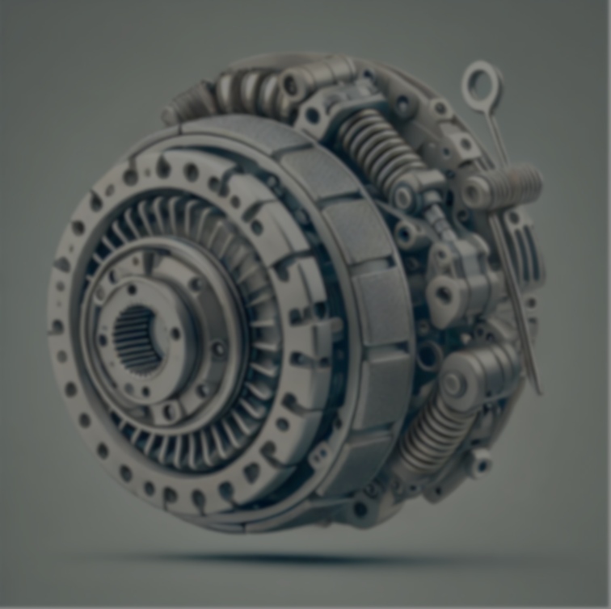
Analysis and Simulation of a Centrifugal Clutch

By Morgan James (1251151)
For the consideration of:
Module:
Module Code :
Programme :
Course :
Institution :
Rob Goodson
Stress Analysis and Dynamics
ACMA5010
School of Engineering Portfolio
Mechanical Engineering BEng
University of Wales Trinity Saint David

Contents
Introduction 3
Development of Centrifugal Friction Clutches 3
Historical Overview 3
Working Principle 4
Design and Materials 4
Diagrams 4
Typical Applications and Operating Conditions 4
Advantages of Centrifugal Clutches 4
Current Application of Electromagnetic Clutches 5
Overview of Electromagnetic Clutches 5
Working Principle 5
Design and Materials 5
Typical Applications 5
Advantages of Electromagnetic Clutches 5
Conclusion 6

Table of Figures
Figure 1 Centrifugal Clutch Diagram (Kholil, et al., 2019). 2
Figure 2 Working Diagram of Centrifugal Clutch (Toulas, 2018) 2
Figure 3 Task 2 Brief 7
Figure 4 Torque Vs RPM Graph of Varying Coefficients of Friction 10
Figure 5 Excel Workbook for Graph Construction 14
Figure 6 Formula For Equation Torque of Different Coefficients of Friction 15

Table of Equations
Equation 1 Outer Drum Diameter 7
Equation 2 Centrifugal Force 7
Equation 3 Hooke's Law 8
Equation 4 Engagement Speed of Centrifugal Clutch 8
Equation 5 RPM Conversion 8
Equation 6 550 RPM to Angular Velocity 9
Equation 7 Force Acting on Each Shoe at 550 RPM 9
Equation 8 Total Force Acting on Clutch Face at 550 RPM 9
Equation 9 Torque 9
Equation 10 Calculated Torque 9
Equation 11 Newtons Second Law 11
Equation 12 Moment of Inertia of a Solid Disk 11
Equation 13 Newtons Second law Rearranged for Alpha and to Include Moment of Inertia of a Solid Disk 11
Equation 14 Breaking Torque 12
Equation 15 Net Torque Available for Angular Acceleration 12

Acronyms
Kg – Kilograms
kN/m – Kilonewtons Per Metre
m – metres
mm – Millimetre
N – Newtons
Rad/s – Radians Per Second
RPM – Revolutions Per Minute

1.0 Task 1

1.1 Introduction
Centrifugal clutches have been a significant innovation in the realm of small motor equipment, particularly over the last century. Despite being gradually replaced by more advanced fluid mechanical clutches, centrifugal clutches still hold a crucial place in various applications due to their simplicity and effectiveness. This study explores the development of centrifugal friction clutches, discussing the choice of materials, typical applications, and operating conditions. Additionally, the advantages and disadvantages of centrifugal clutches are examined. The discussion concludes with an overview of the current application of electromagnetic clutches in modern manufacturing automation.

1.2 Development of Centrifugal Friction Clutches
A centrifugal clutch is an automatic clutch that uses centrifugal force to engage and disengage power, developed to simplify machinery operation, especially in small engines and vehicles, without a manual clutch. As (Liu & Chiang, 2016) describes, the clutch works by using weights that move outward with increased engine speed, eventually pushing against an outer drum to engage the drive. Today, with advancements in materials and design as spoken about by (Panchal, et al., 2023), centrifugal clutches are more efficient and durable, remaining widely used in applications that value simplicity and dependability.

1.2.1 Historical Overview
The concept emerged in the early 20th century as engineers such as Thomas J. Fogarty (Johnston, 2021) sought after a straightforward way to automate clutch engagement based on engine speed, making it ideal for industrial uses due to its reliability and simplicity. By the 1950s and 1960s, centrifugal clutches had become essential in small engines like those in lawnmowers, go-karts, and chainsaws, as they allowed engines to idle without engaging the drive train (The Engineers Post, 2024).

1.2.2 Working Principle
A centrifugal clutch operates based on the principle of centrifugal force, which increases with engine speed. As the engine accelerates, the centrifugal force causes the clutch shoes to move outward, pressing against the drum. This engagement transmits power to the output shaft. The degree of engagement is proportional to the engine speed, ensuring smooth, gradual power delivery without requiring manual control (Cheng & Liu, 2018).

1.2.3 Design and Materials
The design of a centrifugal clutch typically includes, clutch shoes, which are the frictional elements that engage with the drum which are often made of high-friction materials such as asbestos (historically) or modern composites such as Kevlar or carbon reinforced composites (Ramesh, et al., 2021). High tensile steel springs, which keep the clutch shoes retracted at low speeds. The drum or the outer casing that the clutch shoes engage with, which is made of hardened alloy steels, such as Molybdenum Steel (AISI M2) (Purohit , et al., 2014) or traditionally cast iron (Han, et al., 1992).

1.2.4 Diagrams
Below is a simplified diagram of a centrifugal clutch:
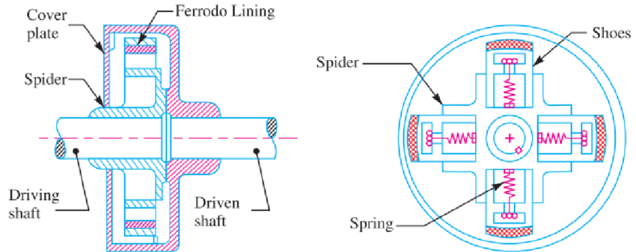
Figure 1 Centrifugal Clutch Diagram (Kholil, et al., 2019).
This demonstrates the inner workings of the clutch and is referenced in task 2 of the report.
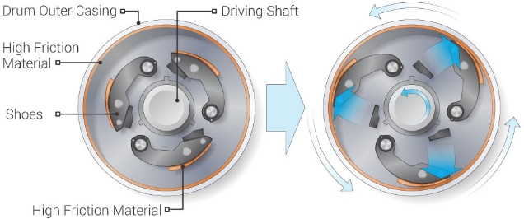
Figure 2 Working Diagram of Centrifugal Clutch (Toulas, 2018)
The working diagram in figure 2 demonstrates another configuration and how the parts move when rotated to the appropriate speed.

1.2.5 Typical Applications and Operating Conditions
Centrifugal clutches are commonly used in lawnmowers where they provide a simple and automatic engagement mechanism, allowing the blades to engage only when the engine speed reaches a certain threshold. Go-Karts find application to ensure smooth power transmission from the engine to the wheels without the need for manual clutch control allowing for a more user-friendly experience, especially for beginners. Chainsaws use them to allow the engine to run at idle without the chain moving which increases both safety and efficiency (Goud, 2017). The operating conditions typically involve low to moderate power transmission which is suitable for small engines and variable speeds which is effective in applications where the speed can vary significantly.

1.3 Advantages and Disadvantages of Centrifugal Clutches
Centrifugal clutches offer several advantages. They are easy to design and manufacture. They have automatic operation that engages and disengages based on engine speed (Engles, et al., 2023). Both of which combine to make them Inexpensive compared to more complex clutches to both manufacture and operate. Their simplicity with few moving parts leads to lower maintenance, increasing the durability and reliability (Lund, et al., 2020). Centrifugal clutches, despite their advantages, also present several disadvantages. They can be prone to slippage, especially at lower speeds, which results in increased wear on the clutch shoes (Al-Zubadi & Abdullah , 2020). This slippage can cause heat build-up, potentially leading to overheating and premature failure if not properly managed. Additionally, centrifugal clutches are generally not suitable for high-torque applications, as the shoes may not provide sufficient grip under heavy loads, reducing overall efficiency (Milev, et al., 2023). The engagement is also less precise, which can result in jerky operation under fluctuating speeds. As a result, they may not be ideal for applications requiring precise control.

1.4 Current Application of Electromagnetic Clutches

1.4.1 Overview of Electromagnetic Clutches
Electromagnetic clutches have gained prominence in modern automation systems due to their precise control and reliability. These clutches use electromagnetic force to engage and disengage power transmission, making them ideal for applications requiring quick and accurate control (Cardosa & Costa , 2024).

1.4.2 Working Principle
An electromagnetic clutch operates by using an electromagnet to actuate the clutch mechanism (Hartomacioglu & Özdemir, 2022). When the electromagnet is energised, it creates a magnetic field that pulls the armature plate towards the rotor, engaging the clutch. When the power is cut off, springs retract the armature plate, disengaging the clutch (Niu, et al., 2023).

1.4.3 Design and Materials
Electromagnetic clutches consist of several key components beyond the electromagnet, which is typically made of a coil of copper or aluminium wire generating a magnetic field when energised. The main elements include the rotor, which transmits power upon engagement, and the armature plate, a friction surface that contacts the rotor to engage the clutch. To withstand high loads, temperatures, and wear, these components are often made from high-strength steels or advanced composites, selected for their mechanical strength, thermal stability, magnetic permeability, and resistance to wear and corrosion.
For general-purpose clutches, medium carbon AISI 1045 steel is widely used due to its strength, toughness, and wear resistance (Portaro, 2022). In more demanding applications, AISI 4140 chromium-molybdenum alloy steel provides superior tensile strength and fatigue resistance, ideal for heavy-duty clutches (Totten , et al., 2024). For high-performance needs, AISI 4340 steel, containing nickel, chromium, and molybdenum, offers enhanced toughness and can be heat-treated for additional hardness (Totten , et al., 2024).
In electromagnetic clutches, silicon steel improves magnetic efficiency in rotor laminations due to its high permeability and reduced core losses (Blomqvist & Schneider, 2020). Martensitic stainless steels like AISI 420 or 440C are used where corrosion resistance is vital. Additionally, composites like phenolic resin-based materials, reinforced with fibres, reduce weight and noise in armature plates (Portaro, 2022), while carbon fibre composites excel in high-performance applications due to their strength-to-weight ratio and thermal resistance. In extreme conditions, ceramic-metal composites provide exceptional wear resistance and thermal stability where standard metals would fail.

1.4.4 Typical Applications
Electromagnetic clutches are extensively utilised in various industries due to their ability to provide precise and efficient control over mechanical systems. In automated manufacturing processes, they play a crucial role by enabling accurate control over machinery operations, ensuring that equipment starts, stops, and changes speed with precision. This is particularly important in production lines where synchronisation and timing are vital for maintaining efficiency and quality. In conveyor systems, electromagnetic clutches allow for controlled starts and stops, which helps prevent the damage that can occur from sudden movements and ensures smooth operation, especially when handling sensitive materials (Šitum, et al., 2021). Furthermore, in the field of robotics, these clutches are essential for enabling accurate positioning and movement control, allowing robotic arms and automated tools to perform intricate tasks with high precision (Belikov, et al., 2024). This capability is critical in applications requiring repetitive motions, such as assembly, welding, or picking operations, where exact movements are necessary to achieve consistent results.

1.4.5 Advantages of Electromagnetic Clutches
Electromagnetic clutches provide a range of advantages that make them highly valuable in modern engineering and manufacturing environments. One of their primary benefits is the precision they offer, allowing for accurate control of power transmission between components (Thilakarathna & Phlernjai, 2024). This precision is essential in applications where timing and accuracy are critical, such as automated production lines. Additionally, these clutches are known for their quick response times, engaging and disengaging almost instantaneously. This rapid response capability ensures smooth operation, which is vital in systems where timing impacts efficiency and safety (Wang, et al., 2022). Another significant advantage is their ability to be controlled remotely. Since they operate electrically, they can be seamlessly integrated into automated systems, allowing for easier and more efficient management of machinery. Moreover, their versatility makes them suitable for a wide array of applications, from conveyor systems to robotics, thus supporting various processes in modern manufacturing industries.

1.5 Conclusion
Over the last century, centrifugal clutches have played a crucial role in small motor equipment, offering an automatic and cost-effective solution for engaging and disengaging power. Developed to simplify machinery operation, they rely on centrifugal force to engage the drive as engine speed increases. This made them ideal for applications like lawnmowers, go-karts, and chainsaws, where simplicity and reliability were essential. By the mid-20th century, they became widely used due to their ability to automatically adjust power transmission without manual input.
Despite advancements in materials like high-friction composites and reinforced steels, centrifugal clutches are primarily suited to applications where simplicity and durability matter more than precision. However, the emergence of electromagnetic clutches has introduced a new level of control, crucial for modern automated systems. These clutches use electrical actuation for rapid engagement and disengagement, making them indispensable in industries requiring precision, such as automated manufacturing and robotics.
As automation technologies advance, electromagnetic clutches are increasingly favoured for their quick response and precise control. Yet, centrifugal clutches remain valuable for specific uses where their straightforward, low-maintenance design still excels, reflecting their enduring role in both traditional and modern applications.

2.0 Task 2
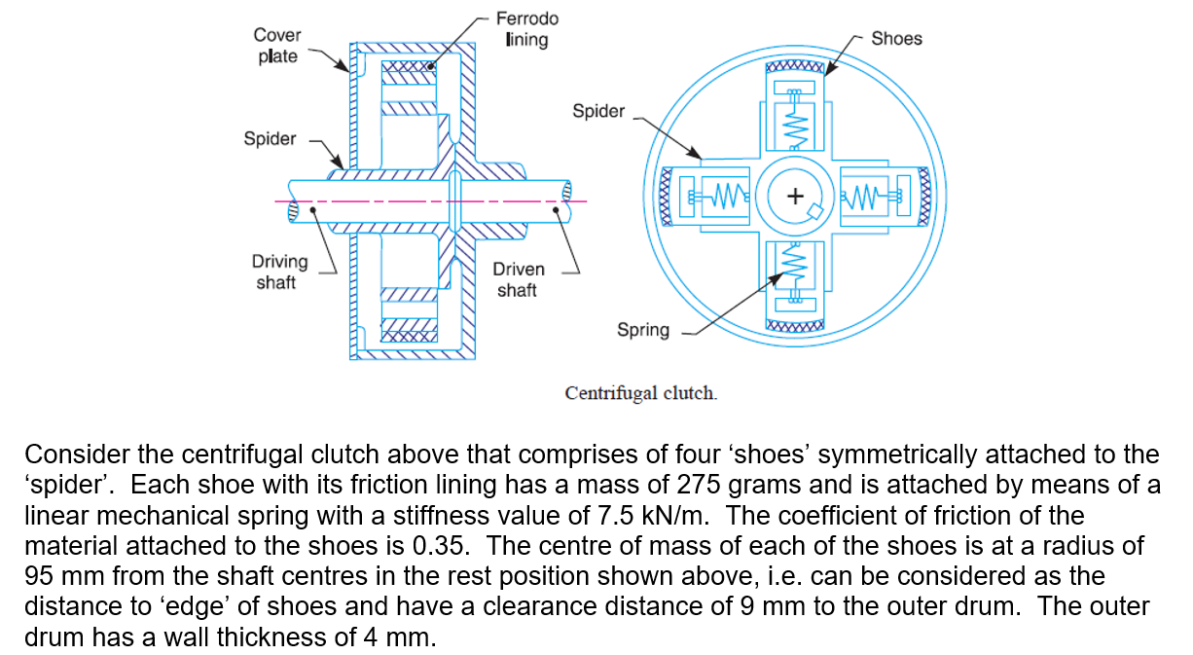
Figure 3 Task 2 Brief

2.1 Diameter of The Outer Drum
Taking the given information, the outer drum diameter can be equated to:
$$\left(95+9+4\right)×2=216$$
Equation 1 Outer Drum Diameter

2.2 Calculating the Engagement Speed in RPM
The engagement speed is the speed at which the centrifugal force on the clutch shoes overcomes the spring force and causes the shoes to expand outward to engage the drum. The formula is generally given by:
$$Centrifugal Force \left(F_{c}\right)=m×r_{engagement}×ω^{2}$$
Equation 2 Centrifugal Force
where:
m = mass of each shoe,
r_{engagment} = radius from inside the drum to the centre of mass of each shoe
ω = angular velocity in radians per second.
The engagement speed $ω_{e}$ is calculated when the centrifugal force equals the spring force. Which can then be converted from $ω_{e}$​ to RPM.
Spring Force ($F_{s}$) is given by Hooke’s Law (Tipler & Mosca, 2019) for the displacement needed to engage. Hooke’s Law describes how elastic materials such as springs return to their original shape once the applied force is removed, given that the force applied was within the elastic limit of the material. It is expressed by:
$$F=-K×x$$
Equation 3 Hooke's Law
Where:
F is the force exerted by the spring to return to its original shape (N)
K is the spring constant (N/m)
X is the displacement from the springs original shape (m)
Therefor $F_{s}=k×\left(r_{engagement}-r\right)$
Taking $F_{c}=F_{s}$ to solve for $ω$:
$$ω=\sqrt{\frac{k×\left(r_{engagement}-r\right)}{m×r_{engagement}}}$$
Equation 4 Engagement Speed of Centrifugal Clutch
$$\sqrt{\frac{7.5×{10}^{3}×\left(104×{10}^{-3}-95×{10}^{-3}\right)}{275×{10}^{-3}×104×{10}^{-3}}}=48.58 rad/s$$
To convert to RPM:
$$RPM=ω×\frac{60}{2π}$$
Equation 5 RPM Conversion
$$48.58×\frac{60}{2π}≈464 RPM$$

2.3 Transmitted Torque to Driven Shaft at 550 RPM
If the rotational speed was to be given as 550 RPM, a conversion into angular velocity (ω) would be required. This can be derived from equation 5 to be:
$$ω=\frac{550 ×2π}{60}=57.6 rad/s$$
Equation 6 550 RPM to Angular Velocity
The centrifugal force acting on each shoe can be derived from equation 2, giving:
$$F_{c}=275×{10}^{-3}×104×{10}^{-3}×{\left(57.6\right)}^{2}=94.89 N$$
Equation 7 Force Acting on Each Shoe at 550 RPM
As there are 4 shoes acting on the clutch face:
$$F_{total}=4×94.89=379.56N$$
Equation 8 Total Force Acting on Clutch Face at 550 RPM
To determine the torque transmitted to the driven shaft, the following relationship for a centrifugal clutch can be used:
$$T=F_{Total}×r_{Engagement}×μ$$
Equation 9 Torque
Where:
F_{Total} Is the total force acting on the clutch face
r_{engagement} is the inside diameter of the drum
μ is the coefficient of friction
Therefore:
$$T=379.56 ×104×{10}^{-3}×0.35=13.82N$$
Equation 10 Calculated Torque

2.4 The Transmitted Torque at The Driven Shaft, Against The Driving Shaft Speed, In 25 RPM Increments From 450 RPM to 700 RPM with Demonstrations of a coefficient of friction of 0.3, 0.35 and 0.4.

Figure 4 Torque Vs RPM Graph of Varying Coefficients of Friction

2.4.1 The Effect of Changing the Coefficient of Friction on The Torque
The graph in Figure 2 illustrates a correlation between torque output and the coefficient of friction for a range of RPMs. It is shown, as the coefficient of friction goes up, so does the torque output, showing a positive correlation among these two variables. Therefore, from this, it can be deduced that material or conditions providing higher coefficients of friction allow the generation of higher torque. From the graph, torque output is higher for greater coefficients of friction at each level of RPM, emphasising again the effects of friction on torque.
This could be explained from the fact that the higher the frictional force, the lesser the slipping, which then can translate the applied forces better into rotational motion. Therefore, systems operating with a higher coefficient of friction will sustain or even gain in torque output across a wide span of speeds. The optimisation of friction coefficient will thus be a critical activity in mechanical systems when attaining desired levels of torque.

2.5 Angular Acceleration of The Drum (When the Mass of The Drum Is Given As 750 Grams and Considered A Solid Disk) When Achieving the Maximum Possible Torque

To determine the angular acceleration (α) of the drum when the maximum torque is applied, an application of the rotational form of Newton's second law can be used:
$$T=Iα$$
Equation 11 Newtons Second Law
where:
T= The maximum torque applied,
I = The moment of inertia of the drum, and
α = The angular acceleration.
The drum is treated as a solid disc with mass m and radius R. The formula for the moment of inertia I of a solid disc is:
$$I=\frac{1}{2}mR^{2}$$
Equation 12 Moment of Inertia of a Solid Disk
Where:
M = 0.75 Kg
R = 0.108 m
Rearranging Newtons second Law equation to solve for α:
$$α=\frac{T}{I}=\frac{T}{\frac{1}{2}mR^{2}}$$
Equation 13 Newtons Second law Rearranged for Alpha and to Include Moment of Inertia of a Solid Disk
$$α=\frac{25.572}{\frac{1}{2}×750×{10}^{-3}×{108×{10}^{-3}}^{2}}=5.846 Krad/s^{2}$$

2.6 The Maximum Possible Angular Acceleration for The Drum If the Driven Shaft Had A Diameter Of 17.5 mm and A Constant Tangential Braking Force Of 500 N

To determine the maximum possible angular acceleration of the drum, given a braking force, the effective net torque after accounting for the braking effect needs to be considered.
The braking torque T_{b} on the drive shaft given a tangential braking force of F_{b}=500 N and a driven shaft diameter of 17.5 mm. The breaking torque can be calculated as follows:
$$T_{b}=F_{b}×r$$
Equation 14 Breaking Torque
Where r = 0.00875m
The maximum transmitted torque is T = 25.572 Nm, therefore the net torque T_{net} available for angular acceleration can be calculated as follows:
$$T_{net}=T-T_{b}$$
Equation 15 Net Torque Available for Angular Acceleration
Using the T_{net} and moment of Inertia I the angular acceleration α can be calculated using a transposed version of Newtons second Law.
$$α=\frac{T_{net}}{I}$$

Where I, is calculated as in equation 12.
Therefore:
$T_{b}=500×8.75×{10}^{-3}=4.375$ Nm
Taking T_{b} to calculate T_{net} where T = the maximum applied Torque 25.572 Nm:
$$T_{net}=25.572-4.375=21.197$$
Taking the T_{net} and applying Newtons second Law:
$$α=\frac{21.197}{\frac{1}{2}×750×{10}^{-3}×{108×{10}^{-3}}^{2}}=4846.136 rad/s^{2}$$

3.0 Appendix
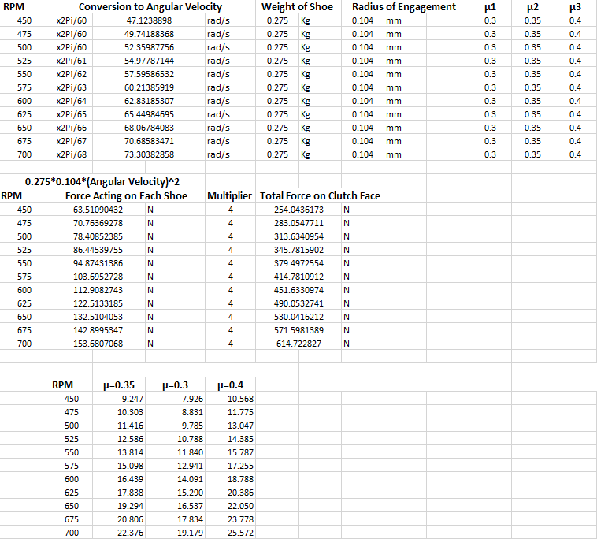
Figure 5 Excel Workbook for Graph Construction
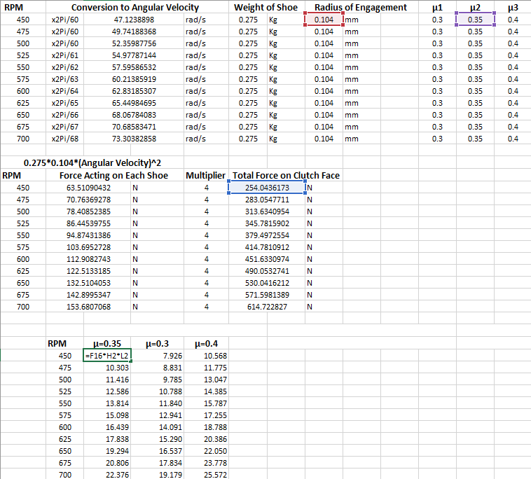
Figure 6 Formula For Equation Torque of Different Coefficients of Friction

4.0 References
Al-Zubadi & Abdullah , 2020. Investigation of thermal influence on the frictional characteristics of friction materials. Journal of the Balkan Tribological Association, 26(1), pp. 63-74.
Belikov, N. V., Khaydukova, I. V. & Poludkin, I. E., 2024. Evolution and current state of robotic catheters for endovascular surgery: A comprehensive review. Engineering Science and Technology, 27(2), pp. 340-352.
Blomqvist, O. & Schneider, M., 2020. Electromagnetic Clutch Efficiency and Material Analysis. International Journal of Mechanical Engineering Research, 8(4), pp. 132-140.
Cardosa, A. M. & Costa , M. G., 2024. Control strategies for electromagnetic clutches in automated systems: Precision and reliability analysis. Machines, 12(1), pp. 34-45.
Cheng , P.-J. & Liu, T., 2018. On the speed-controlled and torque-controlled clutching devices and their mechanical system. Chiba, IEEE.
Engles, M., Jakoby, M. & Andert, J., 2023. Hybrid vehicle powertrain components and the advantages of centrifugal clutches for cost-effective automatic engagement. Vehicles, 5(4), pp. 1622-1633.
Goud, S. P., 2017. Proceedings of the International Conference on Mechanical Engineering. Kolhapur, Bharati Vidyapeeth College of Engineering.
Han, Z., Song, W. & Dai, B., 1992. Measuring surface temperature distributions on clutch discs. Detroit, SAE International .
Hartomacioglu, S. & Özdemir, M., 2022. Finite Element Analysis of Electromagnetic Clutch. The European Journal of Research and Development, 4(3), pp. 102-114.
Johnston, B., 2021. A true pioneer: Dr. Thomas J. Fogarty. [Online]
Available at: https://www.fogartyinnovation.org/a-true-pioneer-dr-thomas-j-fogarty/
[Accessed 4 Nov 2024].
Kholil, A., Dwiyati, S. T., Riyadi & Randika, H. P., 2019. Performance Testing of Motorcycle Centrifugal Clutch Lining. Journal of Physics: Conference Series , 2019(1), p. 12065.
Liu, C. H. & Chiang, Y. P., 2016. Analysis of the Sliding Contact Behavior of a Centrifugal Clutch. Key Engineering Materials , 715(1), pp. 231-236.
Lund, M., Markland, P. & Högland, E., 2020. The role of clutch system designs in improving durability and reducing maintenance costs in small engine applications. Tribology International, 144(1), pp. 1060-1096.
Milev, S., Tasevski, D. & Shabani, M., 2023. Mechanical flexible couplings for torque transmission between two units: Analysis of wear and thermal limitations. International Journal of Mechanical Engineering, 18(3), pp. 457-467.
Niu, R. et al., 2023. Design and experimental study of electromagnetic clutch-type variable pre-pressure ultrasonic motor. AIP Advances, 13(10), pp. 105-121.
Panchal, D., Patel, B. & Gohil, H., 2023. Experimental Investigation on Performance Characteristics of Dry Centrifugal Clutch with Grooved Friction Liners. International Journal of Automotive and Mechanical Engineering, 20(1), pp. 10152-10164.
Portaro, R., 2022. Material Selection for Electromagnetic Clutches. Journal of Materials Science & Engineering, 56(2), pp. 234-245.
Purohit , R., Khitoliya, P. & Koli, D. K., 2014. Design and finite element analysis of an automotive clutch assembly. Mangalore, Procedia Materials Science , pp. 1314-1320.
Ramesh, M. R., Ravindra , K. A. & Ashok, B., 2021. Optimizing thermal performance of a dry rigid clutch by varying groove pattern and friction material.. Chennai, Elsevier.
Šitum, Ž. et al., 2021. Design and control of mechatronic systems with pneumatic and hydraulic drive. International Journal of Mechatronics and Automation, 9(2), pp. 45-56.
The Engineers Post, 2024. Centrifugal Clutch: Diagram, Parts, Working & Uses. [Online]
Available at: https://www.theengineerspost.com/centrifugal-clutch/
[Accessed 4 November 2024].
Thilakarathna, R. & Phlernjai, M., 2024. Design and development of a lightweight, low-cost cylindrical electrostatic clutch. Engineering Science and Technology, 27(2), pp. 121-135.
Tipler, P. A. & Mosca, G., 2019. Physics for Scientists and Engineers. 7th ed. New York: Macmillan Learning.
Totten , G. E., Canale, L. F. & Pleshivtseva, Y., 2024. Induction Quenching of Alloy Steels. In: V. Rudnev, ed. ASM Handbook. Materials Park : ASM International, p. Chapter 3 .
Toulas, B., 2018. How does a Centrifugal Clutch work? What are the pros and cons?. [Online]
Available at: https://mechanical-engineering.com/centrifugal-clutch/
[Accessed 4 Nov 2024].
Wang, S., Cao, Y. & Liu, Z., 2022. Optimal control for a modified Bouc-Wen model in a magnetorheological fluid master robot. IEEE Transactions on Robotics and Automation, 38(3), pp. 453-465.

