Aimee Beynon – 2005750
ECAD6007

A Critical evaluation and the learning steps focusing on a case study on an individual learner or a group of learners, based on an observed critical incident.

Word Count: 3,909

Introduction
The intention of this essay is to critically evaluate an incident I observed in a class within a primary school setting and to analyse why it is important for us as teachers and practitioners to reflect on our own practice and develop our professional lenses through review (Tripp, 2012). Tripp (2012) goes on to explain that we must reflect on our practice critically, without bias, so that we do not reinforce old patterns and ideologies we are used to using in our practice. (Andreev, 2023) agrees by explaining doing this would allow educational professionals to engage with transformative learning, immersing themselves in new information from observing a critical incident and taking that forward to create new perspectives and learning experiences in the classroom environment.
Critical incidents are often defined as an event or situation that has a negative outcome or affect, for example an assault or event causing injury (Victoria State Government, 2011). However, in education Tripp (1993) defines a critical incident as a situation that occurs within a classroom that acts as a catalyst for reflection and ultimately change. Mohammed (2016) supports this view by adding that observing a critical incident requires a teaching professional to delve further into the situation to find out what is ‘under the hood’ as to why that particular incident has occurred, and thus think about what we can do as practitioners to build our knowledge surrounding the incident.
Through the review and comparison of literature and theories relating to my critical incident, I will be able to solidify my understanding of why educational professional use certain methods, and build on the knowledge and the importance of reflective practice in teaching, leading me to think about how I can implement this practice throughout my own teaching career.
By following Tripp’s (1993, 2012) critical incident methodology, this will allow me to engage with different models of reflection and learning theories to evaluate my experiences in educational settings and identify the next teaching and learning steps for my own practice throughout my Post Graduate Certificate in Education (PGCE) and future career. I will aim to discuss the critical incident using a range of relevant literature to support my findings.

Case Study
It must be noted that throughout this assignment and in line with BERA’s Ethical Guidelines for Educational Research (BERA, 2018), I will not be naming the school, the learners, or the staff members to protect their identity and uphold all confidentiality and professional standards (Welsh Government, 2019). This will help me to carry out the appropriate research without compromising any personal details, allowing me to adhere to the highest ethical standards possible (BERA, 2018).
For context, the critical incident I observed took place in an English medium primary school in South Wales, in a Year four classroom at around nine-thirty in the morning. The class consisted of around twenty-three learners, of which roughly fourteen were male and nine were female (Immersive learning space of Primary classroom video, 2023). There was one teaching assistant present in the classroom and the learners were of varying cultures and heritage, of which ten children were identified to have English as an Additional Language (EAL).
The most recent Estyn report shows that the school has four hundred and thirty-five pupils on roll, 29% of which are eligible for free school meals and 12.4% having been identified as having Additional Learning Needs (ESTYN, 2023).
I would like to expand further on the critical incident I observed. I would like to note that the chosen critical incident is one that links with other moments I observed within the class as explained in the observation form, outlined in Appendix A. As the lesson was getting underway, I noticed that the class teacher had a bank of classroom management methods to use in the event that he needed the learners to listen, or he needed to get their attention and create a more controlled and noise level appropriate environment.
First, the class teacher explained that he would be putting different shoes on each of the tables within the classroom. The learners were told they could look at the shoes closely, feel them and even smell them if they wanted, to come up with their own inferences about the objects. The noise levels within the classroom began to rise quite rapidly, along with the gradual loss of concentration from the learners due to a burst of excitement from learning they were about to do something that would not normally happen in a usual English lesson. The class teacher picked up on this and changed his approach to address the class by beginning to whisper his next instructions. As a result of this, the children began to refocus on him and stopped talking so they could hear what they needed to do next.
Once I had observed this method, I then began to pick up on more classroom management techniques. Throughout the lesson, the class teacher also used methods called call and respond techniques. For example, he would clap in a specific pattern to which the learners would immediately respond to, clapping back the same tune in the same way. Furthermore, he used body movements that the pupils would then have to copy – which they did again immediately, resulting in the class teacher having their attention and focus once again. In addition, he also used the phrase ‘un dau tri, eyes on me’, when he needed their attention for a moment from doing the directed task. This also worked really well, the children again began to look at him and stop what they were doing. Lastly, at another moment in the lesson, the class teacher picked up his guitar without warning, and played a few patterned short tunes, again to which the learners repeated it back to him by clapping almost immediately with no hesitation.
From observing this class, it seemed clear to me that the classroom management techniques used by the class teacher were very effective when implemented and always resulted in what the teacher was aiming for: refocussed and listening learners. This indicates to me that the class teacher in this observation has developed his understanding of his classroom over time, through engaging with reflective practice of his own, thus coming to the use of such classroom management techniques.
Seeing the variation of techniques made me reflect in the moment on my teaching methods and practice. For example, behaviour and classroom management is one of my weaknesses and therefore seeing these techniques being implemented effectively was interesting. Seeing these methods being used made me think about why the teacher has implemented these methods in his classroom – do they work this well all of the time with different learners? It also made me think about how he had managed to get the pupils to understand and learn the responses, as it seemed as though they responded to him without a second thought.
It would be relevant to relate this observed critical incident to theory and literature, to gain a deeper understanding of classroom management and why teachers use this, but also for me to build on the knowledge and understanding of the benefits of taking such methods forward into my teaching career.
Literature Review
One of the main reasons for observing in line with Tripp’s critical incident methodology is so that education professionals can engage with reflective practice and improve their judgements and responses as they move through their teaching career (Tripp, 1993, 2012). Mathew et al. (2017) supports this by explaining teachers – and those in training like myself – who reflect on their practice can support themselves in developing a deeper understanding of their practice and of their learners, strengthening the meaning of why we do things the way that we do them. It will also play a pivotal role in their professional and personal development (Banks and Mayes, 2012).
Dewey (1933) underpins these thoughts by stating reflective individuals have three attributes which are open-mindedness, responsibility and whole heartedness. These three attributes support teachers in reflecting on their practice without negative judgement and without bias as recommended by Tripp (2012). Nevertheless, Dewey (1933) further suggests that reflective practice does not just involve the thoughts and actions of education professionals, but should also include focus on the progress of the learner as one of the main priorities. Brierley (2019) supports Dewey (1933) by stating it would be challenging to meet and support the individual needs of every child if practitioners did not reflect on their practice and delivery within the classroom. Without this, teachers cannot continually support the development of themselves, or the learners in their care effectively.
However, Galea (2012) argues that teaching the installation of reflective practice in teachers can often have the opposite effect on its purpose. For example, they explain that expectations for teachers to reflect on their practice has become a compulsory and constant part of teaching, so much so that reflective practice now feels like a ‘check box’ rather than a genuine process to some practitioners and therefore loses its meaning and purpose. Keeping this in mind, it is important for teachers to reflect on their practice with genuine, meaningful intent, rather than just to ‘tick a box’ through being assessed or monitored.
Cherry (2023) adds to Galea’s (2012) argument by stating closed-mindedness can also pose to be a barrier to reflective practice. They argue that teachers who have a closed mindset are often opposed to new ideas or changes to the way that they do things (Bovill, et al., 2015). For example, teachers who engage in reflection of their own practices are not doing so effectively (if at all) if they are of a closed mindset. The new Curriculum for Wales has implemented change and on a large scale regarding assessment, progression and reflection responsibilities for teachers (Welsh Government, 2023a) Therefore, the outcome of these required experiences would remain the same because of the resistance to change and thus, no transformative learning for the learners or the teacher will have taken place.
The observed critical incident of classroom management techniques can be evaluated and linked to various areas of literature and theory. This literature review will discuss the theory behind classical conditional along with the advantages and disadvantages of it. It will also look at the classroom management strategies I observed and how they can link to behaviour management strategies.
Classroom management can be defined as a set of techniques and methods that education professionals implement to help keep learners focussed, organised, civilised and on task (The Glossary of Education Reform, 2014). Emmer and Sabornie (2014) supports this by stating classroom management is used by teachers to ‘shape and maintain appropriate behaviours in the classroom’. Centres for Disease Control and Prevention (2023) agrees by further adding classroom management is a process teachers engage with to create a positive learning environment for pupils with inclusion to also support the social and emotional learning.
The classroom management methods used by the class teacher in the observed critical incident suggests a behaviourist approach to teaching. For example, it can be viewed that the learners have been ‘classically conditioned’ to respond instantly to the teachers cues. McLeod (2023a) defines classical conditioning as learning through affiliation. To expand, this is where two stimuli connect, and a learned behaviour is a reflex and instant response. Yamamoto (2009) further explains that learned behaviour through classical conditioning becomes an unconscious act, which would explain why the learners in the critical incident did not hesitate to respond to the teacher when prompted. This comes from Pavlov’s theory, a Russian psychologist and behaviourist whose most famous experiment with a bell and a dog, resulted in the term ‘classical conditioning’ as can be demonstrated in Appendix B (McLeod, 2023b).
Connect Us (2019) suggests there are some advantages to using classical conditioning to support learners in education. For example, they state that classical conditioning is an example of how we learn in our environments and creates a reflection of who we are. Further to this, they also say that classical conditioning can result in learners developing positive personal traits. However, on the other hand Connect Us (2019) explains some aspects of classical conditioning (depending on how it is used), does not support the idea that everyone has free will. Therefore, it can be argued that if not implemented correctly, classical conditioning can have negative attributes attached to it.
Killian (2021) explains some of Bill Rogers behaviour management techniques, including direction with tactical pausing, which can also be link to the critical incident I observed. The methods used by the class teacher in the observed critical incident can be considered to play a part in behaviour management using this very method. For example, he used the call and respond techniques to gain the learners attention. After doing so, he held a long pause before telling them what he would like them to do, always remaining calm, positive, and never displaying any negativity towards the learners.
Lemov (2013) supports this method by explaining it is good for creating positive energy in the classroom and upholding engagement from learners to instil and develop their knowledge. Rogers (2007) further agrees with this, however, adds that teachers must review and reflect on their behaviour management techniques by consistently thinking about the aims of their actions. He states such techniques should be a way for the teacher to enforce a positive learning environment and uphold consistent practice, not just robotically using them without any intention or goal in mind.
To conclude this section, it is without doubt that there is much supportive literature to show the reasons and connections behind the using classical conditioning, behaviour management and classroom management techniques in the education settings. It is demonstrated that these types of methods help to support the development of the learners’ skills and education, as well as supporting the growth of relationships between teachers and learners and positive engagement within the classroom. This leads to less disruptive behaviour in the classroom and increases respect for the environment and persons around them (Terada, 2019). Therefore, it can be further concluded that the use of classroom management plays an important role in positively supporting pupil achievement (Marzano and Marzano, 2003).
Teaching and Learning Methods
After observing the critical incident there are strategies and methods that I would like to take forward into my teaching career. The ERA model of reflective practice by Jasper (2013) outlined in Appendix C, suggests there are three stages to carrying out effective reflection. Firstly, the University of Cambridge (No Date) explains the ERA Model, as we begin by experiencing something that is new, or it could be something we have seen before. Next, reflection begins where we think about what happened, why it happened and how it made us feel. This moment is also where we start to think about what we can do to improve for the next steps in teaching and learning. Finally, the teacher will take action on what they have experienced. This may involve trying something new, or slightly tweaking an idea they have already tried. This three-stage cycle by Jasper (2013) is one of the most basic reflection models, however it will continue on a cycle as new experiences form from the last, as can be demonstrated in Appendix D.
However, there could be barriers to engaging with effective reflective practice in my career. As a PGCE student, I am lacking the experience in using reflective practice frequently. For example, at this early stage in my career, I may not be able to enforce reflective practice as efficiently as a teacher who has been practicing reflection for a number of years (Scholars, 2013). Therefore, as a trainee teacher and taking into consideration the literature I have reviewed in previous sections of this assignment, I would consider it important for myself to engage with reflective practice frequently going forward, to ensure positive and effective progress for myself in professional development and for the learners in my care (Krolak-Schwerdt et al. 2014).
To help overcome these barriers, according to Hatton and Smith (1995) student teachers can develop their critical reflection by sharing their experiences with other education professionals. For example, discussion amongst teachers in schools encourages a deeper exploration of reflection and opens the umbrella for a broader insight to next teaching and learning steps. Lui (2017) supports this by stating discussion between supervisors and trainee teachers is key to supporting critical reflection, but also transformative learning in classrooms, thus improving teaching practice. Therefore, going forward, I will be sure to discuss with my peers and colleagues my observations and ideas to access support from those who radiate knowledge and experience.
Referring again to the critical incident I observed, the classroom management techniques used by the class teacher clearly had a positive effect on the learners within the classroom. Using such techniques encourages the learners to develop their social skills through set boundaries and expectations by the class teacher, which in turn creates a safe space for them to learn (Rabadi and Ray, 2017). Furthermore, these learned behaviours of knowing how to communicate and behave in a social environment also teaches them the importance of respect to others, and therefore the expectations and social competence that can be applied to real life experiences outside of the classroom (Miller and Pedro, 2006).
Upon reflection, the way I have reviewed my experience with observing the critical incident fits well with Kolb’s 1984 learning cycle as outlined by McLeod (2023c). As shown in Appendix E, I firstly had an experience when I observed the critical incident. I have then reflected on the incident by researching and linking it to theory and literature, delving ‘under the hood’ as to why classroom management techniques are used and why they work. Thus, I have learned from this experience and now I would like to utilise and implement the discussed classroom management techniques and engage with reflective practice in my own classroom.
As I would like to take these teaching and learning methods forward, I have arrived at the conclusion that this is just one way that can help work towards creating ethical, informed citizens of Wales and the world, support the growth of kind and empathetic learners and develop confident and healthy individuals in my classroom, in line with the four purposes of the newly designed Curriculum for Wales (Welsh Government, 2023a). Such implementation of classroom management techniques teaches the learners how to conduct themselves, be respectful and shows them what appropriate listening and social skills look like. It is small directions from class teachers such as these, that start to lay the foundations for the development of positive learners.
Discussion
Thinking about what I have discovered through research about the importance of engaging with methods such as reflective practice will help me work towards achieving the twelve pedagogical principles outlined by Welsh Government (2023b) and the five professional standards (Welsh Government, 2019). These principles and standards are at the centre of the new Curriculum for Wales and highlight good teaching and learning methods (Donaldson, 2015). Donaldson states these principles are there for teachers to work towards the four purposes of the Curriculum and to support the needs of the learners. However, Donaldson does stress that these principles do not magnify any particular teaching approaches, as teaching and learning is specific to different classroom contexts and is purpose built by teachers (Impact Wales, 2022). Therefore, it is important to emphasise the need for teachers and student teachers like myself to critically reflect on our practice to meet the twelve Pedagogical Principles and engage with the five professional standards efficiently and appropriately.
Through researching the literature behind the techniques and methods used in the classroom, I can acknowledge and understand that my teaching practice throughout my placements and into my teaching career, is and will be underpinned by relevant and purposeful theory. For example, theorists such as Maslow and his Hierarchy of Needs (outlined in Appendix F) will have a strong presence in my teaching as I too agree that every child needs their basic needs met first before they can come into a classroom and learn (University of Central Florida, No Date and McLeod, 2023d).
In addition, after observing the critical incident and reflecting on my current placement, I believe I will be a teacher that will carry forward a behaviourist approach to learning as I have learned that if applied correctly and appropriately, it can have a positive affect on the learners in my care and on my own pedagogy.
Nickerson (2023) explains the concept of positive reinforcement which is also a behaviourist ideology to use within a classroom. Reflecting on the observation, I recall the class teacher rewarding a learner with a dojo point for always participating – this is an example of positive reinforcement. By doing this, the learner is more likely to continue to engage and participate in future lessons by being acknowledged for doing so previously. Harvard University (2023) supports this by explaining Skinner’s operant conditioning and positive reinforcement theory. For example, they state that the appearance of a stimulus creates a reaction from a person, whether this is to reduce a behaviour or to increase a behaviour, which is similar to Pavlov’s approach to learning.
However, White (2023) argues that for positive reinforcement to be effective, the learner must first see value in the reward. For example, what may be a reward to one learner, might not be so exciting to another. Therefore, it important for education professionals to reflect on their learners and know their individual likes (White, 2023).
Discussing this, positive reinforcement is something I would also like to include in my next teaching and learning steps as mentioned above, however I will need to assess the learners likes and dislikes, discovering what motivates them for this method to be effective.
Conclusion and Recommendations
It is clear that using a variety of methods is necessary to develop personal progress as a student teacher and also to support the development of the learners in my classroom. Using Tripp’s (1993) critical incident methodology, an observation took place within a South Wales primary school, which was used to begin researching and engaging with the process of reflective practice.
Engaging with reflective practice and reflection models continuously will allow me to support my own progress by identifying the next teaching and learning steps, thus allowing me to make a greater impact on learners’ education and individual development. Through the use and upkeep of a daily reflective journal whilst on professional teaching experience for the PGCE, this will support me in developing my critical reflection skills and thus increase my ability to reflect effectively (Gadsby, 2022).
To conclude, by making these pedagogical choices through observing critical incidents and reflecting on my practice, I aim to be able to uphold and meet the five professional standards in teaching and leadership (Welsh Government, 2019), and also meet the twelve pedagogical principles (Welsh Government, 2023b). In doing so, this will support me in carrying out the requirements for teaching and learning in regards to the new Curriculum for Wales (Welsh Government, 2023a). Finally, it will be important for me to continuously refresh my knowledge by keeping up to date with relevant theory and literature from past, current and future professionals in the field.

Reference list
Andreev, I. (2023) Transformative Learning. Available at: https://www.valamis.com/hub/transformative-learning#what-is-transformative-learning (Accessed: 11 October 2023).
Banks, F. and Mayes, A. (2012) Early Professional Development for Teachers. London: Taylor and Francis.
BERA (2018) Ethical Guidelines for Educational Research. 4th ed. Available at: https://www.bera.ac.uk/publication/ethical-guidelines-for-educational-research-2018-online (Accessed: 11 October 2023).
Bovil, B., Cook-Sather, A., Felten, P., Millard, L. And Moore-Cherry, N. (2015) ‘Addressing Potential Challenges in Co-creating Learning and Teaching: Overcomign Resistance, Navigating Institutional Norms and Ensuring Inclusivity in Student-Staff Partnerships’, The International Jounral of Higher Educational Research, 71, pp. 195-208. DOI: https://doi.org/10.1007/s10734-015-9896-4
Brierley, J. (2019) Working with Two-year-olds: Developing Reflective Practice. London: Taylor and Francis.
Centres for Disease Control and Prevention (2023) Classroom Management: Approaches to Support School Connectedness. Available at: https://www.cdc.gov/healthyyouth/classroom-management/index.htm#:~:text=Classroom%20management%20is%20the%20process%20that%20teachers%20and,academic%20and%20social-emotional%20learning%20among%20all%20students.%207 (Accessed: 19 October 2023).
Cherry, K. (2023) ‘How to Be Open-minded and Why It Matters’, Very Well Mind, 22 March. Available at: https://www.verywellmind.com/be-more-open-minded-4690673 (Accessed: 29 October 2023).
Connect Us (2019) 15 Advantages and Disadvantages to Classican Conditioning. Available at: https://connectusfund.org/6-advantages-and-disadvantages-of-classical-conditioning (Accessed: 30 October 2023).
Dewey, J. (1933) How We Think: A Restatement of the Relation of Reflective Thinking to the Educative Process. Boston: D.C Health.
Donaldson, G. (2015) Successful Futures. Available at: https://www.gov.wales/sites/default/files/publications/2018-03/successful-futures.pdf (Accessed: 2 November 2023).
Emmer, E. And Sabornie, E. (2014) Handbook of Classroom Management. 2nd Edition. New York: Routledge.
ESTYN (2023) Primary School Estyn Report. Available at: https://www.estyn.gov.wales/system/files/2023-04/Inspection%20report%20St%20Thomas%20Community%20Primary%20School%202023.pdf (Accessed: 12 October 2023).
Gadsby, H. (2022) ‘Fostering reflective practice in Post Graduate Certificate in Education students through the use of reflective journals. Developing a typology for reflection’, Reflective Practice, 23(3), pp. 357-368. DOI: https://doi.org/10.1080/14623943.2022.2028612
Galea, S. (2012) ‘Reflecting Reflective Practice’, Education Philosophy and Theory, 44(3), pp. 245-258. DOI: https://doi.org/10.1111/j.1469-5812.2010.00652.x
Glossary of Education Reform (2014) Classroom Management. Available at: https://www.edglossary.org/classroom-management/ (Accessed: 17 October 2023).
Harvard University (2023) B.F Skinner. Available at: https://psychology.fas.harvard.edu/people/b-f-skinner (Accessed: 2 November 2023).
Hatton, N., and Smith, D. (1995) ‘Reflection in Teacher Education: Towards Definition and Implementation’, Teaching and Teacher Education, 11(1), pp. 33-49. DOI: https://doi.org/10.1016/0742-051X(94)00012-U
Immersive Learning Space of Primary Classroom Video (2023). (Accessed: 5 October 2023).
Impact Wales (2022) What are the Twelve Pedagogical Principles and How Should You Use Them? Available at: https://www.impact.wales/news/12-pedagogical-principles/ (Accessed: 2 November 2023).
Jasper, M. (2013) Beginning Reflective Practice. Andover: Cengage Learning.

Killian, S. (2021) ‘5 on-the-spot’ Behavour Management Strategies From Bill Rogers’, Evidence Based Teaching, 27 September. Available at: https://www.evidencebasedteaching.org.au/bill-rogers-behaviour-management/ (Accessed: 21 October 2023).
Krolak-Schwerdt, S., Glock, S. and Böhmer, M. (2014) Teachers Professional Development. Netherlands: Sense Publishers.
Lemov, D. (2013) Call and Response: Adding a bit more Muscle to a Humble and Useful Tool. Available at: https://teachlikeachampion.org/blog/call-and-response-adding-a-bit-more-muscle-to-a-humble-and-useful-tool/ (Accessed: 30 October 2023).
Lui, K. (2017) ‘Creating a Dialogic Space for Prospective Teacher Critical Reflection and Transformative Learning’, Reflective Practice, 18(6), pp. 805-820. DOI: https://doi.org/10.1080/14623943.2017.1361919
Marzano, R. And Marzano, J. (2003) ‘The Key to Classroom Management’, Educational Leadership: Journal of the Department of Supervision and Curriculum Development, 61(1), pp. 6-13. Available at: https://www.researchgate.net/publication/283749466_The_Key_to_Classroom_Management (Accessed: 29 October 2023).
Mathew, P., Mathew, P. and Peechattu, P. (2017) ‘Reflective Practices: A Means to Teacher Development’, Asia Pacific Journal of Education and Communication Technology, 3(1), pp. 126-131. Available at: https://apiar.org.au/wp-content/uploads/2017/02/13_APJCECT_Feb_BRR798_EDU-126-131.pdf#:~:text=Reflective%20practice%20is%20a%20process%20that%20facilitates%20teaching%2C,they%20understand%20themselves%2C%20their%20practices%20and%20their%20students. (Accessed: 17 October 2023).
McLeod, S. (2023a) ‘Classical Conditioning: How it works with examples’ Simply Psychology, 14 June. Available at: https://www.simplypsychology.org/classical-conditioning.html#:~:text=Classical%20conditioning%20%28also%20known%20as%20Pavlovian%20or%20respondent,new%20learned%20response%20in%20a%20person%20or%20animal. (Accessed: 19 October 2023).
McLeod, S. (2023b) ‘Pavlov’s Dog Experiment and Pavlovian Conditioning Response’, Simply Psychology, 24 October. Available at: https://www.simplypsychology.org/pavlov.html (Accessed: 19 October 2023).
McLeod, S. (2023c) ‘Kolb’s Learning Styles and Experiential Learning’, Simply Psychology, 24 October. Available at: https://www.simplypsychology.org/learning-kolb.html (Accessed: 27 October 2023).
McLeod, S. (2023d) ‘Maslow’s Hierarchy of Needs’, Simply Psychology, 24 October. Available at: https://www.simplypsychology.org/maslow.html (Accessed: 2 November 2023).
Miller, R. and Pedro, J. (2006) ‘Creating Respfectful Classroom Environments’, Early Childhood Education Journal, 33, pp. 293-299. Available at: https://link.springer.com/article/10.1007/s10643-006-0091-1 (Accessed: 31 October 2023).
Mohammed, R. (2016) ‘Critical Incident Analysis: Reflections of a Teacher Educator’, Research in Teacher Education, 6(1), pp. 25-39. Available at: https://repository.uel.ac.uk/download/99868ff150915e7d9321b5d5980f3c6f3545df66f25eefd33969d0ed0806c51e/447954/RITE%20MAY%2016%20-%20Mohammed.pdf#:~:text=Critical%20incident%20analysis%20is%20a%20pedagogical%20theory%20developed,teachers%20can%20develop%20their%20professional%20judgments%20and%20practices. (Accessed: 11 October 2023).
Nickerson, C. (2023) ‘Positive Reinforcement: What Is It and How Does It Work?’, Simply Psychology, 9 October. Available at: https://www.simplypsychology.org/positive-reinforcement.html (Accessed: 2 November 2023).
Rabadi, S. and Ray, B. (2017) ‘5 Principles of Outstanding Classroom Management’, Edutopia, 14 November. Available at: https://www.edutopia.org/article/5-principles-outstanding-classroom-management (Accessed: 1 Novemeber 2023).
Rogers, B. (2007) Behaviour Management: A Whole School Approach. 2nd Ed. Melbourne: Down Syndrome Society of South Australia.
Scholars (2013) Why Experienced Teachers Are Important – And What Can Be Done To Develop Them. Available at: https://scholars.org/contribution/why-experienced-teachers-are-important-and-what-can-be-done-develop-them#:~:text=In%20the%20research%20I%20have%20done%20with%20colleagues,alike.%20Teachers%20do%20better%20as%20they%20gain%20experience. (Accessed: 26 October 2023).
Terada, Y. (2019) ‘The Key to Effective Classroom Management’, Edutopia, 27 February. Available at: https://www.edutopia.org/article/key-effective-classroom-management (Accessed: 30 October 2023).
Tripp, D. (1993) Critical Incidents in Teaching: Developing Professional Judgement. London: Routledge.
Tripp, D. (2012) Critical Incidents in Teaching (Classic Edition): Developing Professional Judgement. London: Routledge.
University of Cambridge (No Date) Study Skills. Available at: https://libguides.cam.ac.uk/reflectivepracticetoolkit/models (Accessed: 23 October 2023).
University of Central Florida (No Date) Maslow’s Hierarchy of Needs. Available at: https://pressbooks.online.ucf.edu/lumenpsychology/chapter/maslows-hierarchy-of-needs/ (Accessed: 2 November 2023).
Victoria State Government (2011) Workplace Safety – Coping with a Critical Incident. Available at: https://www.betterhealth.vic.gov.au/health/healthyliving/workplace-safety-coping-with-a-critical-incident (Accessed: 11 October 2023).
Welsh Government (2019) Professional Standards for Teaching and Leadership. Available at: https://hwb.gov.wales/api/storage/19bc948b-8a3f-41e0-944a-7bf2cadf7d18/professional-standards-for-teaching-and-leadership-interactive-pdf-for-pc.pdf (Accessed: 12 October 2023).
Welsh Government (2023a) Curriculum for Wales. Available at: https://hwb.gov.wales/curriculum-for-wales (Accessed: 27 October 2023).
Welsh Government, (2023b) Pedagogy. Available at: https://hwb.gov.wales/curriculum-for-wales/designing-your-curriculum/pedagogy/ (Accessed: 28 October 2023).
White, C. (2023) The Reinforcement Theory of B.F Skinner. Available at: https://warbletoncouncil.org/teoria-reforzamiento-skinner-2133#menu-4 (Accessed: 2 November 2023).
Yamamoto, T. (2009) ‘Classical Conditioning (Pavlovian Conditioning)’, Encyclopedia of Neuroscience, pp. 744-746. DOI: https://doi.org/10.1007/978-3-540-29678-2_1067

Appendix
Appendix A: Observation form.
Date and time, year group: 9:30am, Year 4 class.

Where and When: Context of the observation – subject/AOLE, general classroom context

The learners were engaging in a Languages, Literacy and Communication lesson, focussing on ‘inferences’. I estimate there were roughly 23 pupils in the class of which around 14 were male and 9 were female. There is 1 Teaching Assistant in the classroom and the lesson took place early morning at 9:30am, most likely the first lesson of the day. There are 10 learners with English as an Additional Language (EAL). The school is an English medium setting which is based in South Wales.

What happened: a detailed description of the critical incident (the more detail the better to refer to in your later work)

I noticed a variation of different classroom management techniques used by the class teacher. For example, there was a change in level of interest and excitement from the learners as soon as the class teacher mentioned that they would be putting a different shoe on each of their tables.
They were told they could feel it and have a good look at it and try to think about some of the possible inferences they could make about the footwear. As the excitement started to build at this moment along with the noise levels, the teacher began to whisper his next sentence or two, to manage the level of noise in the class as the children now had to quieten down to listen to what he was saying.
In addition to this the class teacher also used call and respond techniques and attention grabbers. For example, he used clapping patterns, body movements and dance moves to have the learners copy, which ultimately resulted in the children becoming quiet and ready to listen.
At another moment in the lesson, the class teacher also picked up his guitar with no warning and started to play – to which the classroom noise levels dropped, and the children responded by clapping the patterns he was playing back to him.
There were several different class management techniques – all of which worked and did what the class teacher intended.
Finally, I noticed at one moment towards the end of the lesson, the children were beginning to excitedly chatter amongst themselves once the class teacher had explained what was going to happen next. As the noise levels and lack of concentration began to rise, he used the words ‘tri, dau, un – eyes on me’. At this moment, the children all started to look back at the class teacher and most of them stopped talking.

Areas of possible exploration: what do you think could be “under the hood” in these incidents? What avenues of research could you consider?

- These classroom management techniques were only used when the noise levels were considered to be slightly higher than the class teacher wanted, or the class teacher wanted to get the learners’ attention, to stop what they were doing and listen.
What could be under the hood? What could you explore?
- The class teacher has possibly battled noise levels and gaining the learners’ attention in past lessons and has therefore developed classroom management techniques to try to control this or keep it to a minimum.
- The children may keep becoming unsettled and noisy because it is still early in the morning – have they had breakfast? Did they sleep well? Were they late to school?
- Is the teacher showing behaviourist methods? Pavlov’s classical conditioning – the learners are almost programmed to respond when they hear a pattern, or to copy the class teacher.

Notes: any details you can note (is it a busy environment, is it after lunch, are there lots of distractions, are directions made explicit - the more you can refer to the better here)
- It is early morning around 9:30am.
- It is a busy environment, lots of hustle and bustle in the classroom once the task gets underway.
- The class teacher is very clear in his instructions to the learners.
- I wouldn’t say there are many distractions, other than the learners possibly distracting each other at times.
- The children are extremely eager to get their hands on the shoes, it is interesting to watch their level of excitement rise when something unusual is happening for their learning.
- 12.4% of the school has been identified as having ALN.
- 29% eligible for free school meals.
- Class teacher showed behaviourist approaches e.g. providing a learner with a dojo point for participation.

Appendix B: Pavlov’s classical conditioning method with a bell and a dog.
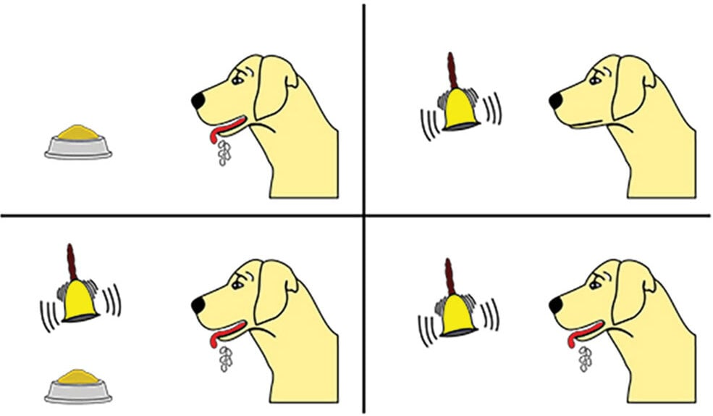

Appendix C: ERA Model of Reflective Practice by Jasper (2013).
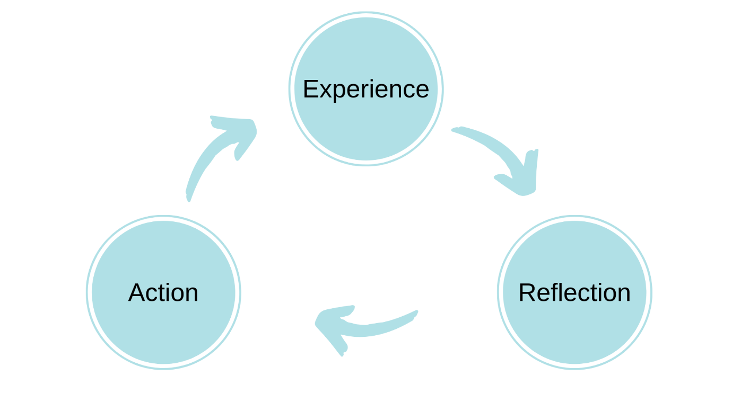
Appendix D: Spiral ERA Model of Reflective Practice by Jasper (2013).
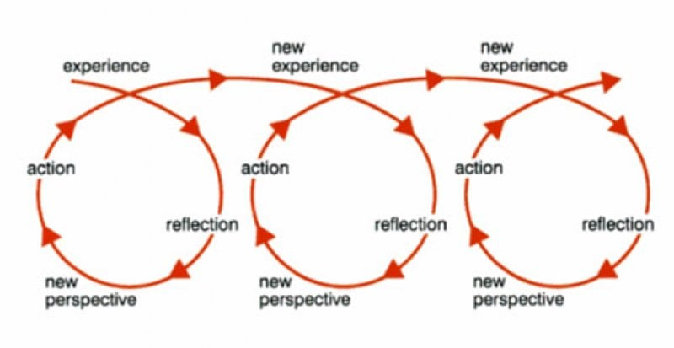

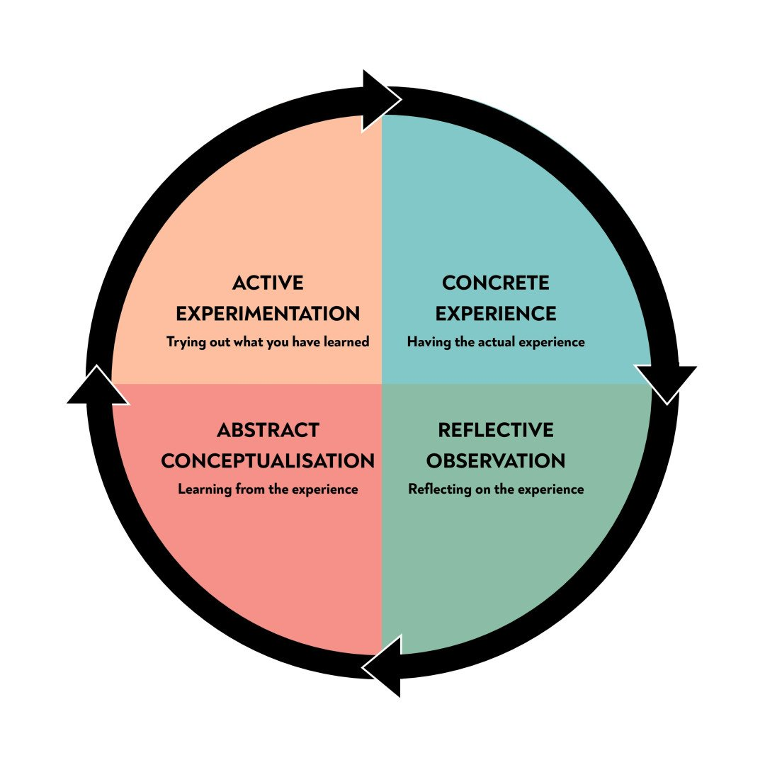
Appendix E: Kolb’s Learning Cycle (McLeod, 2023c).

Appendix F: Maslow’s Hierarchy of Needs Model.


