Implementation and Analysis of Narrow Band Frequency Modulation Jamming Techniques and RTL Design using GNU Radio

Cameron Paul Fitze
University of Wales Trinity St David
Course Number:
Course Name: BEng Embedded Electronic Systems



Abstract
This study evaluates FM signal transmissions using GNU radio, and the effect of implementing a noise signal on the same frequency band with the aim of jamming the FM signal. It is apparent through these evaluations that FM can be easily distorted with a noisy Gaussian signal on the frequency band. Techniques to avoid this include frequency hopping spread spectrum (FHSS). This enables the FM signal to hop rapidly between a set of pseudo-random set of frequencies, thus minimizing the effects of a noisy signal on a particular frequency.
The RTL-SDR can be used to receive a range of FM frequencies. For the purpose of this study, this was limited to the FM radio frequencies in the UK, 87.6MHZ to 107.9MHZ. GNU radio was used to implement the flow and receive the transmissions from the RTL-SDR hardware.
Abstract
Contents
1. Introduction 4
1.1 Aim 4
1.1 Report Layout 4
2. Background Research (Literature Review) 5
2.1 FM communication 5
2.2 Anti-jamming techniques 5
2.2.1 RF Jamming 6
2.2.2 Anti-Jamming 6
3. Task 1: Jammer Techniques Using GNU Radio 8
3.1 NBFM Modulation 8
3.2 NBFM Demodulation 10
3.3 Add a Jammer 12
3.4 Implement FHSS for Anti-Jamming: 14
3.5 Ethics and Impact: 15
4. Task 2 Design and Analyse an RTL-SDR Receiver Using GNU Radio (40%) 16
4.1 Setup and Design 16
4.2 Ethics and Impact 18
5. Conclusions 20
6. Recommendations 21
References 22

Introduction

Aim
This assignment uses practical methods to explore frequency modulation (FM) signals in detail, and the how noise signals can be used to jam or distort that signal.
This assignment will explore Narrow Band Frequency Modulation (NFBM) jamming techniques, to include Wide-Band FM (WBFM) receiver design and Realtech (RTL) software defined radio (SDR) design using GNU radio.
Once the FM signal has been jammed, an anti-jamming technique will be introduced in order to ensure successful transmission and reception of the FM signal
Finally, the ethical implications of receiving FM using RTL-SDR and jamming will be explored.

Report Layout
The sections in this report are as follows:
- Background research (see section 2)
- Jamming Techniques using GNU Radio (see section 3)
- Design and Analyse of an RTL-SDR Receiver (see section 4)
- Conclusions (see section 5)
- Recommendations (see section 6)

Background Research (Literature Review)

FM communication
FM communication techniques vary the frequency of the carrier signal $c(t)$, which mixes with the message signal $m(t)$to enable successful propagation of the transmitted data to the receiver. The mixing of the message signal with the carrier signal is known as Encoding.
Figure 1 shows an FM communication system.
Figure 1 - FM Comms System

The component parts of an FM communication system are as follows:
- Transmit message signal
- Encoder
- Modulator (Frequency)
- Carrier Signal/ Local Oscillator
- Filtering
- Amplification
- Filtering
- Demodulate
- Decode
- Received Message
The part of the FM system that this project will focus on will be the filtering and the techniques used within the signals to enable the transmit signal to bypass any RF jamming efforts.

Anti-jamming techniques

2.2.1 RF Jamming
RF jamming is a technique in which a specific frequency band within the EM spectrum encounters destructive interference. The aim of this is to deny anyone wishing to transmit in that frequency band the ability to do so. RF Jamming is done at the Open Standards Interface (OSI) Physical (PHY) Layer (Layer 1).
There are various reasons or uses for jamming. Military use cases are the main ones; where if Alice is trying to communicate with Bob, then Wally can transmit at high power on that frequency band, causing destructive interference, to deny Alice-to-Bob comms.
Destructive interference, as observed in RF jamming techniques, is not always due to nefarious intentions, and can be as a result of too many transmissions within a particular frequency band, causing collisions and potentially interference. This is important to recognize as various PHY layer techniques are borne out of the desire to have a robust signal transmission for a satisfactory user experience, for example, so that the end user does not experience signal interference, which could interrupt internet connection.

2.2.2 Anti-Jamming
Anti-jamming techniques have evolved as a means of avoiding disrupted comms. They enable Alice to transmit to Bob within their desired frequency band with minimal disruption to their comms. There are a large range of anti-jamming techniques, such as:
- Frequency Hopping Spread Spectrum (FHSS)
- Direct Sequence Spread Spectrum (DSSS)
- Chirp Spread Spectrum (CSS)
These techniques will be referenced to or explored within this project; however, it is important to note that other techniques are used to avoid jamming. The above methods leave an RF signature that can be attributed to that particular technique. Discreet or covert applications cannot leave a signature that can lead to attribution. Therefore, techniques that aim to hide in the noise and obfuscate are also used as to avoid detections, and therefore, avoid being jammed.
The methods mentioned in the list are all spread-spectrum (SS) techniques. SS is a technique where a code independent to the data being transmitted determines the spreading pattern the signal will follow during its propagation [1]. With a frequency-based SS, this will follow a pattern of frequencies, within the desired frequency band, that the transmitted signal will hop between from transmit to receive.
This assignment focusses on FHSS. FHSS is a SS technique where the carrier signal hops rapidly between frequencies with respect to time. FHSS uses a pseudorandom sequence of frequencies. This provides protection against any jamming in a particular frequency band as the speed of the frequency hopping ensures that the signal does not encounter destructive interference. Wireless communications technologies that use FHSS include WIFI, Bluetooth, and LoRa (Long Range).
Figure 2 shows the block representation for FHSS. The process starts with the input data being encoded, and then modulated. The modulated signal, $s(t)$, is then mixed with the frequency hop spreader, which comprises of the pseudorandom bit source, which provides the hopping pattern. This then passes through a bandpass filter, and is the signal now transmits as a spread-spectrum signal.
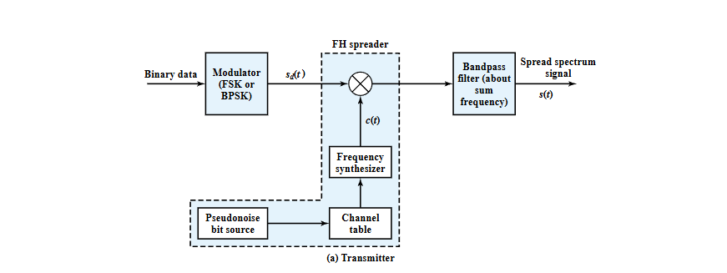
Figure 2 - FHSS Block Diagram [2]

Task 1: Jammer Techniques Using GNU Radio
The aim of this task is to simulate an NBFM communication system in GNU Radio. Then a jammer will be introduced at the transmitted, the effects of which will be analysed, before introducing an anti-jamming technique, specifically FHSS. Then the system’s performance will be analysed under varying RF conditions.
This task comprises of the following sub sections:
- NFBM Modulation and Demodulation (see section 3.1)
- Introduction of Jammer (see section 3.3)
- Implementation of FHSS for Anti Jamming (see section 3.4)
- Ethics and Impact (see section 3.5)
The analysis is contained within each subsection, for example, the FM analysis is within the NBFM modulation section.
Each signal will contain the following analysis:
- Time sink
- Frequency sink
- Waterfall sink
The time sink has time (ms) along the x-axis and amplitude along the y-axis, and displays the amplitude of the signal across time.
The frequency has frequency (Hz) along the x-axis and relative gain (dB) along the y-axis. It displays the gain at across the frequencies.
The waterfall sink has frequency along the x-axis and time along the y-axis. It displays the signal strength/ energy, the colour part, as a function of frequency over a time period. The stronger the signal, the redder it will appear, and weaker signals are blue.

NBFM Modulation
Figure 3 shows the NBFM signal flow on GNU radio. The key parameters are as follows:
- Bandwidth = 24KHz
- Frequency deviation = 12KHz
Frequency deviation is the change in frequency of a carrier signal, $c(t)$, in FM or FSK in relative to the amplitude or phase of the modulating signal, $s(t)$.
A higher frequency deviation will increase clarity of the received signal, but requires more spectrum space [3].
The equation for frequency deviation is:
$$∆f=k_{f}A_{m}$$
Where:
$$k_{f}=frequency sensitiity of modulator$$
$$A_{m }=Modulated signal Amplitude$$

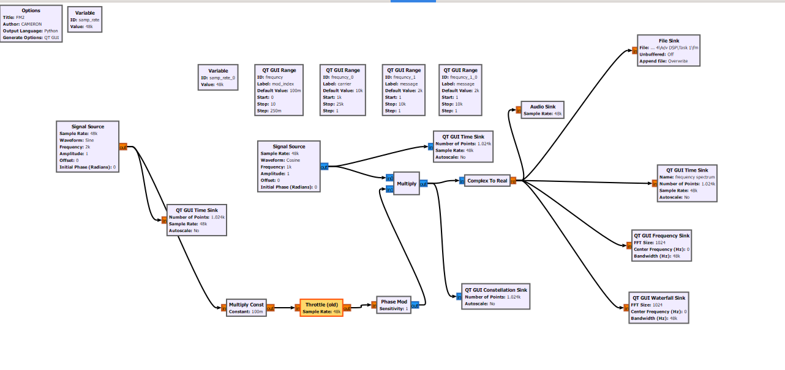
Figure 3 - NBFM Signal Flow
Figure 4 shows the NBFM output signal. A narrow band FM implies that it has a small bandwidth compared to a wideband FM signal. A key parameter to note is that the modulation index is less than 1, in this case 0.1, therefore the signal, $s(t)$, reduces as it goes. The equation for NBFM is as follows:
$$s\left(t\right)=Acos\left(2πfct)-Acβ\sin\left(2πfmt\right)\right)sin\left(2πfct\right)$$
The time sink shows an amplitude of 2 over time.
The frequency sink shows a strong relative gain of around -20dB at around 1kHz and -1kHz.
The waterfall sink shows a strong signal at 1kHz and -1Khz.
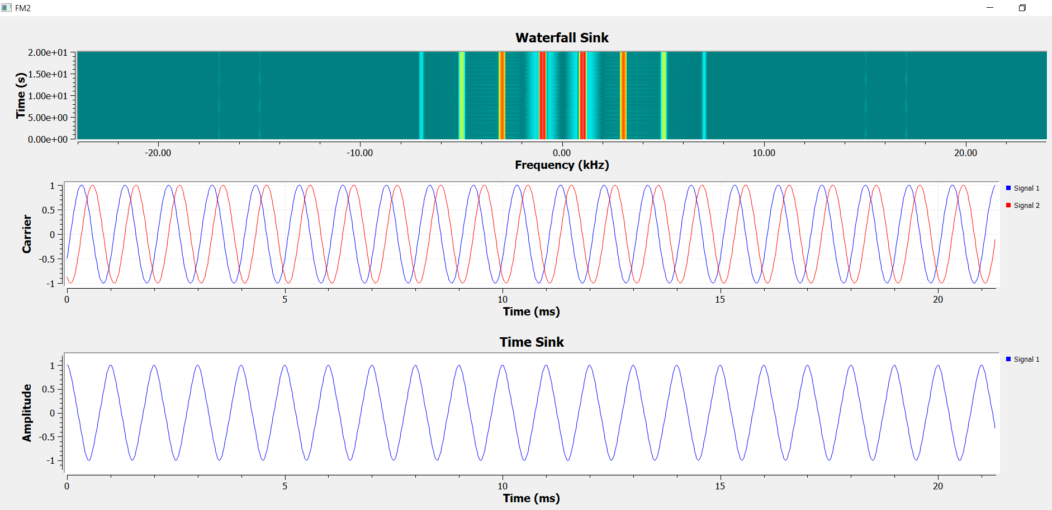
Figure 4 - NBFM Waterfall and Time Sink
Figure 5 shows the frequency sink for the NBFM.
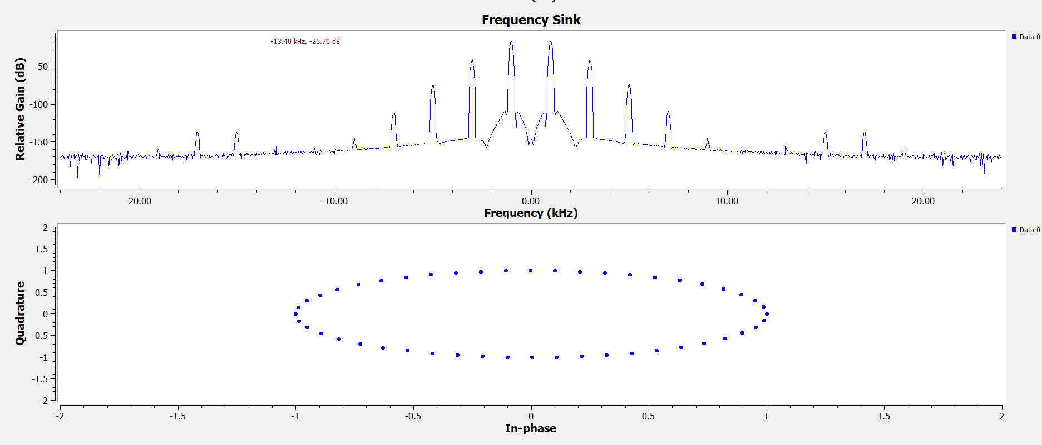
Figure 5 - NBFM Frequency Sink

NBFM Demodulation
Figure 6 shows the FM demodulation. This stage involves capturing the FM channel signal, and down converting it into its baseband I (real) and Q (imaginary) components. This involves taking the modulated signal through filtering: first band pass filter, then low pass filtering, to filter out any unwanted signals. This ensures the original baseband signal is recovered, or demodulated, at the receiver.
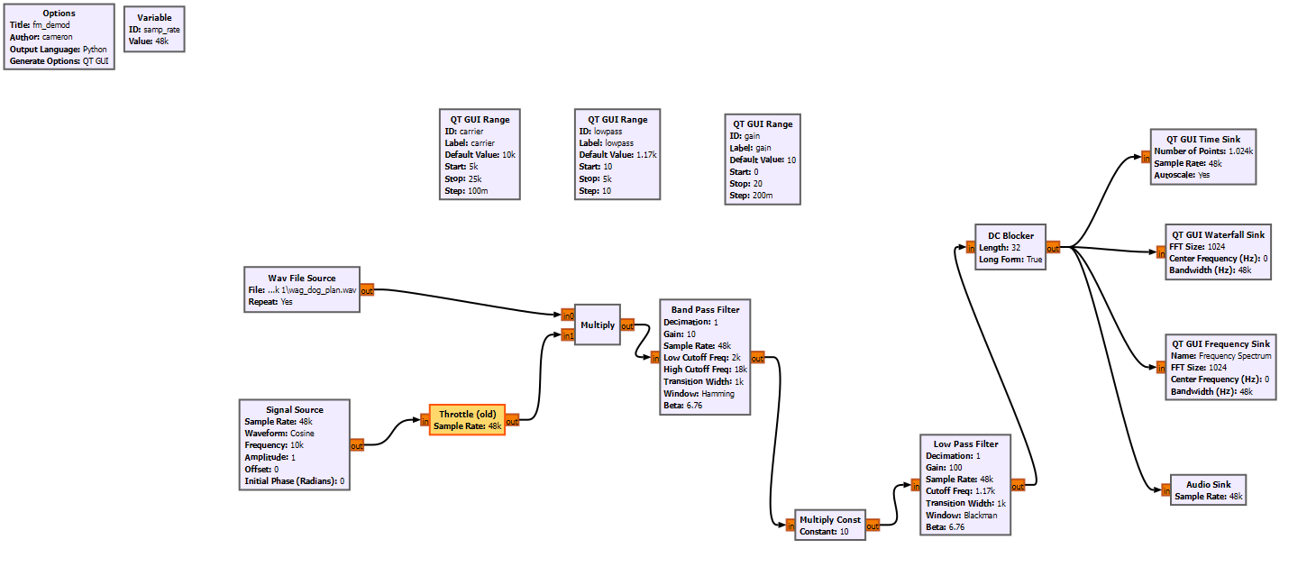
Figure 6 - NBFM demodulation
Figure 7 shows the NBFM demodulation time sink, representing the varying amplitude of the signal over time.
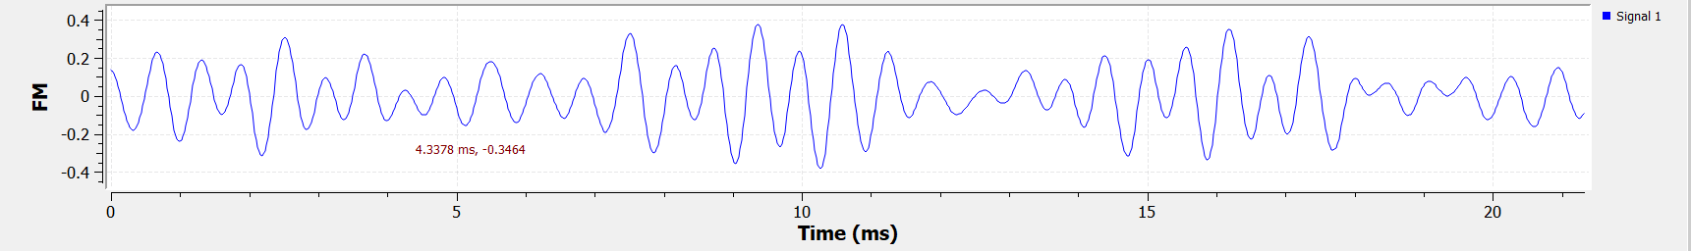
Figure 7 - NBFM Demodulation Time Sink
Figure 8 shows the NBFM demodulation frequency sink, which shows the relative gain of the signal across the passband. As shown, the highest gain is at roughly -1.45kHz and +1.45kHz.
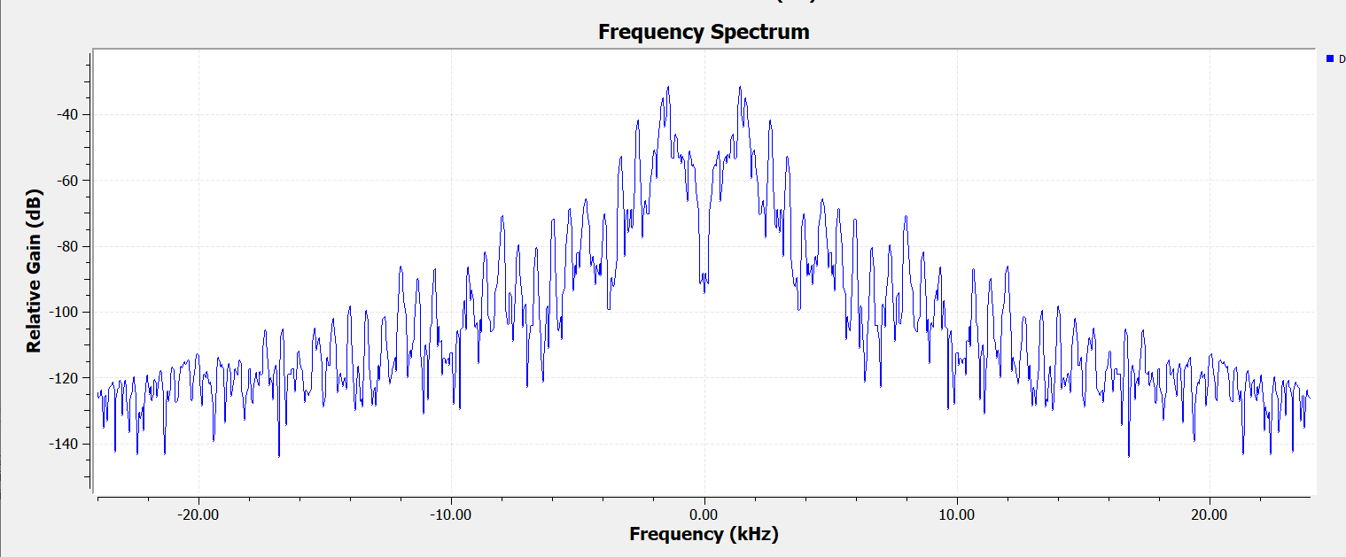
Figure 8 - NBFM Demodulation Frequency Sink
Figure 9 shows the NBFM waterfall sink, showing a high signal power at roughly –1 to 5kHz, and +1 to +5kHz, which corresponds to what is observed in the frequency sink.
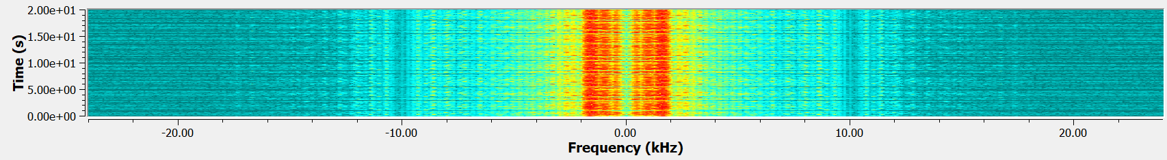
Figure 9 - NBFM Waterfall Sink

Add a Jammer
Figure 10 shows a jamming signal on an RF transmitter. The jamming was the noise source, Gaussian. The signal source is the FM signal used in the previous sections.
The signal source is observed on a QT GUI time sink before it is mixed with the jamming signal. This is to prove the FM signal was transmitting correctly. It is then mixed with the Gaussian noise jamming signal.
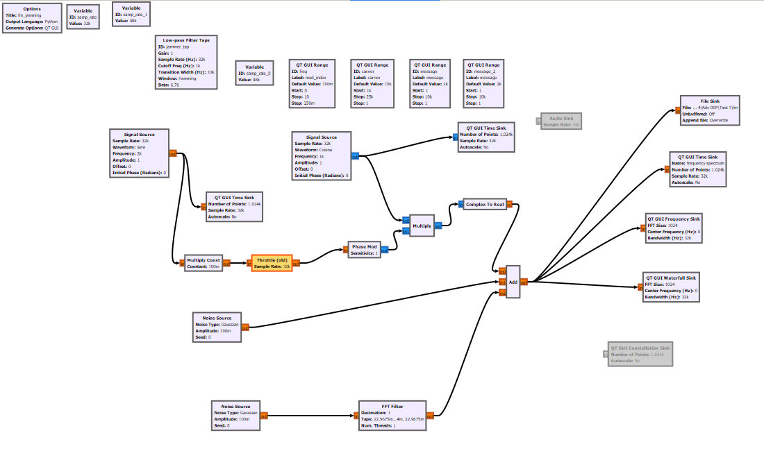
Figure 10 - RF Jammer on NBFM Transmitter
Figure 11 shows the effects of the jamming signal on the FM signal. As seen in the frequency spectrum, there is noise on the FM signal output, caused by the introduction of the Gaussian noise into that frequency band. The peaks of the transmit signal clearly show noise, which will cause distortion to the signal.
The waterfall plot in Figure 11 also shows a strong signal gain across the whole frequency band. The waterfall plot should be blue across the band, with red areas where there is high signal strength.
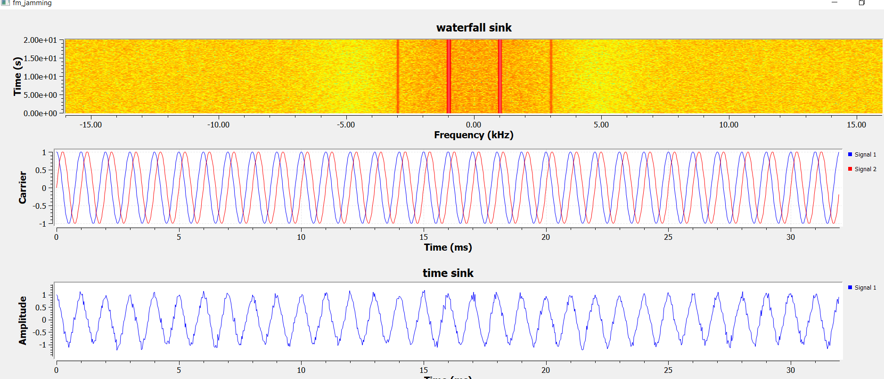
Figure 11 - NBFM Jamming Frequency Spectrum
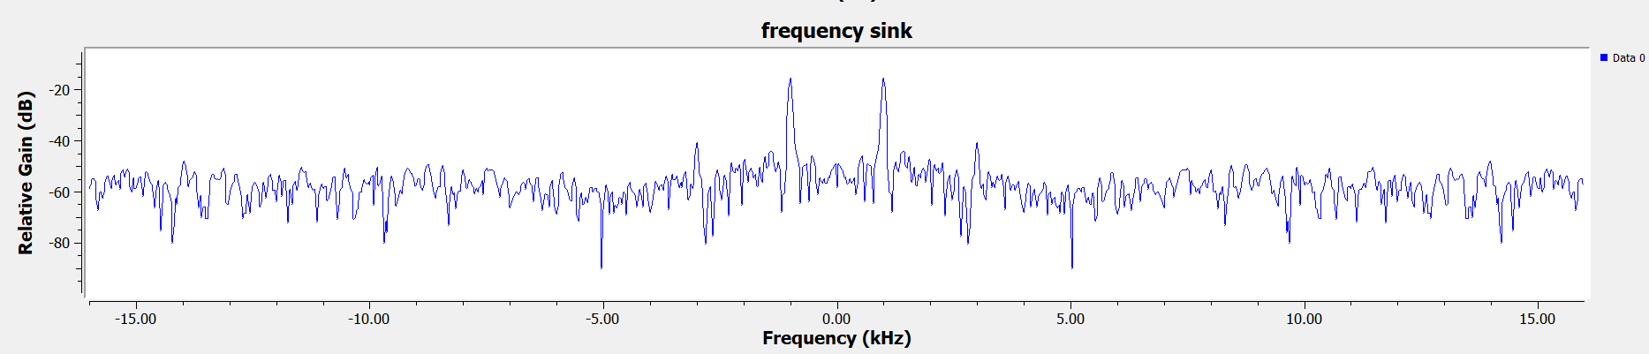
Figure 12 - NBFM Jamming Frequency Sink

The time sink shows an amplitude of 2 over time and is encounter significant interference.
The frequency sink shows a strong relative gain of around -15dB at around 1kHz and -1kHz, representing a change of around 5dB.
The waterfall sink shows significant interference across the spectrum. This is made apparent by the orange/red colour across that frequency band. This indicates that there are relatively strong signals across the band, in areas that are not desired.

Implement FHSS for Anti-Jamming:
Figure 13 shows the FHSS implementation flow to mitigate the effects of the RF jammer observed in the previous section.
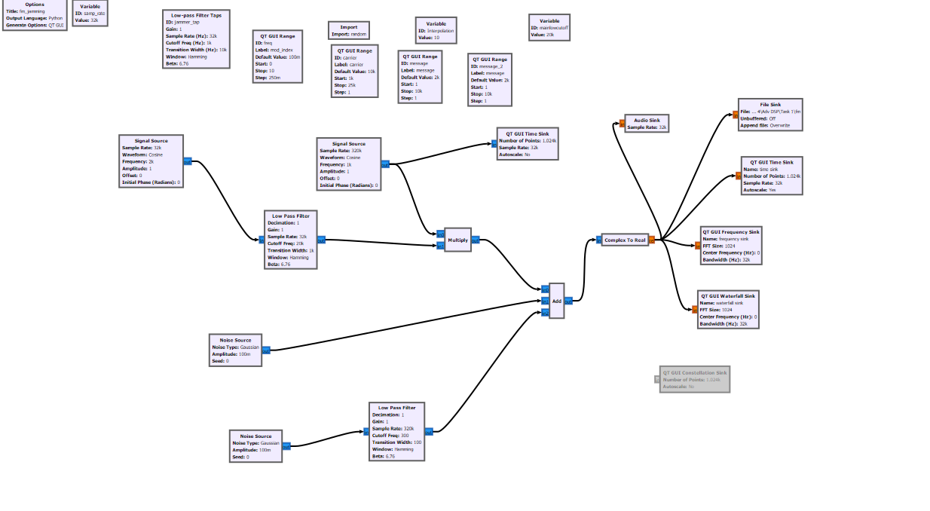
Figure 13 - FHSS Flow

Ethics and Impact:
RF jamming is caused by destructive interference of a signal from another signal on the same frequency band. This can be accidental, for instance in a congested frequency band, or intentional. Intentional RF jamming is observed in military applications with the aim of interrupting enemy command and control (C2). Interrupted C2 causes difficulties for missions as tactical comms become impossible, leading to a higher chance of battlefield mortalities.
So, in a military application, RF jamming can cause casualties, which has various ethical impacts to consider if RF jamming is intentional.
RF jamming has led to technological innovation to improve comms by enabling RF signals to circumvent the effects of destructive RF interference. These methods not only benefit battlefield comms, but also wider society as personal comms technologies, such as Bluetooth and WiFi, are improved by these methods, and as such, wider society user experience is improved. This has even wider benefits to society when talking about aspects such as the economy, as societal comms lead to greater efficiency. FHSS, which avoids interference by hopping quickly between a pseudorandom frequency sequence, has benefits for the military, as adversaries struggle to jam comms, but also in Bluetooth as a civilian using the protocol will have an improved experience.

Task 2 Design and Analyse an RTL-SDR Receiver Using GNU Radio (40%)
The aim of this task is to explore the design of an RTL-SDR receiver in GNU radio. Then, the receiver will be tuned into a desired frequency where it will be analysed. The analysis will focus on the signal quality at different stages. Then the ethical parameters around this process will be discussed.
This task comprises of the following sub-sections:
- Setup and Design (see section 4.1)
- Ethics and Impact (see section 4.2)

Setup and Design
The RTL-SDR is a type of software-defined radio that is low cost and enables users to receive various RF transmissions. It is used in applications such as receiving air-traffic control comms, FM radio, police radio, and more. It can only be used to receive, it cannot transmit. The receive transmit range is roughly 500KHz to 1.75GHz [4].
Figure 14 shows the SDR block diagram with the mathematic equations for each stage.
$S(t)$ is the input RF signal.
$I(t)$ is the mixer output for the In-Phase signal.
$Q(t)$ is the mixed output for the Quadrature phase.
$I'(t)$ is the output signal for In-Phase signal after the Low-Pass Filter removes the higher frequency component.
$Q'(t)$ is the output signal for Quadrature-Phase signal after the Low-Pass Filter removes the higher frequency component.
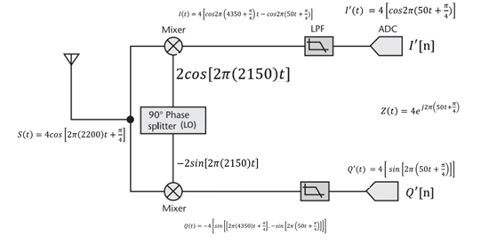
Figure 14 - SDR Block Diagram [5]
An SDR receiver comprises of the following hardware:
- RTL-SDR dongle
- Low pass filter
- WBFM demodulator
- Audio output (e.g., soundcard)
Figure 15 shows the GNU flow for the RTL-SDR receiver. This is a simple design that enables the frequency spectrum to be obtained from the RTL-SDR hardware. The sampling rate is set to 2.048M as that is the maximum sampling rate for the RTL-SDR. The received signal is represented as follows:
$$s(t)=i(t)+jq(t)$$

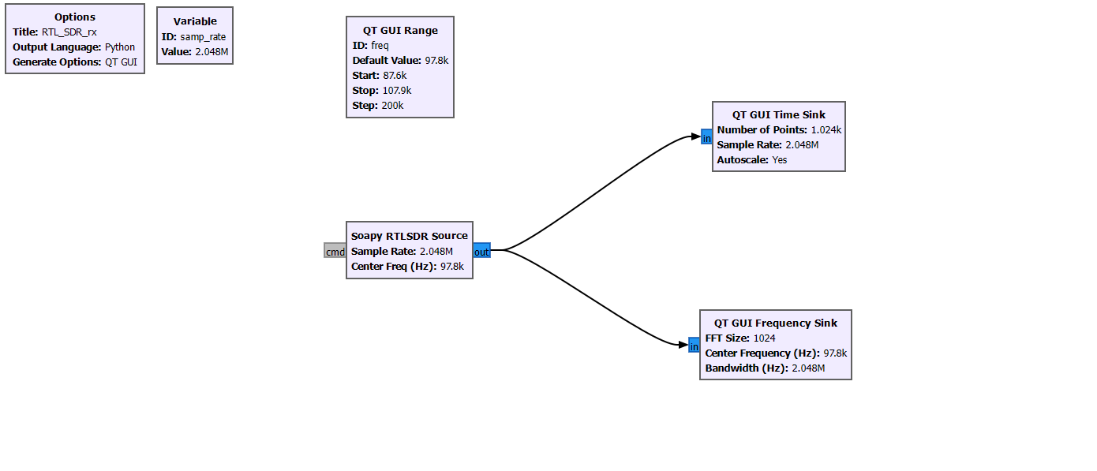
Figure 15 - RTL-SDR receiver flow
The above flow is a simple design, showing that GNU can simply just have a SDR RTL source output to various sinks.
Figure 16 shows the completed flow for the RTL-SDR receive. This now includes a rational re-sampler, low-pass filter, and a WBFM receive, and now receives audio in the passband.

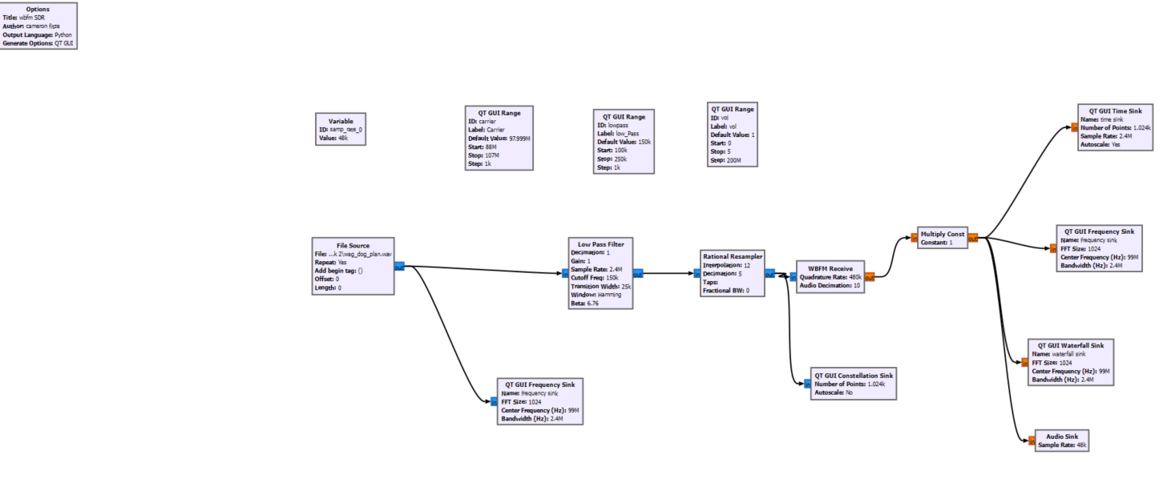
Figure 16 - RTL SDR complete flow

Ethics and Impact
There are various ethical implications with using an SDR for personal use. As this can receive any FM signal within its specified range, a user can listen to air-traffic control, police radios, ambulance radios, and more. Some might argue that there are security implications around civilians listening to air-traffic control or police radios as those transmissions are for live and safety-critical applications – having anyone listen in on these could be deemed a security and safety threat.

Conclusions
There are various findings from the study.
GNU radio is a fairly easy-to-use software for modelling FM and the ability to write one’s own python scripts and import into a project is very beneficial.
FM is an easy signal to jam, and as such, methods such as FHSS should be introduced in applications where safety and security is paramount.
Jamming can easily be observed on a frequency plot as interference on the peaks of the transmitted FM signal.
The RTL-SDR receiver flow is fairly simple, and is an easy method to receive a range of WBFM signals, which might be desirable for personal use such as listening to FM radio, air-traffic control transmission, and any other FM transmissions within the RTL-SDR frequency range. FM is a good method to use for receive as there is plenty of traffic that a user could receive to verify their software flow, which could potentially influence development of a hardware implementation.

Recommendations
There are various recommendations to come out of this study.
To start, other anti-jamming methods should be explored to enable the investigation of the benefits and disadvantages of the currently available methods. This is beneficial as the investigation could lead to the identifying of a more suitable method of anti-jamming for FM applications.
A hardware implementation could be created on the back of this study. This would consist of the RTL-SDR, a low pass filter, and WBFM demodulator wrapped up in a box that could be transported to a location of choice to receive the desired applications. This box could, for instance, be transported to an airport viewing area to enable airplane enthusiasts the chance to receive air traffic control traffic to inform them of the departures and arrivals at that airport.

References

[1] | J. M. T. a. P. P. M. Hasan, "Design and Implementation of FHSS and DSSS," International Journal of Signal Processing Systems, vol. 4, no. 2, April 2016.
[2] | F. Fund, "Frequency hopping spread spectrum," Whitestlab, 16 February 2017. [Online]. Available: https://witestlab.poly.edu/blog/frequency-hopping-spread-spectrum/.
[3] | Talkpod Technology Co., Ltd, "What Is Frequency Deviation," Talkpod Technology Co., Ltd, [Online]. Available: https://talkpod.com/blogs/two-way-radio-wiki/what-is-frequency-deviation#:~:text=The%20significance%20of%20frequency%20deviation,may%20require%20more%20spectrum%20space..
[4] | RTL SDR, "rtl-sdr.com," [Online]. Available: https://www.rtl-sdr.com/about-rtl-sdr/#:~:text=Depending%20on%20the%20particular%20model,and%20provided%20free%20of%20charge..
[5] | Mrs. Jenifer Prince Devaraj, "Advanced Digital Signal Processing: Revision 3," UWTSD, Swansea, 2024.
[6] | International Telecommunication Union (ITU), "Data format definition for exchanging stored IQ data for the purpose of spectrum monitoring," ITU, 2018.

