

Portfolio of Work
Professional Career development

BMSW4005
Krystal Lewis
Richmond Lamptey

Table of content

Contents
Portfolio of Work 0
Table of content 1
Introduction 2
Audit 2
Analyse 3
Asses 4
Conclusion 5
References 6
Appendixes 7

Introduction

This report will be examining how I plan to develop my skillset to succeed in my desired field of employment, once I complete my education with UWTSD. I believe the certificate of higher education will create better employability prospects & allow access to various career paths, which I can then follow to financial freedom & overall job satisfaction. I will also detail the feedback I received from my task 2 assignment where I took part in an interview for a job I had selected & could see myself enjoying if I was to apply. “Employability is a state which maintains & develops work related skills & knowledge throughout an individual’s working life”. This is confirmed by the fact that employability can be dissected into various elements; one being the attributes of the individual applying for the job role & the other being what is currently happening in external labor market & what employers require from an individual to best fill the said roles. Neugebauer, J, & Evans-Brain, J (2016).

Audit

I have created a PDP that outlines what I will need to work on for me to become successful in my chosen field of employment. I believe I must improve my digital skills even though I am proficient in using all Microsoft packages, I will certainly need to familiarize myself with bespoke software that most organizations use to carry out day to day tasks while running the businesses. I may be put in a position where I need to pitch to suppliers & tender for contracts, so I intend to work on my presentation skills & public speaking Infront of various audiences. Being the manager of a team of people also means I will need to work on my conflict resolution skills. Disagreements may arise within my team & my role as a manager would be to ensure these are kept to a minimum & that my team understands their roles & duties clearly. Time management will also be on my agenda as having a young family will require me to balance my responsibilities & time accordingly to ensure neither my children nor employer & team are affected negatively.

Objectives | Time Frame | Activities | Resources | Success criteria
Enhance digital skills | Ongoing | Complete work using Microsoft word.  Become proficient on software packages used for tendering deals & negotiating contracts | Laptop  Books | Successfully submitting assignments
 |  | Increase typing speed. | Books  Typing exercises | Using MS Office competently
Enhance presentation skills | Ongoing | Present a presentation to colleagues | Microsoft power point | Successfully present presentations
Enhance time management skills | Ongoing | Creating to do Lists. | Pen & paper  electronic diaries  Outlook calendar reminders  Arranging childcare around study/ work time | Submitting work by the deadlines set  Work/ home life balance
 |  | Using the 4 D Strategy:  - Do  - Delegate  - Dump  - Delay | Phone diary
Improving my conflict resolution skills | Ongoing | Class based tasks. | Internet based research | Gaining knowledge in selected subject criteria.
 |  | Group dialogue |  | Being more mindful of people’s situations
Becoming less introverted & reaching out to likeminded individuals | Ongoing | Actively starting conversations at networking events to create useful links in the future | Using my linked in profile to find people in my field for potential mentorship programmes | Building bonds with those in my field

A personal development plan is intended to develop skills that are important to work life. Morgan (2017). I intend to use my plan to help me become more in tuned with monitoring and maintaining my progress. I have highlighted what I consider to be my strengths and weaknesses.

Analyse

In the beginning of this module, I was tasked with determining my personality type by taking an online assessment on 16personalities.com, I used my result to determine what type of team role I fit will & identify some of my best attributes. I discovered that I came under a code of ISFP-T my 5 dominant traits of being Introverted (I), observant (S), feeling (F), prospecting (P) & turbulent (T) & fit into the category of explorer. What I found most interesting was that one of my most dominant traits highlighted in the results is what I have chosen to work on to progress towards working within a team setting, I must become less introverted and more open and approachable to build and establish relationships professionally. My strategy to life was constant improvement (See appendix).

Along this journey of self-discovery, I took another career aptitude test during that was designed to find the best 5 career options specific to me, the results were not a surprise as I have had interest in all these sectors. The algorithms suggest that becoming a legal assistant would be the best fitting role. The other four choices where to pursue careers in: Financial consultancy, Fleet operation management, Procurement management & lastly teaching.

For me to become a successful manager in my chosen field, I will need to secure employment within the procurement sector in a facilities management setting. I will need to improve my ability to establish useful relationships within the workplace & various suppliers, once I am able to form these links with people, I can use the rapport built to ensure I am able to get the best deals, establishing these bonds will be valuable when it comes to purchasing products & services at perhaps greater discount for the clients who require me & my team to source appropriate resources for them.

According to indeed.com, (2021). The definition of a Procurement Manager, also known as a Purchasing Manager, they responsible for a company's sourcing & supply chain. They oversee the locating & analyzing of suppliers, products, & services, as well as negotiating contracts whilst obtaining the most cost-effective deals without sacrificing quality.
The duties I will need to undertake to be proficient in this role are as follows.
- I must oversee a team of purchasing agents & delegate tasks across departments when necessary.
- Develop strong relationships with business stakeholders & strategic supply partners to improve business links.
- Performing all procurement activities & negotiate supplier agreements.
- Prepare contracts & tender management of stakeholders.
- Creating policies & procedures for risk management & mitigation.

Asses
As I have been out of employment for almost 4 years due to family commitments, it will be essential for me to find a way to get myself back into a routine that is expected of me in an employment setting & understanding what my potential employer will expect of me.

During this module I was involved in a mock job interview with my lecturer, this required me to apply for a job & be interviewed on my skills & why I feel I am suitable for the role.
The job I applied for was a fleet coordinator. The starting salary was between 20- 30k depending on experience. The company itself was based in the Great Barr area of Birmingham which, is roughly 25 minutes from my home depending on traffic conditions. As I hold a full license and access to a car this is a very reasonable commute for me when considering the locations of my childcare providers.

Unfortunately, I was unable to attend classes on the day of the interviews, so mine was held online via Microsoft Teams. My lecturer that was asking me the questions related to the role and how well I can adapt to changes since being out of work for a considerable amount of time, as fleet can be very fast paced & changeable from previous knowledge. I answered most of the questions asked of me reflecting on prior experiences I have of similar roles on my CV (see appendix). So, I was at ease with being challenged on how I would deal with various situations that may arise. I started nervously as I have not had an online interview of this nature before. As the questions continued I became more comfortable in my responses & even had the opportunity at the end to ask my own questions in relation to the fleet size of the company and what operating systems they use within the organization.

I think that the interview was very good practice for me as mentioned, my last role came to an end in late 2017 so I haven’t had to take part in an activity of this nature for some time since upskilling on this course. I enjoyed reflecting on my previous achievements in my roles and how well they related to the questions being asked of me. What I didn’t really enjoy was the fact that I had to do this from home rather than in person. My internet connectivity is very temperamental, and it can crash or freeze while I am in meetings or when uploading/ downloading content. This can make me appear to be unprofessional when the calls are disrupted by low broadband speeds & buffering which I find very frustrating & embarrassing.

Although I had connectivity issues the feedback I received from the interview made me happy. The comments I received prove that I had done my prior research of the role and company dynamics before attending interview. I was able to demonstrate my strengths in customer services and coordinator roles. (Appendix attached)

My overall score was 70% which would indicate that the job would have been offered to me if it was at my lecturers’ discretion. I can in future ensure I think carefully think before answering questions and relate them to good and bad experiences I have faced using the STAR technique to avoid confusion. Not only this, but I must also ensure devices I am using for internet calls have sufficient network coverage/ data before starting the call.

I could have made sure I was in more suitable office attire such as a shirt, not just a suit jacket, even though it was an online meeting I could have found an outfit to reflect this.

If it was to happen again, I would research the company and role I am applying for and ensure I am using the STAR approach to answer the questions asked of me.

According to Haberman and Delta Kappen, (1995). The star approach is when someone uses the acronym approach to answer a competency-based question. The situation is described, then details are given about what was required of them at the time. They must then outline how they went about achieving the goal and what they had learnt by the end of the challenge faced.

Conclusion

In conclusion the theories and practices I have learnt on this module; will no doubt be carried with me for the rest of my academic career. I have been made aware through the feedback received how I must structure my answers when my competency is questioned via interview and any other scenarios that could arise while finding employment or progressing further with my education.

References

Neugebauer, J, & Evans-Brain, J 2016, Employability: Making the Most of Your Career Development, SAGE Publications, London. Available from: ProQuest eBook Central. [1mDecember 2021].

https://uk.indeed.com/hire/job-description/procurement-manager?gclid=CjwKCAiA78aNBhAlEiwA7B76p8uWc_iAvden3cJL8Fge78li4oSHJINon3ZsKs_vbgSGy7iKcxWI6hoCmBYQAvD_BwE&aceid=

Morgan 2017 – Moodle week 1 Professional Career development presentation 2021

Haberman, M. and Delta Kappan, P., 1995. Selecting 'star' teachers for children and youth - ProQuest. [online] Proquest.com. Available at: <https://www.proquest.com/docview/218527449?pq-origsite=gscholar&fromopenview=true> [Accessed 4 December 2021].

Appendixes

Personality test on 16 personalities result
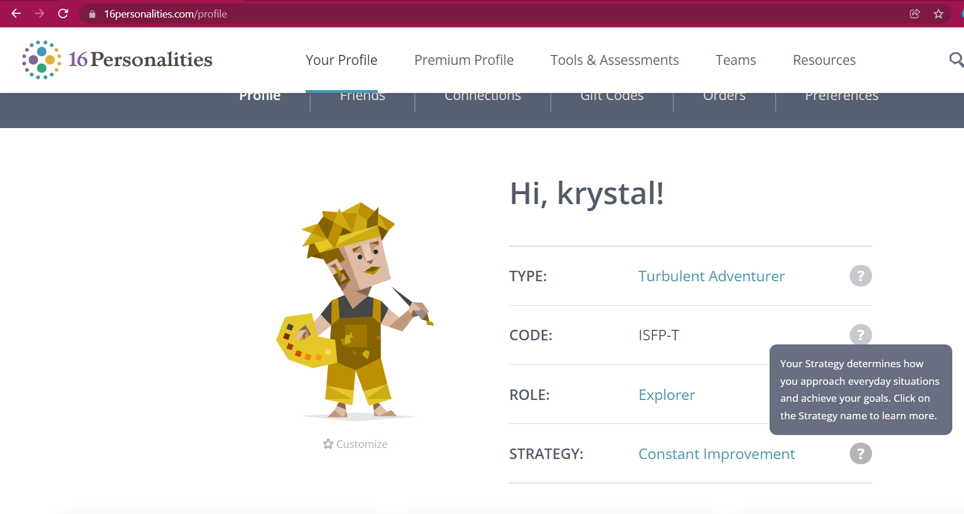

Job specification for mock interview


