Design and implementation of Smart Home

Student Name: Lauren Davies
Student Number: 1805950

Abstract

Within this report, the use of IoT and Smart devices will be discussed. Research of both Internet of Things and Smart & Connected devices has been carried out, and a overall summary of the advantages / disadvantages that they may bring upon their installation, carried on from this is any security issues that may be encountered whilst a smart home is being used and any possible threats that could cause an affect to all devices connected.
After this research, by using the information gathered a concept of a Smart Home will be created, by creating a layout with various appliances/devices being added onto the networks that will be provided with details about the additions and how it will be of benefit to household members.

Introduction
IoT has been around and in development for a long time. The amount that it has developed has allowed an expansion of knowledge and devices, over time the creation of Smart Homes had been a concept of IoT that has been ongoing as time goes on. Once simple fridges and lightbulbs have now become home monitors, fridges having cameras inside of them to allow households to inspect what they may need to buy more of and lightbulbs having the capability of analysing the room environment and will send data back to the main thermostat of the house in order to increase or lower the temperature or even allow the use of smart applications for them to be turned on when a resident is about to come home.

Contents
Abstract 2
Introduction 2
Task One 4
Research of IoT 4
Research of Smart Devices 5
Advantages & Disadvantages of IoT/ Smart Devices 6
Advantages 6
Disadvantages 6
Security Issues 7
Threats to Smart Homes 7
Man in the Middle 7
Data & Identity Theft 7
Hijacking of Devices 7
Task Two 8
Smart Home Concept 8
Key 8
Smart Home – First Floor & Second Floor Concepts 9
Smart Home Concept Summary 9
References 10

Task One

Research of IoT

IoT, stands for Internet of Things, references all devices/things that are able to connect to the internet and is used for entities that can communicate with each other, this includes sensors to smartphones [1]. These devices can connect over the internet, even though it isn’t usually required to be connected to the internet as it can work with the network independently to collect and share data without the need for any household members assisting, regardless of the devices size it can become an IoT device. By being able to connect these devices and connecting sensors to them can implement various levels of virtual intelligence [2].

The creation of IoT devices have led to implementing them into larger scale structures, such as modern cities and homes. Further development of these devices will lead to a Smart City, in turn this will mean street lights that can turn on after it gather data about its environment or turns itself on if it detects any motion if someone is walking home during the night or even having it in place so that if a smart car is developed it will be able to direct its driver to a free parking spot and if required drive itself without the user and park itself [3]. Factories have also begun to use these devices as they can operate at a larger scale and can easily be upgraded if required, they are able to carry out functions which could of previously been carried out by humans which would of taken a longer time .

Research of Smart Devices

When is come to smart devices they are considered by the ability to share and interact with other devices within networks. There are a wide range of smart devices that can help in modern day to day life, the most common tech that is used are smartwatches and smartphones. Smart devices receive commands that are sent by users in order to assist them, such as a person using their mobile device to turn their heating on whilst travelling home from work so that the house is a higher temperature when they arrive [4].
Before smart devices were more developed, they weren’t needed to connect to networks in order to work by themselves, they currently have been adapted to connect to networks to be able to interact with various smart devices that may already be connected such as thermostats, speakers, bulbs. [3]
Due to the constant development of smart devices, each area of homes is covered with a variety of devices. Smart lighting can allow home owners to control rooms in different sections of the household, even if they are not present, all from their smartphone applications, it presents itself with the ability to recognise when there are people within a room, and can change the light according to the time of day [5]. Another aspect is thermostats, as stated previously, they can be remotely controlled from different locations, it keeps a constant monitoring of the temperature in the home by connecting to smart lightbulbs via the home network (Wi-Fi). On top of this, smart thermostats can develop an understanding of what settings best suit the household members behaviours, following this it can then provide the household with reminders and show the energy usage [5].
Smart devices are not just limited to home usage, they can be implemented into garage doors, by having this technology, it will be able to detect when a household member is pulling into the driveway and unlock and open the door for them, this can also apply to the front/back doors of the home as if the smart lock is able to detect when a registered member is nearby the house will unlock certain elements of the house that has been assigned to that member, however if it detects any signs of devious behaviour it will contact authorities if it feels that there is a threat to the home [5].

Advantages & Disadvantages of IoT/ Smart Devices

There are many benefits of incorporating devices in order to create a smart home, it can provide the household with diverse way of security, from the addition of motion sensors and inserting locks into doors which can be controlled from anywhere, even if members of the house aren’t home. A common smart device in use is smart doorbell, which alerts members smartphones if it detects any motions that take place in front of it granted that the members devices are connected to it. Detailed below are some further advantages and disadvantages of IoT/Smart Devices [6].

Advantages
- There are a diverse number of smart devices that have been programmed to fulfil different needs for households.
- Smart devices can communicate with each other to and exchange data that may benefit the household
- Installation for smart devices tend to be quick and easy to set up
- They can provide homes with improved security
- Smart devices can supervise to ensure that energy is being used efficiently meaning it is also environmentally friendly.

Disadvantages
- Smart devices can vary in price, but is often expensive depending on its use
- This type of technology can be confusing to older generations who are not as used to it as younger gens.
- Smart devices are dependent on internet connection to function, if Wi-Fi connections are poor, then they can become unreliable.
- Hackable, meaning that hackers can intercept traffic that is occurring on the smart home network and can gather any sensitive information

Security Issues

Despite providing a variety of benefits to homes, there are some security issues with smart homes even though there are advanced systems that can be implemented for security, due to its connection over the internet with other devices, meaning it is vulnerable of being hacked. Even though thieves general break into homes to steal items of value, if households rely on their smart devices for their security, thieves are able to hack into these systems in order to see household members daily routine, and disable any security elements when they decide to break in [7].
Another factor regarding privacy, is that if the security cameras were to be hacked, the hackers would have full access to view everything that takes place in the home, regardless of how secure it is, as the device is connected to the internet anyone may gain access to the video cameras. This could result in the gathering of personal information that could be used against members maliciously [8].
Even though smart devices are becoming incredibly popular because of their simplicity and ease of use, they still pose a complex side when it comes to users having privacy concerns regarding the devices available, this is mostly due to the fact that even when sensors aren’t in use, they will always be active, and will monitor the users environments and control device communications over the network. Internet Service Providers (ISPs), will be able to detect that the household uses a IoT network, and could analyse any data that is carried through the traffic of the network and could gather details about members that may be incredibly sensitive. An experiment carried out by members from Cornell University, that investigated four different IoT devices, showed that the network traffic rate was able to reveal sensitive interactions carried out by users despite it being encrypted [9].

Threats to Smart Homes
There are a variety of attacks that happens against a vast majority of standalone devices that tend to be the most vulnerable devices connected on smart homes. Here are attacks which can affect smart homes detailed below.

Man in the Middle
When these types of attacks occur, it interrupts communications that are taking place between two different systems. This can be compared to a situation where if a smart lightbulb were to get hacked, which monitors its surrounding environment to check the temperature, the hacker can produce false results meaning the output would communicate to the thermostat to increase or lower its temp. and cause awful effects [10].

Data & Identity Theft
If those who wear smartwatches or have smart appliances get attacked by hackers, there would be plenty of personal information stored about the household members which could be used in a malicious context, such as fraud [10].

Hijacking of Devices
When hackers attack devices, they will be able to gain control of that device, hijacking of devices tend to go unnoticed by the users, as the standard device functionality is not edited. Once one device on the home network has been infected, the hacker is able to gain access to all smart devices connected [10].

Task Two

Smart Home Concept
After gathering research about a wide variety of features within Smart Homes, the final aspect of this report was to create an interpretation of what a smart home could be made up of. The following lists a key of elements for appliances in the concept designed, along with a summary about the outcome.

Key

Smart Light –
Smart Bedside Lamp –
Smart Door (Smart locks) -
Fridge -
Cooker -
Smart TV -
Motion Sensor -
Thermostat -
Burglar Alarm -
Camera -
Smart Windows -

Doorbell -

Smart Home – First Floor & Second Floor Concepts
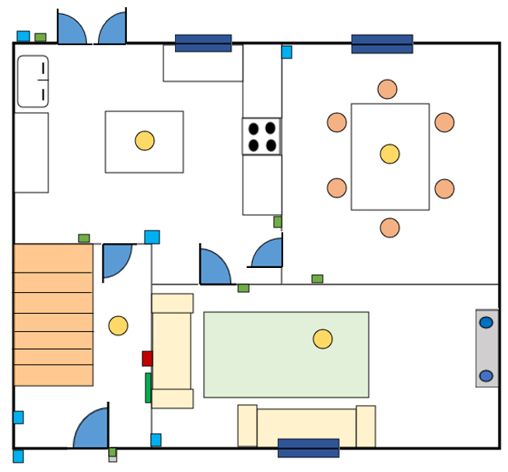
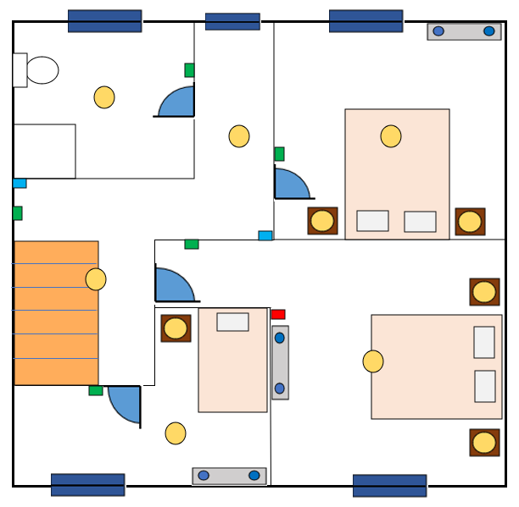

Smart Home Concept Summary
The smart home concept has been taken into consideration after carrying out analysis of research gathered within the first task of this report. The outcome is shown above. Both the front & back doors will only open to the devices that it recognises as an authorised user, if it doesn’t it will trigger the cameras at that location to become active and begin recording both audio and video, this is so that members can detect if an unauthorised/unexpected visitor is present, if they are suspicious that the visitor is there with criminal intentions then they have the option to contact the police, and the alarm within the house will be set off to warn the possible criminal. The Sensors will also trigger the smart lights to turn themselves on in that specific area of the house, and if the user requires to be able to turn it on via an application that they will have on their device if they are not home themselves. This can also be said for the thermostat, due to the smart lightbulbs, it will be able to detect any changes to its environment and can adjust its settings as appropriate and be changed by members from any location.
Security wise, the smart devices will operate on their own virtual network from the main network that is implemented in the house, in order to avoid hackers from damaging the appliances in the house and gathering any sensitive information about the residents.

References

[1] | M. BURGESS, “What is the Internet of Things?,” WIRED Explains, 16 Feb 2018. [Online]. Available: https://www.wired.co.uk/article/internet-of-things-what-is-explained-iot. [Accessed 29 04 2020].
[2] | S. Ranger, “What is the IoT? Everything you need to know about the Internet of Things right now,” ZDNet, 03 02 2020. [Online]. Available: https://www.zdnet.com/article/what-is-the-internet-of-things-everything-you-need-to-know-about-the-iot-right-now/. [Accessed 29 04 2020].
[3] | Y. Malik, “Smart, Connected and IoT Based Devices. What’s The Difference?,” Medium, 05 11 2017. [Online]. Available: https://medium.com/all-technology-feeds/smart-connected-and-iot-based-devices-whats-the-difference-36fc1bdc36b2. [Accessed 29 04 2020].
[4] | techopedia, “What does Smart Device Mean,” Technopedia, ns. [Online]. Available: https://www.techopedia.com/definition/31463/smart-device. [Accessed 29 04 2020].
[5] | M. Rouse, S. Shea and V. Redriksson, “smart home or building (home automation or domotics),” IoT Agenda, 07 2018. [Online]. Available: https://internetofthingsagenda.techtarget.com/definition/smart-home-or-building. [Accessed 29 04 2020].
[6] | Clickatell, “The pros and cons of smart homes,” Clickatell, [Online]. Available: https://www.clickatell.com/articles/technology/the-pros-and-cons-of-smarthomes/. [Accessed 29 04 2020].
[7] | Use Tech Wisely, “Disadvantages of Smart Home Technologies,” Use Tech Wisely, 06 11 2017. [Online]. Available: https://use-tech-wisely.com/post/2017/6/11/disadvantages-of-smart-home-technologies/. [Accessed 29 04 2020].
[8] | “Disadvantages of Smart Home Technologies (SECURITY & PRIVACY),” Use Tech. Wisely, 06 11 2017. [Online]. Available: https://use-tech-wisely.com/post/2017/6/11/disadvantages-of-smart-home-technologies/. [Accessed 29 04 2020].
[9] | N. Apthorpe, D. Reisman and N. Feamster, “A Smart Home is No Castle: Privacy Vulnerabilities of Encrypted IoT Traffic,” Workshop on Data and Algorithmic Transparency, p. 6, 2017.
[10] | SafeWise Team, “What are the benefits of home automation?,” Safewise, 12 10 2018. [Online]. Available: https://www.rambus.com/iot/smart-home/. [Accessed 29 04 2020].

