Angur Ali (1805335)
Group Members: Bitabrata Chowdhury – Faruk Uddin
Website Email: Faruk1805275@gmail.com
Password: dob18.07.76
Questionnaires
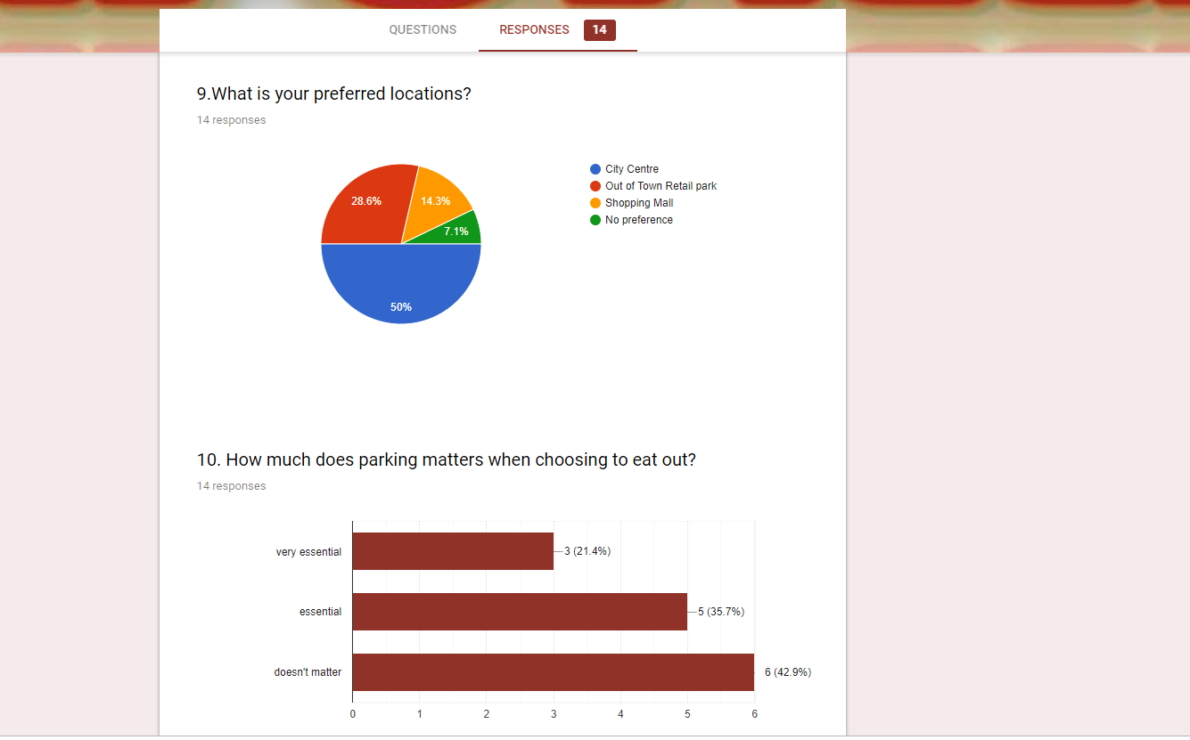
When we decided to do Asian street food, we wanted to know where will be best location to be. The two questions I have chosen are what is your preferred locations? With four options to choose from and second questions is how much parking matters when eating out? With three options. The reason we need to find out about these is if majority customers are will to visit a specific place with or without any issues. Also we needed to know if our business plan is going to be good idea to where we wanted and public are happy with it. When we conducted the questions the findings that came out from the responses are the location of this business is ideal to have in the city centre, as 50% people preferred it. With the second question people responded when eating out parking wouldn’t really matter. When planning a business it is ideal to plan a questionnaire to conduct and see your views are similar to people views. This will help you if you need to make changes or not of place you are looking for. We had plan where we wanted to open the business we just needed other views to see is it ideal, the outcome were what we expected.
Webpage - Homepage
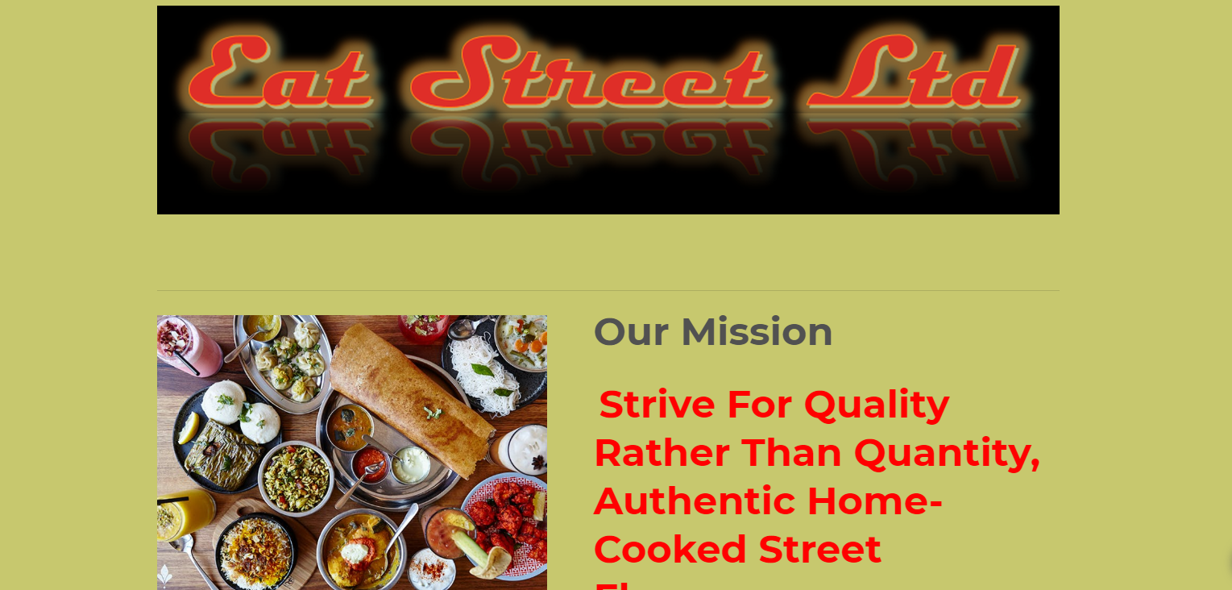

Our business is based on cafe style Asian street food. To create a webpage for this type of business, I have research if anything similar are available online to get some ideas what I will need to create for our webpage. I have taken on to design the main homepage, creating contents and adding images with links to other pages. The design and contents used by most food business for their homepage are with limited writing, appealing and mouth-watering images. By following how other business used the webpage, I decided to use some images of dishes to show what type of foods our company will be selling. I have made the main page as attractive as possible so that when customers visit us on online, they be tempted to try us out. I have added name logo to make the business like a brand to stand out with our mission statement. I have decided to put location of the business on homepage as people will know straight way where we are based, with opening hours. I have also added that we are available on social media platforms, having this give free advertisement and promoting of the business.

