
Computer Architecture and Operating Systems
Report


- STUDENT NAME: PAPY POSO MUKELENGE
- STUDENT ID: 2525113
- MODULE: Computer Architecture and Operating Systems
- MODULE CODE: ACCA4022

- LECTURER: Dr Redhwan AI-Amri

Table of Contents
Introduction 3
Task 1. Key Functions of General Operating Systems 4
1.1 Introduction 4
1.2 Process Management 4
1.3 Memory Management 5
1.4 File System Management 5
1.5 User Management 6
1.6 Device Management 6
1.7 Network Management 7
1.8 Security Management 7
1.9 Summary 8
Task 2. Use of Windows OS CLI Commands 8
Introduction 8
2.1 tasklist 8
2.2 taskkill 9
2.3 dir 9
2.4 mkdir 10
2.5 ipconfig 10
2.6 ping 10
2.7 net user 11
2.8 whoami 11
2.9 schtasks 12
2.10 systeminfo 12
Task 3 – Use of Linux OS CLI Commands 13
Introduction 13
3.1 pwd 13
3.2 ls -la 13
3.3 mkdir 13
3.4 cp 14
3.5 mv 14
3.6 ps 14
3.7 top 15
3.8 ping 15
3.9 whoami 16
3.10 crontab -l 16
Task 4. Use of Windows OS Scripts 16
Introduction 16
Script 1 – Student Grade Calculator 17
Description 17
Script 2 – Countdown Timer 17
Code 17
Description 18
Task 5. Use of Linux OS Scripts 18
Introduction 18
Script 1 – Student Grade Calculator 18
Code Error! Bookmark not defined.
18
Description 19
Script 2 – Countdown Timer 19
Code 19
Description 19
Conclusion 20
Reference List (IEEE) 21

Introduction
Operating systems play a fundamental role in modern computing by managing computer hardware resources and providing an interface between users and applications. They are essential for performing everyday tasks such as file management, process execution, memory allocation, user administration, and network communication. This report explores the core functions of general-purpose operating systems and demonstrates the practical use of command-line interfaces in both Windows and Linux environments. It also presents examples of Batch and Bash scripting to illustrate how routine administrative tasks can be automated. Throughout the report, practical demonstrations, screenshots, and supporting references are used to explain key operating system concepts and highlight the importance of command-line tools in system administration. [1]

Task 1. Key Functions of General Operating Systems

1.1 Introduction
General-purpose operating systems such as Microsoft Windows, Linux, and macOS are designed to manage computer hardware and software resources while providing users with a convenient environment for running applications. They act as an interface between the user and the computer's hardware, ensuring that all components work together efficiently. Without an operating system, a computer would not be able to perform basic tasks such as opening applications, managing files, connecting to networks, or running multiple programs simultaneously. The following sections describe some of the most important functions of modern operating systems. [2] [3]

1.2 Process Management
One of the primary responsibilities of an operating system is process management. A process is an instance of a program that is currently running. The operating system creates, schedules, monitors, and terminates processes while ensuring that each one receives sufficient processor time. Modern operating systems also support multitasking, allowing users to run multiple applications simultaneously without significant performance issues. For example, a user can browse the internet, listen to music, and edit a document at the same time because the operating system efficiently shares CPU resources among these [4]
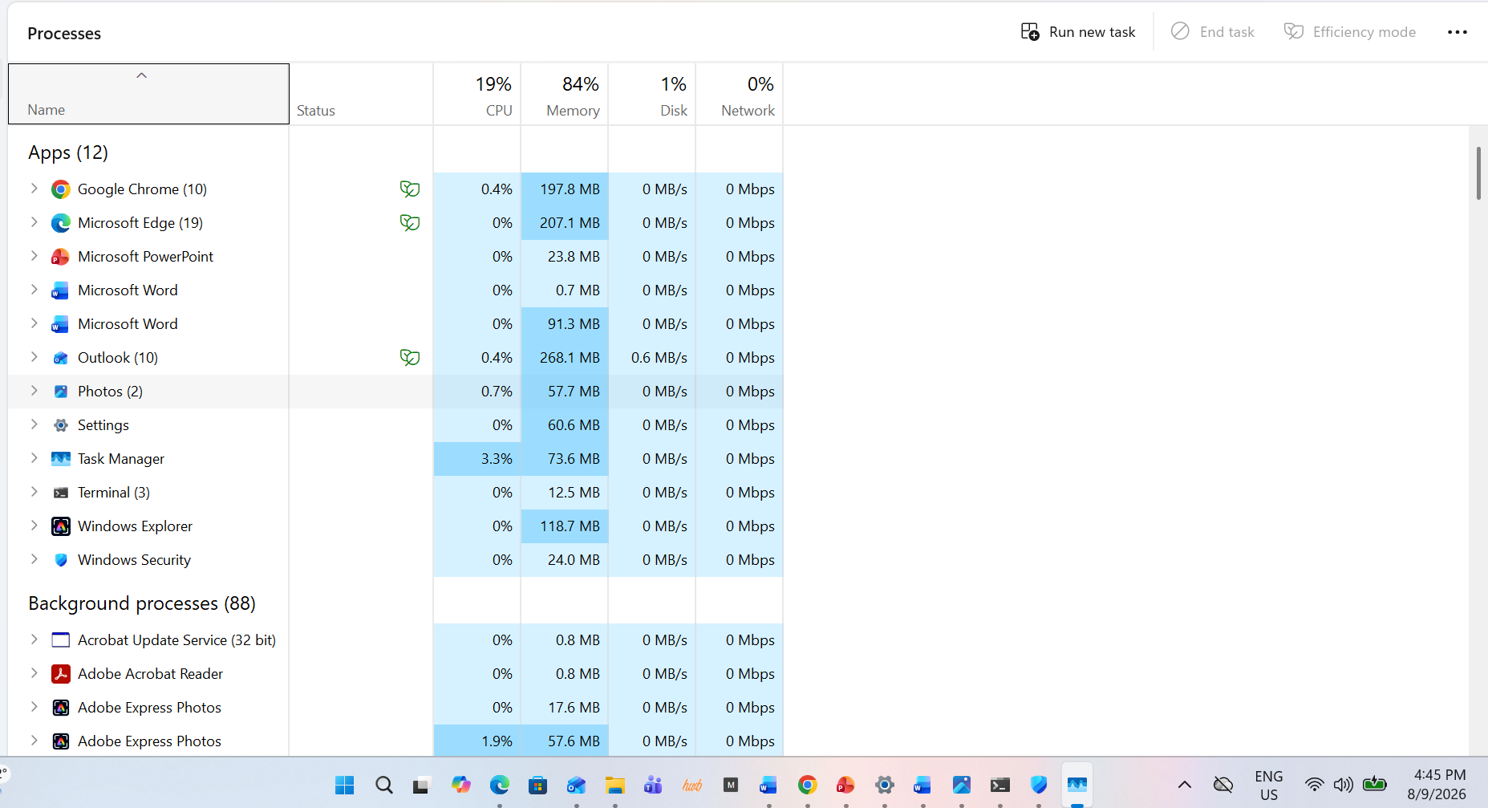

processes.

1.3 Memory Management
Memory management is another essential function of an operating system. The operating system allocates RAM to different applications and releases memory when it is no longer required. This prevents conflicts between programs and ensures efficient system performance. Modern operating systems also use virtual memory, allowing the computer to temporarily use storage space when physical memory becomes limited. Effective memory management improves system stability and enables users to work with multiple applications simultaneously. [5]

1.4 File System Management
Operating systems organise and manage files and directories stored on storage devices. They allow users to create, copy, rename, move, and delete files while controlling how data is stored and retrieved. File management also includes permissions that determine which users can access or modify specific files. This function helps maintain an organised [1]
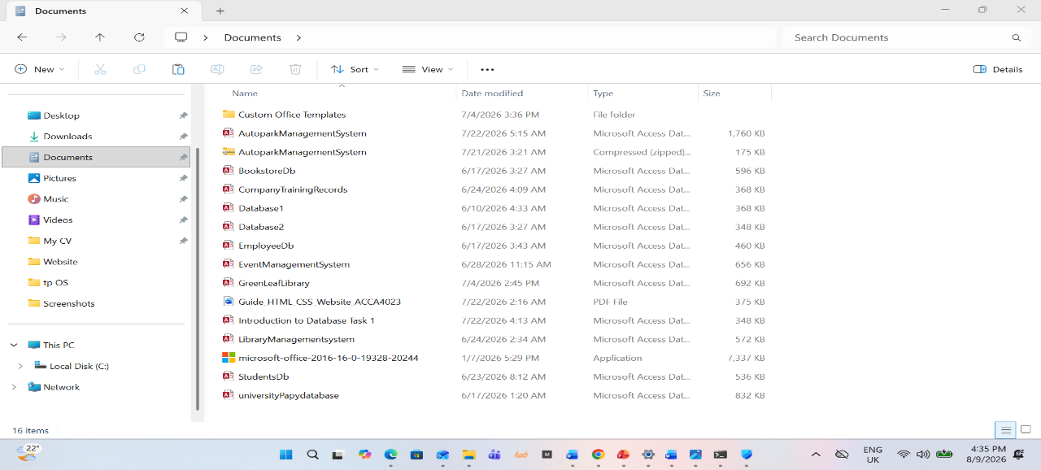

storage structure and protects important information from unauthorised acces

1.5 User Management
Another important function of an operating system is user management. Operating systems allow multiple users to access the same computer while keeping their files and settings separate. Each user account can have different permissions depending on its role. For example, an administrator has full control over the system, including installing software and changing system settings, while a standard user has limited permissions to prevent accidental or unauthorised changes. This feature improves both security and organisation, especially in schools, businesses, and public institutions where multiple people share the same computer. [7]

1.6 Device Management
Operating systems are responsible for managing hardware devices connected to the computer. These include printers, keyboards, mice, storage devices, graphics cards, and network adapters. The operating system communicates with these devices through device drivers, which allow the hardware to function correctly. It also detects newly connected devices and allocates the necessary system resources. Efficient device management ensures that hardware components work together smoothly and reduces compatibility issues. [8]

1.7 Network Management
Modern operating systems provide built-in networking features that allow computers to communicate with each other over local networks and the Internet. They manage network connections, assign IP addresses, monitor network traffic, and provide tools for troubleshooting connectivity problems. These networking capabilities enable users to browse the web, share files, print over a network, and access cloud-based services. Reliable network management is essential for both personal and professional computing environments. [9]
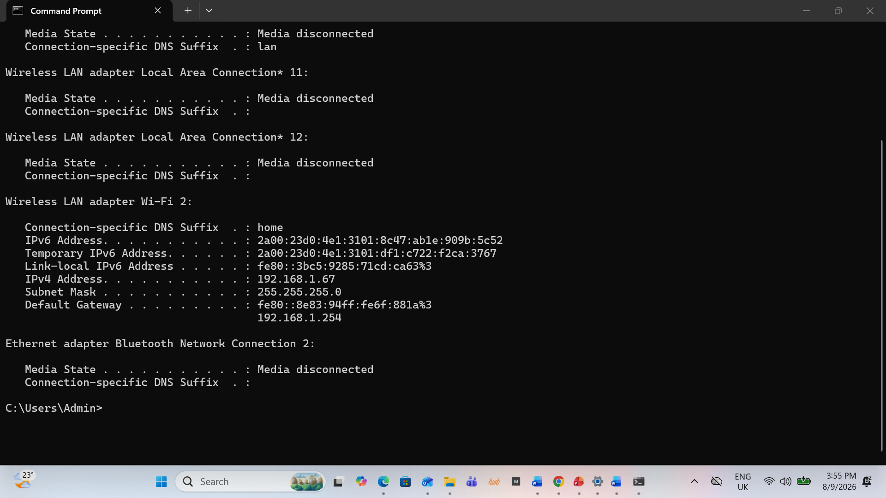

1.8 Security Management
Security is one of the most critical responsibilities of an operating system. Modern operating systems include various security mechanisms such as user authentication, passwords, firewalls, encryption, antivirus integration, and access permissions. These features help protect the system against malware, unauthorised access, and data theft. Operating systems also receive regular security updates that fix vulnerabilities and improve overall system protection. Effective security management ensures the confidentiality, integrity, and availability of information stored on the computer. [10]

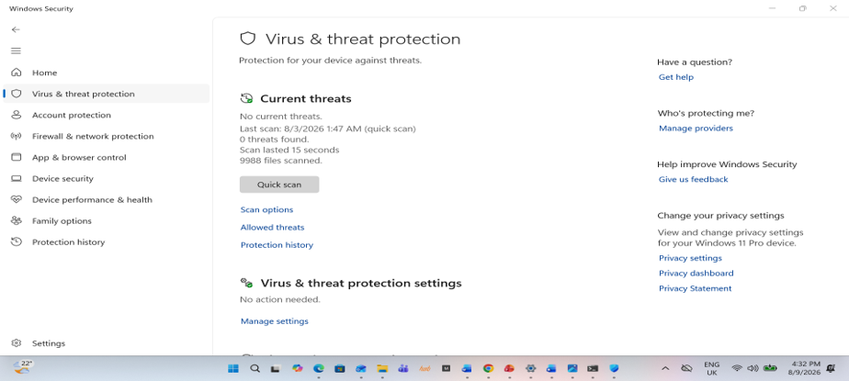

1.9 Summary
In conclusion, general-purpose operating systems perform a wide range of essential functions that enable computers to operate efficiently and securely. They manage processes, memory, files, users, hardware devices, network communication, and system security while providing an easy-to-use interface for users. Without these functions, modern computers would be unable to execute applications reliably or provide the stable environment required for personal, educational, and business activities. [11]

Task 2. Use of Windows OS CLI Commands

Introduction
Windows provides a powerful Command-Line Interface (CLI) through Command Prompt and PowerShell, allowing users and system administrators to perform administrative tasks efficiently. CLI commands are useful for managing files, monitoring system performance, testing network connectivity, administering user accounts, and automating routine operations. This section demonstrates ten commonly used Windows commands and explains their practical applications. [2]

2.1 task list: The task list command in Windows is a powerful tool that allows you to display a list of currently running processes on the local or a remote computer. This command can be used to filter processes based on various criteria such as memory usage, CPU time, user, and more. [13]
Category: Process Management
Command: tasklist
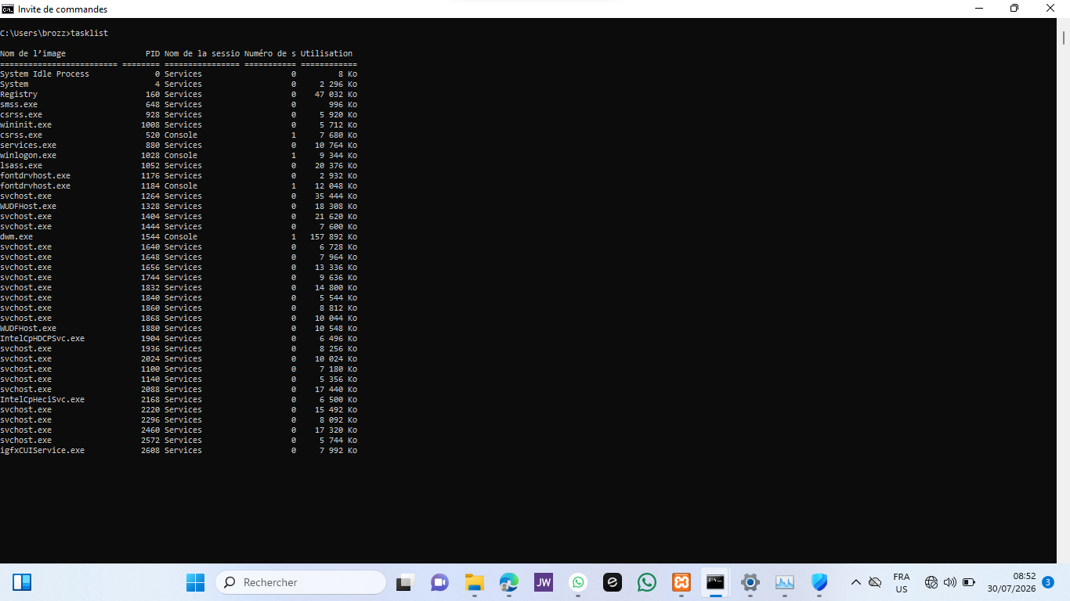

2.2 taskkill

Category: Process Management
Command : taskkill /IM notepad.exe /F

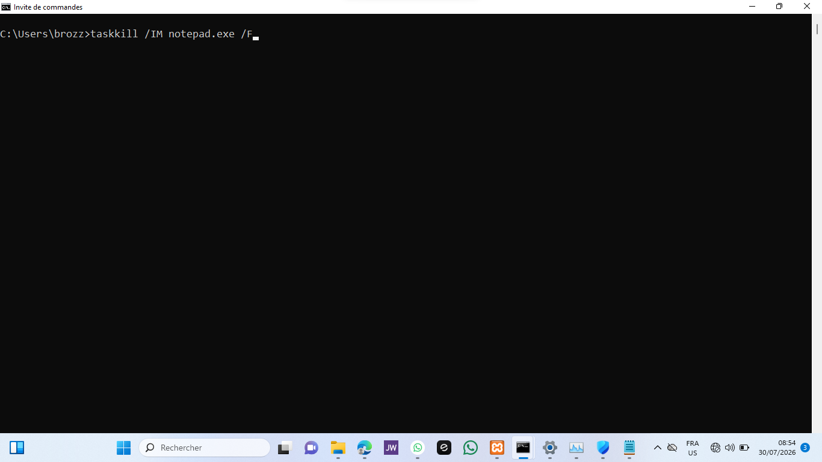

When done :

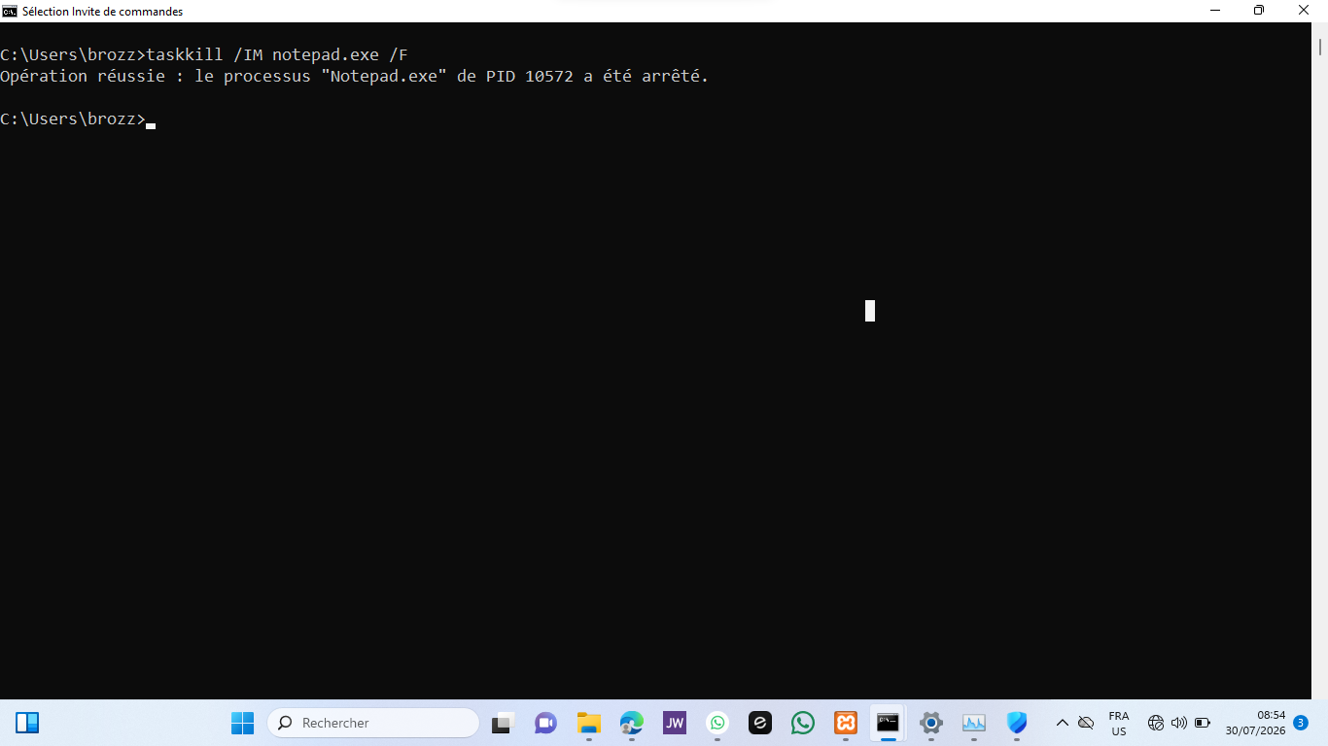

2.3 dir
Category: File and Directory Management
Command: dir
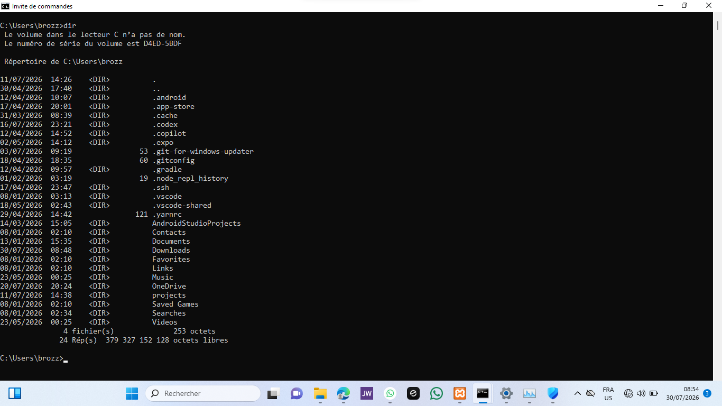

2.4 mkdir
Category: File and Directory Management
Command : mkdir TestFolder


2.5 ipconfig
Category: Network Testing
Command: ipconfig

2.6 ping
Category: Network Testing
Command : ping google.com
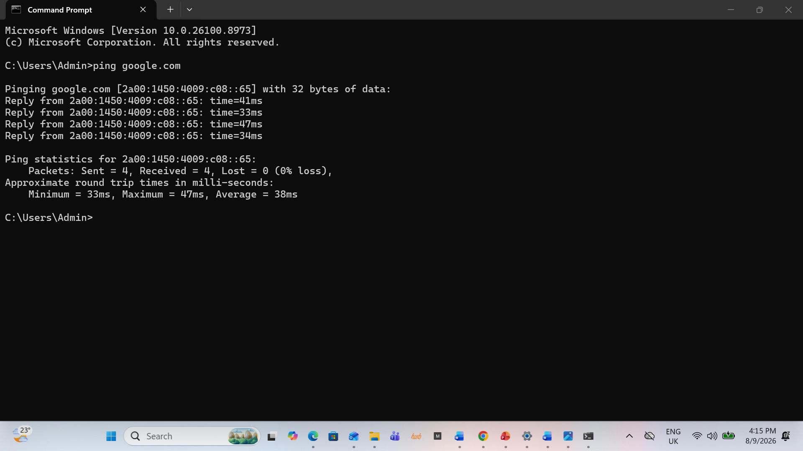

2.7 net user
Category: User Management
Command: net user

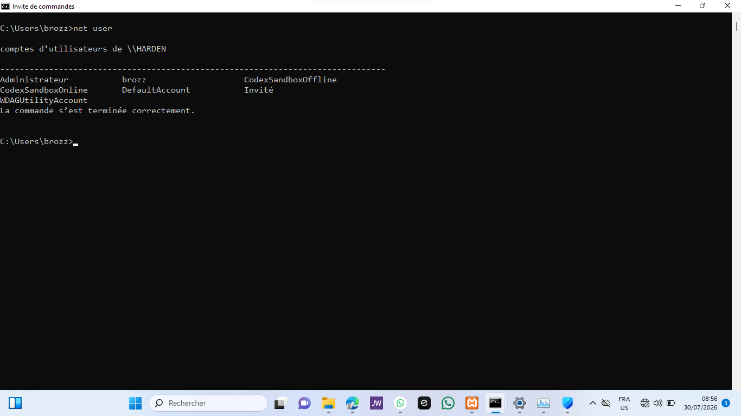

2.8 whoami
Category: User Management
Command: whoami

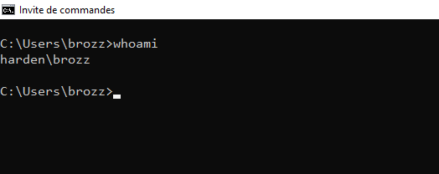

2.9 schtasks
Category: Task Scheduling
Command : schtasks
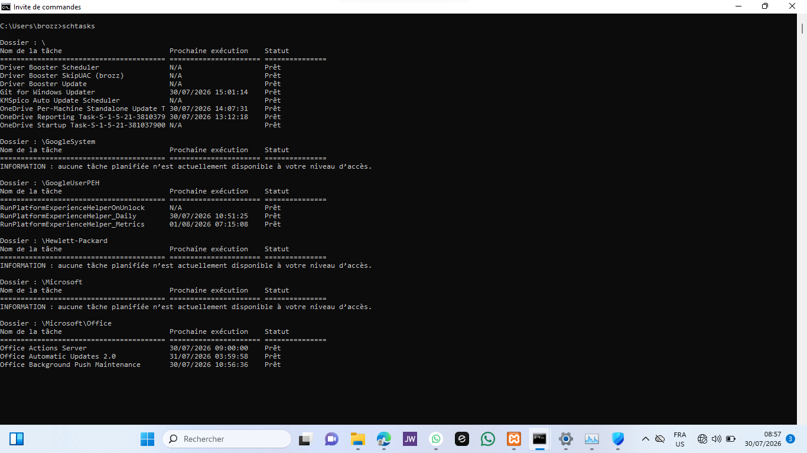

2.10 systeminfo
Category: System Information
Command: systeminfo

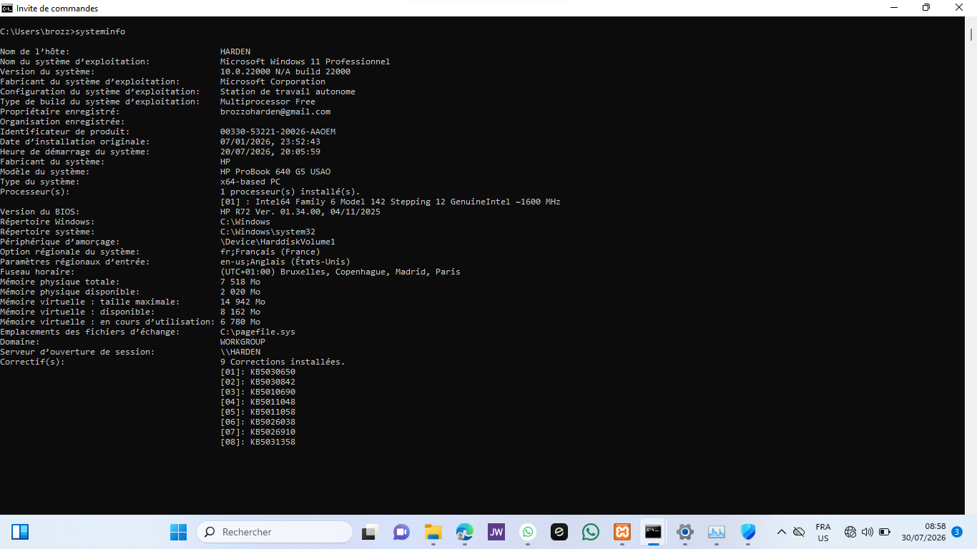

Task 3 – Use of Linux OS CLI Commands

Introduction
Linux command-line tools provide users and system administrators with an efficient way to manage files, monitor system performance, configure users, troubleshoot networks, and automate administrative tasks. Most Linux distributions use the Bash shell, which offers a wide range of commands for interacting with the operating system. Since macOS is Unix-based, many of these commands are also available in the macOS Terminal, allowing users to perform similar administrative tasks. This section demonstrates ten commonly used Bash commands and explains their practical applications. [2]

3.1 pwd
Category: File and Directory Management
Command: pwd
Description
The pwd command displays the current working directory. It helps users identify their location within the file system before performing file management tasks.


3.2 ls -la
Category: File and Directory Management
Command: ls -la
Description
The ls -la command lists all files and directories, including hidden files, together with detailed information such as permissions, ownership, size, and modification dates.
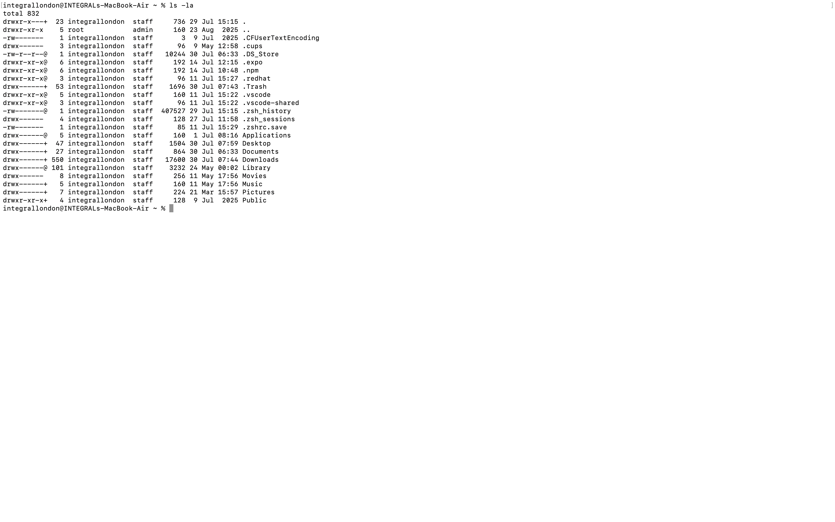

3.3 mkdir
Command: mkdir LinuxTest
Description
The mkdir command creates a new directory. It is commonly used to organise project files and prepare directory structures.

When done:
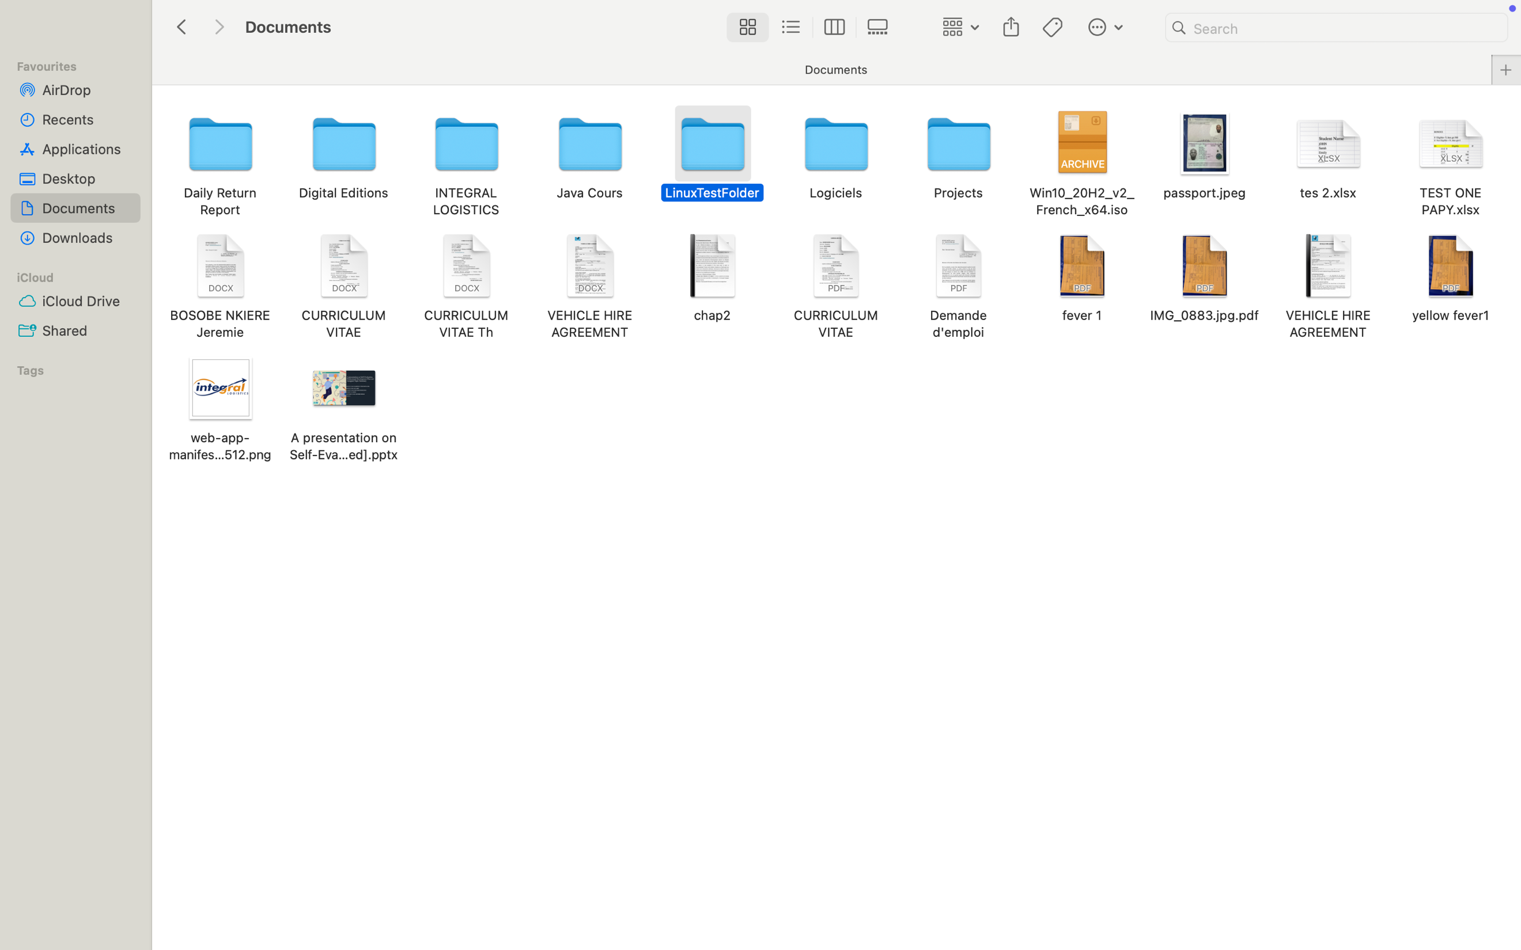

3.4 cp
Command: cp fichier.txt copie.txt
Description
The cp command copies files or directories from one location to another. It is frequently used to create backups or duplicate important files.
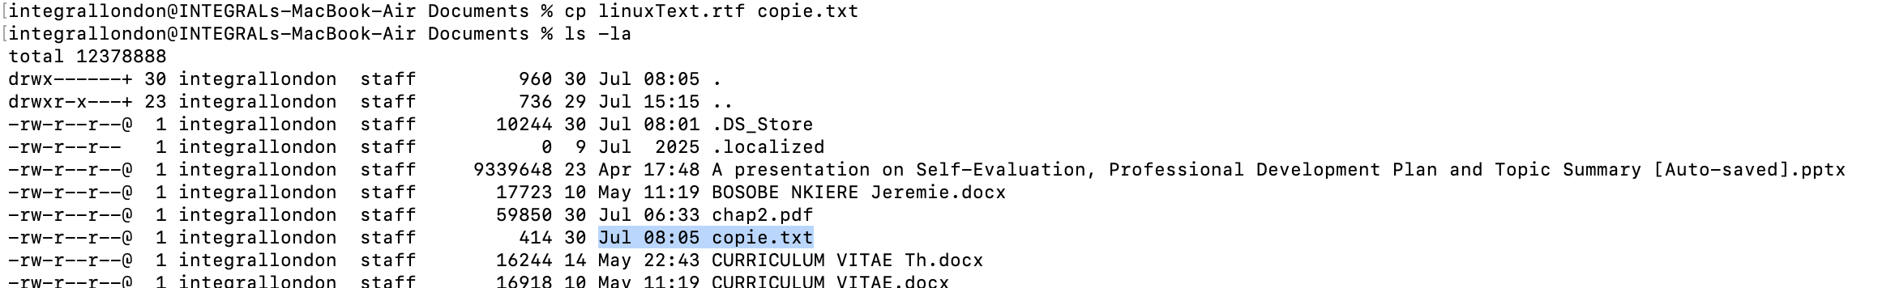

3.5 mv
Command : mv copie.txt nouveau_nom.txt
Description
The mv command moves or renames files and directories. It helps users organise data efficiently without creating duplicate files.
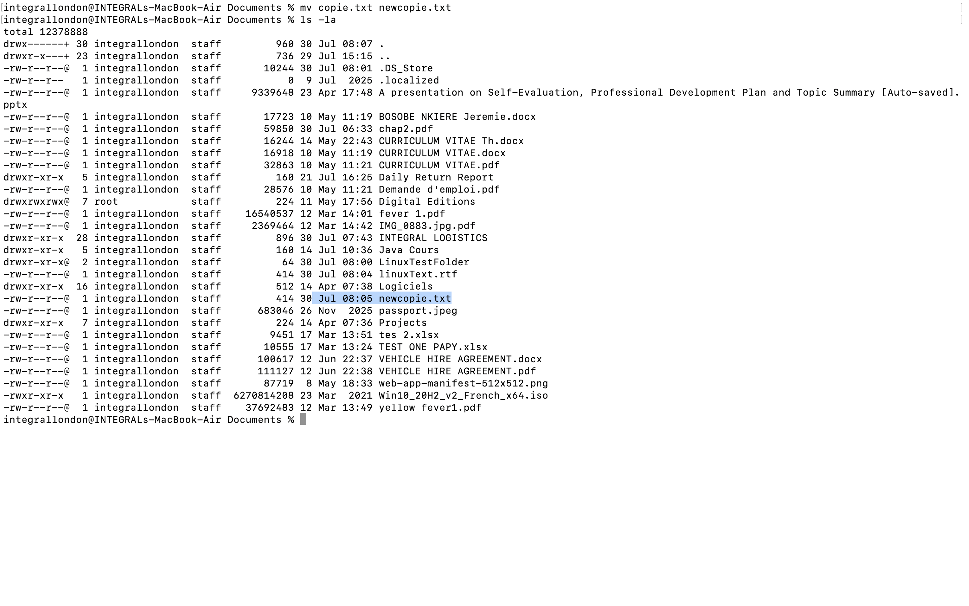

3.6 ps
Category: Process Management
Command: ps
Description
The ps command displays currently running processes. It provides useful information for monitoring active tasks and diagnosing system performance.
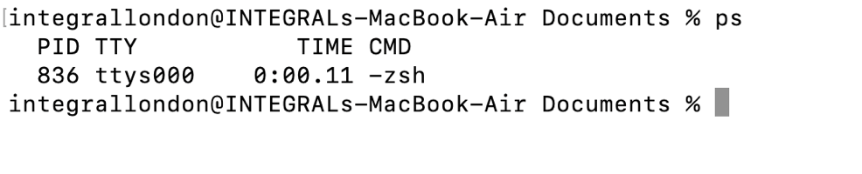

3.7 top
Category: Process Management
Command: top
Description
The top command provides a real-time view of system processes, CPU usage, memory consumption, and other performance statistics. It is widely used by system administrators to monitor system activity.
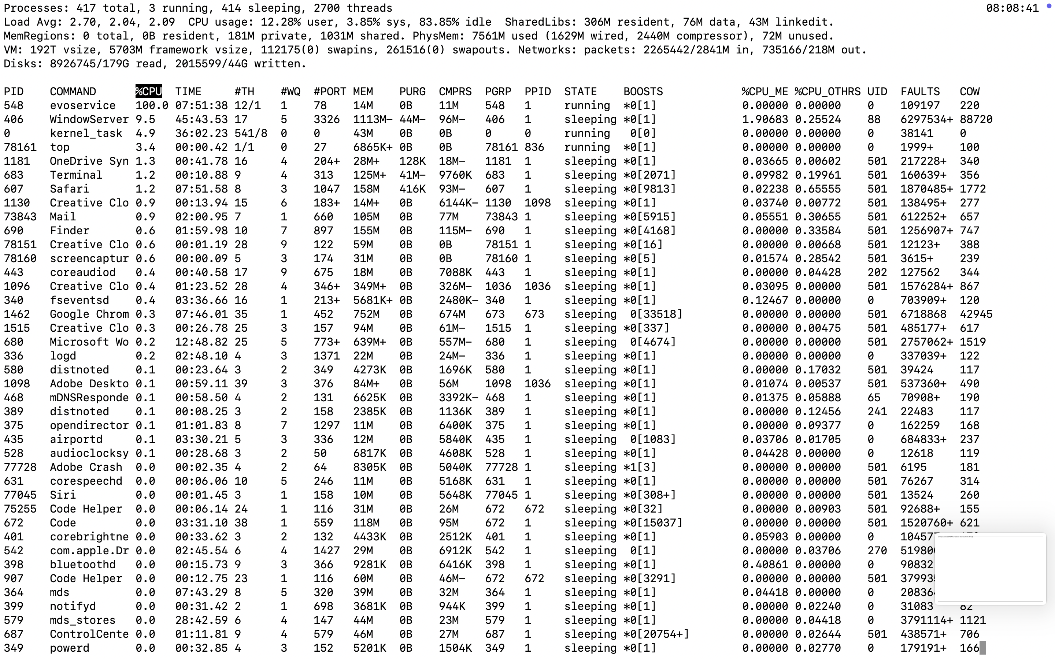

3.8 ping
Category: Network Monitoring
Command: ping google.com
Description
The ping command checks network connectivity by sending packets to a remote host and measuring the response time.

3.9 whoami
Category: User Management
Command: whoami
Description
The whoami command displays the username of the currently logged-in user. It is useful for verifying the active account in a multi-user environment.


3.10 crontab -l
Category: Task Scheduling
Command: crontab -l
Description
The crontab -l command displays the scheduled cron jobs for the current user. Cron is commonly used in Linux systems to automate repetitive administrative tasks.

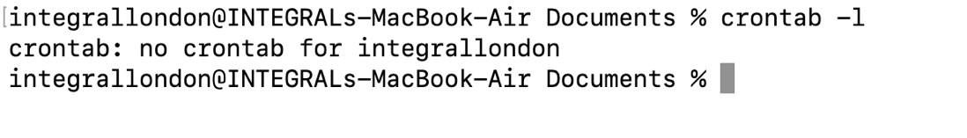

Task 4. Use of Windows OS Scripts

Introduction
Batch scripting allows Windows users to automate repetitive tasks by executing a sequence of commands stored in a text file with a .bat extension. Batch scripts improve efficiency, reduce manual work, and simplify common administrative operations. The following examples demonstrate how variables, user input, arithmetic operations, and conditional statements can be used to automate simple system tasks. [2]

Script 1 – Student Grade Calculator
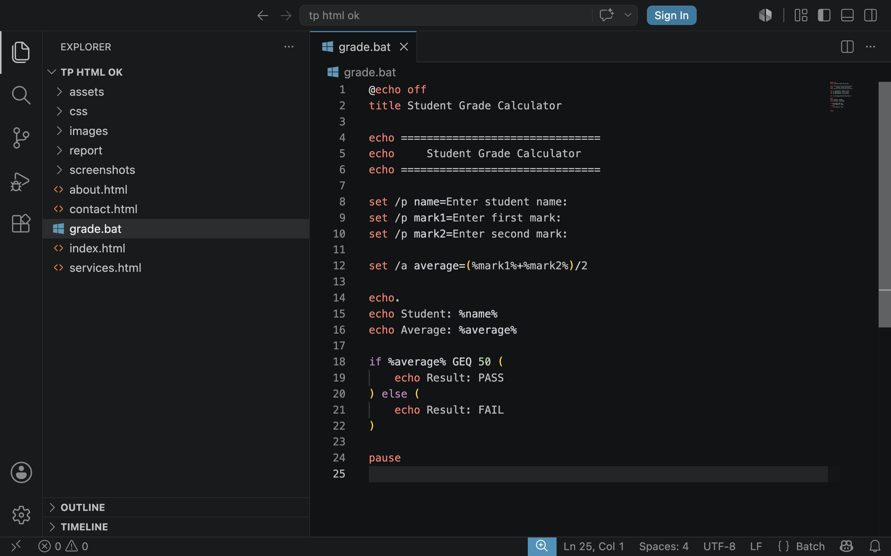

Description
This Batch script demonstrates the use of variables, user input, arithmetic calculations, and conditional statements. It requests a student's name and two marks, calculates the average score, and determines whether the student has passed or failed based on a minimum score of 50.
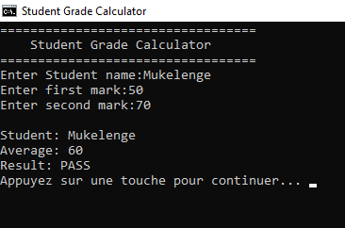
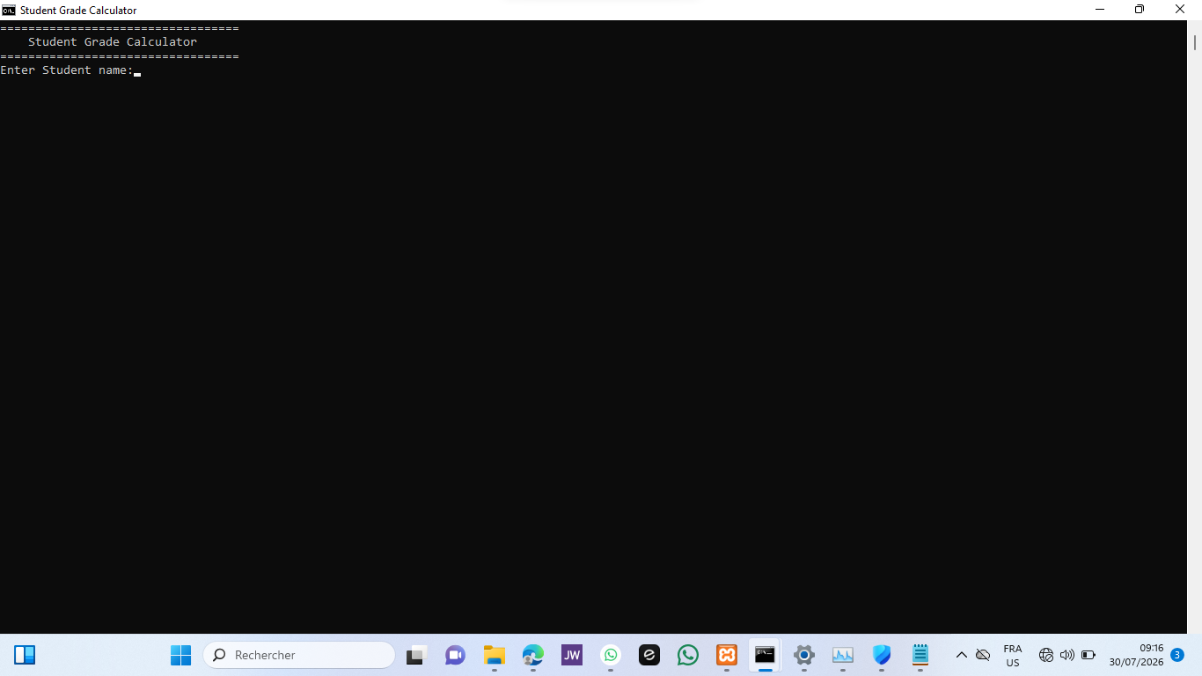

Script 2 – Countdown Timer
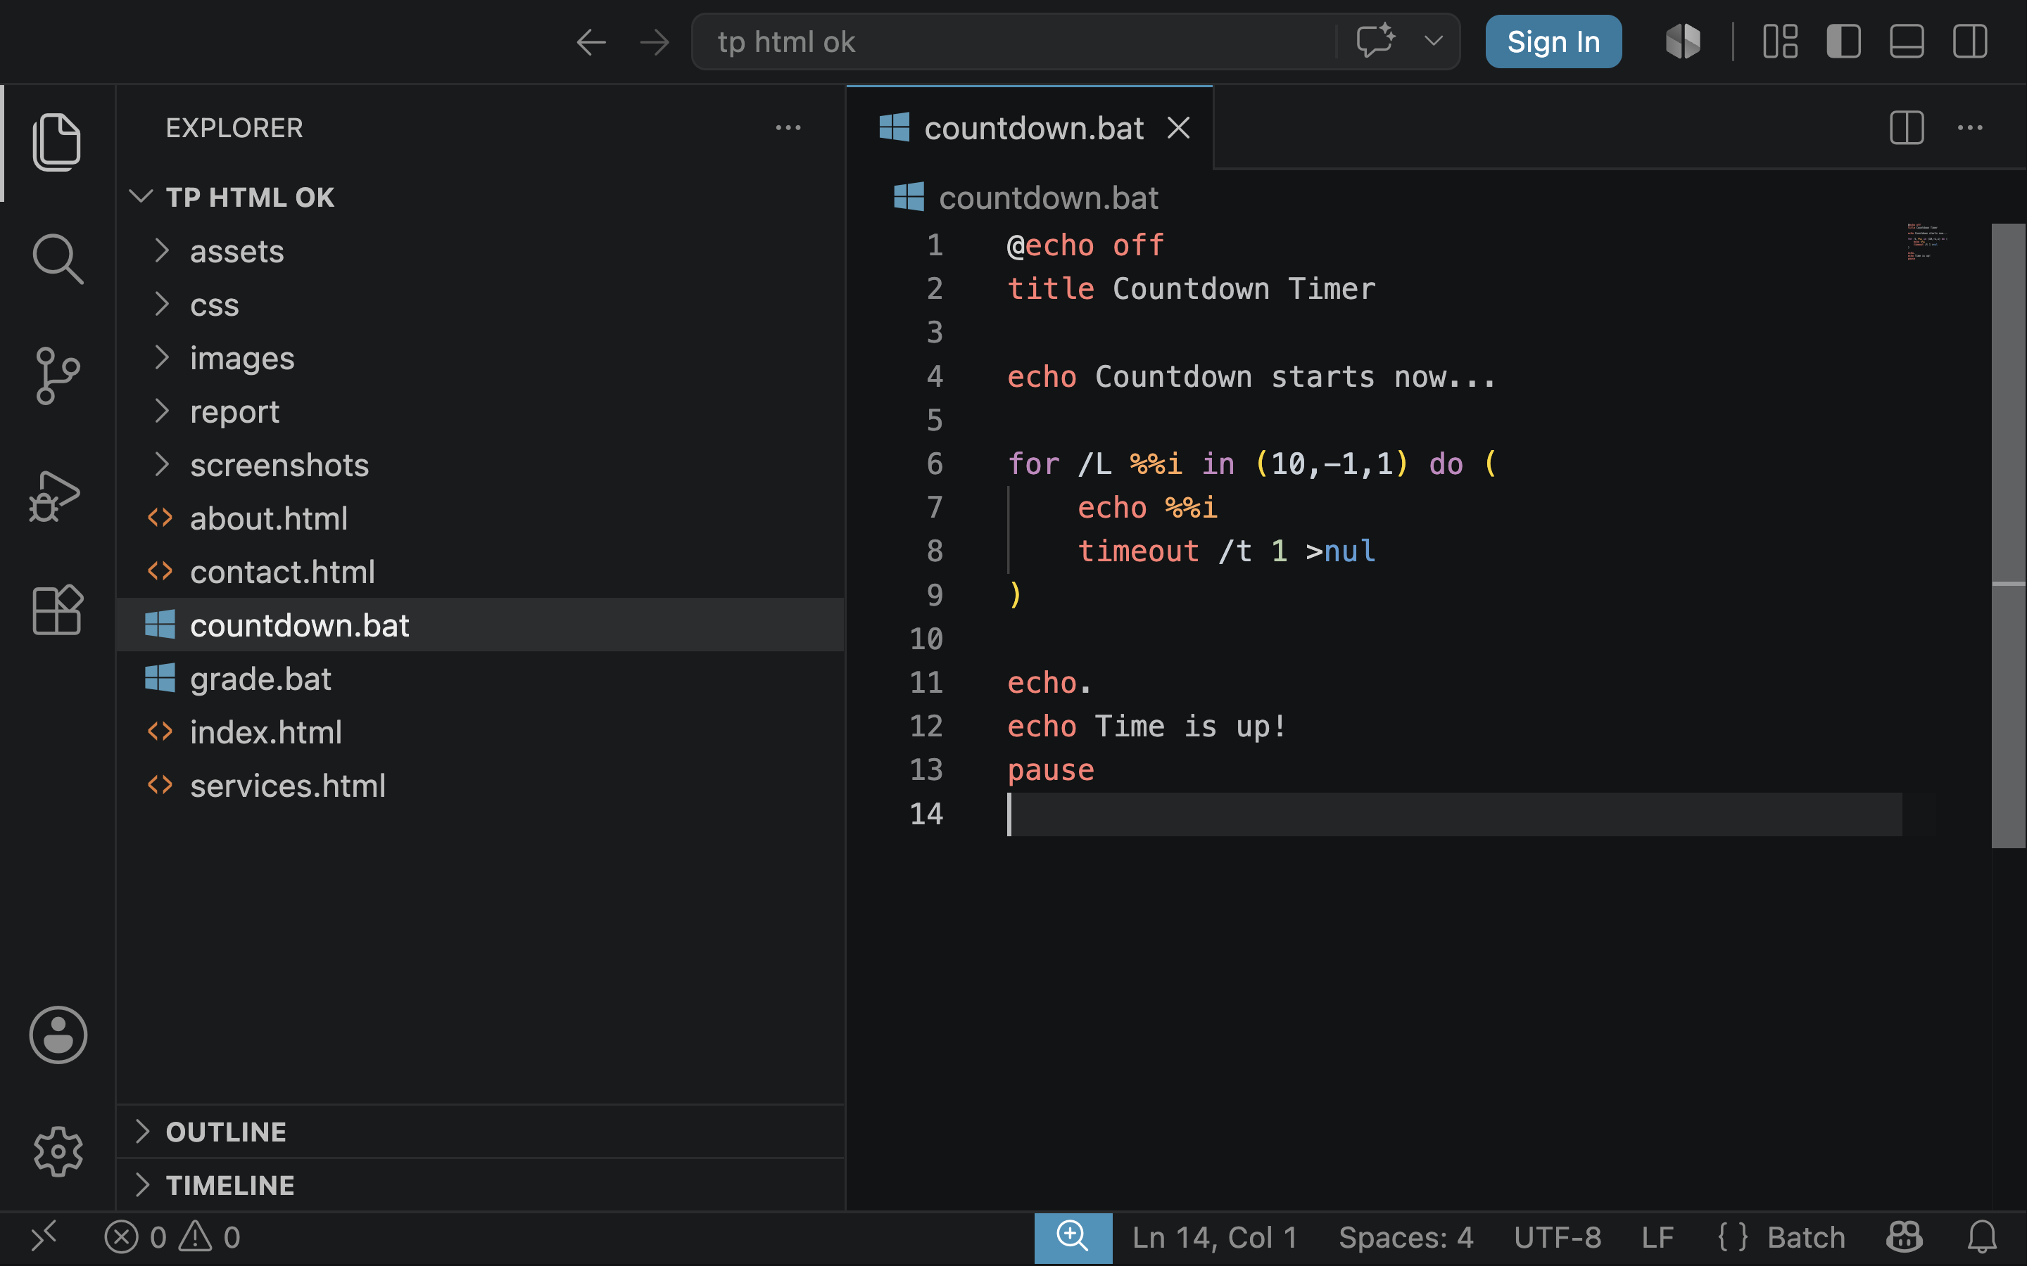

Result
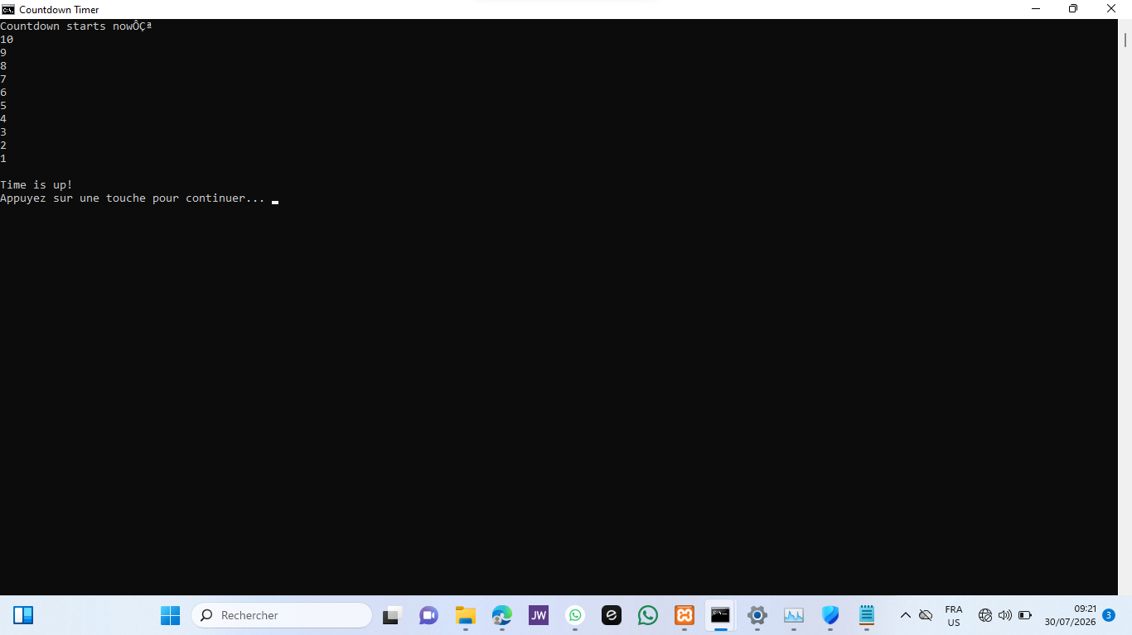
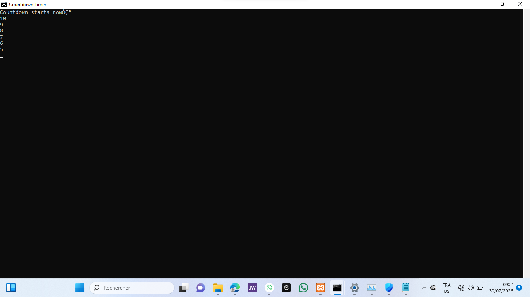

Task 5. Use of Linux OS Scripts

Introduction
Bash scripting is a powerful feature of Linux and Unix-based operating systems that enables users to automate repetitive tasks. By combining commands, variables, loops, and conditional statements, Bash scripts improve efficiency and reduce manual effort. The following examples demonstrate two simple Bash scripts that automate everyday command-line tasks. [2]

Script 1 – Student Grade Calculator
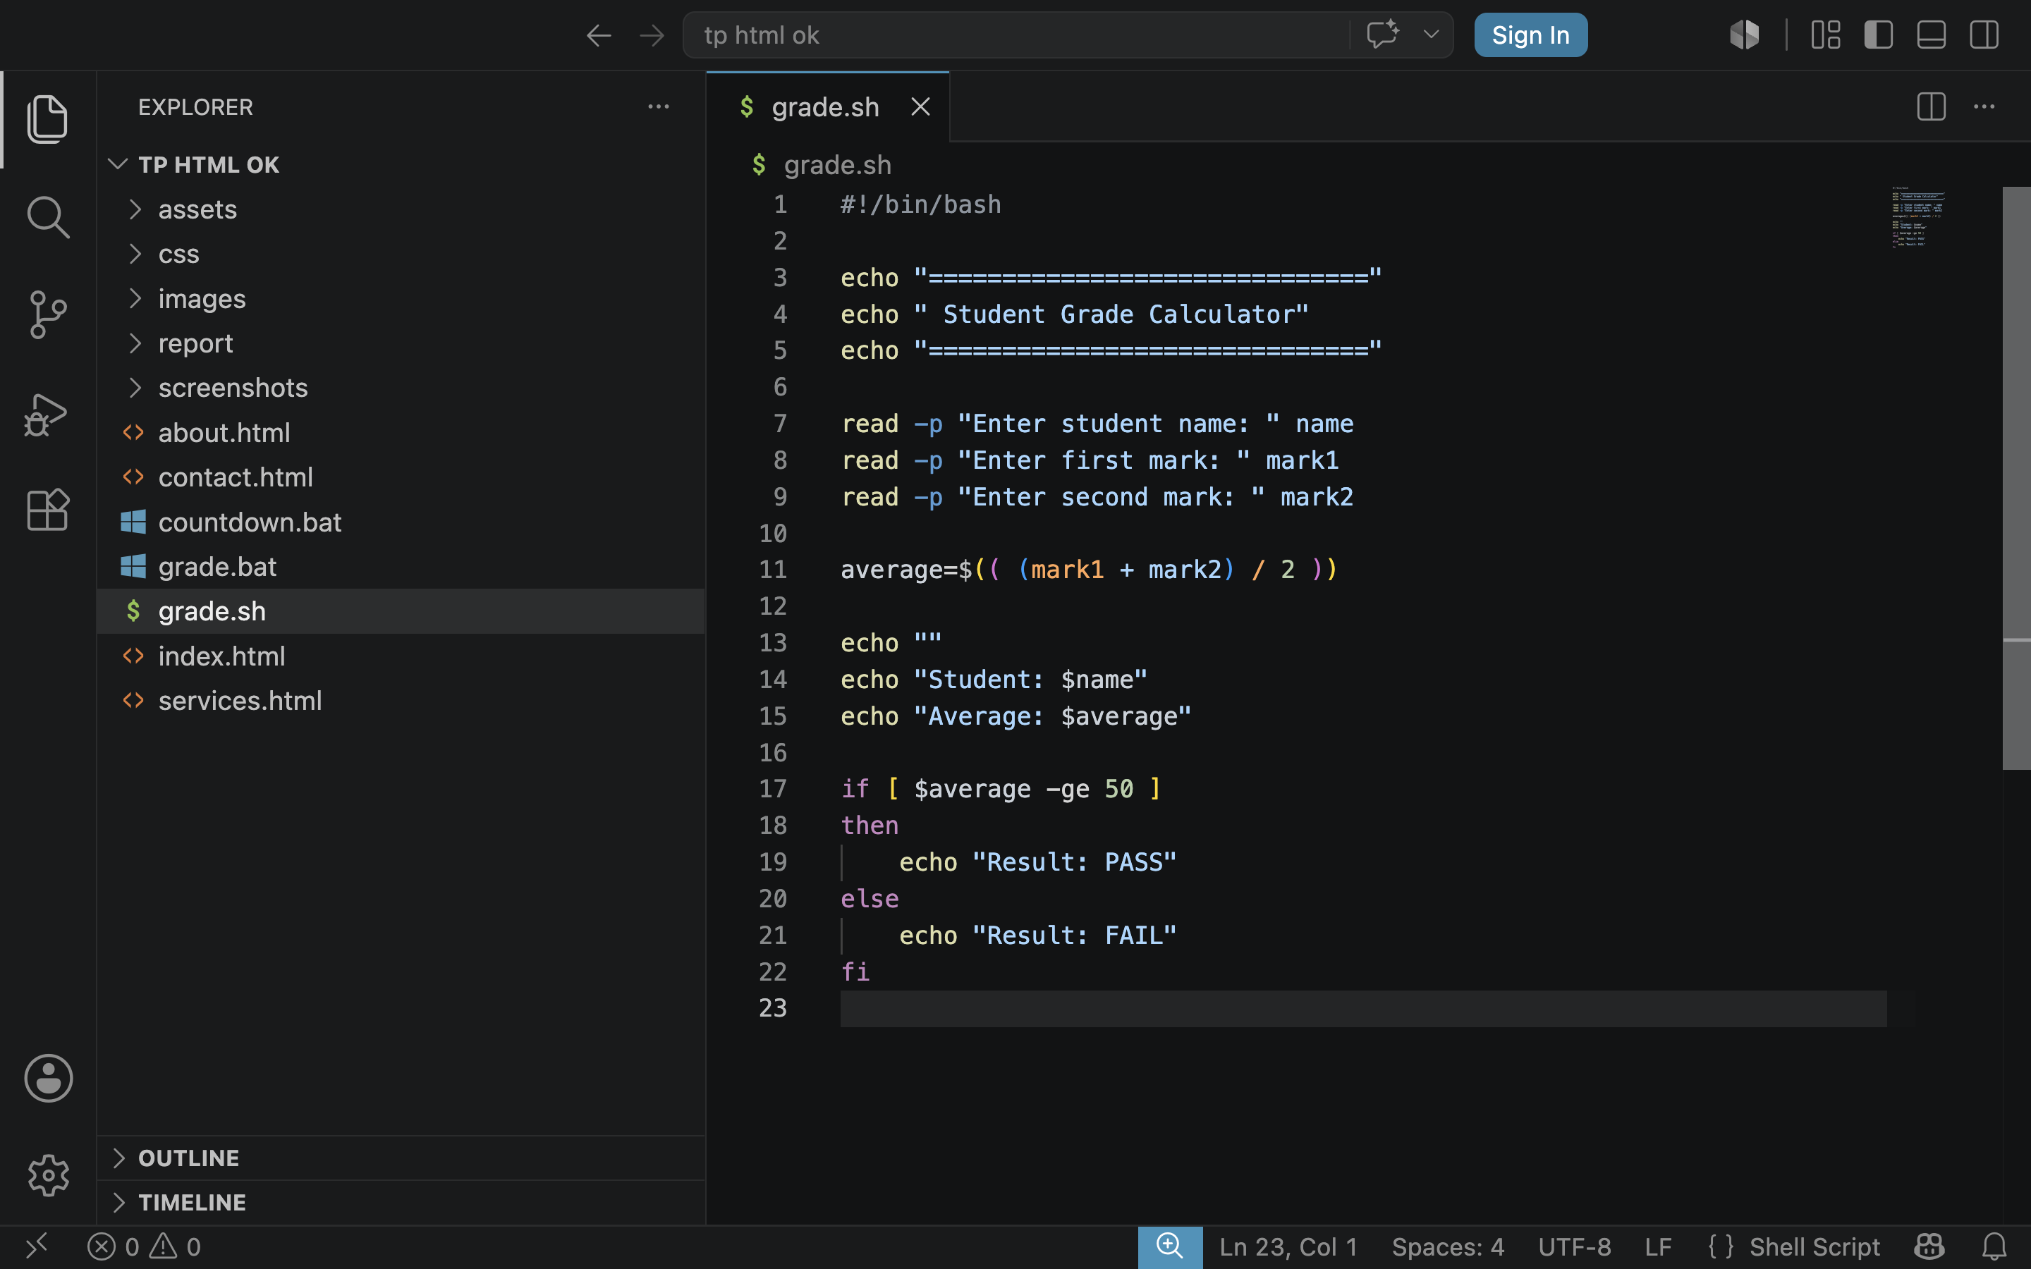

Description
Result :


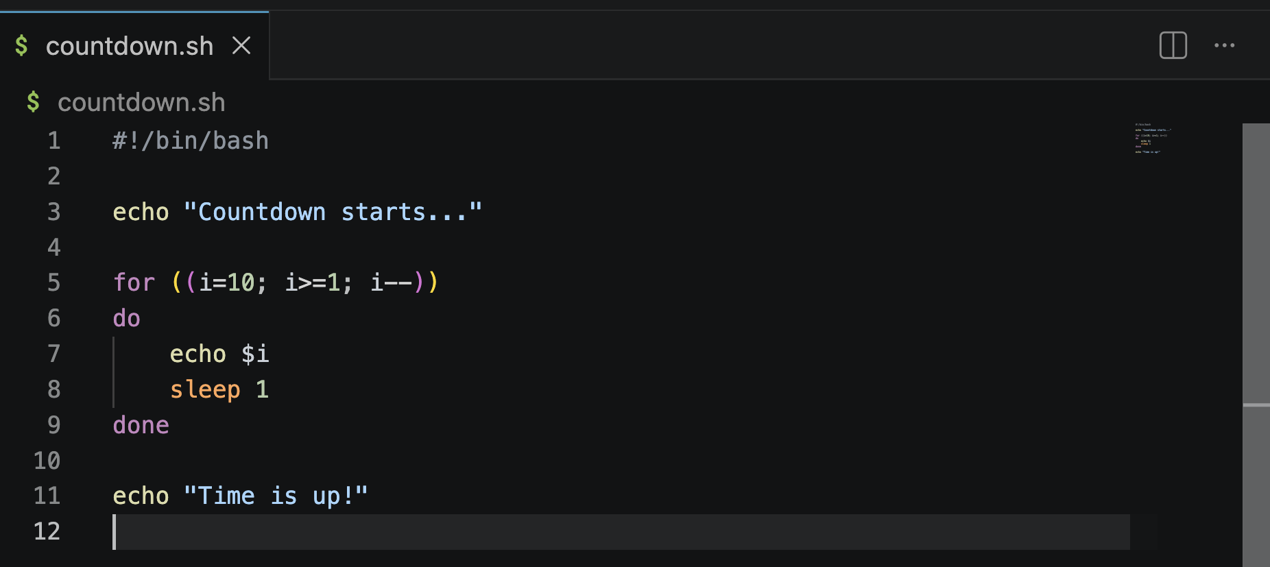

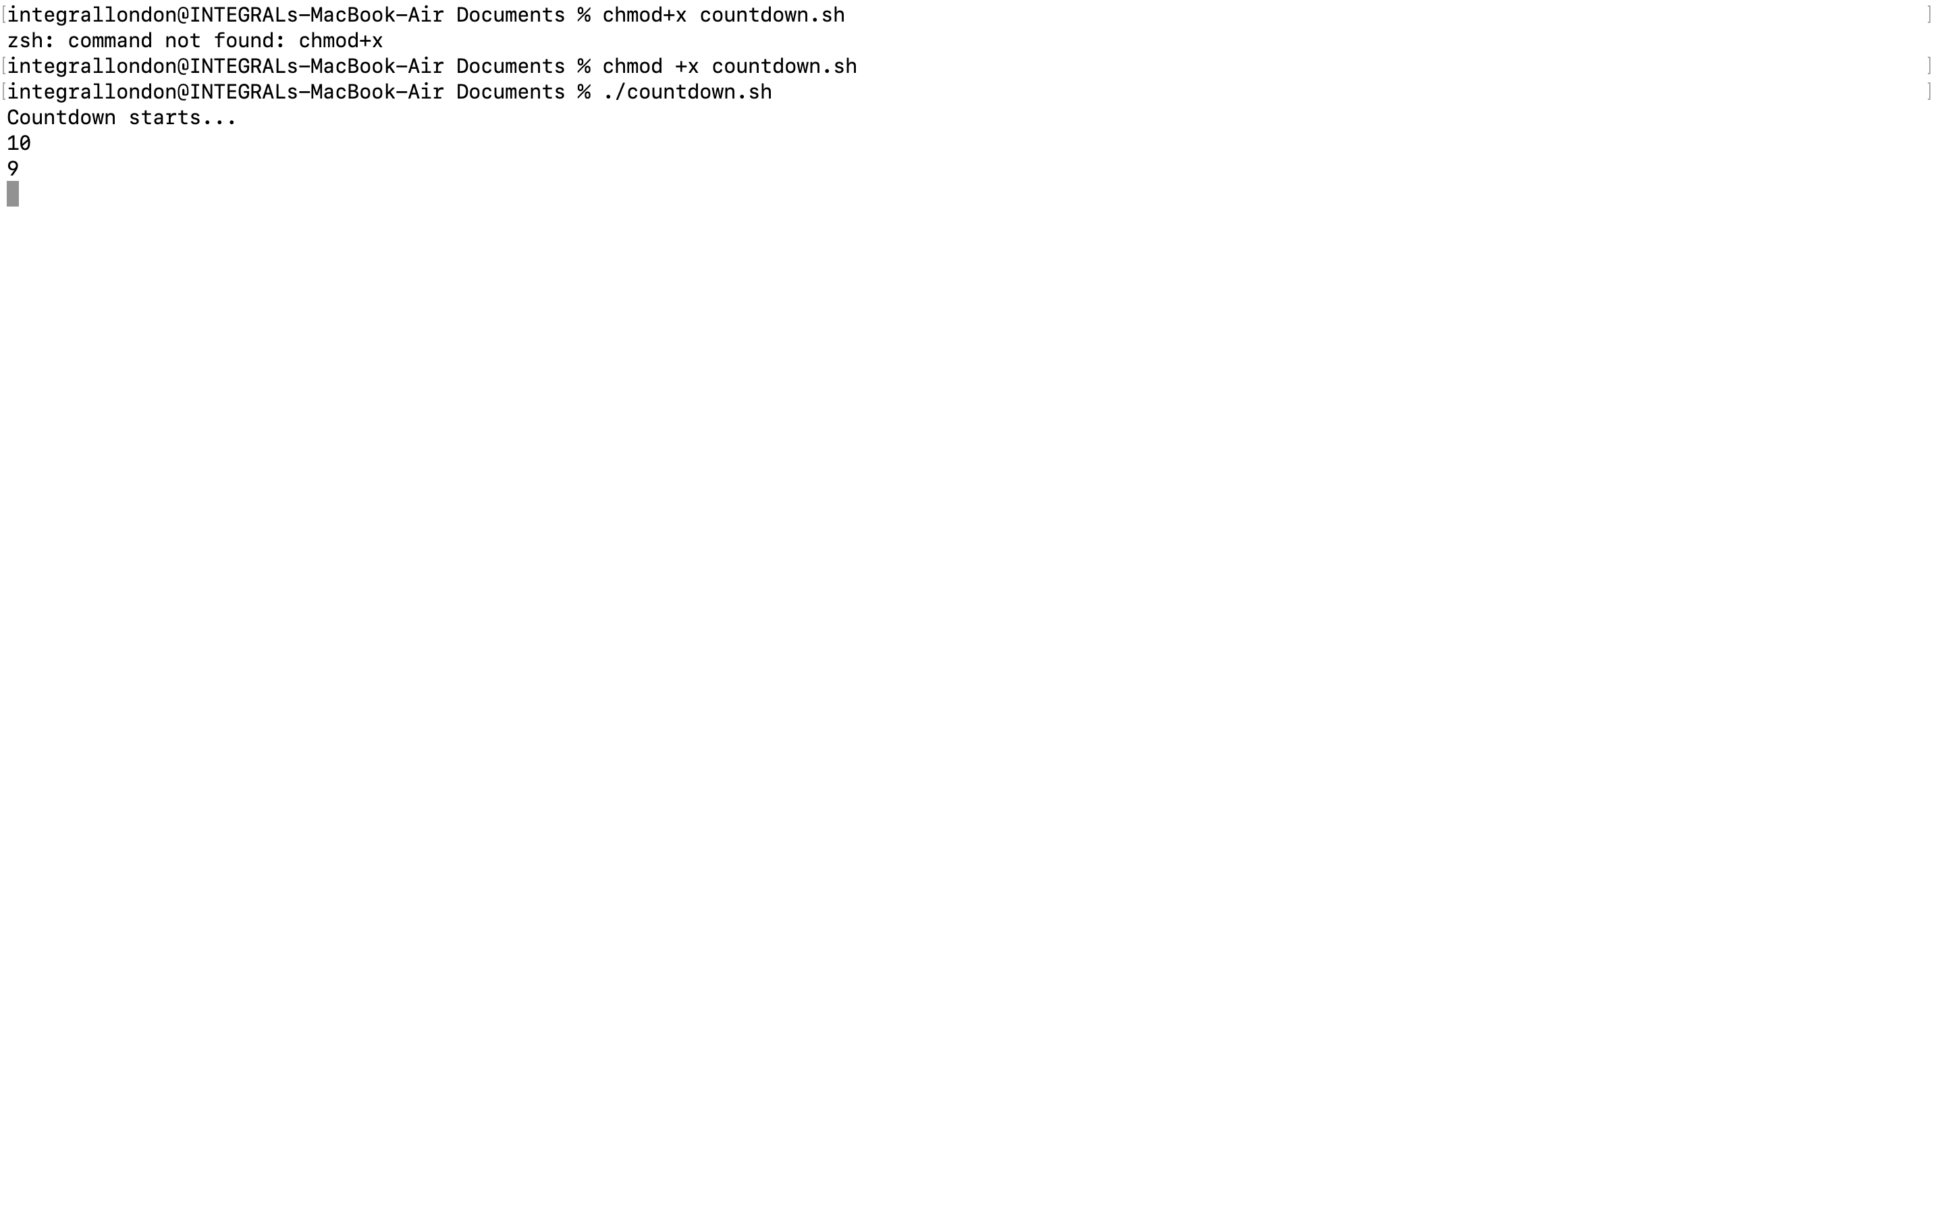

Script 2 – Countdown Timer
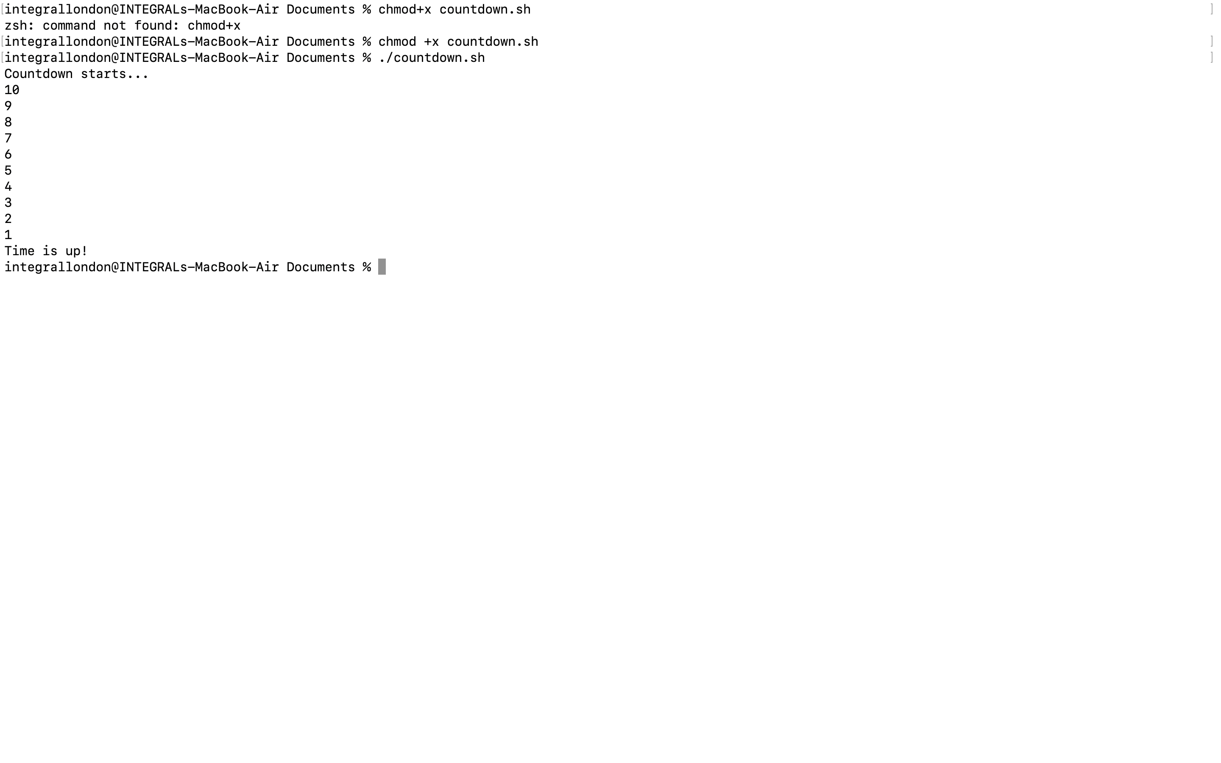

Result :

Result

Conclusion
This report has examined the fundamental functions of modern operating systems and demonstrated how command-line interfaces can be used to perform a variety of administrative tasks. The discussion highlighted key operating system functions such as process management, memory management, file management, user administration, device management, networking, and security. These functions are essential for ensuring that computer systems operate efficiently, securely, and reliably.
The practical activities completed in this assignment provided valuable experience using both Windows and Linux command-line environments. Through the use of Batch and Bash commands, it was possible to manage files, monitor system resources, test network connectivity, administer users, and explore task scheduling. In addition, the scripting exercises demonstrated how repetitive tasks can be automated using variables, conditional statements, loops, and user input.
Overall, this assignment improved my understanding of operating systems and strengthened my practical command-line skills. The knowledge gained will be valuable for future studies in computer systems, networking, cybersecurity, and system administration, where command-line tools continue to play an important role.

Bibliography

[1] | A. Sillberschatz, P. B and Galvin, “Mr,” in Operating system concepts, Wiley, 2018.
[2] | E. Siever, A. Weber and S. Figgings, in Linux in a Nutshell.

Bibliography

[1] | A. Sillberschatz, P. B and Galvin, “Mr,” in Operating system concepts, Wiley, 2018.
[2] | M. M. Chim, R. Ms. Vasundhara and C. Mrs. Pramila , “Linux & Windows Operating Systems,” Journal of Engineering, Computers & Applied Sciences (JEC&AS), 2013.
[3] | G. Anderson, wildsau.enemy.org, 2006.
[4] | J. M. Torres, “Windows Admin Scripting Little Black Book,” The Coriolis Group, 2004.
[5] | E. Siever, A. Weber and S. Figgings, in Linux in a Nutshell.

Bibliography

[1] | C. Dickson, “Everything an Administrator Wanted to Know about Operating System Internals but Was Afraid to Ask,” in USENIX Architecture / LISA17 Conference , 2017.
[2] | S. Murawski, “PowerShell Fundamentals,” in www.usenix.org, San Diego, CA, 2012.
[3] | H. S. Malallah, Z. R. M. Subhi, Z. . R. Rizgar , M. A. M.Sadeeq, Z. S. Ageed, I. M. Ibrahim, H. M. Yasin and K. . J. Merceedi, “A Comprehensive Study of Kernel (Issues and in different operating systems,” Asian Journal of Research in Computer Science, 2021.
[4] | Andrew S Tanenbaum and R. v. Robbert , “Distributed operating systems,” ACM Computing Surveys (CSUR), vol. 17, no. 4, pp. 419-470, 1985.
[5] | F. C. Freiling and S. Vömel, “A survey of main memory acquisition and analysis techniques for the windows operating system,” https://www.sciencedirect.com/, 2011.
[6] | A. Sillberschatz, P. B and Galvin, “Mr,” in Operating system concepts, Wiley, 2018.
[7] | B. Noble, J. Flinn, and K. Lee, “The Case for Operating System Management of User Attention,” https://dl.acm.org/, 2015.
[8] | Z. B. Akhtar, “Operating Systems (OS): An Insight Investigative Research Analysis and Future Directions,” https://e-journals.dinamika.ac.id/joti/index, 2024.
[9] | D. Kumar and S. Bansal, “IoT Ecosystem: A Survey on Devices, Gateways, Operating Systems, Middleware and Communication,” SpringerNature Link, vol. 27, p. pages 340–364, 2020.
[10] | Z. B. Akhtar, “Securing Operating Systems (OS): A Comprehensive Approach to Security with Best Practices and Techniques,” International Journal of Advanced Network, Monitoring and Controls, vol. 09, 2024.
[11] | R. Zebari, A. Abdulazeez, D. Zeebaree, D. Zebari and J. Saeed, “A Comprehensive Review of Dimensionality Reduction Techniques for Feature Selection,” Journal of Applied Science and Technology Trends, vol. 01, pp. 56-70, 2020.
[12] | M. M. Chim, R. Ms. Vasundhara and C. Mrs. Pramila , “Linux & Windows Operating Systems,” Journal of Engineering, Computers & Applied Sciences (JEC&AS), 2013.
[13] | J. M. Richter, “Creating, Managing, and Destroying Processes and Threads under Windows NT,” Microsoft Press.
[14] | G. Anderson, wildsau.enemy.org, 2006.
[15] | J. M. Torres, “Windows Admin Scripting Little Black Book,” The Coriolis Group, 2004.
[16] | E. Siever, A. Weber and S. Figgings, in Linux in a Nutshell.

