Appendix:

Appendix 1: Observation at Lesson Study 1. 20.2.19

Observation schedule.
What’s being observed | Pupil A | Pupil B | Pupil C
Engagement | - The pupil was engaged throughout the lesson – hands-up for questions answering.  - Watched patiently as the others engaged in the lesson.  - Little distracted when other pupils came into task. | - Did contribute to answering questions.  - Stayed engaged throughout the task. | - In the introduction, seemed a little distracted. When a question was asked the class, he looked around then put his hand up gingerly.  - Stayed focused on the lesson when others came into class.
Involvement | Level: 3  - Keen to answer questions throughout the lesson – from start to finish.  - When they got told to go and collect different objects, they went straight away.  - When comparing the different items, they stayed back and watched the others interacting with the objects. | Level: 4  - When they got told to go and collect different objects, they went straight away.  - Good focus on the task, keen to get involved.  - When asked to do investigate the different objects, they were keen to take charge and get involved quickly. | Level: 3-4  - When they got told to go and collect different objects, they went straight away.  - Good focus on task. Enjoyed exploring the different objects. However, focused on two objects rather than explore more.
Understanding | - Very good understanding of the lesson.  - Keen to answer questions from the class teacher. Listening intently to the instructions. | - Understood the task well.  - When asked which item they thought was the heaviest, they replied with the object they picked out even though every other member chose another item (which was obviously the heaviest). | - Understood lesson – comparing the weight of the different objects. He understood what was needed in the lesson.
How did the pupil interact with the concrete object? | - Was interacted in the lesson, keen to find objects to weigh.  - Quite hesitant and sat back whilst everyone else went to investigate the different objects. However, argued with another pupil because they help onto an item for too long. | - When having a discussion with another pupil, child B would play with the object.  - They were keen to get close to the weighing scales to see which item was the heaviest.  - Keen to get involved – first to look at the different objects and wanted to investigate every item, sometimes taking over from other pupils. | - Kept touching the scale.  - When asked to look at the different objects, Child C help onto 2 objects and stayed focus on those two objects.  - When it was Child B turn to order the objects in weight, Child C wanted to take over and change the order.
Did they ask any questions? | N/A | N/A | N/A
Is the pupil on task? | - Yes. First to put their hand-up to answer questions.  - Showing keenness in the lesson.  - Worked well in finding objects – stayed on task and didn’t wander off. | - On task. Keen to do well in the lesson – wanted to find another object, thought outside the box and went outside to find an object. | - Yes, after object was introduced. Some focus on the introduction but continuous focus once they were involved in the task.

Draw an outline of seating arrangement – how many children are with them? Is it difficult to take part? Is there enough resource for them all?

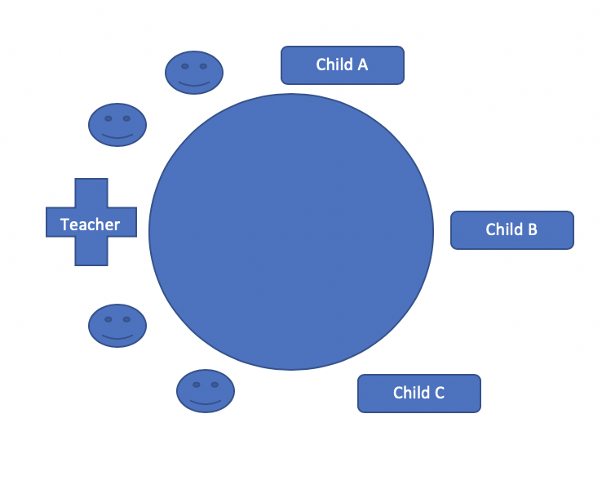

Appendix 2: Brookfield’s reflection model using ARC 20.2.19 Lesson 1

Autobiographical lens  What are your feelings regarding the experience?  What went well?  Disappointing elements?  What will you keep the same to ensure effective teaching and learning in the future?  What elements will you change?  What are your possible solutions to the disappointing issues identified?  What will you do next?” | What are your feelings regarding the experience?  What went well?  The children engaged well with the concrete objects and could talk about the object they had collected. They took turns well and some listened to their peers. They were happy with the objects the chose from around the classroom.  Disappointing elements?  Children found it difficult to use the mathematical terminology (Heavier / Lighter)  Another disappointing element was the use of children’s questioning skills. The children used very little questions.  What will you keep the same to ensure effective teaching and learning in the future?  In future I will use concrete objects to enhance children’s learning. This helped engage the children and consolidate their learning.  I would also keep the element of pupil choice the same, allowing them to chose the item they wanted.  What elements will you change?  Next time I would spend more time drilling the children on the correct use of mathematical vocabulary. Also I would try to introduce more questioning from the children.  What are your possible solutions to the disappointing issues identified?  What will you do next?”  In future I would ensure the children fully understand the mathematical terminology they need for the lesson by asking relevant questions to check for understanding. I would also encourage the children to ask each other more questions by introducing talking partners.
Students’ views (Generated from the interview)  How did you feel about the lesson?  What did you enjoy most?  What did you find difficult?  Do you think you would have gained the same knowledge without using __object__? If we hadn’t used the object do you still think you would have understood?  How can we make the lesson better?  If we did this lesson again tomorrow, how can we make it better? | How did you feel about the lesson?  Child A “ I enjoyed the weighing scales”  Child B “ I liked learning what was heavy”  Child C “ I liked everything about the lesson”  “ it was fun”  What did you enjoy most?  Child A “ enjoyed putting the paint into the bucket”  Child B “ finding my thing in the room”  Child C “Using the scales”  What did you find difficult?  Child A “ I didn’t enjoy finding what was….. the most bigger weight”  Child B  “ It was too easy to lift the things”  “ the paint was too big”  Child C  “ the paint was too messy”  “ I couldn’t find things in the classroom because all the other children were there”  If we hadn’t used the object do you still think you would have understood?  Child A “ no ….because we wouldn’t feel the paint and wood”  Child B “ no ……. Because it’s on paper”  Child C “because kilograms and grams are harder”  How can we make the lesson better?  Child A “ more things to weigh”  Child B “Big things to weigh…… ”  Child C “ We didn’t use kilograms and grams, we could use them next time”  If we did this lesson again tomorrow, how can we make it better?  Child A “we measure the same things again and more things maybe”  Child B “use different items”  “ like big things from the garden”  Child C “ ……. Do the same lesson again” “I don’t know”
Colleagues’ views  What are your feelings regarding the experience?  What went well?  Disappointing elements?  What will you keep the same to ensure effective teaching and learning in the future?  What elements will you change?  What are your possible solutions to the disappointing issues identified?  What will you do next?” | The children stayed engaged throughout the lesson. Children understood to put their hand up to answer a question. All children interacted with the concrete objects.  Child A only interacted with a few of the objects  Child C concentrated on two objects and wasn’t fussed about the rest.  Child B took over, looked at them all  A disappointing element was that the children asked little or no questions throughout.  In future the use of the concrete objects to enhance learning.  Elements that we will change:  - Prompt children to question more.  - A better understanding of the mathematical terminology.  A solution would be to question the children more and allow the children time to question each other more.  During introduction, ensure terminology is drilled.  In tomorrow’s lesson:  - More use of questioning and paired work.  - More drilling of mathematical terminology at beginning of lesson.
Theoretical lens | See Assignment.

Appendix 3: Observation Lesson Study 2. 21.2.19

Observation schedule.
What’s being observed | Pupil A | Pupil B | Pupil C
Engagement | - Very interested when first seeing the objects.  - Engages when reminded.  - Lost interest when it is not their go. | - Very interested when first seeing the objects.  - Engaged well with the objects.  - Took turns well. | - Very interested when first seeing the objects.  - Over engaged to the point Child C took over and had to be reminded to take turns.
Involvement | - Not as involved as partner, happy to allow partner to do the work.  - Happy to watch, helps when asked to.  Level 2 | - Watched other partners doing the task.  - Involved well when measuring out the ‘blood’  Level 3 | - Involved heavily in reading labels to see what the ingredients were.  - Liked to take over, had to be reminded by teacher to let partner take turns.  - Helped others read the scales.  Level 4
Understanding | - Very good understanding of the instructions (stir 10 times).  - Knows what they’re doing.  - Used mathematical language well.  - “you need 2 lots of 100ml to get the 200ml”  - Could easy read the scales and decide which measuring cylinder would be best to use. | - Clear understanding of capacity.  - Could use the ml and Litres vocabulary well.  - Could read the scales on the measuring cylinders. | - Very good mathematical language (ml and Litres)  - Understood the task well and could read the steps clearly.
How did the pupil interact with the concrete object? | - Needed prompting at the beginning to use the objects.  - Could use the objects to decide which cylinder was best suited to measure the larger quality. | - Very intrigued by the objects.  - Could read the scale well when pouring the ‘blood’ into the cylinder.  - Reacted well with the objects and read the scales well. | - Read the scales well and could decide which cylinder would be best to use.  - Understood that the cylinder would not hold 200ml and quickly realised you’d need 2 of them.
Did they ask any questions? | - Could we wash in it? | - Is it real blood? | - Is she going to use it as shampoo?  - Will she drink it?  - Can we tip them in all together?
Is the pupil on task? | - The objects helped keep child A on task. | - Listened well, on task and worked well with partner. | - Likes to be involved, even when not needed.  - Helped partner really well with reading the scales.

raw an outline of seating arrangement – how many children are with them? Is it difficult to take part? Is there enough resource for them all?
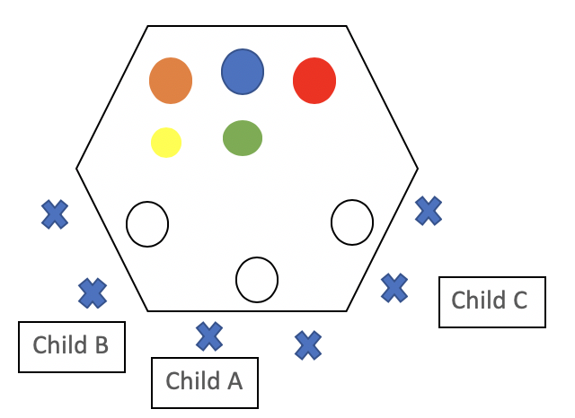

Appendix 4: Brookfield’s reflection model using ARC 21.2.19 Lesson 2

Autobiographical lens  What are your feelings regarding the experience?  What went well?  Disappointing elements?  What will you keep the same to ensure effective teaching and learning in the future?  What elements will you change?  What are your possible solutions to the disappointing issues identified?  What will you do next? | What are your feelings regarding the experience?  What went well?  Children were engaged throughout the task. They all interacted with the concrete objects. However, as they were placed in pairs, some found it difficult to share as they love to take over and complete the lesson themselves. They loved the idea of making a potion to help Rapunzel.  Disappointing elements?  - Classroom management. The concrete objects seemed to have excited the children, although they were focused on the task. They found it difficult to listen to instructions once they were introduced to the concrete objects.  - Another disappointing element to the lesson was the lack of questioning from the pupils. Although some questions were asked from the pupils, none were linked to the concrete objects.  What will you keep the same to ensure effective teaching and learning in the future?  I will continue to use concrete objects in lessons as the children were thoroughly engaged and involved in the lesson. It helped pupils learn as they got to physically see the liquid being poured into the test tubes.  What elements will you change?  I will encourage the children to ask questions about their learning.  I would ensure that the children stay focused on the instructions and not get distracted by the concrete objects.  What are your possible solutions to the disappointing issues identified?  What will you do next?  I would encourage children to ask questions about the learning taking place. I would encourage appropriate behaviour. As the concrete objects was so exciting, they got so distracted and wanted to get stuck into the lesson instead of listening to the instructions on how much you need of each item.
Students’ views (Generated from the interview)  How did you feel about the lesson?  What did you enjoy most?  What did you find difficult?  How can we make the lesson better?  If we did this lesson again tomorrow, how can we make it better? | Did you enjoy that lesson?  All: YES!  How do you feel about the lesson?  Child C (Reuben): Good. I liked it because it was like science and I like science.  Child B (Freya): Funny… *thinking* reading the instructions because of the funny names.  Child A (Amelia D): I thought it was exciting because we got to pour the stuff in.  What did you enjoy the most?  Child C: *thinking* the stirring of the ingredients.  Child B: I enjoyed putting the stuff into the pot.  Child A: Same, I enjoyed putting the stuff in.  What did you find difficult?  Child B: *Thinking* I found it tricky to put it to the right place.  Child A: Put it in the right place.  Child C: I found pouring it in difficult. It was fun, but I kept pouring it too high.  Did you like using the measuring cylinders?  All: YEAH!  Why?  Child A: because… I don’t know… because you got to do it.  Child C: I liked pouring it in… and drinking it.  Did you drink it?  Child C: no.  What about you *Child B* why did you like using it?  Child B: *thinking* I don’t know.  Did the cylinders help you in your learning?  Child A: Yeah!  Child B and C: Yeah!  Why?  Child A: because it had numbers on it  Child C: Because it shows the 10s and the… it goes up in 10s and 2s.  Child B: … millilitres.  Child C: That was a hard one.  Child B and A: yeah.  How can we make the lesson better for next time?  Child C: Filling it all the way to the top, and pouring it in to see what it makes. Pour two jugs… you have to have two and pour them… then pour some of that into the other one.  Do you think that will help your learning?  Child C: Yes, because you will see how much it makes.  Child B: I would like more stuff to measure.  Child A: *Thinking* … More stuff.
Colleagues’ views  What are your feelings regarding the experience?  What went well?  Disappointing elements?  What will you keep the same to ensure effective teaching and learning in the future?  What elements will you change?  What are your possible solutions to the disappointing issues identified?  What will you do next?” | The children really enjoyed the lesson. They all got excited when they were asked to make a potion for Rapunzel's hair. They took it in turns to read the instructions and to measure out the ingredients. They helped each other well. They used good mathematical terminology (ml and Litres and capacity)  Although prompted the children didn’t really ask any questions again.  The practical element helped the children engage with their learning. They enjoyed using the measuring apparatus cause they were hands on. Some of them found it difficult to read the scales because of the size. A solution to this could be to use bigger measuring cylinders, although this would stop children from choosing the best measuring cylinder they think.  In future we would need to encourage the children to ask more questions to themselves and the teacher.
Theoretical lens | See Assignment.

Appendix 5: Consent form.
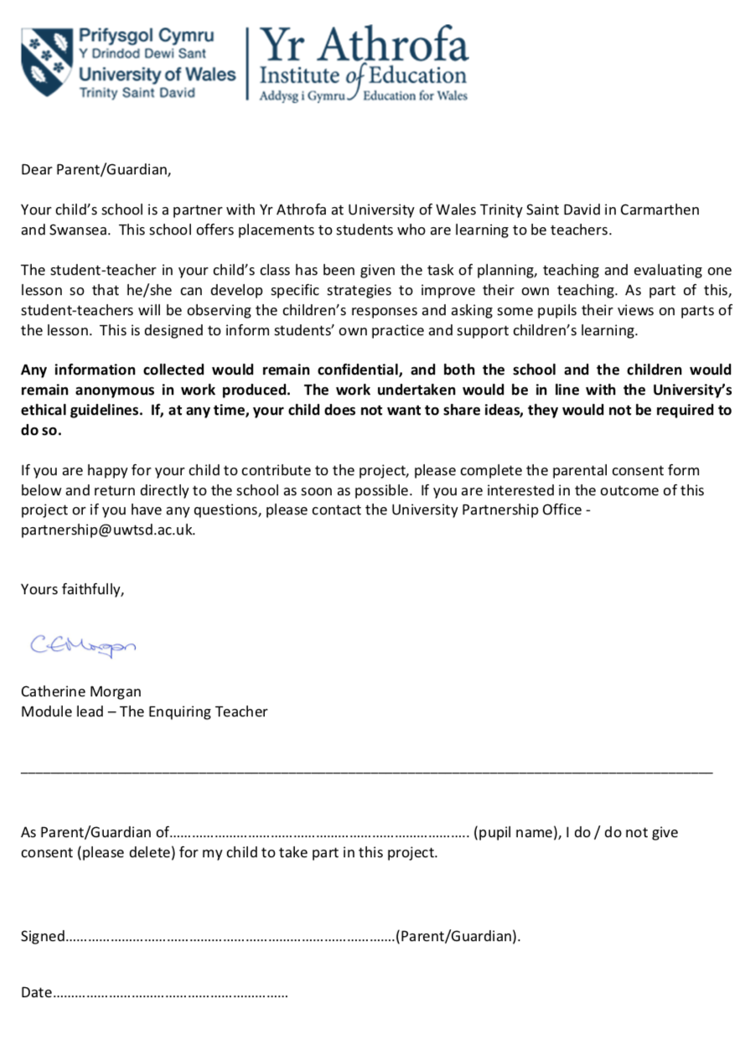

Appendix 6: Leuven Scale of involvement



