RAHEEMA ASHRAF
2334327
BMHP 5019
INTRODUCTION TO INDEPENDENT RESEARCH SKILLS

Task 1 – Personal Brand
Write about your own person brand and how you could develop this to enable you to reach your employment goals (250 words- Minimum of 2 referenced sources)
Ans:
Personal brand is the image, values and qualities that people use to judge my credibility, employability and contribution, and that they associate with me as a professional. The brand of health and social care I want to have is compassionate, dependable, culturally sensitive and open to learning. This should not be superficial self promotion, but shown in ethical behavior, person centered communication and competent demonstration. Gorbatov, Khapova and Lysova (2019) propose that personal branding may enhance perceived employability if it conveys value to employers.
My key strengths include being empathetic, reliable, respecting diversity and being digitally confident. The strengths are suitable for a role in employment where I would try to take on a graduate position in adult health and social care, for example assistant practitioner, senior support worker or care coordinator, and then move towards care home management. I have some areas that I need to develop however, these are limited leadership confidence, developing experience with digital care records, and improving professional report writing. If I don't fill these voids, my brand could seem caring but not fully responsible.
To address these areas of weakness, I will undertake a personal development plan, seek feedback on placement, attend short courses on safeguarding, equality and digital health and work on report writing and inter-disciplinary communication. Values, knowledge, skills, and socialization in teams are key aspects of professional identity within health professions (Cornett, Palermo and Ash, 2022). So my brand will demonstrate safe, respectful and improving practice.

Task 2 - Network Map and Rationale
Create a map of your own network considering career, support, social and community dimensions. Additionally you should provide a supporting rationale explaining and critically assessing this (250 words-Minimum of 2 referenced sources).
Ans:
Network Map
Me – Future Health and Social Care Professional
Career Network: lecturers, placement supervisors, LinkedIn contacts, NHS employers, care home managers, career advisers
Support Network: family, close friends, tutors, classmates, mentors
Social Network: classmates, peers, community friends, online professional groups
Community Network: volunteering organisations, local care services, cultural groups, community health projects

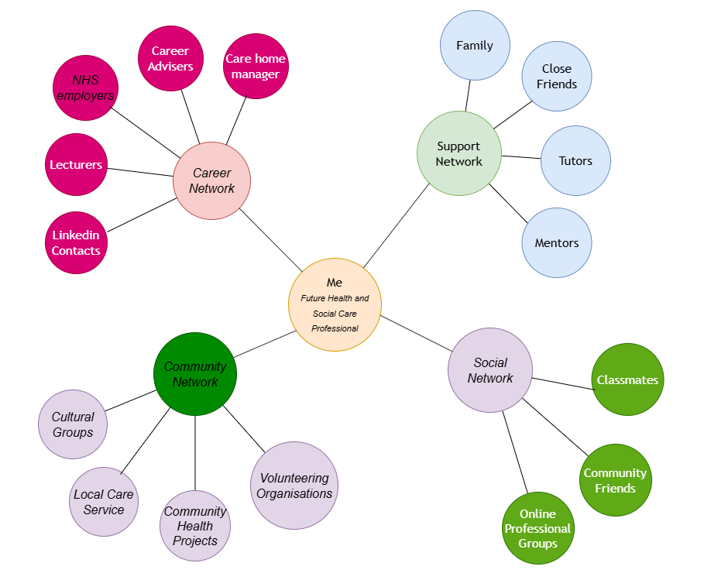
Rationale:
My network map looks like there are four connected but unequal areas that support my employability. My support network is strong because they are family, close friends and tutors providing encouragement, feedback and emotional stability. This is bonding social capital, fostering trust and resilience, but may be restrictive if I rely exclusively on familiar people. I'm building a career network through lecturers, placement supervisors, LinkedIn contacts, organisations in the NHS and care sector, but it needs to be improved as opportunities for graduates can be related to wider professional visibility. Social capital is closely related to employability, as networks facilitate access to information, confidence and career supports, argue (Letnar and Širok, 2025). My social network is helpful for wellbeing, communication practice and confidence but not all social contacts contribute directly to employment. Through my community network, and volunteering, services and cultural groups I have opportunities to learn about different service users and to practice inclusive communication. This is necessary as health and social care require trust, working together and cultural awareness. The findings from Chetty et al (2022) support my goal of increasing bridging and linking ties, as they are related to improved opportunity. So, next steps for me are to engage with care coordinators, attend employability events, do some volunteering and to use LinkedIn professionally. This will help me to have a more balanced, meaningful and sustainable network.

Task 3- Blog
Write a blog exploring a current topic or issue of your choice within the health and social care sector in the UK. The purpose of this is to inform a specific target audience of your choosing (400 words)
Ans:
Topic: Digital Inclusion in Health and Social Care: Why It Matters for Care Workers
Target audience: student health and social care workers
Digital health is now a way of life in care. Patients make appointments online, use the NHS App, get electronic prescriptions, attend a remote consultation and may have their care recorded electronically. Digital inclusion is therefore not just a technology concern for health and social care workers, it's a fairness and safeguarding concern.
Digital exclusion occurs when individuals are unable to access or use digital services due to poverty, disability, old age, limited language proficiency, or low confidence in or lack of access to the internet. If designed without taking into account excluded groups, digital healthcare can exacerbate health inequalities, NHS England (2023) cautions . This is relevant in adult social care as many service users are older, have long-term conditions or rely on carers to get information.
With good use, digital tools can enhance care. Electronic care records can facilitate staff sharing of accurate information, minimize duplication and aid to safer decision making. For individuals who find it difficult to get to their appointments, remote consultations can save time. The benefit is not guaranteed, however. A recent report by Good Things Foundation indicates that digital exclusion is still linked to poverty, age and social isolation. The care worker may assume that everyone can access an app or a portal, which means that the service user might not attend appointments, get information about medication or support.
The practical solution is inclusive digital practice. Care workers should explore service users' confidence in using digital devices, rather than just ask if they have a device. They should communicate about digital options in an accessible way, honor consent and privacy and provide alternative methods if necessary. The staff person can support the access, but not take away the person's choice or independence. Ofcom (2025) notes that media literacy has different levels across the population and workers need to be aware of this when guiding people to online health information.
Including people in the digital world is a component of person centred care. A robust health and social care workforce ought to be able to make good use of technology, but they should also be aware of who is being left behind. The goal is not to replace human care with digital systems, but to use digital systems to ensure dignity, choice, access and equality are maintained.
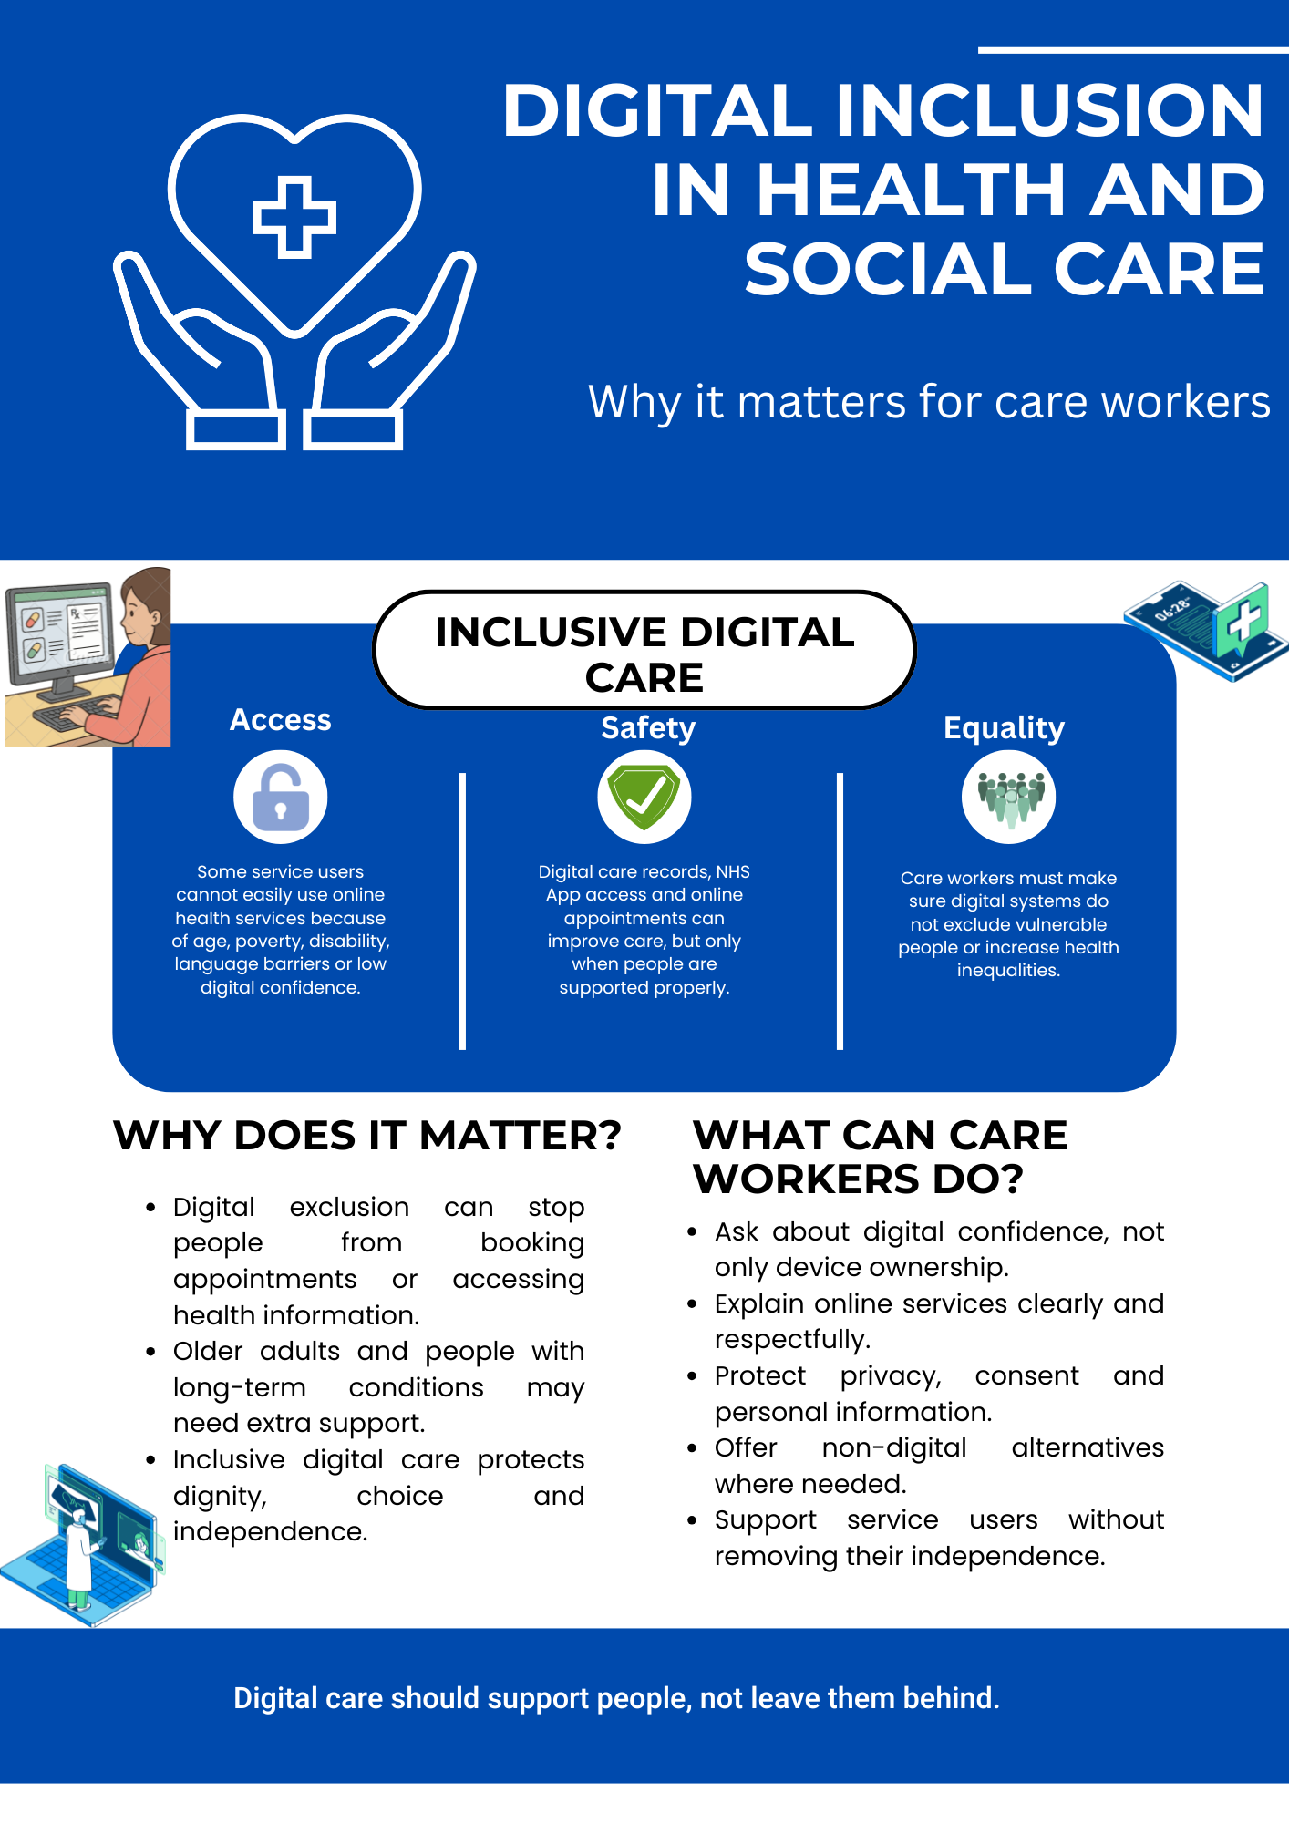

Task 4- NHS Equality, Diversity and Inclusion Quiz (250 words equivalent)
- What is the primary goal of the NHS Equality, Diversity, and Inclusion Improvement Plan?
(Answer in one or two sentences.)

Ans: The main objectives are to enhance equality, diversity and inclusion, foster a sense of belonging amongst NHS staff and minimise discrimination in the NHS workforce (Pritchard and Evans, 2023).

- How does the NHS EDI Improvement Plan propose to tackle the gender pay gap?
(Answer in one to two sentences.)
Ans: To enhance pay transparency, to review pay-gap data and to ensure opportunities for equitable recruitment, promotion and career progression.

- What is meant by the term ‘intersectionality’ as used in the NHS EDI Improvement Plan?
(Answer in one to two sentences.)
Ans: Intersectionality refers to the potential interaction of multiple inequalities, such as gender and race, race and disability, disability and age or religion and disability.
- Why is it important for the NHS to create a psychologically safe work environment?
(Answer in one to two sentences.)

Ans: Wellbeing, retention and patient safety are enhanced as staff can speak up, report concerns and contribute without fear, and experience psychological safety.

- How does the NHS EDI Improvement Plan suggest improving the experience of internationally recruited staff?
(Answer in one to two sentences.

Ans: It encourages improved induction, pastoral care, fair treatment, career development and safeguard against discrimination/exploitation.

- What role does leadership play in advancing EDI objectives according to the NHS Improvement Plan?
(Answer in one to two sentences.)

Ans: Leaders are expected to demonstrate inclusive behaviour, to be evidence led, to challenge discrimination and to make EDI part of their organisation's accountability.

- Identify one way the NHS EDI Improvement Plan aims to reduce health inequalities within the workforce.
(Answer in one to two sentences.)

Ans: It is designed to decrease the disparity in workforce outcomes by providing more development, promotion and support of minority employees.

- Why does the NHS EDI Improvement Plan emphasise the importance of collecting and analysing data on protected characteristics?
(Answer in one to two sentences.)

Ans: Data is used to identify patterns of inequality, to track progress and to inform decisions based on the Equality Act 2010 (Governmnet of Uk, 2010).

- Explain how flexible working policies can contribute to equality and inclusion in the NHS workforce.
(Answer in one to two sentences.)

Ans: Flexible working helps staff who have caring responsibilities, disabilities, health issues or religious beliefs, to be more fair and to stay in the workforce.

- What is one strategy mentioned in the NHS EDI Improvement Plan to combat bullying and harassment in the workplace?
(Answer in one to two sentences.)
Ans: A key approach is establishing a culture where staff can report bullying and harassment without fear of repercussions, and where action and accountability are clear.

Task 5- A Letter to Yourself
Think of a time in the past when you may have been experiencing issues or difficulties, and after considering what you have learned in this module about emotional intelligence and resilience write a letter to your younger self explaining how these attributes were important at that time and perhaps how developing these areas could have been useful (300 words)

Ans:
Dear younger me,

I know you once felt unsure, overrun and afraid of being not good enough. You were attempting to carry on with your studies, your obligations and your expectations, and you were trying to compare yourself with other people who seemed more confident. Then you believed the definition of resilience was to be silent and to deal with things alone. I now realize that the key to being resilient is not to avoid difficulty; it's about adapting, finding help and keeping learning from it.

If you knew about emotional intelligence before, you would not have regarded your emotions as a weakness but as information. Emotional intelligence consists of self-awareness, self-regulation, motivation, empathy and relationship management (Goleman, 2017). These skills would have allowed you to identify stress before it got to you and communicate your needs effectively, reflecting on criticisms instead of doubting yourself. Emotional intelligence is crucial in health and social care as workers need to control their emotions and be able to show empathy.

I'd also share with you that resilience is created by connection, reflection and purposeful action. According to Chye et al. (2024) personal, social and educational factors are factors that affect the resilience of health professions students . This is because you didn't have to deal with your issues by yourself. Talking to tutors, classmates or trusted individuals would have been responsible, not failing. Emotional intelligence and stress-management training can have a positive impact on wellbeing and stress-management.

You could have made this a better learning experience if you took the time to reflect, pause and plan. Confidence comes from practice, not perfection. Through challenge, honesty, care for self, and an attitude of learning, you can be a caring, trustworthy and resilient health and social care worker.

With kindness,
Your future self

Task 6- GANTT Chart (200 words equivalent)
Compile a Gantt chart which illustrates the tasks you have to complete to achieve your future employment goals
Ans:
Tasks | Jan | Feb | Mar | Apr | May | Jun | Jul | Aug | Sep
Task 1: Review career goals and complete PDP
Task 2: Complete safeguarding, equality and digital care training
Task 3: Update CV, LinkedIn and professional portfolio
Task 4: Gain health and social care experience through volunteering
Task 5: Build professional networks and apply for graduate roles
Task 6: Prepare for interviews, secure employment and begin CPD
Supporting Explanation
My career aspirations is to eventually get a job at a graduate level working in adult health and social care, e.g. Assistant Practitioner, Care Coordinator or Senior Support Worker, with the ultimate aim of becoming a Care Home Manager. This Gantt chart is a structured plan of 12 months that will enable me to do this through continuous professional development.
The first stage is to build my knowledge, which involves undertaking safeguarding, equality, diversity and digital care training and reviewing my personal development plan. The next step is to enhance my professional profile by updating my CV, LinkedIn account and portfolio, as well as having the opportunity to develop my skills through volunteering and meeting lecturers, employers and health and social care professionals. Communication, Leadership and Digital Care Record skills will be developed throughout the year as they are increasingly valued in the sector. In the second half of the year, I will start to apply for graduate jobs, practice with STAR for interviews and take into account employer feedback to be better at my job in the future. The final stage centres on securing employment and on-going learning in the workplace through reflective practice and learning. It is realistic, measurable and in line with sustainable career development in health and social care, and will ensure ongoing improvement, not just securing employment.
Task 7- Making Changes- Report
You are the manager of a care home and want to make changes your workplace. Identify one specific change that you want to implement and write a brief report on how this is going to be achieved considering the necessary skills needed and addressing possible barriers to success. Relevant change models can be highlighted (350 words Minimum of - 3 referenced sources).
Ans:
Change proposal: Introducing digital care records in a care home
Introduction
I would implement digital care records, replacing paper-based records, as care home manager. This change is to enhance accuracy, sharing of information, continuity of care and accountability of staff. When implemented, with the right training, consent and governance, digital records can contribute to safer, more responsive and person-centred care (Care Quality Commission, 2024).
How the change will be achieved
I would use Lewin’s three-stage model: unfreeze, change and refreeze. The unfreeze stage would include an explanation of the dangers of paper records—such as loss of information, duplication of information, and delayed communication. Staff, residents and families would be consulted to identify concerns early. The system would be phased in over a period of time in the change stage, including staff training, guidance on passwords, data protection measures and a brief pilot on one unit. Normal practice in the refreeze stage would be digital recording, as this is done during supervision, audits, refresher training and feedback meetings. Lewin’s model is useful because it provides a simple structure for preparing, implementing and sustaining change (Hussain et al., 2016).
Skills needed
Key skills needed are leadership, communication, digital literacy, problem-solving and emotional intelligence. There is a fear of technology if staff are not confident and the manager needs to be clear, listen to staff's concerns and not blame staff for errors. The transition must also be safeguarded by keeping awareness, confidentiality and teamwork alive in the care record, as it contains personal and sensitive information.
Possible barriers
Some barriers are staff resistance, lack of digital skills, cost, time pressure and the fear that technology will be replacing personal care. Others may also be concerned about privacy issues, whether they are residents or relatives. A gradual process of adoption, practical training, peer support and a solid education about the usefulness of digital records for safety (not for the replacement of human care) can overcome these barriers. A key aspect of digital social care records is planning, which needs staff engagement and leadership support, says the Local Government Association (2024).
Conclusion
The transition to digital care records is possible and is a worthwhile change. This helps to create safer care, better communication and a health and social care ready care home. Inclusive leadership and ongoing staff training and assessment is key to success.

Reference List
Care Quality Commission (2024) “Digital record systems: achieving good outcomes for people using adult social care services.” Available at: https://www.cqc.org.uk/guidance-providers/adult-social-care/digital-record-systems-adult-social-care-services
Chetty, R. et al. (2022) “Social capital I: measurement and associations with economic mobility,” Nature, 608(7921), pp. 108–121. Available at: https://www.nature.com/articles/s41586-022-04996-4
Chye, S.M. et al. (2024) “Building resilience among undergraduate health professions students: identifying influencing factors,” BMC Medical Education, 24(1), p. 1168. Available at: https://www.researchgate.net/publication/385049135_Building_resilience_among_undergraduate_health_professions_students_identifying_influencing_factors
Cornett, M., Palermo, C. and Ash, S. (2022) “Professional identity research in the health professions—a scoping review,” Advances in Health Sciences Education, 28(2), pp. 589–642. Available at: https://pmc.ncbi.nlm.nih.gov/articles/PMC10169899/pdf/10459_2022_Article_10171.pdf
Goleman, D. (2017) “Emotional intelligence,” The Cambridge Handbook of Intelligence, pp. 709–735. Available at: https://donainfo.wordpress.com/wp-content/uploads/2017/09/emotional-intelligence-daniel-goleman.pdf
Gorbatov, S., Khapova, S.N. and Lysova, E.I. (2019) “Get Noticed to Get Ahead: The Impact of Personal Branding on Career Success,” Frontiers in Psychology, 10. Available at: https://www.researchgate.net/publication/337840513_Get_Noticed_to_Get_Ahead_The_Impact_of_Personal_Branding_on_Career_Success
Governmnet of Uk (2010) “Equality Act 2010.” Available at: https://www.legislation.gov.uk/ukpga/2010/15/section/4
Hussain, S.T. et al. (2016) “Kurt Lewin’s process model for organizational change: The role of leadership and employee involvement: A critical review,” Journal of Innovation & Knowledge, 3(3), pp. 123–127. Available at: https://www.researchgate.net/publication/309182963_Kurt_Lewin’s_process_model_for_organizational_change_The_role_of_leadership_and_employee_involvement_A_critical_review
Letnar, M. and Širok, K. (2025) “The Role of Social Capital in Employability Models: A Systematic Review and Suggestions for Future Research,” Sustainability, 17(5), p. 1782. Available at: https://www.researchgate.net/publication/389166663_The_Role_of_Social_Capital_in_Employability_Models_A_Systematic_Review_and_Suggestions_for_Future_Research
Local Government Association (2024) “Implementing digital social care records.” Available at: https://www.local.gov.uk/accessibility-statement
NHS England (2023) “Inclusive digital healthcare: a framework for NHS action on digital inclusion.” Available at: https://www.england.nhs.uk/long-read/inclusive-digital-healthcare-a-framework-for-nhs-action-on-digital-inclusion/
Ofcom (2025) “Adults’ Media Use and Attitudes Report,” Ofcom website, (April), p. 182. Available at: https://www.ofcom.org.uk/siteassets/resources/documents/research-and-data/media-literacy-research/adults/adults-media-use-and-attitudes-2025/adults-media-use-and-attitudes-report-2025.pdf?v=396240
Pritchard, A. and Evans, N. (2023) “NHS equality, diversity, and inclusion improvement plan.” Available at: https://www.england.nhs.uk/wp-content/uploads/2023/06/edi-improvement-plan-plain-english.pdf

