A critical evaluation and the identification of next teaching and learning steps focusing on a case study of an individual learner or a group of learners, based on an observed critical incident.

Introduction

This assessment focuses on an incident which developed through observing an individual, it examined their actions and behaviors, which when observed highlighted a critical incident. From the critical incident, the next teaching and learning steps will be identified. The critical incident will develop many areas for potential research in which the literature review will identify and synthesis these key points. The school policies have been respected and fully considered in order for this observation to take place. The school and pupil’s names will be kept anonymous throughout this assessment, following guidelines set by The British Education Research Association (BERA).

It has been said that reflective practice aims to challenge the teacher’s perspective (Bolton, 2005), allowing teachers to solve problems and better their own practice (Bartelheim & Evans, 1993). By providing teachers with opportunities to focus on critical incidents in their practice, creates an excellent opportunity to initiate a critical and in-depth thinking on one’s teaching (McGarr & McCormack, no date). Similarly, Meijer et al (2011), found that allowing teachers to experience critical incidents helps to accelerate their own development. Critical Incidents are commonly thought of as ‘major events’ that occur in the classroom, although critical incidents tend to be less dramatic and often occur in day to day teaching (Tripp, 1993). However, critical incidents are only ‘critical’ when thoroughly evaluated and seen as ‘an example of a category in a wider, usually social context’ (Tripp, 1993, p.25). A critical incident is a personal belief, although it is significant that we attach the basis of this belief to the meaning of the incident (Tripp, 1993). Similarly, the strength of the incident and the effect it may have is what makes this incident ‘critical’ (Yair, 2008).

Observation
Due to this observation involving human participants, The British Education Research Association (BERA) guidelines will be followed throughout (BERA, 2011). In order to protect the anonymity of the school in which this observation took place, the school will not be named. Also, the pseudonym ‘Child X’ will be used throughout this assessment when referring to the child that has been observed (BERA, 2011).

This observation took place in a Welsh and English medium primary school. There are 422 pupils between 3 and 11 years old in the school. The school has 16 single-age classrooms. Approximately half of pupils are educated through the medium of Welsh and 17% of pupils come from English-speaking homes. Around 7% of the school’s population has additional learning needs (ALN), however only a small number of these pupils have a statement of Special Educational Needs (SEN). Very few children come from ethnic minority backgrounds. The school’s outdoor area encourages learning, include a large garden and wider grounds in order to develop children’s imagination and linguistic skills.

My observations took place in a year 1 classroom (welsh medium) with children aged 5 and 6. There were 30 children in this classroom and 4 children had Additional Learning Needs (ALN). The classroom is a happy and welcoming environment for children where the teacher fully encouraged good behaviour based on values that promote and respect care. The classroom celebrates pupils’ good behaviour and achievements by displaying their high-quality work on the walls. The classroom walls are very colorful and wall displays are very effective. There is also an emphasis on ensuring equal opportunities in the classroom and full access to the curriculum.

Methodology
This study focuses on finding a critical incident within the classroom. A critical incident is defined by McAteer et al (2010) as an event that makes you think critically on your own assumptions, allowing you to think deeper into the situation. When evaluating an event to determine whether it is a critical incident, we are often trying to prove what we have already questioned, although the process of evaluating could reveal something new (Tripp, 2012).
In order to define an incident as critical, it should be defined in great detail and differs greatly from what is normal, either positively or negatively (Edwardsson, 1992). A critical incident should question the way how things normally are (Tripp 1993).

In order to find the most appropriate method for this study, many different models were considered. Myres and Avison (2002) define a research method as a ‘strategy of enquiry which moves from the underlying philosophical assumption to the research design and data collection’. Firstly, Semi-structured interviews were considered for this study. This method includes predetermined questions and allows flexibility for the interviewer to draw upon new ideas and issues that may occur during the interview (Wilson, 2009). According to Lodico, Spaulding and Voegtle (2010) pre-formulated questions ensures that the interview remains focused on a particular topic in order for the desired data to be collected. However, Patton (1987) argues that the vocabulary and wording of the questions is one of the most important factors which can determine how the interviewee will respond. It is important for all questions to be open-ended, un-biased and clear. Semi structured interviews have a less fixed format than a structured interview, although ensuring anonymity for socio-biographical details and the standardized questions would remain the same.

Secondly, questionnaires were considered for this particular study. According to Kumer (2011), questionnaires are effective as it is a cheap and anonymous way to collect data with a great potential for response. However, in order to encourage completion, the questionnaires must be interesting and clearly written in order for the participant to understand and complete (De Vaus, 2002). Questionnaires gain a large quantity of well-regulated data, however the quality of the effectiveness of the information hugely depends of the questionnaires format (Clarke and Dawson). This statement is also supported by Anderson and Arsenault (1998) that argue that a well-structured questionnaire encourages completion and gains reliable and reasonably valid data that is collected quickly. Good questionnaires are not possible without careful thinking, numerous drafts and extensive piloting (1996).
After research, it was found that an observation method would be most appropriate for this study. Sharman et al (2007) describe an observation as a ‘camera shot’, providing a true reflection of the event, although the camera does not lie, the incident may alter through analysis. By observing children, we are able to understand their development and change in behaviour depending on the contexts (Palaiologou, 2008). The observation method involves directly observing a child, noting and recording how the participants behave in the environment by focusing on their physical and social development (Pope & Mays (1993); Mulhall (2003). An observation method is most effective for this study as it can provide a new insight of an event by drawing attention to actions and behaviour that would normally be taken for granted or ignored (Patton, Gruba and Lincoln; Cited in Clarke, 1999), which suits the study when looking for a critical incident.

The Ecological System theory by Urine Bronfenbrenner explains how the child’s environment can hugely affect the growth and development of children (Oswalt, 2018). Children feel confident to explore when they are emotionally safe and secure in an environment (Early Years Matters, 2018). Due to the observation taking place in the children’s ‘everyday’ environment, it is hopeful that the observation results would be accurate and reflect from children’s natural behaviour (Tassoni, 2007). This study involves a case study within the classroom. The case study approach can be particulary appropriate for one aspect of a problem to be studied in some depth (Belle, 2007). Case study research can be employed to capture and formalise the knowledge of practitioners, develop theories from practice, and move on to the testing stage (Benbasat et al., 1987).

Four Purposes
My observations occurred in a Welsh and English medium primary school.
My main observations took place within a Year One classroom. Firstly, I observed a group of children that were undertaking a task set by the teacher, my observation then focused on one particular child that took my attention. The task involved a ‘Tric a Chlic’ exercise that aimed to improve the children’s welsh phonics. The classroom teacher set the task by clearly stating the objectives. All pupils listened to the teacher and appeared to be fully engaged and ready to learn. The children understood what was expected from the task and went ahead to complete without hesitation. Prior to this task taking place, the children’s understanding of the subject was not assessed. This task was based on the group’s level of ability and not on the child’s individual level of ability for this particular subject.

As previously stated, the children went ahead to complete the task without any issues, however, one child then caught my attention due to how quickly the task was completed. This child will be reffered to as ‘Child X’ throughout the assessment. ‘Child X’ very quickly completed the task, calling the teacher to show that the task was complete. As the teacher began to mark the work to provide feedback, ‘Child X’ then stated that the task was far too easy and the child did not feel as though they had been challenged in their work. After talking directly to the teacher, the teacher agreed that there was no challenge in the work for ‘Child X’ and the given task was too easy. This critical incident undoubtedly connects with Donaldson’s Four Purposes. The first purpose in which the critical incident connects to is; ‘Ambitious, capable learners, ready to learn throughout their lives’. It is important to note that this purpose set by Donaldson states that children set high standards for themselves, search for challenges and enjoy them. Findings from my critical incident found that ‘Child X’ fully recognised that there was a lack of challenge in their own work and was able to address this to the teacher by stating that ‘the work was too easy’.

Secondly, this critical incident also connects to; ‘Enterprising, creative contributors, ready to play a full part in life and work’. This purposes states that children should be able to recognise opportunities and benefit, however, the critical incident shows that the opportunities for a challenge in ‘Child X’s’ work was not available. ‘Child X’ also recognised that this opportunity was not presented in their work. The critical incident also connects to a part of this purpose which states that children should be ‘willing to play their full part in their life and work’. After completing the task, ‘Child X’s’ response to the work strongly suggests that this individual is willing to play a full part in their life and work. ‘Child X’ looked for a challenge in their work in order to challenge and better their intelligence.
Literature Review
From the critical incident, a number of areas for potential research were discovered. This Literature Review will introduce a wide range of different sources related to the critical incident.

The first area of research that will be discussed is Growth Mindset.
Proffessor of Psychology Carol S.Dweck is known for her work on Growth Mindset.
Mindsets are the thoughts that we have on their own abilities, intelligence and talents which plays an influential role in our own success (Blackwell, Trzesniewski & Dweck, 2007; Dweck, 2016). Dweck (2015) states that people with a Growth Mindset believe that their own abilities can be advanced through hard work, learning and perseverance (Dweck, 2006). It is believed that children with a growth mindset value their failure as a potential for learning and a chance for feedback allowing them to learn from their mistakes (Dweck, 2006). These children look for an academic challenge in their work to enhance their learning (Claro & Paunesku, 2014). Covington (1984) supports the work of Claro & Paunesku, stating that challenging tasks endeavor learning opportunities which can include a risk of failure but also an opportunity for improvement. However, improving the process of learning through challenging tasks may only be appropriate for children with a growth mindset (Fry & Cole, 1980).

According to Dweck’s research, it is believed that there are two different types of mindsets: a growth mindset and a fixed mindset. The Growth mindset allows children to view their ability as something that can be developed through time and achievements and children with fixed mindset view their abilities as static and inflexible (Dweck, 1999). Those with a fixed mindset believe that their intelligence is unchangeable (Hochanadel, 2015). However, both mindsets play an important role in self-motivation, achieving and interpersonal processes and also help to develop children’s social-emotional skills (Dweck, 1999). A vast majority of research has shown that future children need to become active problem solvers and communicators of ideas, with a love for learning (Bialik, Bogan, Fadel & Horvathova, 2015; Masters, 2014). This statement highly connects to the Donaldson’s New Curriculum for Wales (2022). An element of the new curriculum focuses on the 4 Purposes in which the future children should be. One states that children should be ‘Ambitious, capable learners, ready to learn throughout their lives’.

The crtical incident has also lead my research into ‘More Able and Talented’ children. The term ‘More Able & Talented’ (MAAT) is used in Wales referring to children who are more able across the curriculum in comparison to those who show a particular ability in one or more areas of the curriculum; such as, art, drama or sport. (Qualifications, Curriculum and Assessment Authority for Wales (ACCAC), 2003). This term refers to around 20% of school populations (Meeting the Challenge, 2008).

The Curriculum for all Learners (2010) demonstrates how to effectively meet the needs of MAAT learners stating that the best provision for MAAT learners is to widely expend what is available for all learners (Welsh Government, 2010). Until recent years, many MAAT programmes have been tailored towards children at secondary school ages, although a number of writers have recently argued that more must be done to create strategies and policies aimed at children from an earlier age (Kendall, O’Donnell, Golden, Ridley, Machin, Rut, McNally, West & Noden, 2005). It was also argued by Scott & Delgado (2005) that prioritizing the provision for the More Able & Talented children must begin earlier, ideally before they enter the school environment.
The work of Howard Gardner related to the understanding of More Able & Talented learners. Howard Gardner developed The Theory of Multiple Intelligences in the late 1970’s. Gardner’s theory suggests that children have eight or more relatively autonomous intelligences in which children use these intelligences, in order to solve problems that are relevant to their society (Gardner, 1983, cited in Davis, Christodoulou and Seider, 2011). These eight intelligences include; linguistic, logical-mathematical, spatial, musical, bodily-kinesthetic, interpersonal, and intrapersonal intelligences (Gardner, 1999). According to The British Journal of Special Education (2007), generally, schools mainly focus on only two intelligences which include logical-mathematical and linguistic, although Gardner argues that schools should pay equal attention to other intelligences. Davis, Christodoulou, and Seider (2011), support this as they found that Gardner’s analysis shows that only two intelligences; Lingustic and Logical-mathematical, are being tested in modern schooling.
*Bloom (1984) Taxonomy
3 Overlapping domains; the cognitive, psychomotor, and affective.

Differently to Gardner’s theory, the work of Professor Ferre Laevers has been one of the most powerful influences in developing our perceptions of how children learn and the preconditions necessary to make them successful learners. Leaver’s research focuses on how we can help children to become more effective learners, in addition to the ‘content’ of what they know and can do. As well as developing a tool with which to measure these important aspects of development – the Leuven Scales – Leavers’ work shows how practitioners can use this information to account for and support children’s learning through the Process-Oriented Monitoring System (POMS) (Nursery World, 2018).

Reflection/ Evaluation and next steps

From my observation, a critical incident was found. My observation began by observing a working group, however, my focused then quickly moved to observe an individual. The critical incident that developed from the observation was very interesting for myself as a student teacher as I was able to sit and observe how naturally and confidently the child reacted when completing the task. Unfortunately, teachers do not have the time to sit and observe how each individual reacts when completing tasks due to the high numbers of pupils within the classroom. Therefore, this was a great advantage for myself as a student teacher and an important part to consider in my future teaching. Also, it is important to note that if I was not to have observed this matter, the teacher may have not been aware that the child’s ability was much greater than the task that had been set. Observations allow a quick and easy reading of the child’s ability when completing tasks.

I have evaluated this critical incident and considered the possibilities to move forward if this incident became apparent within my classroom. Below are the recommendations I have come across through research, however these are not criticisms, only suggestions. In this section three main points will be discussed to consider the next steps.

Before evaluating the next steps, it is important for the teacher to firstly acknowledge and reward the child for what has been successfully completed. The strategy of questioning is very effective in order for children to discover what they could do next in their own learning. In this case, ‘Child X’ realized that there was no challenge in their work. Through using ‘questioning’, the teacher could ask the child ‘how could you be challenged’ or ‘what could you do next’, which then leads to the child taking ownership of their learning. Bonwell & Eison (1991); Intrator (2005); Vygotsky (1978), state that children learn better when they are active and involved in the process of their own learning. Carpenter (2013) argues that children have little opportunity for taking ownership of their learning when the teacher decides what, when and how they learn and how they must complete it. Allowing children to take ownership of their learning again connects to Donaldson’s Four purposes; Ambitious Capable Learners, which states that children should ‘set themselves high standards and seek and enjoy challenge’ (Donaldson, 2015). The classroom should be an environment where student choice and control is paramount for their own learning (Zimmerman, 2002).
Another recommendation that could be used in the case of this critical incident would be incorporating ‘Assessment for Learning’ (AfL) into lesson planning. ‘Child X’ was given a task to complete in which their ability on the subject was not assessed prior to the task taking place. The Assessment Reform Group (2002) defined Assessment for Learning as ‘the process of seeking and interpreting evidence for use by learners and their teachers to decide where the learners are in their learning, where they need to go next, and how best to get them there’. This Assessment for Learning, which is also known as Formative Assessment, is a learning process which happens within the classroom, where teachers and students work together continuously and systematically in order to achieve their learning goal (Moss & Brookhart, 2009). As well as an assessment taking place prior to children’s learning, teachers must also assess children’s understanding during and after the task in order to move on with their future learning. Lastly, it would also be useful for teachers to over-plan for unexpected events where the planned task becomes too easy or too difficult for the child. A second task in which the teacher may have ‘over-planned’ would have been beneficial for ‘Child X’.

An effective teacher uses the process of ‘critical reflection’ to identify their actions, questions the meaning of their assumptions and reflect on their own practice to develop an alternative and better way of teaching (Cranton, 1996). Similarly, Brookfield (2004) states that critical reflection is the process for teachers to challenge their current social, political, cultural and professional actions. The process of an effective critical reflection allows teachers to recognise events that may lead to formulating new strategies for changing behavior in the classroom (Reagan et al, 2000). However, McKnight (2002) argues, that a critical reflection is not about being able to recognise what is happening in the classroom; that is simply not enough. Rather, teachers must understand and question the ‘whys’, ‘hows’ and ‘what if’s’ in order to complete the process of reflective thinking. Bartlett (1990), similarly points out that a reflective teacher must involve questioning and managerial techniques as part of broader educational purposes. Through reflecting on the questioning techniques, we become more aware and become able of transforming the everyday classroom environment (Bartlett,1990). Brookfield (2004), argued that teachers could risk making poor decisions without the use of reflecting on their own practice.
*How this will inform your own professional and personal development *

Conclusion

To conclude, this assessment has focused on the critical incident that appeared after analysing and evaluating an event which firstly appeared as ‘normal’ within the classroom. As stated, this assessment has followed the guidelines by BERA (2011), in order to protect the school and the participants anonymity. The choice of methodology worked well for this study as the observation provided an insight into a natural and ‘real life’ event, allowing the observer to mainly observe and remain isolated from the children and their learning.

Many areas for research developed when analysing the critical incident. Through researching, the topic ‘Growth Mindset’ was discovered and hugely connected with the nature of the critical incident. The evidenced collected would suggest that ‘Child X’ has a growth mindset, as the child was eager and motivated to develop their intelligence through looking for a challenge in their work.

Another potential connection was made through researching More Able and Talented children.

Final Word Count = 3608

References:
Anderson, G. and Arsenault, N. (1998) Fundamentals of Educational Research. 2nd edn. London: The Falmer Press.
Bartlett (1990)
Bartelheim F. and S. Evans (1993). “The presence of reflective practice indicators in special education resource teachers’ instructional decision making” The journal of special education 27(3): 338 – 347. doi:10.1177/002246699302700305
Benbasat I, Goldstein D and Mead M (1987) „The Case Research Strategy in Studies of Information Systems‟ MIS Quarterly Vol. 11, pp. 369-386.
Bolton, G. (2005). Reflective Practice: Writing and Professional Development, (2nd ed.). London: Sage.

Blackwell, L. S., Trzesniewski, K., & Dweck, C. (2007). Implicit theories of intelligence predict achievement across an adolescent transition: A longitudinal study and an intervention. Child Development, 78(1), 246–263. https://doi.org/10.1111/j. 1467-8624.2007.00995.x
Bonwell, C., & Eison, J. (1991). Active learning: Creating excitement in the classroom. ASHE-ERIC Higher Education Report No. 1. Washington, DC: Jossey-Bass. GS Search
Brace, I. (2013). Questionnaire design how to plan, structure and write survey material for effective market research. 3rd ed. London: Kogan Page Ltd., p.4.
Brookfield, S. (2004). The getting of wisdom: What critically reflective teaching is and why it’s important. Retrieved from http://nlu.nl.edu/academics/cas/ ace/facultypapters/StephenBrookfield.cfm
Bialik, M., Bogan, M., Fadel, C., & Horvathova, M. (2015). Character education for the 21st century: What should students learn? Boston, MA: Center for Curriculum Redesign. Retrieved from http://curriculumredesign.org/wp-content/uploads/ CCR-CharacterEducation_FINAL_27Feb2015-1.pdf.
British Educational Research Association (BERA) (2011) Ethical guidelines for educational research. [Online] Available at: http://www.bera.ac.uk/resources (Accessed on: 28th September, 2019).
Carpenter (2013)
Claro, S., & Paunesku, D. (2014). Stanford University. PNAS, Proceedings of the National Academy of Sciences of the United States of America.
Clarke, A. (1999). Evaluation Research. SAGE Publications Ltd.
Covington, M. V. (1984). The motive for self-worth. In R. Ames & C. Ames (Eds.) Research on motivation in education: Student motivation (pp.77-113). New York, NY: Academic Press.
Cranton, P. (1996). Professional development as transformative learning: New perspectives for teachers of adults. San Francisco: Jossey Bass.
Davis, K., Christodoulou, J., Seider, S. and Gardner, H. (2011). The Theory of Multiple Intelligences.
De Vaus, D. (2002) Surveys in Social Research. 5th Edition, Routledge, London.
Department for Education (2018) Statutory Framework for the Early Years Foundation Stage. Available at: https://www.gov.uk/government/publications/early-years-foundation-stage-framework--2

Dweck, C. S. (1999). Self-Theories: Their Role in Motivation, Personality and Development. Philadelphia, PA: Psychology Press.
Dweck, C. S., (2006). Mindset: The new psychology of success. New York, NY: Random House.
Dweck, C. (2015). Carol Dweck Revisits the 'Growth Mindset'. [online] Education Week. Available at: https://www.edweek.org/ew/articles/2015/09/23/carol-dweck-revisits-the-growth-mindset.html
Edwardsson, B. (1992). Service breakdowns: A study of critical incidents in an airline. International Journal of Service Industry Management 3(4): 17–29.
Evaluation Research (1999)
Fry, P. S., & Coe, K. J. (1980). Interaction among dimensions of academic motivation and classroom social climate: a study of perceptions of junior high and high school pupils. British Journal of Educational Psychology, 50(1), 33-42.
Hochanadel & Finamore (2015)
Intrator, S. (2005). Tuned in and fired up: How teaching can inspire real learning in the classroom. New Haven, CT: Yale University Press.
Kendall, L., O’Donnell, L., Golden, S., Ridley, K., Machin, S., Rutt, S., McNally, S., Schagen, I., Meghir, C., Stoney, S., Morris, M., West, A. and Noden, P. (2005). Excellence in Cities: the National Evaluation of a Policy to Raise Standards in Urban Schools 2000–2003 (DfES Research Report 675A). London: DfES [online].
Kumar, R. (2011) Research methodology: a step-by-step guide for beginners. (3rd edn). London: Sage Publications Ltd.
Reagan, T. G., Case, C. W., & Brubacher, J. W. (2000). Becoming a reflective educator: How to build a culture of inquiry in the schools (2nd ed.). Thousand Oaks, CA: Corwin.
Palaiologou, I. (2008) Childhood Observation. Exeter: Learning Matters.
Sharman, C. Cross, W. & Vennis, D. (2007) Observing children and young people (4th Ed), London: Continuum.
Lodico, G, M. Spaulding, T, D. Voegtle, H, K. (2010) Methods in Educational Research: From Theory to Practice; Second Edition. San Francisco; Wiley Publishers.
Masters, G. N. (2014). Towards a growth mindset in assessment. Practically Primary, 19(2), 4–7. Retrieved from www.alea.edu.au/ documents/item/896.
McAteer, M., Hallett, F., and Murtagh, L. (2010) Achieveing your Masters in Teaching and Learning. Exeter: Learning Matters. Available from: http://lib.myilibary.com?ID=272528.
McGarr & McCormack, (no date).
McKnight, D. (2002). Field experience handbook: A guide for the teacher intern and mentor teacher. College Park: University of Maryland.
Meijer, P., G. De Graaf and J. Meirink. (2011). “Key experiences in student teachers’ development” Teachers and Teaching: theory and practice 17: 115- 129. doi: 10.1080/13540602.2011.538502
Myers, D., Avison, D.(2002). Qualitative Research in Information Systems. London: Sage
Mulhall, A. (2003). Methodological Issues in Nursing Research in the Field: Notes on Observation in Qualitative Research
Nursery World. (2018). Nursery World. [online] Available at: https://www.nurseryworld.co.uk/ [Accessed 29 Oct. 2019].
Patton, Q. M. (1987). How to use qualitative methods in evaluation. Newsbury Park, London, New Dehli: Sage Publications.
Pope, C., Mays, N. (1993) Opening the black box: an encounter in the corridors of health services research.
Tassoni, P. (2007), Child Care and Education. 4th Edition. Heinemann. New Hampshire.
The Assessment Reform Group (2002)
Tripp, D. (1993). Critical Incidents in Teaching. Developing Professional Judgement. London: Routledge.

Vygotsky, L. (1978). Mind in Society. Cambridge, MA: Harvard University Press.
Wilson, E (2009) School-based Research: A guide for education students. London: SAGE Publications.
Welsh Assembly Government (2010) Primary social and emotional aspects of learning- Cymru; Theme four Going for Goals! Foundation Phase. Available at: http://wales.gov.uk/docs/dcells/publications/100930theme4blueen.pdf.pdf
Yair, G. (2008). “Key educational experiences and self-discovery in higher education” Teaching and Teacher Education 24: 92–103. doi:10.1016/j.tate.2007.04.002
Zimmerman, B. J. (2002). Becoming a self-regulated learner: An overview. Theory into Practice, 41(2), 65-70.

Appendices

Observation One:

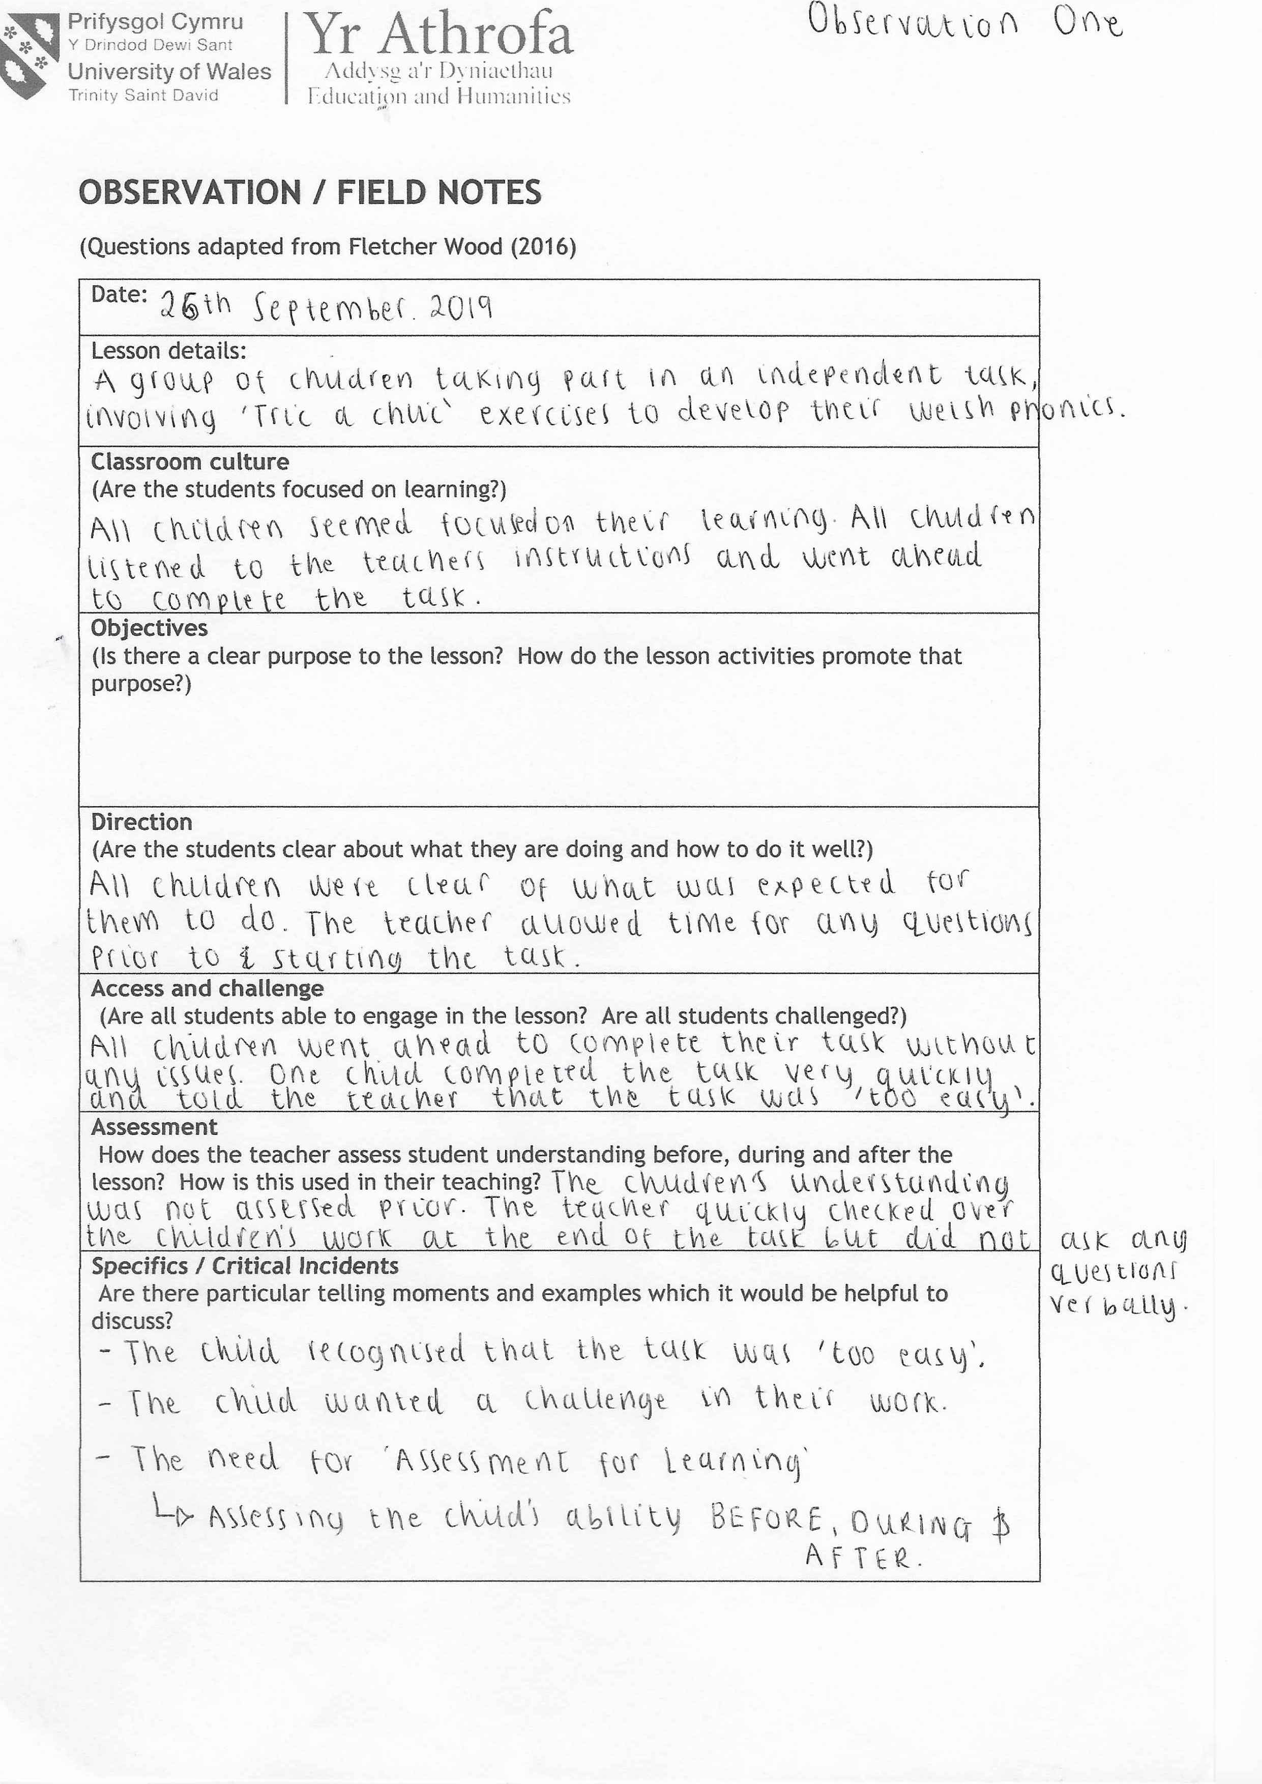

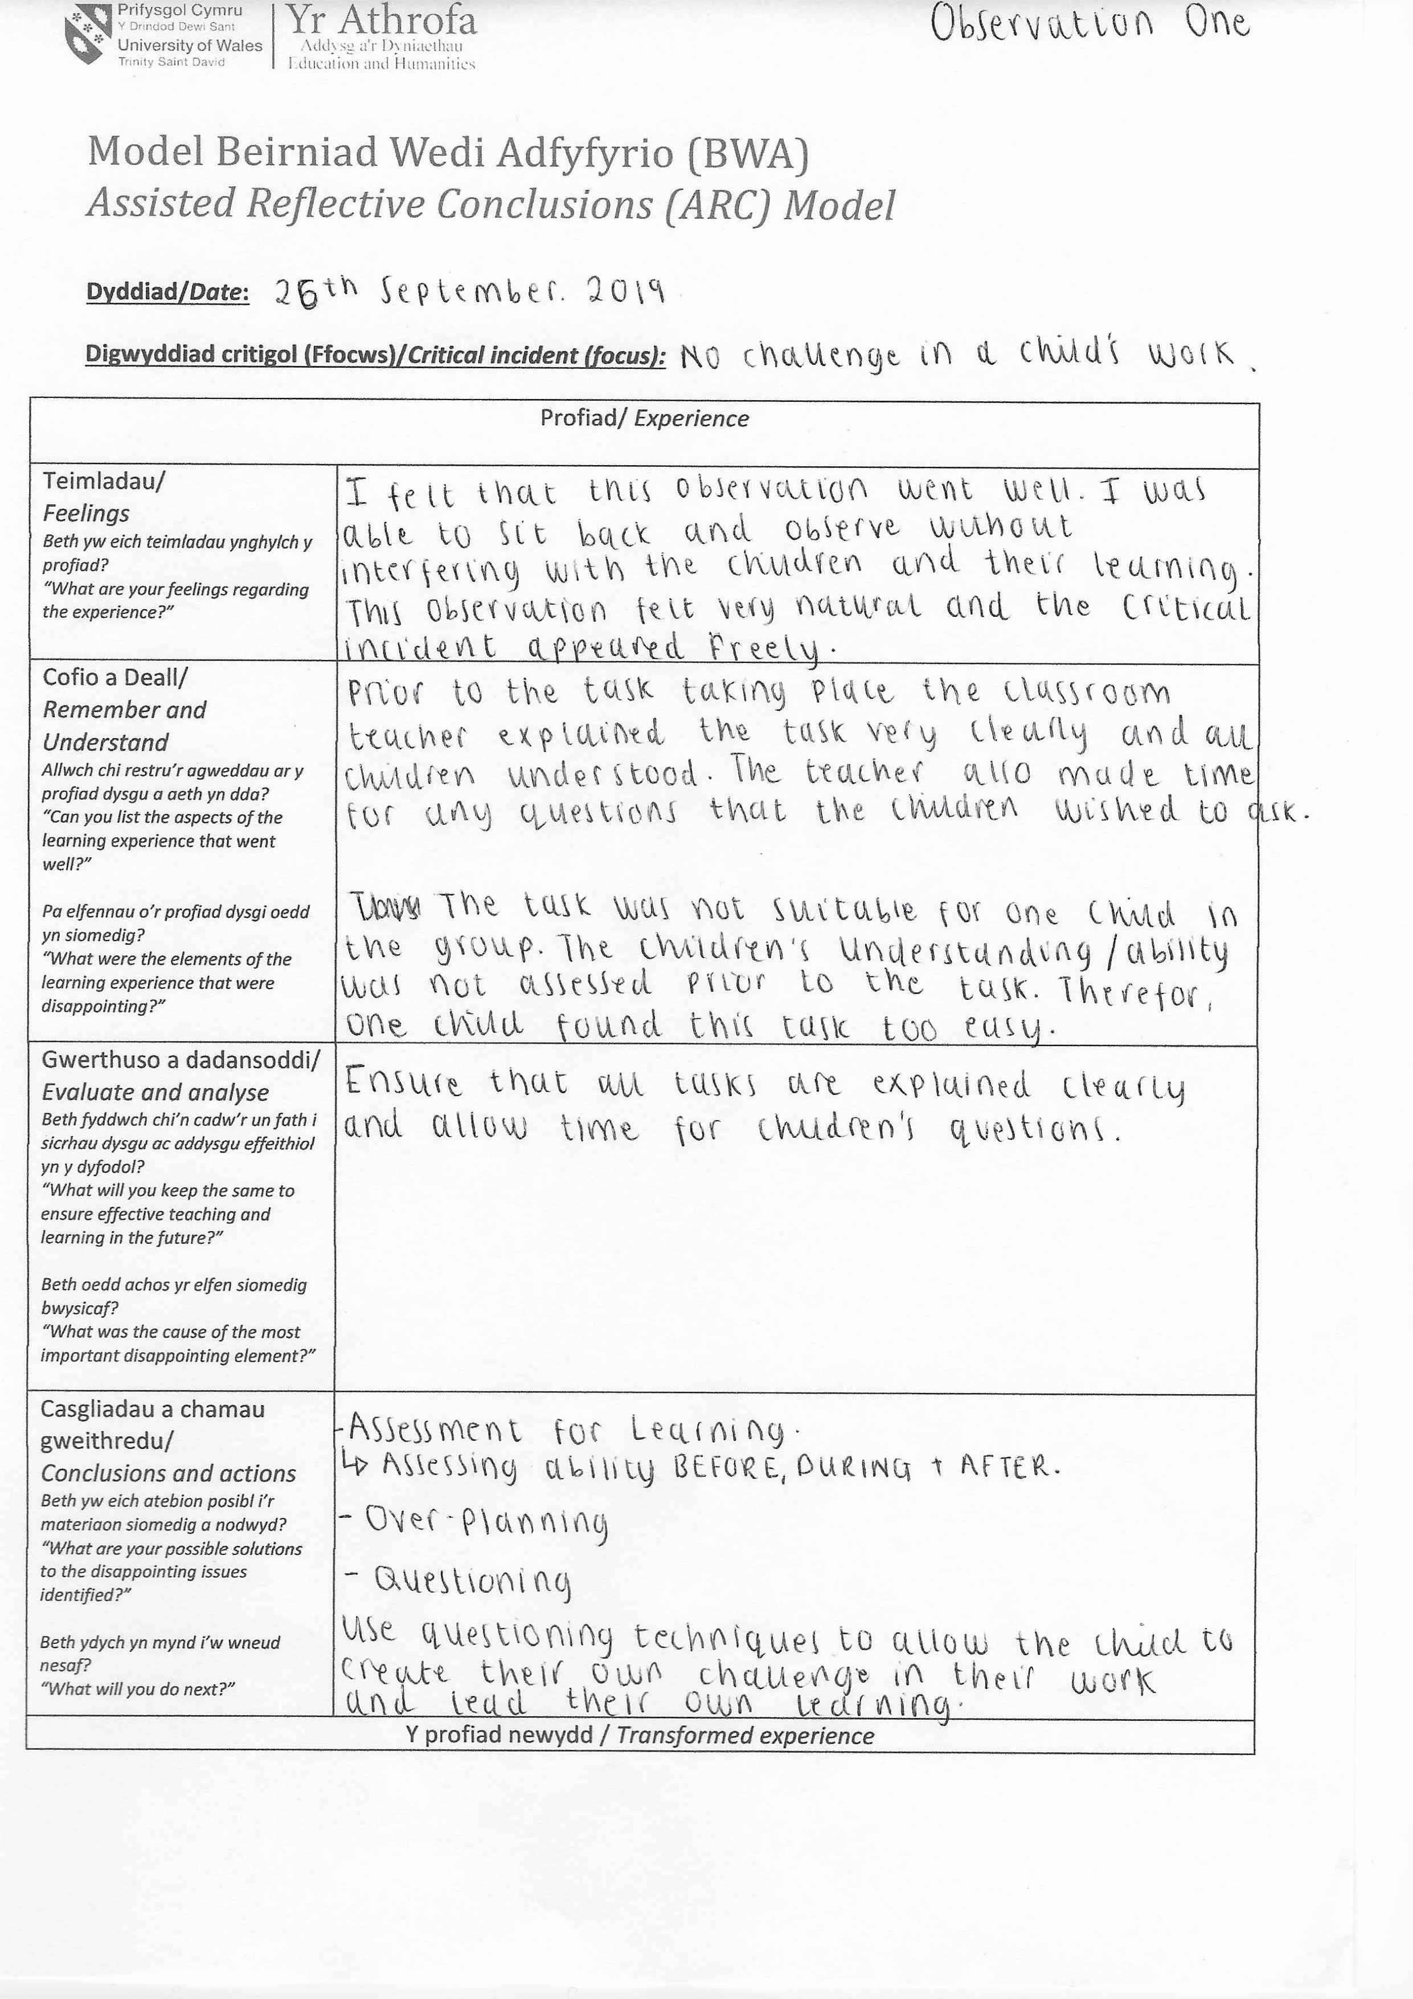

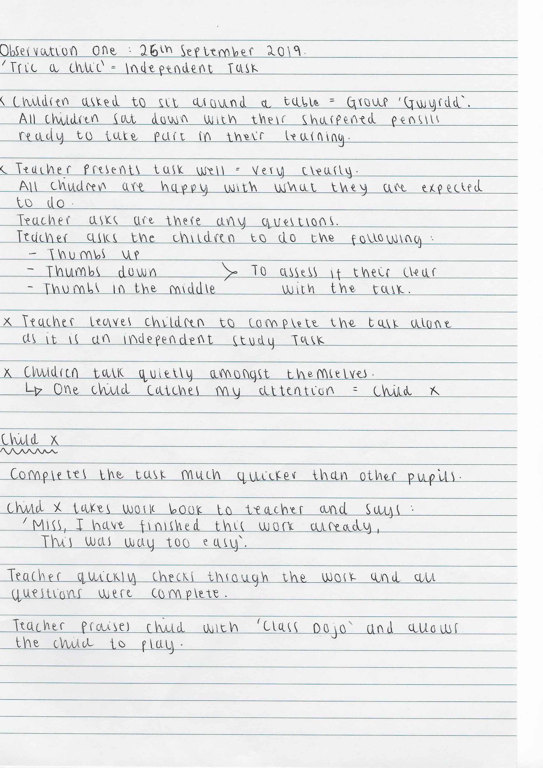

Observation Two:

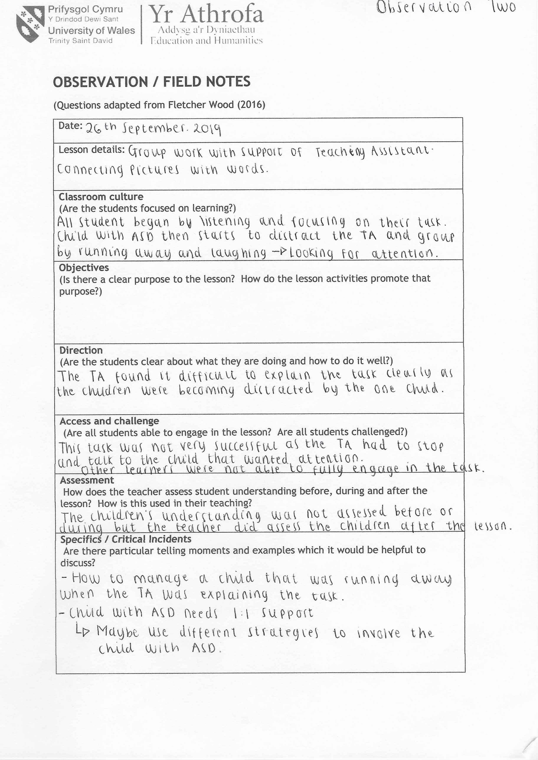

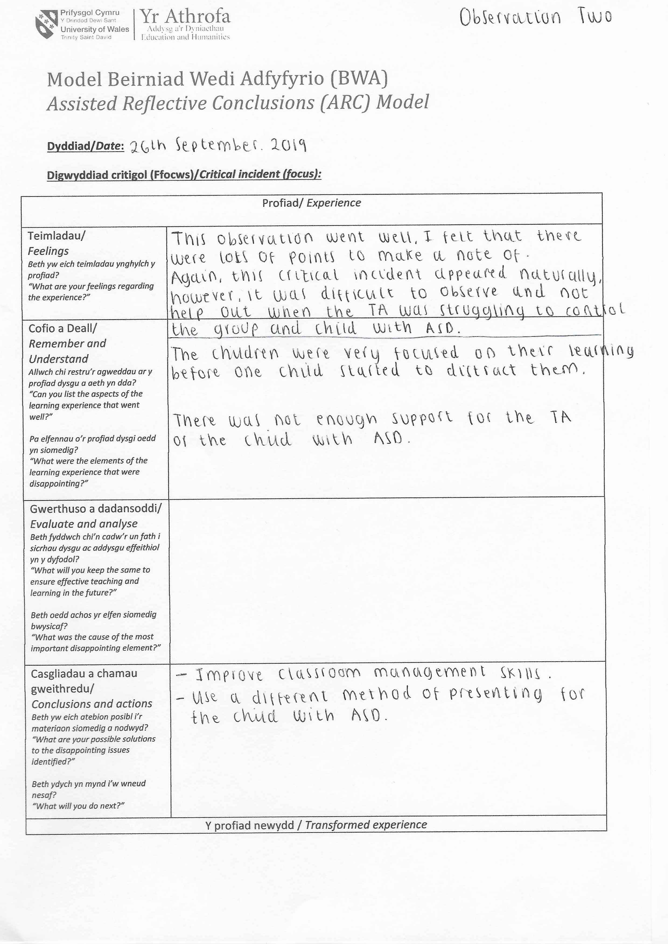

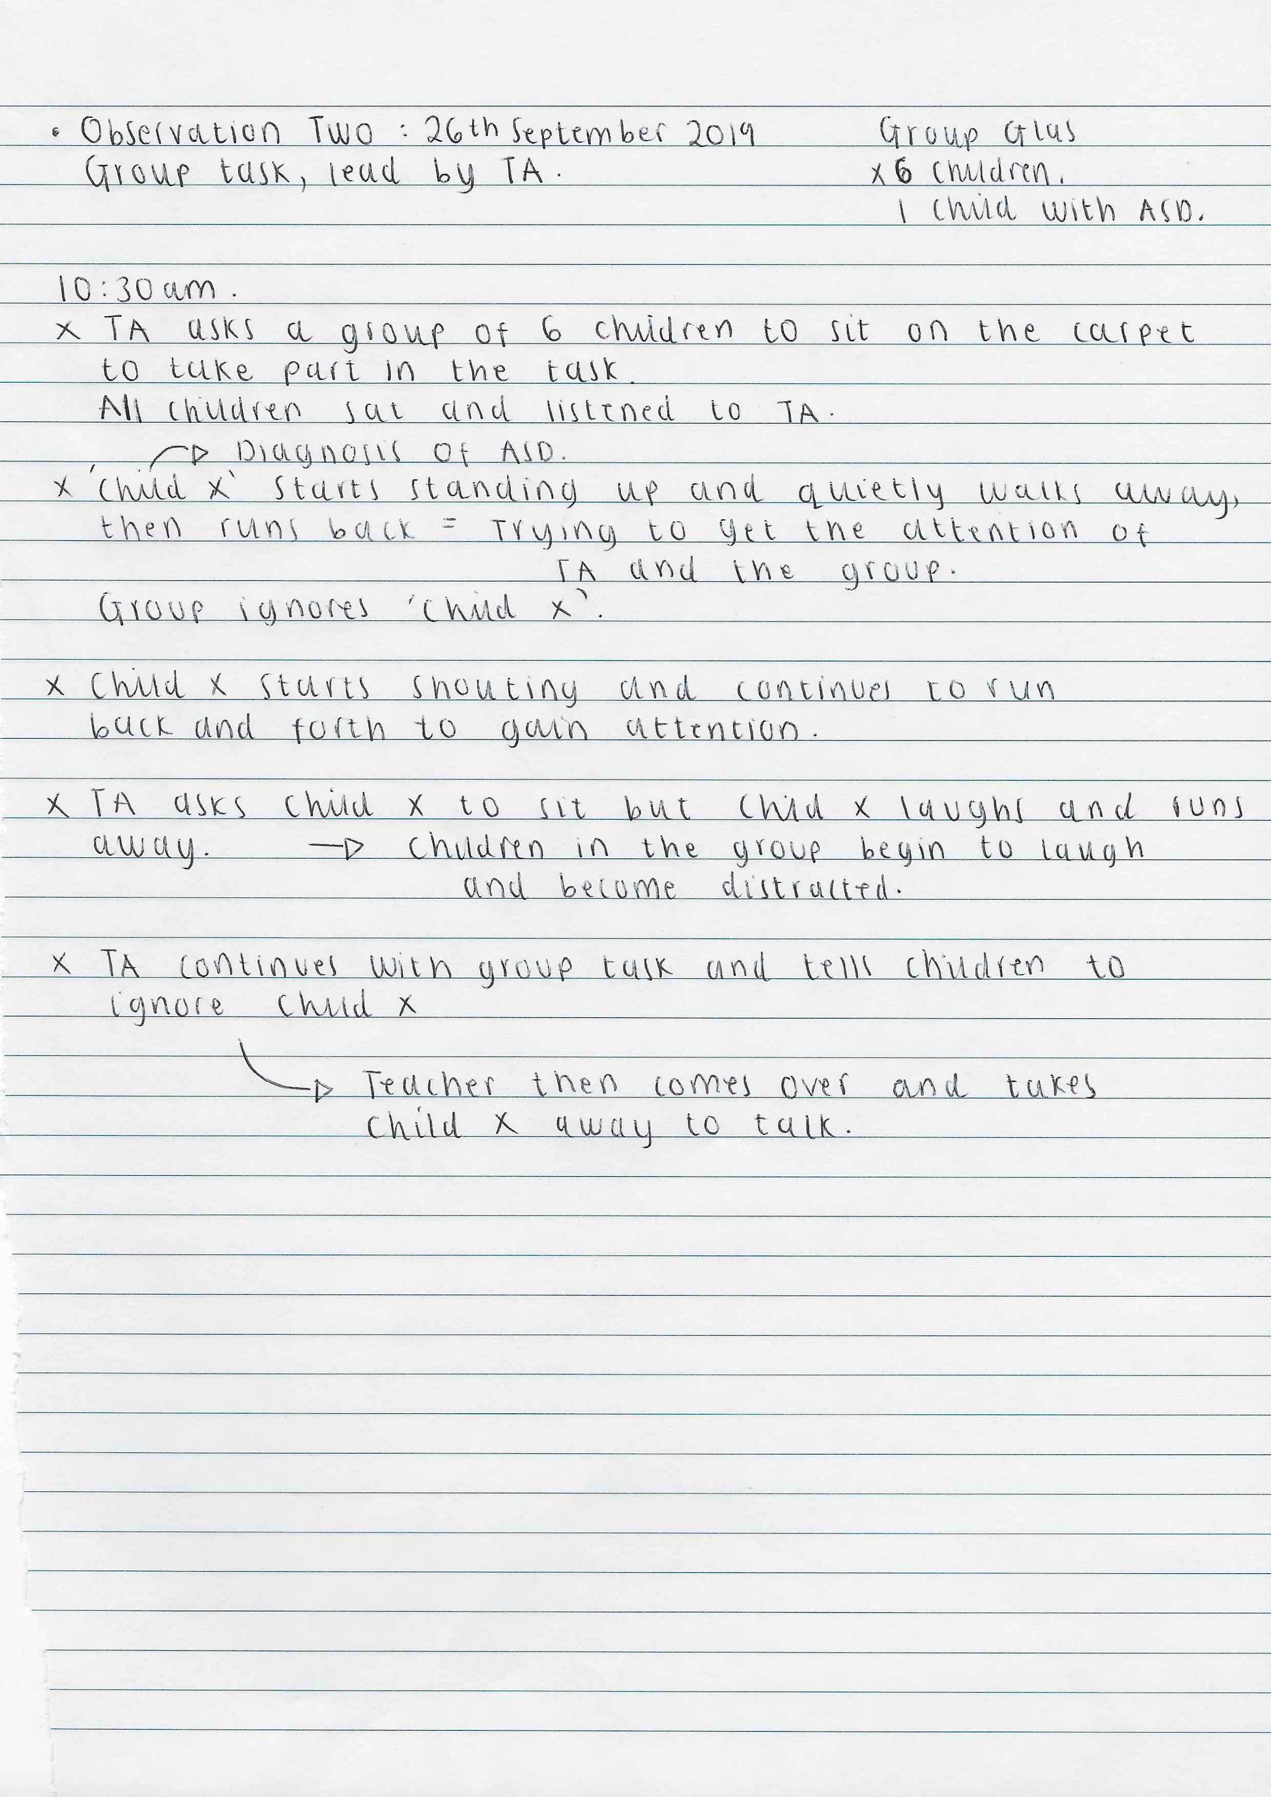

Observation Three:
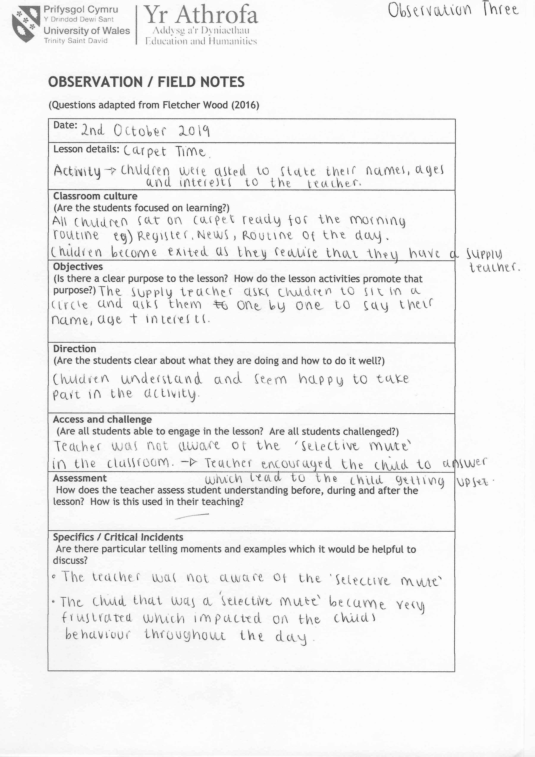

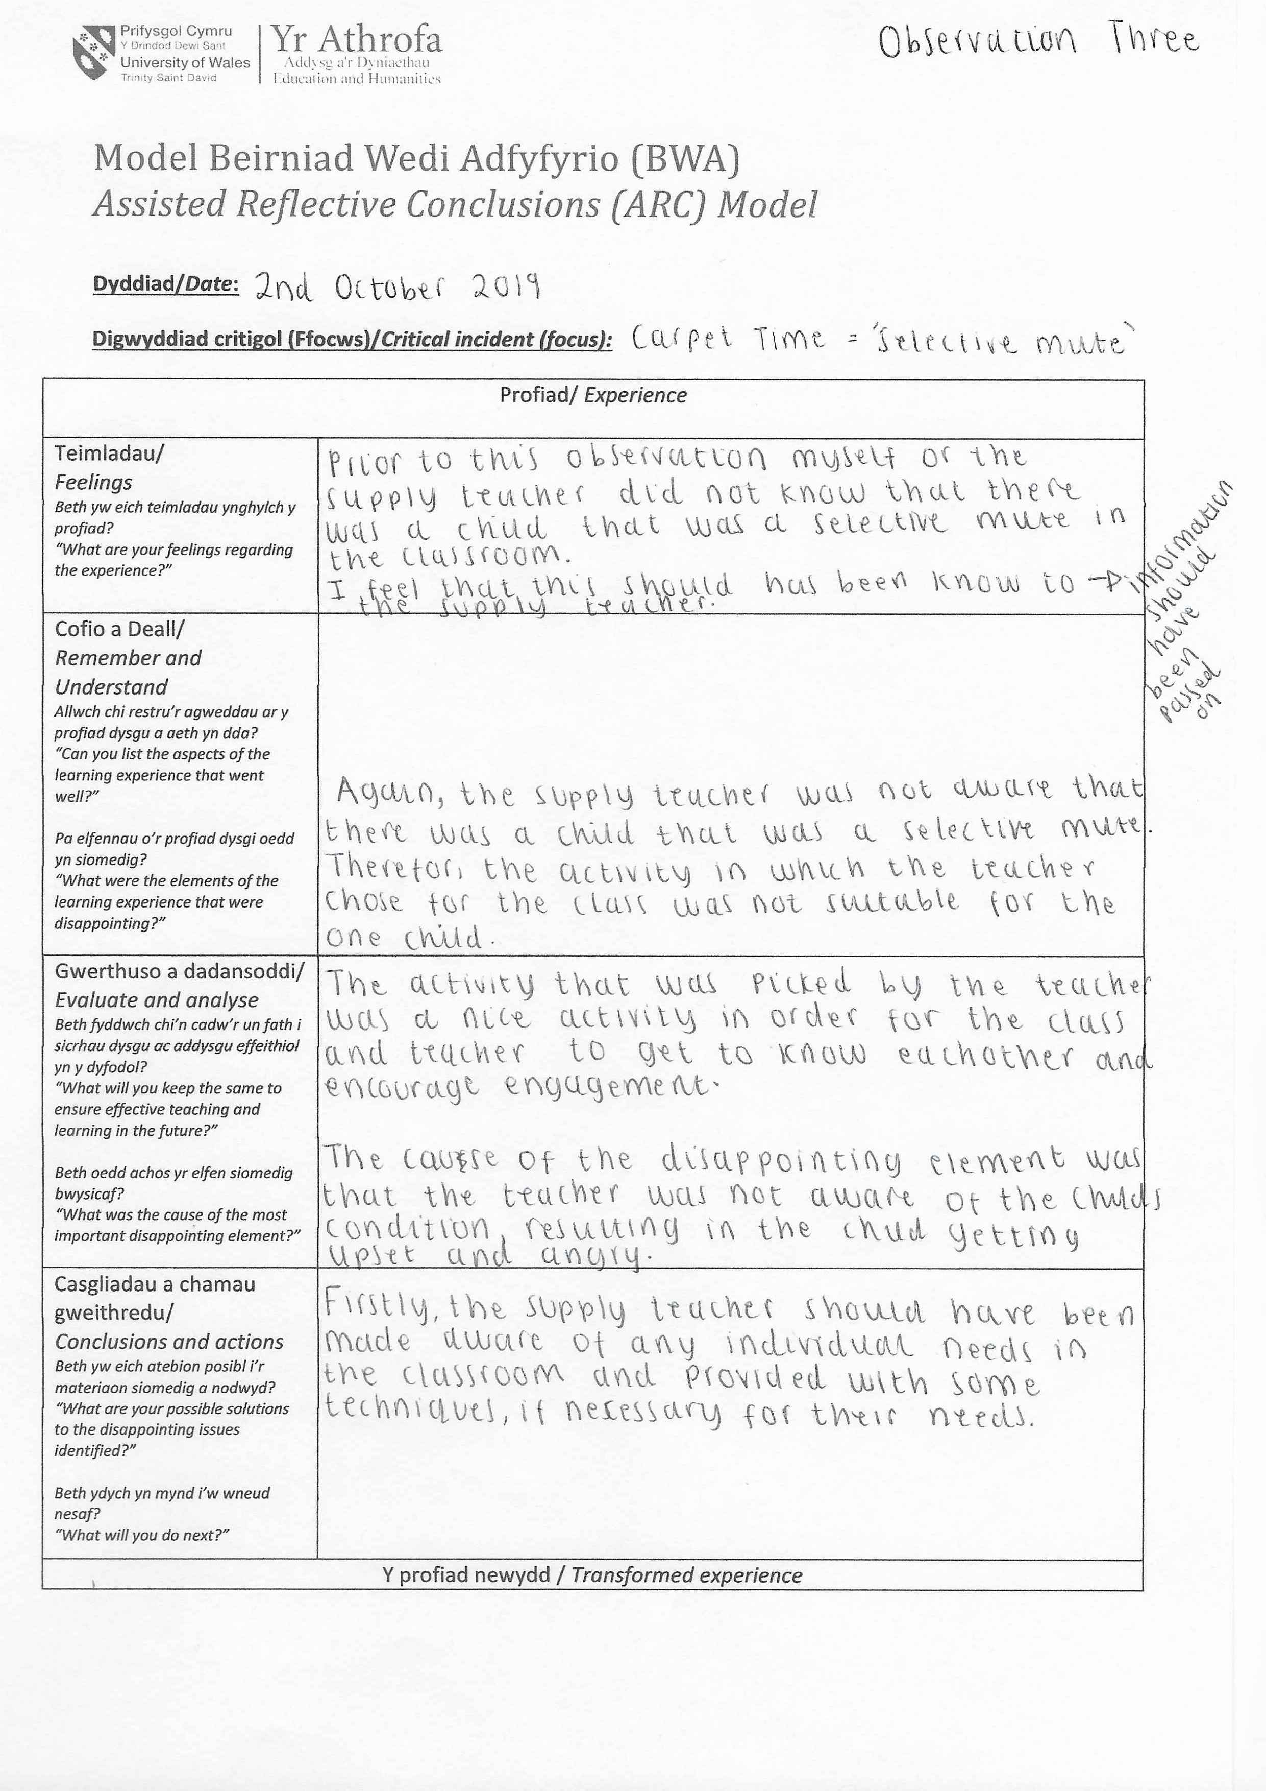

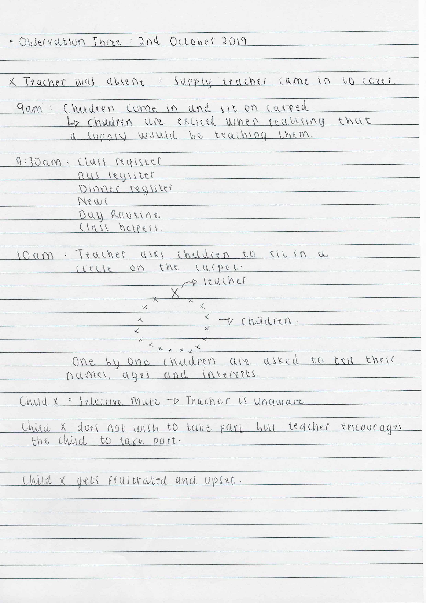
Observation Four:

