Mayne salcedo
STUDENT NUMBER | 2118543
E-Portfolio
Module: Change makers “CREATIVITY and value CREATION” (bmhp5014_lond)

Table of Contents
1introduction 2
2.Mind map 3
3.Blog 4
………………………………………………………………………………………………………….5
4.conclusion 6
5.references 7

Introduction
In this E-portfolio I will present a new project about support of depression in young Peruvians. The uniqueness of my projects is that while it supports Peruvians people suffering from depression, we also help them with finding suitable employment for adolescents which they will integrate to the society and improve their health. This E portfolio present Task 1 the mind map and task 2 a blog.

Task 1. Mind Map
Prevent depression in young peruvian support service
Fatigue
Feeling desiring

Reduce apetite
Symptoms

Tell someone

Specialist in mentalh health
Job opportunity
Ridgeviewhospital,2023 p.1
Organization
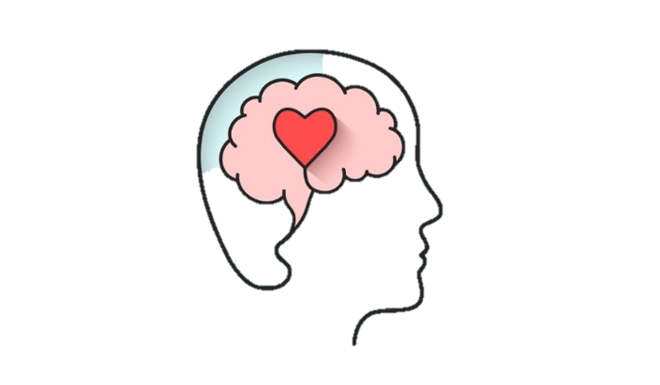
Dictionary,2018
Education

schools
Gp
Families
International,2020
Reduce Stigma
Support people
Physical activity

Treatment
Talk openly
#
Change negativity


Educate yourself!
Eat balance

Harry Jameson,2022 p1

Depression is a major mental illness it is estimated this condition impacts 5% individuals in the world, Chronic sadness, and loss of interest in our daily activities (world health organization,2023) This project is focused to prevent depression in young Peruvians support service. I will introduce the main points. Symptoms we must recognise and be alert how is impact in affect in a person wellbeing such as: reduce the appetite, feeling thirsty, fatigue, change mood, etc. which it will be signal to seek help. Next education it is crucial that we have to educate ourselves and practise as a result we will have more control and choices in our life, also protect the young generation as they are the future we will start to awareness in schools, work with families teach and explain how they can support their parents, offer a job opportunity from which the person will feel integrate and productivity increase improvement in their mental health, also reduce the stigma build mental health awareness in Peru it is a struggle to mention about the mental illness and surfer in silence because they are traditional families where the person is no allow to talk about their mental health conditions for example if you are a man ,you have to be a strong person who care about the family and do not show your emotions for instance we should talk openly, support people, educate ourselves, next organization will play a crucial role to protect and help each patient specialist in mental health ,Gp, therapist, etc, Treatment in this part it is a key for the patient stay active ,practise sports, stay hydrated also have a balance diet such fruit, vegetables, lactose diary, eat low fat .etc
Task 2. Blog
The impact of mental among in Peruvians living in the city
By Mayne Chamorro

By Mayne Chamorro 21 April,2023
“A part of depression is feeling alone even you are surrounded by many people.”
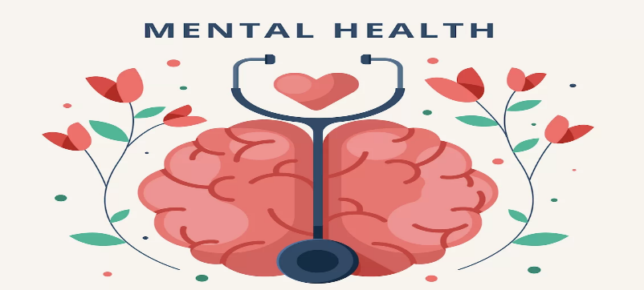

(Plan street,2021)
The most prevalent affective illness is depression, which can range in severity condition characterised by hallucinations and delusion. (Lyer and Khan,2012 p79) In accordance with the Ministry of health’s 2018 data, neuropsychiatric illnesses account for about 7.5 years of lost life per thousand people in Peru due to mental health condition. (Vasquez MD .et al,2020 p1).
- How do recognise the Symptoms
The people can be affected in numerous ways if we notice someone who is abandoned and do not care about themselves, looks always tired, have lack of energy and loss interested, poor hygiene it is a signal of mental health, for example most of us who lives in a city a we have to manage with the stress according we our routine and situations however it will be different from a person who live in the village, also the weather could a factor because is changing most of the times and affect in we our mood (Nhs,2019). Link to websites you can used to explore and find more information.
https://www.nhs.uk/mental-health/conditions/clinical-depression/overview/#symptoms
https://www.ish.org.uk/mental-health-information-for-students/
- Start with Education
Mental health support in the school beings with awareness then we must start in educate ourselves however sometimes it is easier to judge someone, but each person is unique, and we face problems in different ways and the society play a huge role. In the world one in five kids have been diagnosed emotional or behaviours disorders. Educators and administrators have understanding of the importance of addressing mental health needs in schools, so the first step is to pay attention of any alarm have good relationship with the students, ensuring that they have the necessary support, Since we can see in the new a lot of children’s in the world who struggle and surfer in silence and decide to end their lives .also helping them in find a par time jobs, analysing the abilities of each individual (Barile and Ed ,2022p1).

- Dealing with Stigma

obstacle to the improvement of mental health might stem from negative society. The protection in Social rights concerns related to these harmful consequences are becoming progressively recognised area of social action.it is well known that people with mental illnesses experience significant injustices that have an impact on their quality in some cities in Peru no everyone have the right to health since they have to pay for their treatment there is a lot of families with low income and this can cause damage to health in Peruvians and families since they will not receive any treatment (Stuart,2016).

- Work with the Organization
it may be challenging to discuss your own feelings, thoughts affecting you daily life, however we must look for help for example call the general practitioner close to us, when you go there and discuss about your personal situation they will listen, provide suggestions, and refer to will be most beneficial for you. This service was request by specialist, Gp, Organizations, etc the therapy will be privately or in a group setting with patients who are experiencing similar issues also involucre your parents, (Nhs,2022).
Help and support.
If you are looking for support here, there are organisation who will support you:
- National wellbeing l protection: you can call to talk about your concerns 24 h. email to nationationalprotection@peru.com Line on :0052345678987.
- Same community: if you would like to talk in anonymous you can send the message to 8567, they will keep confidentiality and response immediately.
- Together line: if you are struggle with your thoughts and concern from another person who is in suicidal situation call:0051976456345 user website: togetherline.urg@peru.com

- Set we our goal together with the Treatment.
For the patient who is surfer from mental health condition is its crucial stay active practice some exercises thirty minutes per day, also have a balance diet such as: vegetables, fruits include in each meal, proteins, etc, and using social networks are just examples of behaviours that can promote and publicise mental health promotion and prevention for everyone. Social support systems and social interaction can help prevent dementia and cognitive deterioration. Reduced morbidity and mortality are reliably and favourably related to social networks. (Thomas et al,2016).

Conclusion:

Depression is a health condition that should concern to the society, it can be challenging to live with them. However, it has diverse ways to controlling. where that person will improve the quality of life. By doing this project help me to learn about myself and achieve additional knowledge in health care sector of I will apply in the future to support the services users and provide adequate and dignity service of each of them.

References:
Barile and Ed ,2022 How we can support mental health in schools’ education Available at:
https://www.trueeducationpartnerships.com/schools/tips-for-supporting-mental-health-in-schools/#:~:text=A%20huge%20part%20of%20mental,be%20able%20to%20help%20others. (Accessed 12 April 2023).
Dictionary,2018 Emoji (Online) Available at: https://www.dictionary.com/e/emoji/disappointed-face/.(Accessed 10 April 2023).
Harry Jameson,2022 Peak Fitness Available (online) at:https://www.thetimes.co.uk/article/when-to-exercise-in-the-morning-or-evening-tr7gg933g (Accessed 10 April 2023).
ISH’s International students House,2020 mental health (online) Available at:https://www.ish.org.uk/mental-health-information-for-students/ (Accessed 10 April 2023)
Lyer and Khan (2012) Depression A-review ResearchGate Available at:https://www.researchgate.net/publication/273769453_Depression_-_A_Review (Accessed 11 April 2023)
Nhs (2019) Overview clinical depression Available at:https://www.nhs.uk/mental-health/conditions/clinical-depression/overview/#symptoms (Accessed 11 April 2023)
Nhs (2022) How you can access NHS mental health service Available at:https://www.nhs.uk/mental-health/social-care-and-your-rights/how-to-access-mental-health-services/ (Accessed 12 April 2023)
Plan street (2021) Keep an eye of your mental health (online) Available at:https://www.planstreetinc.com/keep-an-eye-on-your-mental-health-for-a-healthier-life/ (Accessed 11 April 2023)
Ridgereviewhospital.2023 Stigma(online) Available at:https://ridgeviewhospital.net/5-tips-for-overcoming-mental-illness-stigma/ Accessed 10 April 2023).
Stuart, H (2016) Reducing the stigma of mental illness National library of medicine. Available at: https://www.ncbi.nlm.nih.gov/pmc/articles/PMC5314742/ . (Accessed 13 April 2023).
Tomas et al (2016) Promoting mental health a preventing mental illness in general practice National library of Medicine Available at: https://www.ncbi.nlm.nih.gov/pmc/articles/PMC5330334/ (Accessed 13 April 2023).
Vasquez MD .et al (2020) Depression in the Peruvian population and is associated factors: analysis of national health survey Science Direct Available: https://www.sciencedirect.com/science/article/abs/pii/S0165032719327302 (Accessed 11 April 2023)

