Dissertation BA
International Travel and Tourism Management
By Sonny Hawkins

A critical review of the public's holiday choices in regard to all-inclusive holidays and how informed these decisions are

By Sonny Hawkins (1900372)

Supervised by Bronwen Williams
1st June 2020



Word Count: 9903
Word Count: 9901

DECLARATION This work has not previously been accepted in substance for any degree and is not being concurrently submitted in candidature for any degree
Signed………………S.Hawkins……………………………

Date…………………01/06/20……………………………

STATEMENT 1 This dissertation is being submitted in partial fulfilment of the requirements for the degree of BA.
Signed………………… S.Hawkins ………………………….

Date……………………01/06/20…………………………

STATEMENT 2 This dissertation is the result of my own independent work/investigation, except where otherwise stated. Other sources are acknowledged by footnotes giving explicit references. A bibliography is appended.
Signed…………… S.Hawkins ………………………………

Date…………………01/06/20……………………………

STATEMENT 3 I hereby give consent for my dissertation, if accepted, to be available for photocopying and for interlibrary loan, and for the title and summary to be made available to outside organisations.
Signed……………… S.Hawkins ………………………………

Date………………………01/06/20…………………………

STATEMENT 4 I hereby give consent for my dissertation, if accepted, to be available on the university’s IT system to those who have consent to use the system.
Signed…………………… S.Hawkins …………………………

Date………………………01/06/20…………………………

Acknowledgements

I would like to take a moment to thank the University of Wales Trinity Saint David and the lecturers at the university. I would like to express their appreciation and a big thank you to my supervisor Bronwen Williams for the support and encouragement throughout the academic year and for guidance throughout this thesis. Also, a huge thank you to Jacqui Jones for personal and academic support during my time at the University.
I would also like to acknowledge the support from my family, friends and loved ones for always supporting and encouraging them to keep going throughout University.

Abstract
This dissertation was undertaken as part of an undergraduate degree in BA International Travel and tourism Management. The researcher of this thesis has conducted, and analysed primary and secondary data concerning the publics holiday choice and how informed these decisions are in regard to all-inclusive holidays and the impacts on host communities.
The researcher produced a comprehensive literature review on consumers understanding of the all-inclusive concept compared to a standard package and the motivations that influence these types of holidays. Moreover, the researcher considered the impacts that all-inclusive holidays have on the host community and how environmentally aware tourists are and how does this affect their behaviour.
The primary research was constructed around the finding of the literature review for this project. The author distributed online surveys to 80 respondents and 5 comprehensive interviews.
The respondents revealed that the main difference between an all-inclusive holiday and a packaged holiday was the addition of all-day food and drinks. For example, an all-inclusive holiday would include; transport, accommodation, transfers, food and drinks, whereas, respondents identified that a packaged holiday can be as little as transport and accommodation.
This research found that cost was the main contributing factor for families aged 22-49 with an income less than £20,000. The study showed that safety was also a factor that influenced them to take an all-inclusive holiday. Moreover, cost and location revealed a trend as respondents with a lower income tend to holiday in cheaper all-inclusive destinations such as Spain and Turkey, whereas, those with a higher income of £30,000 + tend to book more expensive holidays in the Caribbean and Greece.
The research further revealed that 45% of respondents left the resort whilst on holiday and 67% of these respondents were aged 16-21. Research shows that young tourists spend most of the day using on-site facilities, however, they tend to leave the resort in the evening to use bars and clubs.
Finally, the data shows a trend that 65% of respondents agree that the main negative impact that all-inclusive resorts cause is loss of business within the local community. From this, 80% of respondents stated that after discussing these impacts they would not go on an all-inclusive holiday which suggests that education and knowledge might increase consumer and environmental awareness.
Table of content

Chapter 1 12
1.0 Introduction 13
1.1 Background 13
1.2 Rationale 14
1.3 Aims and Objectives 15
1.4 Research 16
1.5 Overview of Chapters 16
1.5.1 Chapter 1 16
1.5.2 Chapter 2 16
1.5.3 Chapter 3 16
1.5.4 Chapter 4 16
1.5.5 Chapter 5 17

Chapter 2 – Literature Review 18
2.0 Introduction 19
2.1 Primary Themes 19
2.1.1 Packaged vs. All-inclusive 19
2.1.1.1 Packaged 19
2.1.1.2 All-inclusive 21
2.1.1.2.1 Butlins 21
2.1.1.2.2 Club 18-30 21
2.1.1.2.3 Rise in alternative holidays 22
2.1.1.3 Cruise ships 22
2.1.1.4 The All-inclusive Package 23
2.2 Understanding Tourism 23
2.2 .1 Consumer Typologies 23
2.2.2 Tourism Destinations 24
2.2.3 Motivations 24
2.2.4 needs and wants 25
2.2.5 Maslow’s hierarchy of needs 26
2.2.6 Maslow’s Hierarchy of Needs Theory in Tourism 27
2.3 Impacts of All-inclusive holidays 28
2.3.1 Economic Impacts 28
2.3.2 Social Impacts 29
2.3.3 Environmental Impacts 30
2.4 Triple Bottom Line Theory 30

Chapter 3 - Methodology 31
3.1 Chapter overview 32
3.2 Research Onion 32
3.2.1 Philosophy 33
3.2.2 Approach 33
3.2.3 Strategy 33
3.2.4 Time horizon 34
3.2.5Collection and analysis 34
3.2.5.1 Collection 34
3.2.5.2 Questionnaire design 35
3.2.5.3 Pilot study 35
3.3 Sampling 36
3.3.1 Analysis 36
3.4 Reliability and validity 37
3.5 Limitations 37
3.6 Ethical considerations 37

Chapter 4 – Data Analysis 39
4.1 Chapter Overview 40
4.2 Section 1 – Demographics 41
4.2.1 Gender 41
4.2.2 Age 42
4.2.3 Income 43
4.2.4 Visitor Profile 44
4.3 Section 2 – Holidaymakers understanding of the all-inclusive concept 46
4.3.1 All-inclusive vs Package 46
4.3.2 Stakeholders who Benefit 48
4.3.2.1 Tourists awareness of negative impacts, who benefits and whether they left the resort to support local businesses with this knowledge 49
4.4 Section 3 – Respondents decision-making process and motivations 50
4.4.1 Factors that Influence Tourists Choice of Holiday 50
4.4.2 Age, Income and Factors (Cost) 51
4.4.3 Holiday Location and Income 51
4.4.4 Age, Gender and Factors (Safety) 52
4.5 Section 4 – Holiday makers awareness of the impacts of all-inclusive resorts on host communities 53
4.5.1 Negative Impacts 53
4.5.2 Leaving the Resort 54
4.5.2.1 Correlation between Negative Impacts/ Environmental issues and Tourists who left the Resort 55
4.5.2.2 Age, Income and Tourists who left the Resort 56
4.5.3 Negative Impacts and Tourists who used service that were not provided within their package 57
4.5.3.1 Age, Income and Services not provided within their package 58
4.5.4 Multiplier effect 60
4.5.4.1 Tourists awareness of the term multiplier effect and their choices of using service not provided by their all-inclusive holiday 60
4.6 Summary 61

Chapter 5 - Conclusion 62
5.1 Chapter Overview 63
5.2 Summary of findings 63
5.3 Aims and Objectives 64
5.3.1 Objective 1 64
5.3.2 Objective 2 64
5.3.3 Objective 3 65
5.4 Research Implications 65
5.5 Research Limitations 65
5.6 Recommendations for future research 65
Bibliography 67
Appendices ………………………………………………………………………………………81

List of figures
Figure 1 - Maslow’s Hierarchy of Needs
Figure 1.1 - Maslow’s Hierarchy of Needs to Tourism
Figure 2 - The Research Onion. Source
Figure 3 – Sampling Diagram
Figure 4 – Gender Graph
Figure 4.1 – Age Graph
Figure 4.2 – Income Graph
Figure 4.4 – Crosstabulation of Age, Gender and Income
Figure 4.5 – Crosstabulation of Travel Companions, Age and Income
Figure 5 – Tourists awareness of the difference between all-inclusive and packaged

Figure 5.1 - Interview Matrix – Table 1 Defining an all-inclusive holiday
Figure 6 – Tourists views of which stakeholders benefit the most
Figure 6.1 Shows a crosstabulation to see if tourists who are aware of the negative impacts left the resort to support the local business that they ranked ‘benefits the least’
Figure 7 – Factor that influence holidaymakers’ choice to book an all-inclusive holiday Graph
Figure 7.1 – Crosstabulation of Age, Income and Factors that Influence holidaymakers to book an all-inclusive holiday (Cost)

Figure 8 – Crosstabulation between Holiday Location and Income

Figure 9 – Crosstabulation of Age, Gender and Factors that Influence holidaymakers to book an all-inclusive holiday (Safety)
Figure 10 – Respondent awareness of the negative impacts of all-inclusive holiday Graph

Figure 11 - Interview Matrix – Table 2 – Impacts on the local community
Figure 12 – Tourists decisions whether to leave their resort or not Graph
Figure 12.1 – Crosstabulation of Tourists awareness of negative impacts and Environmental awareness and their decisions whether to leave their resort or not
Figure 12.2 – Crosstabulation of Age, Income and tourists’ decisions whether to leave their resort or not
Figure 13 – Tourist awareness of negative impacts and the use of services not provided (off-site bars and Restaurants)
Figure 14 –Crosstabulation between Age, Income and the use of services not provided (off-site bars and Restaurants)
Figure 15 – Tourists awareness of the multiplier effect Graph
Figure 15.1 – Tourists awareness of the multiplier effect and the use of services not provided within their all-inclusive holiday (off-site bars and restaurants)

List of tables

Interview Matrix – Table 1 Defining an all-inclusive holiday

Interview Matrix – Table 2 – Impacts on the local community

1
Introduction

Introduction

This thesis aims to critically review the publics holiday choices in regard to all-inclusive holidays and how informed these decisions are. There have been previous studies on this issue, however, with the increase in environmental awareness, the limited understanding of tourist behaviour makes it necessary to conduct further research.

Background

According to Issa (2003), all-inclusive resorts have been the most dynamic and fast-growing sub-sector in the tourism industry. By 1990, British tour operators, travel agents, airlines and hotel groups and other stakeholders geared up to produce and sell over 12 million overseas holidays sold by UK travel operators annually which shows the fast-growing potential of this industry.
According to Poon (1998), all-inclusive resorts originated from Britain in the 1930’s by holiday camps such as coastal resorts in Blackpool and Butlins in Skegness. With the introduction of air travel in the 1950’s, the concept of the first air packaged holiday was later developed by Vladimir Gavrilovich Raitz, a Russian-born founder if the Horizon Holiday Group. The development of the first mass packaged holiday saw the rise in packaged tour operators such as ‘Club Med’ and ‘Thomas Cook’. Clark (2000) states that the concept was designed to eliminate additional costs, resulting in consumers knowing what to expect in advance so they can relax without worrying about exchange rates and exceeding their budget. Sheldon and Mak (1987) also agree that visitors’ ‘value’ all-inclusive packages as they are generally lower priced, lower risk and higher convenience compared to items purchased separately. However, it is unclear what is defined as an all-inclusive package holiday and raises the question if the terms ‘all-inclusive’ and ‘packaged holiday’ have different attributes that define what they are or are they the same?
All-inclusive resorts may identify as causing issues for local communities surrounding the resort. This is been the case in many sun, sea and sand destinations, especially the Caribbean. Due to mass tourism in these small islands, they have been associated with economic, social and environmental issues, therefore, for the sustainability of these developing destinations who depend on tourism as a means of economic benefits, they must address and mitigate these environmental issues whilst increasing their economic benefits and having positive social impacts (Robins and Roberts, 1997).

Rationale

The researcher of this thesis has identified a lack of academic literature around the consumer awareness and impacts of tourists on host communities. Studies often highlight the negative impacts on host destination, however, there is a lack of research on how informed consumer decisions are before booking a holiday that contributes to these impacts.

Aims and Objectives

The aim of this dissertation is to investigate the public's holiday choices in regard to all-inclusive holidays and how informed these decisions are. The objectives are as followed:

- A critical review of the growth of all-inclusive holidays and its impact on the host country

- An examination of holidaymakers' understanding of the impact of all-inclusive holidays on the local community

- To investigate holidaymakers' decision-making processes when choosing a holiday

Research

The researcher will distribute online surveys using google docs to comply with data protection standards. The survey’s will be issued to social media participants on a variety of platforms to reach a wider audience. A questionnaire will allow the investigator to receive a high and rapid response rate which will reduce data collection time.
Qualitative data will be gathered in the form of interviews from a selected audience. These interviews will be processed to identify any key themes raised during the process.

1.5 Overview of Chapters

1.5.1 Chapter 1
The introduction to this thesis comprises of the abstract, acknowledgments, table of contents, list of tables and figures lead this chapter

1.5.2 Chapter 2
This chapter includes a comprehensive review of academic literature relating to the topic of this thesis. This research will provide the author with the appropriate knowledge of the subject with specific focus on key themes and trends within the literature.

1.5.3 Chapter 3
This chapter will highlight the research methods and process that the researcher will implement. The content covered within this chapter consists of; sampling, reliability and validity. The data collection process will consist of both quantitative and qualitative which will be analysed and reviewed by using spss.

1.5.4 Chapter 4
The researcher will present and discuss the primary research collected throughout the chapter. The researcher will identify and discuss themes and trends within the data and will be supported throughout with academic literature. The discussion in this chapter will be supported with visual representation of data gathered from online questionnaires and interviews.

1.5.5 Chapter 5
Chapters 2-4 will be discussed throughout which will build the final chapter of this thesis. The chapter will evaluate the aim and objectives that were set by the researcher and a summary of key findings will also be discussed. The researcher will consider the limitations and consider recommendations for further research into the topic.

2
Literature Review

2.0 Introduction

In this chapter, the researcher will examine the literature relating to the research topic to support chapter 4.
A literature review,
“Summarises and evaluates the existing knowledge on a particular topic. Its purpose is to produce a position on the state of that knowledge; this is the thesis” (Machi, et.al, 2012:2).
Analysing literature relating to the research question will enable the investigator to gain a better understanding of the topic and draw conclusions of any research that needs additional research. This literature review will link to the aims and objectives of this dissertation and will consist of the following areas:

2.1 Primary Themes

The section will define, explain and evaluate the key themes of literature that will be addressed in this thesis.

2.1.1 Packaged vs. All-inclusive

2.1.1.1 Packaged

ABTA (2020) identify that a package holiday must involve “accommodation and a combination of at least two different types of travel services; transport, accommodation, transfers and a tourist service” , all purchased by a single payment. A packaged holiday can be sold in a variety of ways, for example, a ‘ready-made’ package or a tailor-made trip.
At the beginning of the 20th Century, the most appealing holiday for Europeans was a packaged holiday to a sun-sea and sand destination within the EU, Particularly for British tourists. According to the National Statistics (2005), nearly 50% of British residents’ overseas holiday visits were in the form of a packaged holiday. However, due to the recession in 2010, the number of overseas packaged holidays were down to 37%. Nevertheless, after this crisis, packaged holidays increased due to UK tourists looking for greater value in the current climate as numbers increased to 42% in 2011 and 48% in 2012.
With the uncertainty of Brexit in 2016, the tourism industry saw an increase in overseas packaged holidays as people were uncertain with new legislations, free movement of people and currency rates which boosted bookings. In 2015, bookings increased from 47% to 53% (ABTA,2015). According to ABTA (2016) the increase in overseas packaged holidays were driven by 18-24-year olds which accounted for 55% of holidaymakers and 63% of tourists aged 65+. The demand for packaged holidays can be due to the wide range and diversity tour operators now offer to cater for every budget.
However, with the unforeseen events of Brexit and the weakness of the Sterling, with the decrease in overseas holidays in 2017 and 2018, these years saw a slight increase in UK holidays as people start to holiday at home. In 2018, 49% of UK travellers booked a package holiday, which is steady, yet decreasing compared to previous figures, 51% in 2017. With 23% of holidays in the UK were booked as package holidays, slightly up from 21% in 2016. 69% of travellers feedback said that having everything taken care of was their main reason for booking. However, this is slightly down by 6% as value for money is rising to the top of the priority list. 50% of holidays abroad were people who booked travel and accommodation from different companies which continues to stay consistent from 2017 and an increase from 37% to 39% of holidays in the UK (ABTA,2018). From these figures it suggests that staycations are on the rise which may have been a result of Brexit. Yet, it is still tough as to whether these holidays are considered as packaged holidays or all-inclusive, as these terms are usually associated with overseas sun- sea and sand holidays.

2.1.1.2 All-inclusive

Sheldon and Mak (1987) define all-inclusive as,
“a combination of many components of a vacation such as transport, accommodation, sightseeing and meals which are sold to the consumer at a single price.”
The all-inclusive package is typically associated with sun-sea and sand destinations. The modern all-inclusive concept was formed in the 1990’s by ‘First Choice Holidays’ and was introduced to mainstream Britain, where there offers include; transport, accommodation, drinks and activities for one price.

2.1.1.2.1 Butlins

All-inclusive holidays became popular in the early 1900’s which saw the launch of Butlins in 1930(Butlins,2020). In the 1950’s Butlins really launched due to the increase in leisure time, higher incomes and raised living standards post WWII which saw the fast-growing development of the tourism industry and holiday parks like Butlins (Browne, 2005). They became popular due to these factors and the nature of not leaving the resort which appealed to many tourists because they have everything they need within the complex and do not require off-site facilities, resulting in tourists being able to relaxed and not worry about money , food or entertainment.

2.1.1.2.2 Club 18-30

1968 saw the rise in the popular 18-30’s all-inclusive package holidays as the younger generation did not have to worry about transport and accommodation as this is taken care of as well as the nightlife, activities and excursions. The profile for a typical client who will book a club 18-30s holiday is aged 21/22, with a ration of male and females of 50;50, typically in full time employment and single who are taking their first holiday abroad with their friends (Swarbrooke and Horner, 2007, p.256). It is key to note that the package always involved excursions in the evenings, while these tourists would be on site in the day enjoying the free bar and food and in the evening they would use the local facilities and bars.

2.1.1.2.3 Rise in alternative holidays
After the 2012 London Olympics, all-inclusive holidays saw a gradual decrease over the years which was offset by an increase in tourists taking shorter yet more frequent city breaks. Research by the National Statistics (2018) shows that in the last 20 years, the traditional two-week holiday is decreasing as short city breaks increase with 16% of people taking at least three holidays a year. Although packaged holidays booked are roughly over 50%, there are different types of packaged holidays that may counterbalance each other without showing huge effects on the overall figures. For example, in 2016, 18% of holidays booked were all-inclusive and 53% were city breaks, the same in 2017 where all-inclusive holidays dropped, and city breaks were still 53% (ABTA, 2017). However, with the increase in green awareness it does raise the question of whether people are more environmentally aware or are tourists looking for more niche and alternative products. Haarhoff (2015) suggests that the increase in alternative tourism has been directly influenced by the increase in tourist’s awareness of environmental protection, which has also had an impact on the decrease in the packaged holiday. Bergin-Seers and Mair (2009) also agrees that tourists have an increasing outlook on conservation which is also reflected whilst on holiday. Whereas, Mensah (2013) and Saayman (2013:101) suggest that although there is an increase in environmental awareness, the issue and impacts are fuelled by tourism products. Therefore, suggests the increased green awareness and the increase in alternative products could be a factor for the rise in city breaks and decrease in all-inclusive holidays in 2018.

2.1.1.3 Cruise ships

Continuing from Haaroff (2015) statement about an increase in environmental awareness, 2017 saw a decrease in cruise ship bookings by 3% from 10% in 2015 to 7% in 2017 (ABTA,2017). Cruises can either be packaged (not including food and drink) or all-inclusive (including food and drinks). Yet, the impacts that these holidays have on destinations may not be as obvious as a resort in that destination. Although they are not a land resort, like all-inclusive holidays, cruises can be seen as a form of enclave tourism which Cole and Morgan (2010) describe as being isolated and closed off-resort which caters for tourists needs by providing all the facilities and services necessary. Day (2015) proposes that in Venice, visitors do not spend much money or time in restaurants and shops as most tourists travel by cruise ships, so they do not seek accommodation or other supplies. Ross (2015) research show that cruise ships have a huge environmental impact on host regions such as Venice as masses of water causes flood which has damaged hundreds of buildings – resulting in the decline of apartments. Flooding is responsible for the loss of two- thirds of Venice’s population in recent years. Furthermore, not only this but Ross (2015) goes on to mention that the rush of passengers that only spend a few hours in the city is enormous which can be overwhelming on the city and fragile infrastructure.

2.1.1.4 The All-inclusive Package

Whereas, a packaged holiday can be as simple as a flight and accommodation. The National Opinion Poll cited in Swarbrooke and Horner(2016) research shows that 40% of people did not understand the all-inclusive concept and the most common confusion being respondents thought it meant a simple packaged holiday consisting of only accommodation, fight and transfer (Swarbrooke and Horner, 2016). Therefore, for the purpose of this study, the term ‘all-inclusive package’ will be used to describe a holiday that includes accommodation, transport, transfers, food and drinks and activities.

2.2 Understanding Tourism

UNWTO (2020) define tourism as,
“a social, cultural and economic phenomenon which entails the movement of people to countries or places outside their usual environment for personal or business/professional purposes”.
Page (2012) suggests that the demand for tourism dates to the 1950’s, post-world war, where exemplified the phenomenal growth of international travel. Page (2012) later notes that the demand for travel post war was a result of growth in income, increase in leisure time and opportunities for international travel.

2.2 .1 Consumer Typologies
Cohen (1972) cited in Swarbrooke and Horner (2007) classified tourists according to the nature of the environment they prefer. Tourists that participate in all-inclusive holidays and enclave tourism are classed as ‘mass tourists’- low on adventurousness who purchase ready -made package tours and have minimal contact with local culture or people (Cooper and Boniface, 2009). “The individual mass tourist” will purchase a more flexible holiday package. “The explorer” will make their own independent travel arrangements and “The Drifter” who immerse themselves into local communities.
Koc (2013) states that all-inclusive holidays satisfy tourists needs for safety by reducing the perception of financial, psychological, social, physiological, performance and time risks.

2.2.2 Tourism Destinations

According to Tui.co.uk (2020) the average price of the most popular all-inclusive holiday destination for a family of four are listed below:
- Spain - £800pp
- Turkey £900pp
- Greece- £1000
- Jamaica- £1500pp

2.2.3 Motivations
Consumer behaviour is caused by the process of motivations. When an individual has a need, they wish to satisfy it. Solomon (2004) suggests that marketers create products with intensions to reduce the tension between the individual and need, a product that satisfies such need. Motivated factors regarding tourism can be separated into two categories:
- Those which motivate other individuals to take a holiday
- Those who motivate a person to take a particular holiday to a specific destination at a particular time (Mihai and Oana,
Mihai and Oana (2010) suggest that some major motivating factors in tourism include:
- physical: relaxation
- emotional: adventure, fantasy, romance
- personal: visiting friends and relatives
- personal development: increasing knowledge, learning a new skill
- cultural: experiencing new cultures
- exclusivity, obtaining a good deal; (Swarbrooke&Horner, 2007)
However, Swarbrooke and Horner (2007) suggest that every tourist is different and the main factors that determine their individual motivation will be determined by:
- Their personality (mass tourist or explorer)
- Their lifestyle which will determine their decision-making
- Their pervious holiday experiences

Mihia and Oana(2010 ) notes that price is the most influential factor that tourist consider when making a purchase decision. Followed closely by the location of; the destination, hotels, airports and attractions. The time of year is also a key factor for the purchasing decision whether that be peak or off-peak seasons. School holidays are seen as the peak time of demand for holidays, especially all-inclusive holidays, whereas city breaks are more off peak during the beginning and end of the year.

2.2.4 needs and wants

Saxena (2009), states that needs are a basic human supply, whereas wants are required to satisfy needs. According to Blythe (2013), needs are required to fulfil dissatisfaction, whereas if we were not dissatisfied, we would stick to what we have, and we would not need anything additional. Blythe (2013) goes on to note that in developed countries, we have achieved the basic needs for survival, therefore, we seek to fulfil our needs for pleasure which can be seen as ‘wants’.

2.2.5 Maslow’s hierarchy of needs

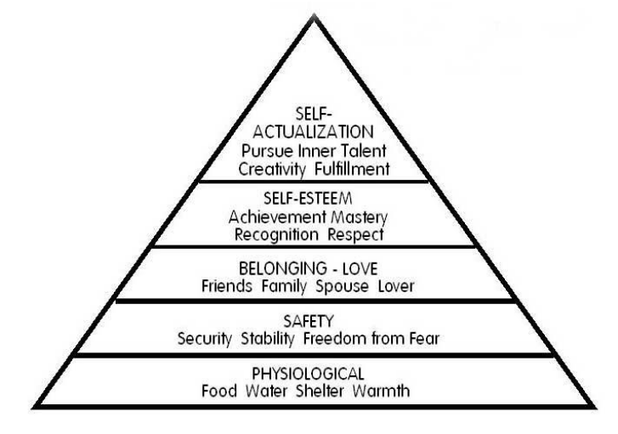
Abraham Maslow developed a hierarchy of needs to classify the basic needs into five layers of a pyramid which was published in 1954 in his book “Motivation and Personality” (McGuire, 2012).

Figure 1 - Maslow’s Hierarchy of Needs (1954) cited in (McLeod, 2017, p.3)

The pyramid is structures from the bottom to the top where each level represents the priority of human needs. Rakowski (2011) states that when an individual fulfils their needs at each level, they can progress to the higher levels.

Maslow’s Hierarchy of Needs Theory in Tourism

Maslow’s hierarchy of needs has been applied to tourism and travel motivations. There has been no factual evidence of an academic theory relating to tourism, however, Ryan (1998) cited in Woodside, et.al (2008) has adapted Maslow’s theory of needs to tourism.

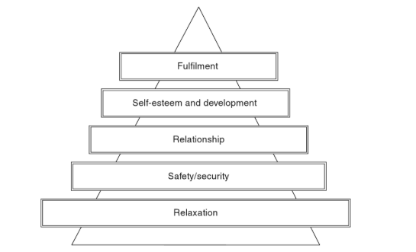
Figure 1.1 - Maslow’s Hierarchy of Needs to Tourism adapted by Ryan (1998) cited in Woodside, et.al (2008: p.17).

2.3 Impacts of All-inclusive holidays

2.3.1 Economic Impacts
Mack (2012) states that all-inclusive resorts bring employment to the community. Initially, tourism can be seen as a way to diversify host economies and improve infrastructure such as airports, health services, transport and general facilities in local communities (Andereck & Vogt, 2000; Schluter & Var, 1998; Yu et al., 2011). However, Kondo (2015), claims that little of the money generated by all-inclusive holidays reaches the local community which had a negative impact on the local economy. Many All- inclusive resorts control the flow of money that flows into the local economy which results in the lack of tourism benefits to local residents. Leakage is the biggest cause of this phenomenon. According to the United Nations Environment Program [UNRP], (2002), leakage is the “unwanted leaving of money from a country as a result of taxes, wages, imports and profits that are paid outside of the country”. Importing products that a country cannot supply to satisfy tourists needs and wants will result in leakage. A study by UNEP (2002) found that the leakage rate for the Caribbean was 80%. This indicates that only 20 Caribbean dollars will remain locally when tourists spend 100 Caribbean dollars. This shows that not enough tourists are spending money locally due to the nature of all-inclusive holidays. In addition, all-inclusive resorts result in the decrease of the multiplier effect. An increase in tourism spends will result in increased income and consumption higher that the initial spent amount (Schuster, 2006). Resulting in the failure to promote local development by diverting tourists away from local businesses. Consequently, reducing potential spend locally which forces restaurants, shops, bar, venues, car rentals, museums, among other business to suffer or even close (Tavares and Kozak, 2015).
Furthermore, Lengefeld and Stewart (2004) research followed 7 hotels that transformed into all-inclusive resorts in the Dominican Republic, Jamaica and Nicaragua. Their study shows that the transformation resulted in the closure of 5 – 11 restaurants and local businesses in the local communities surrounding the establishment. In total, they found this resulted in the loss of 50 jobs, however, it could be argued that 100+ jobs can be created within these all-inclusive resorts. Nevertheless, is has been known that local people have the worst jobs in contrast to staff from outside the country who are likely to be at a management level as many all-inclusive resorts are owned by international companies.

2.3.2 Social Impacts
Issa and Jayawardena (2003), argues that social issues are created because all-inclusive resorts cause minimal interaction between tourists and locals. Schmidt (1979) and Wickens (2000) similarly claim that tourist-host problems are reduced due to the minimal interaction between the two. From this, tourist problems are reduced, and locals will avoid any unpleasantness from tourists with different backgrounds and cultures that may cause offence.
However, Buhalis (2000) interprets it as an “artificial or staged” relationship. Schmidt (1979) argues that all-inclusive resorts are a form of enclave tourism which controls the movement of tourists from one location to another which helps protect the natural resources of the host destination.
Wong and Kwong (2004) suggest tourists travelling to distant destinations within a packaged holiday is safer due to the different cultures and unreliable transport. Armstrong and Mock (1995) also agree that tourists will feel safer within a packaged holiday as they are likely to travel in larger groups of people with similar backgrounds.
As the tourism industry is still rapidly growing and the demand for all-inclusive resorts in destinations such as Turkey and Spain are continually growing. As destinations attract more tourists, this puts a strain on the local residents as prices of goods and services can increase (Huh& Vogt, 2008; Liu & Var,1986). Enclave tourism can also affect the culture of a destination (Gjerald, 2005) and quality of life. Tourism can be a way of providing education, experience and contribute to a greater understanding of the hosts culture and history. However, when tourists stay in all-inclusive resorts, resident-tourist interaction is very limited. In different circumstances, Pizam (1978) suggests that local communities can perceive social and cultural impact of tourism negatively. Furthermore, the nature of mass tourism means a greater number of tourists can lead to greater noise and traffic congestion (Kwon & Vogt, 2010; McGehee & Andereck, 2004) which may cause tension between both tourist and locals.

2.3.3 Environmental Impacts

Gee and Sola (1997:36) state that the increase in the Global concern and environmental issues are due to the increase in tourism figures. Whilst Saayman (2013:311) confirms that “environmental protection has become a globalised concept “ which could be related to the rise in city breaks. Waste production has been a rising concern relating to environmental aspects of tourism products, especially all-inclusive resorts. For example, according Zappino (2005), tourists produce two-times the waste when compared to local residents in the Caribbean. Zappino (2005) goes on to suggest that tourists also overuse natural resources such as water, energy and local produce such as fish. With the increasing flow of tourists, the overexploitation of these resources puts pressure on the ecological system in destinations.

2.4 Triple Bottom Line Theory

Many academic theorists research shows that the solution for tourism is the ‘triple bottom line’ approach. The overall impacts would be minimised if the industry had a high economic impact, low environmental impact and a positive impact on the community it serves. Eco-tourism and alternative tourism will support the triple bottom line approach in developing destinations with negative economic, social and environmental impacts as a result of tourism (Saayman, 2012:63; George and Rivett-Carnac, 2007:34).

3
Methodology

3.1 Chapter overview

This chapter will address the most beneficial research methods to investigate and examine the public's holiday choices in regard to all-inclusive holidays and how informed these decisions are.

3.2 Research Onion

The researcher of this study will collect primary research by following Saunders, et al (2009) ‘Research Onion’ for identifying the methods of data collection and data analysis techniques.
Research can be defined as “something that people undertake in order to find out things in a systematic way, thereby increasing their knowledge” (Saunders, et al.,2009). However, Saunders et al., (2009) also suggests that it can only be classified as research if it is collected and interpreted in a systematic way. Therefore, the strategy of this study will follow the format for research set out by Saunders, et al., (2009). ‘The Research Onion’.

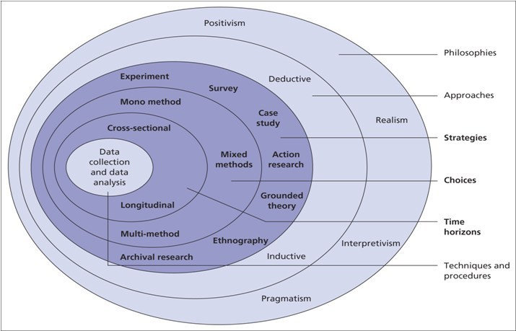

Figure 2 - The Research Onion. Source: (Saunders, et al., 2009)

3.2.1 Philosophy
When conducting research, it is crucial to be aware of the philosophical commitments. It is important to adopt the right philosophy as it will have a substantial impact on the understanding and examination on the research study (Johnson and Clark, 2006). Dudoyskiy (2019) suggests that research philosophy is how research is collected, analysed and used with regards about a specific phenomenon. The two dominant research paradigms are interpretivist and positivist. The interpretivist paradigm according to Collis and Hussey (2003, p.53) is believed to be concerned with understanding human behaviours and focuses on the meaning, rather than measurement of social phenomena. Positivist however refers to quantitative date and is described as being constant which relies on deductive logic (Levin, 1998).
Interpretivist can also be referred to as quantitative research which suggests that this approach is a way to ‘enter the world’ of the research participants to understand their feelings, compared to the positivism approach which is referred to as quantitative research approach of generating scientific ‘facts’ (Saunders et al., 2012). Therefore, the author of this thesis will adopt the interpretivism approach while underpinning this by incorporating elements of quantitative data throughout the study.

3.2.2 Approach

Saunders et al., (2012), notes that research that involves of both quantitative and qualitative data may consist of a combination of a deductive and inductive approach. Veal (2011) suggests that a deductive approach is observational research which tests a hypothesis to either approve or disprove it. Whereas, an inductive approach starts with a question that analysis data to answer or fail to answer the set objectives, where then a hypothesis is generated from these findings. Therefore, an inductive approach will aid in achieving the set objectives by researching consumer thoughts about all-inclusive holidays. This study will be exploratory to identify problems within the topic area and to produce direction for further work. By mainly taking a qualitative approach, the research is concerned with a subjective assessment of attitudes, opinions and behaviours of respondents (Kothari, C., 2004).

3.2.3 Strategy

The researcher will use a mixed method approaches which will consist of both quantitative and qualitative data collection. The researcher will gather data through online surveys, and interviews of people who have participated in all-inclusive holidays. These methods will ensure the researcher gathers data from all different angles to support and draw conclusions. For this reason, the idea of ‘triangulation’ plays a major role in this paper. The qualitative data gathered will be reinforced by the data found from the online surveys.
According to Kumar (2014:171), there are two main ways of collecting data, primary and secondary. Interviews and questionnaires will be the source for primary data, whilst academic journal and books, with the support of the university database will be the main source of secondary data.
Lambert (2012: 102) notes that the advantage of distributing surveys is that it is a well-known method and people will comply if the questionnaire is clear. However, he identifies that once you distribute the questionnaires, they cannot be changes and ‘response rate’ may be low. Therefore, the researcher will issue the questionnaire over a variety of social media platforms. The need for additional primary research such as interviews is to explore the attitudes, opinions and feelings of the interviewees of the topic of in depth, compared to statistics gathered from questionnaires. However, Lambert (2012: 102) identifies that this method can be very overwhelming due to the higher amount of responses and qualitative data gathered. Although the research approach is interpretative, this quantity of qualitative data makes it difficult to separate the valuable and non-valuable data. Therefore, researcher will go into the interviews with set questions they need to ask to support the data found from the online surveys.

3.2.4 Time horizon

Due to time constraints, this thesis will include cross-sectional research as this method will have a higher capability in achieving the aim of this study within the timeframe. In contrast to longitudinal research that is conducted over a longer period (Saunders et, al. 2012).

3.2.5Collection and analysis

3.2.5.1 Collection

The researcher of the paper will collect a mixture of both primary and secondary research. The purpose of analysing the data is to gain a better understanding of the topic and to interpret what it means (Denscombe, 2014). The researcher will follow a rigid procedure to complete a set of pre-conceived questions through a number of interviews. Furthermore, once the researcher has the participants permission, the interviews will be recorded, and the findings will be transcribed onto a word document to be analysed. In addition, the investigator will use a variety of platforms to distribute online surveys to reach respondents.

3.2.5.2 Questionnaire design

The questionnaire consists of a total of 24 questions that include; demographics, impacts of all-inclusive holidays, positive and negative, motivational factors and trends. The questionnaire will include a mix of open-ended and closed-ended questions.

3.2.5.3 Pilot study

The questionnaire was distributed to ten participants who agreed to analyse and provide feedback before making it available to all participants. By using a pilot study, it allows for any faults to be reviewed and corrected which will remove any unreliable results and mitigate the confusion that participants may have with the questions (Bowles and Metcalf, 2002; Thrusfield, 1986). Thus, the researcher was able to adjust questions to become more concise and easier to complete for participants. Questions that involve multiple tick boxes on mobile phones were making it difficult for the user, therefore, a suggestion was to make the questionnaire mobile-friendly as most participants were likely to use their mobile phones.

3.3 Sampling
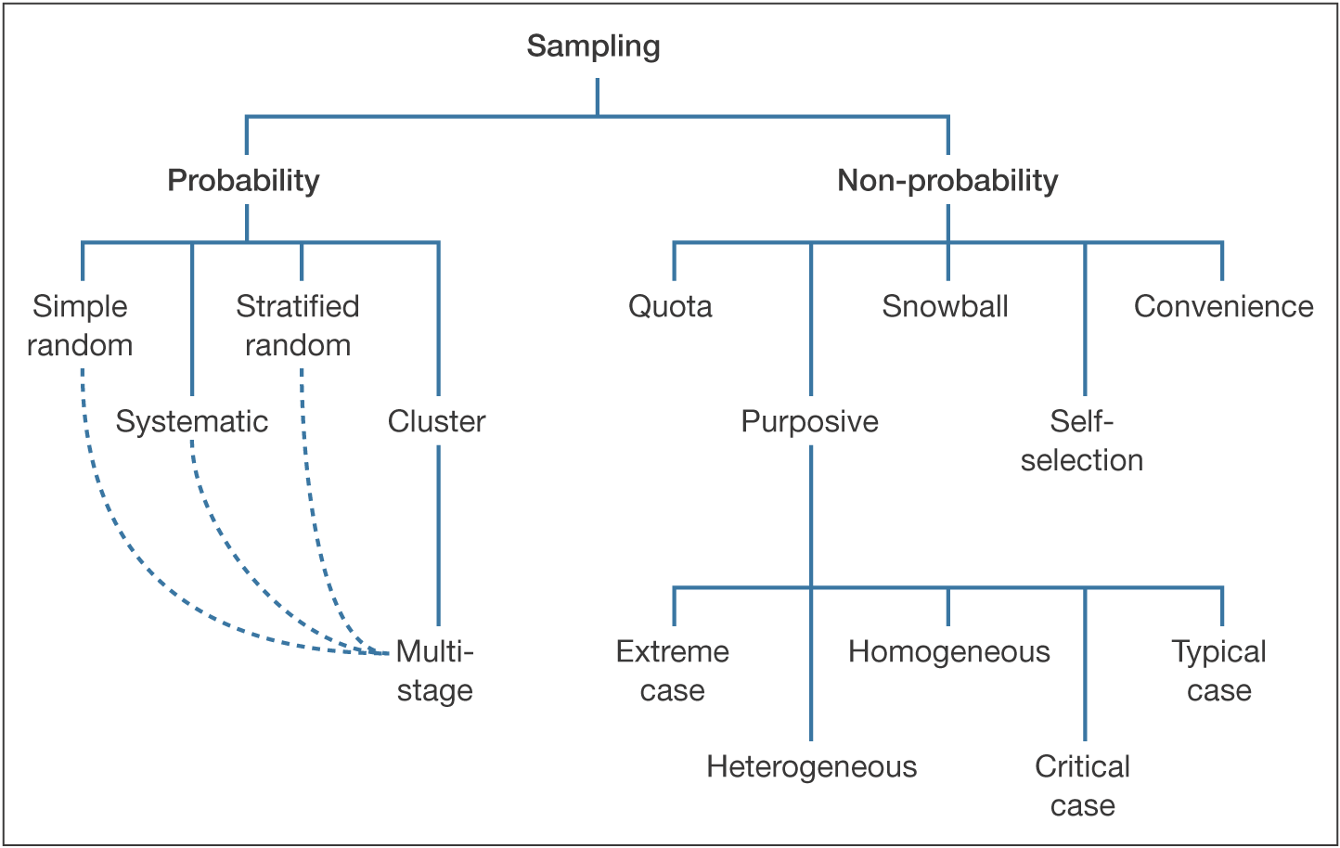
Figure 3 - Saunders, Lewis and Thornhill, Research Methods in Business, 4th Edition © Pearson Education Limited 2007
The online survey will be accessible on most social media platforms to reach all ages, different backgrounds and to receive a higher and fast response rate. Therefore, the sample will be random and will follow the ‘Probability’ route. Whereas, interviews will be focused on participants who have participated in all-inclusive holidays, therefore, the sampling method will follow the ‘Non-probability’ route and use the purposive method.

3.3.1 Analysis

The researcher will process the findings and seek for growing themes and patterns, especially by using a statistical analysis technique (Veal, 2011). A variety of charts and graphs will be used to display the primary data. This method will enable the reader to view numerical data visually (Bonita et al 2006).

3.4 Reliability and validity

Robson (2002) suggests that when undertaking research, it is crucial to understand and identify the ‘threats’ so the researcher can limit bias and ‘participant errors. Validity is concerned with accuracy of the data found and presented. Similarly, Gravetter et, al (2011) states that;
“Any component of a research study that introduces questions or raises doubts about the quality of the research process is a threat to validity”
Therefore, the researcher must have a strong research method and design to minimise the threats to achieve the set objectives of the research (Saunders, al 2009). Whereas, reliability is concerned with the quality of something that is trustworthy. Reliability can be defined as;
“Whether a research instrument is neutral in its effect and consistent across multiple occasions of use. This is frequently translated as the question ‘would the research instrument produce the same results on different occasions (all other things being equal)?” – Denscombe, 2014
To mitigate the uncertainty of the study being valid and reliable, and to create a dependable thesis, triangulation will be used.

3.5 Limitations

One limitation that this study will face is the lack of time enabled to execute the paper. The limitations of this project will be mitigated by improving time management in the form of a ‘Gantt Chart’.

3.6 Ethical considerations

Saunders et al., (2012), proposes that whether research is conducted face to face, online or any other way, the ethical awareness increases where studies involve human participants. This research is relatively low risk due to the research topic. Before collecting data, it is crucial to consider the relevance and be able to justify it so the respondents do not feel like their time is being wasted, which may be unethical. Privacy is crucial when conducting primary research. Therefore, all information provided will be kept anonymous and consent must be given before the researcher undertakes the interviews (Kumar,2014: 281). The research undertaken in this project will follow ethical guidelines throughout in addition to obtaining formal research ethics committee approval at the university.

4
Data Analysis

4.1 Chapter Overview

This chapter of the thesis is an analysis of the researcher’s primary data that was collected through an online questionnaire and interviews, concentrating on holiday makers decision-making process and their views on all-inclusive holidays with specific focus on the difference between packaged and all-inclusive. There was a sample of 80 online respondents and a total of 5 interviews.
Primary data will be presented in the form of percentages, along with responses sighted throughout this chapter.
Section 1 – Understands the demographics of the respondents;
Section 2 – Holidaymakers understanding of the all-inclusive concept,
Section 3– Respondents decision-making process and motivations,
Section 4– Holiday makers awareness of the impacts of all-inclusive resorts on host communities.

Please see Appendix A for the copy of the questionnaire and interview questions.

4.2 Section 1 – Demographics

4.2.1 Gender

Question 1 asked the respondents to confirm their gender. The results were as following; 36% identified as male which was followed by 64% of female respondents.

Figure 4 - Gender

4.2.2 Age
Following on from gender, question 2 asked the respondents to specify the age group they belong in. The smallest sample was 6% of respondents aged 50 +. This was followed by 9% of 16-21-year olds and 40% of 22-29 -year olds. The largest group was represented by 45% of 30-49-year olds.

Figure 4.1 - Age

4.2.3 Income

Question 3 asked for the respondent’s household income which was optional. The largest sample group was represented by 55% of respondents who have a household income of £10,000 - £19,000. This was followed by less than £10,000 at 18 % and over £30,000 at 16%. The smallest sample was represented by 11% of respondents who have a household income of £20,000 - £30,000

Figure 4.2 - Income

4.2.4 Visitor Profile

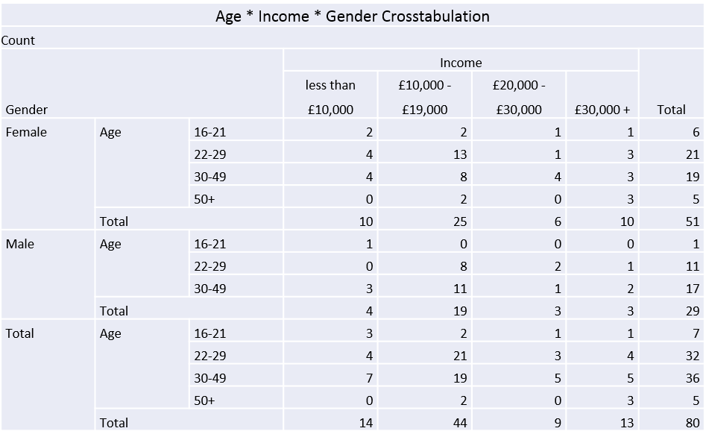
Predominantly, the highest visitor profile who picked all-inclusive as their type of holiday from the sample were 38% of males aged 30-49 with an income of £10,000 - £19,000. It was no surprise to find that this was closely followed by 28% of males aged 22-29 with an income of less than £10,000. Similarly, when we compare this against females, it appears that there is a trend in visitor profiles as 25% of females of this sample were aged 22-29 with an income of £10,000 - £19,000 and 16% of females were aged 30-49 with an income of also £10,000 - £19,000.
Figure 4.4 – Crosstabulation of Age, Gender and Income

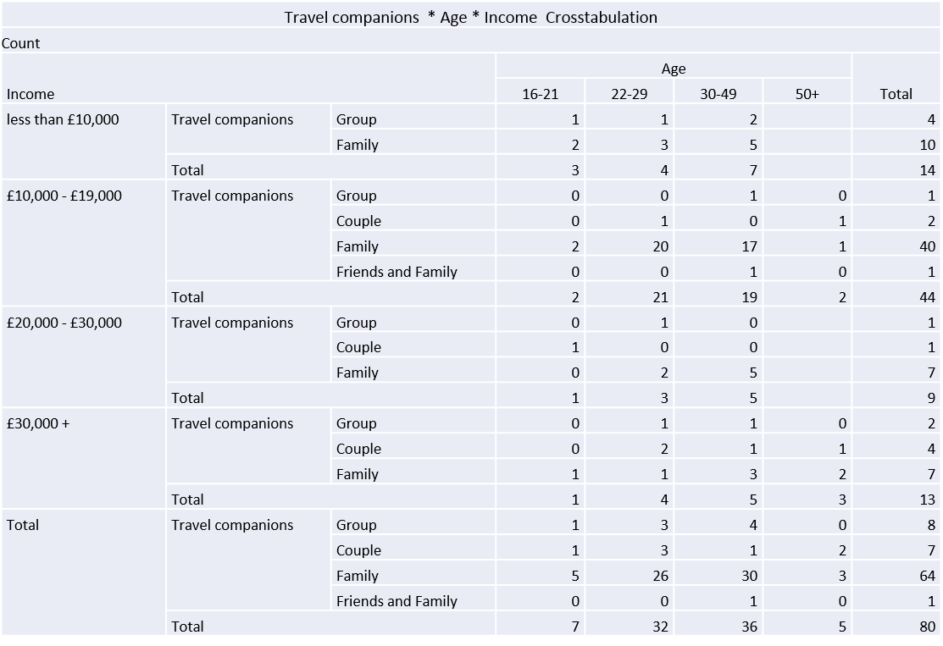
If we group these figures together it shows that the visitor profile of all-inclusive holidays is 64% of visitors aged between 22 and 49 with an income of less than £20,000. When we compare these figures to holiday companions, it is clear that 80% of all respondents were families with 70% of these respondents fitting the age bracket of 22-49. Therefore, it can be said that 70% of holidaymakers who participate in all-inclusive holidays are families aged between 22 and 49. Furthermore, when we compare against income, 56% of all families aged between 22 and 49 have an income of less than £20,000.
Figure 4.5 – Crosstabulation of Travel Companions, Age and Income

4.3 Section 2 – Holidaymakers understanding of the all-inclusive concept

4.3.1 All-inclusive vs Package
An issue raised through this thesis was ‘are holidaymakers aware of the difference between all-inclusive and packaged holiday’. The results for question 5 show that only 21% of respondents knew the difference, compared to 79% of respondents who did not know the difference. This supports the finding from the national opinion poll cited in Swarbrooke and Horner (2016) research which showed that 40% of people did not understand the all-inclusive concept and this data further suggests that double of the respondents agree.
Figure 5 – Tourists awareness of the difference between all-inclusive and packaged

Question 5a allowed respondents who answered yes to elaborate further and explain their awareness of the difference between all-inclusive and packaged. 42% of respondents referred to all-inclusive holidays as including food and drink within the price. While 58% of respondents also agreed that a package holiday can be as basic as transport and hotels. Participant number 10 stated:

“A packaged holiday is combined of transport and accommodation that is put together by a tour operator and sold as a holiday. An all-inclusive holiday means that all meals including food and drinks will be included in your holiday”.

Respondent 30 also agrees that all-inclusive includes food and drink, however, the respondent also argues that an all-inclusive holiday can also be referred to as a packaged holiday. Participant number 30 stated:
“All-inclusive typically includes everything such as; accommodation, transport, food, drinks and entertainment etc. Whereas, packaged can be as simple as accommodation and transportation. However, all-inclusive can be referred to as a packaged holiday”

Participant 50 raises the question that a package holiday will include transport and accommodation and a selection of holiday boards such as self - catering etc. But for it to be ‘all-inclusive’ the hotel must provide “food and drinks all day/night. From this it can be said a package holiday can still include; self-catering, half board, full board (not including drinks), whereas the drinks aspect makes it all-inclusive – includes food, drinks and snacks all day.

Question 18 allowed the respondents to elaborate further for the researcher of this thesis to gain a better of what tourists expect to be included in their holiday package as 79% are unaware of the difference between all-inclusive and packaged. The most frequent trend was that 70% of respondents mentioned that food and drinks would be included in a packaged holiday. Figure (5.1) shows interview responses which also show that for it to be an all-inclusive holiday, tourists expect to receive food and drinks for the duration of their holiday included in the single payment they paid prior to their holiday.

Figure 5.1 - Interview Matrix – Table 1 Defining an all-inclusive holiday
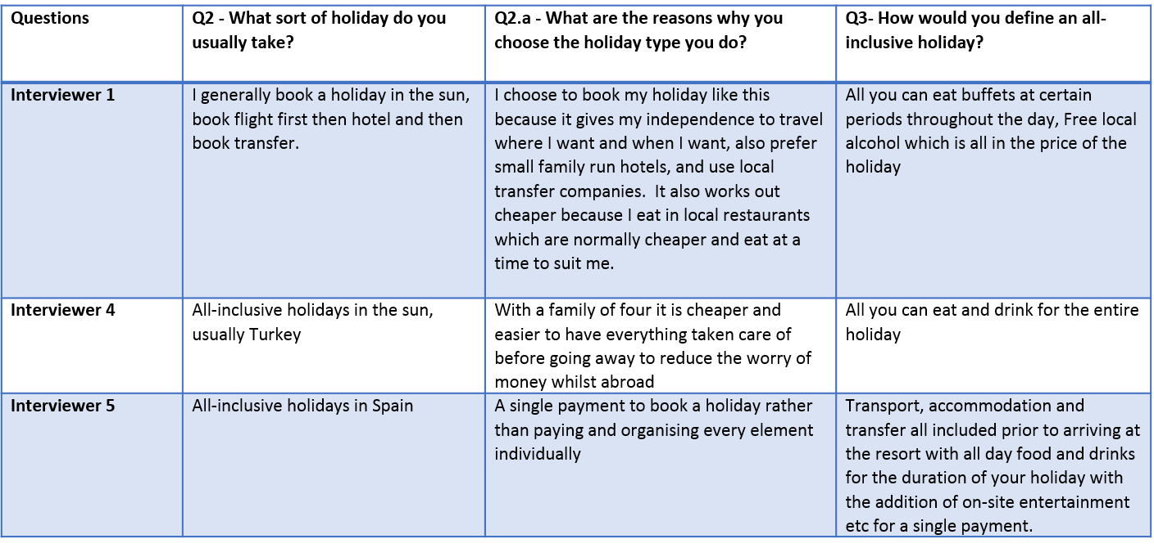

4.3.2 Stakeholders who Benefit

Figure 6 – Tourists views of which stakeholders benefit the most

Question 7 asked respondents to rank stakeholders who benefit the most from all-inclusive resorts to who benefits the least. The results show that tourists believe that the tourists themselves benefit the most from these holidays. They state that travel operators then benefit, followed by 34% who suggest that local community’s benefit. As we look further down the scale, they suggest that other countries do not benefit as much and that 24% believe local businesses do not benefit at all. The study by UNEP (2002) would disagree with the respondents as other countries benefit significantly from all-inclusive as resorts import good and supplies to fulfil the needs of international tourists that cannot be sourced locally which increases leakage.

4.3.2.1 Tourists awareness of negative impacts, who benefits and whether they left the resort to support local businesses with this knowledge

Figure 6.1 suggest that 46% of respondents who left the resort were aware of the negative impacts on the local community and also stated that local businesses benefit the least which suggest because they are aware of these impacts, they went to support such businesses. Although, 30% of respondents did not leave the resort while they were aware of the negative impacts. Nevertheless, 84% of respondents who were not aware of these impacts also did not leave the resort. Therefore, like the 46% who did leave, a greater awareness of the negative impacts all-inclusive resorts has on local businesses may encourage tourists to leave their resort at least once during their holiday to support such businesses.

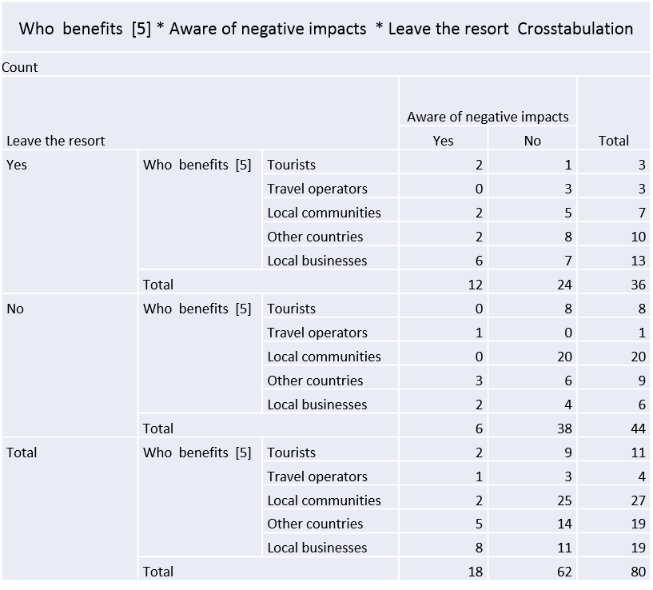
Figure 6.1 shows a crosstabulation to see if tourists who are aware of the negative impacts left the resort to support the local business that they ranked ‘benefits the least’

4.4 Section 3 – Respondents decision-making process and motivations

4.4.1 Factors that Influence Tourists Choice of Holiday

Question 8 asked the respondents to choose which four factors influence them to book an all-inclusive holiday. The results show that the number one factor that is the most important to individuals who book an all-inclusive holiday is the cost which accounts for 84% of respondents. 61% of respondents said that weather was the second most important factor for booking all-inclusive holiday, suggesting hotter countries than others. The third most frequent factor was safety accounting for 50% of respondents which Issa and Jayawardena(2003) suggests that they contribute to social issues as it reduces interaction with the locals, however, it also supports Schmidt(1979) and Wickens(2000) who suggests that tourists will avoid any unpleasant locals and staying in the resorts will allow them to stay safe and enjoy their holiday. Armstrong and Mok (1995) also support the theory that tourist will feel safer with a larger group of people with a similar background. Wong and Kwong (2004) suggested that booking an all-inclusive holiday will avoid unreliable transport and ensure safer travel which 44% of respondents agreed which is why accessibility was a contributing factor.

Figure 7 – Factor that influence holidaymakers’ choice to book an all-inclusive holiday

4.4.2 Age, Income and Factors (Cost)

Figure 7.1 shows that 30% of respondents aged 22-29 with an income of £10,000 - £19,000 first choice of factors that influence them was the cost of the holiday. This was closely followed by 27% of respondents aged 30-49 with an income also of £10,000 - £19,000. This would suggest that cost is the most important factor that influences the ‘family’ profile to book an all-inclusive holiday due to the amount of people travelling.

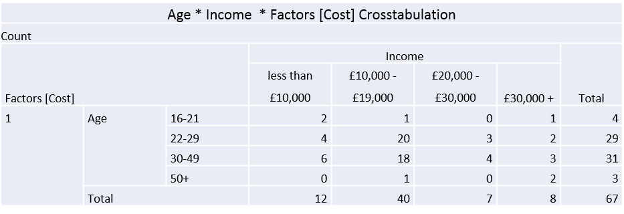
Figure 7.1 – Crosstabulation of Age, Income and Factors that Influence holidaymakers to book an all-inclusive holiday (Cost)

4.4.3 Holiday Location and Income
Figure 7.1 shows a trend between holiday location and cost. There is no surprise that the leading all-inclusive destinations welcome the most visitors with 55% of respondents visiting Spain and 70% of these respondents earning less an £20,000 and 28% of respondents visiting Turkey with 77% of these respondents earning less than £20,000. With cost being the number one factor and considering the holiday location and average cost per holiday according to Tui (2020) these destinations are relatively cheaper to visit which is the result of a higher volume of tourists visiting these European country to stretch their money further, compared to an all-inclusive destination which is evidently more expensive such as Jamaica with an average of £1500pp where only 4% of respondents visited with 34% of these respondents who earns more than £30,000, therefore, their choice of holiday may not be influenced by cost. From this data, it can be concluded that income and location are linked.

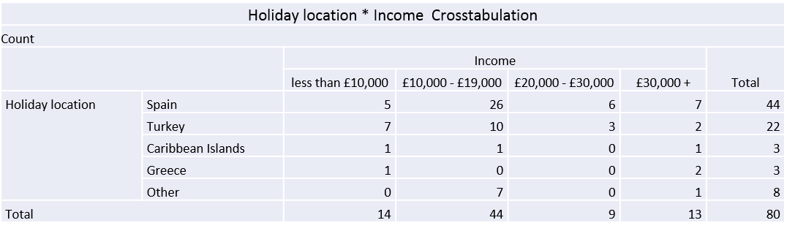

Figure 8 – Crosstabulation between Holiday Location and Income

4.4.4 Age, Gender and Factors (Safety)
From cross referencing the factor of safety against age and gender, It is clear from figure 9 that from the male participants only males aged between 22 and 49 chose safety as a factor with 9% saying it was the most important and 91% stating it was the third most important factor. As these ages fit the ‘family’ profile, it can be said that only males with families answered as safety is an important factor for the protection and welfare of the family and younger children. Furthermore, 82% of females who said safety of all-inclusive resorts influences them to book that type of holiday fit the ‘family’ profile of ages 22-49.

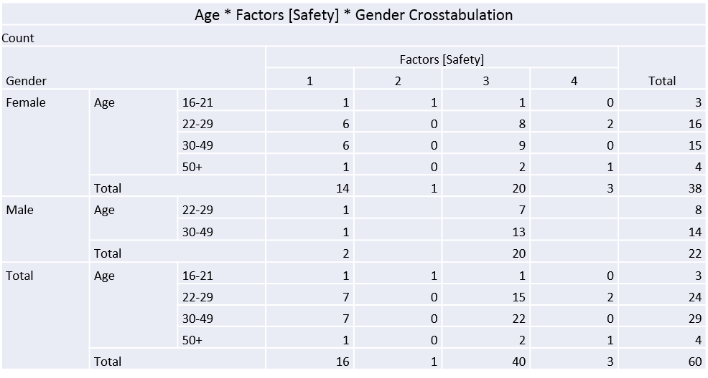

Figure 9 – Crosstabulation of Age, Gender and Factors that Influence holidaymakers to book an all-inclusive holiday (Safety)

4.5 Section 4 – Holiday makers awareness of the impacts of all-inclusive resorts on host communities

4.5.1 Negative Impacts
Question 6 asked if respondents were aware of the negative impacts of all-inclusive resorts on host communities. The results show that only 22% said they are and 78% stated that they are unaware. Question 19 then asked respondents to state why such resorts have a negative impact. The data shows a trend that 65% of respondents agree that the main negative impact that all-inclusive resorts cause is loss of business within the local community, followed by 24% of negative economic impacts directly relating to the loss of local business. This supports the statement made by Kondo (2015), who suggests that local communities receive minimal economic benefits from all-inclusive resorts, which results in the closure of many businesses.

Figure 10 – Respondent awareness of the negative impacts of all-inclusive holiday

Figure 11 - Interview Matrix – Table 2 – Impacts on the local community
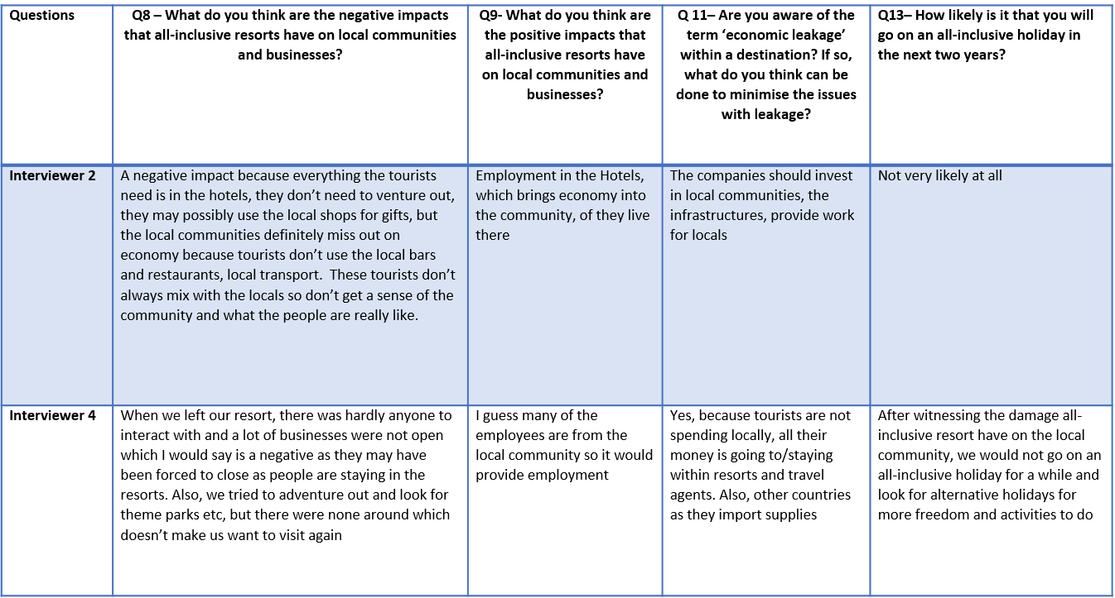

After answering the interview questions, 80% of respondents said that they are not likely to go on an all-inclusive holiday within the next two years. Interviewer 4 answer to question 13 supports the statement made by Saayman (2013:311) that environmental protection has become a globalised concept which is further supported by Haarhoff (2015) who suggests that conservation influences consumer behaviour which has seen the rise in alternative tourism and decrease in packaged holidays

4.5.2 Leaving the Resort
Question 11 asked respondents if they left the resort during their holiday. The results show that 45% of visitors did leave their resort, while 55% of holidaymakers did not leave the resort. 86% of respondents did not encounter any environmental issues whilst on holiday, however, 86% of respondents also stated that they did not leave their resort which suggests because they did not leave their resort, they would not have witnessed any environmental issues if there were any, furthermore, it is also evident that private investors and travel operators only invest in the tourism environment of a destination; resorts, beaches, bars, clubs, however, if you travel a few streets behind these resorts and tourism products you would witness the negative environmental issues of a destination. 33% of respondents who did leave the resort reported that they encountered environmental issues whilst on holiday

It is interesting that 45% said that they did use the off-site facilities compared to 55% who said they did not use these facilities and stayed within the resort they booked into which suggests that they go on an all-inclusive holiday and stay inside the resort which associates to the reasons behind the development of Butlins, the reason cruise ships are so popular and all-inclusive resorts are very popular because they do not use local facilities.

These figures support the reasons for why all-inclusive holidays were developed in the first place. For example, if you want to visit a destination but you want someone to book your accommodation, flights and your transfers, that would be a packaged holiday which suggests there would be no need for an all-inclusive holiday if all tourists are happy to make their own arrangement and eat in local restaurants and bars. However, it seems that the all-inclusive model was created as tourists want to go on holiday with everything taken care of so they can do nothing and not have to worry for the duration of their holiday.
Figure 12 – Tourists decisions whether to leave their resort or not

4.5.2.1 Correlation between Negative Impacts/ Environmental issues and Tourists who left the Resort
It is clear that there is a relationship between tourists’ awareness of environmental issues and tourist awareness of negative impacts. The 33% of respondents who said they encountered environmental issues also stated that they are aware of the negative impacts within the local community. Whereas, the remaining 66% who left the resort but did not encounter any environmental issues which also stated that they are not aware of the negative impacts on local communities.
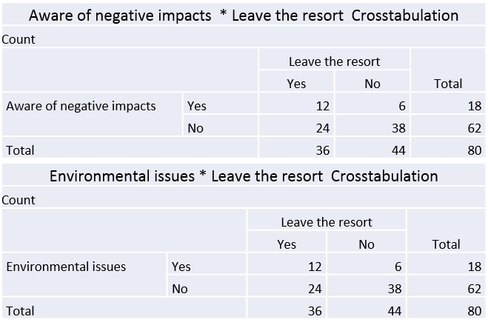
Figure 12.1 – Crosstabulation of Tourists awareness of negative impacts and Environmental awareness and their decisions whether to leave their resort or not

4.5.2.2 Age, Income and Tourists who left the Resort
55% of respondents show that they did not leave the resort whilst on holiday, compared to 45% which did. It can be assumed that 45% spent money within the local community when they left the resort. 67% of respondents aged 16 – 21 with an income of less than £10,000 left the resort, compared to 71% of respondents aged 30-49 with an income of less than £10,000. Whereas, 92% of respondents aged 16+ with an income of over £30,000 left the resort whilst on holiday.

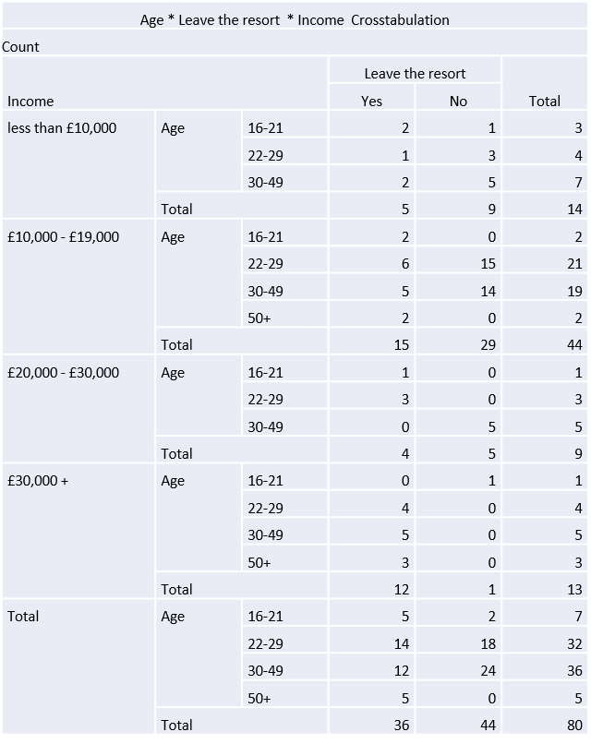
Figure 12.2 – Crosstabulation of Age, Income and tourists’ decisions whether to leave their resort or not

4.5.3 Negative Impacts and Tourists who used service that were not provided within their package
Participants were asked how often they use services that are not included in their all-inclusive package such as off-site; bars, restaurants, transport and activities. There was a clear pattern within respondents’ awareness of the negative impacts and off-site bars and off-site restaurants and the impact on the community. 58% of respondents who are not aware of the negative impacts of all-inclusive on local communities did not use off-site bars whilst on holiday. Whereas, 67% of respondents who are aware of these impacts, did use off-site bars at some point during their holiday. Furthermore, 63% of the respondents who are not aware of the impacts that all-inclusive resorts have on the local did not use off-site restaurants whilst on holiday, whereas, 61% of

respondents who are aware of the impacts stated that they used off-site restaurants during their all-inclusive holiday. This shows that there is a clear link between tourist awareness of these impacts and their decision-making whist on holiday which supports Haarhoff (2015) theory of increased conservation within tourists and their consumer behaviour whilst on holiday.
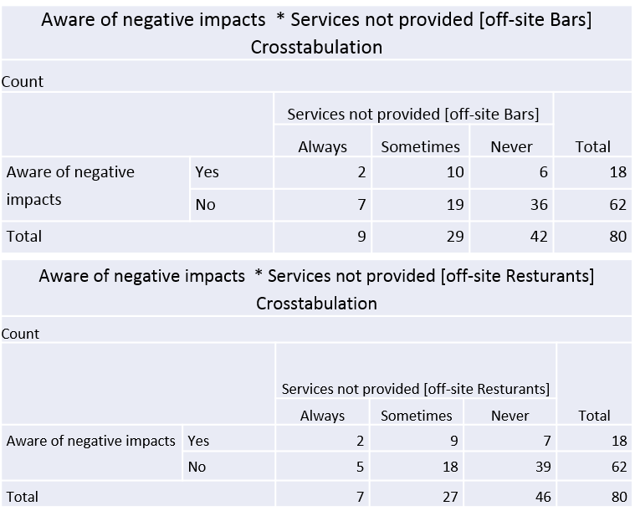
Figure 13 – Tourist awareness of negative impacts and the use of services not provided (off-site bars and Restaurants)

4.5.3.1 Age, Income and Services not provided within their package
The 44% of respondents who always use off-site bars are aged 22-29, with 41% of these stating that they sometimes use off-site bars. However, when we look at their income, only 21% of respondents who earn less than £10,000 sometimes left the resort or used off site bars and restaurants but 79% never left the resort. Whereas, respondents who earn over £30,000 shows that 100% of respondents left the resort at some point of their holiday to visit a local bar and 77% of respondents left their resort to visit a restaurant. The results show that less visitors leave their resort based on their financial income, whereas, 100% of visitors with the highest income bracket left the resort. Nevertheless, 50% of respondents aged 16-21 always use off site bars which could suggest that their main purpose for holidaying was to party and make use of these bar and not because they are aware of the negative impacts. These figures also suggest that younger respondents like to go out to local bars which links to the club 18-30 holidays which always involves excursions in the evenings. Although they would be onsite throughout the day, they would utilise local facilities in the evenings when going out clubbing.

Furthermore, 50% of respondents who never use off-site bars and restaurants fall into the family category and therefore, have younger children who may not be suitable for bar as they supply alcohol or that simply they cannot afford to leave the resort and that is why they chose this type of holiday and cost was the main influence.
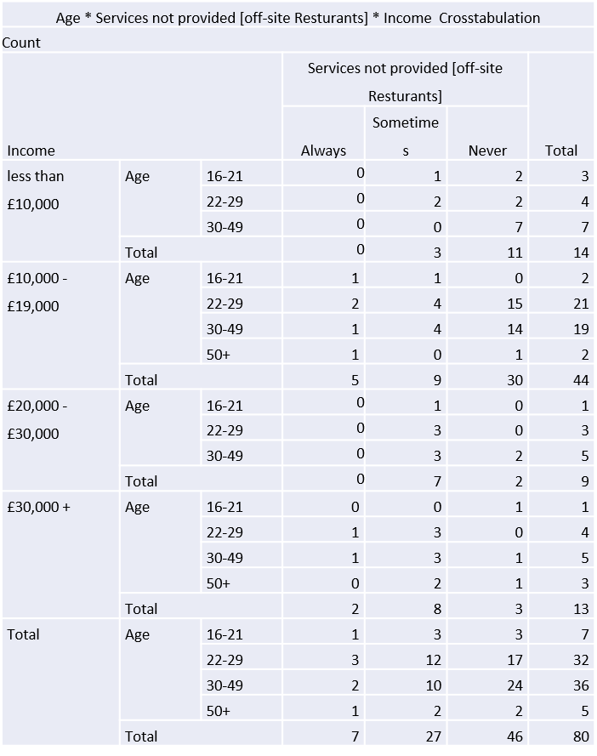
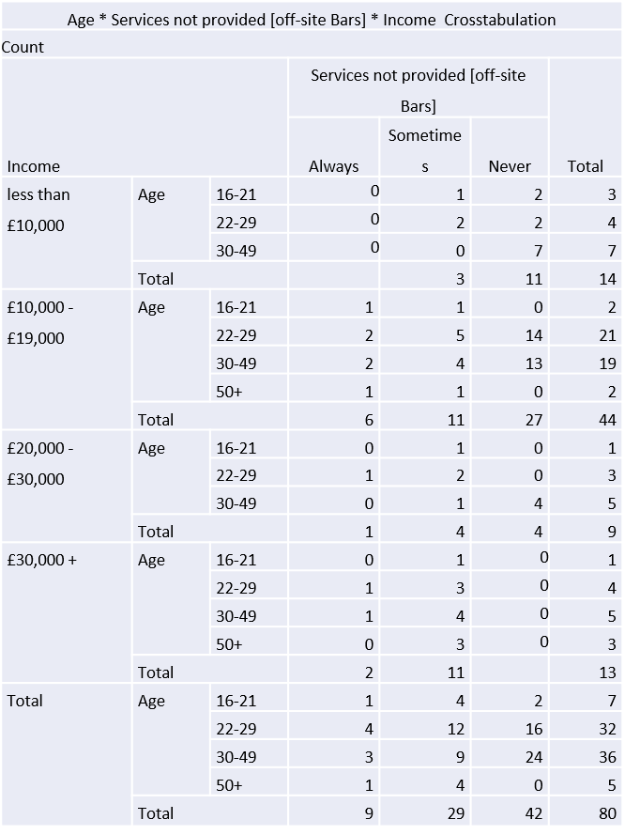

Figure 14 –Crosstabulation between Age, Income and the use of services not provided (off-site bars and Restaurants)

4.5.4 Multiplier effect
Question 9 asked the respondents if they were aware of the term ‘multiplier effect’. 94% of respondents said that they were unaware of the multiplier effect and only 6% were aware of the term.

Figure 15 – Tourists awareness of the multiplier effect

4.5.4.1 Tourists awareness of the term multiplier effect and their choices of using service not provided by their all-inclusive holiday

55% of respondents who were not aware of the term multiplier effect also did not use bars and 60% did not use restaurants outside their resort, therefore, not contributing to the local economy. Whereas, 80% of respondents who are aware of the term did use off site bars and restaurants at some point during their holiday, therefore, contributing to the local economy which was a key negative impact highlighted by respondents. Therefore, the results show that, if tourists had more knowledge of their action and the impacts, they are more likely to use facilities and services outside their resort so local communities also benefit.

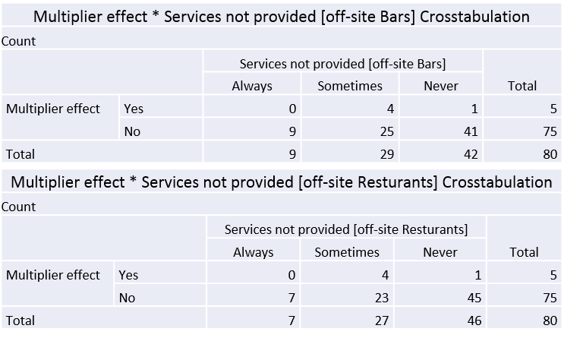
Figure 15.1 – Tourists awareness of the multiplier effect and the use of services not provided within their all-inclusive holiday (off-site bars and restaurants)

4.6 Summary

All quantitative data questions used spss to summarise , run tests and cross tabulate for a more comprehensive analysis which was supported by the qualitative matrix of the interviews.

5
Conclusion

5.1 Chapter Overview

This is the final chapter of this thesis and will discuss and evaluate the researcher’s objectives and whether they have been achieved. Moreover, this will allow the researcher to consider the limitation of the paper and allow for recommendation for further research.

5.2 Summary of findings

The question raised by the researcher was to investigate the publics holiday choices in regard to all-inclusive holidays and how informed these decisions are. The primary research was developed to achieve a deeper understanding of the acquired secondary data of the chosen topic. The quantitative and qualitative data within this analysis supports key themes gathered from the literature review.

Primarily, a key theme throughout the literature review was the difference between all-inclusive and packaged. The findings support the statement made by Sheldon and Mak (1987) that, an all-inclusive holiday is a combination of components that is packaged at a single price, including food, however, respondents also believed that drinks were also included in this. Furthermore, respondents agree with ABTA (2020) that a packaged holiday can be as simple as two components such as transport and accommodation.

Furthermore, finding also indicate that the typical all-inclusive visitor profile are families aged 22 – 49 with an income of less than £20,000. From this there is a correlation between this profile and cost as the most important factor that influences them to book an all-inclusive holiday. The data also revealed that the safety of all-inclusive resorts is a contributing factor for them to book this type of holiday which supports Armstrong & Mok, 1995 theory of tourists feeling safer when enclaved with similar tourists.

Moreover, findings also indicate that the main negative impacts off all-inclusive resorts on local communities is loss of local business. Supporting Tavares and Kozak (2015) who suggests that all-inclusive resorts reduce local spending which forces businesses to suffer or even close. Additionally, Mack (2012) theory that all-inclusive resorts bring employment to the community can be supported by the findings as the data indicates that employment was the main positive impact that all-inclusive resorts have on local communities. Although this seems contradictory, Lengefeld and Stewart (2004) research shows that although there is a small loss of businesses and employment, all-inclusive resorts proved double the amount of jobs within their resorts Nevertheless, this could be researched further to gain a deeper understanding of whether it is a positive or negative as many of these jobs with resorts are low skill and lower paid.
Furthermore, from the qualitative data conducted in this thesis, I can be said that more tourists are environmentally aware as respondents state that they would not go on an all-inclusive holiday after witnessing the impact on host communities.
The final key finding of the impacts on local communities is the lack of tourist’s knowledge of such impacts. The data showed that more tourists left the resorts and spent in local bars and restaurants as they are aware of these negative impacts, compared to less tourists who do not have a greater knowledge of the impacts on the local community, therefore, they did not leave and their money did not reach across the community.

5.3 Aims and Objectives

The aim of this dissertation is to investigate the public's holiday choices in regard to all-inclusive holidays and how informed these decisions are. The objectives are as followed:

5.3.1 Objective 1
A critical review of the growth of all-inclusive holidays and its impact on the host country has been comprehensively covered in the literature review and further supported by the findings in chapter 4.

5.3.2 Objective 2
An examination of holidaymakers' understanding of the impact of all-inclusive holidays on the local community was fulfilled by the distribution of online questionnaires and interviews where the investigator evaluates respondents understanding of the positive and negative impacts through spss and qualitative matrix tables.

5.3.3 Objective 3
To investigate holidaymakers' decision-making processes when choosing a holiday. This objective was fulfilled in the literature review with surrounding knowledge and with the assistance and support of primary research.

5.4 Research Implications

The aim of this thesis was to investigate the public's holiday choices in regard to all-inclusive holidays and how informed these decisions are. The literature review presented key theoretical perceptions of tourist motivations of all-inclusive holidays, decisions and knowledge. The investigator distributed an collected a total of 80 online questionnaires and 5 interviews, therefore, allowing the researcher to compare the theoretical research against the quantitative and qualitative data. Thus, presenting that these findings to support the literature and that further research needs to be done relating to this topic of interest.

5.5 Research Limitations

Due to the recent outbreak of Covid-19, interview questions were sent out to participants. Although this may have resulted in a less bias opinion as the researcher was not present, it can be considered as a limitation as the researcher could have asked respondents to elaborate further on certain questions.
Although the sample size for both quantitative and qualitative was adequate for this size of research, a larger sample would enable the researcher to gather a greater amount of results and overview of the topic.

5.6 Recommendations for future research

It is recommended that the researcher sticks to an online survey that is distributed to a larger audience. This will allow for a faster response rate and a larger volume of respondents so that the data represents a larger proportion of respondents associated with the topic. Additionally, to allow for any implications that may hinder the execution of interviews, in this case Covid -19.
A recommendation for further research is the presumption that all-inclusive means that tourist do not use the local economy ,however, the researchers findings show that people between the age of 16 – 21 do go out and use the local bars and restaurants, particularly in Spain where they are not staying on the resort but are going into town in the evening because they still want the night life. Therefore, further research is needed to investigate the young person’s perception and impacts on the community.

Bibliography

Aguiló, E., & Rossello, J. (2012). Research note: The new all-inclusive board formula in mature destinations–from motivation to satisfaction. Tourism Economics, 18(5), 1117–1123.
[Accessed 4th March 2020]

Armstrong, R. W., & Mok, C. (1995). Leisure travel destination choice criteria of Hong Kong residents. Journal of Travel & Tourism Marketing, 4 (1), 99-104.
[Accessed 23rd March 2020]

Andereck, K. L., & Vogt, C. A. (2000). The relationship between residents' attitudes toward tourism and tourism development options. Journal of Travel Research, 39 (1), 27-36.
[Accessed 20th March 2020]

ABTA. (2018). Holiday Habits Report 2018. [online] Available at: https://www.abta.com/industry-zone/reports-and-publications/abta-holiday-habits-reports/holiday-habits-report-2018 [Accessed 20th February 2020]

ABTA. 2016. Travel Trends 2016. [online] Available at: <https://www.abta.com/industry-zone/reports-and-publications/abta-travel-trends-reports/travel-trends-2016> [Accessed 20th February 2020]

ABTA. 2017. Travel Trends 2017. [online] Available at: <https://www.abta.com/industry-zone/reports-and-publications/abta-travel-trends-reports/travel-trends-2017> [Accessed 20th February 2020]

ABTA. 2015. Travel Trends 2015. [online] Available at: <https://www.abta.com/industry-zone/reports-and-publications/abta-travel-trends-reports/travel-trends-2015> [Accessed 20th February 2020]

ABTA. 2020. Travel Trends 2020. [online] Available at: <https://www.abta.com/industry-zone/reports-and-publications/abta-travel-trends-reports/travel-trends-2020> [Accessed 20th February 2020]

Bowles, D. and Metcalf, P. (2002). GCSE Maths: The AQA Modular Course. 3rd ed. Cheltenham: Nelson Thornes.
[Accessed 14th March 2020]

Butlins.com. 2020. Book Family Holidays And Short Breaks At UK Holiday Parks | Butlin's. [online] Available at: <https://www.butlins.com/>
[Accessed 16th March 2020]

Boniface, B. and Cooper, C., 2009. Worldwide Destinations. [online] Google Books. Available at: <https://books.google.co.uk/books?id=tQzn6q7qsYQC&pg=PA35&dq=cohen+1972+tourist+classification&hl=en&sa=X&ved=0ahUKEwiQn7D_w8zpAhUOY8AKHTTeAjMQ6AEIKDAA#v=onepage&q=cohen%201972%20tourist%20classification&f=false>
[Accessed 22nd March 2020]

Bergin – Seers, S & Mair, J. (2009). Emerging dreen tourists in Australia: Their behaviour – a discussion of opportunities for change. International Journal of Consumer Studies. [Accessed 20th February 2020]
[Accessed 2nd March 2020]

Blythe, J., 2013. Consumer Behaviour. [online] Google Books. Available at: <https://books.google.co.uk/books?id=IWouAgAAQBAJ&printsec=frontcover&dq=blythe+consumer+needs+and+wants&hl=en&sa=X&ved=0ahUKEwjov-7ax7HpAhVOTsAKHRnHBPMQ6AEINzAC#v=onepage&q&f=false>
[Accessed 4th April 2020]

Buhalis, D. (2000). Relationships in the Distribution Channel of Tourism: Conflicts between Hoteliers and Tour Operators in the Mediterranean Region. International Journal of Hospitality and Tourism Administration, 1 (1): 113-39
[Accessed 25th February 2020]

Clark, J. (2000), “The art of all-inclusive vacation deals: a Caribbean comparison of resorts vs crusies” USA Today.
[Accessed 4th March 2020]

Cole, S. and Morgan, N., 2010. Tourism And Inequality. [online] Google Books. Available at: <https://books.google.co.uk/books?id=ePAckpUDP8IC&pg=PA70&dq=enclave+tourism&hl=en&sa=X&ved=0ahUKEwipn4K-5_TnAhWEqHEKHbwiDa4Q6AEISzAE#v=onepage&q=enclave%20tourism&f=false> [Accessed 3rd May 2020]

Collis, J. and Hussey, R. (2003) Business Research: a Practical Guide for Undergraduate and Postgraduate Students, 2nd Ed., Macmillan: Basingstoke.
[Accessed 15Th March 2020]

Day, M. (2015). The death of Venice: Corrupt officials, mass tourism and soaring. [online] The Independent. Available at: https://www.independent.co.uk/news/world/europe/the-death-of-venice-corrupt-officials-mass-tourism-and-soaring-property-prices-have-stifled-life-in-10251434.html
[Accessed 1st March 2020]

Denscombe, M. 2014 The Good Research Guide: For Small Scale Social Research Projects. Fifth ed. Maidenhead:
[Accessed 12^{h} March 2020]

Dudovskiy. J (2019) 2019. Research Methodology [Online] available at: https://research-methodology.net/research-philosophy/
[Accessed 12th March 2020]

Dolnicar, S. (2010). Identifying tourists with smaller environmental footprints. Journal of Sustainable Tourism, Pages, 717-734.
[Accessed 4th May 2020]

Gee, C.Y. and Fayos Sola, E. (1997) International Tourism: A global perspective. Madrid, Spain: World Tourism Organisation
[Accessed 4th March 2020]

George, R. and Rivett-Carnac, K. (2007). Oxford Successful Tourism: Grade 12 Learner’s Book. Cape Town: Oxford University Press Southern Africa.
[Accessed 4th March 2020]

Gjerald, O. (2005). Sociocultural impacts of tourism: A case study from Norway. Journal of Tourism and Cultural Change, 3 (1), 36-58
[Accessed 12th March 2020]

Huh, C., & Vogt, C. A. (2008). Changes in residents' attitudes toward tourism over time: A cohort analytical approach. Journal of Travel Research, 46 (4), 446-455.
[Accessed 12th April 2020]

Haarhoff, R, (2015), ‘Exploring tourist’s attitude towards a greener future’
[Accessed 4th March 2020]
Issa, J. J., & Jayawardena, C. (2003). The "all-inclusive" concept in the Caribbean. International Journal of Contemporary Hospitality Management, 15 (3), 167-171 [Accessed 20th February 2020]
[Accessed 15th February 2020]

Johnson, P. and Clark, M. (2006). Business and management research methodologies. London: Sage
[Accessed 3rd April 2020]

Koc, E. (2013). Inversionary and liminoidal consumption: Gluttony on holidays and obesity. Journal of Travel & Tourism Marketing, 30(8), 825–838.
[Accessed 7th May 2020]

Kothari, 2004. Research Methodology: Methods and Techniques. 2 ed New Dehli: New Age International Publishers.
[Accessed 15th April 2020]

Kondo, M. (2015). [online] Openlab.citytech.cuny.edu. Available at: https://openlab.citytech.cuny.edu/hmgt3502-research-seminar/files/2015/08/The-Economic-Impact-of-All-Inclusive-Resorts-in-Jamaica-Misaki-Kondo.pdf
[Accessed 23rd February 2020]

Kwon, J., & Vogt, C. A. (2010). Identifying the role of cognitive, affective, and behavioral components in understanding residents' attitudes toward place marketing. Journal of Travel Research, 49 (4), 423-435. [Accessed 17th April 2020]

Kumar, R. (2014). Research methodology. 4th ed.
[Accessed 13th^{th} April 2020]

Lengefeld, K., Stewart, R. (2004). All-inclusive resorts and local development: as best practice in the Caribbean. Retrieved May 6, 2015 from http://davidmcmillangroup.typepad.com/consulting/2007/02/all_inclusive_r.html.
[Accessed 26th^{th} March 2020]

Lambert, M. (2012). A beginner's guide to doing your education research project.
[Accessed 12th April 2020]

Levin, D. 1998. The opening of vision: Nihilism and the postmodern situation. London: Routledge. [Accessed 17th March 2020]

Liu, J.C., & Var, T. (1986). Resident attitudes toward tourism impacts in Hawaii. Annals of Tourism Research, 13 (2), 193-214.
[Accessed 24th March 2020]

Mensah, I & Mensah, R, D. (2013). International Tourists’ Environmental Attitude towards Hotels in Accra. International Journal of Academic Research in Buiness and Social Sciences, Page, 444-455.
[Accessed 2nd April 2020]

Malihah Elly & Puspito Heri & Diyah Setiyorini. (2014). Tourism Education and Edu-Tourism Development: Sustainable Tourism Development Perspective in Education 1.
[Accessed 14th March 2020]

McGehee, N. G., & Andereck, K. L. (2004). Factors predicting rural residents' support of tourism. Journal of Travel Research, 43 (2), 131-140. [Accessed 23rd March 2020]

McLeod, S., 2007. [online] Highgatecounselling.org.uk. Available at: <http://highgatecounselling.org.uk/members/certificate/CT2%20Paper%201.pdf>
[Accessed 7th March 2020]

McGuire, K., 2012. Maslow's Hierarchy Of Needs. An Introduction. [online] Google Books. Available at: <https://books.google.co.uk/books?id=_qw6LvpknKkC&printsec=frontcover&dq=maslow%27s+hierarchy+of+needs&hl=en&sa=X&ved=0ahUKEwiHiarTwczpAhUIE8AKHa0bCioQ6AEIOjAC#v=onepage&q=maslow's%20hierarchy%20of%20needs&f=false
[Accessed 14th May 2020]

Mack, C. (2012). All inclusive holidays – the way to a better world? Retrieved from http://www.ethicaltraveller.co.uk/2012/05/all-inclusive-holidays-the-way-to-a-better world/.
[Accessed 13th March 2020]

Mihai t, & Oano s, (2010). consumer behavior in the different sectors of tourism. [Online] https://www.researchgate.net/publication/227351929_CONSUMER_BEHAVIOR_IN_THE_DIFFERENT_SECTORS_OF_TOURISM
[Accessed 8th May 2020]
Machi, L., et.al 2012. The Literature Review. [online] Google Books. Available at: <https://books.google.co.uk/books?id=QJ8nmTc4mnAC&printsec=frontcover&dq=what+is+a+literature+review&hl=en&sa=X&ved=0ahUKEwjG_eWbxszpAhWITsAKHRtjDzYQ6AEIOzAC#v=onepage&q=what%20is%20a%20literature%20review&f=false>
[Accessed 5th May 2020]

National Statistics. (2005). Travel Trends 2004. London: The stationery Office
[Accessed 18th March 2020]

National Statistics. (2018). Travel Trends 2017. London: The stationery Office
[Accessed 18th March 2020]

Office For National Statistics (1999). [online] Available at: <https://www.ons.gov.uk/peoplepopulationandcommunity/leisureandtourism/articles/holidaysinthe1990sandnow/2017-08-07>
[Accessed 21st March 2020]

Page, S., 2012. Tourism Management. [online] Google Books. Available at: <https://books.google.co.uk/books?id=oX2PQz6oIXcC&pg=PA49&dq=the+rise+in+1950%27s+tourism&hl=en&sa=X&ved=0ahUKEwjozpD9rbTpAhVRaRUIHYJZCIgQ6AEIKDAA#v=onepage&q=the%20rise%20in%201950's%20tourism&f=false>
[Accessed 14th April 2020]

Pizam, A. (1978). Tourism's impacts: The social costs to the destination community as perceived by its residents. Journal of Travel Research, 16 (4), 8-12.
[Accessed 27th April 2020]

Poon, A. (1998), All-Inclusive Resorts, Economic Intelligence Unit, Travel & Tourism Analyst
[Accessed 10th March 2020]

Pizam, A., Chon, K. and Mansfeld, Y., 1999. Consumer Behavior In Travel And Tourism. [online] Google Books. Available at: <https://books.google.co.uk/books?hl=en&lr=&id=Z4iAl2CpQpQC&oi=fnd&pg=PA7&dq=maslow%27s+hierarchy+of+needs+in+tourism&ots=leS5bbA076&sig=rVkklnRWMApjCIv69xcXmnBgHKQ#v=onepage&q=maslow's%20hierarchy%20of%20needs%20in%20tourism&f=false> [Accessed 17^{h} March 2020]

Rakowski, N., 2011. Maslow's Hierarchy Of Needs Model - The Difference Of The Chinese And The Western Pyramid On The Example Of Purchasing Luxurious Products. [online] Google Books. Available at: <https://books.google.co.uk/books?id=74pn6CPxKrQC&printsec=frontcover&dq=maslow%27s+hierarchy+of+needs&hl=en&sa=X&ved=0ahUKEwilk6GP6LHpAhXcQkEAHQ3oBfYQ6AEIMTAB#v=onepage&q&f=false>
[Accessed 8th May 2020]

Robins,N and Roberts,S. 1997. ‎International Institute for Environment and Development : Available at : https://books.google.co.uk/books?id=_ovrT0INdEoC&pg=PA1989&dq=economic+social+and+environmental+impacts+of+allinclusive&hl=en&sa=X&ved=0ahUKEwiuzsDf3d3pAhXEiFwKHQ0pDecQ6AEIKjAA#v=onepage&q=economic%20social%20and%20environmental%20impacts%20of%20all-inclusive&f=false
[Accessed 4th May 2020]

Ross, W. (2015). The death of Venice: Corrupt officials, mass tourism and soaring. [online] The Independent. Available at: https://www.independent.co.uk/news/world/europe/the-death-of-venice-corrupt-officials-mass-tourism-and-soaring-property-prices-have-stifled-life-in-10251434.html
[Accessed 19th February 2020]

Saxena.R, 2009 MARKETING MANAGEMENT 4E – page 19 [Accessed 19th March 2020]

Swarbrooke, J. and Horner, S., 2016. Consumer Behaviour In Tourism. [online] Google Books. Available at: <https://books.google.co.uk/books?hl=en&lr=&id=y9wRDAAAQBAJ&oi=fnd&pg=PP1&dq=Swarbrooke,+J.+and+Horner,+S.+(2016).+Consumer+behaviour+in+tourism&ots=fAKn-Ae7D5&sig=ysIkux627NVJe-UewnwG57gRo-g#v=onepage&q=Swarbrooke%2C%20J.%20and%20Horner%2C%20S.%20(2016).%20Consumer%20behaviour%20in%20tourism&f=false>
[Accessed 23rd March 2020]

Swarbrooke, J. and Horner, S., 2007. Consumer Behaviour In Tourism. [online] Google Books. Available at: <https://books.google.co.uk/books?id=Bhp_rUTv3_AC&printsec=frontcover&dq=Swarbrooke,+J.+and+Horner,+S.+(2007).+Consumer+behaviour+in+tourism&hl=en&sa=X&ved=0ahUKEwjGh7bHvczpAhXMfMAKHfVkAisQ6AEIKDAA#v=onepage&q=Swarbrooke%2C%20J.%20and%20Horner%2C%20S.%20(2007).%20Consumer%20behaviour%20in%20tourism&f=false>
[Accessed 15th March 2020]

Schmidt, C. (1979). The guided tour: Insulated adventure. Urban Life, 7(4), 441-467
[Accessed 14th April 2020]

Solomon, M. (2004) Consumer Behavior: Buying, Having and Being- Prentice Hall
[Accessed 25th March 2020]

Solomon, M. R. (1996). Consumer behavior (3rd ed.). Engle-wood Cliffs, NJ: Prentice-Hall. [Google Scholar]).
[Accessed 25th March 2020]

Saayman, M. (2013). En route with tourism. South Africa: Juts and Company Ltd. [Accessed 20th February 2020]

Saayman, M. (2012). An introduction to Sports Tourism and Event Management: South Africa [Accessed 20th March 2020]

Saunders, M. N. K., Thornhill, Adrian, and Lewis, Philip. Research Methods for Business Students. Fifth ed. 2009. Web. [Accessed 13th April 2020]

Saunders, Mark, Philip Lewis, and Adrian. Thornhill. Research Methods for Business Students. 6th ed. Harlow: Pearson, 2012. Print.
[Accessed 11th April 2020]

Saunders, M., Lewis, P. and Thornhill, A. (2007) Research Methods for Business Students, 4th Edition, Financial Times/Prentice Hall: Harlow
[Accessed 11th April 2020]

SA Tourism (2013). Annual Tourism Performance Report. Available from: www.gov.za/sites/www.gov.../Tourism_Annual_Report_2013-2014_
Wong,‖C.‖S.,‖&‖Kwong,‖W.‖Y.‖(2004).‖Outbound‖tourists’‖selection‖criteria‖for‖choosing‖all-inclusive package tours. Tourism Management, 25 (5), 581–592.
[Accessed 23rd March 2020]

Sandals foundation. (2020). Home | Sandals Foundation. [online] Available at: https://sandalsfoundation.org/
[Accessed 22nd March 2020]

Sandals. (2020). Eco-Friendly Practices at Our Caribbean Resorts | Sandals. [online] Available at: https://www.sandals.co.uk/about/eco-friendly/
[Accessed 22nd March 2020]

Schuster, J.(2006) Fiscal Policy. In Encyclopedia of world poverty. [Accessed 3rd^{th} May 2020]

Sheldon, P.J, and J.Mak (1987). “The demad for package tours: A mode choice model”. Journal of travel research
[Accessed 16th March 2020]

Schluter, R., & Var, T. (1988). Resident attitudes toward tourism in Argentina. Annals of Tourism Research, 15 (3), 442-445.
[Accessed 26th March 2020]

Tavares, J. and Kozak, M. (2015). [online] Available at: https://www.researchgate.net/profile/Jean_Tavares3/publication/280386268_TOURISTS%27_PREFERENCES_FOR_THE_ALL-INCLUSIVE_SYSTEM_AND_ITS_IMPACTS_ON_THE_LOCAL_ECONOMY/links/55b3f99a08aec0e5f434dd70/TOURISTS-PREFERENCES-FOR-THE-ALL-INCLUSIVE-
SYSTEM-AND-ITS-IMPACTS-ON-THE-LOCAL-ECONOMY.pdf
[Accessed 18th March 2020]

Tui.co.uk. 2020. TUI Holidays Search Results | Discover Your Smile. [online] Available at: <https://www.tui.co.uk/destinations/packages?airports%5B%5D=LGW&units%5B%5D=GRC%3ACOUNTRY&when=20-07-2020&until=&choiceSearch=false&flexibility=true&monthSearch=false&flexibleDays=3&flexibleMonths=&noOfAdults=2&noOfChildren=2&childrenAge=11%2C12&duration=1415&searchRequestType=ins&searchType=search&sp=true&multiSelect=true&room=&isVilla=false&reqType=&sortBy=totalPriceAsc#658931ad9e75738c700c573500e879c90078c9aa>
[Accessed 14 ^{th} May 2020]

Travelmatters.co.uk. (2019). The Positive Impact. [online] Available at: https://www.travelmatters.co.uk/travelmattersblog/positive-impact-tourism-can-local-communities/ [Accessed 20th February 2020]

United Nations Environment Program. (2002). Economic impact of tourism. http://www.uneptie.org/pc/tourism/susttourism/economic.htm
[Accessed 19th April 2020]

Unwto.org. 2020. Glossary Of Tourism Terms | UNWTO. [online] Available at: <https://www.unwto.org/glossary-tourism-terms>
[Accessed 27th March 2020]

Veal. A.J, (2011), ‘Research methods for leisure and Tourism a practical guide’, fourth ed Essex. [Accessed 4th April 2020]

Woodside, et. Al 2008. Tourism Management. [online] Google Books. Available at: <https://books.google.co.uk/books?id=fMFx-ssVmZYC&pg=PA14&dq=maslow%27s+hierarchy+of+needs+tourism+theory&hl=en&sa=X&ved=0ahUKEwjOlqz1-rXpAhXkShUIHbPwDtwQ6AEIKDAA#v=onepage&q=maslow's%20hierarchy%20of%20needs%20tourism%20theory&f=false>
[Accessed 11th May 2020]

Wong and Kwong, W (2004).‖Outbound‖tourists’‖selection‖criteria‖for‖choosing‖all-inclusive package tours. Tourism Management, 25 (5), 581–592. [Accessed 15^{h} March 2020]

Wickens, E. (2000). Authenticity in Promotional Information. Do Package Holidaymakers set itShould Tour Operators Convey it? Management, Marketing and the Political Economy of Travel and Tourism: Reflections on Internacional Tourism, Business Education Publishers Ltd, ed. M Robinson et al.
[Accessed ^{23rd} March 2020]

Yu, C. P. S., Chancellor H. C., & Cole, S. T. (2011). Measuring residents' attitudes toward sustainable tourism: A reexamination of the sustainable tourism. Journal of Travel Research, 50 (1), 57-63.
[Accessed 25th February 2020]

Yoon, J., & Shafer, E. L. (1997). Research: An analysis of sun-spot destination resort market segments: All- inclusive package versus independent travel arrangements. Journal of Hospitality & Tourism Research, 21(1), 141–159
[Accessed 25th February 2020]

Zappino, V. (2005). Caribbean tourism and development: An overview. European Centre for Development Policy Management (ECDPM)
[Accessed 9th May 2020]

Appendices

Appendix A

To investigate the public's holiday choices in regard to all-inclusive holidays and how informed these decisions are.
This survey will approximately take 10 minutes to complete. This research is part of an undergraduate dissertation. If you would like to contact me regarding the questionnaire, please email me : 1900372@student.uwtsd.ac.uk. Thank you for giving your time to participate in this research.
*Required
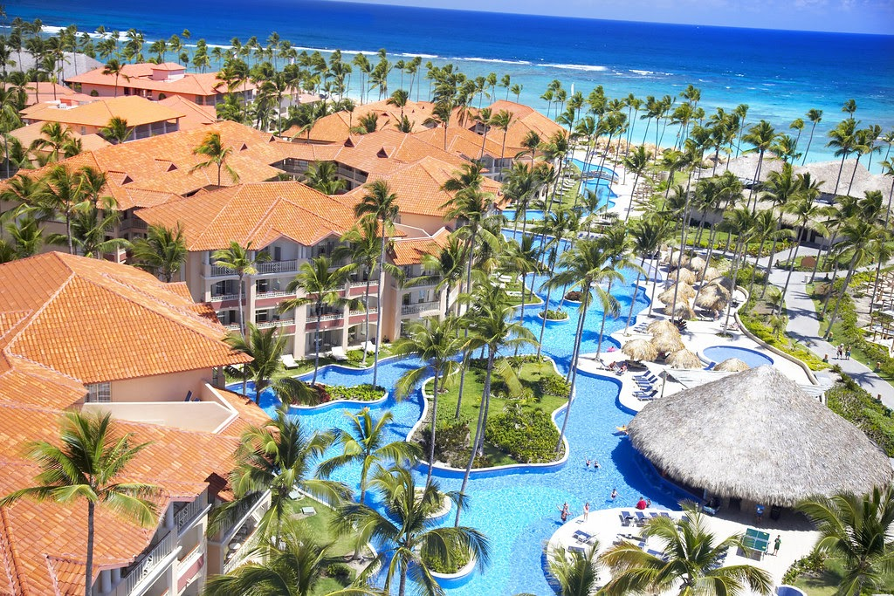
Dissertation Research:
Do holidaymakers understand the impact of all-inclusive holidays on the local community. Would this knowledge in regard to the impacts change their choices of a holiday package?
I hereby acknowledge that the data collected by this survey will be anonymous and confidential, and will be used by the University of Wales Trinity Saint David for academic and educational purposes only: *
Yes

Q1. What is your gender? *
Female
Male
Prefer not to say
Other:
Q2. How old are you? *
16-21
22-29
30-49
50+
Q3. What is your household income? *
Less than £10,000
£10,000 - £19,000
£20,000 - £29,000
Over £30,000
Prefer not to say
Q4. How often do you usually holiday for? *
1 week
10 days
2 weeks
3 week
Other:
Q5. Are you aware of the difference between an all-inclusive holiday and a 'packaged holiday'? *
Yes
No

Q5a. If answered yes, please explain your reason
Your answer
Q6. Are you aware of the negative impacts all-inclusive holidays have on the local community? *
Yes
No

Q7. Who do you think benefits most from all-inclusive holidays? (1 being benefits the most, 5 benefits the least) *
Tourists
Travel operators
Local communities
Other countries
Local business'
1
2
3
4
5

Q.8. What are the four most important factors that influence your choice when booking an all-inclusive holiday? (please pick one per column, 1-4)
1
2
3
4
Cost
Weather
Safety
Accessibility
Culture
Tourist attractions
Pool
Beach
Bar
Cost
Weather
Safety
Accessibility
Culture
Tourist attractions
Pool
Beach
Bar

Q9. Are you aware of the term 'multiplier effect? *
Yes
No

Q10. Did you encounter local people when on holiday? *
Yes
No

Q11. Did you leave the resort to visit other attractions? (not including shopping) *
Yes
No

Q12. Did you encounter any environmental issues? *
Yes
No

Q13. On your all-inclusive holiday, how often did you use these services not provided in the package? *
Always
Some days
Never
Private Transport
off-site Resturants
off-site Bars
Tourist attractions
Private Transport
off-site Resturants
off-site Bars

Tourist attractions

Q14. Have you ever taken an all-inclusive holiday in the UK? *
Yes
No

Q14a. If answered yes, please state where
Your answer

Q15. Where do you typically take your all-inclusive holiday? *
Spain
Greece
Turkey
Disney Resort
Caribbean Islands
Other:

Q16. When do you take your holiday? *
December- February
March - May
June - August
September - November

Q17. How many holidays do you take a year? *
1
2
3
4
5
More than 5

Q18. What would you expect to be included in your all-inclusive holiday? *
Your answer

Q19. What do you think are the main negative impacts of all-inclusive holidays on the host communities?
Your answer

Q20. What do you think are the main positive impacts of all-inclusive holidays on the host communities?
Your answer

Q21. Where do you book your all-inclusive holidays?
Online
In-store
Other:

Q22. Do you tend to travel?
In a group of friends
As a couple
Solo
As a family
Other:

Thank you for completing my questionnaire.

Graphs – Questionnaire Data

Question 1

Question 2

Question 3

Question 4

Question 5

Question 5a

All-inclusive means all your meals and drinks are included during your stay in the hotel and a packaged holiday is things included like transfers, flights , accommodation etc...

All-inclusive is all food and drink included usually local alcohol
all-inclusive includes food and entertainment

All inc usually includes food/drink/treats as well as package holiday. Package holiday is flights transfers room etc

All-inclusive is with your food and drink included in the price of the holiday.

All-inclusive is the board basis whereas package holiday refers to the hotel, flights and transfers being booked at one time together

All-inclusive you get everything free

All-inclusive is just your hotel which means you can eat and drink as much as you’d like, packaged is where your flight, hotel and transfer is all included

All-inclusive includes food and drink whereas a package holiday is usually transport and hotels.

All-inclusive includes all meals and drinks, packaged is when hotel, flights transfers are booked together with various meal options

Packaged holiday would include flight, hotel and transfers but the accommodation maybe be self-catering etc; whereas all-inclusive refers to hotel inclusive of food and drink all day/night
Reason? Do you mean the difference? One includes all food, usually local drinks & activities as well as accom, flights & transfer the other is just the flights, transfers & accom!

All-inclusive is drinks and food and packaged holiday is where you get all Disney parks in 2week deal (example)

Packaged holiday does not have to be all inclusive… could be bed and breakfast, self-catering etc

I assume all inclusive is everything is included, and package has a few restrictions
All Inclusive includes all meals and all drinks

All-inclusive includes everything from accommodation to food and drink whereas a package holiday can just be travel and accommodation.

Package is flight hotel and transfer and may include some meals. AI is flight hotel transfer and food and drinks at hotel
A packaged holiday is combined of transport and accommodation that is put together by a tour operator and sold as a holiday. An all-inclusive holiday means that all meals including snacks and drinks will be included in your holiday.

All Inclusive holiday - food, drink, entertainment etc all within the hotel complex Package Holiday - choice of board basis RO, SC, HB & FB. Eating & drinking outside hotel complex which helps the local economy.

All-inclusive holiday involves the whole holiday from the flights to transfers& the hotel which even includes all food& drinks in the price. A packed holiday is a holiday put together meaning flights, transfers, hotels (All- inclusive, Full board, half board or even self-catering) are included in the price& also a packaged holiday may even include excursions.

All-inclusive typically includes everything such as; accommodation, transport, food, entertainment etc. Whereas, packaged can be as simple as accommodation and transportation. However, all-inclusive can be referred to as a packaged holiday

All-inclusive is meals and drinks included, package is flight and hotel

All-inclusive is a package holiday with extra entitlements subject to terms and conditions

Question 6

Question 7

Question 8

Question 9

Question 10

Question 11

Question 12

Question 13

Question 14

Question 15

Question 16

Question 17

Question 18

Food and drink
Everything
Food and drinks
food and drinks
Everything
Food and drink
Food and drinks
All-inclusive alcohol and food
Drinks, pop, all meals and snacks
Drinks, food, snacks and entertainment
Drinks, 3 meals a day and snacks
Food and transport
All attraction passes, airport transport, drinks and meals and entertainment.
All food & drink
Food, drink and entertainment
food/drinks and entertainment
unlimited food and drinks
Food, drink alcohol
Food and drink ice-cream
bar, accommodation and entertainment
Breakfast
Food and drinks
Motor sports
food and drink
Meals, snacks, drinks, cocktails
A great variety of restaurants and good evening entertainment within the hotel/complex
Food & Drinks
All food and drinks
Drinks, food
All meals, snacks, drinks (not branded), sports activities, local shuttle bus, airport shuttle, access to sister hotel.
transfers and accommodation
All drinks & food
Food, drinks, facilities of hotel and beach facilities
Food drink towels
Food, entertainment, use of pool
Food and drink
Good choice of food and drink
Drink, food, transfers and accommodation
Accom, food, local alcohol & water sports
Hotel all food and drinks
Booze and food
drinks, snacks, 3 meals a day, towels at pool
transport, accommodation, entertainment and food/ drinks
All food and drinks for each day with a variety across the week
Food and drink including
Food and alcohol
Food, drink, bed, activities
water
Flight, hotel, food and transport to and from hotel
Meals, snacks, drinks
All u can eat and drink
food and drinks
Meals, drinks, snacks, flight, transfer, hotel, room service in some cases
All meals, snacks & drinks
accommodation, food, drink and entertainment
Entertainment, food, drinks, kids’ clubs etc
transfers, accommodation and food
Food & drinks
Food drink activities
accommodation, food and drinks
Food and entertainment
Local drinks and meals
everything
All food and selected drinks
Food drinks snacks entertainment
24hr access to food and drinks, hotel, flights & transfers.
Family entertainment, 3 fresh meals a day and snacks
Breakfast, dinner,tea, unlimited drinks and snacks

Question 19

Loss of income
They don’t earn money from tourists e.g. cafes, bars and restaurants
People drinking too much
Less income for local business as people has been encouraged to go on an all-inclusive holiday because they have everything, they need without having to go anywhere (leave the hotel).
No support to local businesses
People go overboard with alcohol which causes anti-social behaviour.
People tend to stay on complex
Not spending money off resort
Stops tourists going out of the resort
lack of tourist spends in the community
Don’t support local businesses
Never had any negatives only in Cuba where they were hiding the food and alcohol.
Loss of spending outside the hotel
None
I think that the main negative impacts are the lack of visitation to the local businesses as many people don’t want to spend money on food/drinks if it already paid for within their package. I also think that damage to the host communities is also a negative factor due to littering and lack of respect of tourists.
Less income
People getting ridiculously drunk taking advantage of the all inclusive
They don’t get visits from tourists, therefore losing out on money
Lose money possibly
Not spending money into that local economy, meaning that small business won’t be able to keep running if we only book all-inclusive holidays
Over crowding
Lack of use of local restaurants bars and attractions
Not sure
Reduced spending in the local economy
Local independent business
No benefits to the local community & resort
Losing money
Holiday makers staying on the resort
tourists do leave the resort
Profit
Tourists not supporting local communities / businesses
Losing money
The local business loses out on customers coming to their establishments as tourists are having their meals and drinks on their resort
I can’t think of any
Seasonal tourism depending on the country some month busy and then some months a ghost’s town
Tourists not leaving resorts to make use of businesses
social, economic and environmental
Using other bars/restaurants in the town
Limited options
People stay at the resort rather than going site seeing and eating out
Less interaction with the local community and use of other services
No local business trades
Lack of tourist income to local shops bars and restaurants as people will use the facilities at the hotel
No money being generated into the community. Local businesses will suffer due to tourists not wanting to go out for meals/drinks as their food is already paid for.
Local businesses restaurant etc suffer
Local communities do not benefit off economic factors as the tourists aren’t spending at their local restaurants, bars, shops.
local businesses lose out
Loss of local business
Lack of tourists leaving their hotels to eat out or spend money in the area
Taking business away from other businesses
They keep you on site so local businesses may not benefit
Not spending money in local shops

Question 20

People are encouraged to the area
Keeps tourists out
All-inclusive holidays do attract families and are likely to want to do excursions and activities meaning they will have to leave the hotel, so they can see what local business have on offer on their outings
Business when people wander outside the resort
Families on a lower income can afford the holiday
Jobs for locals
Tourism
Smaller business may get more custom
employment in the community
Provides jobs
There’s food always available and drink whenever needed.
Brings large numbers of holiday makers into the area. Most holiday makers need to pay a local tax which I imagine would go towards the community
Everything you need in one place
I think the main positive impacts are that there is a great opportunity for tourists to learn about the culture of the host community and therefore learn to respect it.
More people
They got a lot of tourists visiting.
Don’t have to travel far to get something you want. Don’t have to carry your purse everywhere and worry about how much the bill at the end will be.
Increased chance of getting customers
Not having to take any extra money that you may not have, it’s easy and accessible
Money
Provides employment to the area
Jobs
Jobs for local communities
Employment opportunities
Less intrusion from tourists
Job employment
Bringing money to local areas
Restaurants, bars, etc will gain business
employment and tourist spend
More headcount of colleagues required to prepare for demand
Attracting tourists to come to the area
More guests
Not sure
local jobs
Able to generate a higher income with more people paying in advance for their holidays
Large volume of tourists
economic, e.g. employment
I can really rest
Not many customers
Everything in one place
Employment to local people
Cheaper and easier to plan
Bringing tourists to the country to potentially spend money within the local economy
Attract more tourists who are likely to visit attractions and use public transport, generating more money
Jobs within hotel complex for local communities.
Maybe can prevent overcrowding& footfall if it is busy area?
employment
Employment
Convenient
Brings more customers to the area
Hotel jobs
All in 1 place

Question 21

Question 22

Interview Questions

This interview is being undertaken as part of a Travel and Tourism Management BA dissertation. The data collected will be used to investigate consumer holiday choices and motivations regarding all-inclusive holidays. Due to the recent impacts of Covid-19, this interview will be mailed to the appropriate individual. These questions will be tailored to individuals who have participated in some type of holiday.

The data collected will be held anonymously, confidentially and securely. No personal data will be retained, and your name will not appear anywhere in the dissertation.
You maintain the right to withdraw your participation tin this study at any given point.

By participating in this interview, you will be agreeing that:
- I am over the age of 18.
- I understand that I do not have to take part in this interview, and I am voluntarily participating in this project.
- The data I provide in this interview will be used to inform the researchers dissertation.
- I am free to contact the researcher with any question I may have regarding the interview and dissertation in the future.
- I have read and understand the above text.

Q1 - Have you been on an all-inclusive holiday? If yes, go to question 2. If no, why not?

Q2 - What sort of holiday do you usually take?

Q2.a - What are the reasons why you choose the holiday type you do?

Q3- How would you define an all-inclusive holiday?

Q4 – What factors influence you to take an all-inclusive holiday?

Q5 – Thinking of your last all-inclusive holiday, how often did you use services not provided in the package and why?

Q6– Who do you think benefits from all-inclusive holidays?

Q7– Do you think All-inclusive holidays have a higher positive impact or negative impact on local communities?

Q8 – What do you think are the negative impacts that all-inclusive resorts have on local communities and businesses?

Q9- What do you think are the positive impacts that all-inclusive resorts have on local communities and businesses?

Q10– What do you think can be done to minimise the negative impacts of all-inclusive holidays?

Q 11– Are you aware of the term ‘economic leakage’ within a destination?

If so, what do you think can be done to minimise the issues with leakage?

Q12 – Are you aware of any fair models of all-inclusive resorts?
If so, how do they minimise the negative impacts while maximising the positives

Q13– How likely is it that you will go on an all-inclusive holiday in the next two years?

This interview is being undertaken as part of a Travel and Tourism Management BA dissertation. The data collected will be used to investigate consumer holiday choices and motivations regarding all-inclusive holidays. Due to the recent impacts of Covid-19, this interview will be mailed to the appropriate individual. These questions will be tailored to individuals who have participated in some type of holiday.

The data collected will be held anonymously, confidentially and securely. No personal data will be retained, and your name will not appear anywhere in the dissertation.
You maintain the right to withdraw your participation tin this study at any given point.

By participating in this interview, you will be agreeing that:
- I am over the age of 18.
- I understand that I do not have to take part in this interview, and I am voluntarily participating in this project.
- The data I provide in this interview will be used to inform the researchers dissertation.
- I am free to contact the researcher with any question I may have regarding the interview and dissertation in the future.
- I have read and understand the above text.

Q1 - Have you been on an all-inclusive holiday? If yes, go to question 2. If no, why not?

yes

Q2 - What sort of holiday do you usually take?

I generally book a holiday in the sun, book flight first then hotel and then book transfer.

Q2.a - What are the reasons why you choose the holiday type you do?
I choose to book my holiday like this because it gives my independence to travel where I want and when I want, also prefer small family run hotels, and use local transfer companies. It also works out cheaper because I eat in local restaurants which are normally cheaper, and eat at a time to suit me.

Q3- How would you define an all-inclusive holiday?

All you can eat buffets at certain periods throughout the day, Free local alcohol which is all in the price of the holiday

Q4 – What factors influence you to take an all-inclusive holiday?

I wouldn’t

Q5 – Thinking of your last all-inclusive holiday, how often did you use services not provided in the package and why?

I didn’t I don’t think. I may have gone on a few trips

Q6– Who do you think benefits from all-inclusive holidays?

Young families.

Q7– Do you think All-inclusive holidays have a higher positive impact or negative impact on local communities?
Negative

Q8 – What do you think are the negative impacts that all-inclusive resorts have on local communities and businesses?

Less tourists spend money in the community because they hardly leave the resort

Q9- What do you think are the positive impacts that all-inclusive resorts have on local communities and businesses?

Employment

Q10– What do you think can be done to minimise the negative impacts of all-inclusive holidays?

The tour operators could use local transfer companies. Try to make sure all hotels are using staff from the local community, ie. Holiday Reps, Admin, waiters/waitresses, cooks etc.

Q 11– Are you aware of the term ‘economic leakage’ within a destination?

No

If so, what do you think can be done to minimise the issues with leakage?
N/A

Q12 – Are you aware of any fair models of all-inclusive resorts?
No

If so, how do they minimise the negative impacts while maximising the positives

Q13– How likely is it that you will go on an all-inclusive holiday in the next two years?

Not likely

This interview is being undertaken as part of a Travel and Tourism Management BA dissertation. The data collected will be used to investigate consumer holiday choices and motivations regarding all-inclusive holidays. Due to the recent impacts of Covid-19, this interview will be mailed to the appropriate individual. These questions will be tailored to individuals who have participated in some type of holiday.

The data collected will be held anonymously, confidentially and securely. No personal data will be retained, and your name will not appear anywhere in the dissertation.
You maintain the right to withdraw your participation tin this study at any given point.

By participating in this interview, you will be agreeing that:
- I am over the age of 18.
- I understand that I do not have to take part in this interview, and I am voluntarily participating in this project.
- The data I provide in this interview will be used to inform the researchers dissertation.
- I am free to contact the researcher with any question I may have regarding the interview and dissertation in the future.
- I have read and understand the above text.

Q1 - Have you been on an all-inclusive holiday? If yes, go to question 2. If no, why not?

Yes

Q2 - What sort of holiday do you usually take?

All-inclusive

Q2.a - What are the reasons why you choose the holiday type you do?
Everything is included so we don not have to worry about money on holiday and can relax

Q3- How would you define an all-inclusive holiday?

An all-inclusive holiday would include transfers, accommodation, food and drinks all for one price

Q4 – What factors influence you to take an all-inclusive holiday?

Cost and safety with the resort

Q5 – Thinking of your last all-inclusive holiday, how often did you use services not provided in the package and why?

Not often, only taxis to get into town

Q6– Who do you think benefits from all-inclusive holidays?

Tourists and tour operators

Q7– Do you think All-inclusive holidays have a higher positive impact or negative impact on local communities?

On the local community, possibly more negative

Q8 – What do you think are the negative impacts that all-inclusive resorts have on local communities and businesses?

A negative impact because everything the tourists need is in the hotels, they don’t need to venture out, they may possibly use the local shops for gifts, but the local communities definitely miss out on economy because tourists don’t use the local bars and restaurants, local transport. These tourists don’t always mix with the locals so don’t get a sense of the community and what the people are really like.

Q9- What do you think are the positive impacts that all-inclusive resorts have on local communities and businesses?

Employment in the Hotels, which brings economy into the community, of they live there

Q10– What do you think can be done to minimise the negative impacts of all-inclusive holidays?

Source local food and alcohol and promote local attractions bars and restaurants

Q 11– Are you aware of the term ‘economic leakage’ within a destination?

Yes

If so, what do you think can be done to minimise the issues with leakage?
The companies should invest in local communities, the infrastructures, provide work for locals

Q12 – Are you aware of any fair models of all-inclusive resorts?
No

If so, how do they minimise the negative impacts while maximising the positives
N/A

Q13– How likely is it that you will go on an all-inclusive holiday in the next two years?

Not very likely

This interview is being undertaken as part of a Travel and Tourism Management BA dissertation. The data collected will be used to investigate consumer holiday choices and motivations regarding all-inclusive holidays. Due to the recent impacts of Covid-19, this interview will be mailed to the appropriate individual. These questions will be tailored to individuals who have participated in some type of holiday.

The data collected will be held anonymously, confidentially and securely. No personal data will be retained, and your name will not appear anywhere in the dissertation.
You maintain the right to withdraw your participation tin this study at any given point.

By participating in this interview, you will be agreeing that:
- I am over the age of 18.
- I understand that I do not have to take part in this interview, and I am voluntarily participating in this project.
- The data I provide in this interview will be used to inform the researchers dissertation.
- I am free to contact the researcher with any question I may have regarding the interview and dissertation in the future.
- I have read and understand the above text.

Q1 - Have you been on an all-inclusive holiday? If yes, go to question 2. If no, why not?

Yes

Q2 - What sort of holiday do you usually take?

Cultural holidays

Q2.a - What are the reasons why you choose the holiday type you do?
Explore local culture and their way of life

Q3- How would you define an all-inclusive holiday?

A holiday that includes everything with mass tourism

Q4 – What factors influence you to take an all-inclusive holiday?

None

Q5 – Thinking of your last all-inclusive holiday, how often did you use services not provided in the package and why?

Always

Q6– Who do you think benefits from all-inclusive holidays?

Tour operators and private investors

Q7– Do you think All-inclusive holidays have a higher positive impact or negative impact on local communities?

Negative

Q8 – What do you think are the negative impacts that all-inclusive resorts have on local communities and businesses?

Mass tourism on beaches and lack of money in local business

Q9- What do you think are the positive impacts that all-inclusive resorts have on local communities and businesses?

Employment

Q10– What do you think can be done to minimise the negative impacts of all-inclusive holidays?

Increase prices so less people go self-catering and use local services

Q 11– Are you aware of the term ‘economic leakage’ within a destination?

Yes

If so, what do you think can be done to minimise the issues with leakage?
No enough money being kept within the local community

Q12 – Are you aware of any fair models of all-inclusive resorts?
Sandals Resorts

If so, how do they minimise the negative impacts while maximising the positives
Promote community involvement and invest in sustainability and conservation of the environment

Q13– How likely is it that you will go on an all-inclusive holiday in the next two years?

Never

This interview is being undertaken as part of a Travel and Tourism Management BA dissertation. The data collected will be used to investigate consumer holiday choices and motivations regarding all-inclusive holidays. Due to the recent impacts of Covid-19, this interview will be mailed to the appropriate individual. These questions will be tailored to individuals who have participated in some type of holiday.

The data collected will be held anonymously, confidentially and securely. No personal data will be retained, and your name will not appear anywhere in the dissertation.
You maintain the right to withdraw your participation tin this study at any given point.

By participating in this interview, you will be agreeing that:
- I am over the age of 18.
- I understand that I do not have to take part in this interview, and I am voluntarily participating in this project.
- The data I provide in this interview will be used to inform the researchers dissertation.
- I am free to contact the researcher with any question I may have regarding the interview and dissertation in the future.
- I have read and understand the above text.

Q1 - Have you been on an all-inclusive holiday? If yes, go to question 2. If no, why not?

Yes

Q2 - What sort of holiday do you usually take?

All-inclusive holidays in the sun, usually Turkey

Q2.a - What are the reasons why you choose the holiday type you do?
With a family of four it is cheaper and easier to have everything taken care of before going away to reduce the worry of money whilst abroad

Q3- How would you define an all-inclusive holiday?

All you can eat and drink for the entire holiday

Q4 – What factors influence you to take an all-inclusive holiday?

Cost

Q5 – Thinking of your last all-inclusive holiday, how often did you use services not provided in the package and why?

A few bars and restaurants

Q6– Who do you think benefits from all-inclusive holidays?

Tour operators

Q7– Do you think All-inclusive holidays have a higher positive impact or negative impact on local communities?

Negative

Q8 – What do you think are the negative impacts that all-inclusive resorts have on local communities and businesses?

When we left our resort, there was hardly anyone to interact with and a lot of businesses were not open which I would say is a negative as they may have been forced to close as people are staying in the resorts. Also, we tried to adventure out and look for theme parks etc, but there were none around which doesn’t make us want to visit again

Q9- What do you think are the positive impacts that all-inclusive resorts have on local communities and businesses?

I guess many of the employees are from the local community so it would provide employment

Q10– What do you think can be done to minimise the negative impacts of all-inclusive holidays?

Promote the use of local businesses as the resorts will not lose out as everything is already paid for

Q 11– Are you aware of the term ‘economic leakage’ within a destination?

Yes,

If so, what do you think can be done to minimise the issues with leakage?
because tourists are not spending locally, all their money is going to/staying within resorts and travel agents. Also, other countries as they import supplies

Q12 – Are you aware of any fair models of all-inclusive resorts?
No

If so, how do they minimise the negative impacts while maximising the positives
N/A

Q13– How likely is it that you will go on an all-inclusive holiday in the next two years?

After witnessing the damage all-inclusive resort have on the local community, we would not go on an all-inclusive holiday for a while and look for alternative holidays for more freedom and activities to do with the family

This interview is being undertaken as part of a Travel and Tourism Management BA dissertation. The data collected will be used to investigate consumer holiday choices and motivations regarding all-inclusive holidays. Due to the recent impacts of Covid-19, this interview will be mailed to the appropriate individual. These questions will be tailored to individuals who have participated in some type of holiday.

The data collected will be held anonymously, confidentially and securely. No personal data will be retained, and your name will not appear anywhere in the dissertation.
You maintain the right to withdraw your participation tin this study at any given point.

By participating in this interview, you will be agreeing that:
- I am over the age of 18.
- I understand that I do not have to take part in this interview, and I am voluntarily participating in this project.
- The data I provide in this interview will be used to inform the researchers dissertation.
- I am free to contact the researcher with any question I may have regarding the interview and dissertation in the future.
- I have read and understand the above text.

Q1 - Have you been on an all-inclusive holiday? If yes, go to question 2. If no, why not?

Yes

Q2 - What sort of holiday do you usually take?

All-inclusive holidays in Spain

Q2.a - What are the reasons why you choose the holiday type you do?
A single payment to book a holiday rather than paying and organising every element individually

Q3- How would you define an all-inclusive holiday?

Transport, accommodation and transfer all included prior to arriving at the resort with all day food and drinks for the duration of your holiday with the addition of on-site entertainment etc for a single payment.

Q4 – What factors influence you to take an all-inclusive holiday?

Weather and everything is included so we don’t have to take extra cash

Q5 – Thinking of your last all-inclusive holiday, how often did you use services not provided in the package and why?

We used theme parks and local attractions

Q6– Who do you think benefits from all-inclusive holidays?

Local attractions and tour operators

Q7– Do you think All-inclusive holidays have a higher positive impact or negative impact on local communities?

Balanced

Q8 – What do you think are the negative impacts that all-inclusive resorts have on local communities and businesses?

Lack of business for bars and restaurants which many result in them closing

Q9- What do you think are the positive impacts that all-inclusive resorts have on local communities and businesses?

Employment and investment in infrastructure

Q10– What do you think can be done to minimise the negative impacts of all-inclusive holidays?

For resorts to provide vouchers to promote local bars and restaurants

Q 11– Are you aware of the term ‘economic leakage’ within a destination?

No

If so, what do you think can be done to minimise the issues with leakage?
N/A

Q12 – Are you aware of any fair models of all-inclusive resorts?
No

If so, how do they minimise the negative impacts while maximising the positives
N/A

Q13– How likely is it that you will go on an all-inclusive holiday in the next two years?

Likely

