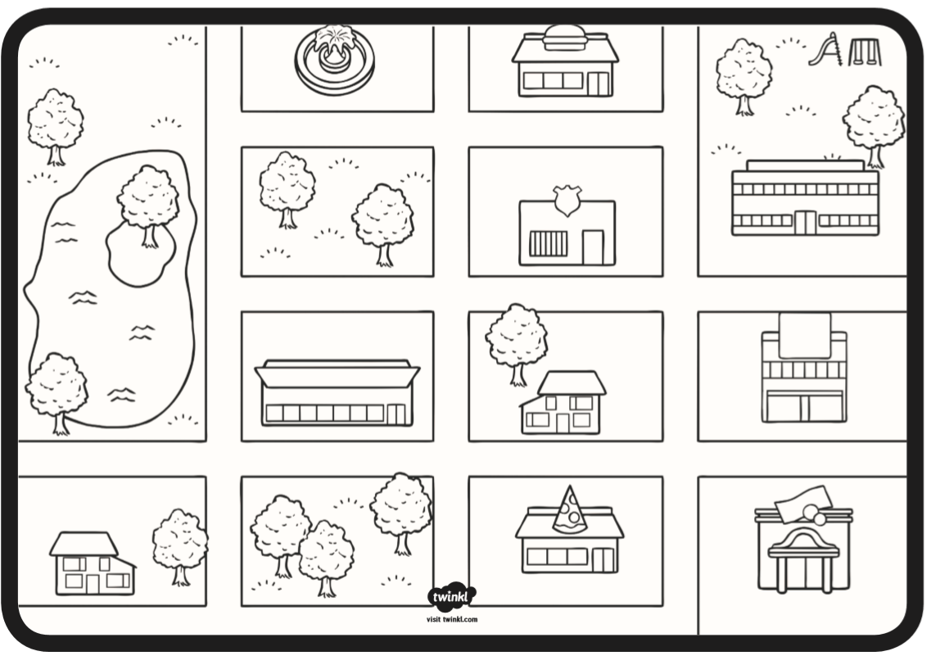
Hospital
School
Police
5
24
Bank

