Doing History Journal Reflection
This journal will describe and reflect upon the module ‘Doing History: Past in Practice’. The reflection will detail the activities that I have partaken in throughout the module, such as the field trips to the Carmarthenshire Archives and the National Library of Wales. I will also reflect on these experiences by exploring what I have learnt, how my knowledge has been enhanced by this module, and what I will do in the future after gaining this knowledge.
The first lecture that I attended was an introduction to the module. This outlined the modules assignments, which were a 2000-word primary source evaluation and a 2000-word reflective journal. For the remainder of the class I was taught the definitions of a primary source, a secondary source, and historiography and their importance within the discipline of history. The understanding of these definitions will be useful for future assignments.
The next lecture was my first field trip of the module, which was a trip to the Carmarthenshire Archives. I was unfortunately late arriving to the archives due to a scheduled meeting. This meant that I missed much of a talk about the documents on the table in front of me when I arrived. After the talk had finished the rest of my class and I started to look at the old maps, drawings and photographs of Carmarthen. The dates of the maps laid on the table ranged from the 18th and 19th centuries. Whilst looking at the maps the staff at the archives were giving us information. I also started to compare the different maps I was looking at to see changes in the town over time. Soon after, I was shown how to use the digital archives by a member staff. It was explained to me that they have tens of thousands of digitised archives and records. I was shown examples of records from past census’ and records from newly acquired and digitised archives of concentration camp records. Once we had all looked at the archive material on the table for a while, we were taken to where the archives were stored to look at other material. One archive material that I looked at whilst there was a book of convictions. This detailed the crimes of people in the 19th century outlining the persons age, date of birth, their crime, and sometimes their photograph. Overall, the trip to the Carmarthenshire Archives showed me how to compare maps and showed me how archival material is stored. This trip also showed me how useful the archives are in relation to future assignments, and with my readers card, I can return to learn more about the contents of the archive.
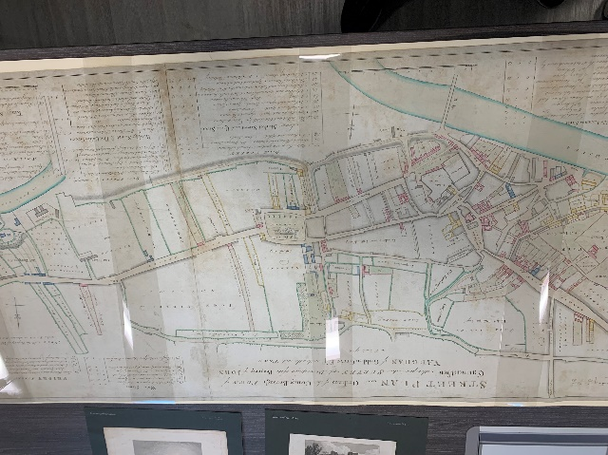
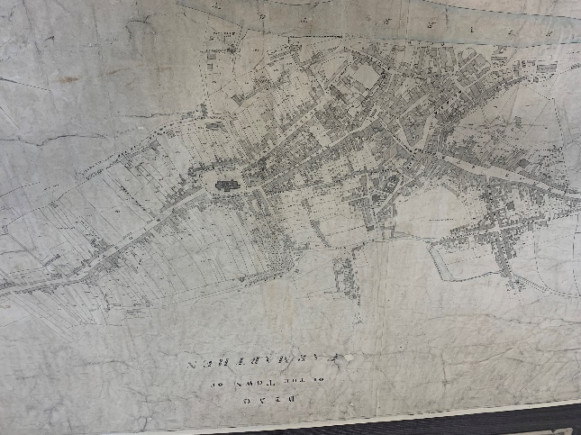Archived Map of Carmarthen Street Map of Carmarthen 1786

For the next lecture I was learning about the advantages and disadvantages of Virtual Reality (VR) being used in education. To learn more about VR first hand we were given VR headsets for an educational experience. The experience that we would be interacting with was a virtual tour of Anne Frank's House. This started out as educational until one of my classmates managed to exit the Anne Frank House experience and travel to another experience on the International Space Station. This prompted others, including myself, to leave the Anne Frank House experience and travel to other experiences. We then played around with these headsets for a while until we had a break. Afterwards, we had a long discussion on the advantages and disadvantages of VR. Moreover, VR was a lot of fun to use. I had learnt that the main advantage of VR is that it is a more immersive experience for education, it can mean that students can experience activities that would otherwise be too dangerous to be experienced in a safe environment. It is also a way to travel without journeying or spending money. However, the main disadvantage of VR is the accessibility of other programmes can be distracting. As proven when classmates started viewing alternative programmes.
The following lecture was an immersive room experience, where we were taken to it to be shown and discuss the uses, advantages and disadvantages. Once we arrived there, we were given an introductory talk about the immersive room. During this we were told that the room was made of exposed LED’s, making the room fragile. Afterwards, we were shown examples of the uses of the immersive room. We were shown that it could be used for videos, panoramic photos, presentations and looking at google maps. We were also told that anyone can book the room to use. We returned to the classroom to discuss the advantages and disadvantages it. Reflecting on this lecture I found that the immersive room is useful as an alternative to VR and a good immersive experience for young children. However, in my opinion it is not as immersive as VR. Also, the main disadvantage that they are not widespread and therefore not easily accessible, and they are expensive to establish and maintain.
In another lecture I was given a more in depth look at historiography. At a previous lecture we were each given an author who had written a book on the English Reformation. The author that I was given was JJ Scarisbrick and the book title was ‘The Reformation and the English People’. Our task was to research the book to find its main argument, which I found was that the lay people did not want the reformation and were slow to accept it.This lecture helped me to understand historiography in greater detail . The homework task also demonstrated good research and reading skills. This greater understanding of historiography and the skills from the homework task will be used in future assignments.
The next field trip was a trip to the National Library of Wales in Aberystwyth. The first activity that I experienced was a talk by a staff member explaining what was in the libraries catalogue and archives, what was in their system, and how to access the online material. After the talk had ended, we were given a tour of other parts of the library before ending up in the Summer Room. In this room the staff had laid out multiple medieval books, manuscripts, and documents in glass cases. We went to each glass case in turn and the documents in each were explained. These documents included a family tree and a poem written in old Welsh on a piece of slate. The staff also expressed their hatred for 19th century archivists throughout as they did not keep medieval documents in good condition. Once every document had been explained we had a look at the documents ourselves before having lunch. Afterwards, we were taken to another room where we had a further talk, which explained the different programmes that we could use for Welsh historical sites such as Coflein and Historic Wales. Following this, we were given another tour of some of the archives, which we were shown aerial photographs from the 1940s, old maps, and drawings of Welsh landmarks. After exploring some of the archives we were taken back to the same room to look at documents that had been set up for us. Looking at this archive material allowed me to research the Picton Monument in Carmarthen, which was another piece of homework for a later lecture. Once we had looked at this archive material for a while, we were taken back to the archives to have another tour, where we were shown where other material such as books. The tour was finished and we returned to the entrance where I got my readers card, and we headed back to campus.
In conclusion, the National Library of Wales was an intriguing to experience. I have learnt a great deal such as what is material is stored, where and how they are stored in the archive. In the future I plan to visit the library again due to the vast resources. However, the distance to the National Library poses a minor challenge. I will also be using my readers card in the future to access their online archives for future assignments. The library also subscribes to other archive sites that I can access using my reader's card. This will be very useful for future assignments as it removes paywalls on source material making research for assignments easier.
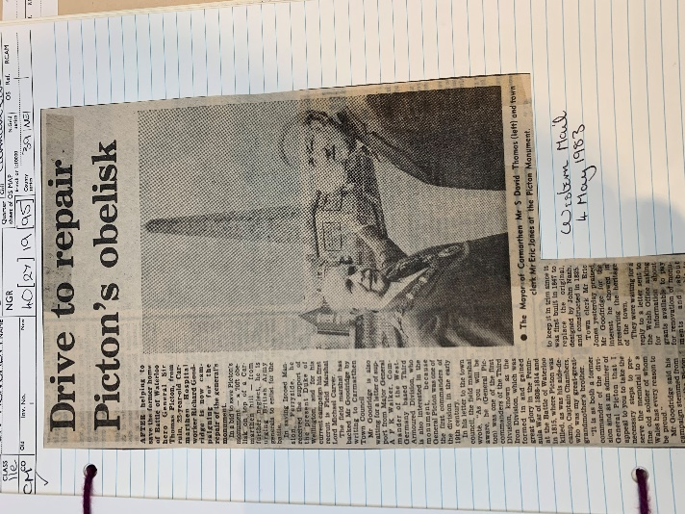
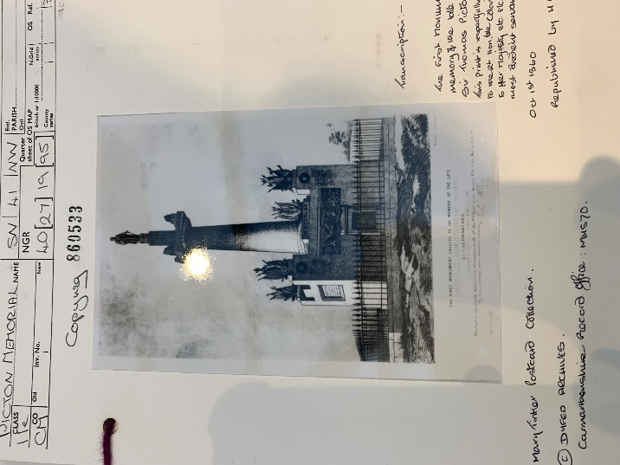
Original Picton Monument Current Standing Monument

For my next lecture I had two tasks to perform. The first was collecting information on a place of my choice in Carmarthen and then adding that information to a shared google map, which would be used in the final field trip. The place which I had chosen was the Picton Monument. The second task was learning about the advantages and disadvantages of Artificial Intelligence (AI) in assignments. To do so we were asked to find an article on the English Reformation, then ask an AI programme, for example, ChatGPT or Copilot, to summarise the text and ask how this text fits into the wider area of study. Then we were asked to compare what we had read from the article to the AI summary. The main advantage of an AI summary is it creates very coherent notes of an article. However, the information that the AI provides is not at a university standard. Therefore, I have not used AI in my assignments and neither plan to in the future.
In the next lecture we were taught some historical approaches that I can use in future assignments. To test our knowledge, we were split into two groups and given post it notes to write down different approaches. These were then stuck on the wall to create a mind map of historical approaches. We were also explained a specific historical approach called microhistories. Microhistories are books usually explaining the history of one person. It was also explained that microhistories often use judicial records for information.
My final field trip was a walking tour of Carmarthen. This was where, as a group, we visited each place that we researched for the shared map. When each of us arrived at our chosen place we would recite what we had researched. Overall, the walking tour was a lot of fun, we were able to walk around Carmarthen getting to know our surroundings better and immersing ourselves in Carmarthen's history. The only drawback of the walking tour is that the large amount of walking can be exhausting for some people.
For one of the last lectures we learnt about other historical approaches such as modernism, post-modernism and Great Man Theory. The idea of modernism is that all historians have one shared goal and one truth for each part of history, whereas post-modernism is the idea that there is no set truth in history, rather there may be many different truths to one part of history. Great Man Theory I found particularly interesting as it is the idea that history is created and written mainly by man. It is also a top-down elitist viewpoint that the men that write history are mainly very wealthy. I found these historical approaches interesting and changed my perspective for the approach I take when writing assignments. In the future I will be mindful of these historical approaches throughout writing my assignments.
In conclusion, this module has been both enjoyable and interesting. Throughout the module I have learnt multitudes of knowledge whilst doing fun activities. The field trips throughout the module, such as the Carmarthenshire Archive and National Library of Wales, have showed me interesting documents in archives and where they are stored. I have also learnt and immersed myself in Carmarthen’s history through both field trips and fun activities. The historical approaches that I learnt through the module have changed my perspective of history and will make me more mindful when writing my assignments. Learning about historiography in further detail has prompted me to use it in future assignments. I have also taken part in multiple discussions throughout the module such as the discussions on VR in education and the immersive room. I found, through these discussions, that whilst VR is incredibly immersive and useful when it comes to education, it can be a distraction from learning.

Bibliography
- Royal Commission on the Ancient and Historical Monuments of Wales, Coflein, 2021, <https://coflein.gov.uk/en/>, [Accessed: 19th February 2026]
- Royal Commission on the Ancient and Historical Monuments of Wales, Historic Wales, 2021, <https://www.historicwales.gov.uk/>, [Accessed: 19th February 2026]
- Scarisbrick, JJ, The Reformation and the English People, (Oxford: Blackwell, 1984)
- The National Library of Wales, The National Library of Wales Catalogue, Unknown, <https://discover.library.wales/discovery/search?vid=44WHELF_NLW:44WHELF_NLW_NUI>, [Accessed: 19th February 2026]
- Zell, Michael, ‘The Reformation and the English People, by J.J Scarisbrick. Edinburgh: Basil Blackwell, 1984. 203pp.’, The Sixteenth Century Journal, Vol. 15 No. 4, (1984), pp 492, <https://www.journals.uchicago.edu/doi/abs/10.2307/2540366?journalCode=scj>, [Accessed: 19th February 2026]

Authors Own
Authors Own
For further reading, read JJ Scarisbrick’s The Reformation and the English People, where it is explained that the English people did not want the reformation and so were slow to accept it.
Michael Zell, ‘The Reformation and the English People, by J.J Scarisbrick. Edinburgh: Basil Blackwell, 1984. 203pp.’, The Sixteenth Century Journal, Vol. 15 No. 4, (1984), pp 492, p 492, <https://www.journals.uchicago.edu/doi/abs/10.2307/2540366?journalCode=scj>, [Accessed: 19th February 2026]
The National Library of Wales, The National Library of Wales Catalogue, Unknown, <https://discover.library.wales/discovery/search?vid=44WHELF_NLW:44WHELF_NLW_NUI>, [Accessed: 19th February 2026]
Royal Commission on the Ancient and Historical Monuments of Wales, Coflein, 2021, <https://coflein.gov.uk/en/>, [Accessed: 19th February 2026]
Royal Commission on the Ancient and Historical Monuments of Wales, Historic Wales, 2021, <https://www.historicwales.gov.uk/>, [Accessed: 19th February 2026]
Authors Own
Authors Own

