

ASSIGNMENT TITLE - A COMPARATIVE STUDY OF ATTITUDES TOWARD VEGANISM AMONG VEGANS AND NON VEGANS

MODULE CODE AND NAME - IUPS5006 SOCIAL PSYCHOLOGY: GLOBAL PERSPECTIVES

PROGRAMME - BSc Psychology (Dual Award) UMW

LECTURER - DR. JUDITH MARSHALL

STUDENTS NAME | STUDENT ID
SREEJA KINTHALI | 2423930@student.uwtsd.ac.uk
NHIVVESHA CHANDRA SEARAN | 2436817@student.uwtsd.ac.uk
TUNKU MAISARA | 2423928@student.uwtsd.uk
WAZIRA SHARIEFF | 2423929@student.ac.uk

INDEX

Abstract
1.0 INTRODUCTION
1.1 Background of the study
1.2 Social-psychological context
2.0 LITERATURE REVIEW
2.1 Relevant Social-Psychological Theory
2.2 Previous Research on Veganism and Attitudes
2.3 Research Comparing Vegans and Non-vegans
2.4 Research Gap and Rationale
3.0 METHOD
3.1 Design
3.2 Participants
3.3 Materials and Measures
3.4 Procedure
3.5 Ethical Considerations
4.0 RESULTS
5.0 DISCUSSION
6.0 CONCLUSION
7.0 REFERENCES
8.0 APPENDICES

1.0 INTRODUCTION
1.1 Background of the study
Veganism is a dietary and lifestyle practice, which involves abstaining from eating animal-based foods. Vegans usually voice concerns on animal welfare, environmental sustainability, health, and ethical values. The growing visibility of veganism has made the way in which people perceive and evaluate this lifestyle relevant to social-psychological research. The attitudes toward veganism could influence the people’s willingness to perform the vegan behaviors, support the vegan choices, and socially interact with the individuals on a vegan diet. Studies suggest that health awareness, environmental concerns, animal welfare, and social influences may influence attitudes toward vegan consumption (Miguel et al., 2021). Thus, attitudes toward veganism can be seen as a multidimensional construct, rather than a simple positive or negative evaluation.
The present study is focused on comparisons between vegans and non-vegans. It is relevant to look at these two groups as people who follow a vegan diet may have different values and experiences in relation to veganism than people who do not follow a vegan diet. Such differences may illuminate the relationship between dietary group membership and attitudes toward veganism.

1.2 Social-psychological context
Veganism also has important social-psychological dimensions, because food choices can be associated with personal values, social identity and interaction with others. Dietary practices can affect perceptions of self and perceptions of self by people with different dietary practices. Vegans and vegetarians have been found to experience conflict between their dietary practices and the social norms of their social networks (Salmivaara et al., 2022). In addition, vegans experience positive and negative social perceptions suggesting that veganism perceptions may contain both social acceptance and stigma (Napoli & Ouschan, 2024).
Thus, comparing vegans and non-vegans provides a useful social-psychological perspective to examine whether membership in a dietary group is associated with differences in attitudes toward veganism. Thus, the present study examines attitudes toward several domains, such as general perception, animal welfare, environmental issues, health and nutrition, social acceptance, practicality, and overall evaluation.

2.0 LITERATURE REVIEW
2.1 Relevant Social-Psychological Theory
The Social Identity Theory (SIT) (Tajfel & Turner, 1979) Serves as an appropriate theoretical framework for the discussion of differences in attitudes towards veganism. According to SIT, individuals define themselves on the basis of membership in a social group and thus distinguish between their in-group and out groups. Being vegan can be considered a part of one's social identity; however, non-vegans can assess.Vegans as an outgroup. This theory may provide an explanation as to why people have different views regarding veganism. In support of this point of view Nezlek et al. (2023) revealed that perception of vegans was different depending on their own eating habits, specifically, more restrictive consumption of meat resulted in more positive attitude towards vegans. The conclusion made by the researchers is that dietary practices can serve as the basis of social identity and determine perception of another dietary group. Thus, SIT can be used to explore differences in attitudes towards veganism based on vegan and non vegan group affiliations.

2.2 Previous Research on Veganism and Attitudes
Previous research reveals that the attitude towards veganism is not usually purely positive or negative but can vary between these extremes. As was discovered by de Groeve et al. (2022), omnivores may have a normalized attitude towards the ethics of vegans behavior while seeing them as arrogant and too committed at the same time. It means that while the positive perception of motives that vegans choices can be present, there can also be negative attitudes towards their personhood at the same time. In addition, Markowski & Roxburgh (2019) demonstrated that non-vegans were expecting the stigma related to adoption of the lifestyle in question and described distancing techniques to avoid it. This means that attitudes towards veganism can be defined by moral evolution as well as social perception at the same time. Moreover, stigma, negative attitudes, and moral or ethical beliefs were recognized as crucial themes in the social-psychological research on veganism through a systematic review conducted by Vestergren and Uysal (2022). Thus, people's attitudes towards veganism may be socially complex and vary depending on one's dietary identity.

2.3 Research Comparing Vegans and Non-vegans
In the research directly comparing the vegans and non-vegans, it can be seen that there exist differences in perception of veganism related to people’s belonging to one of the two groups. In the study by Park & Kim (2022), it was shown that there are differences in perception of veganism among the participants of vegan and non-vegan communities on the internet. Differences were mainly associated with the understanding of veganism in relation to its lifestyle aspect and concerns about animals and food. The data shows that people’s belonging to different dietary groups might have an impact on their perception of veganism and evaluation of it. Similarly. Nezlek et al. (2023) showed that there are differences in the perceptions of vegans depending on personal dietary preferences. Individuals who consumed less meat had a more positive perception of vegans.

2.4 Research Gap and Rationale
Even though some prior studies have investigated the issue of veganism in connection with issues like social identification, stigma, stereotyping and perception of dietary groups, there still exists the need to conduct research that will compare the attitudes toward veganism in vegans and non-vegans directly. In this respect, existing research studies have mostly concentrated on some specific aspects like the social perception, online discussion or stigma issues, but they have not used any attitude assessment tool to compare attitudes towards veganism in vegans and non-vegans. For this reason, it is the purpose of the current study to address this lack by comparing the attitudes toward veganism in vegans and non-vegans.

3.0 METHOD

3.1 Design
This research used a quantitative, cross-sectional, between-group design to test differences in attitudes towards veganism among vegan and non-vegan university students. Dietary group (vegan vs. non-vegan) was the grouping variable, whereas Meat-Eating Justification Scale (MEJS) (Rothgerber, 2012) was the dependent variable (DV).

3.2 Participants
A total of 30 responses were collected. Of those, 20 participants completed all 27 items of the MEJS, while one participant completed 23 items. Ten participants did not provide responses to the MEJS items and were therefore excluded from the MEGS analysis. The participant who completed only 23 MEJS items was also excluded from the main analysis because a complete 27 item score was required. Therefore, 20 complete image responses were.Edwin. However, one participant had a missing response for dietary pattern and was excluded from the between group comparison. Consequently, 19 participants were included in the final comparison of the vegan and non vegan groups.

Participants were eligible if they were university students aged 18 years or older. Participants were recruited through the relevant university challenges and participation was participants. They were informed that they could withdraw from the study before submitting the questionnaire. Dietary practices were assessed to determine participants' group affiliation. Demographic information collected was limited to age and gender.

3.3 Materials and Measures
An online questionnaire administered through Quality Tricks was used for data collection. The questionnaire included questions assessing dietary pattern as well as age and gender. Attitudes related to meat consumption were associated using the 27 item meat eating justification scale (MEJS; Rothgerber, 2012). The MEDS uses a nine-point response scale ranging from strongly disagree to strongly agree. The questionnaire was completed independently by the participants and took approximately 10 minutes to complete.

3.4 Procedure
The questionnaire was administered through an online link. Prior to completing the tasks, the participants were given a participant information sheet informing them of the study objectives, procedures, time estimates, voluntary participation, confidentiality, withdrawal rights, and other relevant details. The participants gave informed consent electronically. Individuals who did not give informed consent couldn't participate in the study. The participants then completed the diet groups questionnaire, MEJS (Rothgerber, 2012), and demographic questions in the questionnaire. They could choose not to respond to certain questions if they did not feel like doing so. After completing the questionnaire, participants were provided an electronic debriefing form providing more information about the study and the use of the collected data.

3.5 Ethical Issues
Ethical approval was sought prior to data collection. Throughout the research process, ethical considerations have been taken into account in order to ensure the protection of the rights, privacy, and well-being of the participants. Only the information that is essential for research purposes has been collected from the participants. Confidentiality of their responses has been maintained at all times, and anonymity of their information has also been maintained. The collected data has been kept safe by means of Qualtrics and password-protected computers.

4.0 RESULTS
4.1 Data Preparation and Screening
The data collected through Qualtrics were first screened and prepared for statistical analysis. The Meat-Eating Justification Scale (MEJS) consisted of 27 items, with each item scored from 1 to 9. The responses were coded numerically according to the response options. Where higher scores represented stronger endorsement of the statements measured by the scale. A total MEJS score was then calculated by summing the 27 item scores for participants who had completed all items.

A total of 30 responses were collected. Of these, 20 participants completed all 277 MEJS items, while one participant completed 23 items. Ten participants did not provide responses to the MEJS items and were therefore excluded from the MEJS analysis. The participant with 23 completed items was also excluded from our study and the main total score comparison because a complete 27 items score was required to effectively conduct the statistical analysis. Therefore, 20 complete MEJS responses were initially available. However one of these participants had a missing response for dietary pattern, resulting in 19 participants being included in the comparison between vegan and non vegan groups.

The final groups consisted of 9 vegan participants and 10 non vegan participants.

4.2 Descriptive Statistics
Descriptive statistics were calculated to examine the MEJS scores for the vegan and non vegan groups. The vegan group had a mean MEJS score of 77.80 ( SD = 38.06), while the non vegan group had a higher mean score of 109.30 (SD = 57.27).

This indicated that, on average, the non vegan participants showed stronger endorsement of meat eating justification compared with the vegan participants. The difference between the group means was 31.50 points.
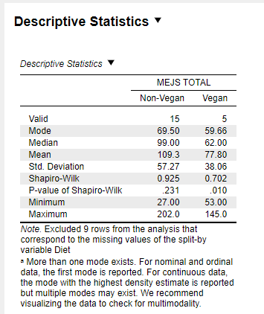
Figure 1 : Descriptive Statistics of MEJS scores by Dietary Groups

As shown in Figure 1, the vegan group (M=77.80, SD = 38.06) had a lower mean MEJS score than the non vegan group (M=109.30, SD=57.27).
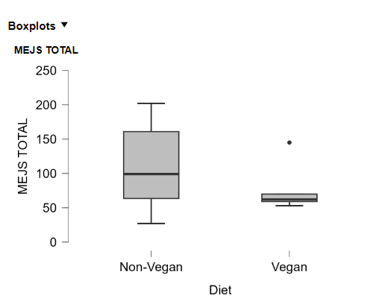
Figure 2 : Distribution of MEJS scores by Dietary Groups

4.3 Inferential Statistical Analysis
An independent sample t-test was conducted to examine whether MEJS scores differed between vegan and non vegan participants.

The Shapiro Wilk test indicated that MEJS scores were normally distributed for the non vegan group, W = .925, p = .231, but the assumption of normality was not met for the vegan group, W = .702, p = .010. Levene’s test indicated that the assumption of equal variances was not significant violated, F(1,18) = 3.151, p = .093.

The Student’s independent samples t test showed that the difference in MEJS scores between vegan and non vegan participants was not statistically significant, t(18) = 1.137, p = .270.

As a non parametric analysis, The Mann-Whitney U test was also conducted due to the violation of normality in vegan groups. The result was not statistically significant, U = 51.50, P = .238

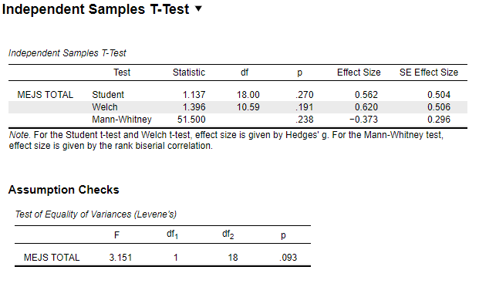
Figure 3 : Independent Samples t-test comparing MEJS scores

4.4 Effect Size and Confidence Intervals
The analysis produced a Hedges’ g of 0.562, indicating a moderate effect size. The positive value reflects the higher MEJS scores observed amongst the non vegan participants compared with the non vegan participants. With a 95% confidence interval ranging from -0.4774 to 1.583. This indicated a moderate effect with the non vegan group showing higher MEJS scores than the vegan group.

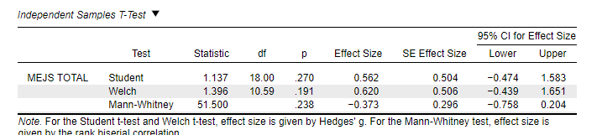
Figure 4: Effect size for the difference in MEJS scores

5.0 DISCUSSION
The current study compared meat-eating justification between vegan and non-vegan university students. While non-vegans received higher MEJS scores compared to vegans, the difference was statistically insignificant. Thus, the results of the study cannot provide enough evidence for significant differences between dietary groups in terms of meat-eating justification. However, the medium effect size suggests that the difference might be present although it could not be detected by the statistical analysis due to the limitations of the sample size.

The direction of the obtained results seems to correspond to Social Identity Theory suggested by Tajfel & Turner (1979). The theory postulates that people define themselves via the groups they belong to. Thus, their dietary identities can shape attitudes supportive of their diets. Non-vegans justify meat consumption as it corresponds to their dietary habits while vegans reject such justification as it contradicts their identity and values. Such interpretation aligns with the study by Nezlek et al. (2023) in which perceptions of vegans have been found to differ based on participants' dietary habits, as lower meat consumption corresponded to more positive perceptions of vegans.

However, one has to treat the results with caution. First, the last comparison included only 19 people, nine vegans and ten non-vegans. Moreover, the scores obtained by the vegans did not satisfy the assumption of normal distribution of data, meaning that even though Mann-Whitney U test has been used and yielded the same results, the small sample size is still a limitation. Finally, due to the cross-sectional design, no causal conclusions can be made regarding the relation between the variables studied.

Future research needs to employ a larger and more representative sample to prove the presence of the effect obtained. Future researchers can also conduct further studies on the impact of factors such as strength of dietary identity, ethical beliefs, environmental concerns, and social stigma on attitudes towards meat consumption.
6.0 CONCLUSION
In summary, non-vegan individuals had higher meat-eating justification compared to vegan individuals even though there was no statistical significance. The medium effect size provides a hint that there could be an association between membership in different dietary groups and meat-eating justification.

However, it must be noted that due to the small sample size, no clear conclusion can be drawn about the relationship between meat-eating justification and dietary group membership. The results of the study are consistent with Social Identity Theory since dietary identity could play a role in shaping attitudes toward the current diet.

REFERENCES

De Groeve, B., Rosenfeld, D. L., Bleys, B., & Hudders, L. (2022). Moralistic stereotyping of vegans: The role of dietary motivation and advocacy status. Appetite, 174, 106006. https://doi.org/10.1016/j.appet.2022.106006
Markowski, K. L., & Roxburgh, S. (2019). “If I Became a Vegan, My Family and Friends Would Hate Me:” Anticipating Vegan Stigma as a Barrier to Plant-based Diets. Appetite, 135, 1–9. https://doi.org/10.1016/j.appet.2018.12.040
Nezlek, J. B., Forestell, C. A., & Krishnamurti, H. (2023). Spontaneous verbal descriptions of vegans, non-vegan vegetarians, and omnivores and relationships between these descriptions and perceivers’ diets. PLoS ONE, 18(12), e0293899. https://doi.org/10.1371/journal.pone.0293899
Rothgerber, H. (2012). Real men don’t eat (vegetable) quiche: Masculinity and the justification of meat consumption. Psychology of Men & Masculinity, 14(4), 363–375. https://doi.org/10.1037/a0030379
Tajfel, H., & Turner, J. C. (1979). An integrative theory of intergroup conflict. In W. G. Austin & S. Worchel (Eds.), The Social Psychology of Intergroup Relations (pp. 33–48). Brooks/Cole.
Vestergren, S., & Uysal, M. S. (2022). Beyond the choice of what you put in your mouth: A systematic mapping review of veganism and vegan identity. Frontiers in Psychology, 13, 848434. https://doi.org/10.3389/fpsyg.2022.848434
Miguel, I., Coelho, A., & Bairrada, C. M. (2021). Modelling attitude towards consumption of vegan products. Sustainability, 13(1), 9. https://doi.org/10.3390/su13010009
Napoli, J., & Ouschan, R. (2024). Through the eyes of non-vegans: Using photovoice to explore the stigmatisation of vegans. Qualitative Market Research: An International Journal, 27(1). https://doi.org/10.1108/QMR-03-2023-0037
Salmivaara, L., Niva, M., Silfver, M., & Vainio, A. (2022). How vegans and vegetarians negotiate eating-related social norm conflicts in their social networks. Appetite, 175, 106081. https://doi.org/10.1016/j.appet.2022.106081

8.0 APPENDICES



