Module Title: Management & Organisational Behaviour
Module Code: BMIH5004
Student Name: Nicoleta Elena Bugaciu
Student ID: 2230707
Lecturer: Lola Villard Coles

I confirm that I have not used any AI tools in the research and creation of this assignment. I confirm that I have not presented any AI generated materials as my own work. I confirm I have copies of my drafts, notes, and other resources I used, which I may be asked to provide in evidence

Executive Summary
This report presents a comprehensive analysis of Wyndham Hotel & Resorts, one of the world's largest hotel franchising companies. It examines the organization's structure, culture, goals, recent change initiatives, and strategic direction. The analysis reveals Wyndham's strong focus on franchising, its asset-light business model, and its commitment to growth through brand diversification and technological innovation. The report concludes with recommendations for improving Wyndham's standing in the hospitality industry.

Table of Contents
Executive Summary 2
Introduction 5
Organization Structure, Culture, and Goals 6
Organizational Structure 6
Corporate Culture 6
Organizational Goals 6
Recent Change Initiatives 8
Strategic Direction 10
Conclusion 11
Recommendations 11
References 13

Introduction
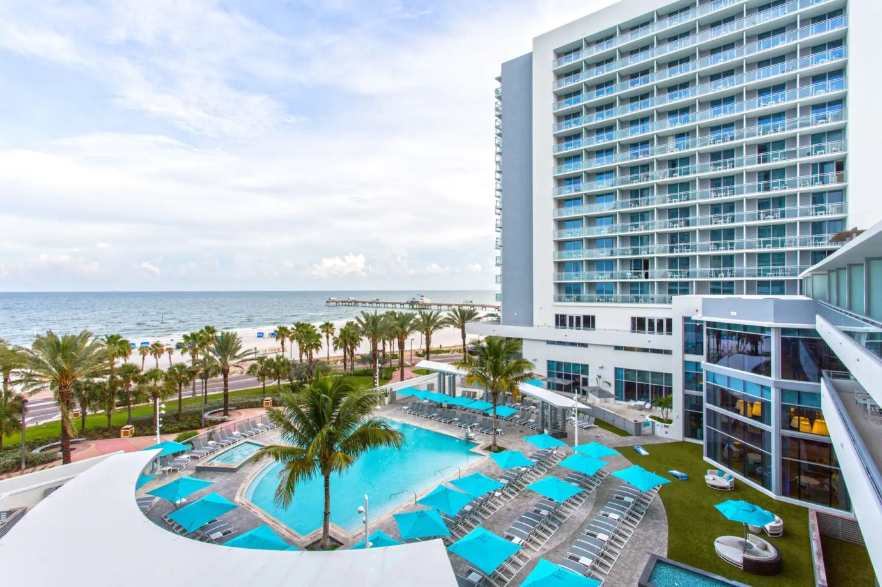
Wyndham Hotel & Resorts constitutes one of the leading hotel chains with membership of 20 diverse brands and around 8,950 hotels across almost 95 markets (Wyndham Hotels, 2024). Wyndham is one of the largest hotel franchising companies all over the world, and as such, it has set the tone for the contemporary hospitality.
Wyndham Hotel & Resorts is the subject of this report, and the work aims at identifying a range of the most fundamental factors that form the structural and operational model of the company (Hassanien and Dale, 2019). It will focus on the analysis of the company’s hierarchical structure revealing the possible strategies of its efficient governance together with the local requirements in relation to the brands of the company. The organizational culture of Wyndham will be analysed with focus on the objectives and the mission statement that guide this company and the way it operates (Lockyer, 2013). In addition, this study will reveal diversified objectives that manage and direct Wyndham’s operations and determinations on the company’s corporate level as well as within hotel chain. However, looking at these objectives, the researchers seek to explain how the company, via its franchised properties, connects with its overarching corporate strategy.
This paper will also consider certain change initiatives that were implemented in Wyndham in recent period to determine how the company responds to shifting market circumstances and emerging consumer needs. This will allow a determination of Wyndham’s abilities to be nimble and creative in responding to forces that shape the hotel market. By dissecting the firm in this manner, we hope to obtain useful insights into how one of the major stakeholders in the hospitality industry operates and function, allowing us to get a snapshot of Wyndham’s operations of managing and franchising of hotels in the global marketplace.

Organization Structure, Culture, and Goals

Organizational Structure
Wyndham Hotel & Resorts organization structure is a mixture of functional, divisional, and a matrix structure. Mitnick and Hunt’s Organizational configuration theory can used to analyse these structures especially within the Divisional zed Form (Pappas & Bregoli, 2016). Ultimately at the corporate level Wyndham has a strategic apex of the CEO and executive team, middle line staff of regional presidents and brand managers, techno structure of the corporate functions and support staff departments, and an operating core of individual hotels mostly operated by franchise owners (Stringam, 2020). This structure enables the formulation of strategic decisions at the corporate level for the overall management of the company and promoting brand standardization but at the same time facilitating decentralization of operation control at the brand and property level due to market conditions of the area.

Corporate Culture
There are key aspects of Wyndham’s corporate culture, and they include the organization embraces a culture that promotes innovation or innovative thinking, that is, a culture of entrepreneurship (Laerdal, Palmer and Lester, 2022). Process of sustainably is endemic in the corporate environment, with a major emphasis on environmentalism. As per the franchise-based operational model, Wyndham promotes a franchise culture and therefore sustain good relations with franchise proponents (Pappas, 2015). It affects operations by encouraging flexibility, enhancing the bonding between franchisors and franchisees, and encouraging process enhancement in a portfolio of brands that guests are exposed to.

Organizational Goals
Goals in Wyndham organization are both at the corporate and property levels and thus give a roadmap to property performance in line with corporate strategies. At the corporate level, specific objectives may include the growth in the numbers of properties owned or managed and the penetration into new locations (Hudson and Hudson, 2012). Brand building is another objective, more specific targets being aimed at improving brand awareness and brand equity throughout the division (Lockyer, 2013). The company has set a goal to enhance the service sales revenue through improving the revenue per available room (RevPAR) and the business performance. Technology advancement is pursued with an aim of enhancing both the guests and the organizational performance (Hudson & Hudson, 2012, p. 420). The other purpose focuses on sustainability leadership, which targets on environmental management and tourism sustainability.
Whereas at the individual hotel level goals are specific, they tend to be more on specific operations. Facilities strive for guest’s high turnout to guarantee a high degree of utilization of the rooms (Marques and Marques, 2023). There is a continuous drive to increase guest satisfaction with measures are being taken to ensure that service delivery and physical infrastructure are kept to the highest possible standards. Another important area is revenue management where properties develop the best pricing plan to increase revenue. Having these multiple levels of objectives forms a consistent strategic map that can be easily adopted to run various business units of Wyndham.

Recent Change Initiatives
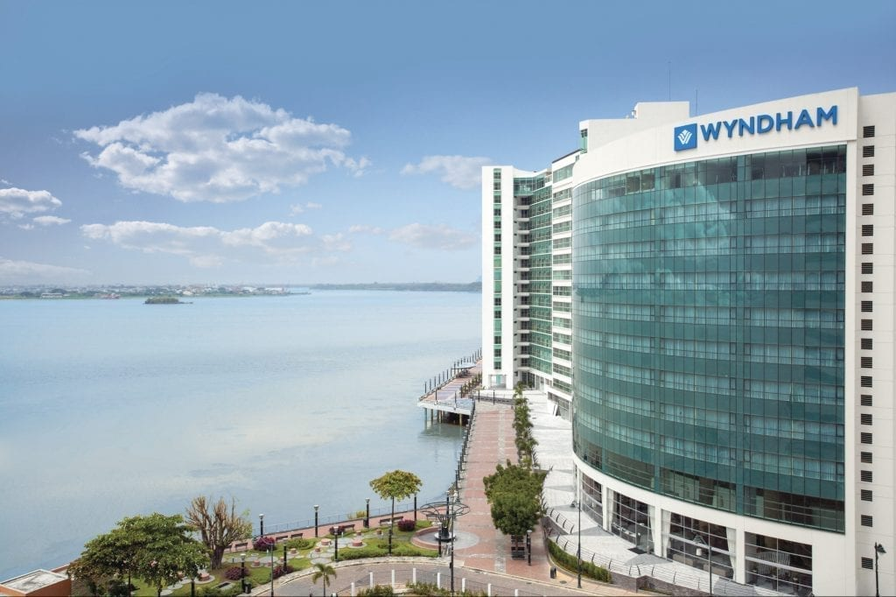
Source: (HTN Editors, 2023)
Wyndham Hotel & Resorts has undertaken several significant change initiatives in recent years:
- Digital Transformation: Due to advancement in technology, Wyndham has embraced the use of digital competencies in the delivery of services as well as operations (Tajeddini, Ratten and Merkle, 2019). This covers mobile application for simplified bookings, and checking, the adoption of cloud-based property management systems (Rajagopal and Rajagopal, 2019). These changes have led to better operating results, guest satisfaction, and marketing insight.
- Brand Consolidation and Refresh: The company has emerged as a sleek brand manager and has pulled off some brands, while rebasing others to fit the changing market palate (Tajeddini, Ratten and Merkle, 2019). This has resulted in enhanced clarity of brand identity, optimal outcomes in marketing communication and better positioning of marketing offering with marketing segments.
- Sustainability Program Expansion: In the recent past, Wyndham has stepped up its sustainability efforts and brought environmentally friendly policies to their hotels and a vast ESG program (Melissen and Sauer, 2018). This has enhanced the image of the company, targeted clients with a concern for the environment and possibly minimized cost down the line.
- Franchise Support Enhancement: Some of the specific changes evidenced include enhanced training structures, marketing assistance and general operational solutions that have been provided to the franchisees (Melissen and Sauer, 2018). This has helped to enhance the companies’ association with the franchisee, enhance the brands’ standardisation as well as the overall company’s growth.
Evaluation of Change Management:
Wyndham has managed these changes relatively well, employing a systematic approach that aligns with Kotter's 8-Step Change Model:
- Creating a Sense of Urgency: Clearly communicating the need for change in response to market trends and consumer demands (Laig and Abocejo, 2021).
- Building a Guiding Coalition: Involving key stakeholders, including franchisees, in the change process (Aksoy et al., 2022).
- Forming a Strategic Vision: Articulating a clear vision for each change initiative.
- Enlisting a Volunteer Army: Engaging employees and franchisees in the implementation of changes (Laig and Abocejo, 2021).
- Enabling Action by Removing Barriers: Providing necessary resources and support for change implementation.
- Generating Short-Term Wins: Celebrating early successes to maintain momentum.
- Sustaining Acceleration: Continuously refining and expanding change initiatives based on feedback and results.
- Instituting Change: Incorporating new practices into the company's standard operating procedures.
While the overall management of these changes has been effective, there have been challenges, particularly in ensuring consistent adoption across the diverse franchise network (Laig and Abocejo, 2021). However, Wyndham's transparent communication and supportive approach have helped mitigate resistance and facilitate smoother transitions.

Strategic Direction
The positioning strategy of Wyndham Hotel & Resorts consists of three elements: sustainable development, enhanced brands, and new technologies. There has always been a policy of the company operating under an asset light strategy thus franchising to expand very fast but with little capital (Haley & Inge, 2013). Wyndham focuses on the organizational positioning of the brands to distinguish them for the different group of consumers and examines the opportunities of taking over other companies to meet the new tendencies in travelling.
Geographical growth is seen as a priority, especially in Asia-Pacific and Latin America, where the proportion of middle-income people is expected to grow, and travel is likely to become more popular. Currently, Wyndham has embarked on the adoption of technology in a general aspect to improve guest experiences, efficiency, and to get an edge (Morrison, 2022). Some of these are, for example, the current trends in mobile solutions, use of artificial intelligence to offer custom-specific services, and utilization of analysis of who and how to make optimal decisions.
Wyndham remains committed to enhancing its loyalty program, Wyndham Rewards to encourage consumers to book directly and cut on guest sensitivity to room rates (Morrison, 2022). The fourth strategic issue is the sustainability leadership, where the company mainstreams environmental aspects into operation and development plans to serve green-aware consumers and cut future expenses. To attain these objectives, the following are some of the strategies adopted by Wyndham (Igor, 2017). Such activities consist of ensuring that franchiser offer adequate support to franchisee, enter new alliance for improving distribution and guest’s services, invest in employee training and growth, accurately market through digital media, and establish best practices for operations.
These strategies are in line with the company’s strategic direction outlined in Wyndham’s vision statement as the leading select-service hotel brands’ company with additional value to both guests and franchisees (Sharma, 2023). Through cooperation, the Wyndham strives at maintaining balance between growth, development and stability with the goal at enhancing its market presence within the highly competitive hospitality industry of today while catering to newly emerging and changing customer needs and expectations.

Conclusion
Wyndham Hotel & Resorts shows a sound and centralized organizational structure with decentralized operational style. An innovative, customer-centric, and sustainable organizational culture emphasises the company’s recent change initiatives and strategy. The fact that the company limited its operations to owning and franchising, with minimal direct operations allowed the company to expand quickly and easily in a volatile industry. The latter change initiatives, predominantly digital inquiries and decree in sustainability, have prepared Wyndham for more demands from consumers and the advancement in the industry. However, there are challenges the company experiences regarding brand management especially over a large coverage area and brand distinction in the market. Wyndham’s development plan is coherent and aimed at organic improvement through market coverage, technology, and brands division. This strategy is as relevant as the key players of the industry but must be updated on a regular basis to prevent obsolescence.

Recommendations
To improve the competitive advantage of Wyndham in the sector of hospitality industry, the following recommendations are given. Firstly, adoption of sophisticated AI-generated customization throughout the consumer interface journey would add value as well as uniqueness to Wyndham and enhance the consumer commitment (Rajagopal and Rajagopal, 2019). Secondly, creating a dedicated sustainable innovation centre would make Wyndham the forefront company in green-functioning hospitality, attractive to such customers. Third is having a localized experience program that would develop local experience in each of the properties it offers, making the stay of guests different and interesting. Fourthly, introducing a concept of the franchise innovation incubator would imply the utilization of the integrated knowledge of the franchisees, as well as creating a practice of the active search for the improvements and the high-quality performance. Finally, the development of a next-generation hospitality training academy would go way in filling the skills deficiency in the industry while on the other putting Wyndham in the map as a preferred employer (Popescu, Nicolae and Pavel, 2015). These initiatives would be done with coordinated partnerships of its IT department, sustainability team, brand management, franchise relations, and human resource department. A closer look at Wyndham can show that with targeted focus on individual experience, environmentally friendly solutions, embracing local environments, more authority to franchisees, as well as employing and developing people, Wyndham can achieve tighter brand message and identity, better operations, and therefore attract more guests and franchisees. These strategic developments would establish Wyndham as a key leader in innovation in the transforming face of the hospitality business.

References
- Haley, M. and Inge, J., 2013. Revenue Management. Prism–Travel & Leisure consulting, pp.1-10.
- Hudson, S. and Hudson, L., 2012. Customer service in tourism and hospitality. Goodfellow Publishers Ltd.
- Igor, M., 2017. Corporate brand portfolio management.
- Laerdal, K.M., Palmer, C. and Lester, J.A., 2022. Constructing and performing hotel hospitality culture. Hospitality & Society, 12(1), pp.3-26.
- Laig, R.B.D. and Abocejo, F.T., 2021. Change management process in a mining company: Kotter’s 8-step change model. Journal of Management, Economics, and Industrial Organization, 5(3), pp.31-50.
- Lockyer, T.L., 2013. Global cases on hospitality industry. Routledge.
- Marques, J. and Marques, R.P., 2023. Digital transformation of the hotel industry: Theories, practices, and global challenges. Springer Nature.
- Melissen, F. and Sauer, L., 2018. Improving sustainability in the hospitality industry. Routledge.
- Morrison, A.M., 2022. Hospitality and travel marketing. Routledge.
- Pappas, N. and Bregoli, I. eds., 2016. Global dynamics in travel, tourism, and hospitality. IGI global.
- Rajagopal and Rajagopal, 2019. Brand Portfolio Management. Competitive Branding Strategies: Managing Performance in Emerging Markets, pp.143-173.
- Tajeddini, K., Ratten, V. and Merkle, T. eds., 2019. Tourism, hospitality and digital transformation: strategic management aspects. Routledge.
- Wyndhamhotels.com. (2024). Wyndham Hotels & Resorts. [online] Available at: https://www.wyndhamhotels.com/en-uk [Accessed 17 Oct. 2024].
- ‌ Hassanien, A. and Dale, C., 2019. Hospitality business development. Routledge.
- Stringam, B.B., 2020. A profile of the hospitality industry. Business Expert Press.
- Pappas, N., 2015. Marketing hospitality industry in an era of crisis. Tourism Planning & Development, 12(3), pp.333-349.
- Lockyer, T.L., 2013. Global cases on hospitality industry. Routledge.
- Aksoy, L., Choi, S., Dogru, T., Keiningham, T., Lorenz, M., Rubin, D. and Tracey, J.B., 2022. Global trends in hospitality. Journal of Business Research, 142, pp.957-973.
- Sharma, R., 2023. Hospitality sustainable practices, a global perspective. Worldwide Hospitality and Tourism Themes, 15(3), pp.212-219.
- Popescu, M.A., Nicolae, F.V. and Pavel, M.I., 2015, November. Tourism and hospitality industry in the digital era: General overview. In Proceedings of the 9th International Management Conference (pp. 163-168).

