Draft Essay

In this essay I will be discussing about 3 keywords that spark my interest. These three words consist of branding, fashion, and social media. I will be exploring each word as well as their links together. Firstly, in chapter 1 I will be discussing branding and exploring the branding prism by J. Kapferer and the effect it has on brands. Furthermore, I will be discussing the importance of brand strategy and the impact it can have on businesses. Secondly, in chapter 2 I will be exploring the brand Peachy Den by evaluating their branding as well as discussing how important branding is for fashion companies and the impact it has on the consumer. Thirdly I will discuss the importance of social media presence and how brands rely on it to help them.

Chapter 1, Branding

A brand identity or cooperate identity is the image of which a business or firm presents itself towards their audience. “A brand image is a customers’ perception of the brand” (Rukosuev, YEAR). Elements of this include logos, tag lines, typeface, shapes, colour schemes etc. Figure 1 shows a brand identity prism created by J. Kapferer in 1986 which highlights six important steps to a good brand identity.
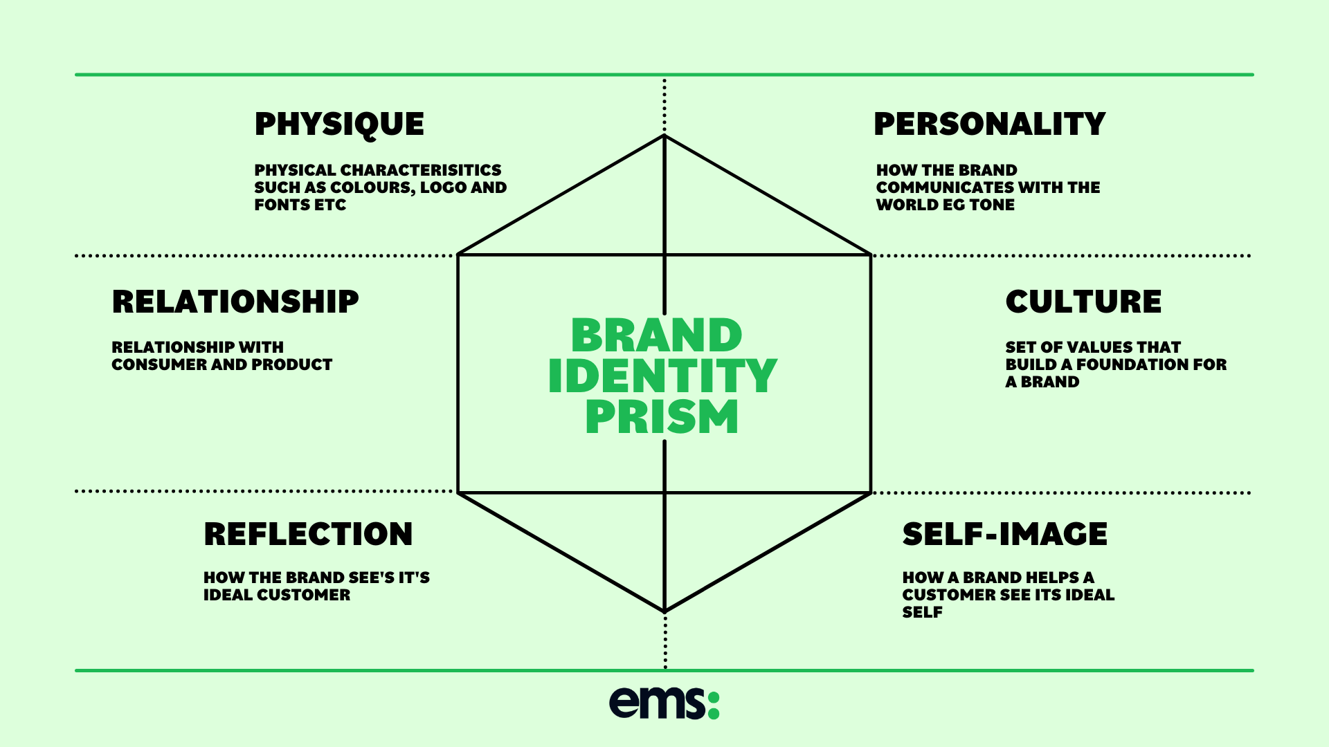
Figure 1 Brand Identity Prism (Bailie, 2021)
This prism is a marketing model intended to help a brand understand and enhance all aspects of its identity (Indeed Editorial Team, 2023). This consists of physique, personality, culture, relationship, reflection, and self-image (Bailie, 2021). The physique is the logo, fonts, colours and shapes. This part of the brand needs to be recognisable. An example of this is the Nike logo being a tick mark. The personality is how the brand presents and communicates itself to the public, such as McDonald`s personality is known to be happy and friendly. Culture can be what the brand stands for and represents, any values or principles they hold as a company. An example of this would be how H&M believe in being one team “We encourage and help each other to win together” (H&M, 2022). Relationship stands for trust between the brand and the consumer, do customers expect anything outside of the product/service they offer? The reflection stands for the target audience, who is the ideal buyer/customer? Finally, is self-image which is how the customer sees their ideal self. What lifestyle does this brand aim to give the consumer? Later in this essay, the importance of lifestyle within branding will be discussed. This brand identity prism has been around for 20 years, which helps achieve a successful branding identity for anyone who uses it.

Branding is incredibly strong and effective. There is a reason for everything when it comes to brand identity. For example, the use of negative space and the effect that has on the consumer. Negative space is used to make design look less cluttered, also giving the design a certain elegance. Luxury brands know this and apply it even in their store designs as well as any design elements they have. Products are displayed one at a time, with each product being surrounded with plenty of negative space. It shows customers the exclusivity of the items and shows them that these items are high end. The use of negative space can be applied to any part of branding whether that’s in stores or brand logos. What is negative space in logo design? It is the empty space which has been left surrounding the illustrated object that helps to define it (Miller, 2023).

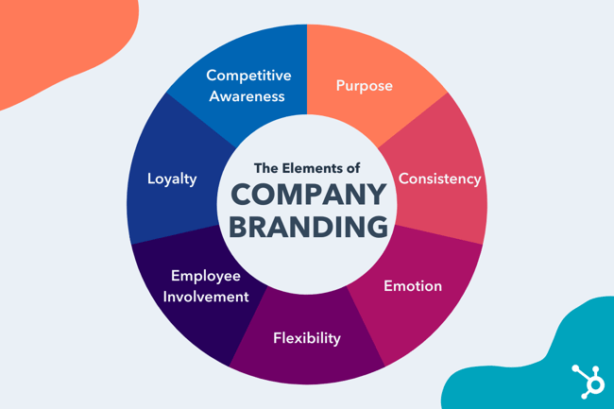
Figure 2 Brand Strategy 101 (Stec, 2022 a)

A branding strategy is also important for brands and businesses. “Brand strategy is part of a business plan that outlines how the company will build rapport and favorability within the market” (Stec, 2022 B). The first aspect to brand strategy is purpose. What is your brand’s purpose, and how does it differentiate from other brands? The purpose can be defined in two ways, functional and intentional. The focal point of functional is making money, with intentional being able to make money and have a positive impact on the world. Consistency is important for brands to help keep their customers and gain new customers. It also helps customers achieve a higher knowledge of the brand. “Consistency builds that bridge by increasing consumer knowledge about the brand” (Wong, 2022).

Chapter 2, Fashion

“Branding is the conscious management of the public perception of, and personal identification with, a fashion label” (REF). Branding is important for fashion labels as people associate a certain lifestyle with it which they can choose to be a part of by buying into that brand. New fashion labels could struggle with gaining loyal customers because the public do not yet know what lifestyle the brand represents.

Independent fashion brands can utilise branding to stand out against larger more established fashion labels. “The number of independent fashion businesses has grown by 23 per cent in just one year” (Smith, 2022). Designers could possibly have more freedom in their work when working with independent brands as opposed to bigger and popular brands. “If your client or manager understands why you want to make certain creative choices, they may be more likely to go along with them” (Indeed, 2022).
Look for reference about consumer trust in smaller brands. Relate back to branding prism Relationship section.

Peachy Den is an independent fashion brand that promotes sustainability and empowerment of women (Peachy Den, 2023). They believe you can be comfortable and confident in what you are wearing which is their focus when designing their clothes. This brand also focuses on quality and wanting their customers to be able to rely on that, as well as having an all-seasons approach with colour pallets etc. They have a fun but simple and timeless branding that perfectly captures the brand lifestyle for consumers to see. As previously discussed, this factor is important, which likely plays a role in the success of the Peachy Den fashion brand.

What is sustainable fashion? “Put simply, it is fashion that is ethically made and environmentally friendly” (Marshall, 2022). This brand pushes for customers to invest in high quality pieces that are wardrobe staples which can be worn multiple different ways. For example, this description of a cotton jumpsuit from their online store: “You can pair this organic cotton jumpsuit with anything from heels to trainers to bare feet; the perfect stay-at-home fit, easily dressed up or down” (Peachy Den, 2023). Over the past few years sustainable fashion has become more and more popular, which could be considered another factor in Peachy Den’s success.

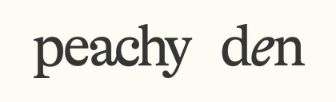
Figure 3 Peachy Den logo (Peachy Den, 2023a)

Peachy Den’s branding is very simplistic and timeless which is important for brands. “A timeless brand that doesn't require updating to avoid looking outdated will make your logo continue to work for you, rather than against you” (Dodhia, 2021). This logo is simplistic and minimal yet captures the aesthetic of the brand perfectly well.

Is branding different in the fashion industry? “Building a strong identity is key for any fashion brand. It allows for representation of a clear idea of what’s being sold” (Moore, 2021). As previously discussed, branding in the fashion industry is incredibly important and will determine the brands success. Customers need to know what type of lifestyle they are buying into and becoming a part of. “A brand is a company’s personality and what it hopes to represent to the customer” (Moore, 2021) A way of a brands communicating their lifestyle to consumers can be done in many ways. One which has grown significantly over the years is having ambassadors and influencers to promote their products and to reach potential customers. Brands carefully curate who fits their lifestyle and ensure they have the correct target audience. This is done because brands today understand consumer behaviour. “Consumer behaviour consist of the psychological and social processes people undergo in the acquisition, use and disposal of products” (Bagozzi et al., 2010). Another point is peer to peer influence, research shows that people are more likely to trust other people rather than brands/companies. Research that was carried out showed that 75% of Gen Zers and Millennials typically see content from influencers at the minimum of once a day and 72% of them expressed that they are more likely to trust a recommendation from an influencer if they had shown brand loyalty (Jakobsson, 2022).

Chapter 3, Social Media

Bibliography

Bagozzi, R.P., Gürhan-Canli, Z. and Priester, J.R. (2010) “Chapter 1 Introduction: overview of consumer behaviour,” in The Social Psychology of Consumer Behaviour. Buckingham: Open University Press, pp. 14–14.
Bailie, E. (2021) Brand identity prism: The importance and how it works, Enterprise Made Simple. Available at: https://enterprisemadesimple.co.uk/brand-identity-prism-the-importance-and-how-it-works/ (Accessed: April 28, 2023).
Dodhia, Z. (2021) Council Post: Why A personal brand logo should be timeless, Forbes. Forbes Magazine. Available at: https://www.forbes.com/sites/forbesbusinesscouncil/2021/03/09/why-a-personal-brand-logo-should-be-timeless/?sh=2e92f3ae2073 (Accessed: April 12, 2023).
Indeed Editorial Team (2023) What is the brand identity prism? (with benefits of use) - indeed. Available at: https://www.indeed.com/career-advice/career-development/brand-identity-prism (Accessed: April 24, 2023).
Jakobsson, S. (2022) Why do fashion brands use Influencers?, Cure Media. Available at: https://www.curemedia.com/why-do-fashion-brands-use-influencers/ (Accessed: April 24, 2023).
Moore, G. (2021) Fashion promotion: Building a brand through marketing and Communication. LONDON: BLOOMSBURY.
Rukosuev, D. (no date) What is brand identity?, Training Courses & Accredited Qualifications for Professionals. Available at: https://www.professionalacademy.com/blogs/what-is-brand-identity/ (Accessed: April 19, 2023).
Smith, C. (2022) Demand for 'sustainable brands' up 614%, What's driving a surge in demand for sustainable fashion?Available at: https://www.simplybusiness.co.uk/knowledge/articles/2022/08/demand-for-sustainable-fashion-and-second-hand-clothing-on-the-rise/ (Accessed: April 13, 2023).
H&M (2022) H&M Culture and workplace, H&M Careers. Available at: https://career.hm.com/culture-and-benefits/ (Accessed: May 1, 2023).

Marshall, D. (2022) What is Sustainable Fashion and why is it so important, IMMAGO. Available at: https://immago.com/sustainable-fashion-important/ (Accessed: May 1, 2023).
Indeed Editorial Team (2022) 11 Pros and Cons of being a graphic designer, https://www.indeed.com/career-advice/finding-a-job/pros-and-cons-of-being-graphic-designer. Indeed. Available at: https://www.indeed.com/career-advice/finding-a-job/pros-and-cons-of-being-graphic-designer (Accessed: May 1, 2023).
Miller, C. (2023) Negative space in Logo Design - Tips & Inspirations, Tailor Brands. Available at: https://www.tailorbrands.com/blog/negative-space-in-logo-design (Accessed: May 1, 2023).
Stec, C. (2022) Brand strategy 101: 7 important elements of a company Branding Plan, HubSpot Blog. HubSpot. Available at: https://blog.hubspot.com/blog/tabid/6307/bid/31739/7-components-that-comprise-a-comprehensive-brand-strategy.aspx (Accessed: May 2, 2023).

Wong, J. (2022) Why consistency is vital to your branding efforts, Entrepreneur. Entrepreneur. Available at: https://www.entrepreneur.com/starting-a-business/why-consistency-is-vital-to-your-branding-efforts/425791 (Accessed: May 2, 2023).

