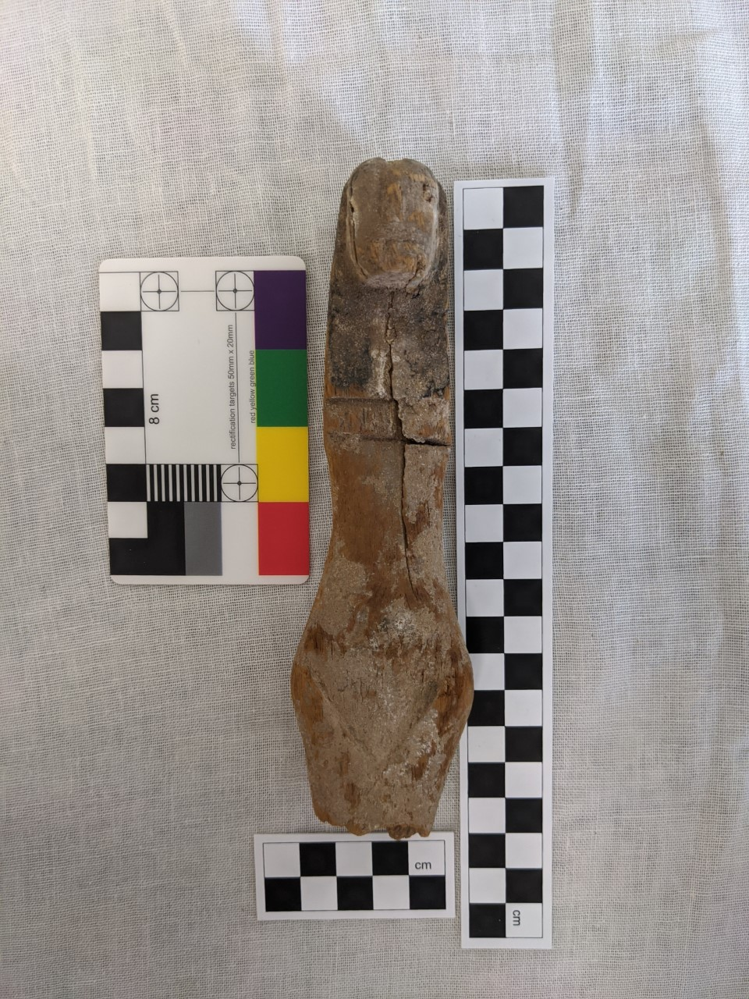
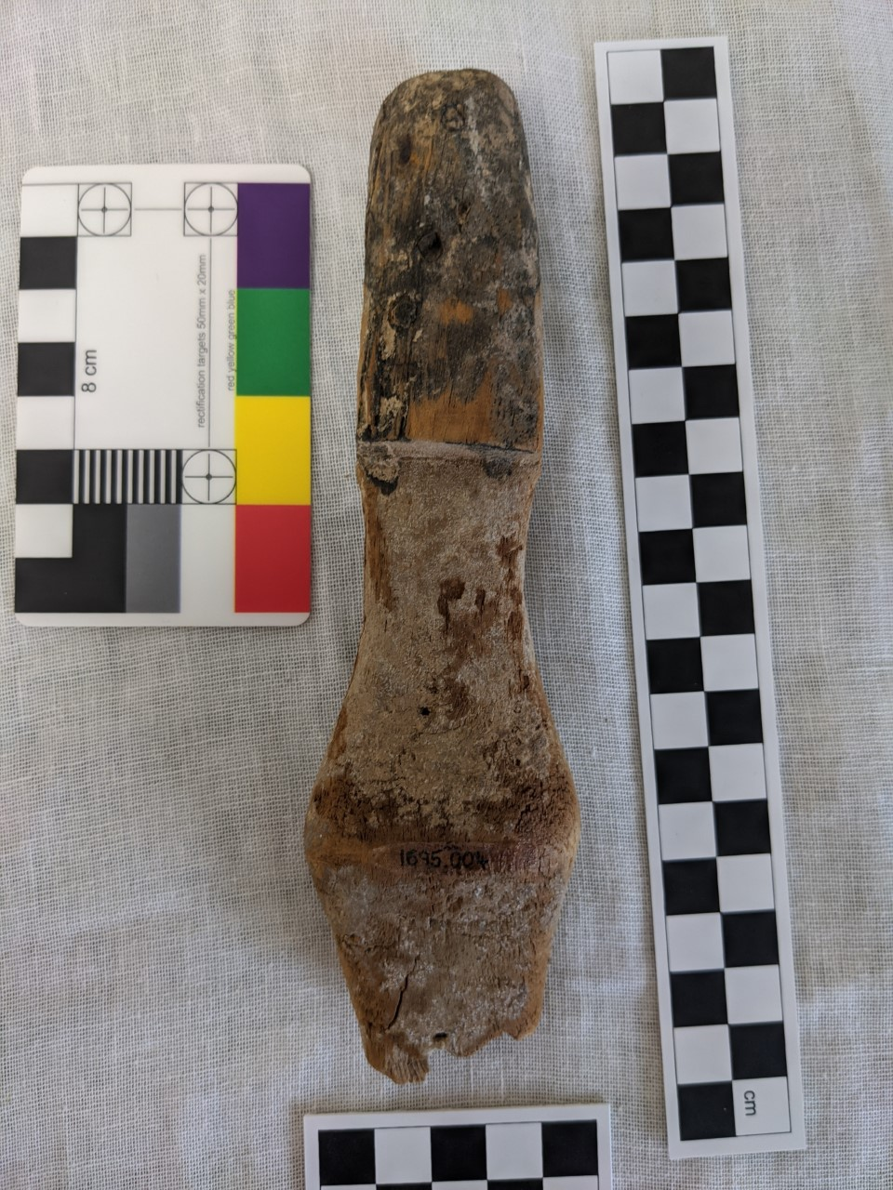
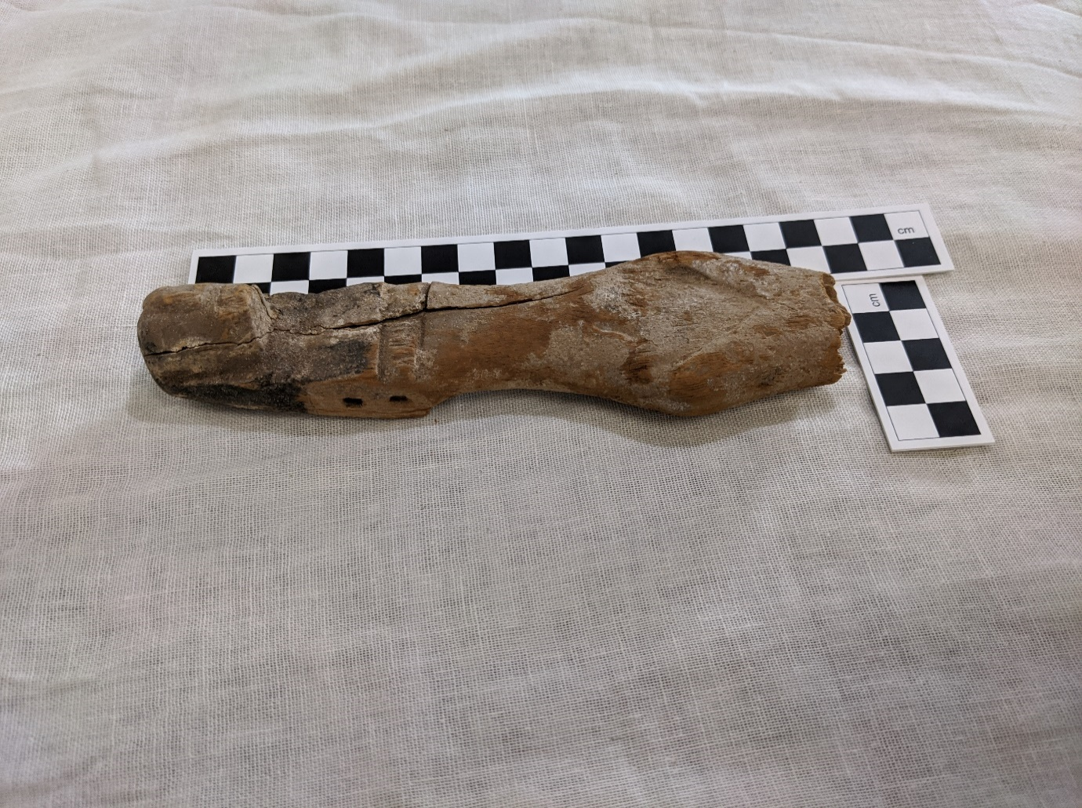
Figure 3: Front View (Cyfarthfa, 1695.004)

Figure 3: Back View (Cyfarthfa, 1695.004)
Figure 3: Right Side View (Cyfarthfa, 1695.004)

Wooden Female Figurine
Cyfarthfa Castle, Merthyr Tydfil, 1695.004
Object Type: Small wooden figurine, roughly carved to resemble a woman, with no arms, and exaggerated hips.
Material: Wood
Period: Middle Kingdom
Provenance: Egypt
Dimensions: Height: 170mm, Head Width: 25mm, Waist Width: 27mm, Hip Width: 45mm, Base Width: 30mm, Head Depth: 30mm, Waist Depth: 8mm, Hip Depth: 25mm, Base Depth: 20mm
Object Analysis by Lilian Earp

Description
Although worn and damaged, there is a lot of detail to this figurine. She has a carved face, with eyes, nose and mouth all clearly visible, and a long black wig that stands out from her body. There is a carved line across her chest, most likely to emphasise breasts, and she has exaggerated waist and hips. The pubic triangle has also been clearly marked. Whilst no arms remain, on each of her shoulders are two peg holes, suggesting that once there would have been arms attached. Traces of the black pigment used to emphasise the wig are still visible on the wood, and there is a white pigmentation across much of the body and face, although it is unclear whether this is as a result of deliberate application of colour, or natural discolouration of the wood over time. On the back of her wig are three filled peg holes, which may be there to hold the figurine together, since there is a large crack that runs through her body, and is most clearly visible on left side. In addition to this crack, there is another that runs down her front. Her lower legs are not present. Due to the lack of legs, she fits the basic description of a Truncated Figurine, although it is unclear whether this is a deliberate choice, or whether that jagged edges of the legs mean that this as a result of later damage. However, due to the prevalence of Truncated Female Figurines, it is likely that this is a deliberate choice.
It can be very difficult to accurately identify the type of wood that such artefacts are made of, without access to more equipment and funding than is available for most, and as such we do not know exactly what kind of wood that the figurine is made of. Wooden objects in Egypt came from a range of trees, and many particularly high value wooden items would have been made from imported wood, as the native species are small and fast growing, which produces less dense, and less long lasting, wood. Due to the relative simplicity, and the apparently contemporary with creation damage (and resulting repairs), the wood is likely to be native to Egypt, and likely from a small tree, since larger pieces would have been reserved for larger objects. However, without more detailed examination it is difficult to speculate further.
This figurine has been dated to the Middle Kingdom, because it is in this period that we see an increase in such female figurines. Ashby argues that it is during this period that Nubian women arrive as dancers for Hathor, and that traditional Nubian dances were incorporated into Egyptian Ritual. Morris also argues that it is during the later dynasties of this period, and into the New Kingdom, that the Khener-Dancers, and figurines of them and related to them, became particularly important. It is likely that many of such female figurines depict Nubian dancers.
Such female figurines have a range of suggested purposes. The most common, but also most basic argument is some form of ‘fertility figurine’, erotic doll, model of a concubine or other sexual purpose. A secondary use of such dolls has been suggested by Pinch, that they were used a magical symbol, or a ritual focus, to invoke fertility and protect during childbirth. Waraksa argues that the sphere of influence for female figurines extends beyond sexuality, fertility, and childbirth, and that such figurines were also used in general healing medicine and spells, such as healing a stomach-ache, or to chase away venomous creatures such as snakes.
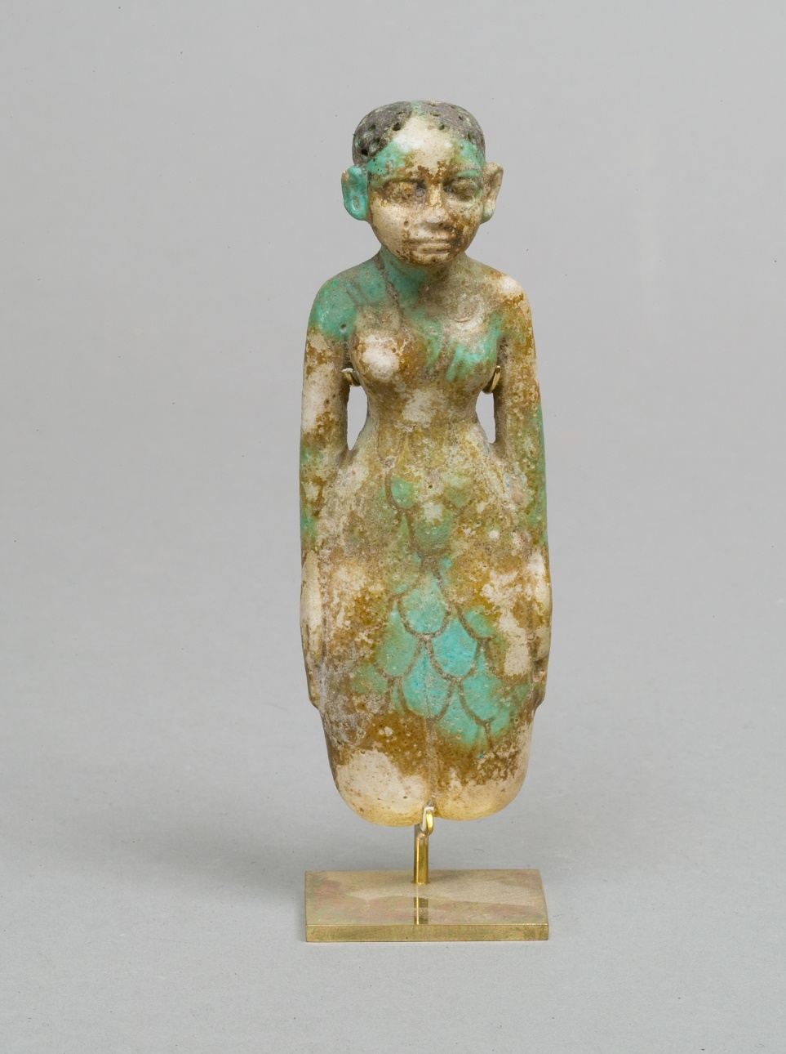
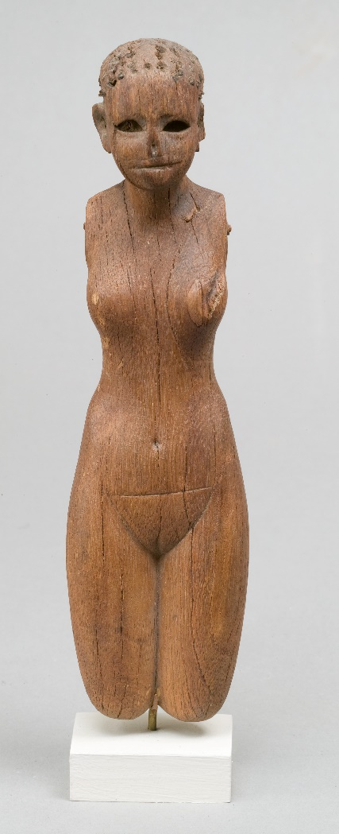
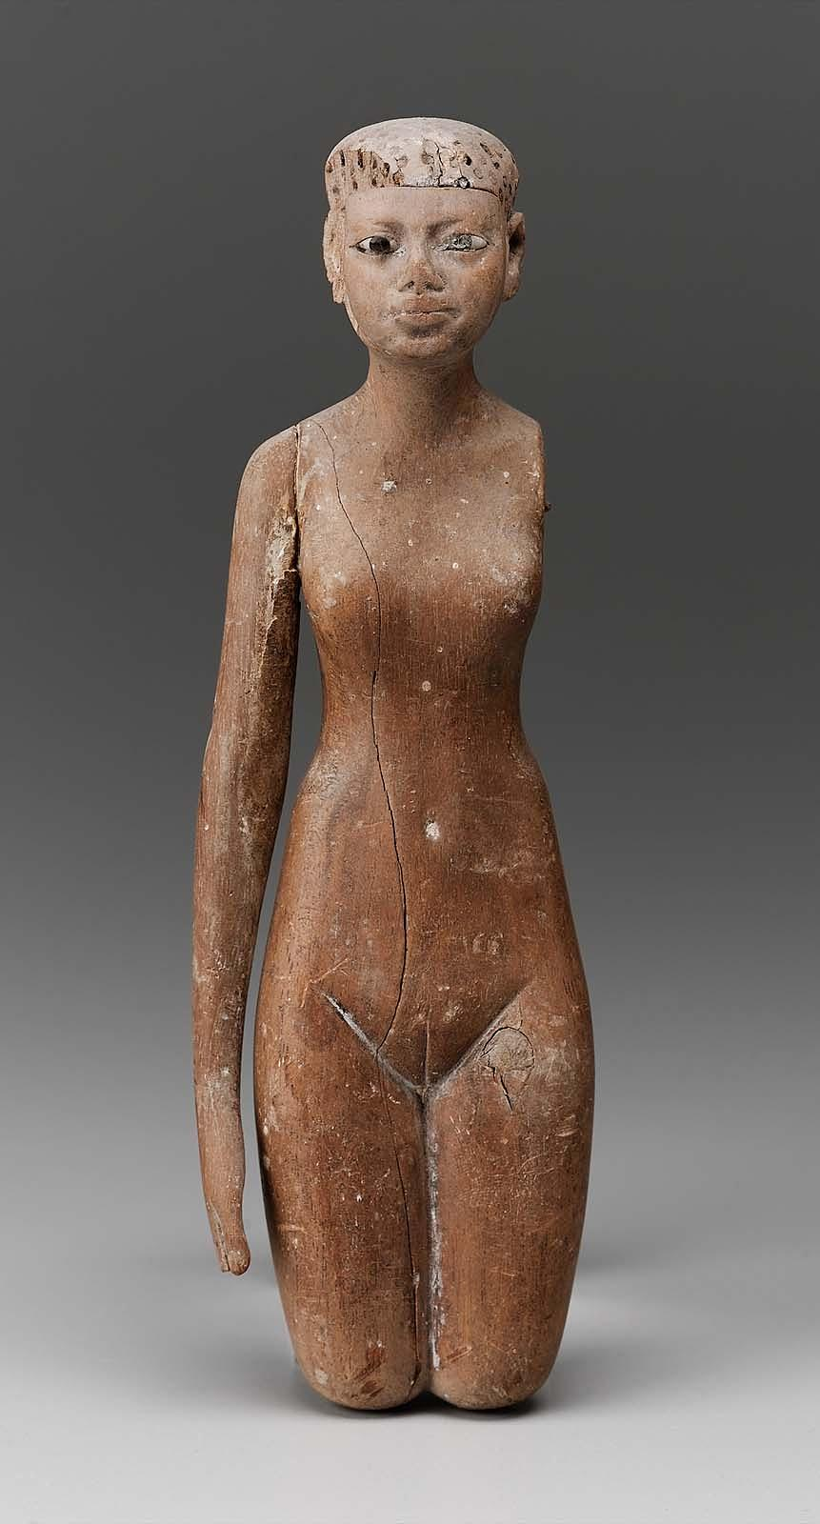
Whilst these are commonly discussed uses of female figurines, figurine 1695.004 is most likely connected with dance and performance. Dance troupes were an essential part of many rituals in Ancient Egypt, not least funerary rites. Morris argues that both truncated female figurines, and paddle dolls, were associated with burials of Khener-Women dancers. These dancers were associated with the Goddess Hathor, and would have performed a ritual re-enactment of the re-birth of the Sun God, and therefore of the deceased, at the funeral of the deceased.
Figure 4: Faience Female Figurine (MET, 34.1.125)
Figure 5: Wooden Female Figurine (Met, 08.200.22)
Figure 6: Wooden Female Figurine (MFA 20.1121)
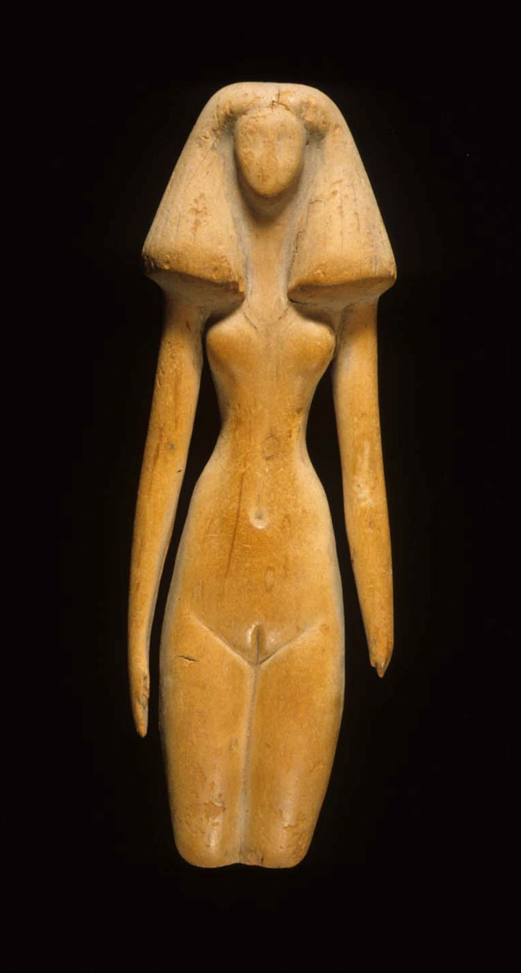
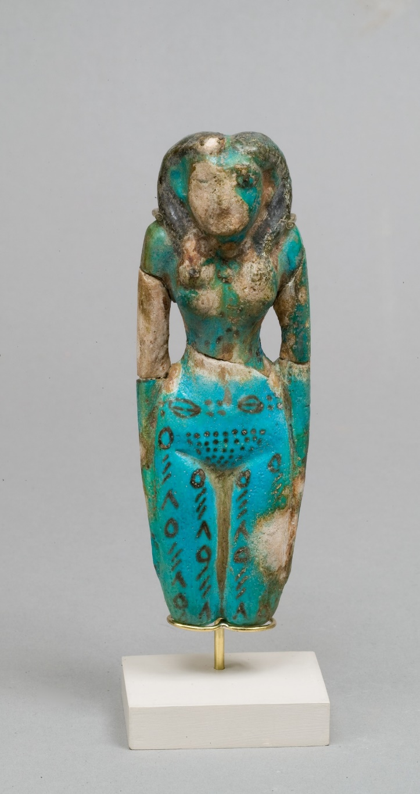
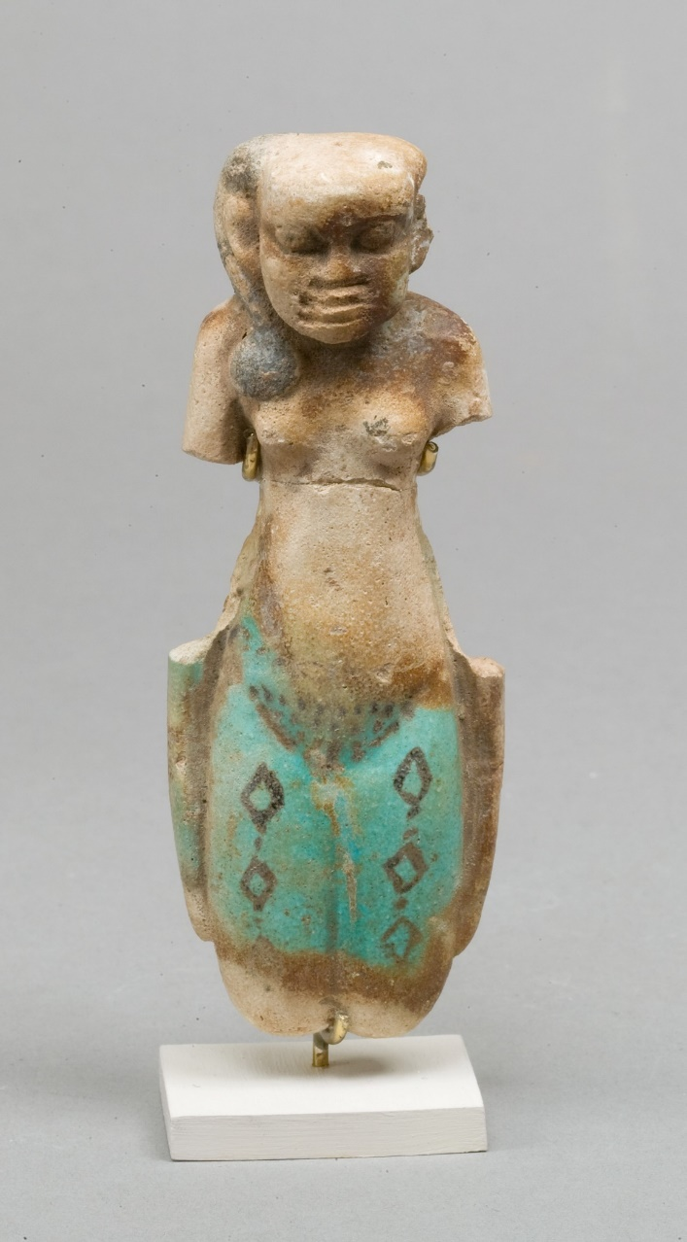
There is a wide range of other figurines, all also dating to the Middle Kingdom, that bear similarities to this figurine. Figure 4 depicts a figurine from Lisht, coming from a Tomb of a girl believed to have been a Khener dancer. Whilst figure 4 is faience, and stylistically very different, it shows the range of styles that these figurines came in, and the strong connections to dance and performance. There are many more examples of female figurines with much more similarity to Object 1695.004. Figures 5, 6, and 7 show three variations on Middle Kingdom wooden figurines. Figure 5 and 6 are two examples of figurines with the same style of arm, which are separately carved, and later attached with pegs. As is obvious from these examples, this makes the arms particularly vulnerable to loss. These figurines also showcase different styles of hair, both of these have short hairstyles, with small pegs to simulate tight curls or knots. Figure 7 is very different. Carved from Cedar wood, she has arms that are attached, so she has been carved entirely from one single piece of wood, and also wears a long wig, similar to what we see on 1695.004.
Figure 7: Cedar Wood Female Figurine (MET 26.7.1416)
Figure 8: Faience Female Figurine (MET, 08.200.18)
Figure 9: Faience Female Figurine (MET, 22.1.180)
Figures 8 and 9, whilst very different from object 1695.004, help to illustrate another important, often ritual, aspect of female figurines, which is Tattoos. Many female figurines and paddle dolls show elaborate tattoos, most often across the thighs and pubic triangle, as can be seen on both of these figurines. Tattoos on such figurines, and those found on some female mummies, are most likely to honour Hathor, and many of the figurines and mummies found with such tattoos are connected with dances and priestesses of Hathor.
Overall, it is clear that Female Figurines were closely linked with Hathor, and often used in burials to depict the women of dancing groups such as the Khener-Women, and to act as symbols of their connection to the goddess.

Bibliography
Morris, E., (2011) ‘Paddle Dolls and Performance’, Journal of the American Research Center in Egypt, 47, pp. 71-103
Tooley, A., (2017) ‘Notes on Type 1 Truncated Figurines: The Ramesseum Ladies’, in Miniaci et al (ed), Company of Images: Modelling the Imaginary World of Middle Kingdom Egypt (2000-1500 BC), Proceedings of the International Conference of the EPOCHS Project held 18th20th September 2014 at UCL, London, Leuven-Paris-Bristol: PEETERS
Waraksa, E., (2008) ‘Female Figurines (Pharaonic Period)’, in Wendrich et al (ed), UCLA Encyclopedia of Egyptology, Los Angeles: UCLA
Pinch, G., (1983) ‘Childbirth and Female Figurines at Dier el-Medina and el-’Amarna’, Orientalia, NOVA SERIES, 52(3), pp. 405-414. Available at: https://www.jstor.org/stable/43077567 (Accessed: 26th May 2020)
Gale et al, (2009) ‘Wood’, in Nicholson, P., and Shaw, I., Ancient Egyptian Materials and Technology, Cambridge: Cambridge University Press
https://www.metmuseum.org/art/collection/search/544220, (Accessed 22nd January 2021)
Metropolitan Museum, Female Figurine 22.1.180, Available at: https://www.metmuseum.org/art/collection/search/546858 (Accessed 22nd January 2021)
Museum of Fine Arts, Female Figurine, 20.1121 Available at: https://collections.mfa.org/objects/143277 (Accessed: 22nd January 2021)
Metropolitan Museum, Female Figure 26.7.1416. Available at: https://www.metmuseum.org/art/collection/search/544222?searchField=All&sortBy=Relevance&ft=Female+figurine+Egypt&offset=0&rpp=80&pos=34 (Accessed: 22nd January 2021)
Metropolitan Museum, Statuette 08.200.22. Available at: https://www.metmuseum.org/art/collection/search/556790?searchField=All&sortBy=Relevance&ft=Female+figurine+Egypt&offset=0&rpp=80&pos=30 (Accessed: 22nd January 2021)
Ashby, S., (2018) ‘Dancing for Hathor: Nubian Women in Egyptian Cultic Life’, Dotawo: A Journal of Nubian Studies, 5(1) pp. 63-90, Available at: https://digitalcommons.fairfield.edu/djns/vol5/iss1/2 (Accessed: 28th January 2021)
Metropolitan Museum, Fertility Figurine, 34.1.125 Available at: https://www.metmuseum.org/art/collection/search/546436?searchField=All&amp;sortBy=Relevance&amp;ft=MMA+34.1.125&amp;offset=0&amp;rpp=20&amp;pos=1 (Accessed: 3rd February 2021)
Metropolitan Museum, Female Figure, 08.200.18, Available at: https://www.metmuseum.org/art/collection/search/544220, (Accessed 22nd January 2021)
Mark, J., (2017) ‘Tattoos in Ancient Egypt’ Ancient History Encyclopedia, Available at: https://www.ancient.eu/article/1000/tattoos-in-ancient-egypt/ (Accessed: 4th February 2021)

Image Bibliography
Figure 1: Cyfarthfa Museum, 1695.004 (Image © Rebecca Smith, 2020)
Figure 2: Cyfarthfa Museum, 1695.004 (Image © Rebecca Smith, 2020)
Figure 3: Cyfarthfa Museum, 1695.004 (Image © Rebecca Smith, 2020)
Figure 4: Metropolitan Museum, Fertility Figurine, 34.1.125 Available at: https://www.metmuseum.org/art/collection/search/546436?searchField=All&amp;sortBy=Relevance&amp;ft=MMA+34.1.125&amp;offset=0&amp;rpp=20&amp;pos=1 (Accessed: 3rd February 2021)
Figure 5: Metropolitan Museum, Statuette 08.200.22. Available at: https://www.metmuseum.org/art/collection/search/556790?searchField=All&sortBy=Relevance&ft=Female+figurine+Egypt&offset=0&rpp=80&pos=30 (Accessed: 22nd January 2021)
Figure 6: Museum of Fine Arts, Female Figurine, 20.1121 Available at: https://collections.mfa.org/objects/143277 (Accessed: 22nd January 2021)
Figure 7: Metropolitan Museum, Female Figure 26.7.1416. Available at: https://www.metmuseum.org/art/collection/search/544222?searchField=All&sortBy=Relevance&ft=Female+figurine+Egypt&offset=0&rpp=80&pos=34 (Accessed: 22nd January 2021)
Figure 8: Metropolitan Museum, Female Figure, 08.200.18, Available at: https://www.metmuseum.org/art/collection/search/544220, (Accessed 22nd January 2021)
Figure 9: Metropolitan Museum, Female Figurine 22.1.180, Available at: https://www.metmuseum.org/art/collection/search/546858 (Accessed 22nd January 2021)

Tooley, 2017, pp. 422
Gale et al, 2009, pp. 334
Morris, 2011, pp. 73
Ashby, 2018, pp. 63-64
Morris, 2011, pp. 73
Morris, 2011, pp. 72
Pinch, 1983, pp. 414
Waraksa, 2008, pp. 3
Morris, 2011, pp. 72
Morris, 2011, pp. 72
Morris, 2011, pp. 92
MET, Female Figure 26.7.1416.
Mark, 2017, Tattoos in Ancient Egypt

