Analysis
and Evaluation
of Nestle

Author: Milen Enchev
St. number: 1908493
Module: Marketing fundamentals
Assignment Title: Marketing Fundamentals
Analysis and Evaluation
Tutor: Tushara Balendran

2020

Content:
Introduction | 3
Task 1A | 3
Definition of Marketing. Marketing process | 3
SWOT Analysis | 4
Porter Five Forces | 5
Segmentation, Targeting, Positioning | 7
Marketing Mix | 9
The role of Marketing in creating value for customers | 10
Ansoff Matrix | 11
Task 1 B | 12
Refection – communication tools for promotion and advertisement | 12
Shannon and Weaver model of communication | 12
Integrated Marketing Communication | 13
Recommendation | 13
Conclusion | 13
References | 14

Introduction
The essay is focusing on the company Nestle from a marketing point of view. This project contains two tasks. Task number one will provide information and analyse the marketing processes and steps and relate the Marketing Mix elements to Nestle. Also, the essay will provide some facts and figures regarding Nestles position in Food&Bevarige industry worldwide. This project will also analyse how the company is building up value for the consumers. Task number two involves data about marketing communication and recommendation.

Task 1
Definition of Marketing. Processes of Marketing and Marketing Mix of Nestle.
Marketing is the actions , set of institutions, and processes to create communication, delivery, and exchange of offerings that have value for customers, consumer, partners , and society at large. (Baines, et al., 2017)
The Marketing Process can be put into two main categories: the first one contains aggregation of activities that create value for customers. This is the largest and main part of the process and can be additionally divided into four steps. In return, the company can capture value from customers, which is the second part of the Marketing Process. These are the steps: (Claessens, 2015)

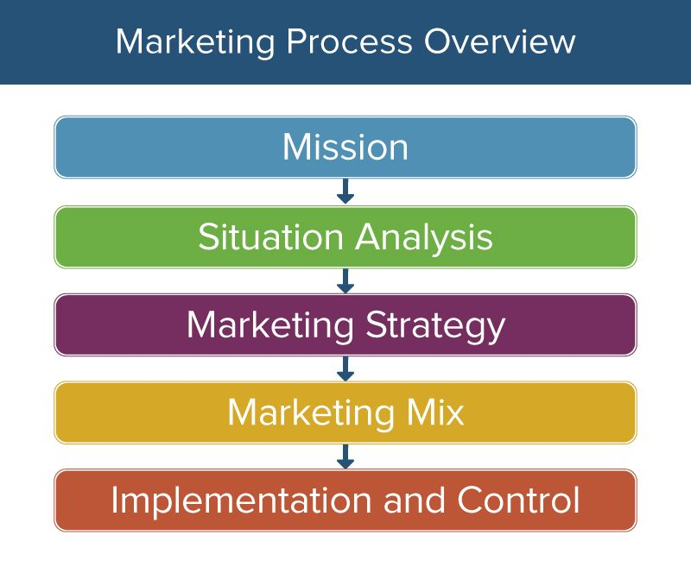
Image Courtesy (Weller, 2017)

Nestles mission is called “Good Food, Good life”. The aim of the mission is to provide to the customer’s products with good quality, taste and healthy nutritional value and wide variety of products suitable for every taste. Nestle is leading company in food and beverage industry and delivers enhanced shareholder value by being favourite and preferred employer, supplier and product producer. (Nestle-esar.com, 2020)
Nestle is developing its marketing tactic and strategy through analysing marketing mix, marketing process suitable about the brand. The company is using tools as Swot analysis, Pestle/Macro environment. When the company collect the information it needs, they have to make a judgement whether that’s the right strategy, or right time to launch a certain product, and if it’s not they must redirect or shift their plan in a favourable for the company direction. (Bhasin, 2019)

Swot Analysis
Swot Analysis has the objective to present the strengths, weaknesses, opportunities and threats of a business. This framework allows to identify and analyse the internal and external factors that influence the business. Moreover, weaknesses should be addressed, not avoided, as they could be converted into opportunities. Threats must be considered as well, as with the right tools and strategy they could be turned into strengths. (Baines, et al., 2017)

SWOT ANALYSIS
Strengths  The strong revenue growth enlarges the organization’s ability to distribute its funds for its potential future growth prospect. The company has reported 1.2% annual growth for 2019. In 2018 the company reported CHF91,439, and in 2019 CHF92,568. The revenue growth was in result of a higher performance by United states, Brazil and Western Europe. (Nestle, 2020)  Global Market Presence decrease the chance of business risk. The organization operates in 187 countries. It’s the largest company in USA, and it’s a company with outstanding position in Europe, Australia and Japan. Nestle sustains prominent geographical presence in emerging and developed markets. (Nestle, 2020) | Weaknesses  Product recalls can negatively influence the company’s brand image. The organization’s subsidiary (Nestle USA) withdrew out of the market its cookie dough products in November 2019 because of rubber contamination. The company have received many complaints from customers, who have found a rubber pieces in some of their cookie dough products.  The recall includes several Cookie dough products, distributes I the United States and Puerto Rico. (Nestle, 2020)
Opportunities  Food allergy therapies investment  In February 2020, Nestle Health Science department have made an investment of $200 million in An Aimmune Therapeutics, biopharmaceutical company. This additional funding will improve the financial position of Aimmune Therapeutics as it prepares to launch PALFORZIATM, the first food and drug allergy treatment approved by the Food and Drug Administration of United States for children and adolescents. (Nestle, 2020)  Focusing on Pet Care Business  Nestle Purina Pet Care acquired Lily’s Kitchen (provider of pet food). The acquisition helps the company to broaden its pet care business by adding the already existing and developed portfolio of products, experience, distribution network and industry trends of Lily’s Kitchen. (Nestle.co.uk, 2020) | Threats  Regulations  The Food and Drug Administration (FDA) and the US Department of Agriculture (USDA) are responsible for overseeing the company, these agencies are responsible for compliancy with provisions. They have done an inspection on the low acid canned food for pets, in a Nestle facility in Pennsylvania (USA). The inspection showed significant deviations from the regulations. Nestle had to pay levying penalty /fines for non-compliance, which may affect company’s operating costs. (Fda.gov, 2015)  Competitors  Nestle appears to have strong competition in the industry, based on product quality, innovation, service, brand awareness, loyalty, product launches, successful advertisement strategies, marketing initiatives and price. Nestle appears to have competition from national, regional and local organizations. The main competitors of the company are famous brands like Kellogg, Danone, Mondelez and others.  While the main competitors started expansion plans to match the growth rate, the market also registered coalition following confluence and acquisitions. DANONE entered into agreement to buy a very big stake in Harrogate Water, a company in UK. In the beginning of 2020, Strauss reached an agreement to buy a majority stake of a producer of bakery products - Give and Go Prepared Foods Corp. (Bhasin, 2018)

Porter 5 forces
Definition
The framework may be used to assess the industry's competitiveness and thus its future profitability. The concept proposes that the competition in an industry is an aggregation of 5 principal competitive forces. They are: new competitors penetrating the market could be a threat, risk of new substitute products entering the market, trading power of buyers and suppliers, and that could affect the strength of competitiveness between the current opponents. As a general rule, the more powerful the competition between organization in the industry, the lower their overall results and the opposite, the lower the rivalry, the better results of the industry players will be. (Jeff, 2008)
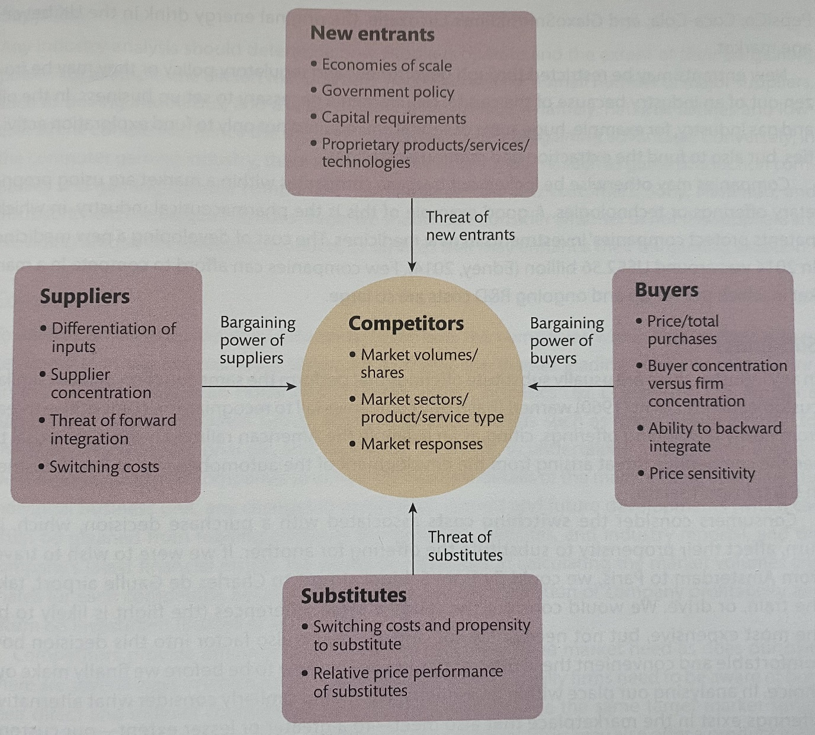
(Baines, et al., 2017)

Competitors
Nestle is very large and successful company in the food&drink industry, but it’s not monopoly, it has rivals. There are companies Nestle share the market with. All these big organizations are trying to be innovative in everything, marketing strategies and specialists, good quality, cost reduction, best price, PR and advertisement. All these factors lead to the conclusion that competitor’s rivalry is high for Nestle. (Bhasin, 2018)
New Entrants
Food industry offers very strong variety of products nowadays. The current leaders in food industry maintain large market shares, the number one leader is Nestle. (Statista.com, 2020) These organizations have created for themselves stable network of distribution and economies of scale that allow them to perform manufacturing process at low costs. (Fdf.org.uk, 2020) Nestle has a major market share in America – 45,7%. Its followed by Europe, Middle East and North Africa with 28,6% each and Asia, Oceania and sub-Saharan Africa with 25,7%. (Statista.com, 2020) Therefore, it could be said that the threat of market being penetrated by new entrant is low.
Suppliers
Nestle produce large variety of products, therefore require dependable suppliers of raw materials and products. Also, the company maintaining the largest market share in the food industry, thus its very attractive for the suppliers. The organization has created a well-maintained network of suppliers. Considering all facts said above we could conclude that Nestle has a Low Bargaining power of suppliers. (Nestle.com, 2020)
Buyers
There is a high rivalry in the industry, Nestle operates, therefore the bargaining power of the consumers is high. There so many similar products on the market, so customers easily can change their preferences from one brand or product to another, based on taste, packaging, price, advertising. The company realize that, so they work hard to satisfy they customer and making more tempting products for the buyers.
Substitutes
The global food market is growing and there are more and more new products on the market and that put Nestle in inconvenient position, as it could encourage the consumer to change their buying habits and preferences. That would put Nestle in high risk of substitution. (Statista.com, 2020) Many companies are producing products, similar to nestles products. For example, Mondelez, Mars, Danone, Hershey’s, Kellogg etc. (Bhasin, 2018) In 2018, the company has been accused in forswearing ethical Marketing codes and exploiting consumers with false healthy claims about their recipes for baby milk. (Neslen, 2018) Now Nestle is trying to work on more healthy foods, for example chocolate with no added sugar. (Gretler, 2019)
Segmentation, Targeting and Positioning
Market segmentation is the division of the customer market into separate and recognisable categories or segments within which people share common characteristics and needs, and show similar responses to market behaviour. (Baines, et al., 2017)
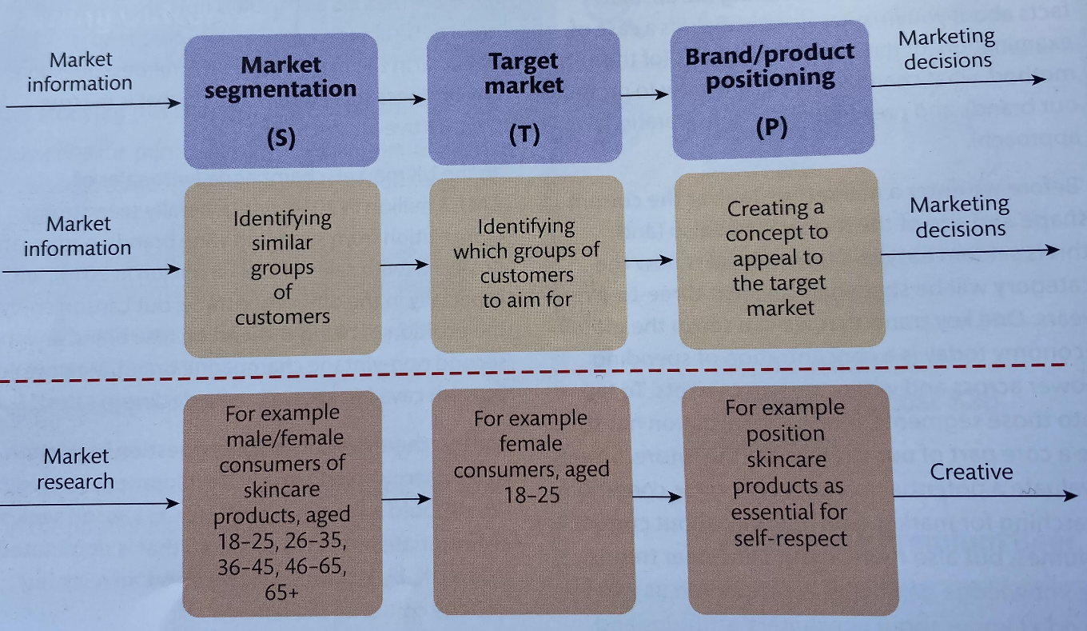
(Baines, et al., 2017)
Nestle divides the market it operates on geographic region. The company divide the areas it operates in 3 geographic zones: Emena (includes Europe, Middle East, North Africa), AMS ( Zones Americas) and AOA(Oceania, Sub-Saharan Africa and Asia). (Nestle.com, 2020)
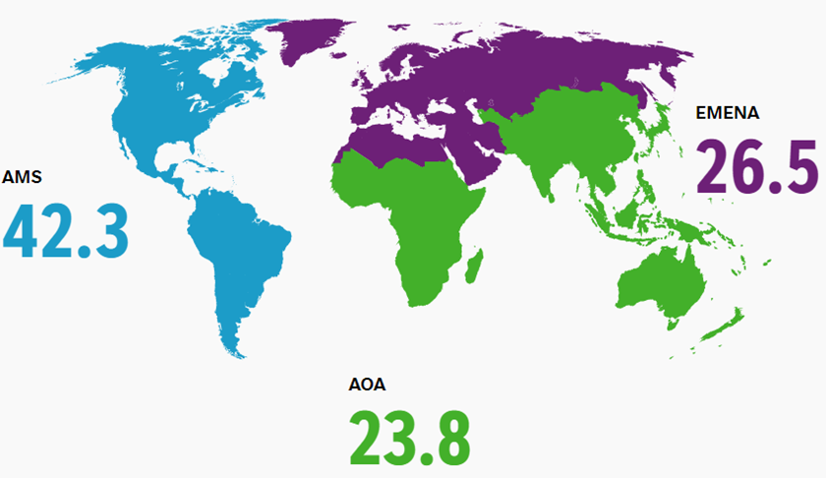

Nestle is using psychographic segmentation as well, as some of the Nestles products are focused on consumer preference or lifestyle – candy bar with chocolate with low sugar chocolate fans, or Maggie noodles and soups for consumers with busy life. (Maggi.co.uk, 2020) Positioning is the process of forming the concept of the business to introduce the products of certain organization. (Baines, et al., 2017)
Nestle has positioned it brand on the market as a producer of high quality products which main goal is to satisfy the consumers of food industry with high quality production.

The elements of Marketing Mix
Evaluating company’s marketing strategy and making sure that the taken actions in the organization are consecutive could be done by determining the elements of marketing mix. (Baines, et al., 2017)
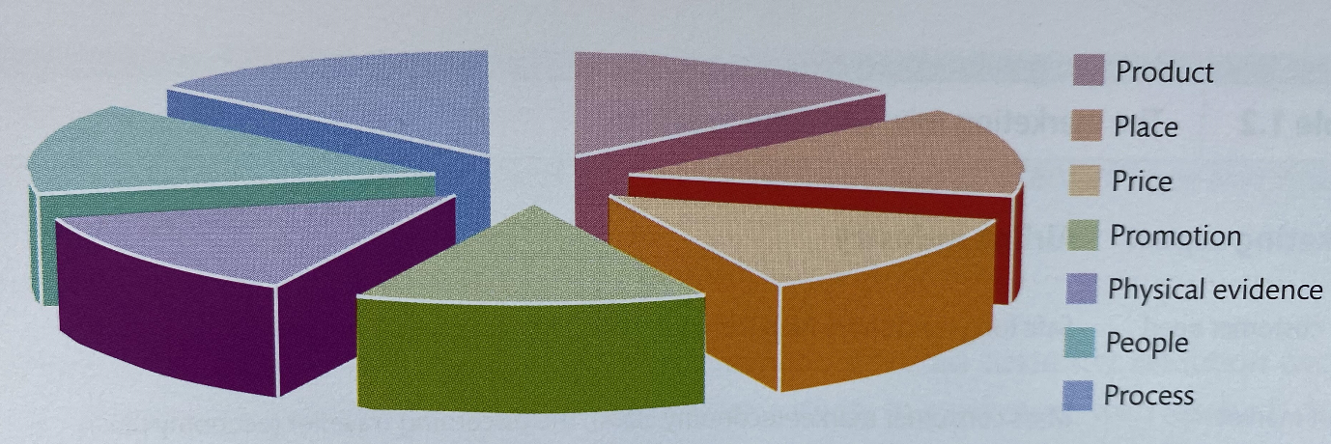 (Baines, et al., 2017)
Product – Nestle has more than 2,000 brands. The company’s portfolio has a product in every food and beverage division. There are products for stage of life – baby milk, snacks and drinks for children and adults, pet food, culinary foods, health care foods etc. (www.Nestle.com, 2020)
It could be concluded that the company is using Range Branding, it uses different brand names for different range of the products, produced by Nestle.
Place – The company is selling its products in 187 countries. (www.Nestle.com, 2020) Nestlé products could be bought almost anywhere, in supermarkets, grocery stores, in smaller local stores , in coffee shops. Also, the company has created an online platform where people can order their favourite products. (www.Nestle.com, 2020)
Price – Nestles has to offer competitive pricing to its products as his rivals do the same. The company offers a variety of prices, some affordable, some premium, and others super premium. Mainly the company is targeting the middle class customer, although produces a product for higher class clients. Nestlé’s pricing strategy also varies by geographic market, packaging market and target market. For some products the price is determine by the market. (Nestle, 2012)
Process - Currently Nestle has 418 factories in 86 countries. The company manufacturing capacity is very strong in all of the company’s business. Otherwise, the expectations of the customers and shareholders could not be covered. (www.Nestle.co.uk, 2020)
Promotion – Nowadays the company accentuate a lot on Digital Marketing. Social media (Facebook, Instagram,) and TV advertisement take big role in Nestlé’s promotion methods and tactics.
Physical evidence – It relate to the logo of the brand. Nestle is using same logo (with slightly changes) for decades, which automatically could be an asset for the company as Nestles logo is easily recognisable from the customers. Also, physical evidence relates to the packaging.
People – Currently the number of Nestles employees is 291,000 and they have essential role for accomplishing Nestles set goals. (Nestle, 2020)

The role of Marketing in creating value for customers.
The marketing concept is the philosophy that organizations have to analyse the needs of the consumers and then make the right judgements to satisfy those needs, better than their rivals. (Center, 2010)
The satisfaction that consumers feel (or expect to feel) by taking a given action in relation to the expense of that action, is called customer value. The given action is usually a buying something, whereas the cost refers to everything that a consumer has to lose to obtain the desired value, such as money, data, time, information. (Baines, et al., 2017)
Nestle is using a different channels of communication with the customers, such as TV and social media. For example, the company is using television advertisement to inform the customers for the advantages of their products. Some of Nestlé’s cereals contains low quantity of sugar and rye flour and their packaging give that information. That inform and encourage people to stick to healthy lifestyle. (Affairs, 2011)
Branding is process involved developing a recognisable name and identity of a product in the minds of customers for an organization, mainly through advertising campaigns with a common theme. Branding aims to create an important and differentiated market presence which attracts and retains loyal customers. (www.Businessdictionary.com, 2020)

The Ansoff Matrix
The Ansoff Matrix is especially useful for strategic planning, as it offers a structure to help executives, senior managers and marketers formulate future growth strategies. The Ansoff Matrix can help a company to develop a plan for product-market growth tactic by accentuates on 4 growth alternatives. (Spencer, 2013)
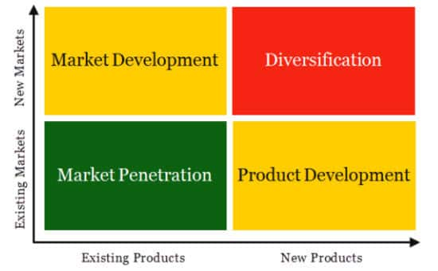 (Spencer, 2013)
To retain on the top of the food industry, the company makes investments in new and modern product and improving the already existing products. Also, nestle invest in enhancing the manufacturing process. The company invested in new online platform, where the customers can see and order some of their products, also to read more about their nutritional value. Another example for investment could be the improved Nestle Lion. Not long time ago the company launched Nestle Lion Protein Bar with low sugar.
Nestle is using different tactics to penetrate the market, to satisfy as many consumer as it can. Once that is achieved, the sales will go even higher the through satisfying the existing market with the existing product. By using their tactic for development, the company manage to target new markets with popularised products everywhere worldwide where they operate.

TASK 1B
Reflection - communication tools for promotion and advertisement
Marketing communications could be described as management processes and activities used to try to interest its wide range of customers. The messages which are great value are being conveyed in order to encourage the audience to respond in both attitudinal and behavioural way. (Baines, et al., 2017)

Shannon and Weaver Model of Communication
This model is designed specifically for the development of effective communication between sender and receiver. They also find factors that affect the communication process named "Noise." To improve the technical communication, the model was developed at first. It is later commonly applied in the Communication field. (www.Communicationtheory.org, 2020)
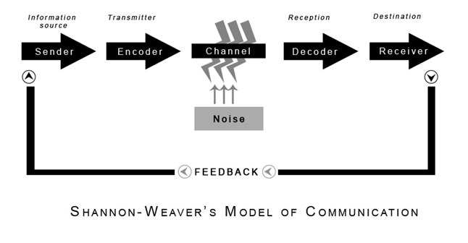 (www.Communicationtheory.org, 2020)
Sender - The originator of the message or the source of the information chooses the message you want
Encoder: The transmitter that translates your message to signals.Messages from the sender translated into signals such as waves or binary data that can be compactly transmitted through cables or satellites. For example: In the telephone the voice is transformed into wave signals and transmitted through cables
Decoder - Signal reception place that translates signals into post. Reverse encoding method
Receiver - Destination of sender's message
Noise - The messages are transferred via channel from encoder to decoder. During this process, messages that are interrupted or influenced by physical noise such as horn sounds, thunder and crowd noise or encoded signals may interrupt in the channel during the transmission process, or the receiver may not receive the correct message. (www.Communicationtheory.org, 2020)

Integrated Marketing Communication
Integrated Marketing Communication is a very useful theory. It is providing information about the relationship between the enterprise and market. Moreover, it ensures that all types of communications are correctly connected. (Multimediamarketing.com, 2020)
Recommendations
Nestle should consider the idea of producing sweets with 0% sugar and more gluten free products. Instead, they can use natural substitute of sugar like a Stevia. Stevia is a plant, from which could be extracted substitute of sugar. The percentage of overweight children is increasing, so for example a tasty chocolate bar with zero sugar would be tempting for many people. Also, people with diabetes could be considered as potential target niche. Also, the number of people who stop consuming animal products and sugar is increasing as well, so Nestle can take advantage of all that.
The Company was involved in several scandals for the last two decades. We can start from mislabelling products, go through the scandal with the baby formula, forced labour in the Thai fishing industry and others. The company website looks great, they are talking about human rights, embracing diversity, focusing on customers’ needs, etcetera. The company should put all that into practice.

Conclusion
Nestle is the leading company in food industry for 2019. The company work in nearly 190 countries. With portfolio of over 2000 brands and history of 150 years the company is keeping their position on the top of the industry they operate in. The company is investing in new branding strategies, new product, factories, marketing and research. It certainly helps Nestle to keep their prepotency the solicitude to the customers.

References
Advantage-marketline-com, 2020. Nestle SA. [Online]
Available at: https://advantage-marketline-com.ezproxy.uwtsd.ac.uk/Company/Profile/nestle-sa?swot
[Accessed 10 May 2020].
Affairs, M. a. C. C. P., 2011. Nestlé Consumer Communication Principles , s.l.: Nestle.
Baines, P., Fill, C., Rosengren, S. & Antonetti, P., 2017. Fundamentals of Marketing. Oxford: Oxford University Press.
Bhasin, H., 2018. Top Nestle Competitors across the world. [Online]
Available at: https://www.marketing91.com/top-nestle-competitors-across-the-world/
[Accessed 10 May 2020].
Bhasin, H., 2018. Top Nestle Competitors across the world. [Online]
Available at: https://www.marketing91.com/top-nestle-competitors-across-the-world/
[Accessed 11 May 2020].
Bhasin, H., 2019. Segmentation, targeting, positioning in the Marketing strategy of Nestle. [Online]
Available at: https://www.marketing91.com/marketing-strategy-nestle/
[Accessed 11 May 2020].
Center, N. M. B. K., 2010. Marketing concept. [Online]
Available at: http://www.netmba.com/marketing/concept/
[Accessed 11 May 2020].
Claessens, M., 2015. THE MARKETING PROCESS – ALL ASPECTS OF MARKETING AT ONE GLANCE. [Online]
Available at: https://marketing-insider.eu/marketing-process/
[Accessed 10 May 2020].
Fda.gov, 2015. Warning Letter. [Online]
Available at: https://www.fda.gov/inspections-compliance-enforcement-and-criminal-investigations/warning-letters/nestle-purina-petcare-01022015
[Accessed 10 May 2020].
Fdf.org.uk, 2020. The Food and Drink Industry, https://www.fdf.org.uk/publicgeneral/FDF-GT-Exec-Summary.pdf: Food and Drink Federation (FDF) .
Gretler, C., 2019. Nestle Creates New Chocolate—With No Added Sugar. [Online]
Available at: https://www.bloomberg.com/news/articles/2019-07-16/nestle-invents-new-way-to-make-chocolate-without-adding-sugar
[Accessed 11 May 2020].
Jeff, C., 2008. Strategic Management. s.l.:Los Angeles, Calif.; London: SAGE.
Maggi.co.uk, 2020. Maggi® 3 Minute Noodles Chicken Flavour. [Online]
Available at: https://www.maggi.co.uk/products/detail/maggi-3-minute-noodles-chicken-flavour-59g
[Accessed 11 May 2020].
Multimediamarketing.com, 2020. Integrated Marketing Communications. [Online]
Available at: https://multimediamarketing.com/marketing-communications/
[Accessed 11 May 2020].
Neslen, A., 2018. Nestlé under fire for marketing claims on baby milk formulas. [Online]
Available at: https://www.theguardian.com/business/2018/feb/01/nestle-under-fire-for-marketing-claims-on-baby-milk-formulas
[Accessed 11 May 2020].
Nestle.co.uk, 2020. Nestlé Purina PetCare acquires natural pet food brand Lily’s Kitchen. [Online]
Available at: https://www.nestle.co.uk/en-gb/media/pressreleases/allpressreleases/nestle-purina-petcare-acquires-natural-pet-food-brand-lilys-kitchen
[Accessed 10 May 2020].
Nestle.com, 2020. Anual Report. Facts and Figures, s.l.: Nestle.
Nestle.com, 2020. Responsible sourcing. [Online]
Available at: https://www.nestle.com/aboutus/suppliers
[Accessed 11 May 2020].
Nestle, 2012. Products and brands, s.l.: Nestle.
Nestle, 2020. Annual Review 2019, Cham and Vevey (Switzerland): Nestle.
Nestle, 2020. Nestlé Health Science further invests in Aimmune Therapeutics. [Online]
Available at: https://www.nestle.com/media/news/nestle-health-science-investment-aimmune-therapeutics
[Accessed 10 May 2020].
Nestle, 2020. Nestlé reports full-year results for 2019. [Online]
Available at: https://www.nestle.com/media/pressreleases/allpressreleases/full-year-results-2019
[Accessed 10 May 2020].
Nestle, 2020. Nestlé USA Announces Voluntary Recall of Ready-to-Bake Refrigerated Cookie Dough Products Due to Potential Presence of Foreign Material. [Online]
Available at: https://www.nestleusa.com/media/pressreleases/allpressreleases/nestle-usa-announces-voluntary-recall-of-nestle-toll-house-and-mms-cookie-dough-products
[Accessed 10 May 2020].
Nestle-esar.com, 2020. Mission & Vission. [Online]
Available at: https://www.nestle-esar.com/aboutus/missionvision
[Accessed 11 May 2020].
Spencer, T., 2013. Product/Market Expansion Matrix. [Online]
Available at: https://www.spencertom.com/2013/10/09/ansoff-matrix/#.U60YwZSSz3Q
[Accessed 11 May 2020].
Statista.com, 2020. Food Worldwide. [Online]
Available at: https://www.statista.com/outlook/40000000/100/food/worldwide
[Accessed 11 May 2020].
Statista.com, 2020. Global sales share of the Nestle Group in 2019, by region. [Online]
Available at: https://www.statista.com/statistics/268894/food-sales-of-the-nestle-group-by-region/
[Accessed 10 May 2020].
Statista.com, 2020. Most valuable food brands worldwide in 2019. [Online]
Available at: https://www.statista.com/statistics/410354/most-valuable-food-brands-worldwide/
[Accessed 10 May 2020].
Weller, J., 2017. The Definitive Guide to Strategic Marketing Planning. [Online]
Available at: https://www.smartsheet.com/strategic-marketing-processes-and-planning
[Accessed 11 May 2020].
www.Businessdictionary.com, 2020. Branding, definition. [Online]
Available at: http://www.businessdictionary.com/definition/branding.html
[Accessed 11 May 2020].
www.Communicationtheory.org, 2020. Communication Theory. [Online]
Available at: https://www.communicationtheory.org/shannon-and-weaver-model-of-communication/
[Accessed 11 May 2020].
www.Nestle.co.uk, 2020. MANUFACTURING & PRODUCTION. [Online]
Available at: https://www.nestle.co.uk/en-gb/careers/career-area/manufacturing-production
[Accessed 11 May 2020].
www.Nestle.com, 2020. How many countries do you sell your products in?. [Online]
Available at: https://www.nestle.com/ask-nestle/our-company/answers/where-in-the-world-do-you-operate
[Accessed 11 May 2020].
www.Nestle.com, 2020. Our Brands. [Online]
Available at: https://www.nestle.com/aboutus/overview/ourbrands
[Accessed 11 May 2020].
www.Nestle.com, 2020. Where can I buy Nestlé products?. [Online]
Available at: https://www.nestle.com/ask-nestle/products-brands/answers/where-can-i-buy-nestle-products
[Accessed 11 May 2020].

