Plant and Asset Engineering
ACMA 6007

Evaluating the Effectiveness of Chosen Maintenance Strategies for Dedicated Equipment.

James Wybron

Introduction.

Maintenance is critical to ensuring the reliability, safety, and operational efficiency of industrial processes, particularly in heavy industries such as nickel production. In such environments, the failure of key assets such as motors, conveyors, and pressure systems can lead to significant financial losses, unplanned production downtime, and increased safety risks. As a result, effective maintenance strategies are essential not only for sustaining production output but also for ensuring compliance with safety and regulatory standards.
This report focuses on the maintenance strategy for a pelletising unit at a nickel production facility. The unit operates under demanding conditions, where continuous operation and equipment reliability are vital. The study evaluates the current maintenance system, including structured turnaround activities and planned interventions, with particular attention to how maintenance tasks are planned, executed, and controlled in an industrial environment.
A critical review of the existing maintenance approach is undertaken, identifying both strengths—such as structured turnaround planning and effective electrical maintenance practices—and limitations, including reliance on traditional time-based and reactive strategies. The report then explores alternative and more advanced maintenance methodologies, including preventive maintenance (PM), predictive maintenance (PdM), and Reliability-Centred Maintenance (RCM), assessing their potential to improve reliability and reduce downtime.
In addition, the report considers the practical and financial implications of implementing these improvements, including resource allocation, system integration (e.g. SAP-based planning), and compliance with statutory regulations such as pressure system inspection requirements. The overall aim is to provide evidence-based and practical recommendations that enhance maintenance effectiveness, optimise resource utilisation, and support long-term operational performance within the plant.

Background to the business and the equipment.

Nickel production is a key component of the global mining and metallurgical industry, with applications in stainless steel production, batteries, and high-performance alloys. The pelletising unit is a crucial part of the process, particularly in laterite ore processing. Its process is protected under technical and intellectual property rights.
The process completed at the Clydach Nickel refinery is the Mond Process. This process was named after its founder. Vale Ltd is a nickel refinery situated in Swansea, South Wales, and was founded in 1902 by a gentleman, Ludwig Mond. Ludwig was a German chemist who discovered the carbonyl extraction process known as the “Mond” process. This process is still used today to produce pellets, powders, and flats with 99.97% purity. (ltd, 2022)



The materials are made and shipped worldwide to customers who produce products ranging from kitchen sinks to car batteries. (ltd, 2022).

The pelletising unit typically consists of several key components, including vessels, elevators, and process medium storage. Both mechanical containment, electrical, and instrumentation controls control these. There are also key individual components within these disciplines, such as solenoids, pressure transmitters, flow transmitters, gearboxes, chain elevators, actuators, and motors.
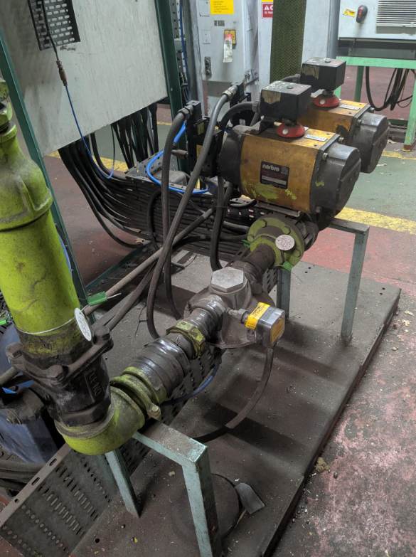

The reliability of the pelletising unit is critical, as any disruption can halt upstream and downstream operations. Failures in motors, gearboxes, bearings, or conveyor systems can lead to unplanned downtime, production losses, and increased operational costs. Therefore, an effective maintenance strategy is essential to ensure consistent production and equipment longevity.
However, critical controls are in place for many of these terms, such as thermocouples and pressure and flow transmitters. They will have set tolerance values that trigger both an alarm and a trip to the IA control. These are part of the integrated safety system that prevents catastrophic failure of the unit during its day-to-day operation.

Critical review of current maintenance systems.
At the time of initiating this report, a planned periodic maintenance turnaround system was in place. “Turnaround” is the term used within the plant to describe a scheduled unit overhaul during which Mechanical, Electrical, and Instrumentation (MEI) maintenance activities are carried out in a structured and coordinated manner. Overall, the turnaround system is well organised, particularly from an electrical maintenance perspective, where documentation, task allocation, and execution standards are strong.
A key strength of the current system is the use of structured turnaround sheets, which clearly define maintenance activities. The turnaround is broken down into Day 1, Day 2, Day 3, and Day 4 sections, allowing work to be sequenced logically and aligned with plant availability and operational constraints. This phased approach ensures that critical electrical tasks—such as motor inspections, cable checks, control panel servicing, and pressure flow transmitter calibrations — are completed in a controlled and traceable manner. In addition, the presence of separate turnaround sheets, including dedicated damper sheets, demonstrates a high level of task segregation and specialisation. This improves accountability, reduces the likelihood of missed tasks, and enhances maintenance traceability.
From an electrical engineering standpoint, this structured documentation system is highly effective. It enables technicians to follow predefined procedures, ensures compliance with safety standards, and supports efficient fault identification during shutdown periods. The clarity and organisation of the turnaround sheets align with best practices in maintenance planning, where standardisation and documentation are critical for reliability and repeatability (Salawu, 2023; Molęda, 2023).
However, while the turnaround system is operationally strong, it still reflects a largely traditional maintenance strategy that combines elements of reactive and preventive maintenance.
In many industrial environments, including pelletising plants, maintenance strategies rely on a combination of reactive maintenance and preventive maintenance (PM). Reactive maintenance, often referred to as “run-to-failure,” involves repairing equipment only after a breakdown occurs. While this approach may reduce short-term maintenance costs, it significantly increases the likelihood of unplanned downtime, safety risks, and production losses (Molęda, 2023; Salawu, 2023).
Preventive maintenance, which is also evident within the current turnaround system, involves scheduled inspections and servicing at predefined intervals. Although this reduces the risk of sudden failures, it is typically based on time-based scheduling rather than actual equipment condition. As a result, it can lead to inefficiencies such as over-maintenance, unnecessary component replacement, or failure to detect emerging faults between inspection intervals (IntechOpen, 2022; Sulistyowati, 2024). All of which has a cost.
Organisational constraints, including limited budgets, a lack of condition-monitoring technologies, and gaps in technical expertise often influence the reliance on these traditional strategies. In addition, legacy systems such as paper-based turnaround sheets and fixed schedules can discourage the adoption of more advanced, data-driven maintenance approaches (Karim, 2025). While the current turnaround sheets are well-structured, they are primarily static and do not incorporate real-time feedback or predictive insights.
Despite its strengths in organisation and execution, the current system has several limitations. The absence of real-time condition monitoring (e.g., vibration analysis, thermal imaging, or IoT-based sensors) restricts the ability to detect early-stage faults in critical electrical components such as motors, drives, and gearboxes. This increases the risk of unexpected failures occurring between turnaround periods. Furthermore, reliance on scheduled maintenance windows can mean that emerging issues are not addressed promptly, particularly if they fall outside the planned Day 1–4 maintenance cycle.
Research shows that reactive and time-based preventive strategies are less effective than proactive approaches, such as predictive maintenance (PdM), which uses real-time data to anticipate failures (Benhanifia, 2025). Compared to traditional methods, PdM can significantly reduce downtime, improve equipment reliability, and optimise maintenance costs. The current system, while robust in structure, does not yet fully leverage these advanced methodologies.
In summary, the existing turnaround maintenance system demonstrates strong organisational practice, particularly through the use of day-based scheduling and specialised maintenance sheets, which enhance the efficiency and accountability of electrical maintenance. However, it remains limited by its reliance on traditional maintenance strategies. To achieve higher reliability and performance, the system would benefit from integrating condition-based and predictive maintenance technologies with the existing well-structured turnaround framework.

Evaluation of Improved Maintenance Strategies.

To address the limitations identified in the existing maintenance system, a more advanced, structured approach was implemented, integrating elements of predictive maintenance (PdM), Reliability-Centred Maintenance (RCM), and improved planning into the SAP maintenance framework.
A key improvement was the transition from a day-based turnaround structure (Day 1–4) to a task-based execution model. Previously, maintenance activities were grouped broadly by day, which created ambiguity in task ownership, inconsistent progress tracking, and opportunities for inefficiencies such as duplicated effort or incomplete work. It also allowed individuals to choose easier or preferred tasks rather than following the flow of work. To overcome this, dedicated tasks were created and aligned directly against individual work orders within SAP. This also meant that similar activities in areas requiring breathing apparatus and specialised personalised protective equipment were done in chronological order.
Each turnaround activity was broken down into specific, clearly defined operations, with detailed operational text written within the SAP work order. These operational descriptions outlined the exact scope of work, required tools, safety requirements, and execution steps. In addition, new turnaround sheets were developed to mirror these SAP operations, ensuring consistency between documentation and execution on the plant floor. Subsequent feedback from the team leaders was positive, with clear insight and understanding of specific tasks.
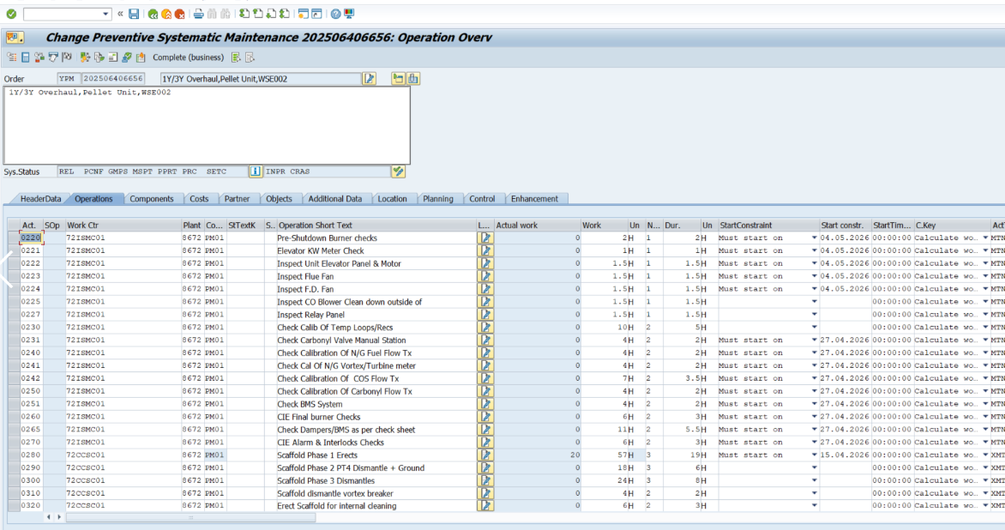

A major enhancement to the planning process involved integrating materials into a structured Bill of Materials (BOM). Previously, materials were often added manually by planners, which increased the risk of omissions, delays, and inefficiencies. By embedding all required components—such as gaskets, seals, fasteners, and instrumentation parts—directly into the BOM, materials were automatically linked to each task. This ensured that all necessary resources were available prior to execution, significantly reducing downtime caused by missing parts and improving overall maintenance efficiency.
The introduction of task-level accountability also enabled maintenance activities to be booked against specific permits, improving safety compliance and traceability. This was particularly important for high-risk activities, such as working in confined spaces or handling hazardous systems, where permits must be tightly controlled. By aligning each task with a permit, it became clear who was responsible for each activity, when it started, and when it was completed.
This structured approach eliminated previous inefficiencies where technicians were unsure where to begin or end their work. The clear allocation of tasks ensured that no work was missed, duplicated, or left incomplete. Furthermore, it prevented the issue of “cherry-picking” tasks, in which individuals would select easier jobs rather than completing critical or complex ones. Instead, tasks were executed in a strict chronological sequence, ensuring that all maintenance activities followed a logical and optimised workflow.
An additional operational improvement was the coordination of interdependent tasks, particularly those involving specialised equipment or safety requirements. For example, activities requiring breathing apparatus and transmitter work were scheduled for the same day. This minimised the need for repeated setup and dismantling of safety equipment, reducing delays caused by stop-start working patterns over multiple days. As a result, overall turnaround time was reduced, and resource utilisation was significantly improved.
From a theoretical perspective, these improvements align closely with predictive maintenance (PdM) principles, which aim to optimise maintenance scheduling based on equipment condition and operational requirements. PdM has been shown to significantly improve equipment reliability and reduce downtime by leveraging real-time data and advanced analytics (Taoufyq, 2025; Singgih, 2024). While the implemented system does not fully rely on real-time condition monitoring, it establishes the structured foundation required for future PdM integration.
It is important to note that certain equipment remains subject to statutory maintenance requirements, particularly under the Pressure Systems Safety Regulations 2000 (PSSR). These regulations require periodic inspections, including non-destructive testing (NDT), thickness measurements, and pressure vessel testing, to be conducted at specified intervals. These requirements are documented within the company’s Written Scheme of Examination (WSE) and must be agreed with insurers to ensure legal compliance. As such, while predictive and condition-based approaches can optimise maintenance, they must operate alongside these mandatory inspection regimes.
Modern predictive maintenance systems utilise technologies such as vibration analysis, thermal imaging, and machine learning algorithms to enable early fault detection and prognosis (Ulansky, 2025). In parallel, Reliability-Centred Maintenance (RCM) provides a structured methodology for determining the most appropriate maintenance strategy based on asset criticality and failure modes. RCM focuses on maintaining system functionality and prioritising resources where they deliver the greatest operational value (Ariaratnam et al., 2022; Bhatti, 2025). Studies have shown that RCM can significantly reduce downtime and improve overall system reliability (ResearchGate, 2024).
Furthermore, Total Productive Maintenance (TPM) supports these approaches by encouraging operator involvement in routine maintenance and fostering a culture of continuous improvement. TPM has been widely linked to increased equipment availability and enhanced operational performance, particularly when integrated with lean manufacturing principles (Shamim, 2025).
In practice, the implemented system represents a hybrid maintenance approach that combines structured planning, improved resource management, and elements of proactive maintenance. Research indicates that integrating data-driven, physics-based, and knowledge-based maintenance models provides superior outcomes compared to relying on a single strategy (Taoufyq, 2025). The transition from day-based scheduling to task-based execution within SAP demonstrates a significant step towards this integrated and optimised maintenance framework.

Cost and Resource Considerations
The implementation of advanced maintenance strategies requires a significant initial investment, particularly in condition-monitoring technologies, digital infrastructure, and data-analysis systems. However, these costs must be evaluated against the long-term operational benefits, including improved reliability, reduced downtime, enhanced safety, and more efficient resource utilisation. In modern industrial environments, there is increasing emphasis on digitalisation and data-driven maintenance approaches, which provide greater control, visibility, and optimisation of maintenance activities.
A key opportunity for modernisation lies in the digital identification and tracking of plant assets. Technologies such as QR codes and RFID (Radio Frequency Identification) tags can be applied directly to equipment, enabling maintenance personnel to access asset-specific information using handheld devices or tablets instantly. By scanning a QR code or RFID tag, technicians can retrieve maintenance history, work instructions, risk assessments, permits, and real-time status updates. This removes reliance on paper-based systems, reduces human error, and improves the overall efficiency and accuracy of maintenance operations. In addition, these systems can be integrated with platforms such as SAP, allowing real-time updates to work orders, automatic feedback on task completion, and enhanced traceability across the organisation.
At a more advanced level, IoT-enabled sensors can be installed on critical assets to continuously monitor parameters such as vibration, temperature, and pressure. These sensors provide real-time data that can be analysed with machine learning algorithms to detect early signs of failure. Predictive maintenance systems supported by these technologies have been shown to reduce maintenance costs while improving operational efficiency (Vijaya Bharati et al., 2025). Furthermore, proactive maintenance strategies can reduce downtime by up to 70% and maintenance costs by approximately 25% (Jardine et al., 2006; Benhanifia, 2025). This demonstrates the significant value of transitioning from traditional reactive and time-based approaches to more advanced predictive systems.
From a cost perspective, the implementation of these technologies can be approached in a phased and scalable manner. At a conservative level, low-cost solutions such as QR code tagging, digital turnaround sheets, and improved integration with SAP can deliver immediate benefits with minimal investment. These solutions enhance traceability, improve task management, and reduce inefficiencies without requiring significant changes to existing infrastructure. At an intermediate level, RFID tagging and mobile maintenance applications can be introduced, alongside digital permit-to-work systems and basic condition-monitoring tools, such as handheld vibration and thermal imaging devices. These improvements increase asset visibility, reduce administrative workload, and enhance safety compliance.
At a more advanced level, higher investment in fixed IoT sensors, centralised data platforms, and predictive maintenance software enables continuous condition monitoring and data-driven decision-making. This allows maintenance activities to be scheduled based on actual equipment condition rather than fixed intervals, significantly improving reliability and reducing unplanned downtime. At the highest level, often referred to as Industry 4.0, organisations can implement fully integrated systems including digital twins, artificial intelligence-driven maintenance strategies, augmented reality support for technicians, and autonomous inspection technologies such as drones and robotics. These systems represent the most advanced form of maintenance management, delivering near-zero unplanned downtime and maximum operational efficiency.
Despite the clear advantages, successful implementation depends on organisational readiness. Resistance to change, lack of technical expertise, and cultural barriers can limit the effectiveness of new technologies. Therefore, change management is essential to ensure successful adoption. A phased implementation strategy is recommended, allowing the organisation to gradually introduce new technologies, build technical capability, and demonstrate early benefits. Staff training and stakeholder engagement are also critical, ensuring that maintenance personnel can effectively utilise new systems and processes. Research highlights that structured implementation and strong organisational support significantly improve the success of digital transformation initiatives (Nature, 2023).
In conclusion, while advanced maintenance technologies require an initial investment, the long-term benefits in reliability, cost reduction, and operational efficiency are substantial. The integration of QR codes, RFID systems, IoT sensors, and predictive analytics provides a clear pathway towards a modern, data-driven maintenance strategy. By adopting a phased approach and aligning technological improvements with organisational capabilities, it is possible to transition from traditional maintenance practices to a highly efficient, optimised system that supports long-term performance and competitiveness.

Conclusion

In conclusion, this report has critically evaluated the current maintenance system for the pelletising unit in a nickel production environment. The existing approach demonstrates several strengths, particularly in the structured execution of turnaround activities and the effective use of electrical maintenance documentation. The use of clearly defined turnaround sheets, including day-based planning and specialised documentation such as damper sheets, provides a strong foundation for maintenance control, accountability, and safety compliance.
However, the review has also identified key limitations associated with the reliance on traditional maintenance strategies, including reactive and time-based preventive approaches. While these methods are simple to implement, they cannot respond dynamically to equipment condition, resulting in inefficiencies such as unplanned downtime, over-maintenance, and missed failure modes. The absence of real-time condition monitoring and limited integration of digital technologies further restricts the effectiveness of the current system.
To address these challenges, the report has proposed a transition towards a more advanced and integrated maintenance strategy. The introduction of task-based planning within SAP, combined with structured Bills of Materials (BOMs), improved permit control, and clearly defined operational tasks, significantly enhances maintenance execution, traceability, and efficiency. In addition, the adoption of modern technologies such as QR codes, RFID tagging, and IoT-based condition monitoring provides a pathway towards predictive maintenance, enabling earlier fault detection and more effective resource utilisation.
The integration of maintenance frameworks such as Predictive Maintenance (PdM), Reliability-Centred Maintenance (RCM), and Total Productive Maintenance (TPM) further strengthens the proposed approach by aligning maintenance activities with equipment criticality, operational requirements, and continuous improvement principles. Importantly, these improvements must be implemented alongside statutory requirements to ensure compliance with regulations such as pressure system inspection standards.
While implementing these advanced strategies requires initial investment and organisational change, the long-term benefits are significant. Improved reliability, reduced downtime, enhanced safety, and optimised maintenance costs all contribute to increased operational performance and competitiveness. A phased implementation approach, supported by training and effective change management, is essential to ensure successful adoption.
Overall, the transition from a traditional, schedule-based maintenance system to a modern, data-driven and integrated approach represents a critical step in improving the efficiency and sustainability of maintenance operations within the plant. By combining strong existing practices with advanced technologies and methodologies, the organisation can achieve a highly effective maintenance system that supports long-term industrial performance.

References.

Benhanifia, A. (2025). ‘Systematic review of predictive maintenance practices’, Mechanical Systems and Signal Processing.
Bhatti, M.A. (2025) ‘Reliability-centred maintenance strategies in mechanical systems’, RME Journal.
Gomaa, A.H. (2025) ‘Advancing total productive maintenance in smart manufacturing’, Scientific Publishing.
IntechOpen (2022) ‘Maintenance types and strategies’.
Jardine, A.K.S., Lin, D. and Banjevic, D. (2006) ‘Machinery diagnostics and prognostics’, Mechanical Systems and Signal Processing.
Karim, M.R. (2025) ‘Optimising maintenance strategies in smart manufacturing’, Review of Applied Science and Technology.
Molęda, M. (2023) ‘From corrective to predictive maintenance’, PMC Journal.
Salawu, E.Y. (2023) ‘Impact of maintenance on machine reliability’, E3S Conferences.
Shamim, M.M.R. (2025) ‘Lean and TPM integration’, AJIS Research.
Singgih, M.L. (2024) ‘Machine learning for predictive maintenance’, ITS Journal.
Sulistyowati, E. (2024) ‘Effectiveness of predictive maintenance’, AJCD Journal.
Taoufyq, H. (2025) ‘Predictive maintenance approaches’, Journal of Industrial Engineering and Management.
Ulansky, V. (2025) ‘Predictive maintenance models’, ScienceDirect.
Vijaya Bharati, P. et al. (2025) ‘IoT and predictive maintenance’, ArXiv.
Zhou, X. (2007) ‘Reliability-centred predictive maintenance’, Reliability Engineering Journal.
Swanson, L. (2001) ‘Linking maintenance strategies to performance’, International Journal of Production Economics.
Wireman, T. (2014) Total Productive Maintenance. Industrial Press.
Smith, A.M. and Hinchcliffe, G.R. (2004) RCM – Gateway to World Class Maintenance. Elsevier.
Muchiri, P. and Pintelon, L. (2008) ‘OEE and maintenance performance’, International Journal of Production Research.
Ariaratnam, S.T. et al. (2022) ‘RCM literature review’, Maintenance Journal.
Ani, C.S. et al. (2025) ‘Feature engineering in predictive maintenance’, Journal of Data Science.



