Researching and Analysing Data
Module Code: EMPL4012
MODULE CO-ORDINATOR: Dr Sheraz Alam Malik
Student Name: Mohammad Shuna Miah
Student ID: 1605672

Table of Contents
Introduction 3
Articulating a Question 3
Collecting Information 3
Interrogating the Data 6
Conclusion 10
Appendices 10
References 11

Figure 1: Top 10 Telecommute Career Industries (Source: VirtualVocations.com) 4
Figure 2: Trend in Telecommuting in the USA and the UK (source: zdnet.com) 5
Figure 3: Participation of Different Industry in Telecommuting (source: author) 8

Introduction
Analytical skill is a must needed skill in today’s world for being successful in doing business or getting a job. Analytical skill includes the collection of information by researching properly and analysis of the collected data for drawing any conclusion (Trilling and Fadel, 2009). There are many sources available to collect data and many methods and techniques to analyse the data. Working from home is a concept of a modern world in which a person can work in a firm without presenting in the office all the time. The technology helps the employees to connect with the customers and company directly and the employees can work in a flexible environment. The assignment is all about running a research on the effectiveness of working from home and drawing a conclusion by analysing the collected data.

Articulating a Question
Article 2 under the topic working from home has been chosen to articulate the question on which the research will be run. The article deals with the effectiveness of working from and it indicates that the future will experience the working from home as an effective technique for increasing productivity and performance (McGregor, 2017). Now the question is:
Whether working from home will really be more effective in near future or not?
The report will be completed by doing research on the question and analysing the information to reach the conclusion of giving an opinion.

Collecting Information
There is a wide range of techniques which are used for collecting two types data. The questionnaire, personal interview, online interview, telephone interview, gumshoe research, hypothesis testing etc. are the techniques for collecting primary or authentic data (Sullivan-Bolyai and Singh, 2014). For collecting previously collected or secondary data, people use internet, research paper, article, books, annual report, newspaper, library, cases etc. (Sullivan-Bolyai and Singh, 2014). The research will be completed by collecting both secondary and primary information.
For collecting primary information, we have prepared a questionnaire that is presented in the appendix part. The questionnaire contains 15questions about the working from home and we have run a survey of 100 employers who have both regular office employees and working from home or remote employees.
For collecting secondary data, we have used books, internet, journal, and articles mainly. With the advancement of technology, it is now possible to work from outside of the office. With the personal computer, smartphone, and internet connection, the employee can connect with the firm and customers immediately. Both full-time workers and part-timers have the opportunity to work from home in different companies and business firms. Approximately 91% of the companies of Britain have at least one employee who works from home and 19% company have 50% workers who work from home (Remote.co, 2017). The current tradition of outsourcing also inspires the employers to offer a job with great flexibility.
Business like engineering, marketing, information technology, technical service, online service provider, education and training, mobile apps, healthcare etc. offer working from home facility (Virtual Vocations, 2017). Mainly employees like a legal advisor, software engineer, financial analysts, customer supports, trainer, marketing specialists etc. get the opportunity to work outside the office for at least some days or hours in a week.
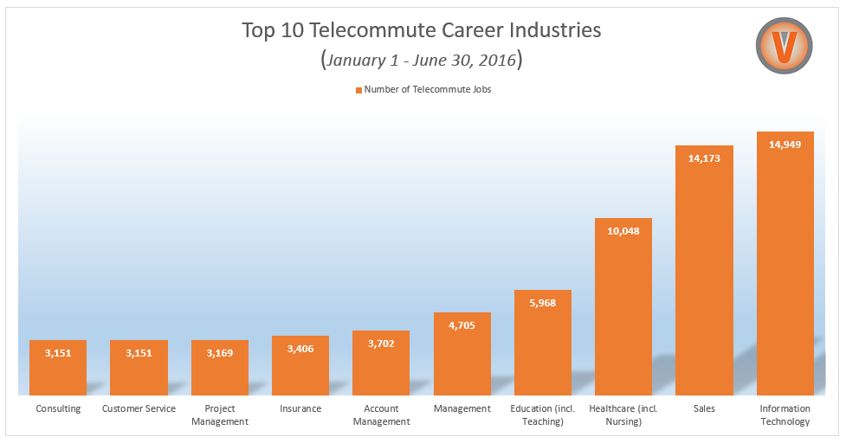
Figure 1: Top 10 Telecommute Career Industries (Source: VirtualVocations.com)
According to a research, the number of people working from home is increasing at a very high rate. For last 5 years, the percentage of people working from home has increased by around 40% or 1.5million people in which 912,000 are men and 609,000 are women (Ellis, 2017). In 2016, the total number of people working from home was around 4.1 million people (Guides, 2017).
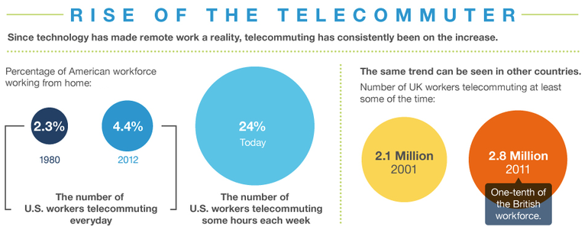
Figure 2: Trend in Telecommuting in the USA and the UK (source: zdnet.com)
The number of women working from home has increased by 35% more than 2005 (Guides, 2017). The participation of women is increasing at a very high rate. A study reveals that main reason behind joining working from home workforce is to balance the work life (Felstead and Walters, 2015). Working from home gives them more flexibility to work for a firm as well as for the family.
A research by TUC says that working from home helps the old people and disable people by giving flexibility to their life. About 160,000 disabled people and 414,000 people with age more than fifty years are working currently from home (Ellis, 2017). The TUC also shows that one out of 5 people with age 55+ work from their home (Hess, 2017).
A research by the government is saying that there is a huge demand in the market but the employers are not fulfilling the demand. Other 4million workers want to work from home at least for some days in a week but the employers are not giving them the opportunity (BBC News, 2017). They think the working from home will increase their performance by providing flexibility in their work.
The number of employers who offer to work from home is increasing according to CBI. Among the respondents around 60% want to give the opportunity to the employees for working from home for some hours or days in a week (BBC News, 2017). They think that this method will increase the efficiency and productivity of the employees.
A study from the University of Texas shows that people work more and spend more hours in working from home rather than the typical regular office working hours (Guides, 2017). The full-time employees want the opportunity to work from home more than the part-timers.
Mainly employees who have dependent people on them search for this kind of job which gives them the flexibility to balance their life (Harpaz, 2012). Women, old people, disabled people also want to work from home. Another research shows that 59% of the millennial workers want to work from home (Remote.co, 2017). So, the young generation also wants the flexibility and independence at their work.
Now it’s time to see the impact on the performance of the employees who work from home. A recent study shows that 86% of the respondents believe that working from home will increase the productivity (Remote.co, 2017). 66.7% of the managers who were interviewed during this research told that employees who work outside the office are the main reason to increase their overall productivity (Remote.co, 2017). The remote employees are more satisfied, less expensive, loyal, and have a high organizational commitment which leads them to work more to hit maximum productivity (Bloom and Ying, 2014). 82% of the remote workers under the study said that working from home has lessened their stress level and increased their efficiency (Felstead and Walters, 2015). 68% millennials under the study told that they need flexibility in their work and should have the opportunity to work outside the office for some days in a week (Remote.co, 2017).
A study of Stamford University shows that 60% of the employers believe that this technique is able to decrease the employee turnover and increase employee engagement (Guides, 2017). Working from home also reduces the overhead cost and real estate cost of their business.

Interrogating the Data
From the survey on 100 employers in the UK, it is found that 36% of the employers run medium-size business firms, 46% of the employers run small size business firms and 18% of them run big size business firms. 36 of the small business firms have employees who work from home. 19 of the medium size business firms have employees who work from home and only 5 big size firms have employees who work from home for some days or hours in a week. So there are 60 firms among the 100 firms which have employees who work from home. So, 60% of the employers have employees who work from home.
Although 71 employers out of 100 like working from home, 11 of them can’t exercise the technique because of their business model. So, 71% of the employers like working from home.
The industries in which the employers are running their business are given below:
Industry | Number of Business Firms
Information Technology | 32
Marketing | 27
Training and Education | 13
Technical Service | 9
Retailer | 7
Transportation Service | 3
Online Products sellers | 9

The number of firms in different industries which have employees who work outside the office are given below:
Industry | Number of business firms who have remote employees | Percentage of firms among the total firms
Information Technology | 18 | 56.25%
Marketing | 21 | 77.7%
Training and Education | 9 | 69.2%
Technical Service | 3 | 33.3%
Retailer | 2 | 28.5%
Transportation Service | 3 | 100%
Online Products sellers | 4 | 44.4%

The average number of firms that have the working from home opportunity is 8.57 but there is a high dispersion of the data as the standard deviation is 7.267484 which close to the mean. The calculation of the mean and standard deviation in the spreadsheet is given in the Appendix part.
The participation of the industry in giving the opportunity to work from home can be represented by a chart.

Figure 3: Participation of Different Industry in Telecommuting (source: author)
From the chart, we can see that the participation of marketing, training and education, transportation service and information technology-based firms are very high in offering an opportunity for working from home by the employees.
The main reason the 60 employers offers the working from home technique are given below:
Number of employers | Percentage of total | Reasons
28 | 28% | Increase Productivity
45 | 45% | Cost Reduction
13 | 13% | Increase Efficiency
9 | 9% | Increase organizational commitment
15 | 15% | Reduce turnover and absenteeism

So the main reasons for the employers for offering to work from home opportunity are to reduce cost and increase productivity.
44% of the other employers who don’t like the working from home said that they don’t want to lose control over the activities of the employees. 29% said that they want the employees to work side by side physically in a team. 18% said that this approach may compromise the quality for giving benefit to the employers and approximately 70% of the employers said that they don’t have trust on the employees (Bloom and Ying, 2014).

According to the 60 employers, the percentage of the workforce who work from home is given below:
Number of Firms | Percentage of Remote Workforce
18 | 10%
23 | 30%
0 | More than 50%
3 | 50%
12 | 20%
4 | 40%
So, the average percentage of employees who work from home for some days or hours in a week is 30%.
According to the employers, the communication channel to connect with the employees are given below:
Number of employers | Percentage of total | Communication Tools
51 | 51% | Skype
47 | 47% | Slack
16 | 16% | Hangouts
24 | 24% | WhatsApp
14 | 14% | Google Drive
15 | 15% | Facebook
41 | 41% | E-mail
So the most popular communication tools to communicate with the employees who work from home are Skype, Slack, and E-mail.
According to the employers, the employees want the working from home opportunity for following reasons:
Number of employers | Percentage of total | Advantages
49 | 49% | Flexibility
28 | 28% | Freedom
19 | 19% | Family Responsibilities
11 | 11% | Productivity
6 | 6% | Saving Time
18 | 18% | Less pressure
So, flexibility and freedom are the main reasons behind working from home.
The 32% of the employers said that the disadvantage of working from home is loneliness (Harpaz, 2012). 18% said that there is a timing problem for the employees to interact with the firms as well as customers and 10% said that the disadvantage is lack of idea generation (Harpaz, 2012).

Conclusion
From the survey, it is clear that 60% of the respondents think that working from home increases the overall performance of the company by increasing productivity and reducing cost. Both the primary data and secondary data give the same type of indication. The employers in the UK are finding more interest in providing working from home opportunity. The communication software company is solving the major problems in the system day by day by updating their services. The young employees love to work in the flexible environment and it will increase their performance more than the typical office performance (Felstead and Walters, 2015). So it can be concluded that the working from home will be effective in near future.

Appendices
Appendix 1
- In which industry you run your business?
- What is the size of your business?
- Do you like working from home?
- If yes, then why?
- If not, then why?
- Do your business offer work outside the office opportunity?
- If yes, then what is the main reason?
- What is the percentage of remote employees?
- What is the communication channel you use to connect with them?
- What are the advantages of remote work to the employees?
- What are the disadvantages that the employees face by working from home?
- Does your overall performance of the company increase due to the remote employees?

Appendix 2

References
BBC News. (2017). The myth of working from home. [online] Available at: http://www.bbc.com/news/magazine-21588760 [Accessed 2 Dec. 2017].
Bloom, N., and Ying, Z.J., 2014. Does working from home work? Evidence from a Chinese experiment. The Quarterly Journal of Economics, 130(1), pp.165-218.
Ellis, M. (2017). Working from home soars with 1.5million people shunning the office. [online] mirror. Available at: http://www.mirror.co.uk/news/uk-news/working-home-soars-15million-people-8008210 [Accessed 2 Dec. 2017].
Felstead, A., and Walters, S., 2015. A Statistical Portrait of Working at Home in the UK: Evidence from the Labour Force Survey. Working Paper.
Guides, H. (2017). 7 Remote Work Trends to take into consideration in 2017 | Remoters. [online] Remoters. Available at: https://remoters.net/remote-work-trends-2017 [Accessed 2 Dec. 2017].
Harpaz, I., 2012. Advantages and disadvantages of telecommuting for the individual, organization and society. Work Study, 51(2), pp.74-80.
Hess, K. (2017). Death of the office and rise of the telecommuter | ZDNet. [online] ZDNet. Available at: http://www.zdnet.com/article/death-of-the-office-and-rise-of-the-telecommuter/ [Accessed 2 Dec. 2017].
McGregor, H. (2017). Heather McGregor: 'Working from home is the future'. [online] the Guardian. Available at: https://www.theguardian.com/money/2013/mar/02/working-from-home-heather-mcgregor [Accessed 2 Dec. 2017].
Remote.co. (2017). 10 Stats About Remote Work - Remote.co. [online] Available at: https://remote.co/10-stats-about-remote-work/ [Accessed 2 Dec. 2017].
Sullivan-Bolyai, S., and Singh, M.D., 2014. Data-collection methods. Nursing Research in Canada-E-Book: Methods, Critical Appraisal, and Utilization, p.287.
Trilling, B. and Fadel, C., 2009. 21st century skills: Learning for life in our times. John Wiley & Sons.
Virtual Vocations. (2017). Virtual Vocations 2016 Telecommuting Top 10 Mid-Year Report. [online] Available at: https://www.virtualvocations.com/blog/telecommuting-news/virtual-vocations-2016-telecommuting-top-10-mid-year-report/ [Accessed 2 Dec. 2017].

