

STRATEGIC MANAGEMENT AND SUSTAINABILITY

Lecturer: Tanja Nathan
Student name: Monika Ivanova
Student number: 1817321

Table of Contents
Introduction 3
1) Evaluation of the UK's current scenario and the global Haulage industry 3
2) Evaluation of the competitive environmental position of British petroleum 10
Conclusion 14
References 15
Appendices 18

Introduction
Strategic analysis is basically a process that is useful for analyzing the environmental position of a firm. The importance of the report is to explore the current environmental situation of British Petroleum. This report has the purpose of presenting the external environmental scenario from the UK. Moreover, the evaluation has been made based on the UK position and also from the data on global Haulage. The framework has been used for making the evidence for the competitive position of BP. This evaluation has mainly expressed the strategic position of the organization.

1) Evaluation of the UK's current scenario and the global Haulage industry
The shortage in the supply of fuel has been observed in the country of the UK. Blocking the climate protest has deported the current consumption of fuel in the market. Most of the drivers are facing issues in the problem area of the supply of fuel. An increase in the price value of diesel and petrol has severely impacted the haulage industry. In contrast with the opinion of Kaewunruen et al. (2021), road transport in the UK has mainly been affected for different kinds of reasons. The fuel consumption in the road transport has majorly affected as they are dependent on petrol or diesel. 98% of the needs have been explored a needs of petrol and diesel.
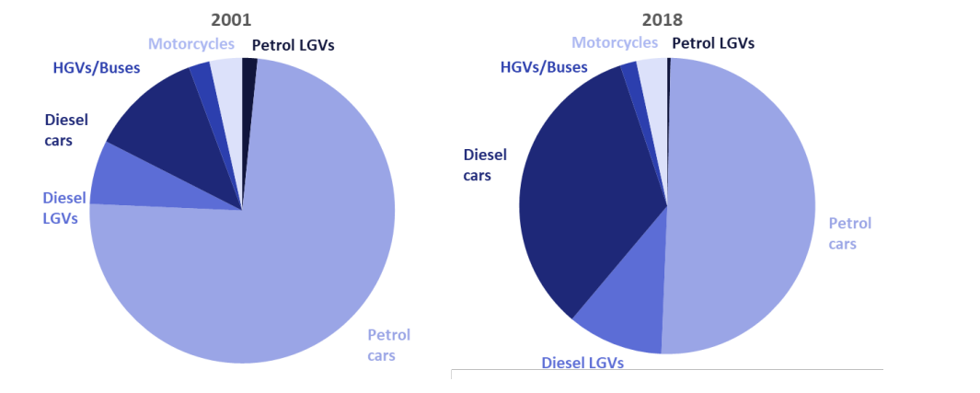
Figure 1: Global Haulage industry data
(Source: El Hannach et al. 2019)
UK haulage industry
Haulage industry in the UK is mainly considered as one of effective biggest sector in the market. In this industry, more than 2.54 million people are commonly involved. It is considered as fifth largest employer industry in the UK. The presented data has basically described the need for petrol in 2001 and also in 2018. Most of the cars in the UK are controlled with petrol which has majorly affected in recent times. It has provided more than £124 billion in the economical context in UK. Most road transport has been highly affected by the impact of fuel consumption. In this consideration, it has majorly evaluated a higher level of petrol consumption in the recent time.
UK haulage industry & BP
The haulage industry & BP has established a positive relation that has been highly effected for the fuel crisis. The increase in the emission of CO2 has caused protests in the area. Most of the emissions are from the Haulage industry (Gössling et al. 2021). Most of the fuel has been collected from the BP that is used in the haulage industry in UK. Number of 1218 petrol pump are mainly is in the UK region. For this reason, most portion of the haulage industry is dependent on BP. Strategic analysis has been conducted from an external environmental position. In order to do that, the pestle analysis has been conducted for compromising the process. In this process, it has majorly included the factor that is affecting the process.
 | Topic | Explanation
P | Political | The impact of the Brexit factor has affected the market scenario of the UK. The supply of the Fuel has mainly been hampered by the impact of the Brexit issues. This type of decision has made uncertainties in the market position. Importing the goods into the market is costing more than the previous one (Dhinakaran and Kesavan, 2020). The rise in the price has been seen as the impact of the Brexit effect on the haulage industry. The price has increased from 112P to 116P. £64.2 is required for making a full tank of a public vehicle. It has negatively affected the Haulage industry in the UK.
E | Economical | The economical context of the UK has majorly explored a lower position for the impact of fuel rate. It has sold a total light-duty vehicle (LDV) in the UK market which is 8% lower than the 2017 sales rate. The current implication of the fuel economy policy in the market of UK has affected the market evaluation. The EU regulations have adopted CO2 emissions. It has a target of 95g of CO2 in every kilometer (assets.publishing.service.gov.uk, 2022). The average emission of carbon from a public vehicle can be 147 gm. It is mainly for commercial vehicles in the haulage industry. This type of law in the market has mainly resulted in a lower purchase of light vehicles. New types of petrol and also diesel cars will be launched by the market by 2030.
S | Social | The current changes in society have highly affected the supply of fuel in the UK market. The current scenario is basically projecting that a drop of 20% in fuel consumption has been highly affected. It has made a significant impact on pricing levels and also on fuel consumption. The analysis of the social changes majorly highlighted the preferences that have impacted climate changing issues. The increase in carbon emissions in the environment has caused protests in society (Welfle et al. 2020). It has highly impacted the haulage industry in the market. Impact on the industry has majorly affected the supply of the fuel that has decreased the market changes in the social factor.
T | Technological | The Govt. of the UK has mainly focused on improving the configuration of public transport and also cars. It will emit lower carbon into the air. It has made an impact on the technological advancement that can make changes in the haulage industry. The changes in the marketing effectively improved the social factor that has helped in the activities. Technological improvement is included in concern to carbon emission. Maximum protest for carbon has occurred in the society that has made a negative effect on the supply of fuel.
E | Environmental | The environmental effect of carbon emission has mainly started protests in society. The currently available data is projecting 112.8 grams in every kilometer in the year 2020. After the impact of the protest, the emission has basically decreased by 12% every year. As per the data of 2019, personal cars are basically emitted 52% of carbon, and also heavy and lightweight vehicles are emitting 35% of the carbon in the environment (ons.gov.uk, 2022). Most car manufacturing companies have focused on reducing the carbon emission in the society which has effectively impacted the society.
L | Legal | The UK govt. Recently passed a law against carbon emission.it has majorly affected the current scenario of society. The government has mainly implemented the "Clean air act of Section 111” and further implemented the “climate change act of 2009”. The valid emission of carbon for 95gm in the personal vehicle and 147gm for the public vehicle. This type of implication has majorly affected the haulage industry and other transport activities.
Table 1: Pestle analysis
(Source: ons.gov.uk, 2022)
The effect of the social changes has highly affected the market position of the UK. The excessive emission of carbon has majorly impacted the activities in the UK region. In this analysis factor, it is highly affected the emission of the carbon that has highly affected the carbon emission of the UK. On the other hand, the impact of carbon emission is the major part that has negatively affected the haulage industry (Raza et al. 2020). The analysis has further demonstrated some factors. It has majorly demonstrated using swot analysis using the organizational factors. The impact of the sector has been demonstrated through this implication of the process.
Strength | Weakness
- Decrease the level of carbon level in the air  - Improvement in the service level  - Development in conjuring better systems in vehicles  - The implication of laws in order to save the environment | - Decrease in the haulage industrial position  - Negative effect in making the process  - Shortage in the supply of products in the market
Opportunities | Threat
- The improvement in material and activities  - Environmental development for the protest  - Implementation of the law has monitored a lower level of performance  - Effective involvement in the trade development activities | - Decrease in the supply chain process  - Increase of pricing level of goods  - Fuel supply issues have underlaid the supply process  - Shortage in the fuel level as per the marketing value
Table 2: SWOT analysis
(Source: Raza et al. 2020)
Strength
The analysis of the process basically highlighted the current position of British petroleum. The analysis of the development basically includes the market value. The carbon has decreased 12% every year. The implication of the process can be effective for developing the major evaluation of the process. On the other hand, 35% of the carbon emission can be useful for implying the process that can be useful for effective evaluation (Agyemang et al. 2019). As per the manufacturing process, it is majorly included in developing the activities as per the process. The implication of the protest has enhanced the level of services that is useful for developing the activities.
Weakness
As per the industrial position, it is majorly included the value that can be effective for developing the organizational position. The protest has majorly restored the shortage in the process that can be useful for developing the activities. It has made a negative impact on evaluating the effectiveness of the marketing position. On the other hand, the deficit in fuel supply in the fuel can be useful for developing the effective application of the process. Involvement of the industrial impact has reduced the level of transport facilities in the market affairs. As per the effectiveness of the process, it is useful for developing the activities in the marketing value (Shcherbakova et al. 2020). The analysis is useful for conducting the supply shortage in the marketing position.
Opportunity
The analysis of the marketing position has mainly evaluated a better impact on the environmental factor. As per the implication of the protest in society, it has implemented a law that has made a major activity as per the marketing value. The analysis can be effective for evaluating the process. The analysis implied a better process for making the development as per the value (Liu et al. 2020). On the other hand, the implementation of law and also trade activities can be part of major marketing activities. This evaluation has made a major implication as to the value that can be monitored as the effective positional factor.
Threat
Different types of negative impacts in the marketing activities can make a major impact on the process. The analysis of the process can be useful for evaluating the process. The analysis of the protest has majorly made a negative effect on the Haulage industry (Chen et al. 2020). The analysis of the process can be used to implicit a better process.

2) Evaluation of the competitive environmental position of British petroleum
The competitive position of the organizational affairs and also the industry can be effective for evaluating the actual position. As per the current value, it has been found that the competitive analysis is crucial with respect to the industrial position. As per the involvement of the value, it has majorly involved the process that can be crucial for the organizational affairs. On the other hand, the analysis can be effective for managing the competitive environment (Wang et al. 2020).
BP petrol retail stations
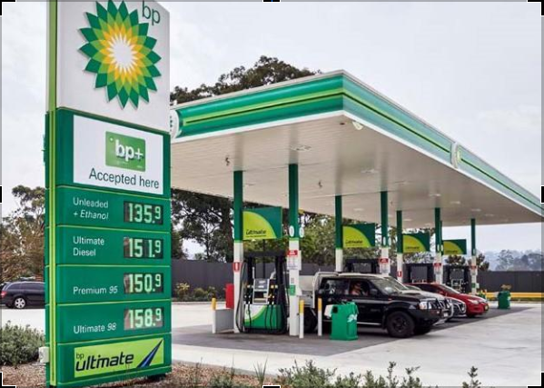

(Source: bp.com, 2022)
The number of the retail sector of BP is counted as 1218 in the UK market. It is considered as second largest retailing station of petrol in UK market. In order to analyze the competitive environment, it has mostly highlighted the position of the factor. Most of the UK market vehicle and also the other industry are mainly dependent on the fuel of BP. A number of other operators is also available in the market but BP is considered as one of effective company (bp.com, 2022). The As per the analysis, it has further provided a value that can be useful for managing individual affairs. The analysis has been conducted by using the industry's five forces that have included:

Figure 3: Porter’s five forces
(Source: Wang et al. 2020)
- Bargaining power of the buyer
- Bargaining power of seller
- Threat to new entrants
- Competitive rivalry
- Threat of substitute
Bargaining power of buyer: the bargaining power is majorly involved as a crucial part of the market affairs. British petroleum has controlled a major part of the market that can be useful for enhancing the position affairs. Furthermore, It has also demonstrated the market factors. As per the current global economy, it has an oligopoly type of market that has mainly consisted of 1200 stations in the different markets. As per the opinion of Huertas et al. (2022), the increased level of buyers has made a potential effect on the supply of petroleum. On the other hand, the company has a higher customer base that has an effective impact on the marketing value. Buyers can be usefully bargained with the process that can be effectively used for developing the current activities. The current market position of the UK has majorly demonstrated that most of the customers require a higher level of fuel which has implied a crisis in the market position.
Bargaining power of seller:
The company has mainly maintained an oligopoly type market in the sector. As per the current industry position, it has made a higher position in the market. In the UK area, it has consisted of a lower number of suppliers in the market area. The effect of the process can be crucial for developing the activities. In this involvement, the limited impact of the process can be crucial for managing the effect (Zhang et al. 2018). The effective application of a limited level of suppliers has made a better position for British petroleum. It has made a higher position in the marketing affairs. Limited availability of market competitors in the UK market has made a potential position for British petroleum. Market involvement of the positional factor is useful for demonstrating the factors. As per the process, It is crucial for managing the activities in the market value. Involvement in the activities can be crucial for making an effect as per the process.
Threat to new entrants
Different companies are trying to make an entry into the current market value of the Uk. As per the current position, it has made a major effect as per the position. Involvement in the process can be crucial for managing an impact. The company has entered a better process that can be useful for making a better value in the market (Castaño-Rosa et al. 2019). Companies like star, Rix, Go, maxol, and also other new companies are trying to enter the market. Different innovative strategic approaches and improved strategies are useful for capturing a better marketing position. It has made a threat as per the current position that is useful for conducting the process properly.
Competitive rivalry
In the current industrial structure, multiple companies are involved in providing services in the UK market. The companies are mainly monitoring a better rivalry that can be crucial for monitoring a better value. The current competitive position as per the process can be crucial and it is also for maintaining better support in the market value (Jackson et al. 2019). Involvement in the process is crucial for gaining a better competitive position. The effective application as per the process is useful for managing the activities as per the marketing impact.

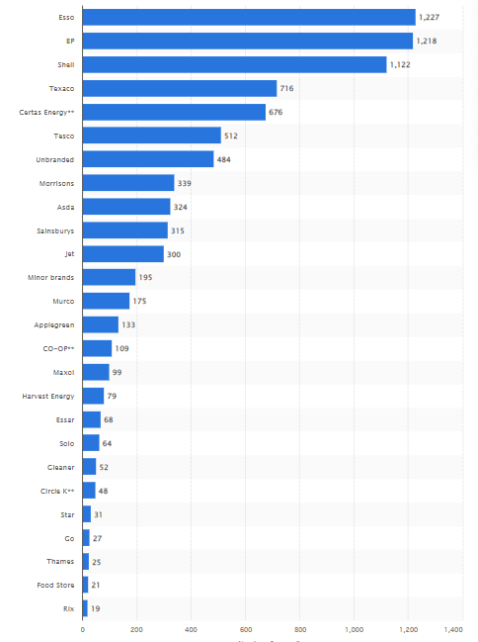
Figure 4: Competitive position
(Source: Statista.com, 2022)
Jet, shell, Essar, Tesco, Sainsbury, and also other multiple companies are considered in-between competitive companies. As per the analysis of the competitive position, it has majorly computed the Tesco, Esso, jet, and also the other items that can be crucial for maintaining a better value.
Threat of substitute
In order to save environmental factors, different types of substitute products have arisen which include Biodiesel, hydrogen, electricity propane, and ethanol. This type of product is useful for conducting better social development in society. Competitor companies have arisen these types of substitute products that are considered a great threat to British petroleum. Electric vehicles have increased rapidly in the market which is considered a higher threat in the market.

Conclusion
It can be concluded that the Current position of the UK market has highly impacted the rapid increase of environmental pollution. The analysis of the market condition has basically involved the effective application of the policies and laws for fuel vehicles. The increase of implication of laws has decreased the current position as per the market. The current market scenario has reflected a major implication of substitutes for a low supply of fuel. It has been further found that a lower supply of fuel has highly made an impact on the haulage industry. The competitive analysis in British petroleum has analyzed a better position in the supply of fuel than other companies.

References
Agyemang, J.K., Yensu, J. and Otchere, M.I.O., 2019. The Impact of Working Capital Management on Profitability of Global Haulage Company, Ghana. Asian Journal of Economics, Business and Accounting, 12(4), pp.1-17.
Assets.publishing.service.gov.uk (2022) .UK consumption data. Available at: https://assets.publishing.service.gov.uk/government/uploads/system/uploads/attachment_data/file/812622/Road_fuel_consumption_and_the_UK_motor_vehicle_fleet.pdf [Accessed on 12th April, 2022]
bp.com (2022) .corporate news. Available at: https://www.bp.com/en/global/corporate/news-and-insights.html [Accessed on 26th April, 2022]
Castaño-Rosa, R., Sherriff, G., Thomson, H., Guzmán, J.S. and Marrero, M., 2019. Transferring the index of vulnerable homes: Application at the local-scale in England to assess fuel poverty vulnerability. Energy and Buildings, 203, p.109458.
Chen, S.Y., Zhang, Q., Mclellan, B. and Zhang, T.T., 2020. Review on the petroleum market in China: history, challenges and prospects. Petroleum Science, 17(6), pp.1779-1794.
Dhinakaran, D.D.P. and Kesavan, N., 2020. Exports and imports stagnation in India during COVID-19-A Review. GIS Business (ISSN: 1430-3663 Vol-15-Issue-4-April-2020).
El Hannach, M., Ahmadi, P., Guzman, L., Pickup, S. and Kjeang, E., 2019. Life cycle assessment of hydrogen and diesel dual-fuel class 8 heavy duty trucks. International Journal of Hydrogen Energy, 44(16), pp.8575-8584.
Gössling, S., Meyer-Habighorst, C. and Humpe, A., 2021. A global review of marine air pollution policies, their scope and effectiveness. Ocean & Coastal Management, 212, p.105824.
Huertas, J.I., Serrano-Guevara, O., Díaz-Ramírez, J., Prato, D. and Tabares, L., 2022. Real vehicle fuel consumption in logistic corridors. Applied Energy, 314, p.118921.
Jackson, R.B., Friedlingstein, P., Andrew, R.M., Canadell, J.G., Le Quéré, C. and Peters, G.P., 2019. Persistent fossil fuel growth threatens the Paris Agreement and planetary health. Environmental Research Letters, 14(12), p.121001.
Kaewunruen, S., Rungskunroch, P., Liu, R. and Jack, A., 2021. Highspeed rail systems.
Liu, Y., Shi, X. and Laurenceson, J., 2020. Dynamics of Australia's LNG export performance: A modified constant market shares analysis. Energy Economics, 89, p.104808.
Ons.gov.uk (2022) Available at: https://www.ons.gov.uk/economy/environmentalaccounts/datasets/ukenvironmentalaccountsfuelusebytype [Accessed on 12th April, 2022]
Raza, Z., Svanberg, M. and Wiegmans, B., 2020. Modal shift from road haulage to short sea shipping: A systematic literature review and research directions. Transport Reviews, 40(3), pp.382-406.
Shcherbakova, N.S., Nazarova, Y.A., Kirichenko, O.S., Gorunov, O.A. and Dubrovsky, A.V., 2020. Evaluation of gas industry competitiveness in the foreign market. International Journal of Energy Economics and Policy, 10(6), p.272.
statista.com (2022) Available at: https://www.statista.com/statistics/312085/petrol-station-outlet-share-in-the-united-kingdom-uk/ [Accessed on 12th April, 2022]
Wang, T., Zhang, D., Ji, Q. and Shi, X., 2020. Market reforms and determinants of import natural gas prices in China. Energy, 196, p.117105.
Welfle, A., Thornley, P. and Röder, M., 2020. A review of the role of bioenergy modelling in renewable energy research & policy development. Biomass and Bioenergy, 136, p.105542.
Zhang, R., Tao, J. and Zhou, H., 2018. Fuzzy optimal energy management for fuel cell and supercapacitor systems using neural network based driving pattern recognition. IEEE Transactions on Fuzzy Systems, 27(1), pp.45-57.

Appendices
Appendix 1: PESTLE analysis
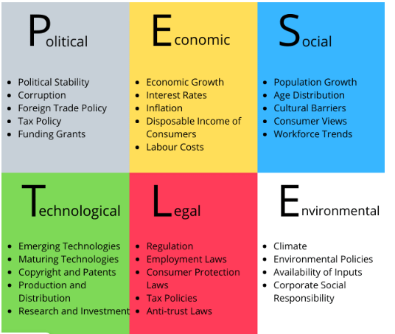

Appendix 2: SWOT


