
Skills for the Workplace
Module Assignment Submission
Student Name: | Samantha Griffiths
Student Number: | 2014899
Module No: | BMSK4002
Module Title: | Effective Team Working and Communication

Statement of Confirmation of Authenticity
By the act of making this submission, the student declares that this is the work of the student named above. The work has not, in whole or in part, been knowingly presented elsewhere for assessment, or where assessment has been built on a previous assessment, this has been identified. Where materials have been used from other sources it has been properly acknowledged. If this statement is untrue, the student acknowledges that an assessment offence has been committed.
Attention is drawn to the plagiarism and unfair practice policies of both the University and of ILM.
Permission for ILM to use this script
ILM uses learners’ submissions – on an anonymous basis – for assessment standardisation. By submitting, both the centre and the learner agree that ILM may use this script on condition that identifying information is removed. However, if you are unwilling to allow ILM use this script, please refuse by ticking the box: □

Table of Contents
Effective Communication in the workplace – Definition and Importance 2
Part 1 2
1.1 Introduction 2
1.2 Research 4
1.3 Conclusion 11
Part 2 13
References 22
Appendix 1 24
Appendix 2 25
Appendix 3 26

Effective Communication in the workplace – Definition and Importance

Part 1

Introduction

What do we mean by Communication?
There are many elements to effective communication, so much so, that to provide a fully detailed report regarding the subject, the report writer would have to break down each element and discuss the importance of every detail. What the writer will present, will be an overview of effective communication and the need for such, and some detailed models that have been designed to maximise communication.
According to managmentstudyguide.com (2021) “The success of an organisation depends on the transparency between the team members and clear understanding of the ideas between them. How does anyone have clear understanding? The answer is effective communication”
We are taught to communicate from the very moment we are born. We are hard wired with an ability to ask for help, food, comfort and to be nursed. We realise from this moment that we must communicate to survive, grow, and nurture. The same goes for business and the workplace. To be able to deliver goals set and to reach targets we must communicate the process to arrive at that goal. Communication is delivered by many ways, from verbal, body language, written forms – both electronic and by writing – Formal and non-formal, and the report writer will attempt to give an overview of what these and other forms mean.

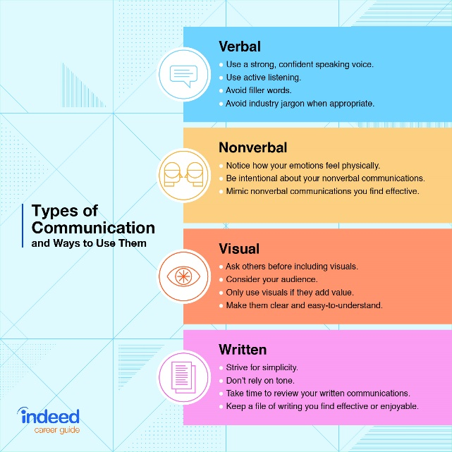
(https://www.indeed.com/career-advice/career-development/types-of-communication)

1.2 Research

Communication Cycle
The communication cycle is the conveying and receiving of messages between individuals or entities in an easy-to-understand format, Talking and listening are two types of communication. (https://harappa.education/harappa-diaries/process-of-communication 2021)
Here is an example of a basic communication cycle
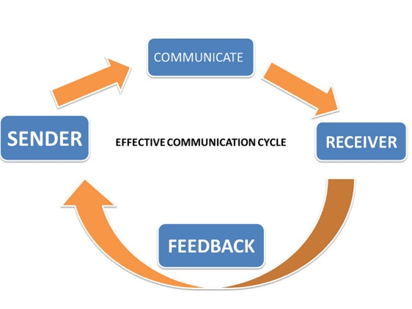
To begin, the sender must first encode the message to which they need to communicate. This means translating information into a message in the form of symbols that represents ideas or concepts. The symbols can take on different forms, such as Language, words, or gestures. This encoding is critical so that the receiver can understand. It is critical for the Sender to take many things into consideration when encoding, such as the receivers existing knowledge and assumptions, along with what additional information the sender wants the receiver to have. According to research, a good way for the sender to improve encoding their message, is to mentally visualise the communication from the receiver’s point of view.
After encoding, the sender will use some sort of channel – examples of which include oral, written, or visual forms as technology advances. The correct channel must also be selected depending on to whom the message is going to be received – for example, a written channel is more beneficial to communicate to a team other than an individual, where a one-to-one communication requiring immediate feedback is more appropriate. If a message is sent through an inappropriate channel, then its effectiveness can be diminished or misinterpreted.
The next part of the cycle is the decoding of the message, and this is done by the receiver. The individual then translates the messages, symbols, and gestures to their own set of experiences to make the message meaningful. It is worth noting that when the receiver correctly interprets the sender’s message, then this is classed as a successful communication.
The final element in the cycle is the Feedback. Very simply, an acknowledgment that the message has been received and understand, and the receiver will carry out or understand the sender’s message.
(Communication process By Bick Sanchez Web.njit.edu 2021)

“Feedback plays an important role by indicating significant communication barriers: differences in background, different interpretations of words, and differing emotional reactions (Bovee & Thill, 1992)

The Shannon-Weaver Mathematical Model
As mentioned in the introduction, the writer will now highlight some of the models used to explain effective communication.
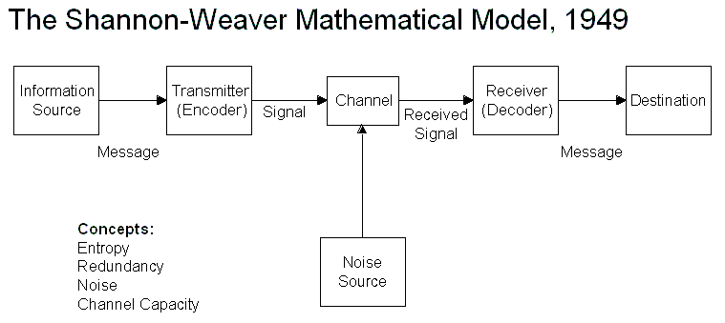

The Shannon-Weaver model although essentially a communication model, has additional elements that need clarifying. The Noise element is any other information that is not required or interruptions whilst transmitting the encoded message before the receiver can decode it. Examples of which might include static on the telephone line, poor or intermittent internet connection. It is worth bearing in mind that the original model was developed to help electrical engineers improve communications via an analogue telephone network where noise and interference would often cause severe communication problems.
Noise can also be any external factors which may influence clarity of the sender’s message, or indeed the receiver’s translation during the transmission.
Noise can be categorized into three groups: technical, semantic, or efficacy related.
Examples of noise include environmental noise, physiological-impairment noise, semantic noise, syntactical noise, organizational noise, cultural noise, and psychological noise.
(https://courses.lumenlearning.com/boundless-management/chapter/barriers-to-effective-communication/ 2021)
These issues must all be considered in effective communication in the workplace.

Berlo’s Model of Communication
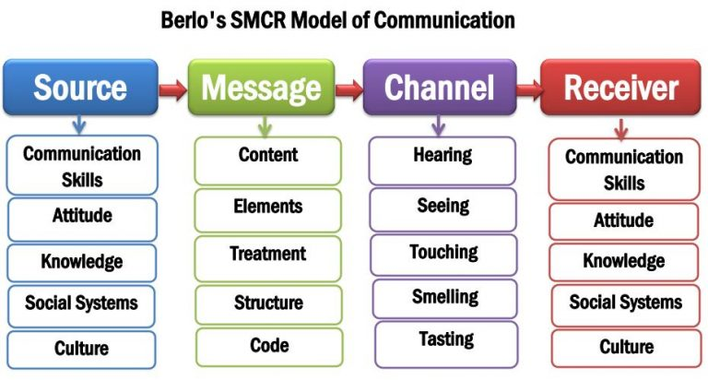

First devised in 1960, this model details the many factors that constitute the main headings that the writer has introduced in the initial communication cycle. It deals with the multitude of factors that can affect the process of communication. These include language barriers, personal disagreements, cultural misunderstandings, such as certain symbols potentially being offensive, accents spoken, perceptual barriers and so on. The writer will discuss some of these elements within the section on Verbal and Nonverbal communication.

Schramm’s Model of Communication
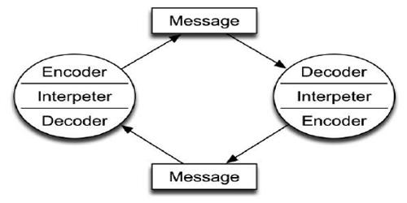

What is different to Schramm’s model compared to those previously discussed?
This model is what is described as a cyclical model – meaning that decoding and encoding is happening all the time between the sender and the receiver. It is a dynamic model that shows us that whilst communicating the complex processes and elements that were highlighted in Berlo’s model are constantly working, that the sender and receiver are constantly interoperating those elements.

Formal and non-formal methods of communication
The writer will now highlight some of the phrases that have come up during the investigation, and compare methods of communication: 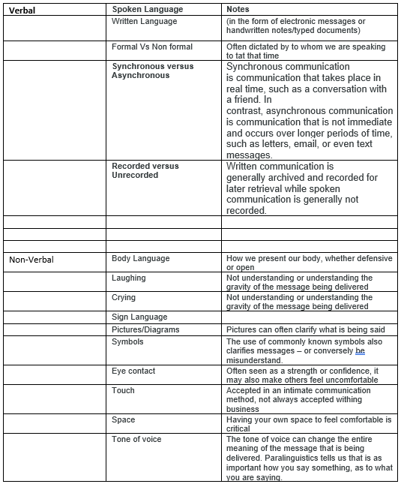

The report writers’ range of verbal and written communication in the workplace varies depending on the type of message being delivered, it’s urgency and the audience and environment into which it is to be delivered. For example, written Team 5 messages are cascaded from the office by means of intranet – where managers and shift leaders deliver the message verbally in face-to-face conversations with the relevant colleagues. In this way, each colleague gets a corporate message delivered in a warm and friendly manner.
Each day, a “Team 5” briefing is held between the management team to discuss the previous days business and business for the day ahead. Each manager then delivers the relevant messages to their own team or individual as they prioritise the business.
Records of verbal conversations are captured on a “let’s talk form” where a brief outline of the discussion is made, and any agreements or next steps are noted – this can be foe either positive purposes in instances for improvement or supporting the colleague’s performance.
An internal intranet system called “Communication Centre” is accessible by all management and shift leaders where relevant business information and urgent messages are sent to the store and actioned by the store.
Each store has a specific email account where individuals and stores can all contact each other.
Tesco corporate at Head Office regularly email all colleagues with up-to-date news and in many instances, videos are made of board members delivering critical business messages, such as year end results.

1.3 Conclusion

There are eight main recognised models of communication, and the preceding study has highlighted the most efficient and recognised forms. The appendices will show examples of other models, namely:
Dance’s model of communication.
He states that there 5 elements within the model, that it is Cyclical, Influenced by time and experience, Continuous, Non-repetitive and Accumulative. It is represented by the shape of a Helical cone (See Appendix 1)
Aristotle's Model.
This simple model first proposed before 300 BC was designed to help speakers or leaders communicate to large audiences such as Armies and mass gatherings.
(See Appendix 2)
Lasswells communication model
This model is about process of communication and its function to society, According to Lasswell there are three functions for communication:
- Surveillance of the environment
- Correlation of components of society
- Cultural transmission between generation
Lasswell model suggests the message flow in a multicultural society with multiple audiences. The flow of message is through various channels. And this communication model is similar to Aristotle’s communication model.
In this model, the communication component who refers the research area called “Control Analysis”,
Says what is refers to “Content Analysis”,
In which channel is refers to “Media Analysis”,
To Whom is refers to “Audience Analysis”
With What Effect is refers to “Effect Analysis”
(https://www.communicationtheory.org/lasswells-model/ 2021)

Part 2

Assessing My own Communication skills
The first stage in assessing my own skills was the completion of the communication effective questionnaire by a colleague from my workplace. I asked for honest feedback based on experience of working together and of my behaviour in team meetings. These were the results. I shall present a brief conclusion of the results which will then form part of personal development plan. I will not agree nor disagree with any of the results but take this as a learning to move forward. I shall begin by presenting a gap analysis to identify my current position, coupled with feedback, I shall create and present my Personal development plan.
Objective | current position | defficiency | action
what do i want to do | what can i already DO? | what am i lacking | how do i fix THIS?
be more confident | present a proffesional image | confidence | btreak out of my comfort zone
be more prepared for meetings | obtain all relevant data | time management | plan day based around daily impacts
clearer underatnding of tasks | listen | if missunderstood i don’t speak up as it makes me look as though i am not qualified | talk back instructions and paraphrase to clarify understanding

Questionaire (A) 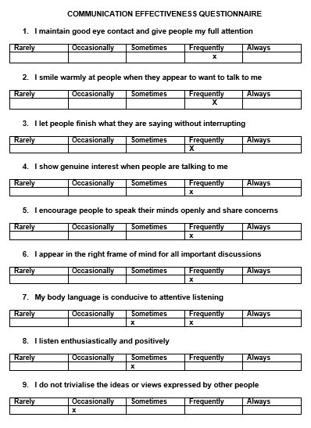

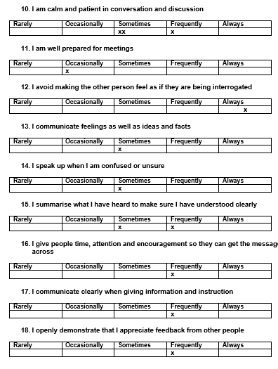
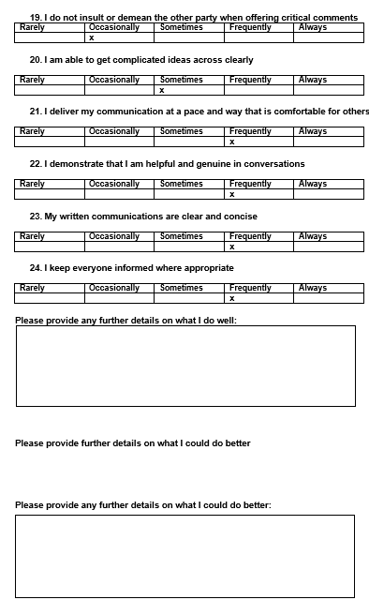
Conclusion of Questionnaire.
The results show that I am positive in my body language and that my body language helps define my communication skills. I need to prepare more for meetings, as I don’t always have the up-to-date data required for the team. There are elements that I have learned about during this report that I intend to work on that I feel I need to approve on to make me a better communicator. These will be within the Personal development plan.

Questionnaire (B)
The second part was to obtain what others thought of my methods of communication. Using this tool was an effective way of challenging my own preconceptions about myself, and once again I shall summarise after the results shown below. Any edges or improvements will be reflected in my action plan attached to this report.
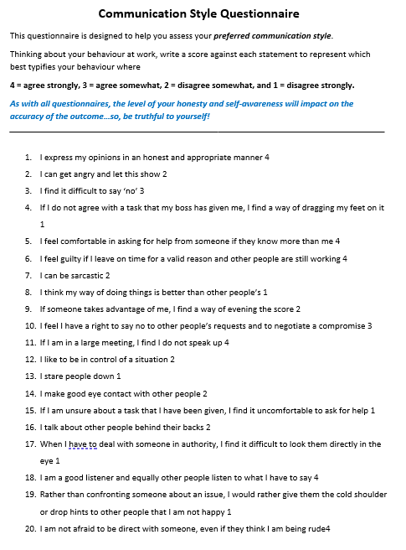

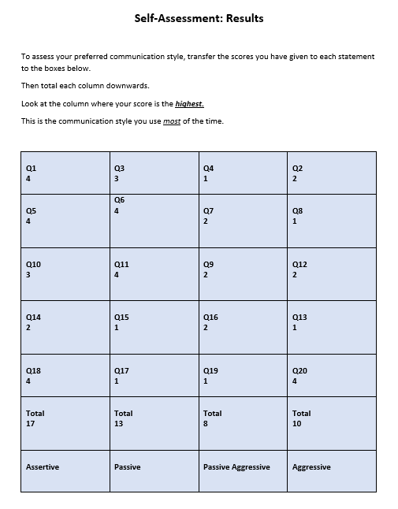

As can be seen in the table above, I have calculated my communication style as assertive. I am professional in both appearance and character when communicating, and I find that my teams respond very well to me. Other forms of feedback are that I am friendly, approachable and deliver instructions very well. Once again, there are improvements which will help me grow, and these shall be reflected in my PDP.

Personal Development Plan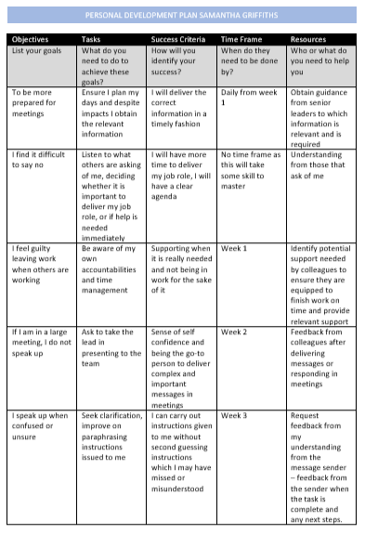
Conclusion
To be able to build a complete plan to improve communication skills the author will spend some time gathering more feedback from as many colleagues across the workforce as possible. It is essential to obtain a cross section from the leaders, peers and those that work for you, as the way in which the author communicates with different people needs to be tailored as we can see within this study.

References

Juneja, Prach (2021) Berlos Model of communication [online]. Available at: https://www.managementstudyguide.com/berlo-model-of-communication.htm (Accessed May 2021)

Juneja, Prach (2021) Shrammss Model of communication [online]. Available at : https://www.managementstudyguide.com/schramm-model-of-communication.htm (Accessed May 2021)

Oxford Reference (2021) Shannon-Weaver model of communication [online] Available at: https://www.oxfordreference.com/view/10.1093/oi/authority.20110803100459436 (Accessed May 2021)

Indeed.com (Apr 2021) 4 Types of Communication and How to Improve Them [online]. Available at: https://www.indeed.com/career-advice/career-development/types-of-communication (accessed May 2021)

Sanchez, Nick (2021) Communication Process [online] Available at : https://web.njit.edu/~lipuma/352comproc/comproc.htm (Accessed May 2021)

Lumen Learning (2021) Barriers to effective communication [online]. Available at: https://courses.lumenlearning.com/boundless-management/chapter/barriers-to-effective-communication/ (accessed May 2021)

Communication Theory (2021) Aristotles Communication theory [online]. Available at: https://www.communicationtheory.org/aristotle%e2%80%99s-communication-model/ (Accessed May 2021)

Drew, C (Nov 2019) 5 features of Dance’s Helical model of communication [online]. Available at: https://helpfulprofessor.com/helical-model-of-communication/ (Accessed May 2021)

Communication Theory (2021) Lasswells’s Model [online]. Available at: https://www.communicationtheory.org/lasswells-model/ (Accessed May 2021)

Management study guide (2021) Communication Skills [online]. Available at: http://managmentstudyguide.com/Communication_Skills.cfm (Accessed May 2021)

Bovee & Thill (1992) Business Communication Today. 7th edition. New York. Pearson

Appendix 1

Additional Communication models.
Dance's Helical Model
(https://helpfulprofessor.com/helical-model-of-communication/ 2021)

Appendix 2

Aristotle's Model.
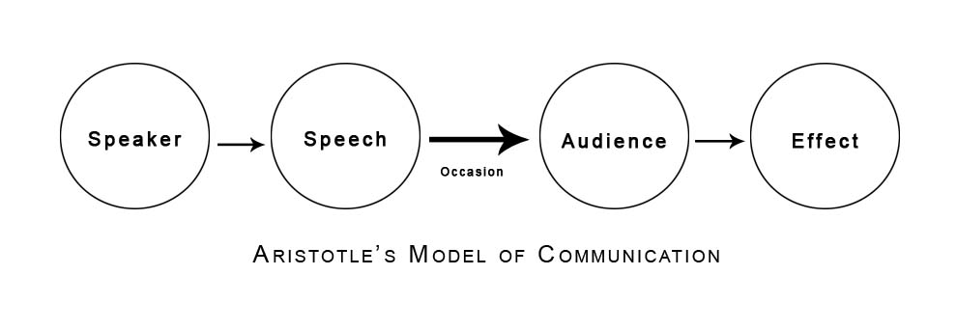
(https://www.communicationtheory.org/aristotle%E2%80%99s-communication-model/ 2021)

Appendix 3

Lasswell's Model
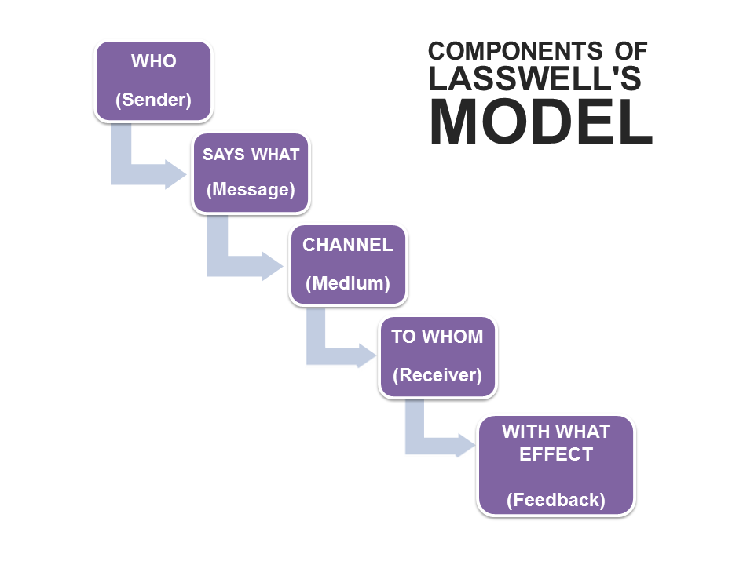

(https://www.communicationtheory.org/lasswells-model/ 2021)

