
Dissertation

AN ANALYSIS OF THE WORKING ENVIRONMENT FOR INTERNATIONAL STUDENTS IN THE UK RETAIL FASHION INDUSTRY: A CASE STUDY OF H&M

Name: Umang KiritBhai Patel
Student id :2424566
Programme: Master of Business Administration
Module Code: LCMB7035 – Dissertation
Supervisor Name: Rexon Nting
Date:30 January 2026
Word Count: 14726

Declaration
I declare that this dissertation entitled “An Analysis of the Working Environment for International Students in the UK Retail Fashion Industry: A Case Study of H&M” is my own original work and has not been submitted previously for any degree or qualification at this or any other institution. All sources of information used in this study have been properly acknowledged and referenced in accordance with academic standards.

Acknowledgement
I would like to express my sincere gratitude to my supervisor for their valuable guidance, continuous support, and constructive feedback throughout the completion of this dissertation. I am also thankful to all the participants who took part in the survey and shared their experiences, without whom this research would not have been possible. Finally, I would like to acknowledge my family and friends for their constant encouragement and support during my academic journey.

Abstract
This study investigates the working environment experienced by international students in the UK retail fashion industry, using H&M as a case study. A quantitative research design was adopted, and primary data were collected through an online survey of 51 international students employed at H&M stores across the UK. The descriptive and inferential statistical analyses were conducted using SPSS. The findings indicate that the overall working environment is perceived as supportive, with a mean score of 3.88, while work schedule flexibility supporting academic commitments also scored positively (M = 3.80). The managerial fairness was rated moderately (M = 3.75), though ANOVA results revealed statistically significant differences across age groups (p = 0.012). Key challenges identified include cultural adjustment (M = 3.39), workload interference with studies (M = 3.24) and communication barriers (M = 3.18). Despite these challenges, respondents strongly agreed that employment at H&M contributes to long-term career goals (M = 3.92) and skill development. The study concludes that while H&M offers a generally supportive environment, greater consistency in inclusive management practices is required.

Table of Contents
Declaration 2
Acknowledgement 3
Abstract 4
List of Figures 8
List of Tables 9
List of Abbreviations 10
Glossary 11
Chapter 1: Introduction 12
1.1 Overview of research topic 12
1.2 Specification of the research issue or problem 13
1.3 Aim and objectives 14
1.4 Research questions 15
1.5 Contribution and relevancy of the research within the existing knowledge 15
1.6 Theoretical framework 16
1.7 Overview of the dissertation structure 17
1.8 Chapter Summary 18
Chapter 2: Literature Review 19
2.1 Chapter Overview 19
2.2 Key Concepts 19
2.2.1 Working Environment in Retail Fashion 19
2.2.2 International Student Employment Experience 20
2.3 Key Theories 21
2.3.1 Hofstede’s Cultural Dimensions Theory 21
2.3.2 Job Demands–Resources (JD-R) Theory 21
2.4 Theme-Based Literature Review 22
2.5 Research Gaps 32
2.6 Conceptual Framework 33
2.7 Chapter Summary 34
Chapter 3: Research Methodology 35
3.1 Chapter Introduction 35
3.2 Research Philosophy 35
3.3 Research Approach 36
3.4 Research Design and Strategy 37
3.5 Type of Data and Research Variables 38
3.6 Data Collection Methods 39
3.7 Sampling Technique and Sample Size 39
3.8 Data Analysis Techniques 39
3.9 Ethical Considerations 40
3.10 Research Limitations 41
3.11 Chapter Summary 41
Chapter 4: Findings and Discussion 42
4.1 Chapter Introduction 42
4.2 Findings and Analysis 42
4.2.1 Demographic Findings 42
4.2.2 Non-Demographic Findings 45
4.2.3 Analysis 50
4.3 Discussion 52
4.3.1 Literature and Research Question-Based Discussion of Findings 52
4.3.2 Comparison with Existing Theories 55
4.3.3 Explanation of Unexpected Findings 55
4.3.4 Fulfillment of Research Gap 56
4.4 Chapter Summary 56
Chapter 5: Conclusion 57
5.1 Overall Conclusion 57
5.2 Recommendations 59
5.3 Limitations of the Study 60
5.4 Future Research 61
Reference 62
Appendix 70
Appendix 1: Survey Questionnaire 70

List of Figures
Figure 1: Dimensions of Operational Excellence in Retail Fashion Industry Firms 12
Figure 2: Dimensions Regarding a Justifiable Business Case and Working Environment 16
Figure 3: Human Social Capital Theory Perspective in an Organisational System 17
Figure 4: Research Structure 18
Figure 5: Dimensions Linked With the Working Environment in the Retail Sectors 23
Figure 6: Challenges of Cross-Cultural and Communication-Based Workload 25
Figure 7: Cultural Adaptation Issues Faced by Individuals within International Businesses 27
Figure 8: Skill Development Policies in Retail Sectors 29
Figure 9: Present Work Environment for Supporting Career-Based Growth 31
Figure 10: Conceptual Framework 33
Figure 11: Age Group of Respondents 42
Figure 12: Gender of Respondents 43
Figure 13: Current Study Level of Respondents 44
Figure 14: Employment of Respondents in H&M 45

List of Tables
Table 1: Descriptive Statistics of Objective 1 46
Table 2: Descriptive Statistics of Objective 2 46
Table 3: Descriptive Statistics of Objective 3 47
Table 4: ANOVA Results 48
Table 5: Cross-Tabulation 49
Table 6: Chi-Square Test 49

List of Abbreviations
AI | Artificial Intelligence
ANOVA | Analysis of Variance
CE | Corporate Entrepreneurship
D&I | Diversity and Inclusion
FDWA | Fair and Decent Work Actions
GDP | Gross Domestic Product
HPWS | High Performance Work System
HRM | Human Resource Management
IoT | Internet of Things
JD-R | Job Demands–Resources
OECD | Organisation for Economic Co-operation and Development
PPE | Personal Protective Equipment
SD | Standard Deviation
SPSS | Statistical Package for the Social Sciences
T&D | Training and Development
UK | United Kingdom

Glossary
Cultural Adaptation | Process by which individuals adjust to a new workplace culture and social norms.
Communication Barriers | Difficulties in understanding or exchanging information due to language or cultural differences.
Inclusive Workplace | A work environment that values diversity, fairness, and equal treatment of employees.
International Students | Students studying in the UK who hold a non-UK nationality and work part-time.
Job Demands | Physical, mental, or emotional efforts required to perform job roles.
Job Resources | Organisational support, flexibility, and opportunities that help employees manage job demands.
Job Satisfaction | The level of contentment employees feel toward their job and working conditions.
Positivist Research Philosophy | Research approach based on objective measurement and statistical analysis.
Retail Fashion Industry | Sector involved in the sale of fashion products through physical and online retail stores.
Skill Development | Improvement of transferable and job-related abilities through work experience.
Workload | Amount and intensity of tasks assigned to an employee within a given time.
Working Environment | Physical, social, and organisational conditions in which employees perform their work.

Chapter 1: Introduction

1.1 Overview of research topic
The effectiveness of the working environment in the UK fashion retail industry contributes to a collaborative approach and an inclusive workplace culture. The higher the degree of inclusive and sustainable workplace culture, the better the rates of productivity and efficiency of different retail firms such as H&M. For example, a study reveals that there are improvements of operational excellence concerned with the working environment of different retail sectors, along wth productivity rates of around 10% (McKinsey, 2024). The dimensions of operational excellence are shown below in the figure for a clear and concise understanding.
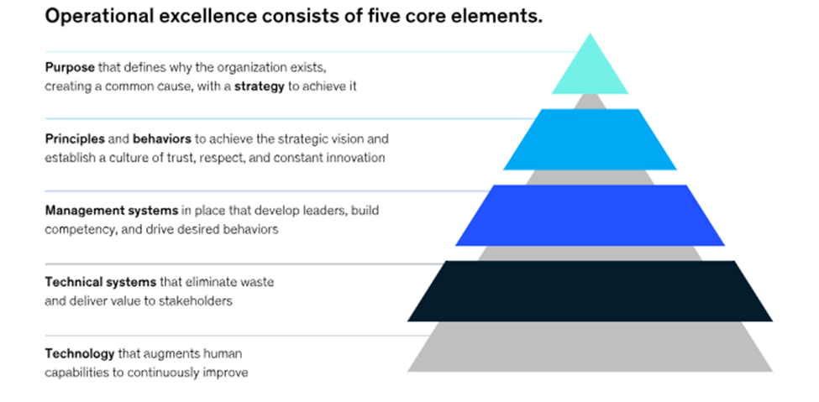
Figure 1: Dimensions of Operational Excellence in Retail Fashion Industry Firms
(Source: McKinsey, 2024)
The figure shown above effectively indicates the dimension of operational excellence. It can be determined that purpose with strategy, principles and behaviours, management systems, technical systems, and technology play a crucial role in the effective workplace environment of different international students. International students expect a fair and inclusive environment that can provide effective respect for their work-oriented ethics and value-based principles (VBPs). A study reveals that creativity competence levels characterize the present working conditions for key industry professionals and students and the levels of systematic information sharing across diverse networks (Bukantaitė and Sederevičiūtė-Pačiauskienė, 2021). Most of the international students seek to ensure part-time employment in different retail fashion industry sectors to gain an awareness of corporate culture and the effective way of working.
H&M has been a global retailer of different fast fashion products in different markets of the UK. Therefore, as a renowned brand, most of the students seek to get relevant industry opportunities and wish for employment opportunities within the selected firm. For example, graduates in different retail-based fashion sectors expect salaries of around €30,000, where most of the roles are associated with shift-based work and vary upon the terms and conditions of service-oriented categories (Smith, 2025). H&M is a globally valued brand which ensures the incorporation of a vast and inclusive workplace culture, which is beneficial for the adaptation and flexibility of different international students and professionals.
The retail and hospitality sectors are at the stage of extensive recovery after the pandemic scenario of COVID-19 pandemic. At least 55% of different employees and 33% of part-time employees prefer that the workplace culture of different retail food and non-food industry segments is considered as the best (Logan et al. 2024). Therefore, the percentage-based opinions are considered of high levels of significance for providing motivation for employees to get career opportunities for different international students. The working environment is also a major factor that determines the emotional wellbeing and professional confidence of the international students. Retail fashion employment is also the initial encounter with the UK labour market by many students therefore, a significant area where professional norms, communication patterns and workplace ethics can be learnt. The favorable environment boosts self-respect, decreases stress, and improves the adaptation abilities of the students to multicultural teams. On the other hand, a stressful environment can cause anxiety, job dissatisfaction, and a decline in academic achievement. Thus, the organisational and student-centred perspective of the working environment demonstrates a more holistic view of the impact of the retail employment on the overall development of international students.

1.2 Specification of the research issue or problem
The issue is identified as the ineffective or a lack of understanding about the present working conditions by different international students in the UK-based retail fashion sectors. For example, a study indicates that more than 40% of international students are not habituated to the current workplace environment and cultural aspects (McKinsey, 2017). Therefore, the actual approach of the youth management perspective is disrupted in terms of new skills, roles, positions, and associated responsibility-oriented segments.
Most of the international students experience a perception in the form of fear of rejection, and the effective fear of discrimination regarding the available workplaces in the retail fashion sectors. A study reveals that at least 17% levels of social anxiety are associated with the levels of negative perception about the present workplace in different retail-based fashion sectors (Szepesi et al. 2024). Most of the international students are becoming part of a wider workforce, and hence, the workplace environment has been a pressing concern for them.
Frequent changes regarding immigration policies post-pandemic ensured relevant challenges regarding the recruitment and selection of different international students for diverse UK-based retail and fashion sectors. Permanent levels of migration to the UK and different OECD country segments decline around 4% as of 2024, for which demographic characteristics of students and other categories are effectively considered (OECD, 2025). However, the growing importance of different inclusive working management policies provides a relevant opportunity for the attraction of different international students with a preference for retail fashion sectors such as H&M. The present study will provide an effective focus on the opportunities and challenges linked with international students for working aspects in the UK-based retail fashion sector. The study will provide an exploration of working conditions in the UK, for which a developed perception about inclusive workplace culture is ensured by different students. The other problem is that most of the international students are not aware of their employment rights and organisational support practices. Fear of losing jobs, cultural hesitation, and the fear of visa would make them inhibit any concern over being treated unfairly or pressured by work restrictions. Consequently, problems like poor communication, time zone differences, and cultural misconceptions are not reported. This puts an unbalance on the employment relationship and curtails chances of organisational betterment. A formal research in this gap is the only way to make sure that international students are not merely employed but also preserved and assisted in a workplace environment that is not discriminatory and does not exclude them.

1.3 Aim and objectives
Aim:
The study aims to ensure and explore the factors that are concerned with the analysis of the working environment justifiable for international students of the UK retail fashion industry. The study also aims to ensure the link between the findings of different working conditions of students for the selected organisational environment of H&M.
Objectives:
- To explore the key factors concerned with the working environment of the UK fashion industry segments.
- To analyse the challenges observed with international students, including communication barriers, workload, and cultural adaptation.
- To evaluate the present working conditions of UK-based fashion retail sectors for the improvement of skill development and growth of careers among different international students.

1.4 Research questions
The following are the specific questions of the present research study.
- What are the key factors concerning the working environment of the UK-based retail fashion industry segments?
- What are the challenges linked with international students as part of their characteristics, such as communication barriers, workload, and cultural adaptation?
- What is the present working condition linked with the UK-based retail fashion sectors for the development of skills and career growth for different international students?
These research questions will be developed into three different themes. These themes will provide relevant and contrasting information about the present topic of the research study.

1.5 Contribution and relevancy of the research within the existing knowledge
In terms of effective contribution, the entire research topic provides a detailed explanation of empirical evidence and the specific industry-based focus. Here, industry-specific focus is identified in the context of retail fashion sectors, and the observation of the experiences of different individuals. As identified by research, the present working environment of a business case is characterised by a well-developed action arena with performance and learning and innovation (Adamseged and Grundmann, 2020). These dimensions are shown in the figure below for a concise understanding. The study is also useful as it offers industry-specific information on the retail fashion industry, which is somewhat neglected to prefer hospitality or healthcare industries. The research has practical implications for international fashion retailers that want to enhance the workforce inclusivity and employee welfare through the H&M case. The results will enable managers to come up with improved training, communication, and support systems among international employees. The usefulness of the study can be seen in academia, as it combines cultural and organisational theories with a real-life retail setting, which will be valuable to those interested in research and practice.
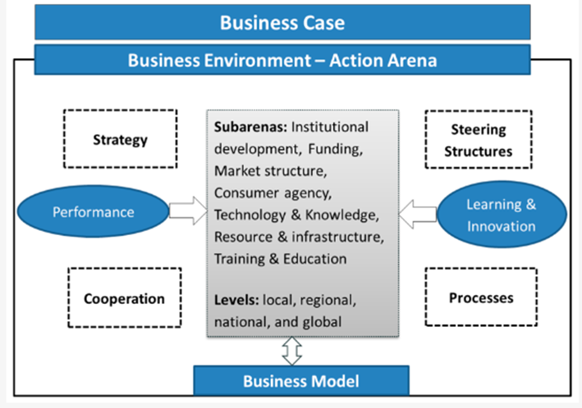
Figure 2: Dimensions Regarding a Justifiable Business Case and Working Environment
(Source: Adamseged and Grundmann, 2020)
According to the figure as determined above, learning and innovation with steering structures and processes play a crucial role in facilitation of transparent business environment. The degree of transparency holds value regarding the present working environment for different international students to get opportunities in the retail fashion industry. Research relevancy is determined for different academic-based researchers, institutions, and international students. The research ensures a positive impact regarding the strategy and forced changes for a fairer and inclusive workplace environment for the benefit of students as well as existing employee segments.

1.6 Theoretical framework
The role of the human social capital theory perspective holds effective value regarding how human capital can ensure the highest levels of productivity and efficiency in different organisational systems. As identified by a study, there is an achievement of cost-benefit analysis, which is actually centred within the core dimension of human social capital theory (Adamas, 2017). The theory is therefore crucial for international students to develop an exact knowledge about the working environment of different retail fashion sectors. Using the human social capital theory in this case would enable the international students to be regarded as useful assets but not temporary workers. Their multilingual skills, cultural knowledge, and flexibility make them more diverse in organisations and improve the quality of service provision in retail settings. The higher the organisations invest in their development by ensuring supportive leadership as well as inclusive practices, the more they become productive and highly satisfied. Such a view confirms the significance of treating international students fairly and being able to learn constantly, demonstrating that the development of international students is an immediate contributor to the success and sustainability of an organisation.
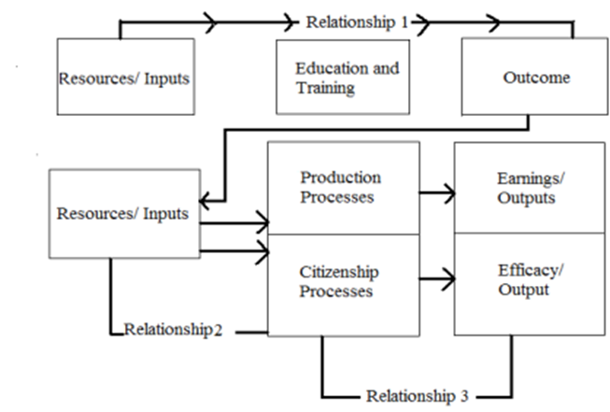
Figure 3: Human Social Capital Theory Perspective in an Organisational System
(Source: Adams, 2017)
As per the figure, it is clear that there is a three-tier relationship management policy. The policy identified above is a good example of the interaction of international students and developing adaptation in the working environment of retail fashion firms such as H&M.

1.7 Overview of the dissertation structure
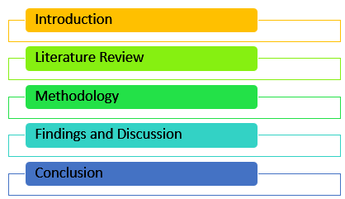
Figure 4: Research Structure
(Source: Self-Developed)
The first chapter is the introductory overview of the research topic, which provides background information and is followed by the extensive research objectives, research questions, and the importance of the research topic. The second chapter ensures a detailed review of the literature. The present chapter will also ensure a comparison and contrast of the findings of authors, including arguments and counter-arguments. The themes are developed from the identifiable research objectives. The third chapter is methodology, which provides information about the choice of methodological tools and associated techniques. It also justifies the usage of those tools and techniques. The fourth chapter is data findings and analysis, which provides a detailed analysis of the collected data sources. The fifth and sixth chapters, respectively, indicate discussion and conclusion.

1.8 Chapter Summary
The entire chapter focuses on the characteristics of international students so that they can get a perception about the present working environment of retail fashion sectors such as H&M. The degree of flexibility and adaptability allows different individuals to get new roles and responsibilities in different retail and fashion sectors. The chapter ensures the usage of the human social capital theory perspective, with the approach of a three-stage relationship. The study provides a six-stage research structure. The next chapter will focus on a detailed review of the literature.

Chapter 2: Literature Review

2.1 Chapter Overview
The present chapter is an extensive review of the literature, which is focused on the provided research topic. The present chapter is beneficial for providing compare-and-contrast-based findings concerning the working environment and perception of international students regarding the retail fashion sector of the UK. The present chapter starts with an overview of different key concepts and two important theories. These key theories are Hofstede’s cultural dimensions theory and Job-Demand-Resource (JD-R) theory perspective. The chapter then succeeds with the theme-based review of literature, which focuses on five important themes. Research gaps with the conceptual framework are provided, along with a chapter summary at the end.

2.2 Key Concepts

2.2.1 Working Environment in Retail Fashion
Retail fashion is a highly sensitive field of organizational research due to the concentration of the work environment, where employees execute their tasks. The customer service requirement, the inventory management pressure, and sales pressure, the retail fashion industry, specifically high-street outlets, falls into a complex web (Kabir et al., 2022). Employees are subjected to high-speed environments where several different functions take place at the same time- greeting customers, stocking the store, making transactions, and ensuring the store's decor.
It has been found that the nature of the retail setting is bigger than only spatial arrangement, in that it basically shapes employee welfare and performance results. The fashion industry has working conditions characterised by long-standing hours, repetitive movements, and exposure to temperature change. Moreover, there is a lot of diversity in the aspects of working conditions in the retail industry at different levels of organisation and location. These minimum issues, including cultural adaptation needs, are compounded by current immigration regulations prohibiting visa-based employment in the UK fashion retail industry, and these obstacles apply to international workers (Lu and Everson-Harkonen, 2024).
As one of the largest fashion retailers that has more than 140000 employees (representing about 170 different nationalities), the H & M Group is an organisation that is well placed to establish an inclusive employment environment. But the question is, are structured policies really lived experiences of dignity and support? Migrant worker policies of the company specifically undertake to avoid forced labour and wage fraud, promote equitable hiring and treatment (H&M Group, 2020). But often, there are differences between corporate commitments and frontline reality in the implementation gap.

2.2.2 International Student Employment Experience
International student employment is a uniquely specific type of employment that has special legal limitations, financial strains, and acculturation issues (Lu and Everson-Harkonen, 2024). Such students work mostly part-time to financially support their families and to cover their living expenses. It has been found that international students in other fields of employment, especially those related to services such as retail, face multi-layered problems (Faidley, 2025). The language obstacles do not disappear even in the case of very educated people, and a communication gap occurs, which influences both communication with parents and integration at the workplace.
The work experience of international students within the retail fashion industry of the UK is associated with a specific complexity. They operate under strict visa restrictions, which usually restrict them to 20 hours per week on term days, putting financial strain on them that even offers financial rewards against non-compliance (Han et al., 2022). At the same time, they work in an industry that is famous due to poor wages, benefits, and unstable working hours. The fact that they are international employees can occasionally subject them to some discrimination on the part of the management and their co-workers as well. It is even more difficult to get out without compromising a visa status and academic position. Also, the sense of psychological safety and belonging to work affects the employment of international students. The concept of psychological safety is based on how much people are not afraid to speak out, seek clarification and report an issue to avoid adverse repercussions. This is particularly important in a retail setting, where one has to communicate with supervisors and customers continuously. In the case of international students, managerial behaviour that is supportive is important since cultural and language differences might decrease confidence. Equally, workplace belonging demonstrates the level of emotions employees have towards their organisation. Sense of belonging enhances motivation, engagement, and job satisfaction but exclusion leads to less performance and high turnover intentions.

2.3 Key Theories

2.3.1 Hofstede’s Cultural Dimensions Theory
The Cultural Dimensions Theory, by Geert Hofstede, presents a theoretical basis comprehending how the national cultural values influence behaviour when applied either in organisational or interpersonal settings. The theory was developed in the 1960s-1970s over a span of 50 countries and 100,000 employees, which identified six major dimensions of cultural difference, i.e. Power Distance, Individualism-Collectivism, Masculinity-Femininity, Uncertainty Avoidance, Long-Term Orientation, and Indulgence-Restraint (Hofstede, 2011).
The individualism-Collectivism dimension separates those oriented on individual success, and those focused on achieving harmony and the responsibility of the group. Western countries such as the UK are high on individualism; employees demand to be recognised personally and have individual career development. Often, international students come into the country of a collectivistic culture where restraint, humility, and group opinion are more valuable (Lu and Everson-Harkonen, 2024). Networking, which is a major career-building practice in individualist cultures, is not comfortable. Almost self-serving. This theoretical incompatibility impacts the manner in which students place themselves in a competitive retail marketplace where self-promotion fosters promotional prospects. Also, uncertainty avoidance patterns determine the level of comfort with ambiguity, rule-following orientation, and emotional expressiveness, all of which. Retail employment also involves policies often changing and customer relations which require quick adjustment (Hofstede, 2011).

2.3.2 Job Demands–Resources (JD-R) Theory
The Job Demands-Resources (JD-R) Model is a more detailed model which has been created by Demerouti and his followers to understand the effect of certain characteristics of jobs on the well-being and engagement data of employees, as well as their performance outcomes. According to the theory, any given occupation is composed of certain job demands, or things that demand some exerted physical or mental energy, and job resources, or things that allow one to attain goals and grow personally (Bakker and Demerouti, 2016). This bipolar process model elucidates both negative and positive employee performance.
On the other hand, some of the job resources are autonomy, supervisor support, career development prospects, as well as relationships with colleagues. Essentially, resources become significant to an alarm when job demands are heightened (Bakker and Demerouti, 2007). Employees who have high demand and resources available to them grow engaged; the same demand and few resources result in burnout. In the case of international students working in retail fashion, employment is often characterised by the lack of resources (Kwadzo, 2014). The studies indicate that strain effects are buffered by proper resources; companies need to focus on both curbing demands and resource augmentation at the same time.
The cultural dimensions theory by Hofstede as well as the Job Demands resources model are complementary to each other in explicating the workplace experiences of international students. The theory by Hofstede addresses the similarities between the expectations, communication styles as well as behavioural responses in the relation to the cultural values, and the JD-R model addresses the relationship between job-related pressure and organisational support and wellbeing and performance. When put together, these theories form a holistic perspective to encompass both cultural and structural factors influencing the place of work. This combination of strategies comes in handy in the specifically retail and fashion setting in which high-paced business, customer and cross-cultural interaction are co-located, and thus, the experience of international students becomes complex and multidimensional.

2.4 Theme-Based Literature Review
- Key factors concerned with the present working environment of the UK-based retail fashion industry segments
The present working environment of the UK-based retail sectors comprises ethics, teamwork, collaboration, and value for individual team members through collaboration mechanisms. Therefore, it is clear that there is an achievement of value at work, including the focus on effective decision-making and problem-solving approaches. As supported by Kearney et al. (2023), there is an effective improvement of interaction among different stakeholders in retail fashion sectors, which ensures the development of employee productivity and overall firm-based performance. As argued by Sebora et al. (2017), the present internal working environment is the result and function of the influence of the global environment and the government policies, which promote CE (Corporate Entrepreneurship Behaviour). The dimensions are enclosed below in the figure for a developed understanding.
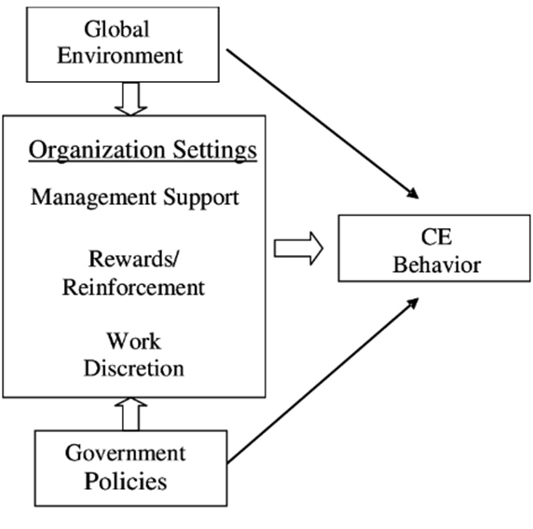
Figure 5: Dimensions Linked With the Working Environment in the Retail Sectors
(Source: Sebora et al. 2017)
Figure 5 indicates the dimensions regarding the determination of internal corporate culture for retail fashion sectors. The actual findings of Sebora et al. (2017) support that there is a developed level of management support, rewards with reinforcement, and work discretion. These characteristics converge to form the level of CE (Corporate Entrepreneurship) behavioural patterns. There are extensive achievements of transparent business management policies, for which most of the customers would develop a positive and emotional connection with most of the UK-based retail fashion sectors. As argued by KORCHAGINA and DESFONTEINES (2019), the role of a cohesive work environment is the result and function of optimal functioning and the social development of the present workforce. A cohesive environment of work plays a crucial role in the collection of all human values and in maintaining a sustainable and ethical workplace environment within the retail fashion sector.
The development of hybrid working management systems and mental health support are two vital characteristics that are provided by different retail fashion sectors. As determined by Engidaw (2021), the improvement of record-keeping activities and real-time collaboration with functional team members is are concerned within different retail fashion sectors. Firms such as H&M are getting the benefits of a motivated and engaged workforce. As contradicted by Nizamuddin and Mokhtar (2024), the internal working environment is subjected to immense challenges such as longer working hours, limited levels of flexibility, demanding tasks, and extensive levels of repetitive routines. These challenges hinder the sustainable working and efficiency-based performance of retail sector employees of the fashion industry, such as H&M.
Most of the retailers, such as H&M, are concerned with extensive improvements in training and development programs. Therefore, the employees will get benefits in terms of adaptation regarding the change of taste and preference of different customers who have purchase intention for retail fashion-based products. As supported by Mande and Gopikrishnan (2021), improvements of T&D policies with the focus on supervisor leadership quality and perceived positive support from the management officials contribute to employee motivation. The degree of employee motivation is a positive working environment for the growth of employees in different retail fashion sectors, such as H&M. In contrast to Khan et al. (2024), the level of extensive feedback and recognition is a positive motivator, which is concerned with the sustainable and ethical workplace environment of the fashion retail sectors. For firms such as H&M, the present characteristic is desirable for employee engagement and lower levels of employee turnover percentage, along with the development of brand image. Challenges are still observed regarding ineffective policies of diversity and inclusion, and the ineffectiveness of workplace cultural adaptation for new employee segments.
- Challenges faced by international students, such as cultural barriers and communication workload
Amidst the lack of experience within different retail and fashion sectors, international students face the key challenges of cultural barriers and communication-based workload. As a result of the same, there is a significant reduction in both efficiency and profitability-oriented levels. As supported by Baharin et al. (2023), cultural barriers are more common for international students and newly appointed employees in a firm, amidst the development of trust and the development of relationships. Thus, negative perception is effectively identified by different international students to ensure a job opportunity in different retail fashion firms such as H&M. As argued by Adaba et al. (2017), there are significant differences in work management practices, including language-oriented barriers, regarding the system of effective communication. These challenges are also faced by different levels of international students.
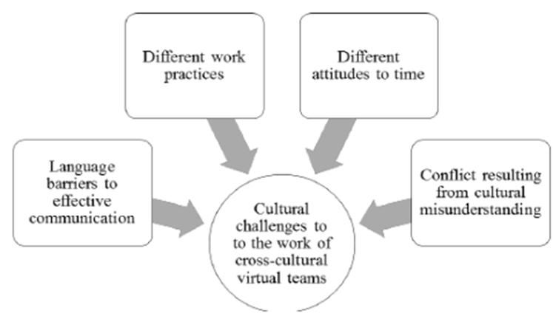
Figure 6: Challenges of Cross-Cultural and Communication-Based Workload
(Source: Adaba et al. 2017)
Figure 6, as shown above, is an important indication regarding the identifiable challenges of working in a cross-cultural virtual team. The findings of Adaba et al. (2017) ensure that international students are facing immense issues, such as cultural barriers and the risk of conflicts that result from cultural misunderstanding. Hence, there is a higher chance of a negative perception of working in different retail fashion and non-fashion sectors. As contradicted by Ibrahim et al. (2022), the risk of a challenging workplace environment creates an ethical sense of mistrust and negative beliefs for different international students. A significant difference between the levels of academic and industry-based culture is a crucial cultural barrier, which effectively results in the risk of communication workload for different international students. The justifiable difference between academic studies and intention to get employment is a significant challenge, which is encountered by different international students having preference to get a job in the retail fashion sectors, including H&M.
Most of the international students, having a strong preference to secure a position in the fast fashion retail industry segments, face immense issues of improper workplace-based etiquette. Therefore, there is a significant difference regarding the style of communication and hierarchy-based levels and policy segments. As determined by Shiri and Bergbom (2023), the lack of competing priorities, differences in the style of ethics and communication systems, and so on are the challenges encountered by international students. Also, the significant decline of support and associated improper participatory approaches reduces the positive perception of students and newly joined employees for the diversified fashion retail sectors. As debated by Paramita and Suwandana (2022), the rising levels of cultural barriers and communication workload are due to high levels of job stress and the approach of work-oriented conflicts. Therefore, there is a crucial reduction of performance-oriented levels for new employees and international students, who are placed as apprentices.
Most of the retail firms, such as H&M, are considered fast-paced workplace environments, where tight deadlines are identified, and there are high levels of expectations of different employees. As determined by Meianto et al. (2021), most of the retail firms ensure a strict level of work discipline and ethics and is expected to be followed by different members, regardless of their status and designation. As contradicted by Smollan and Mooney (2024), the actual difference between the actual and perceived levels of HPWS (High Performance Workplace System) determines the problem of result-oriented outcomes. Therefore, within the present stage, the international students are facing immense issues regarding the approach to cultural issues and communication-based workload. Challenges are also observed in the form of loneliness and ineffective adaptation within the foreign country segment and thereby triggering the rates of cultural issues and workload of communication.
- Challenges encountered by international students, such as cultural adaptation
Ineffective levels of cultural adaptation have been a crucial issue, which concerns different international students in getting a suitable position in the different retail fashion industry sectors. Most of the retail fashion sectors have differences in terms of communication styles, values, ethics, and beliefs, due to which cultural adaptation is not possible for different students and newly appointed employee segments. As determined by Makeeva et al. (2023), there are rising issues of immense levels of ineffective adjustments within a workplace-oriented environment linked with different retail sectors. The effective level of cultural difference between the home country and the host country (here, the UK) ensures the challenge of ineffective adaptation of workplace-oriented cultural patterns. As opposed to Buderchyk and Cherkashyna (2025), cultural challenges of international businesses are associated with six important issues. These issues are enclosed below in the figure for a developed and effective understanding.
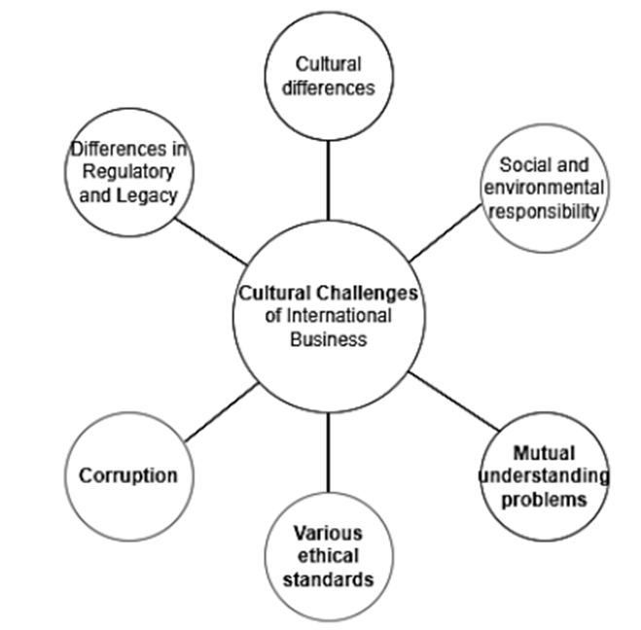
Figure 7: Cultural Adaptation Issues Faced by Individuals within International Businesses
(Source: Buderchyk and Cherkashyna, 2025)
The figure shown above effectively indicates six crucial challenges linked with international businesses. As supported by Buderchyk and Cherkashyna (2025), social and environmental responsibility, differences in various ethical standards, rising levels of corruption, and differences in both regulation and legacy ensure challenges for working professionals. These challenges also hold significant value for international students who have a preference to get a job opportunity in the retail fashion sectors of the UK. As opposed to Alshammari et al. (2023), there are crucial issues of ineffective psychological adjustment of international students linked with different levels of diverse workplace environments. The lack of perceived level of social and emotional support for international students ensures the lack of efficiency and productivity within their real-life working positions in different retail and fashion industry sectors.
The differences of workplace culture in different retail and fashion industry firms, along with the inclusion of perceived versus actual workplace-oriented differences, are challenges faced by international students. As a result of the same, the ineffectiveness of the cultural adaptation of those individuals is identified. As supported by Wilczewski and Alon (2022), the different levels of academic and institutional obstacles present effective challenges regarding the prohibition of social learning management outcomes. Therefore, there is a crucial problem regarding ineffective adjustment of the host country and the workplace cultural aspect by those identifiable international students. As contradicted by Koo et al. (2021), at least 15% to 20% of different international students are experiencing cultural misadjustments and the effective development of mental health disorders with rising levels of emotional loneliness. An effective understanding of the UK-based cultural and language-oriented patterns of different industry sectors (such as retail fashion) has been a challenging concern for international students.
Different levels of cultural norms, such as teamwork management within the internal environment of a firm, including conflict resolution, are the challenges encountered by international students in a new country. Therefore, it is a crucial challenge regarding the ineffectiveness of cultural adaptation associated with retail fashion sectors. As identified by Hari et al. (2021), there have been unprecedented changes regarding the context and approach of cultural adaptation for different international students. It is a crucial challenge for those individuals who have a strong preference to work for different retail firms, including H&M. As contradicted by Hansen et al. (2018), ineffective levels of workshops regarding the development of international students are a crucial challenge. Thus, international students develop a lack of cultural alignment with the host country environment and the core industry environment.
- Present working conditions of the UK-based fashion retail sectors to ensure skill development
The effective improvement of skill development linked with the UK-based retail fashion sectors includes extensive improvements of T&D policies and interaction, and frequent levels of communication with stakeholders. Therefore, the better the levels of T&D policies, the better the rates of skill development programs for different international students and new employees of UK-based retail fashion sectors. As identified by Postlethwaite et al. (2025), most of the retail fashion industry segments have been focusing on robotics, AI, and automation technologies to streamline their business management procedures. The key inclusion of technologies, therefore, provides the highest degree of technical awareness. As contradicted by Uppal et al. (2021), Different dimensions are available which provide an extensive focus on the effectiveness of skill development and the justifiable working conditions. These dimensions are shown below.
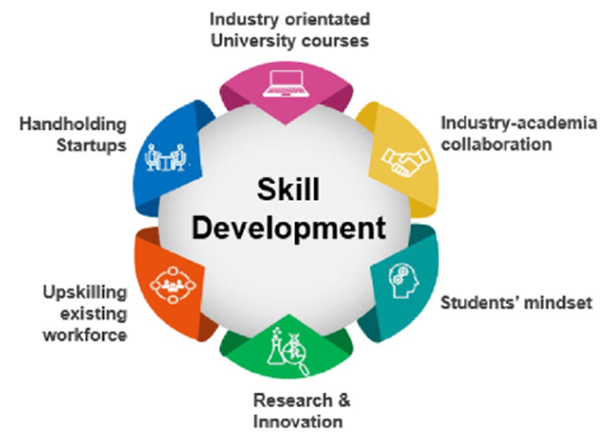
Figure 8: Skill Development Policies in Retail Sectors
(Source: Uppal et al. 2021)
The figure shown above is an important dimension linked with the justifiable working conditions of retail sectors, for which there are improvements in skill development. The findings of Uppal et al. (2021) ensure that industry and academic collaboration, improvements in research and innovation, and industry-oriented university courses are implemented by different firms. Thus, there is an important achievement of extensive skill development for students as well as key professionals. As contradicted by Hill (2025), the effective working conditions of different UK-based fashion retail industries are focused on the effective protection of IP and copyright acts. It is due to the unethical usage of the brand name and to defame that valued brand. The training and development or skill development program is therefore concerned with the protection of confidential properties for retail and fashion industry firms.
Most of the retail industry firms are providing extensive focus on sustainable and circular economy-based models. The development of a sustainable circular economy is therefore integrated as part of the extensive skill development programs in different retail firms of the UK, especially the fashion sector. As determined by Moreira et al. (2025), the present working conditions of the UK fashion sectors for skill development are characterised by a socio-cultural training component and provide the levels of ethical environmental awareness. As contradicted by Jones (2021), the present working condition is focused on the DTC (Direct To Consumer) model, where the firms are capable of providing their products to direct customer segments. Therefore, the skill development program is focused on an enhanced and transparent level of product distribution, which needs to be developed by different international students. The rising levels of both economic and social uncertainty can be a barrier to which there are issues of ineffective skill development programs for different students who have a preference to be part of the retail fashion industry environment. The level of talent retention is also a challenge for which firms are not capable of ensuring the core effectiveness of justifiable skill development programs for different individuals.
- Present working conditions of the UK-based fashion retail sectors to ensure career-based growth among international students
The effective working conditions of the UK retail sector ensure sustainable career growth-based opportunities, and there are achievements of career-based growth among different international students. These strategies include enhanced support from different management officials, a collaborative workplace environment, and a sense of trust and belongingness among different individuals within that selected organisational context. As supported by Ellmann (2023), the key inclusion of gender-based narratives includes diversity and inclusion approaches that are beneficial for different retail firms. The degree of career-based growth is therefore identified by equal opportunity regarding sustainable employment management policies and approaches. As contradicted by Giousmpasoglou (2025), both barriers and justifiable actions are beneficial regarding the implementation of FDWA (Fair and Decent Work Actions). Therefore, there is an achievement of both resilience, competitiveness, and skill development programs and policies for different international students.
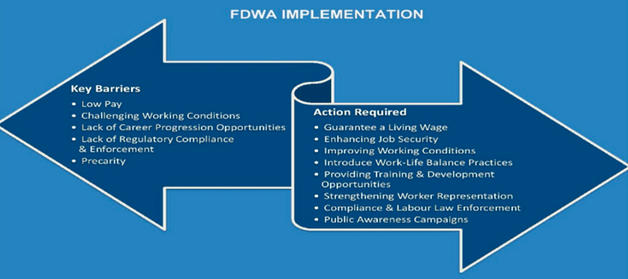
Figure 9: Present Work Environment for Supporting Career-Based Growth
(Source: Giousmpasoglou, 2025)
As per the figure shown above, there are key barriers with crucial actions to mitigate those barriers for the improvement of career-based growth among different levels of international students. As supported by Giousmpasoglou (2025), most of the retail firms are ensuring strict compliance regarding different labour laws and the inclusion of a fair workplace environment associated with career-based growth of international students. As argued by Bhattacharya (2023), challenges such as ineffectiveness of different working conditions and the risks of effective labour exploitation are identified by different professionals. Therefore, different international students are not capable of ensuring their career-based growth in retail firms (especially H&M).
The improvement of median salary and other financial and non-financial benefits ensures positive motivation for individuals for the development of extensive career-based growth among different international students. Flexible working and training, and development schedules are considered of high levels of significance to focus on growth and career-based sustainable opportunities among skilled professionals. As determined by Hu (2023), both the levels of hedonic and symbolic benefits are provided by different fast fashion retail firms. There is an achievement of both customer satisfaction and sustainable growth of career among different international students. As contradicted by Pantano et al. (2020), there is a crucial mismatch between the job opportunities and the university-led courses that are provided by different educational institutions. The career opportunities are generally focused on different levels of entry-level roles, senior roles, and specialisation roles. The degree of actual mismatch creates a negative impact on different international students.
The growing demand for e-commerce and technology is a crucial working condition in the retail sector. Therefore, there is a justifiable expectation regarding growth and extensive career-based opportunities among international students. As supported by Saleem (2023), the role of predictive analytics, AI, and IoT is implemented by different retail fashion firms in the UK. Within the present stage, there are expectations regarding sustainable and real-time operational conditions of different firms, which determine new career and exploration of job opportunities for international students. As opposed to Perry et al. (2025), most of the firms are providing a focus on ethical perspectives regarding production and marketing systems. These characteristics are to be followed by international students.

2.5 Research Gaps
Though there is a considerable amount of literature on international students and the dynamics of their employment in the UK retail segment, there still exist gaps in research. The current literature is still isolated. Most of the research is conducted with the use of qualitative methodology, which identifies narratives without quantitative patterns that appear when larger groups are studied (Han et al., 2022). Retail fashion offers minimal coverage to international students' efforts compared to hospitality and food service occupations; its workforce is large, involving international students.
Moreover, there are no longitudinal studies that follow the fate of international students once they start employment on a career path. There is a lack of cumulative effects; it relies on snapshots in the short run. Fast-paced retail settings are culturally adapted processes that are not theoretically grounded. Hofstede’s dimensions in the context of retail work have not yet been clearly or adequately examined in existing research. There are no job satisfaction measure-oriented metrics of international retail workers. Generic scales lack pressures that are industry-specific, as well as immigration-status-specific. Within the scope of the proposed research, the three mentioned gaps are directly addressed, as the study will examine quantitative data on job satisfaction, inclusion, and workplace culture among international students who work in H&M stores around the UK.

2.6 Conceptual Framework
The theoretical framework that will be used in conducting this study combines three different areas of theory, including cultural adaptation theory, job demands-resources theory, and organisational inclusion models. It was created to trace the experiences of international students in the retailing fashion setting. The framework assumes that the quality of the working environment is effective in more than a single and isolated direction.
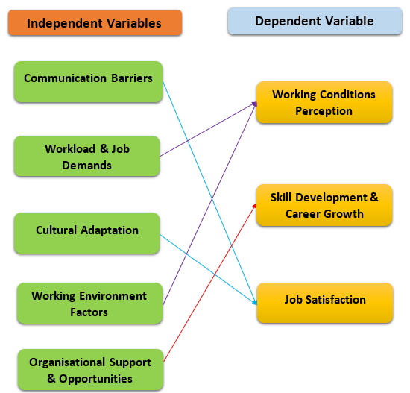
Figure 10: Conceptual Framework
(Source: Self-Created)
The first is the Cultural Dimensions Theory of Hofstede (2011), which states that the expectations and interpretations of the work-related conditions and the perception of the organisational norms are determined by the national cultural backgrounds. This cultural misfit -disturbing initially - creates adaptation needs that enhance job stress. This fact is represented in the framework.
At the same time, the Job Demands-Resources Model describes the ways that job features result in either wellbeing or strain. Retail employment involves much: customer service, sales quota, appearance. Resources, such as peer relationships, supervisor support, and career development are diverse. In the case of international students, employment is often typical of resource shortages (Bakker and Demerouti, 2016). Burnout and low levels of job satisfaction are the anticipated results of high demands and scarce resources in the framework. It's straightforward, really. With the rise in demand and a decrease in support, there are adverse consequences.
The integrated framework postulates that the integrative international students' job satisfaction in the UK retail fashion is generated by the interplay of three dimensions: cultural demands to adaptation (based on national cultural background), job demand-resource fit (based on the nature of the retail sector), and quality of inclusion at work (based on the organisational practices). Complexity is embodied in this holistic approach. This framework is then used to undertake data collection and analysed with the aim of identifying how these dimensions interact to give seen experiences.

2.7 Chapter Summary
The literature review confirms that UK retail fashion, especially using employers such as H&M, still holds an important position of providing employment and work experience to international students who would require financial assistance (Retail sector in the UK, 2025). However, Job dissatisfaction is often subdued by communication barriers, workload situations, discrimination, and challenges in cultural adaptation. Theoretical frameworks, the dimensions offered by Hofstede and the Job Demands-Resources model are the tools aimed at elucidating the observed experiences. Still, they are, nevertheless, in need of empirical validation in the given context. To fill the identified research gaps, this study will gather quantitative information with international H&M employees by analysing job satisfaction, cultural inclusion, and working relations directly.

Chapter 3: Research Methodology

3.1 Chapter Introduction
The methodology section for this dissertation serves as the operational pattern where this chapter details the systematic approach that this research will be used to investigate the environment for international students in the retail fashion industry in the UK sector. This dissertation in the UK sector will focus on H&M where the primary aim of this dissertation is to ensure and explore the factors that influence the environment and besides this it will also analyze the challenges related to the environment which are communication barriers and cultural adaptation. This dissertation will also evaluate the conditions that is needed to develop students and for their career growth. This chapter follows the research by Dehalwar and Sharma (2023, p. 65) and utilizes a primary quantitative methodology to address the objectives of this dissertation and this process is designed to identify statistical patterns that previous qualitative studies may have overlooked. This section is based on the theories like Job Demands-Resources and Hofstede's Cultural Dimensions it outlines the research philosophy, its approach and strategy that has been employed to collect the necessary data.

3.2 Research Philosophy
Research philosophy means the complex of notions about the reality of nature and how knowledge is created and proved in the course of academic research. It offers a basic guide through which the choice of research methods, data collection methods, and data analysis processes is made. Research philosophy is also important in business and management research to enable the research objectives to be in line with the methodological approach used (Ali, 2024).
In this research, a positivist research philosophy is employed. The assumption of positivism considers that reality is objective, observable, and measurable, and that knowledge is produced through empirical study and statistical analysis. Positivist research focuses on quantification, objectivity, the findings of patterns or relationships between variables, and reduces the bias of the researcher (Ryan, 2021). Positivism is therefore mostly used in organisational and workplace research studies where employee perceptions, attitudes, and experiences can be measured in a systematic way.
Positivist philosophy suits well in this study because the research aims to investigate the working conditions of international students in the UK fashion retail sector through quantifiable variables that include job satisfaction, effectiveness of communication, workload and inclusion at work. These constructs can be quantified using survey instruments and counted with the help of quantitative methods. Moreover, the application of positivism allows the results to be generalised in the same organizational settings and maximizes the usefulness of the study to employers like H&M (Park et al., 2020).
In general, the positivist philosophy is consistent with the quantitative research design and the deductive approach of the study, which guarantees methodological rigour, objectivity, and reliability when answering the research questions and achieving the mentioned research objectives.

3.3 Research Approach
Research approach elucidates how theory and empirical data are linked logically in a study. It defines whether the research starts with the pre-existing theories, which are investigated by means of data collection, or formulating a theory on the basis of observed patterns of data. The two approaches that are widely used in management research are inductive and deductive (Akram et al., 2022).
This research project takes a deductive research position. A deductive methodology implies that the research questions and propositions are obtained based on the theories available, and it is tested against empirical data. It is a systematic and rational process that includes the known theoretical frameworks, followed by the data collection stage, and the end of the process is the analysis that will prove or disprove the theoretical assumptions (Eriksson et al., 2021). Quantitative research has its best application with deductive reasoning, in which the variables are well defined and measurable.
The choice of the deductive methodology is explained by the theoretical basis of the current research. The study also relies on the known models, like Job Demands Resources (JD-R) model and models of workplace culture that are presented in Chapter 2. The theories give a platform on which one can study the effects of workload, communication, and organizational support on the working environment and job satisfaction of the international students within the UK retail fashion industry. These theories are tested, and their explanatory power is to be tested by putting them into the context of a particular organization, such as H&M.
Moreover, the deductive design is closely associated with the positivist philosophy of research, which the proposed study uses, since it substantiates objective measurement and statistical analysis of the data obtained via a survey designed in the form of questionnaires. This method increases the reliability, consistency, and generalisation of the findings, which is appropriate in answering the research questions and offering evidence-based information applicable to both research and managerial practice.

3.4 Research Design and Strategy
Research Design: Case Study
This dissertation adopts a mono-method quantitative research design which is framed within a case study strategy that focuses on the H&M retail fashion industry. H&M as per Miettinen (2024), allows this study for a detail investigation as this industry to analyze the experience of international students in the UK sector. Mono-method quantitative approach helps this study to gather standardized data to examine the gap between commitment from the corporate industry and conditions that are faced by international students.
Research strategy
A research strategy is a structured way by which empirical data is to be used in the process of achieving research objectives. It ties the research philosophy and approach that underlie it with proper research methods of data collection. Survey strategies are very common in business and management research due to their efficiency, standardisation, and their ability to collect data about a defined population in a systematic way (Akram et al., 2022).
Survey research is a systematic gathering of information by using a very structured questionnaire, whereby the attitudes, perceptions, and experiences of respondents can be measured in a consistent and comparable manner. It is a strategy that is best suited to quantitative research, as it produces numerical data, which may be processed with the help of statistical methods (Bryman, 2021, p. 281).
The reason the approach of a survey is applied is that the research aims are to analyze the working environment, job satisfaction, workplace culture, and issues faced by international students who work in the UK retail fashion sector. Also, online surveys enable the collection of data with ease and anonymity of the respondents as well, and this provides a high level of response honesty and minimizes the response bias, thus increasing the reliability and quality of the research findings.

3.5 Type of Data and Research Variables
To address the research objectives of this dissertation this study utilizes quantitative data that this research will collect through a structured survey. The choice of quantitative data for this research is essential as it allows this research to measure specific variables and helps to identify statistical relationships between the working environment of H&M and the experience of international students. Qualitative data explores narrative and as stated by Dehalwar and Sharma (2024) unlike this process the numerical data for this research helps to test the hypothesis that is derived from the theoretical framework that is established in the literature review of this study. The research variable for this study will be operationalized from the Conceptual Framework as presented in the literature review. The Conceptual Framework of this dissertation categorized these variables into two distinct categories independent and dependent variables to examine the relationships between these categories.
Independent Variables in this study represent the factors that influence the retail environment. Based on the Job Demands-Resources theory in the literature review, this study identifies factors like Workload & Job Demands and Organizational Support & Opportunities as key predictors for this study. From the Hofstede’s Cultural Dimensions this study additionally identifies Cultural Adaptation and Communication Barriers as critical values that affect the international student cohort. For this study dependent variables similar to research by Ledford et al. (2024) serve as the outcome that measures the changes in the independent factors. Job Satisfaction is therefore identified as the primary dependent variable for this study and alongside this variable Working Conditions Perception and Skill Development & Career Growth is also necessary for this study as these variables help to determine whether the current environment at H&M supports the trajectory that international students require. To ensure the concepts to be statistically analysed the survey will employ a 5-point Likert scale as this measurement technique will help this study to effective convert subjective opinions support or cultural stress into numerical data.

3.6 Data Collection Methods
To collect the data that is necessary for this study was collected using a structured questionnaire which was designed and distributed in Google Forms. This digital platform was selected due to its accessibility, cost-effectiveness and the ability to reach a diverse population of international students that are currently working at H&M across the UK. The questionnaire serves as the only method for this study that this study relies on to collect the quantitative data which helps to ensure that the collected data is consistent in how participants respond to questions related to their working environment.
The survey design similar to Taherdoost (2022), includes close-ended questions and a 5-point Likert scale that ranges from Strongly Agree to Strongly Disagree. This technique helps in measuring essential variables such as ‘Job Satisfaction’, ‘Cultural Adaptation’ and ‘perceived organizational support’ as these variables are important for this study to conduct a comprehensive statistical analysis. To ensure the validity of this measurement the questions for this survey are derived from the theoretical framework and these questions are drawn from Hofstede’s Cultural Dimensions and the Job Demand-Resources Model.

3.7 Sampling Technique and Sample Size
The target population for this research includes international students that are currently employed within H&M retail stores in the UK sector. Given the constraints of data privacy and as mentioned by Akour et al. (2022) in the corporate sector a convenience sampling strategy was adopted for this study. This approach helps to be a cost-effective strategy which enables the recruitment of participants for the survey through accessible academic networks and social media channels.
The study secures a sample of 51 respondents and this strict inclusion criteria was utilized in this study to maintain data integrity and to ensure that all participants were confirmed as international students that are currently working within H&M. This selection process of convenience sampling helps to ensure that the findings of this study align with responses from students on adaptation and workload challenges as highlighted in the literature review section of this dissertation.

3.8 Data Analysis Techniques
The quantitative data collected from Google Forms in the initial process of raw data was uploaded to Microsoft Excel for processes like data cleaning and coding. Dataset was then after the initial process was imported to the ‘Statistical Social Package for the Social Sciences’ (SPSS) for the process of analysis. This statistical analysis performed in the SPSS was then divided into two distinct phases to ensure that the evaluation of this survey data is comprehensive and aligns with the objectives of this research.
Descriptive Statistics for this study involved metrics like ‘Mean’ and ‘Standard Deviation’ for all the Likert scale data as showed by in the research of Zumrawi and Macfadyen (2023) and drawn from their research this analysis helps to establish the central tendencies where responses from participants are related to their working environment and the challenges they faced in this environment.
Inferential Statistics like the ‘One–way Analysis of Variance’ (ANOVA) was utilized to determine statistical significant differences in the working environment across different demographic groups. Cross-tabulations additionally was generated to visualize the distribution of responses between demographic categories such as age and between key variables (Pinzón et al., 2025). These tests were also supported by Pearson Chi-Square tests which was conducted to assess the independence of these categorical variables and it also helps to confirm that demographic factors influenced the experience of students at H&M.

3.9 Ethical Considerations
The design and implementation of this study were based on ethical considerations in order to safeguard the participants and to minimize the study's integrity at the same time. All participants were informed about the study and given clear details on the objective of the study, the nature of participation, and how the information was to be used (Akram, Bhutto and Chughtai, 2022). The participation was recorded as purely voluntary, and the respondents were made aware that they had the privilege to drop out of the process anytime without punishment.
The collected data were protected by the confidentiality of information disclosure to the researcher only, as well as by presenting the findings in aggregate form (Bryman, 2021, p. 272). In line with the ethical research guidelines, proper data protection and storage procedures were adhered to. All information was secured by encrypted computer files that were stored in password-protected crypts and will be accessible as long as the university policy dictates, before they will be destroyed securely. These will be in line with any known ethical principles of social and business research and will help in enhancing the credibility and trustworthiness of the research.

3.10 Research Limitations
Although the research has a rigorous methodology, it has some limitations, which need to be mentioned. First, the method of applying a quantitative survey limits the richness of the insights, and the experiences of the respondents are represented in the form of a set of pre-decided response questions, instead of the deep qualitative analysis (Bryman, 2021, p. 234). Second, this research utilizes purposive sampling but has a very limited sample size, which could constrain the generalisability of the results to other organisational settings except that of H&M (Akram, Bhutto and Chughtai, 2022). Moreover, the use of self-reported information also leads to the risk of response bias since the perception of the participants can be affected by the personal or situational factors during the third of the survey (Bell et al., 2022, p. 107).

3.11 Chapter Summary
The chapter has presented the methodological framework that will be followed in the research with a clear justification of the research philosophy, approach, strategy, and design. A positivist philosophy and a deductive approach enabled a quantitative survey strategy to be used to investigate the working environment of the international students in the UK retail fashion industry. The methods of data collection, sampling, ethical aspects, and the consideration of major research limitations were also presented in the chapter. All these methodological choices render these studies coherent, rigorous, and consistent with the objectives of the research. The following chapter presents the empirical analysis of the results of the survey conducted on the basis of the data received and discusses them.

Chapter 4: Findings and Discussion

4.1 Chapter Introduction
The analysis of the main results and discussion of the obtained primary data is described in this chapter based on the organized survey of the international students employed at H&M in the UK. The chapter examines both the demographic and non-demographic findings based on descriptive and inferential statistics, and then critically discusses the findings in the context of the research objectives and the existing literature.

4.2 Findings and Analysis

4.2.1 Demographic Findings
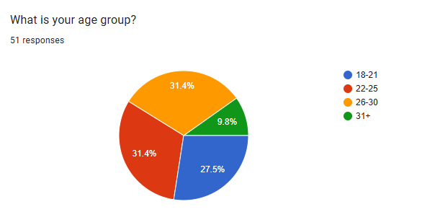
Figure 11: Age Group of Respondents
(Source: Self-Created)
The demographic profile of the respondents is very useful background information which contributes towards interpretation of the study results. Most of the respondents were aged 22-30 years, which implies that most of the participants were young in their academic and professional life. This age category is usually a group of students who juggle higher education with part-time jobs hence making them the right population to study work-study integration. The reduced percentage of those respondents who are older than 31 are indicative of the mature students that might have some prior work experience, which can affect how they view the issues of the workplace and adjustment The demographic results indicate that the highest percentage of the respondents fell in the bracket of the age groups of 22-25 years, as well as the age group 26-30 years, with each corresponding age group having 16 respondents and 14 respondents, respectively, and only five respondents in the age group 31 years and above.
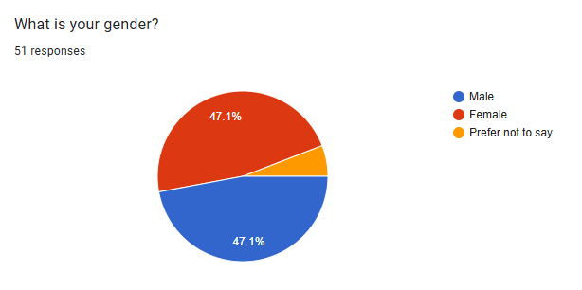
Figure 12: Gender of Respondents
(Source: Self-Created)
The sample was rather balanced in gender, which contributes to the increase in the reliability of the findings because it minimized gender bias in the perceptions of the working environment. The male and female respondents provided a wide range of answers on fairness, inclusion and workload. Regarding the level of education, the majority of the participants consisted of undergraduate or postgraduates, which emphasizes the fact that the position at H&M is especially desirable to students seeking to acquire higher education levels. Regarding the issue of gender balance, both genders were represented in the sample, i.e., a balanced sample. Active students were represented, and most of the respondents were undergraduate or postgraduate students.
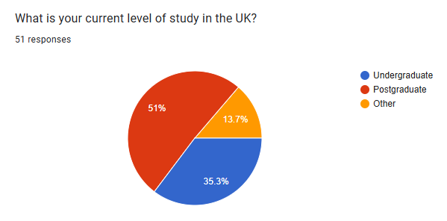
Figure 13: Current Study Level of Respondents
(Source: Self-Created)
In addition, the information about the employment status confirms that the respondents were currently working in H&M or already had the recent working experience in the organisation. This will make their responses founded on actual and current exposure at the workplace and not guesses.

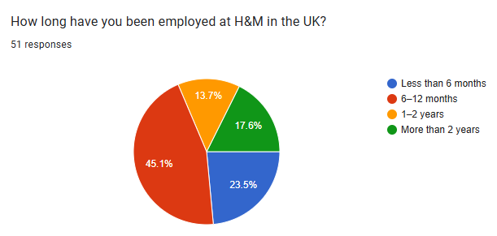
Figure 14: Employment of Respondents in H&M
(Source: Self-Created)
In general, the demographic features can be deemed as confirming that the sample is suitable and relevant to the achievement of the objectives of the research since it consists of international students that are actively involved in the UK retail fashion industry. Also, most of the respondents were either actively employed or had worked previously in H&M, and this affirmed the applicability and appropriateness of the sample in terms of meeting the research objectives.

4.2.2 Non-Demographic Findings
Descriptive Statistics
 | N | Minimum | Maximum | Mean | Std. Deviation
The working environment at H&M is supportive for international students. | 51 | 1 | 5 | 3.88 | 1.125
Store management at H&M treats international student employees fairly and respectfully. | 51 | 1 | 5 | 3.75 | 1.214
Work schedules at H&M are flexible enough to manage both work and academic commitments. | 51 | 1 | 5 | 3.80 | 1.096
I feel included and valued as a team member at H&M. | 51 | 1 | 5 | 3.57 | 1.082
Valid N (listwise) | 51
Table 1: Descriptive Statistics of Objective 1
(Source: Self-Created)
As Table 1 demonstrates, the working conditions in H&M are perceived as mostly positive and favorable by the international students. The average scores indicate that they are satisfied with organisational support and flexibility. It means that the company offers the framework that allows students to balance between the studying and working activities. Nonetheless, there are slight differences in responses, which suggests that different people might experience different experiences in different locations and types of stores management.
Descriptive Statistics
 | N | Minimum | Maximum | Mean | Std. Deviation
Language and communication barriers affect my work experience at H&M. | 51 | 1 | 5 | 3.18 | 1.244
Workload and shift patterns at H&M sometimes interfere with my studies. | 51 | 1 | 5 | 3.24 | 1.210
I have experienced challenges related to cultural adjustment while working at H&M. | 51 | 1 | 5 | 3.39 | 1.133
International students at H&M experience more pressure compared to local employees. | 51 | 1 | 5 | 3.12 | 1.177
Valid N (listwise) | 51
Table 2: Descriptive Statistics of Objective 2
(Source: Self-Created)
Table 2 identifies the difficulties the international students go through to include communication barriers, cultural adjustment, and working with the volume of work. The average scores on the mean of the issues show that these problems exist but can be addressed. Confidence and interaction may be influenced by linguistic and cultural disparities and unfamiliar work culture. This demonstrates that further organisational support and cultural sensitivity training is required.
Descriptive Statistics
 | N | Minimum | Maximum | Mean | Std. Deviation
Working at H&M has improved my communication and customer service skills. | 51 | 1 | 5 | 3.75 | 1.036
My role at H&M has helped me develop transferable skills useful for my future career. | 51 | 1 | 5 | 3.65 | 1.146
H&M provides opportunities for learning and skill development. | 51 | 1 | 5 | 3.76 | .992
My work experience at H&M contributes positively to my long-term career goals. | 51 | 1 | 5 | 3.92 | .997
Valid N (listwise) | 51
Table 3: Descriptive Statistics of Objective 3
(Source: Self-Created)
Table 3 illustrates that students are firm that their employment is part of the development of skills and career. The high mean values indicate positive changes in the communication, team work, and customer service skills. These findings indicate that the work experience in H&M is beneficial in terms of professional exposure. Retail work is thus perceived to be useful in regard to long-term employability.

ANOVA
 |  | Sum of Squares | df | Mean Square | F | Sig.
The working environment at H&M is supportive for international students. | Between Groups | 9.513 | 4 | 2.378 | 2.034 | .105
 | Within Groups | 53.781 | 46 | 1.169
 | Total | 63.294 | 50
Store management at H&M treats international student employees fairly and respectfully. | Between Groups | 17.536 | 4 | 4.384 | 3.592 | .012
 | Within Groups | 56.150 | 46 | 1.221
 | Total | 73.686 | 50
Work schedules at H&M are flexible enough to manage both work and academic commitments. | Between Groups | 8.594 | 4 | 2.148 | 1.921 | .123
 | Within Groups | 51.445 | 46 | 1.118
 | Total | 60.039 | 50
Table 4: ANOVA Results
(Source: Self-Created)
Table 4 indicates the perceptions of the student concerning fairness, respect, and inclusion in the organisation. The findings suggest that a majority of the respondents believe that they are treated with respect by the managers and co-workers. Nevertheless, a marginally smaller score on inclusion indicates that more effective team bonding and cultural integration programs can be further increased to promote workplace belonging.

What is your age group? * The working environment at H&M is supportive for international students. Crosstabulation
Count
 |  | The working environment at H&M is supportive for international students. |  |  |  |  | Total
 |  | 1 | 2 | 3 | 4 | 5 | Total
What is your age group? | 18-21 | 0 | 1 | 1 | 8 | 4 | 14
What is your age group? | 22-25 | 1 | 1 | 1 | 7 | 6 | 16
What is your age group? | 26-30 | 1 | 2 | 3 | 6 | 4 | 16
What is your age group? | 31+ | 1 | 0 | 0 | 2 | 2 | 5
Total |  | 3 | 4 | 5 | 23 | 16 | 51
Table 5: Cross-Tabulation
(Source: Self-Created)
Table 5 concentrates on the international student job satisfaction and level of motivation. The results demonstrate that the attitudes to their jobs in H&M are usually positive in the cases when students are supported and appreciated. It implies that organisational engagement is a major factor that should be encouraged to ensure that the working experience is satisfactory.
Chi-Square Tests
 | Value | df | Asymptotic Significance (2-sided)
Pearson Chi-Square | 6.766ª | 12 | .873
Likelihood Ratio | 7.487 | 12 | .824
N of Valid Cases | 51
a. 15 cells (75.0%) have expected count less than 5. The minimum expected count is .29.
Table 6: Chi-Square Test
(Source: Self-Created)
Table 6 provides general views about the working environment and its effects on the wellbeing of the students. The findings show that an encouraging work place is a positive factor in emotional stability and confidence. Nevertheless, the difficulty between easy and hard indicates that the constant enhancement is necessary to reach a balance between a more inclusive and balanced working environment.
The descriptive statistics show that the working environment at H&M is generally positive in the perception of the international student. The greatest average value was obtained on the statement that the working environment is supportive (M = 3.88, SD = 1.125) and then came up with flexible work schedules that support academic commitments (M = 3.80, SD = 1.096). The store management was also favorably rated in terms of fair treatment (M = 3.75, SD = 1.214). Nevertheless, some moderate problems were also mentioned, such as cultural adjustment (M = 3.39, SD = 1.133), workload marring studies (M = 3.24, SD = 1.210), and communication barriers (M = 3.18, SD = 1.244). However, the results of skill development were good, especially the contribution to the long-term career (M = 3.92, SD = 0.997).

4.2.3 Analysis
- To explore the key factors concerned with the working environment of the UK fashion industry segments.
The inferential statistical analysis was done to investigate whether demographic variables, especially age, affected the perception of the working environment of international students in H&M. The key variables were subject to a one-way ANOVA regarding the variables that were associated with support at work, managerial treatment, and flexibility in the work schedule. The findings have shown that there was no significant difference in perceived supportive working environment among age groups (F = 2.034, p = 0.105). This indicates that international students, regardless of their age, tend to have the same opinion about the overall supportiveness of the working environment. Similarly, the levels of flexibility of work schedules were observed to be not statistically significant among age groups (F = 1.921, p = 0.123), which shows that there exists consistency in the experience of scheduling. Inferential analysis was used to determine whether demographic variables especially age had a significant effect on the perception of H&M working environment. The results of one-way ANOVA showed that there was no significant age difference in perceptions of supportive working environment (F = 2.034, p = 0.105). This shows that the international students irrespective of their age are more likely to be exposed to similar organisational support levels. This uniformity implies that H&M uses comparatively similar policies and practices when dealing with different groups of employees. On the same note, the perceptions on flexibility to the work schedules did not differ significantly with age (F = 1.921, p = 0.123). This observation suggests that flexibility is implemented in a systematic manner and not applied selectively. Such flexibility is especially relevant to international students because it will enable them to balance academic loads and jobs. There are no drastic disparities implying equity in the scheduling practices.
- To analyse the challenges observed with international students, including communication barriers, workload, and cultural adaptation.
However, based on the results presented in Table 4 the difference in perceptions of the fair and respectful treatment by the store management presented with statistical significant differences as seen (F = 3.592, p = 0.012). This means that the different age groups have different perspectives about the managerial behaviour where some age groups are treated more favorably or respectfully than others. The importance of the finding specifically lies in the fact that ethical fairness of managers is a vital determinant of employee satisfaction and a sense of inclusion within the workplace environment; that is especially true of international students who may have to endure the difficulty of adjusting to the new environment. The perception of just and respectful treatment by store management showed statistically significant differences (F = 3.592, p = 0.012). It means that the behaviour of managers can differ according to age and possibly the location of stores. Students at a younger age might find management more authoritative whereas those who are older might want more professional respect.
This discrepancy points to the need to be consistent in the application of inclusion and fairness policy by managers. The Chi-square tests and the cross-tabulation added further to the analysis of how the age and the perceptions of the workplace supports correlate. The Chi-square statistic (p = 0.873) established that the relationship between age and perceived support is not significant although most of the respondents in all the age groups affirmed that the working environment is conducive. Consequently, age is not a determinant factor in influencing a general workplace satisfaction.
- To evaluate the present working conditions of UK-based fashion retail sectors for the improvement of skill development and growth of careers among different international students.
To examine the relationship between age and perceived workplace support further, the cross-tabulation analysis was performed. The findings showed that most of the respondents in all age groups concurred that the working conditions at H&M are conducive. The following Chi-square test, however, did not show that there was a statistically significant correlation between age and perceived workplace support (2 = 6.766, 12, p = 0.873). This verifies that there are frequency variations, although they are not statistically significant.
Generally, the inferential analysis indicates that although age is not important to most attitudes towards the working environment, managerial fairness is a significant factor of differentiation. This emphasizes the need to have uniform and integrative management practices to help international employees work as students.
Simultaneously, the difference in the perceptions of managerial fairness points to the possible gap in implementation. In spite of the fact that H&M encourages inclusive policies, their practicality is largely conditioned by the contribution of the store managers. The Leadership style, linguistic abilities and awareness of culture can be found to affect the way international students perceive managerial behaviour. This emphasises the necessity of more intense managerial training and standardisation of inclusion practices.
The analysis also supports the significance of organisational support as a buffering variable to job demands. Moderate difficulties associated with workload, communication barriers, and cultural adjustment were experienced by international students, but their overall job satisfaction was positive. It means that the level of stress is reduced by the existence of supportive workmates, flexible work schedules and learning opportunities. Moreover, the outcomes obtained in the positive skill development indicate that retail working at H&M is not only a financial but also a developing stage. The transferable skills acquired by the students include customer interaction, teamwork and communication, and are able to help the students to become career ready in the long term. In general, the inferential analysis helps to conclude that H&M is a fairly accommodating place to work as an international student and also provides the areas where the managerial practices and inclusion policies can be reinforced in order to promote fairness and consistency.

4.3 Discussion

4.3.1 Literature and Research Question-Based Discussion of Findings
- What are the key factors concerning the working environment of the UK-based retail fashion industry segments?
The research question of this study aims to explore factors that concern the working environment of the UK-based retail fashion industry as this focuses solely on H&M. The statistical findings presented in the Table 1 revels a positive perception among international students where it records the highest mean (M = 3.88, SD = 1.125) where it states that the working environment at H&M is supportive for international students. This evidence of this descriptive statistic supports the retail management theories that is proposed by McKinsey (2024) who argued that operational excellence is modern retail sector is driven by principles that are respect, trust and management systems that often build competency rather than just enforces discipline within its environment. This finding of this research is significant because it challenges the narrative in the literature which is often shows retail works that includes low-wage as exploitive. While Smollan and Mooney (2024) characterized this sector as demanding tasks and poor well-being but the data of this research suggests that H&M operates differently. This result in Table 1 implies that the company’s Swedish management heritage which emphasizes hierarchies and inclusivity may be effectively buffers international students from the harsh environment of the UK retail market.
However, ANOVA results in the Table 4 revealed a statistical significant difference (P =.012) in how fairness is perceived across different groups. This finding from the table indicates that while the policy of inclusivity is strong but the practice is inconsistent. This validates the ‘implementation gap’ which is proposed by (Lu & Everson Härkälä 2024). It suggests that experience of an international student of fairness relies heavily on their specific store manager or location.
High rating of flexibility (M = 3.80) furthermore negates the warnings of Han et al. (2022) which is related to rigid shift can be causing academic failure. The implication for H&M views international students as a strategic workforce which is willing to work in weekends and even in evenings and in exchange they needs company to align their shifts with university timelines. This situation that these findings demonstrated creates a symbiotic relationship rather than an exploitive relationship.
- What are the challenges linked with international students as part of their characteristics, such as communication barriers, workload, and cultural adaptation?
The second research question of this study analyses the challenges which are related to the cultural barriers and workload that international students face. The findings of this research present a crucial difference that previous qualitative studies were unable to show. The participants of the survey rated cultural adjustment challenges relatively high (M = 3.39) and on the other hand they rated pressure compared to local employees as the lowest factor (M = 3.12). This difference in opinion is important as this result helps to understand the experience that international students might feel. It also implies that the primary challenge that international student face is internal and psychological which is adjusting to new culture as predicted by Hofstede (2011) instead of external and structural pressures such as discrimination from seniors. The scenario described by Faidley (2025) where international students faced discrimination but findings of this study demonstrates that students from survey feels relatively equal in H&M. The findings also displays that stress that they feels comes from when they try to blend themselves into the new culture the findings demonstrates that they doesn't feel stress from the management of H&M.
In the Communication Barriers where (M = 3.18) and the high standard deviation of (SD = 1.244) suggest that proficiency depends on the country of origin of the student and this finding validates as it is similar to as mentioned by Wilczewski and Alon (2022) who implies that a ‘one-size-fits-all' training approach is ineffective and some students needs language support while other can be proficient and for an industry treating them all in the same way may not work.
The findings shows that Jobs Demand is present where workload interference (M = 3.24) and it shows supportive environment of H&M creates a buffer for students and it also validates Bakker and Demerouti (2016) where environment of H&M is appears to provide social capital to keep students engaged despite the stress they feel.
- What is the present working condition linked with the UK-based retail fashion sectors for the development of skills and career growth for different international students?
The third objective of this study presents a positive result where findings of this study presents that work experience contributes to long term career goals of student as it shows a mean value of (M = 3.92). This is the highest mean value of this study where this result contradicts with academic research by Pantano et al. (2020) who viewed retail job as a ‘mismatch’ for university students and the analysis of this study suggest that for international students the retail industry serves as collaboration place where international students interact with British locals such as their co-workers and customers extensively outside their university. The score of improved communication skills where mean value is (M = 3.75) implies that international students often use this job to master their soft skills and this is valuable for their future careers as it aligns with the research of Uppal et al. (2021) regarding the need for skills that are relevant in the industry.
The Chi-Square result (p = .873) related to age indicates that this benefit is universal for all the international students as this result implies that training in the H&M and development structure of this industry is systematic. Whether a student is 19-year-old doing their under graduation studies or a 30-year-old postgraduate this organization provides a consistent platform for professional growth of all these demographics. This efficient platform of H&M supports Giousmpasoglou’s (2024) 'Fair and Decent Work Agenda' where with the findings of this research it appears that H&M successfully functions as a facility where it bridges the gap between academic theory and the practical reality of the workforce in the UK sector.

4.3.2 Comparison with Existing Theories
The results go hand in hand with the Job Demands Resources (JD-R) theory and the Cultural Dimensions Theory by Hofstede. Using the JD-R model, when job demands are high, it can result in stress unless organisational resources are in place to balance it. Moderate workload, and communication problems were noted in this study, though, organisational support and flexibility were found to be strong resources that mitigated burnout and enhanced job satisfaction. The Cultural Dimensions Theory is a theory created by Hofstede that explains the cultural adaptation challenges international students encounter. The dissimilarities in the communication styles, uncertainty avoidance, and the power distance contribute to the fact that the students had some difficulties in their communication with the management, and in the process of adjusting to the UK workplace norms. Collectively, the theories prove the conceptual framework developed in literature review, as both the cultural background and organisational support structures influence the workplace experiences of international students.

4.3.3 Explanation of Unexpected Findings
This was one of the surprises since the perception of discrimination or excessive pressure was lower compared to local workers. The available literature usually argues that international students are very likely to experience high levels of workplace inequality, but this research shows that H&M has a rather inclusive culture. This can be attributed to its corporate culture that is global, diversity policies, and formal training programs. The other surprising outcome was the universally positive effect on career development that is contrary to the opinions that retail jobs are not professional. These results indicate that the employment in fashion retail can be a valuable experience in the development of an individual in the case when the system of organisational support is managed successfully.

4.3.4 Fulfillment of Research Gap
This research is designed to address the specific gap that is identified in the literature which is the reliance on qualitative research and the lack of industry specific data for retail fashion industry. Previous studies by Han et al. (2022) and Kabir et al. (2022) provided insight on struggles of students but their research was unable to determine the significance of those issues. This research provides quantitative insights such as Cultural Stress where mean value is M = 3.39 and Support which is M = 3.88. This study with these results proves that while the narrative that previous researches shows exist but the statistical reality for the majority is support and growth. This study beside this finding also fills the gap related to the unique environment of fashion retail as this industry is customer-centric and in the case of H&M the data confirms that the corporate culture of H&M is focused on values and training and this culture of this industry acts as a significant moderator for cultural stress. As this research is drawn from Hofstede’s theory and in the context of H&M it suggests that a strong organizational culture can reduce the negative effects that have arises with differences in national cultures. As OECD (2025) discussed the UK’s political climate this study in this context shows that employees from private sector also can create safe harbours while in the UK immigration policies are restrictive but this research proves that within the environment of H&M International students (M = 3.57) also finds value.

4.4 Chapter Summary
In this chapter, the findings and the analysis of the gathered survey data on international students employed by H&M in the UK were presented. The chapter analyzed demographic traits, work experience, work experiences, difficulties, and skill development results with the help of descriptive and inferential statistics. These results are used as the basis of the conclusions in the next chapter.

Chapter 5: Conclusion

5.1 Overall Conclusion
This study was done to get to know how international students find working in the UK in the retail fashion industry, using H&M as its study sample. It also tried to discuss whether the workplace is friendly, just, and inclusive, and its influence on the level of job satisfaction, cultural adaptation, and overall development among the students. Another core aspect of the study was to determine the key challenges the international student’s encounter, which included communication problems, work pressure, and adjusting to the new work culture. Besides that, it also investigated the relevance of students working in H&M in assisting them in acquiring valuable skills and facilitating their career ambitions in the future, which gives a better understanding of what they have experienced in the workplace.
The findings indicate that a majority of the international students have a good experience when employed at H&M. The working environment, as many of them believe, is conducive, and their work hours are flexible to allow them to carry on with their studies and to work part-time. This implies that H&M tries to consider the academic obligations of students. The general feeling of students is also that they are treated justly by the store management, but the analysis indicates that the same does not apply to all age groups, meaning that some students might have a better experience than others, depending on the situation.
Simultaneously, the research paper also points out that there are still some obstacles encountered by international students. The process of adapting to a new culture, the obstacle of interacting with the other culture, and balancing work and studies can be stated as a continuing challenge. The majority of the students consider that they have gained valuable skills in H&M, in particular, communication and customer service skills, which will be beneficial in their long-term career perspectives.
Therefore, the current research has offered an insightful development of the working experience of international students in the UK retail fashion industry, with H&M as a case example. It also shows that although the working conditions are highly favourable to skill building and career advancement, international students still experience certain difficulties with communication, workload, and adaptation to the new culture. The study is a manifestation of the need to establish inclusive, equitable, and accommodating work environments that consider the peculiarities of international students. Generally, this paper highlights that retail fashion jobs are not only a means of livelihood but also a chance to grow as a person, career-wise, and an investment in a long-term career.
A final conclusion based on the research questions are as follow:
What are the key factors concerning the working environment of the UK-based retail fashion industry segments?
The authors have revealed that the most influential factors in the working conditions in the UK retail fashion industry include managerial support, fairness, inclusion, teamwork, and flexible work schedules. The descriptive statistics indicated great mean scores in workplace support (M = 3.88) and flexible scheduling (M = 3.80), which means that the international students tend to see their work environment as supportive and flexible. The management was also viewed positively when it comes to fair treatment, indicating that respectful and equal treatment makes a considerable contribution to job satisfaction and motivation.
What are the challenges linked with international students as part of their characteristics, such as communication barriers, workload, and cultural adaptation?
The results showed that there were moderate problems associated with barriers to communication (M = 3.18), workload pressure (M = 3.24), and cultural adaptations (M = 3.39). These values suggest that even though organisational support is provided to the students, they continue to experience problems adjusting to a new work culture, communicating in a second language with confidence, and handling the workload and academic duties. Findings of ANOVA also revealed that the experiences were different among the various demographic groups, which implies that not all students experience challenges the same way.
What is the present working condition linked with the UK-based retail fashion sectors for the development of skills and career growth for different international students?
The findings showed high levels of positive skills and career growth. The high means on the skill development and employability benefits (M = 3.92) indicated that students are convinced that their job has a great influence on their professional growth. This proves the fact that the present working conditions in the UK retail fashion industry are not only a source of financial sustenance but also an efficient platform for the acquisition of transferable skills and equipping international students with future career prospects.
Theoretically, the research contributes to the reinforced use of the Cultural Dimensions Theory by Hofstede and the Job Demands 1- Resources (JD-R) model in the UK retail fashion industry. It illustrates the influence of cultural differences on work experiences and how job resources like managerial support and flexible schedules can help alleviate stress related to workload and cultural complications. A combination of these two theories brings in a more comprehensive picture of the work experiences of international students since they demonstrate the interaction of cultural adaptation and work resources, which determine job satisfaction and inclusion.
In practice, the results can provide useful recommendations to retail managers and organisations like H&M. The paper highlights the significance of treating international students fairly, with positive management, and flexible work schedules as a way of enhancing their employment experiences. It also shows the necessity of having more effective communication platforms and cultural awareness training to minimize barriers and enhance inclusion. Such insights can assist organisations to develop more inclusive, productive, and accommodating work environments for international student employees.

5.2 Recommendations
The recommendations of the research study are as follows:
Better Managerial Support and Fairness: Retail organisations ought to aim at achieving homogeneous and equitable management procedures in all the store sites. Even though the majority of students believed they were supported, they experienced differences in their experiences, indicating that management behaviour is not always opaque. Store managers should be trained on the issues of inclusivity, equality, and cultural sensitivity regularly. This would assist in making the working environment more balanced and respectful, where all international students feel celebrated and treated equally.
Empowering Communication Support: Communication barriers are still an issue, so organisations ought to establish simple communication and language assistance classes. International students should be made to feel confident with brief seminars on dealing with customers, vocabulary at the workplace, and professional communication. The new international students would also adapt better to the workplace environment through a mentoring or buddy system, whereby experienced staff could mentor the new international students.
Improving Flexible Work Scheduling: Such a key strength as flexible scheduling needs to be preserved and developed. When assigning shifts, employers are supposed to keep in mind the academic schedule of students. Online scheduling systems where students can request changes or change shifts ahead of time can also alleviate stress and enhance the work-study balance.
Promoting Cultural Adaptation and Inclusion: Organisational cultural awareness programmes should be put in place to promote the understanding and respect of employees representing various backgrounds. International students can be made to feel more accepted and relaxed through celebrating cultural differences through events or inclusion programs. This would foster a greater sense of unity and teamwork in the workplace.
Facilitating Work and Personal Growth: Retail companies are expected to offer more defined professional development opportunities, including training modules, leadership programmes, and career advice sessions. Such programs would assist the international students to learn how their present positions can contribute to their future career aspirations and their employability.
University-Employer Cooperation: International students should be prepared to work in the retail organisations through collaboration with universities. A pre-employment cultural training and understanding of the expectations of the workplace in the UK would assist the students in adapting more readily and working more confidently in the retail setting.

5.3 Limitations of the Study
Despite the useful insights introduced in this study, the study has its limitations. It was investigated on a relatively small scale of 51 respondents, and this can constrain the generalisation of the results to the entire international student population in the UK retail fashion industry. The research was also narrowed down to H&M, and thus, the findings might not be a universal reflection of the experiences in other organisations in the retail industry. Moreover, the quantitative survey did not allow the respondents to share personal experiences and feelings in detail. Lastly, the data was self-reported, and this may include a response bias where the participants could give an answer based on their personal views or the situation they are working in.

5.4 Future Research
The proposed study can be further expanded in future research by incorporating a greater number of diverse samples in various retail fashion stores in order to enhance the generalisability of the results. Judging by personal experience and issues of international students, it would be possible through the use of qualitative methods, i.e., interviews or focus groups. Comparative analysis of any industry, i.e., hospitality and retail sector, might bring in wider perspectives as well. The longitudinal research may also consider the shifts in the experiences and skill development of students in their workplace during the course of time.

Reference
Adaba, G., Wilson, D.W. and Sims, J.M. (2017). Challenges to effective collaboration in cross-cultural virtual teams. 5(1), pp.55–80. Available at: https://eprints.bbk.ac.uk/15363/1/AdabaWilsonSimsIADIS2015.pdf
Adams, H.N. (2017). College education choice: An investigation of first-year students’ enrollment decisions’ conformity to the principles of human capital theory. Mercer University. Available at: https://www.proquest.com/openview/8244581f492721d516059fac04bf114a/1?pq-origsite=gscholar&cbl=18750
Adamseged, M.E. and Grundmann, P. (2020). Understanding business environments and success factors for emerging bioeconomy enterprises through a comprehensive analytical framework. Sustainability, 12(21), p.9018. Available at: https://doi.org/10.3390/su12219018
Akour, I., Alnazzawi, N., Alshurideh, M., Almaiah, M.A., Al Kurdi, B., Alfaisal, R.M. and Salloum, S. (2022). A conceptual model for investigating the effect of privacy concerns on e-commerce adoption: A study on United Arab Emirates consumers. Electronics, 11(22), p.3648. Available at: https://doi.org/10.3390/electronics11223648
Akram, H., Bhutto, M.H. and Chughtai, M.S. (2022). An analysis of business students’ stressors and their coping strategies in the post-pandemic era. Decision, 49(2), pp.239–252. Available at: https://doi.org/10.1007/s40622-022-00319-8
Ali, I.M. (2024). A guide for positivist research paradigm: From philosophy to methodology. Idealogy Journal, 9(2), pp.187–196. Available at: https://doi.org/10.24191/idealogy.v9i2.596
Alshammari, M.K., Othman, M.H., Mydin, Y.O. and Mohammed, B.A. (2023). The challenges of psychological adjustment for international students: A critical analysis of coping mechanisms and support services. Information Sciences Letters, 12(4), pp.1241–1245. Available at: https://doi.org/10.18576/isl/120439
Arbale, H. and Mutisya, D.N. (2019). Book review: Research methods for business students (eighth edition) by Mark N. K. Saunders, Philip Lewis, and Adrian Thornhill. African Quarterly Social Science Review, 1(2), pp.8–21. Available at: https://www.ajol.info/index.php/aqssr/article/view/272950
Baharin, N.K., Sakrani, S.R. and Maidin, A. (2023). Communication barriers in the work environment: Understanding impact and challenges. International Journal of Academic Research in Business and Social Sciences, 13(11), pp.1489–1503. Available at: https://doi.org/10.6007/IJARBSS/v13-i11/19498
Bakker, A.B. and Demerouti, E. (2016). Job demands–resources theory: Taking stock and looking forward. Journal of Occupational Health Psychology, 22(3), pp.273–285. Available at: https://doi.org/10.1037/ocp0000056
Bell, E., Bryman, A. and Harley, B. (2022). Business research methods. 6th ed. Oxford: Oxford University Press.
Bhattacharya, P. (2023). Impact of corporate social responsibility on customer satisfaction and the organisational attractiveness of the clothing industry in the UK. Doctoral dissertation. University of Wales Trinity Saint David. Available at: https://repository.uwtsd.ac.uk/id/eprint/3711/1/Bhattacharya_P_DBA_Thesis.pdf
Bryman, A. (2021). Social research methods. 5th ed. Oxford: Oxford University Press.
Buderchyk, A. and Cherkashyna, T. (2025). Ethics and corporate social responsibility in the era of globalisation: Compliance of international companies. International Journal of Psychology and Strategic Communication, 45(2), p.415. Available at: https://doi.org/10.61030/FUTL6253
Bukantaitė, S. and Sederevičiūtė-Pačiauskienė, Ž. (2021). Fashion industry professionals’ viewpoints on creativity at work. Creativity Studies, 14(1), pp.145–159. Available at: https://doi.org/10.3846/cs.2021.14277
Dehalwar, K. and Sharma, S.N. (2023). Fundamentals of research writing and uses of research methodologies. Edupedia Publications Pvt Ltd.
Dehalwar, K.S.S.N. and Sharma, S.N. (2024). Exploring the distinctions between quantitative and qualitative research methods. Think India Journal, 27(1), pp.7–15. Available at: https://www.researchgate.net/profile/Kavita-Dehalwar/publication/377624694 (Accessed: 19 December 2025)
Ellmann, A.M. (2023). Gender narratives in the professional trajectories of women architects in South Africa. Available at: https://open.uct.ac.za/bitstreams/c28869ed-c7f6-487a-b6a3-ea7201734527/download
Engidaw, A.E. (2021). Exploring internal business factors and their impact on firm performance: A small business perspective in Ethiopia. Journal of Innovation and Entrepreneurship, 10(1). Available at: https://doi.org/10.1186/s13731-021-00167-3
Eriksson, P., Woiceshyn, J. and Montonen, T. (2021). Inductive case study research with organisations: A framework of collaborative research strategies and intersecting knowledge interests. Available at: https://erepo.uef.fi/items/8c00c6ab-9f2d-41c8-b2d6-ec10ce435d12 (Accessed: 28 January 2026).
Faidley, E.W. and University of Central Arkansas (2025). Reimagining career services' role in international students' higher-education-to-U.S.-work transition. New York Journal of Student Affairs, Article 2. Available at: https://files.eric.ed.gov/fulltext/EJ1470445.pdf (Accessed: 28 January 2026).
Giousmpasoglou, C. (2024). Working conditions in the hospitality industry: The case for a fair and decent work agenda. Sustainability, 16(19), p.8428. Available at: https://www.mdpi.com/2071-1050/16/19/8428
H&M Group (2020). Migrant workers fair recruitment and treatment guidelines. Available at: https://hmgroup.com/wp-content/uploads/2020/10/Migrant-Worker-Guideline.pdf (Accessed: 28 November 2025).
Han, Y., Gulanowski, D. and Sears, G.J. (2021). International student graduates’ workforce integration: A systematic review. International Journal of Intercultural Relations, 86, pp.163–189. Available at: https://doi.org/10.1016/j.ijintrel.2021.11.003
Hansen, H., Shneyderman, Y., McNamara, G. and Grace, L. (2018). Assessing acculturative stress of international students at a U.S. community college. Journal of International Students, 8(1), pp.215–232. Available at: https://doi.org/10.5281/zenodo.1134293
Hari, A., Nardon, L. and Zhang, H. (2021). A transnational lens into international student experiences of the COVID-19 pandemic. Global Networks, 23(1). Available at: https://doi.org/10.1111/glob.12332
Hill, K.A. (2025). Intellectual property frameworks in the United Kingdom: Growth and challenges facing London’s fashion industry. Journal for Global Business and Community, 16(2). Available at: https://doi.org/10.56020/001c.144599
Hofstede, G. (2011). Dimensionalising cultures: The Hofstede model in context. Online Readings in Psychology and Culture, 2(1). Available at: https://doi.org/10.9707/2307-0919.1014
Hu, S. (2023). An exploration of service quality in access-based consumption focusing on sustainability within the context of the UK rental luxury fashion industry. Doctoral dissertation. The University of Manchester. Available at: https://research.manchester.ac.uk/files/337484684/FULL_TEXT.PDF
Ibrahim, M., Saputra, J., Adam, M. and Yunus, M. (2022). Organisational culture, employee motivation, workload and employee performance: A mediating role of communication. WSEAS Transactions on Business and Economics, 19(5), pp.54–61. Available at: https://doi.org/10.37394/23207.2022.19.6
Jones, S. (2021). Fashion is disconnected: Exploring the potential of design-integrated, locally-based manufacturing units to reconnect designer and maker, and ultimately reconnect the consumer with the garment creation process for a new system of fashion 2.0. Doctoral dissertation. University of Huddersfield. Available at: https://eprints.hud.ac.uk/id/eprint/35517/1/FINAL%20THESIS%20-%20Jones%2C%20Sharon.pdf
Kabir, H. et al. (2022). A qualitative study of the working conditions in the readymade garment industry and the impact on workers’ health and wellbeing. Environmental and Occupational Health Practice, 4(1). Available at: https://doi.org/10.1539/eohp.2021-0020-ohw
Kearney, T., Coughlan, J. and Kennedy, A. (2023). The influence of the physical work environment on retail employees. Journal of Services Marketing, 37(6). Available at: https://doi.org/10.1108/jsm-04-2022-0130
Khan, M.A., Farooqi, M.R., Ahmad, M.F., Haque, S. and Alkhuraydili, A. (2024). Influence of compensation, performance feedback on employee retention in the Indian retail sector. SAGE Open, 14(2), p.21582440241236615. Available at: https://doi.org/10.1177/21582440241236615
Koo, K., Baker, I. and Yoon, J. (2021). The first year acculturation: A longitudinal study on acculturative stress and adjustment among the first year international college students. Journal of International Students, 11(2), pp.278–298. Available at: https://doi.org/10.32674/jis.v11i2.1726
Korchagina, E. and Desfonteines, L. (2019). Internal resources of increasing retail efficiency. Intellectual Economics, 13(2), pp.55–80. Available at: https://doi.org/10.13165/IE-19-13-2-03
Kwadzo, M. (2014). International students’ experience of studying and working at a Northeastern public university in the US. Journal of International Students, 4(3), pp.279–291. Available at: https://files.eric.ed.gov/fulltext/EJ1054990.pdf (Accessed: 13 December 20265).
Ledford, J.R., Lane, J.D. and Lloyd, B.P. (2024). Selection, characterization, and measurement of dependent variables. In: Single case research methodology (pp.43–68). Routledge. Available at: https://www.taylorfrancis.com/chapters/edit/10.4324/9781003294726-5/selection-characterization-measurement-dependent-variables-jennifer-ledford-justin-lane-blair-lloyd (Accessed: 28 January 2026).
Logan, B., Fuller, D. and Jakic, N. (2024). How retailers can build and retain a strong frontline workforce in 2024. Available at: https://www.mckinsey.com/industries/retail/our-insights/how-retailers-can-build-and-retain-a-strong-frontline-workforce-in-2024 (Accessed: 28 December 2025).
Lu, W. and Everson Härkälä, T. (2024). International student experience of employment integration in Finland. Research in Comparative and International Education, 19(2), pp.133–152. Available at: https://doi.org/10.1177/17454999241238172
Makeeva, E., Kulinich, M. and Yakovleva, I. (2023). Adaptation of international students: Challenges and solutions. Journal of Intercultural Communication, 21(3), pp.41–54. Available at: https://immi.se/index.php/intercultural/article/download/20/35
Mande, A. and Gopikrishnan, G. (2021). Various motivational factors and their impact on employees of the retail sector in Pune region. Annals of the Romanian Society for Cell Biology, 25(6), pp.7831–7841. Available at: https://www.researchgate.net/profile/Aboli-Mande/publication/363800300_Various_Motivational_Factors_and_Its_Impact_on_Employees'_of_Retail_Sector_in_Pune_Region/links/632ecb34694dbe4bf4b8c840/Various-Motivational-Factors-and-Its-Impact-on-Employees-of-Retail-Sector-in-Pune-Region.pdf
McKinsey (2017). Education to employment: Designing a system that works. McKinsey Center for Government. Available at: https://www.mckinsey.com/~/media/mckinsey/industries/public%20and%20social%20sector/our%20insights/education%20to%20employment%20designing%20a%20system%20that%20works/education%20to%20employment%20designing%20a%20system%20that%20works.pdf (Accessed: 28 November 2025).
McKinsey (2024). The future of operational excellence. Available at: https://www.mckinsey.com/capabilities/operations/our-insights/todays-good-to-great-next-generation-operational-excellence (Accessed: 28 November 2025).
Meianto, S., Bahiramsyah, A. and Endri, E. (2021). Work effectiveness in relation to communication, workload, and work discipline. Linguistics and Culture Review, 6(1), pp.134–145. Available at: https://doi.org/10.21744/lingcure.v6ns1.1998
Miettinen, S. (2024). Examining corporate social responsibility reporting and accountability: A case study of H&M’s practices in fast fashion. Available at: https://www.theseus.fi/bitstream/handle/10024/869362/Miettinen_Silja.pdf (Accessed: 28 January 2026).
Moreira, S., Felgueiras, H.P. and Marques, A.D. (2025). Circular economy practices in fashion design education: The first phase of a case study. Sustainability, 17(3), p.951. Available at: https://doi.org/10.3390/su17030951
Nizamuddin, N.N. and Mokhtar, D. (2024). Working environment, employee motivation and job satisfaction among retailers in Klang Valley. International Journal of Academic Research in Business and Social Sciences, 14(1). Available at: https://doi.org/10.6007/ijarbss/v14-i1/20374
OECD (2025). Recent developments in international migration movements and labour market inclusion of immigrants: International migration outlook 2025. Available at: https://www.oecd.org/en/publications/2025/11/international-migration-outlook-2025_355ae9fd/full-report/recent-developments-in-international-migration-movements-and-labour-market-inclusion-of-immigrants_203de29e.html (Accessed: 28 November 2025).
Pantano, E., Pizzi, G. and Rogers, A. (2020). Who is interested in retail education? The (mis)match between the leading universities’ offerings and job demand in the UK. International Journal of Retail & Distribution Management, 49(3), pp.317–340. Available at: https://doi.org/10.1108/IJRDM-04-2019-0139
Paramita, N.K.S. and Suwandana, I.G.M. (2022). Effect of job stress, work conflict, and workload on employees’ performance. European Journal of Business and Management Research, 7(4), pp.125–128. Available at: https://doi.org/10.24018/ejbmr.2022.7.4.1508
Park, Y.S., Konge, L. and Artino, A.R. (2020). The positivism paradigm of research. Academic Medicine, 95(5), pp.690–694. Available at: https://doi.org/10.1097/ACM.0000000000003093
Perry, P., Osburg, V.S., Huq, F.A. and Diallo, M.F. (2025). Exploring ethical perspectives in the production, marketing, and consumption of fashion. Journal of Business Ethics, 196(4), pp.711–721. Available at: https://doi.org/10.1007/s10551-024-05913-7
Pinzón, N., Koundinya, V., Dowling, W.O.R. and Galt, R. (2025). From data to action: An adaptable crosstabs template for participatory survey data analysis. The Journal of Extension, 63(2), p.17. Available at: https://open.clemson.edu/joe/vol63/iss2/17/10.34068/joe.63.02.17
Postlethwaite, S., Thiel, K., Atkinson, D., McCall, C. and Tupikovskaya-Omovie, Z. (2025). Advancing automation and robotics for sustainable manufacturing: Strategic pathways for the UK fashion and textiles industry. pp.55–80. Available at: https://e-space.mmu.ac.uk/638079/1/1-Advancing-Automation-and-Robotics-10.01.25-V2-double-page.pdf
Retail sector in the UK (2025). Available at: https://researchbriefings.files.parliament.uk/documents/SN06186/SN06186.pdf (Accessed: 18 November 2025).
Ryan, G. (2021). Introduction to positivism, interpretivism and critical theory. Nurse Researcher, 25(4), pp.41–49. Available at: https://oro.open.ac.uk/49591/
Saleem, A. (2023). The emerging trends of automation and data management techniques are importance to optimise management operations: A case study of the UK fashion industry. Available at: https://sjbmss.com/wp-content/uploads/2024/11/The-emerging-trends-of-automation-data-management-techniques-.pdf
Sebora, T.C., Theerapatvong, T. and Lee, S.M. (2017). Corporate entrepreneurship in the face of changing competition: A case analysis of six Thai manufacturing firms. Journal of Organisational Change Management, 23(4), pp.453–470. Available at: https://doi.org/10.1108/09534811011055421
Shiri, R. and Bergbom, B. (2023). Work ability and wellbeing management and its barriers and facilitators in multinational organisations: A scoping review. Healthcare, 11(7), p.978. Available at: https://doi.org/10.3390/healthcare11070978
Smith, J. (2025). Overview of the retail sector in the UK. Available at: https://www.prospects.ac.uk/jobs-and-work-experience/job-sectors/retail/overview-of-the-retail-sector-in-the-uk/ (Accessed: 28 November 2025).
Smollan, R.K. and Mooney, S.K. (2024). The bright side and dark side of performance expectations: The role of organisational culture and the impact on employee performance and wellbeing. International Studies of Management and Organisation, 54(3), pp.1–20. Available at: https://doi.org/10.1080/00208825.2024.2320580
Szepesi, C.I., Böszörményi-Zelizi, P., Szemán-Nagy, A., Soós, M., Horváth, N., Rekenyi, V., Zurashvili, S. and Kolozsvári, L.R. (2024). Multimodal assessment of social anxiety among international students. Personality and Individual Differences, 225, p.112637. Available at: https://doi.org/10.1016/j.paid.2024.112637
Taherdoost, H. (2020). Sampling methods in research methodology: How to choose a sampling technique for research. International Journal of Academic Research in Management, 5(2). Available at: https://hal.science/hal-02546796/ (Accessed: 28 January 2026).
Taherdoost, H. (2022). Designing a questionnaire for a research paper: A comprehensive guide to design and develop an effective questionnaire. Asian Journal of Managerial Science, 11(1), pp.8–16. Available at: https://doi.org/10.51983/ajms-2022.11.1.3087
Uppal, A., Chakrabarti, R., Chirmule, N., Rathore, A. and Atouf, F. (2021). Biopharmaceutical industry capability building in India: Report from a symposium. Journal of Pharmaceutical Innovation, 5(1). Available at: https://doi.org/10.1007/s12247-021-09596-9
Wilczewski, M. and Alon, I. (2022). Language and communication in international students’ adaptation: A bibliometric and content analysis review. Higher Education, 85(6), pp.1235–1256. Available at: https://doi.org/10.1007/s10734-022-00888-8
Zumrawi, A.A. and Macfadyen, L.P. (2023). Proposed metrics for summarizing student evaluation of teaching data from balanced Likert scale surveys. Cogent Education, 10(2), p.2254665. Available at: https://doi.org/10.1080/2331186X.2023.2254665

Appendix

Appendix 1: Survey Questionnaire
Do you consent to participate in this study?
- Yes
- No
Section A: Demographic Questions
- Age group
  - 18–21
  - 22–25
  - 26–30
  - 31 and above
- Gender
  - Male
  - Female
  - Prefer not to say
- Level of study in the UK
  - Undergraduate
  - Postgraduate
  - Other
- Duration of employment at H&M (UK)
  - Less than 6 months
  - 6–12 months
  - 1–2 years
  - More than 2 years
Section B: Non-Demographic Questions
Objective 1
- The working environment at H&M is supportive for international students.
  - Strongly agree
  - Agree
  - Neutral
  - Disagree
  - Strongly disagree
- Store management at H&M treats international student employees fairly and respectfully.
  - Strongly agree
  - Agree
  - Neutral
  - Disagree
  - Strongly disagree
- Work schedules at H&M are flexible enough to manage both work and academic commitments.
  - Strongly agree
  - Agree
  - Neutral
  - Disagree
  - Strongly disagree
- I feel included and valued as a team member at H&M.
  - Strongly agree
  - Agree
  - Neutral
  - Disagree
  - Strongly disagree
Objective 2
- Language and communication barriers affect my work experience at H&M.
  - Strongly agree
  - Agree
  - Neutral
  - Disagree
  - Strongly disagree
- Workload and shift patterns at H&M sometimes interfere with my studies.
  - Strongly agree
  - Agree
  - Neutral
  - Disagree
  - Strongly disagree
- I have experienced challenges related to cultural adjustment while working at H&M.
  - Strongly agree
  - Agree
  - Neutral
  - Disagree
  - Strongly disagree
- International students at H&M experience more pressure compared to local employees.
  - Strongly agree
  - Agree
  - Neutral
  - Disagree
  - Strongly disagree
Objective 3
- Working at H&M has improved my communication and customer service skills.
  - Strongly agree
  - Agree
  - Neutral
  - Disagree
  - Strongly disagree
- My role at H&M has helped me develop transferable skills useful for my future career.
  - Strongly agree
  - Agree
  - Neutral
  - Disagree
  - Strongly disagree
- H&M provides opportunities for learning and skill development.
  - Strongly agree
  - Agree
  - Neutral
  - Disagree
  - Strongly disagree
- My work experience at H&M contributes positively to my long-term career goals.
  - Strongly agree
  - Agree
  - Neutral
  - Disagree
  - Strongly disagree

