Fadul Mikail Omar: 1912914
2020
Omar
Fadul Mikail
10/15/2020
Professional Career Development



BMSW 4005
Abdi Rahman
October 15, 2020
Joe Hodgson on 0121 454 5000
Reference: Career Structure: 441104039
Job ID: 90899910
Deer: Mr Hodgson
Fadul Omar
72 Flat B Stamford Road
Handsworth
B20 3PR
Email: fdlmikail@yahoo.co.uk
07906660113

I am writing for the recent job advertised on your website for Heathy and Safety manager after when I have read the job descriptions I felt very confident that I would have a perfect fit for the position in my abilities, skills and potential of future to much your requirements.
I truly feel lucky to be part of your company because I highly qualified and trained with high range of working history as I have worked in my own business as Healthy and Safety manager in many years life experience, if you hire me I will lead your company to the successes of my ability, honesty and flexibilities these are my unique characters identify the best of me, as I am learning as I am going my weakness always grows my strength and that highlighted my ability to on my own initiative that give me knowledge and wisdom to became professional bride and ability to lead and work with a team.
I have a great communication skill, time management, critical thinking, and problem-solving skills. Because of those abilities I will represent your company always in professional manner. Ability to work in any environment of change, deadlines, challenges is my priority to meet the workload and the targets with an excellent customer service.
For more information about my capabilities please kindly review my attached resume for list of my qualification, accreditation membership, full UK driving licence and relevant H.E Cards.
I am ready and willing to work for a reputable company like yours, I am sure that me and talents would add an exploration and huge value to your company if I would welcome for interview opportunity. Then we can have an ability to discuss more deeper details about me and what value can I add to your successful company. My greatest thanks for your time and I look forward to hearing from you.

Yours sincerely.
Fadu Omar

Fadul Omar
72 Flat B Stamford Road
Handsworth
B20 3PR
Mobile: 07906660113
Email: fdlmikail@yahoo.co.uk

Personal Profile
I am conscious, confident, and reliable person. I am highly motivated and relish the challenge of learning new skills and working to strict deadline. I have an excellent record with time management, and I have gained high qualification with many job experiences and excellent customer services. I am happy contributing to a team effort, but I am although comfortable using my own initiative and take responsibility to achieve a satisfactory outcome.
Qualifications, Training, Skills and Abilities
Qualifications and Trainings 2019
- University of Wales Trinity Sand David
- Achievement: Certificate in Higher Education Skills for the Workplace
- Skills; Excellent Team Player
- Good Leadership Skills
- Critical thinking
- High Level of Knowledge
- Strong problem Solving and Creativity
- Self-awareness and Self-confidence
Bournville College 2007
Horticulture training course consisting of: Healthy and Safety, using hand tools and pre-check on machinery. Adding to Skills and employment history
- CSS Card Construction Skills Healthy and Safety Test using verity of equipment cover all aspect of safety updated every 4 Years.
- Registration on 2993166
- IPF Power Access License
- Mobile (3a)
- Mobile Boom (3b)
- Forklift Trucks
- Full UK Driving License over 13 Years

South Birmingham College 2007
Foundation Construction Award in Painting and Decorating (D2)
- Various Foundation Achievements
- Level 2 in Maths, English, and IT
AST Cleaning Ltd Umbrella of 2015
AST Home Maintenance Ltd 2009
- Owner and Director of two Companies
- Experiences on Directing both company partners with famous UK Companies:
- Operating work new and old buildings maintenance and demolishing
- Compliances with Healthy and Safety Regulation
- Managing our own Healthy and Safety Software Edit to suit the job specification whether demolishing or maintenance
- Gaining accreditation Award from H.S And partnership for legal purpose

Hobbies and interests
I have an avid interest in health and fitness in particular gym facilities, swimming and reading difference theory for self-development. I get long easy with people from all cultural backgrounds understanding, and I have a large circle of friends.

References: Are available on request

Please Note this draft related the job descriptions
Health, Safety and Compliance Manager, Birmingham, West Midlands
£50000 per annum, Executive Network, Permanent, Recently
Check your Fit Score
Activate one-click apply. What is one-click apply?
HSE Recruitment are working with a growing Facilities Management business to recruit their Health, Safety and Compliance Manager, based in Birmingham.
The business predominantly provide soft services to a range of clients across the UK. Reporting into the Operations Director, the Health, Safety and Compliance Manager will oversee all strategic and operational improvements in Health, Safety and Compliance across the business. Historically, safety was outsourced but due to growth there is a need for a permanent employee to really set the standards and lead the business through further growth plans. This role offers a fantastic opportunity for someone to be part of a hard working team and the opportunity to truly make your mark. You will be in control of setting your own standards, policies and procedures, will be trusted to manage your own time and be self-motivated and driven to strive for excellence.
This is a part time position, working 3 days per week. The post holder will have autonomy to plan and manage their diary, but a degree of flexibility is required by the company.
Key responsibilities include:
- Rewriting and revamping all Health and Safety policies, procedures, strategy and vision
- Engage key stakeholders across the business to develop and improve a collaborative and cohesive behaviour safety culture
- Build upon and manage the safety management system and external accreditation's including IS045001, ISO9001 and ISO14001
- Lead on operational Health and Safety management including audits, accident investigation, training and completing risk assessments
- Provide appropriate advice to the business on risk management, including identifying, assessing and mitigating risks where appropriate
- Qualification requirements:
- NEBOSH Diploma or equivalent qualification
- Grad IOSH (advantageous)
- Experience within Facilities Management, Property Management or Real Estate is desired but other sectors may be considered
- Strong communication and engagement skills
- Recent experience in a management position with a proven track record of enhancing Health, Safety and Compliance standards
- Full UK driving license and access to a vehicle
In return, the Health, Safety and Compliance Manager will be paid a salary up to £50,000 per annum (pro rata) plus further benefits.
For more information and a confidential discussion, please contact Joe Hodgson on 0121 454 5000 or email your CV to
Contact: Joe Hodgson
Reference: Career Structure/441104039, Job ID: 90899910, Activate one-click apply. What is one-click apply?
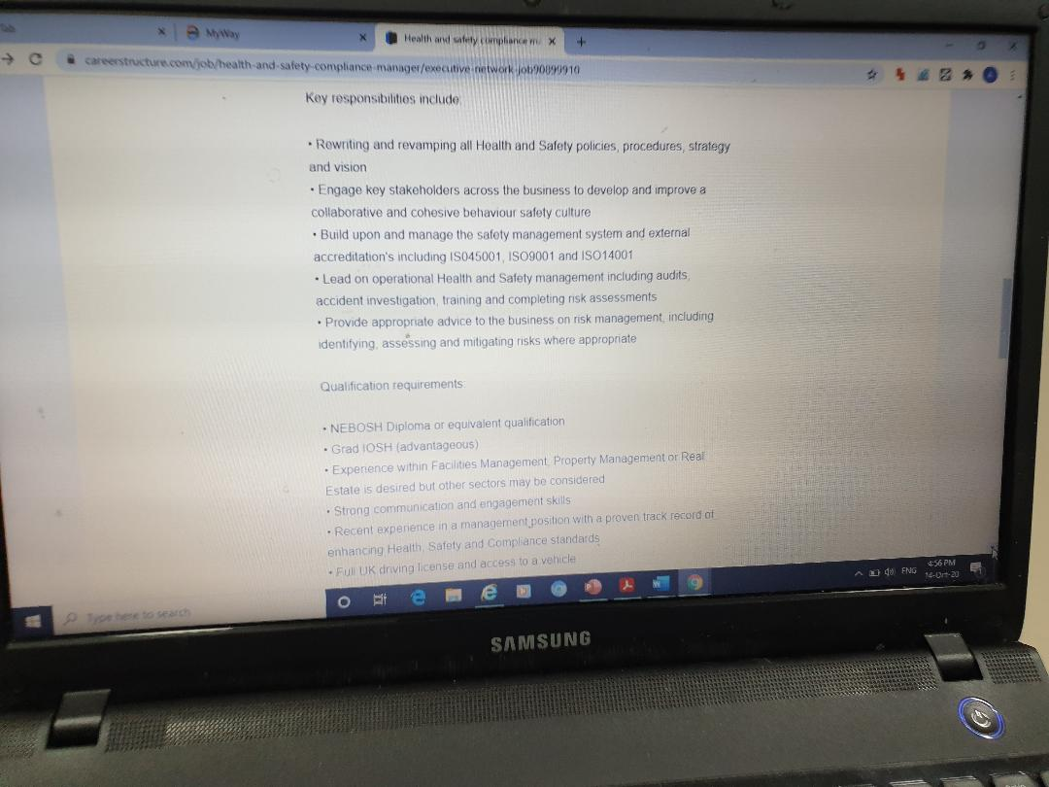
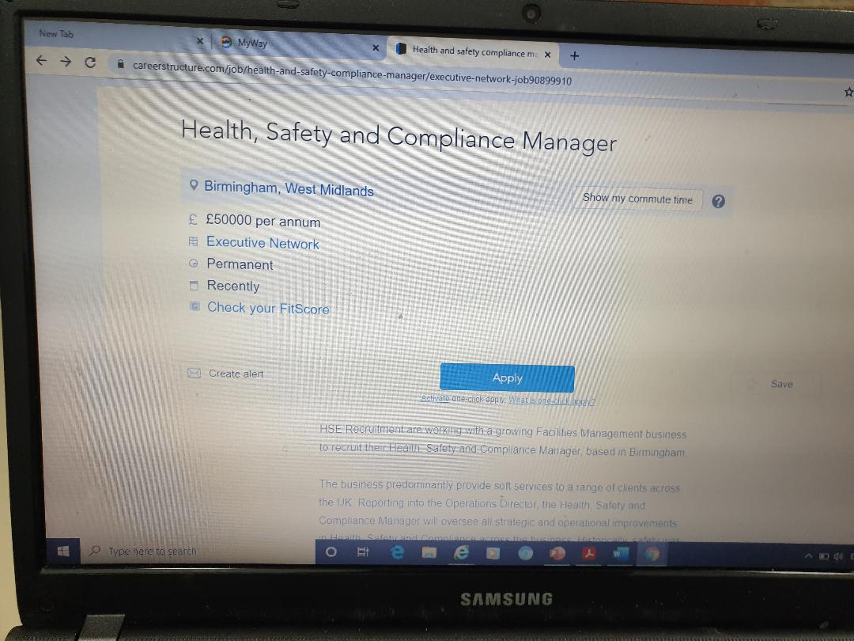
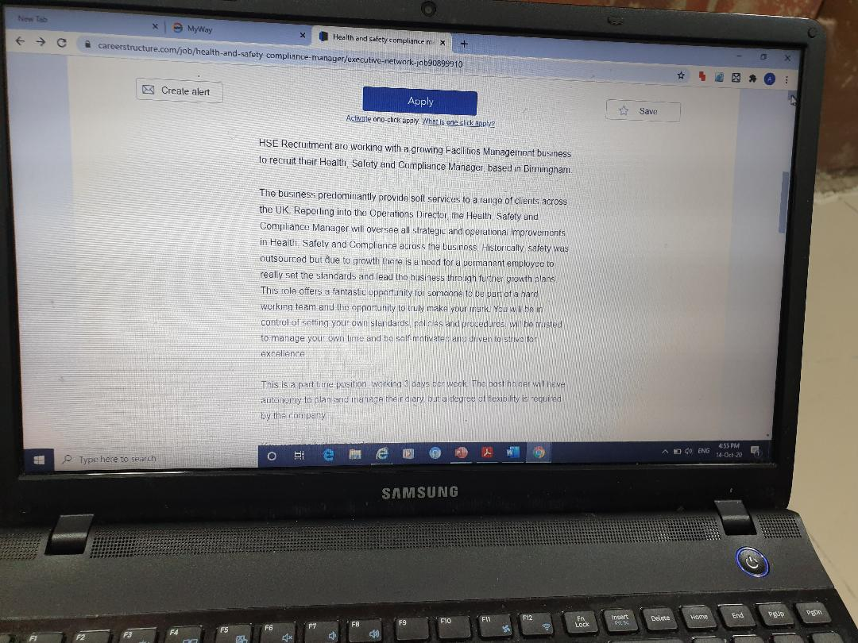

THANK YOU!

